Task 2
- Setup: Generate RSA Key Pair for Bob
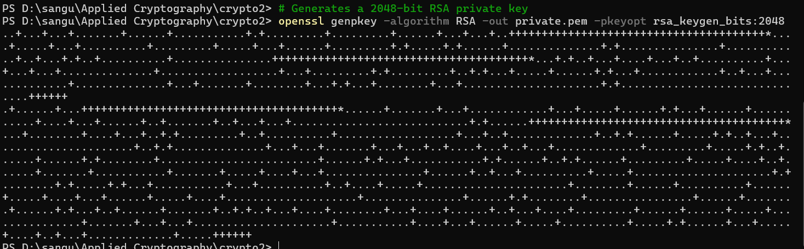
Derive Public Key
- Alice creates the secret file and calculates its original hash.

Compute Original SHA-256 Hash for Integrity Check
- Alice uses a symmetric cipher (AES-256) to encrypt the message
Generate Random Key and IV
Encrypt File
- Alice uses Bob's public key to encrypt the random AES key. This ensures only Bob can decrypt the key

- Bob Decrypts the AES Key (RSA)
Bob receives the encrypted file and the encrypted AES key. He uses his private key to recover the AES key.

6. Bob Decrypts the File (AES) and Verifies Integrity
Bob uses the recovered AES key and the (unencrypted) IV to decrypt the file
Compute Final SHA-256 Hash and Compare
They are same
The process uses a hybrid approach to leverage the strengths of both symmetric (AES) and asymmetric (RSA) cryptography.
- Preparation (Bob): Bob generates a unique RSA public/private key pair. The public key is shared with Alice, while the private key remains secret.
- Symmetric Encryption (Alice): Alice generates a fast, one-time random AES-256 key and IV. She encrypts the large plaintext file (alice_message.txt) using this AES key, creating the ciphertext (encrypted_file.bin).
- Asymmetric Key Exchange (Alice): To securely transmit the AES key (which is small), Alice uses Bob's RSA public key to encrypt the AES key, creating the secure key package (aes_key_encrypted.bin).
- Transmission: Alice sends the large encrypted file (encrypted_file.bin) and the small encrypted key (aes_key_encrypted.bin) to Bob.
- Asymmetric Decryption (Bob): Bob uses his secret RSA private key to decrypt the small key package and recover the original AES key.
- Symmetric Decryption & Verification (Bob): Bob uses the recovered AES key and the IV to decrypt the large file, recovering decrypted_message.txt. He then computes the SHA-256 hash of the recovered file and compares it to the hash of the original file (pre-calculated or sent alongside the data, e.g., in a signed manifest) to ensure data integrity and confirm no unauthorized modification occurred during transit.

📊 Comparison: AES vs. RSA
Feature | AES (Symmetric) | RSA (Asymmetric/Public Key)
Speed | Extremely Fast (especially for large data) | Very Slow (computationally intensive)
Use Case | Bulk Data Encryption (files, network traffic) | Secure Key Exchange and Digital Signatures
Key | One shared secret key | A pair: Public Key (shared) & Private Key (secret)
Security | Security relies solely on the secrecy and size of the single key. | Security relies on the complexity of factoring large prime numbers.
Conclusion: AES is ideal for encrypting the data due to its speed, and RSA is ideal for securely transporting the small, secret AES key due to its ability to encrypt using a public key only decryptable by a private key.
You can check this text README.md and README.txt as I have done it in ssl I also added README.txt

