Lab 5

Topics: Simon Says Game

**________________________________________**

Aaron Zhong 67737879

05/25/16

**Schematic**

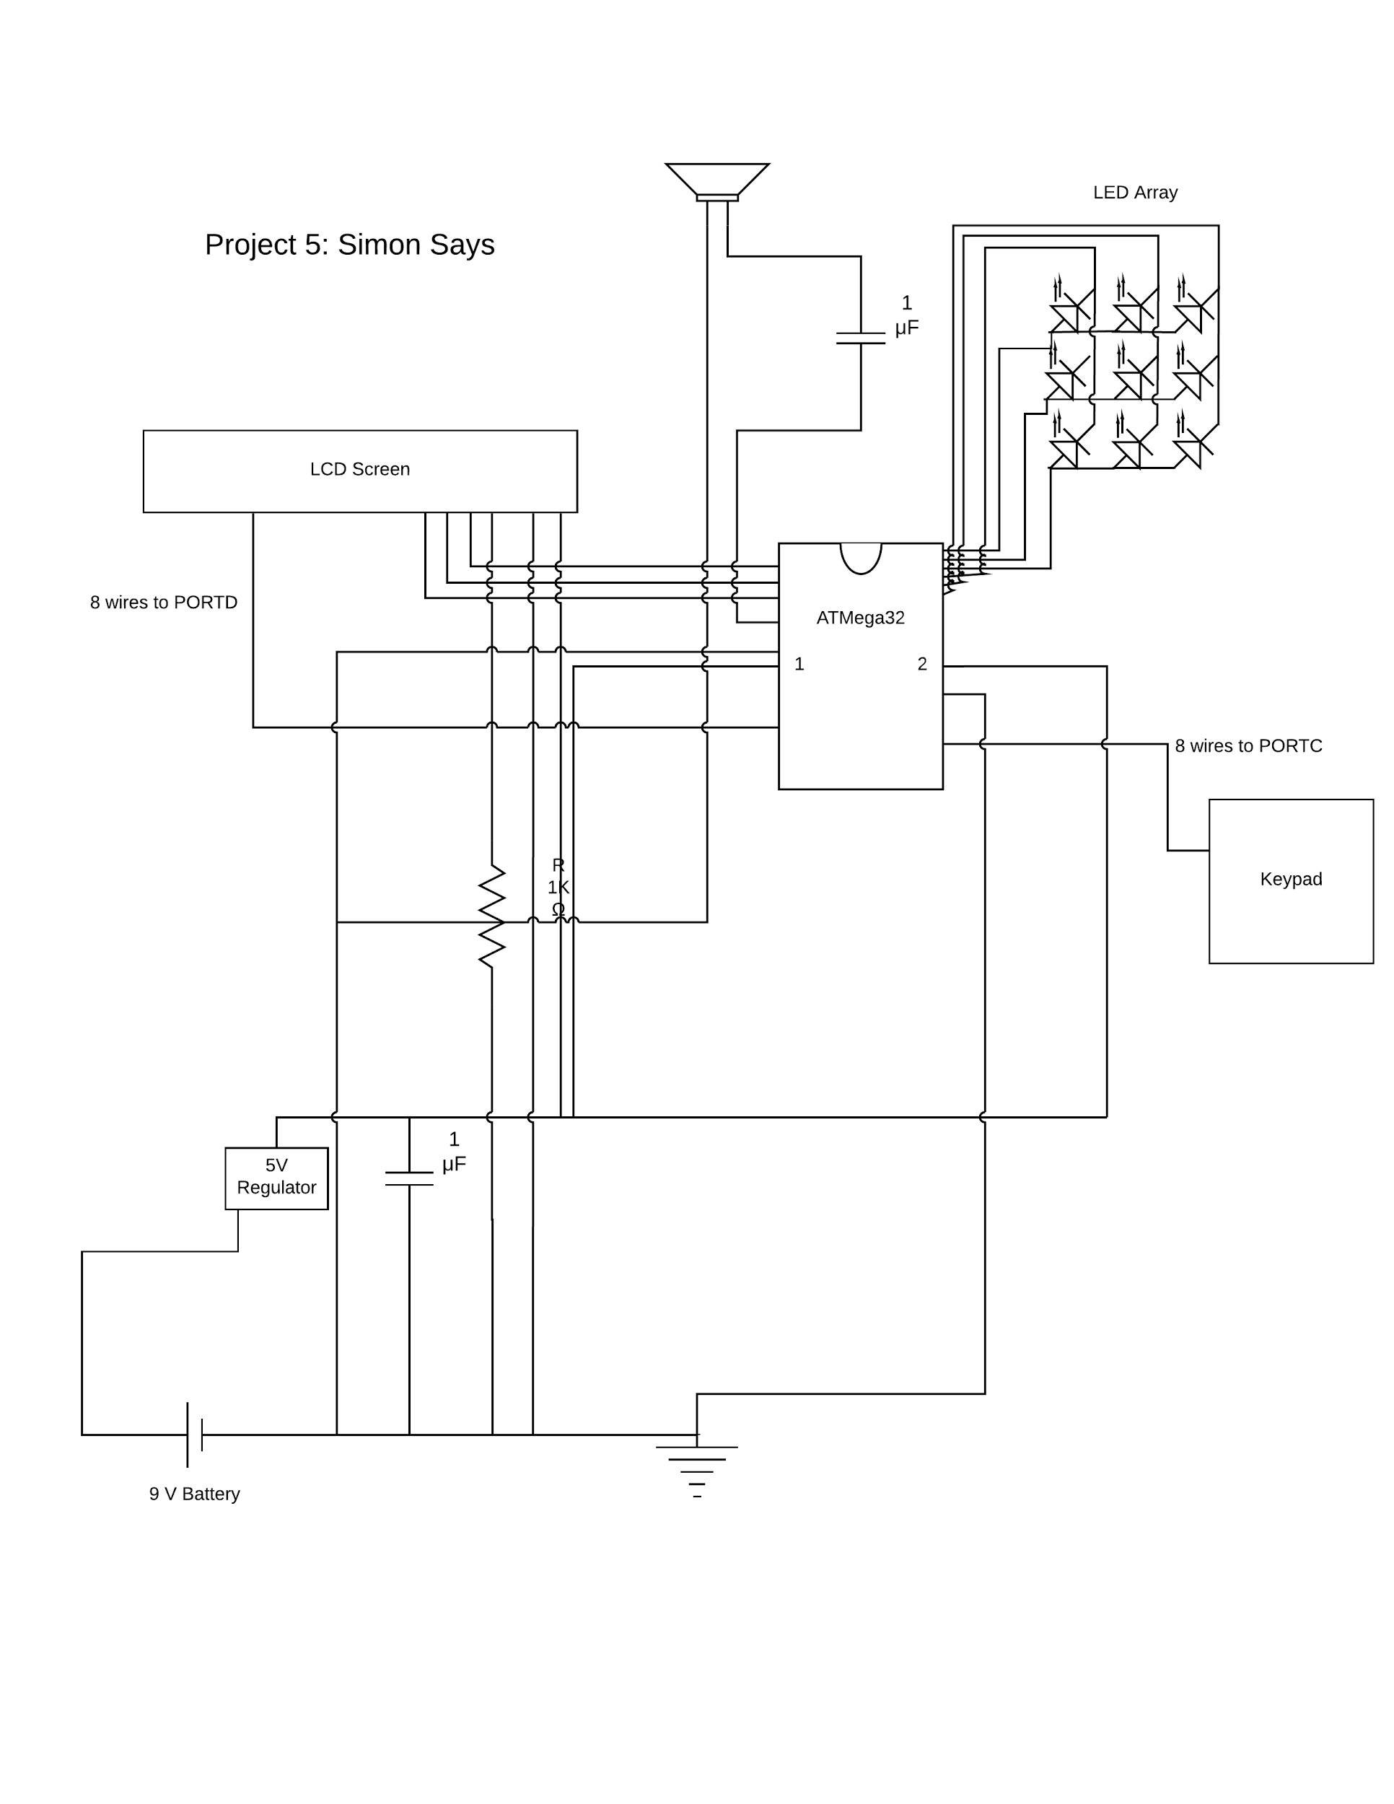

**Images**

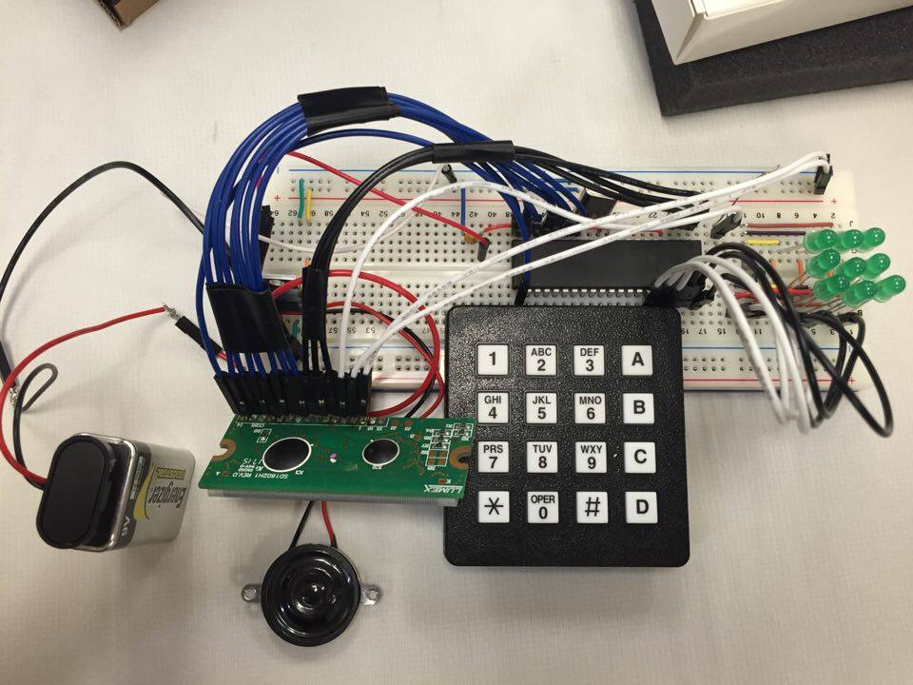

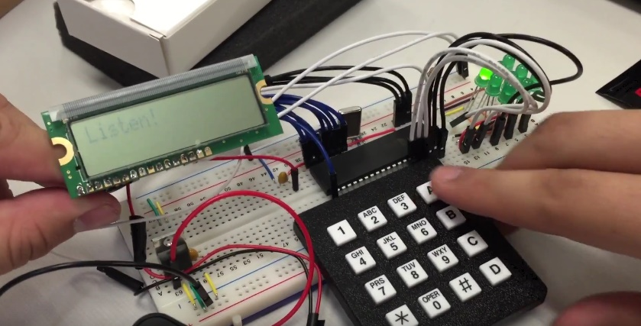

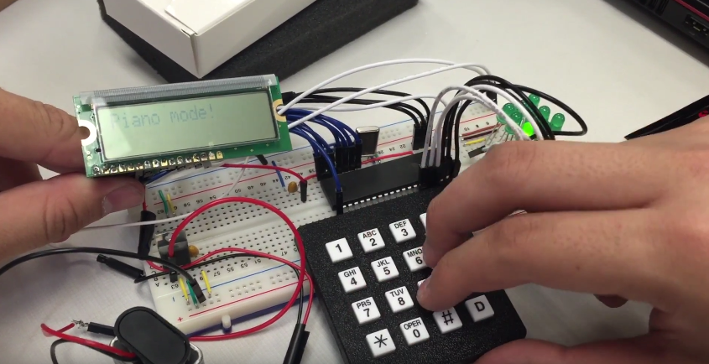

**Video Examples**

[**https://youtu.be/EjI8whOFOv0**](https://youtu.be/EjI8whOFOv0)[**https://youtu.be/vqjgABhYxdA**](https://youtu.be/vqjgABhYxdA)

**Homework**

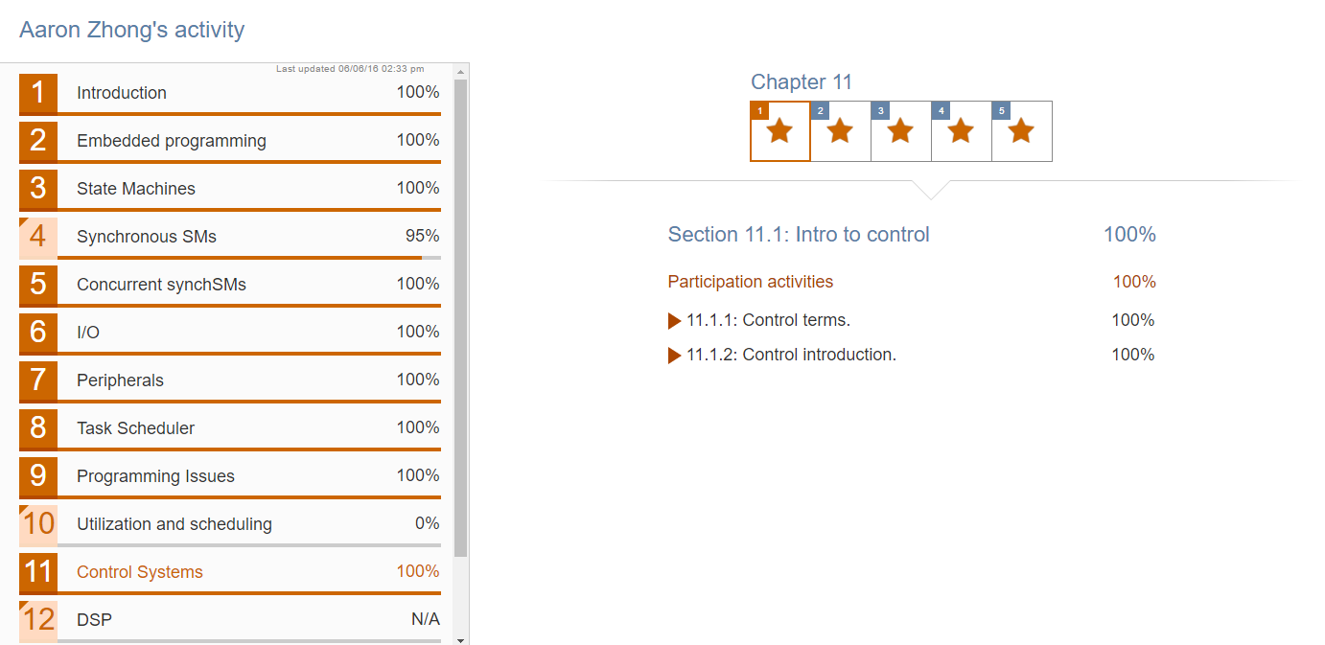

**Code (also attached in zip)**

*---------- self written ----------*

main.c

<http://pastebin.com/h6Ud7jWq>

keypad.c

<http://pastebin.com/JUiqyCq6>

keypad.h

<http://pastebin.com/d2s2sk2A>

music.c

<http://pastebin.com/tTURywbG>

music.h

<http://pastebin.com/B6msVmGi>

*---------- modified ----------*

avr.c

<http://pastebin.com/BkdLjvBF>

*---------- provided ----------*

avr.h

<http://pastebin.com/eCAmenxv>

lcd.c

<http://pastebin.com/HTR02mJt>

lcd.h

<http://pastebin.com/tTPiWtfy>