**Breast Cancer Cell Classification and Prediction**

**Akshat Garg(E22CSEU0263)**

**SCSET, Bennett University**

Introduction:

Amidst the global healthcare landscape, breast cancer stands as a formidable challenge, demanding precision and innovation in its diagnosis and treatment. To respond to this pressing need, our Data Mining Project seeks to pioneer a revolutionary approach to the classification and prediction of breast cancer cells. The process of preprocessing, where raw data undergoes rigorous cleaning, normalization and feature selection in order to ensure its suitability for analysis, is carried out with a keen focus on data quality and relevance. We train models to distinguish between malignant and benign breast cancer cells with unprecedented accuracy, using the power of diverse classification algorithms, including Logistic Regression, Support Vector Machines, Random Forest.

By improving diagnostic accuracy and informing treatment decisions in the management of breast cancer, our project goes beyond theoretical advances and aims to have a real impact in clinical practice. We demonstrate the effectiveness of our approach through a comprehensive model evaluation, including metrics such as accuracy, precision and recall. In addition, we're focusing on seamless user interaction through the development of an intuitive Graphical User Interface that facilitates breast cancer diagnosis and treatment decision making. By bridging the gap between research and application, we're empowering healthcare professionals with accurate information that will ultimately lead to improved patient outcomes and a new era of precision medicine in the fight against breast cancer.

Problem Definition:

Breast cancer remains a significant health concern globally, posing challenges in accurate diagnosis and treatment planning. The lack of precise methods for distinguishing between malignant and benign breast cancer cells often leads to delayed diagnosis and inappropriate treatment, impacting patient outcomes. Additionally, the complexity of breast cancer datasets and the need for expertise in interpreting them hinder effective decision-making by healthcare professionals. In addition, these challenges are exacerbated by the lack of robust predictive models, which hinders the implementation of personalised treatment strategies. Furthermore, the integration of Advanced Predictive Analytics in healthcare practice is hindered by a lack of user friendly interfaces that limit their utility to enhance outcomes for patients. In order to bridge this gap, it is therefore necessary to develop accurate and intuitive tools to empower healthcare professionals with accurate and intuitive information, which will ultimately improve patient outcomes in breast cancer treatment.

Implementation:

1. Data Collection:

Obtain the Wisconsin breast cancer dataset, ensuring it includes relevant attributes such as tumor characteristics, patient demographics, and diagnosis outcomes.

1. Data Preprocessing:

* Data Cleaning:

Identify and handle missing values: Use techniques such as mean imputation, median imputation, or removal of rows/columns with missing values to address missing data.

Remove duplicates: Check for and remove, identify and handle missing values: Use techniques such as mean imputation, median imputation, or removal of rows/columns with missing values to address missing data.

* Normalization:

Normalize numerical features to a similar scale to prevent certain features from dominating others during model training.

* Encoding:

Use label encoding for ordinal categorical variables with inherent order, assigning a unique integer to each category.

Apply one-hot encoding for nominal categorical variables without inherent order, creating binary dummy variables for each category.

* Visualisation:

Histograms or density plots depict numerical feature distributions, highlighting outliers.

Scatter plots or pair plots reveal correlations between numerical features, exposing underlying relationships.

Bar plots or count plots explore categorical variables, uncovering trends or patterns.

A correlation matrix heat map illustrates pairwise correlations between numerical features.

* Model Training:

Implement machine learning algorithms such as Support Vector Machine (SVM), Decision Tree, Naive Bayes, etc.

Train the models using the preprocessed dataset.

* Model Evaluation:

Evaluate the performance of each model using metrics such as accuracy, precision, recall, etc.

* Graphical User Interface:

Develop a user-friendly GUI comprising welcome, prediction, and about pages.

Integrate the trained models with the GUI to enable users to interact with the predictive model seamlessly.

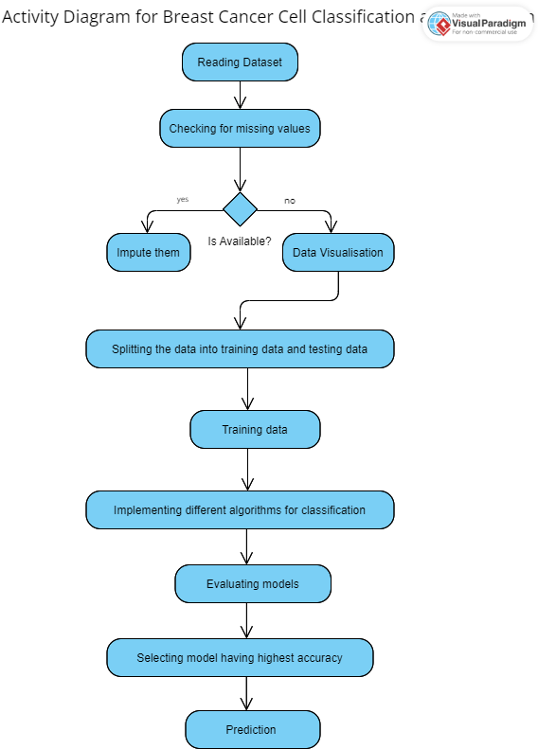

Results and Conclusion:

