**DTSC –Dynamic Taxonomy on Structural Colour: A Visual Interface to Bridge Science and Design Innovation**

Carlos Fiorentino (PhD Human Ecology, MDes Art & Design)

Supervision: Dr. Megan Strickfaden, Dr. Anne Bissonnette (Human Ecology, U of A) Scientific Advisor: Dr. Tomislav Terzin (Biological Sc. U of A, Augustana)

The Dynamic Taxonomy on Structural Colour –DTSC is a browsing interface, conceptually similar to any webpage browser, with the capacity to find, arrange and visualize scientific information (metadata) about species (animals, plants, etc.) showing structural coloration.[1] Based on a Rich Prospect Browsing experience,[2] users –designers and scientists– should be able to find, select, and customize their search results, inviting to more exploration and eventual contributions. The initial dataset for such a dynamic tool, will be provided in a spreadsheet, which includes images and data about a selection of species to populate a database. This information is organized in a scientific taxonomical manner, with main categories, sub categories, facets, details, etc. The main tool for initiate any query is a “colour picker” available on the home page, however the user should be able to also navigate the database by clicking on categories, individual species, or typing keywords on a search engine. The way a CMPUT 401 team could contribute to this project is by developing a working prototype of the DTSC interface for testing purposes.

An example of how the user of the DTSC interface may find basic information can be described as follows:

1. The user opens the interface home page and a main modular menu shows a taxonomic arrangement of options (fig.1a), a colour picking tool (fig.1b), and a search engine field (fig.1c).
2. The user picks a colour hue from the color picker and the interface prompts a collection of images related to that hue, collected from the available database (fig.2).
3. The user picks one image (one species) and the interface prompts a “page profile” of this particular species with all the scientific data available about it (fig.3).
4. There is a number of possibilities from this point of the process that may be offered to the user in the future (access to more data in scientific repositories, access to developed visualizations and widgets, review and contribution tools, etc.); for now achieving a basic navigational experience in a first prototype is aimed for CMPUT 401.

Structural colour is an exciting emerging area within biomimetic design (biomimicry[3]) and scientific innovation. Scientists and designers alike are embarked in research projects that may provide important advancements on materials, new products and communication technology based on structural colour observed in nature. DTSC may contribute and facilitate the communication between scientists and designers involved in current biomimetic projects, as well as inspire new ones.

c

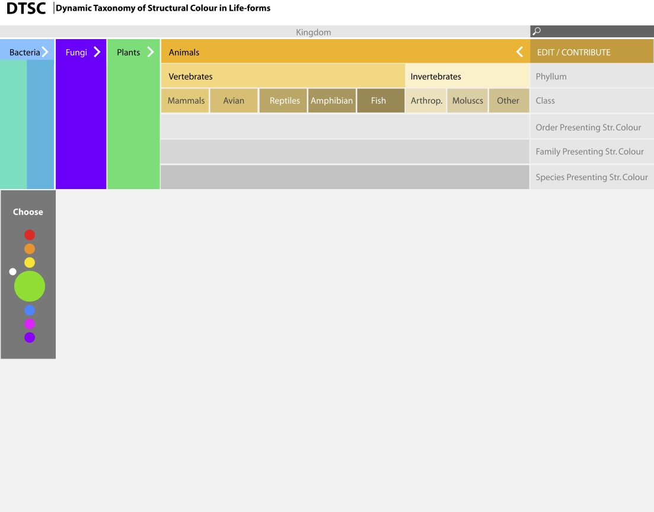

b

a

*Fig.1: DTSC home page shows a main modular menu organized as a biological taxonomy: kingdoms, phylum, class, order, family and species (a), a colour picking tool to select a hue (b), and a search engine field (c).*

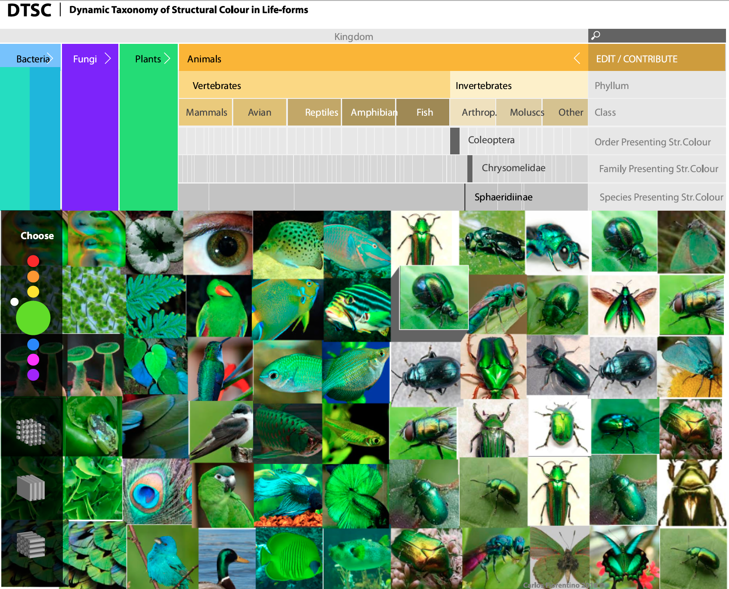

*Fig.2:After picking a colour hue, the interface is able to prompt a collection of images related to that hue, collected from the available metadata.*

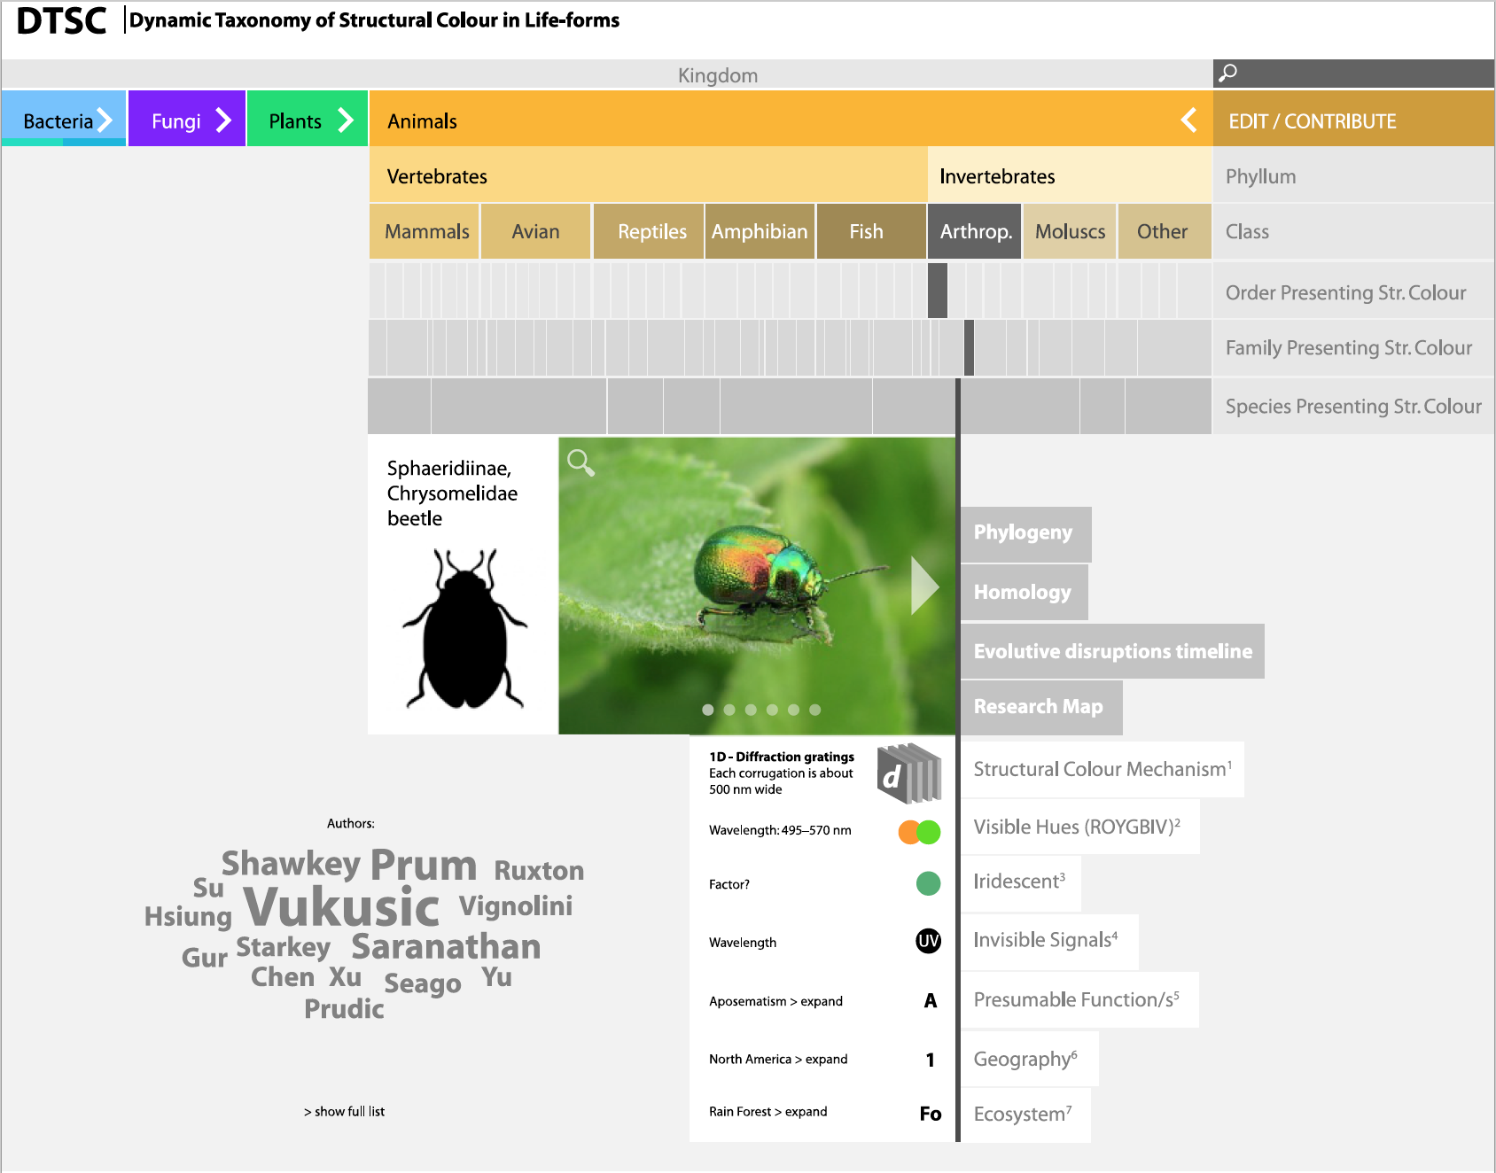

*Fig.3:* *When the user picks one species, the interface prompts a “species page profile” with all the scientific data available about it:structural colour mechanisms, visible hues, iridescence, UV, IR, functions, location and bibliography available, as well as other options to be developed in the future (e.g. phylogeny, homology, timeline and maps visualizations).*

MOCKUP VERSION: <https://xd.adobe.com/view/db3f8da5-fc16-4a54-b75a-68ff8eba2f9e/>

FLOWCHART OF THE PROJECT:

<https://carlosfiorentino.files.wordpress.com/2016/11/flow-diagram-copy.jpg>

(password protected: carlos)

FLOWCHART OF DTSC INTERFACE CONTENT: <https://carlosfiorentino.files.wordpress.com/2016/11/dtsc_flowchart.pdf>

(password protected: carlos)

1. Structural Colour –in physics “light interference”– which is a way of achieving colour without relying on pigmentation or chemical coloration processes, but rather by adding “information” to material surfaces at the nano-scale. In nature Structural Colour is observed in an abundant number of species across animals, plants, fungi and bacteria.
2. A Rich Prospect Browser is an experimental interface, in which the home page displays a visual representation of every item in a given collection, combined with tools for manipulating the display.
3. Biomimicry is an emerging design discipline that studies “nature’s best ideas” with the purpose of emulating them to address human problems by design. Biomimicryis “an approach to innovation that seeks sustainable solutions to human challenges by emulating nature’s time-tested patterns and strategies” (Biomimicry Institute, 2017.