FeROS
Ferrite Retro Operating System
Project Vision, Identity & Architectural Direction
A performance-first, hardware-first operating system built from scratch for retro handhelds and embedded gaming platforms.

No Linux runtime. No hidden platform dependency. Every layer is ours to understand, design, and evolve.

1. The New Beginning
FeROS represents a new beginning for the project originally started as FerroOS. The earlier experiment explored a Linux-oriented path using Docker, Buildroot, RetroArch, and an application/frontend layer. That work remains useful as historical reference and tooling, but it no longer defines the architecture.
The new objective is substantially deeper: FeROS is intended to become an independent operating system whose own software controls the machine from the earliest practical post-ROM boot stage through the kernel, drivers, runtime, graphics, audio, storage, input, and gaming environment.

2. Name & Identity
The working name is FeROS. Its capitalization intentionally exposes the structure of the name:
Element | Meaning | Identity
Fe | Ferrite | Hardware, core material, low-level systems; also evokes Fe, the chemical symbol for iron.
R | Retro | The project's gaming heritage and its focus on retro handheld platforms.
OS | Operating System | The complete software environment being designed and built.
FeROS keeps the strong sound of FerroOS while giving the name a cleaner technical decomposition: Fe + R + OS.

3. Product Statement
FeROS - Ferrite Retro Operating System
A superb, performance-focused retro gaming operating system intended for fully customizable handheld consoles and embedded platforms.
FeROS is not intended to be a Linux distribution. Linux may be used as a reference implementation or diagnostic environment during hardware reconnaissance, but it is not intended to be the FeROS runtime.

4. Project Philosophy
- Hardware-first design.
- Predictable behavior over unnecessary abstraction.
- Every important layer should be understandable and observable.
- Minimal magic: dependencies and platform behavior should be explicit.
- Portability through clean separation of generic kernel, architecture, SoC, and board code.
- Performance should be designed into the system rather than added as an afterthought.
- Documentation is part of the engineering product, not an accessory.
Guiding idea: No magic. Every layer is visible.

5. Architectural Identity
The original Linux-oriented direction can be summarized as:
Docker -> Debian/Buildroot -> Linux -> RetroArch -> Frontend
The new FeROS direction is:
Boot ROM -> FeROS boot code -> FeROS kernel -> FeROS HAL/drivers -> FeROS runtime -> Applications/Games

6. What FeROS Intends to Own
- Boot-stage code after the immutable SoC ROM boundary
- Kernel
- Physical and virtual memory management
- Task scheduling and synchronization
- Interrupt and exception handling
- Hardware abstraction
- Device drivers
- Input subsystem
- Graphics stack
- Audio stack
- Storage and filesystem layers
- Runtime environment and system APIs
- Gaming frontend and application environment

7. First Hardware Target: PowKiddy X55
The PowKiddy X55 is the first physical board target, not the definition of FeROS itself. It provides a practical ARM64 platform based on the Rockchip RK3566 with integrated display, controls, storage, audio, networking, battery management, and other embedded peripherals.
The design goal is to prevent generic kernel code from knowing that a PowKiddy X55 exists. Hardware specificity should increase only as the architecture moves downward.
Application / Game
|
FeROS API
|
Kernel
|
HAL
------- hardware boundary -------
|
AArch64
|
RK3566
|
PowKiddy X55

8. Proposed Source Architecture
feros/
├── arch/
│ └── aarch64/
├── kernel/
├── drivers/
├── soc/
│ └── rockchip/
│ └── rk3566/
├── boards/
│ └── powkiddy/
│ └── x55/
├── runtime/
├── sdk/
├── tools/
├── docs/
└── examples/
The exact tree should evolve from real requirements rather than being filled with speculative abstractions. Directories should appear when FeROS has code that genuinely belongs there.

9. Language Direction
C should predominate during initial kernel and driver development, with AArch64 assembly restricted to places where direct architectural control is required.
C | AArch64 Assembly
Kernel, memory management, scheduler, drivers, filesystems, HAL, libraries | Entry point, initial stack, exception vectors, context switching, special CPU instructions
The initial environment is freestanding: FeROS cannot assume libc, printf, malloc, processes, files, or any other operating-system service until FeROS itself provides them.

10. First Bring-up Milestone
The first milestone is deliberately tiny: code written by the FeROS project must execute on the physical PowKiddy X55 after power-on and produce an observable result.
Power On
|
RK3566 Boot ROM
|
early hardware/DRAM initialization
|
FeROS entry point
|
AArch64 startup
|
UART
|
FeROS v0.0.1
Board: PowKiddy X55
SoC: RK3566
FeROS booting...
UART - Universal Asynchronous Receiver/Transmitter - is the preferred first diagnostic output because it can provide visibility before FeROS has initialized the LCD, graphics stack, filesystem, USB, or networking.

11. Development Progression
1. Boot and establish controlled execution
2. UART diagnostic output
3. CPU and exception-level initialization
4. DRAM and memory-map understanding
5. Exception handling
6. Interrupt controller
7. Timer
8. Physical memory allocator
9. MMU and virtual memory
10. Scheduler
11. SD/MMC storage
12. Filesystem
13. Input controls
14. Display
15. Audio
16. GPU acceleration
17. Runtime, applications, and games

12. Living Documentation: The FeROS Book
FeROS should be documented as a system that can be studied years later. A living engineering handbook can evolve alongside the implementation:
Chapter | Scope
00 - Philosophy | What FeROS is, why it exists, design principles, and project boundaries.
01 - Boot Process | RK3566 Boot ROM, early loading, DRAM initialization, and FeROS entry.
02 - AArch64 Architecture | CPU execution levels, MMU, exceptions, interrupts, caches, and timers.
03 - Memory | Physical memory, allocators, virtual memory, address spaces, and protection.
04 - Scheduler | Tasks, context switching, synchronization, interrupts, and timing.
05 - Drivers | UART, GPIO, SD/MMC, input, display, audio, networking, and USB.
06 - Graphics | Framebuffer bring-up through hardware-accelerated graphics.
07 - Runtime & SDK | System APIs, application model, executable format, SDK, and developer experience.

13. Historical Continuity
The original FerroOS repository should be treated as project history rather than discarded blindly. Existing assets can be classified as KEEP, REFERENCE, REWRITE, or REMOVE. CI concepts, documentation patterns, naming conventions, and development tooling may survive; Linux runtime assumptions, Buildroot architecture, and Linux-specific boot/frontend design should not constrain the new system.
A concise historical note can state: "Originally started as FerroOS. The project was renamed to FeROS when it evolved from a Linux-based experiment into an independent operating-system project."

14. Long-Term Intent
FeROS should not become PowKiddy X55 firmware. The X55 is the first board used to prove the architecture. The long-term model is a portable OS with architecture-specific, SoC-specific, and board-specific layers that allow additional handhelds and embedded platforms to be introduced without rewriting the system.
FeROS begins when code we wrote executes on the real machine.

15. Brand Identity & Logo Concept
The FeROS identity should visually communicate the structure of the name itself. The wordmark is not merely a label: it exposes the project's three conceptual elements.
Fe R OS
│ │ │
│ │ └── Operating System
│ └─────── Retro
└──────────── Ferrite

15.1 Primary Wordmark
The primary wordmark is FeROS, written as one continuous name while allowing Fe, R, and OS to remain visually distinguishable. Fe anchors the identity in hardware and material; R represents retro gaming; OS states clearly that the project is an operating system.

15.2 The Fe Isotype
The strongest compact symbol is Fe. It can be framed as a technical material marker inspired by the visual language of a periodic-table cell without becoming a literal chemistry logo. The association is deliberate: Fe evokes iron, ferrite, hardware, physicality, and the project's close-to-the-metal philosophy.
The Fe isotype can be used independently for boot splash screens, firmware identifiers, application icons, PCB markings, device shells, favicons, documentation marks, and future hardware.

15.3 Visual Construction
- Fe — physical core, hardware, ferrite/iron, low-level engineering.
- R — retro heritage, gaming, preservation, experimentation.
- OS — the complete operating system and the project's technical destination.
- FeROS — all three ideas combined into a single recognizable product name.

15.4 Brand Principles
- Technical rather than ornamental.
- Strong enough to appear directly on physical hardware.
- Readable in monochrome as well as in a richer product palette.
- Recognizable at boot-screen, icon, PCB, documentation, and full wordmark scales.
- Modern rather than artificially nostalgic: retro describes the purpose, not a requirement to imitate old visual design.
- The visual identity should reinforce the engineering philosophy: close to the metal, observable, controllable, and deliberately constructed.

15.5 Initial Brand Study
The following concept study explores a Fe-based isotype, the FeROS wordmark, the Fe / R / OS decomposition, device placement, a minimal boot screen, typography, and a preliminary palette. It is a design direction rather than a frozen specification; individual colors, typefaces, proportions, and marks can evolve as the project matures.
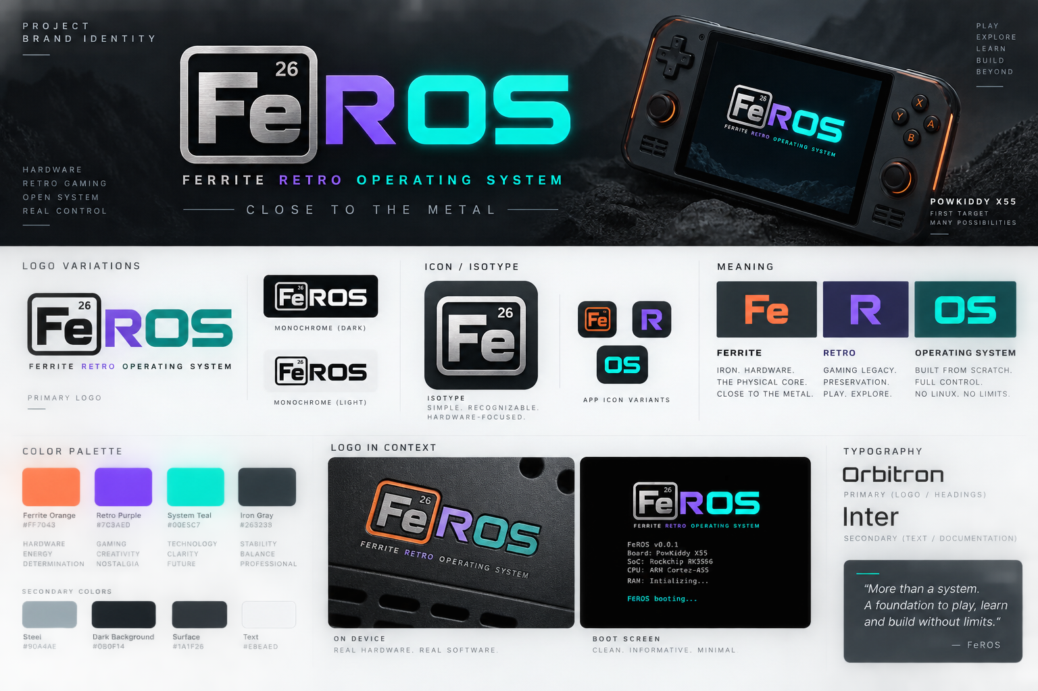
Figure 1 — Initial FeROS visual identity and logo concept study.

15.6 Suggested Brand Language
Primary expansion: FeROS — Ferrite Retro Operating System.
Working engineering tagline: Close to the metal.
The phrase describes both the visual identity and the architectural objective: FeROS should minimize unnecessary distance between its own software and the hardware it controls.

15.7 Brand Evolution
The logo should evolve with the operating system. Early development can use a simple monochrome FeROS mark that works in UART documentation and primitive framebuffers. As display and graphics support mature, the richer visual identity can appear on the physical device. This allows the brand itself to follow the same progression as FeROS: from the first machine instructions to a complete gaming environment.

