ManageStay

Senior Project Ishit Lal Pradhan Professor Miller
Ramapo College of New Jersey
08/13/2022

Table of Contents

- Introduction 1.1.Description 1.2.Features 1.3.Objectives
- Installation and Setup 2.1.Installation
    - Installing the backend dependencies

    - Installing the frontend dependencies
- Guide to using M a nageStay
3.1.Initial page
    - Home Page
    - Register Page

    - Login Page
3.2. Dashboard
    - Bookings Dashboard
    - Seller Dashboard
  - Booking Procedure
  - Posting rooms procedure
- Design

  - Summary
  - Essential Third-Party libraries
    - Express-JWT (JSON Web Tokens)

    - Axios

    - Stripe

    - FS

    - Bootstrap, Material UI, Antd and CSS third parties

    - React-Redux

  - MVC model implementation:
    - Backend Models and Controllers
    - Frontend Components/Views
  - File Structure
    - Backend file structure
    - Frontend file structure
    - Database

- Conclusion

Code and References used

Introduction

  - Description

ManageStay is a simple web application that helps users to post and buy their vacant hotel rooms in safe and easy manner from one user to another user in the United States. It is a full-stack web application where the frontend program interacts with the user and then passes the actions performed by the user to the backend program that can store that information safely in data models and can access and manipulate that data as per the requirements.
It is developed using an Model-View-Controller model and it is a platform that provides the opportunity for users to be both the buyer and seller of the hotel rooms. The application is simple to use, with initial registration in ManageStay and also the app is associated with stripe, people can pay with different variations of cards such as Mastercard, Discover, Visa, Amex and many more. Moreover, the seller has to setup a payout account through stripe in order to be able to post hotel rooms in this app.
In order to maintain authentication and authorization, I have used JWT and bcrypt to compare the password. In addition, I particular chose to do my project in React because I was familiar with it and React-Redux, does a great job for state management purpose. Moreover, React is a front-end JavaScript library developed by Facebook in 2011. It follows the component based approach which helps in building reusable UI components. It is used for developing complex and interactive web and mobile UI. Another advantage of using react is, it uses virtual DOM. A virtual DOM is a lightweight JavaScript object which originally is just the copy of the real DOM, which makes it faster and the DOM manipulation is easier.

  - Features

The core functionalities of ManageStay are listed and described briefly below.

Users should be able to:

    - Register: The User should be able to register successfully once the they fulfill the input valid data in the form.

    - Login: The user’s authentication is ensured using bcrypt and express-jwt and the user has the ability to successfully Login once they register.

    - Search : The user can search for their desire place . “Search Hotel” features that will take the information of the user that posted the room in the application and shortlist the search. Remove the rooms that have passed the current date.
    - Map Location : Include the map for the convenience of the customers using Leaflet and Mapbox API, also has get direction feature.
    - Order Hotel : The user has the ability to book a room through Stripe.

    - Buyer Dashboard:
      - Rooms booked: the Buyer has the ability to see their bookings.
      - Map: The Buyer will have the ability to see the location of the room they booked.
    - Seller Dashboard:
      - Room Owner has ability to change the rates, and information about of the rooms.
      - Room Owner has the ability to delete the room they posted.

Objectives

ManageStay has been designed as a simple platform for the user to post vacant hotel rooms and buy the rooms that they like that’s available on the web application.
The major objectives that ManageStay wishes to focus on are listed below:

- To ensure that only authorized users exist on this platform.
- To validate the login user with their credentials and allow money transfer only after setting payouts in Stripe.
- To give a convenient UI experience, have used bootstrap and material UI.
- To maintain a clear record of all transaction events that take place

Installation and Setup

Installation

As mentioned before, this project is built in an MVC model– the site’s main backend consists of Model and controllers and the frontend (has the View) which consumes the API endpoints provided by the backend via routes and actions.
Starting with the installation and setup of the app, we have to git clone or download the code from https://github.com/ialphha/ManageStay. Before we run the program we need to install our dependencies both on the front end and the backend part. Also, we need to make we have node.js and mongoDB installed in your system before we run the program.
You can check the by typing the following command in your terminal:
node -v
this will give the version of node installed in your computer.

And for the MongoDB:
mongo --version and mongod --version
This will also provide you with the information about the version of mongodb installed.

Installing the Backend dependencies:

Once that is done, Now you can just navigate into the server project directory and install all the node package dependency with the command:
npm install

After that, you can simply run the command :
npm start
on the server side
This should be displayed on the terminal.

2.1.2 Installing the Front End dependencies:
Similarly, on Front End, “Client” we need to the same thing, open the integrated terminal and hit the command:
npm install
and then npm start

Once that’s done, the application be running on localhost:3000 in your default browser.

Important Note:

The project uses a free trial Map Box for geocoding and autocomplete of location. This basically means that although the Account ID details for the Map Box account has been attached to the program, it has got limited number of request that you can send for the free trial account, and once the free trial ends, the map may not show up.
Moreover, I have used Stripe to handle payments and it is just used for testing purpose as no real money transactions have been made through the application.

Guide to using ManageStay

Home page

ManageStay’s home page has a simple custom design imported from the bootstrap package from boostwatch. Initially, on the home page, users can see the hotel list that is posted by other users, in order to book a room or post rooms, the user have to login.

    - Home Page
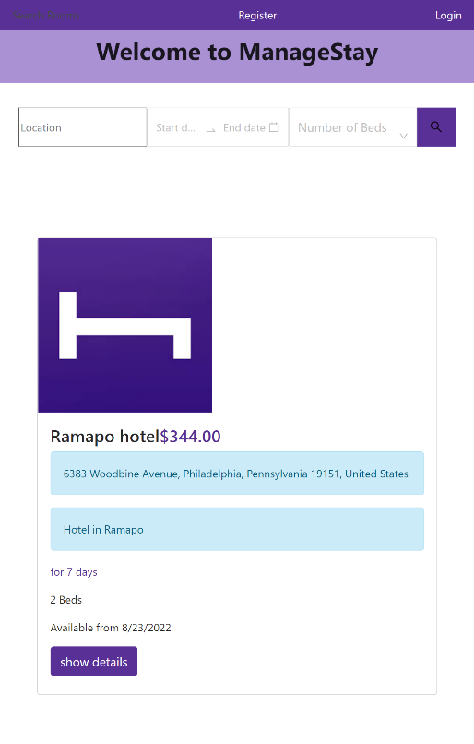
Here’s the screenshot of the home page.

    - Register Page To register, a user can go to the top right portion of the site’s home page to find the Register button.

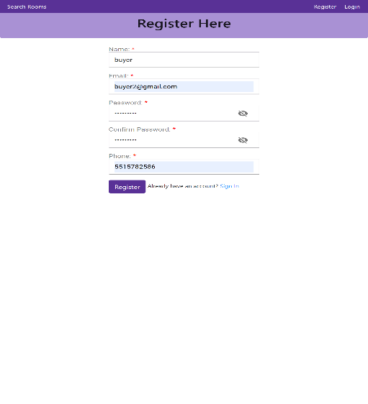

    - Login Page
After successful registration it will redirect you to the login page.
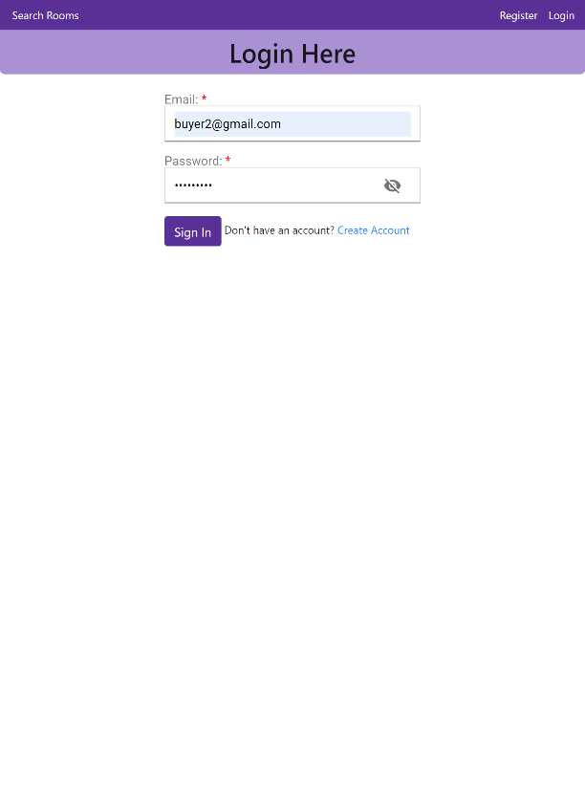

On both, the login page and registration page, I have used material UI for password hide/show feature and aesthetic UI.

  - Dashboard
Once signed in you will redirected to the dashboard portal. Dashboard has two sub sections: Your Bookings and Your list of selling rooms.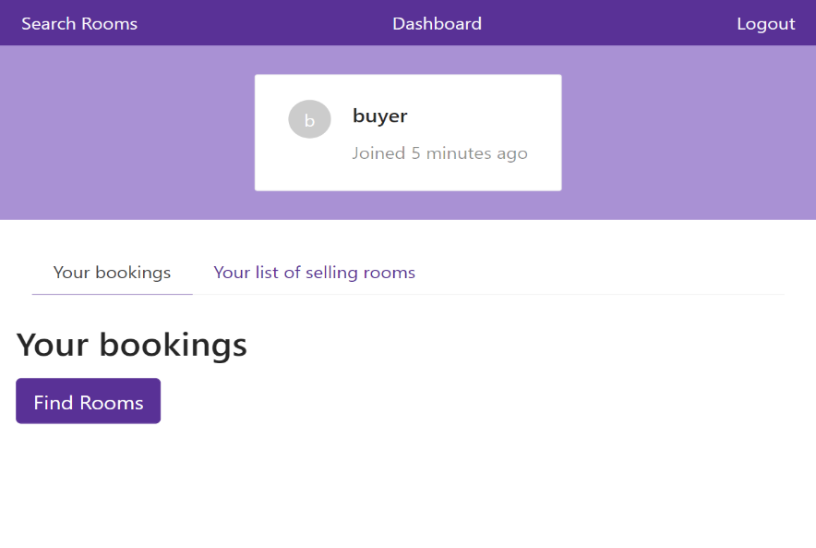
    - Bookings Dashboard:
The above diagram shows the Bookings portal of the dashboard.
    - Seller Dashboard:
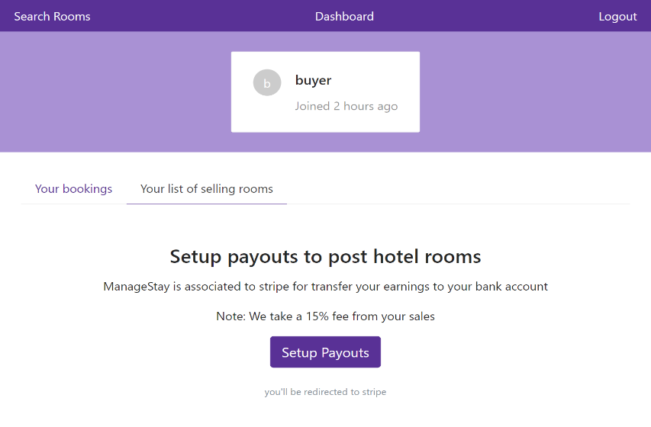
Similarly, here’s a screenshot of the seller section of the dashboard.
Note: User have to Setup payouts in order to be able to post rooms here and there’s also 15% fee that the app charges for the service.

3.3 Booking Procedure
Users can however, just buy the room, without setting up payouts from stripe if are not looking for posting rooms.
Here is a quick snippet of the process: 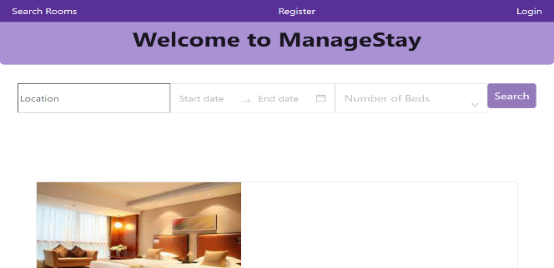
So you go the home page, i.e. the search page, by clicking the search rooms button on the navigation bar on the top left.
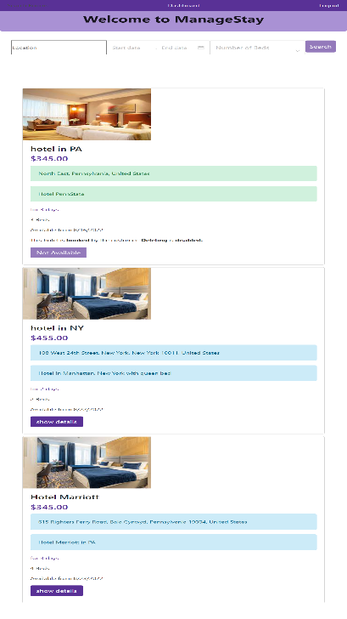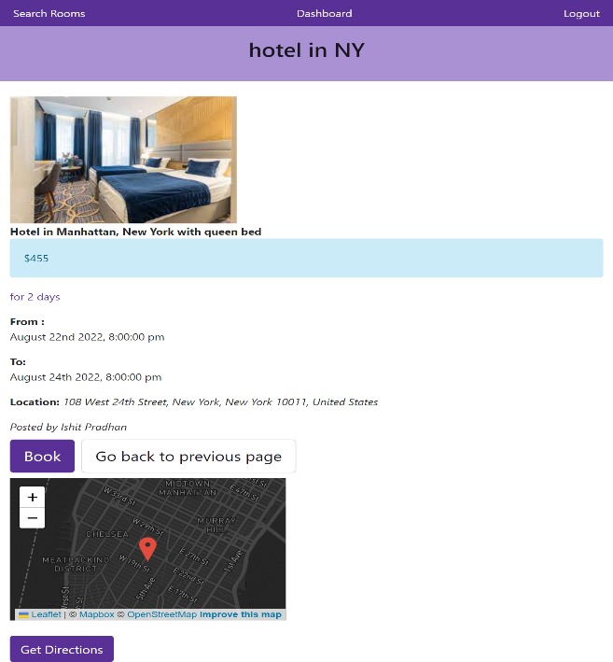
And when you click the show detail button on the left page, you will be redirected to the page on the right. On every hotel registered, the application stores the latitude , longitude of the address of the hotel is stored to the schema and that data is extracted on the right page and used for geocoding using Mapbox and leaflet API.

After clicking the Book button on the right, the user will be redirected to stripe checkout session.
The page would look something like this: 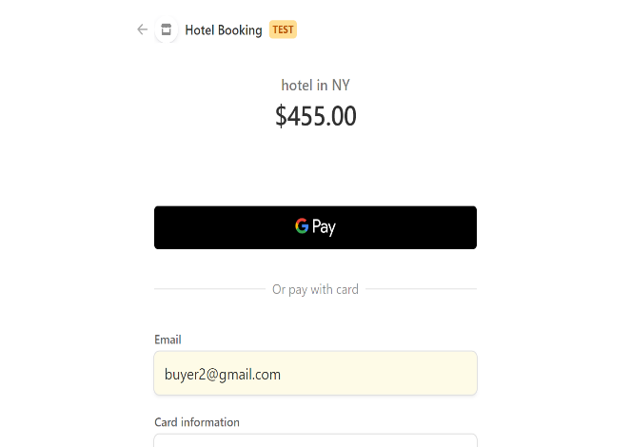
.

After the successful payment, the user will be redirected to ManageStay and with successful payment, the order is confirmed as the controller stripe.js has the function called “stripeSuccess” which ensures that the order is confirmed once the payment is fulfilled.

3.4 Posting rooms procedure:
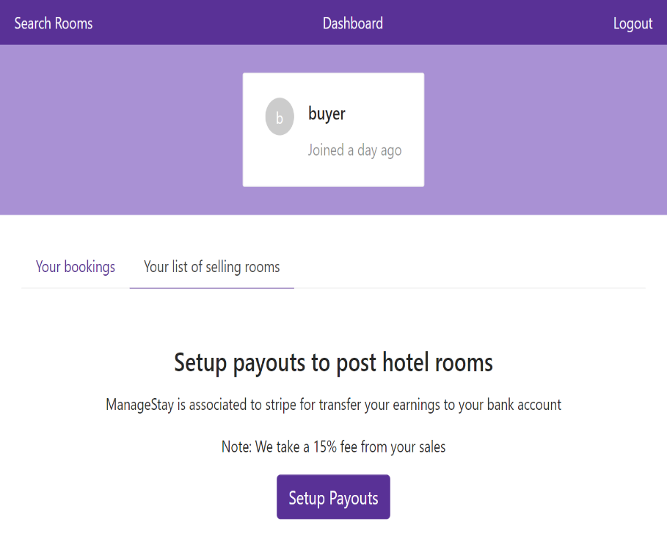
Back to the seller Dashboard. As mentioned before, the user needs to setup payouts for posting rooms in ManageStay and since, user above has not signed up for that, they cannot post rooms. So, when click on the “Setup Payouts” button, the user will be directed to stripe for creating an account.

After creating the account successfully, the user will be redirected to ManageStay and the AccountInfo component in client gets updated with new widget and the seller dashboard will also enable the user to post rooms to ManageStay.
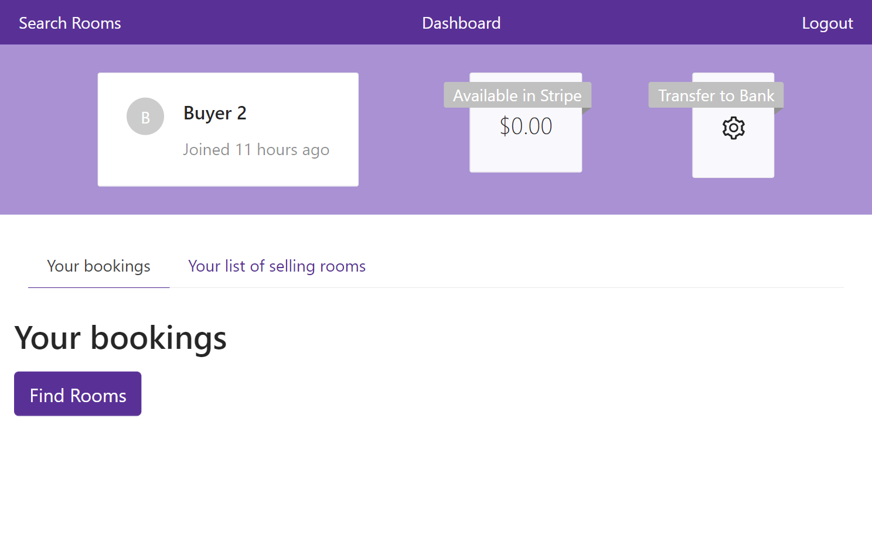

Design

Summary

The foundation of the project is the MVC model. Moreover, there is a backend API service via "routes", which binds the frontend and the backend application. That is how the backend can take requests and provide the necessary data to the View(frontend) that interacts with users.

This project works exactly on those principles. The backend server accepts user requests such as registering a user, logging in a user, and requesting different kinds of information for instance: user details, hotel details, create new hotels or user and many more. These requests are made by the frontend React application via the action and with axios requests is requested to the api which the routes holds, connecting the controllers to view.

Essential third-party libraries/dependencies:

    - JWT (JSON Web Token)

When users are making API requests from their ManageStay app, the server needs to verify whether the information requested actually belongs to the user requesting it. So, the project uses JWT which is a great standard tool for securing API services. JWT allows the project to securely share information between the user’s frontend app and the backend server. Here’s an example of the use of JWT and the controllers for handling the login:

And the above code is a method added to the “User” Schema in order to compare the password entered by the user while logging in.

Axios

The project uses the Axios library to make HTTP request over to the backend server. It is a great tool to easily send asynchronous HTTP requests to the URL endpoints provided by an API service. The Axios library helps the backend easily identify which CRUD operation the frontend is requesting for.

This project makes use of the Axios library and the JWT library by generating an Axios instance that automatically attaches the JSON web access token for a user to any API requests that ask for user data. The Axios library allows a frontend client to attach multiple headers to a request. After a user signs in, the frontend app needs the access token connected in order to perform any requests, hence the instance is present in the.js file and is largely utilized inside the user dashboard.

    - Stripe
Manage Stay is associated to stripe and it follows the stripe API in order to complete payment procedures. Handling payment procedure all by oneself would be a painful journey, thanks to Stripe. The payment method has been very easy because of stripe.
ManageStay have implemented various stripe api calls in order to fulfill the requirements of the payment procedures.
Here are some snippets:
This is a code snnipet from stripe.js in the controllers Here, the backend code sends the a link made by the stripe.accountlinks.create api as a response to the view.
Similarly, there are other Stripe API that have been used in ManageStay. Moreover, I would like to add another snippet which I struggled figure out initially.
In the code above stripe.session.id of the currently logged in user is passed to stripe.checkout.sessions.retrieve and if the payment status is equal to paid, the order of the hotel room is confirmed.

    - FS
ManageStay has used fs.readFileSync for storing image data for the hotel rooms and also readdirSync for the middleware of the routes in server.js.
Here’s a snapshot.
    - Bootstrap, Material UI, Antd and CSS third parties
ManageStay has used various third parties for handling the CSS and for the icons.
Bootstrap is one of the commonly used CSS framework, that is the same case for ManageStay. Moreover, a custom bootstrap file imported from boostwatch was also used in this project.
There are quite a few icons from Ant design and materialUI that have been used for this application.
The ribon component from ant design has been used in the screenshot below.Similar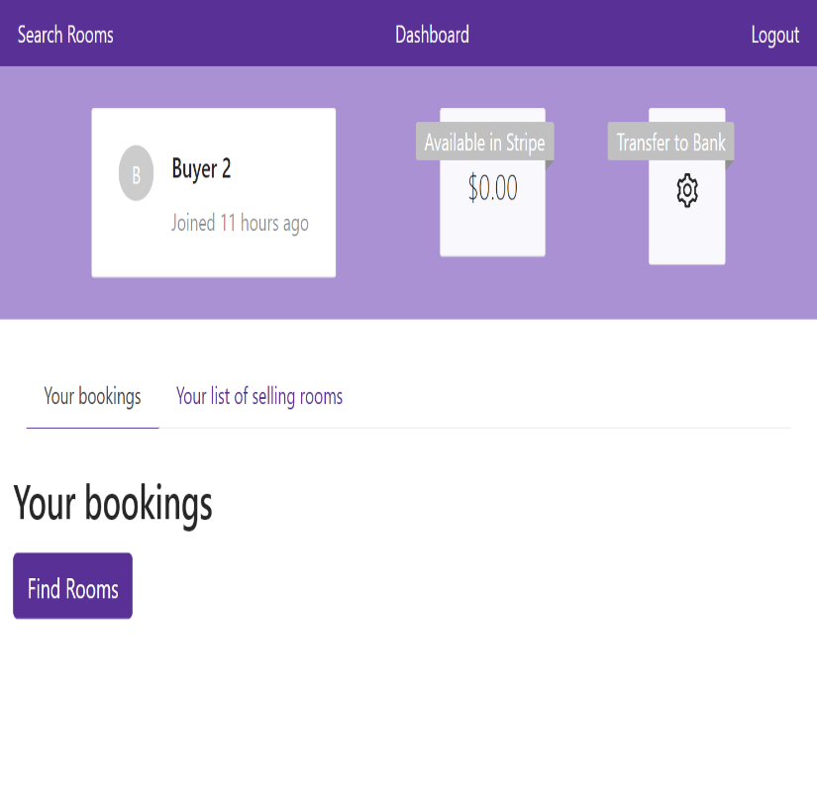
Similarly, material UI has been used in the screenshot below:
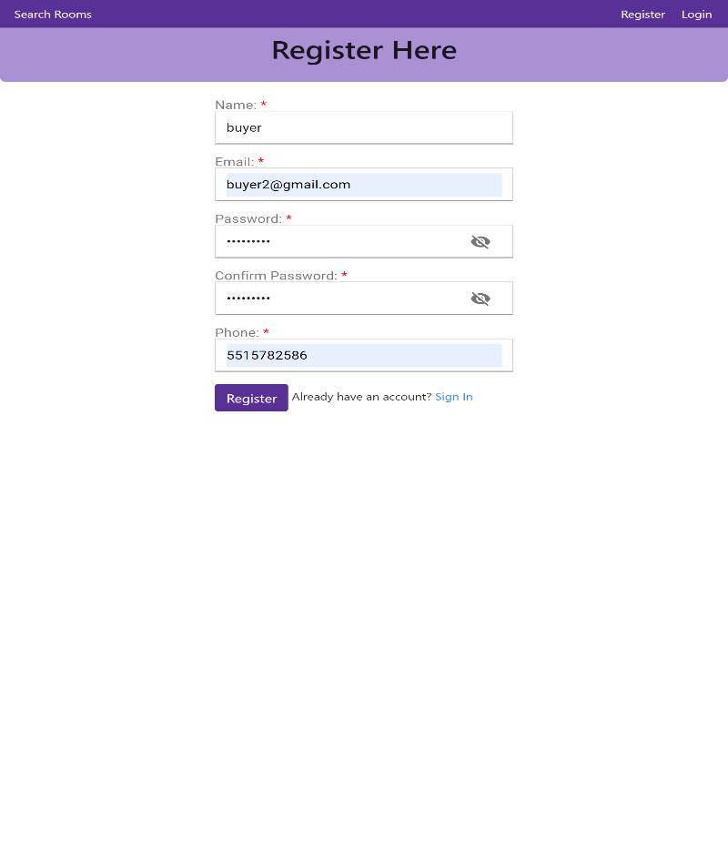

    - React-Redux:
React-Redux has been a benediction for programmers in terms of managing the state. It has made state management so much easier, it helps to mitigate the issue of prop drilling in react. Context API can also be used to solve the problem. However, Redux is more robust and a little expensive than Context api.
Here’s a screenshot of how react-redux was implemented in ManageStay:

  - MVC model implementation:
ManageStay is build based on MVC, and here are a list of Model, View and Controllers on ManageStay:
    - Backend Models and Controllers:
- Models:
      - hotel.js
      - order.js
      - user.js
- Controllers:
      - auth.js
      - stripe.js
      - hotel.js

    - Frontend Components/Views:
- Register.js
- Login.js
- stripeCallBack.js
- stripeFail.js
- stripeSuccess.js
- Dashboard.js
- SelllerDashboard.js
- EditHotel.js
- NewHotel.js
- SearchResponse.js
- Search.js
- Navigation.js
- Accountinfo.js
- DashBoardNav.js
- PrivateRoute.js
- OrderModel.js
- HotelCard.js
- ListBookingCard.js
- Forms:
      - CreateHotel.js
      - EditHotelForm.js
      - LoginForm.js
      - Registration.js
      - SearchHotel.js

File Structure:

As mentioned before, this app was developed under the MVC model. Backend consist of Model and

Controllers and the front-end consists of the View.

    - Backend:

    - Frontend:

  - Database:

For the Database, I have used NoSQL database which is Mongoose from MongoDB. Mongoose is a MongoDB object modeling tool which is built on top of the MongoDB driver for MongoDB and Node.js .
The reason for choosing to build the application with Mongoose is for the structured schema rather than a flexible schema of MongoDB. It supports data modeling, managing connections between data, and defining the schema for documents contained in collections. Users may easily generate and manage data in MongoDB thanks to Mongoose. Using MongoDB APIs to manage data, establish schemas, etc. is doable but can extremely challenging. Mongoose has made life simpler. Moreover, connecting to MongoDB atlas is super simple.
Here's the implementation of connecting to Mon

There are three models (mongoose schema) made:

Furthermore, here’s a snapshot of how the data schema looks in the MongoDB atlas:

Conclusion

Making this application was a great experiential and experimental learning. Looking back and reflecting, I can see that it was a long process to build this full stack application. I had initially opted to make an android application, however, the state management part was a hassle for me in Android. Therefore, I decided to switch to making a web application using React, as I was familiar with using React and its state management using React-redux.
While building the app, it felt quite overwhelming for the first few weeks. As mentioned before, I switched my plan from making an android app to a web application as I found learning to code mobile apps very frustrating and could not up with a proper state management procedure. However, that was not the case with react, react-redux made life so much better. Another perks of using React is that, it has one of the largest communities supporting it and if you end up with any issues, it’s easier to navigate the path to the solution.
Moreover, there’s a platform called code sandbox where the developers practice and share their code. It was a lot easier to learn through that platform as the developers made their code open source, they provided an opportunities for growth for other developers and themselves as well.
Version control platform such as git was something that I learnt during the course of making this application.

Moreover, I got to learn a lot from developing this project. Building this project , tough at some instances, however, this gave me the opportunity to learn the notion to tackle with the problems. I learned that doing everything from scratch is very time consuming and it’s important learn how follow the documentation while developing web applications.
Code and References used:
https://medium.com/swlh/elements-of-mvc-in-react-9382de427c09
https://medium.com/@vrinmkansal/quickstart-jwt-based-login-for-react-express-app-eebf4ea9cfe8
https://jwt.io/
https://www.npmjs.com/package/express-jwt
https://www.npmjs.com/package/express-jwt
https://codebots.com/docs/what-is-axios#:~:text=Axios%20is%20a%20promised%2Dbased,of%20request%20and%20response%20data.
https://www.mongodb.com/docs/manual/tutorial/getting-started/
https://mongoosejs.com/docs/
https://reactjs.org/docs/getting-started.html
https://bootswatch.com/

https://developer.mozilla.org/en-US/docs/Web/JavaScript/Reference/Statements/async_function
https://www.npmjs.com/package/react-mapbox-autocomplete
https://mui.com/material-ui/
https://react-leaflet.js.org/
https://stripe.com/docs/development/get-started
https://dashboard.stripe.com/developers
https://getbootstrap.com/docs/4.0/getting-started/introduction/
https://ant.design/components/overview/
https://www.npmjs.com/package/mongoose
https://www.geeksforgeeks.org/node-js-fs-readdirsync-method/
https://expressjs.com/en/resources/middleware/cors.html
https://www.w3schools.com/jsref/jsref_tolocalestring_number.asp
https://mongoosejs.com/docs/middleware.html

