LEFT COLUMN — Data Audit & Cleaning
Before drawing any conclusions, the dataset required careful preparation. Of the 27 variables collected across 2,232 customers, only Income presented missing values — 24 in total. Assuming these are Missing At Random, they were imputed using the median income within each education group rather than a global median, preserving the socio-demographic structure of the data.
The enrollment date was stored as plain text and converted to datetime. From this we derived each customer's seniority and age, both anchored to 2014 — the last recorded entry in the dataset — so that the features reflect how old customers actually were when their purchasing decisions took place.
One income value stood out: $666,666. While plausible on paper — and in a luxury retail context potentially worth investigating as a single high-net-worth customer — the repeating digits told a different story. With a total spend of just $62, six times below the dataset median, the data entry error hypothesis was unambiguous. It was removed using an IQR × 3 cap.
Finally, Marital_Status contained three invalid categories: Alone was recoded as Single, while Absurd and YOLO were dropped — 7 rows in total.

RIGHT COLUMN — Who Are Our Customers?
The customer base is predominantly middle-aged, with a clear peak around 40–45 years and a long tail extending toward 55–70. Very few customers are under 30. Around 65% are partnered — married or cohabiting — suggesting that many purchasing decisions reflect household rather than individual preferences. Most households have no children or just one; TotalKids was engineered by combining teenagers and small children into a single household size indicator.
Income is approximately normally distributed between $20k and $80k, with a right tail reaching ~$160k. The median of ~$51,000 is consistent with US household income in 2012 — the period the dataset covers — and unlikely to represent a European market, where national medians sat well below this figure.
Education levels are notably high: over 80% of customers hold at least a university degree, with Graduation (1,125), PhD (483) and Master (369) dominating the base. Only 54 customers have Basic education. This matters — spending increases monotonically with education level, confirming it as a meaningful predictor of purchasing behaviour.
Partnership status, surprisingly, shows almost no effect on spending. What does drive it dramatically is the presence of children: customers with zero children spend roughly three times more than those with one or more, suggesting household budget is redirected away from the discretionary categories this company sells.

💡 The single strongest predictor of total spending is income (r = 0.79). Children at home carry a strong negative effect (r = −0.50) — even after controlling for income, the pattern holds across all income groups.
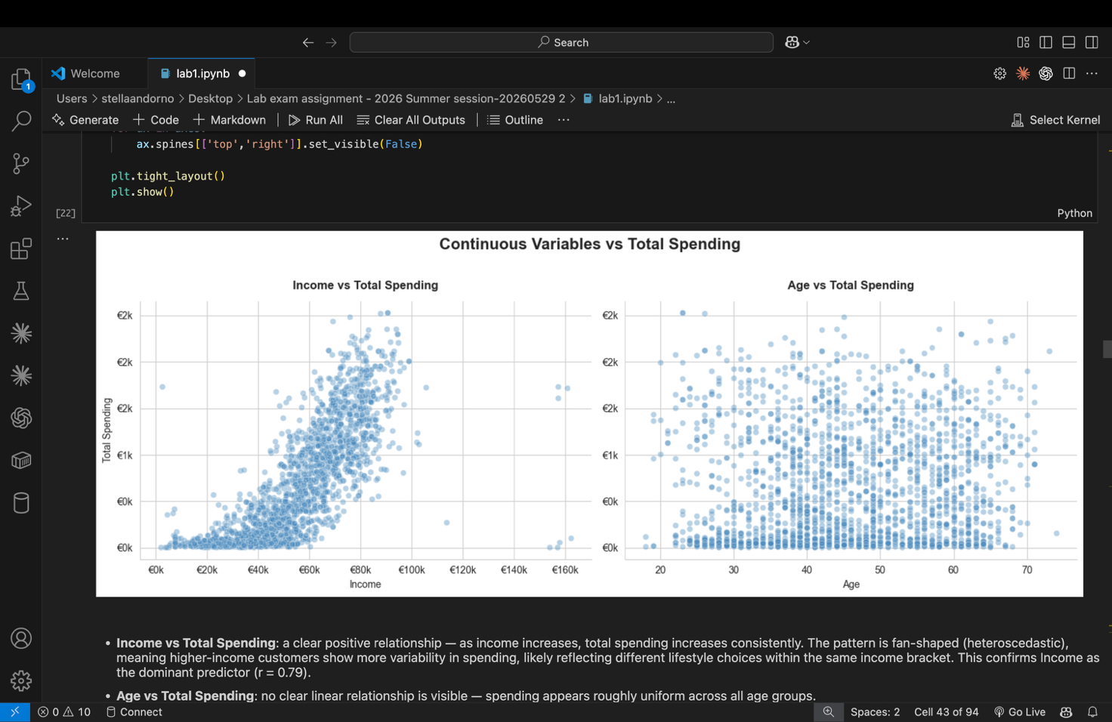

- **Income vs Total Spending**: a clear positive relationship — as income increases,
total spending increases consistently. The pattern is fan-shaped (heteroscedastic),
meaning higher-income customers show more variability in spending, likely reflecting
different lifestyle choices within the same income bracket. This confirms Income as
the dominant predictor (r = 0.79).

- **Age vs Total Spending**: no clear linear relationship is visible — spending appears
roughly uniform across all age groups.
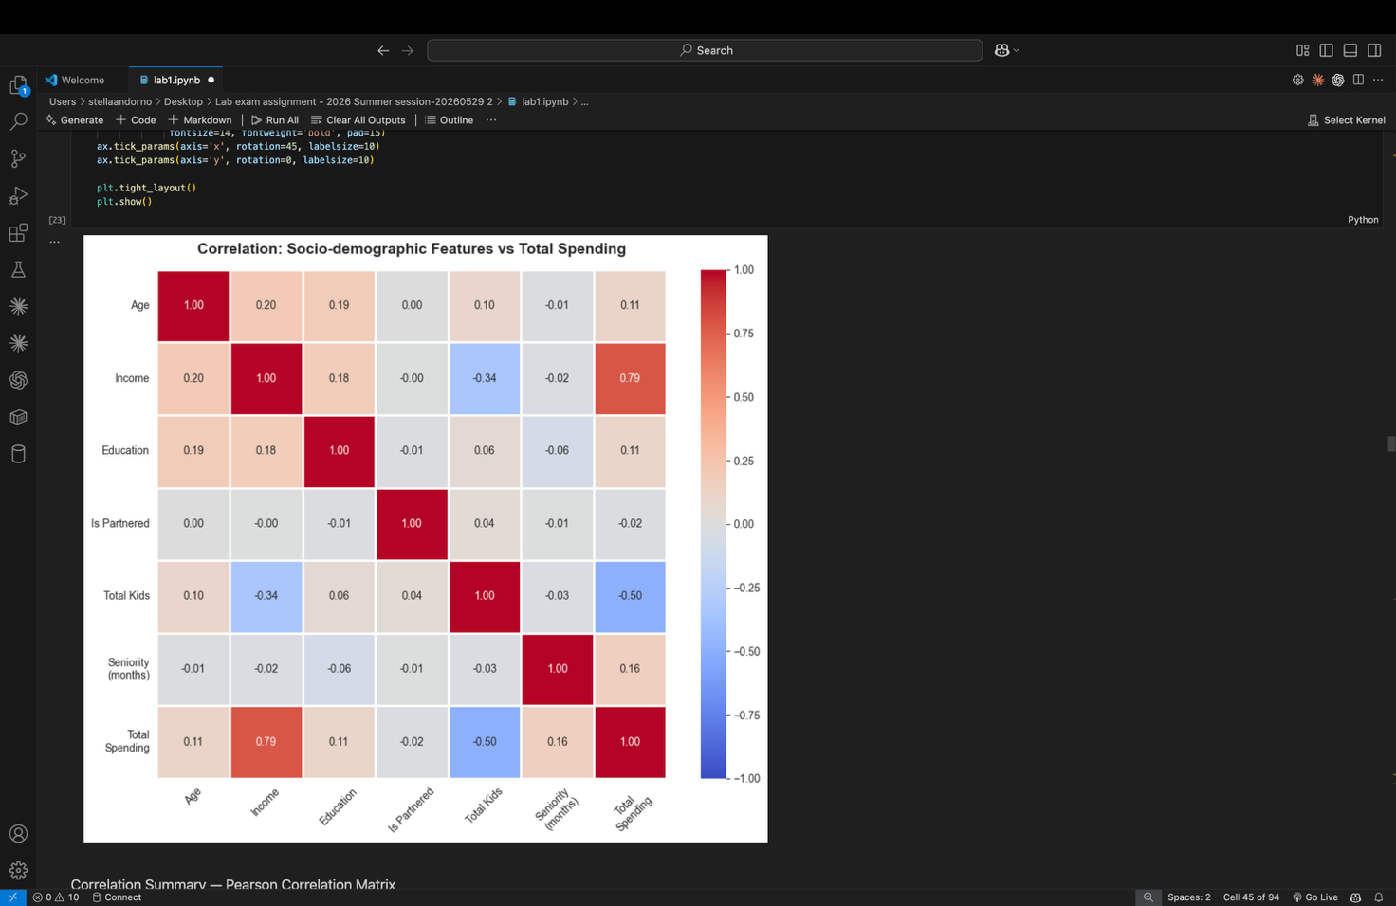

#### Correlation Summary — Pearson Correlation Matrix

The matrix uses **Pearson correlation** as the primary method, which is appropriate
for the continuous and count variables in this feature set (`Age`, `Income`,
`TotalKids`, `SeniorityMonths`, `TotalSpending`).

For `Education_enc`, Pearson assumes equal-interval distances between qualification
levels (Basic → 2n Cycle → Graduation → Master → PhD), which may not hold in
practice. I considered using **Spearman rank correlation** as an alternative —
which does not make this assumption and yielded a slightly different result.
`IsPartnered` is binary (0/1) and is valid in both methods.

The matrix confirms and quantifies the patterns observed in the visualisations above:

- **`Income` (0.79)**: by far the strongest predictor of total spending. The
income–spending relationship is positive and consistent across the customer base.

- **`TotalKids` (−0.50)**: a strong negative relationship — customers with children
at home spend considerably less overall, consistent with the boxplot analysis.

- **`Age` (0.11)**, **`Education` (0.11)**, **`Seniority` (0.16)**: weak positive
correlations — limited predictive power individually, though potentially useful
in combination within a segmentation model.

- **`IsPartnered` (−0.02)**: essentially zero — partnership status alone has no
meaningful relationship with total spending.

- **Notable inter-feature correlation**: `Income` and `TotalKids` show a moderate
negative correlation (−0.34), suggesting higher-income customers tend to have
fewer children at home.

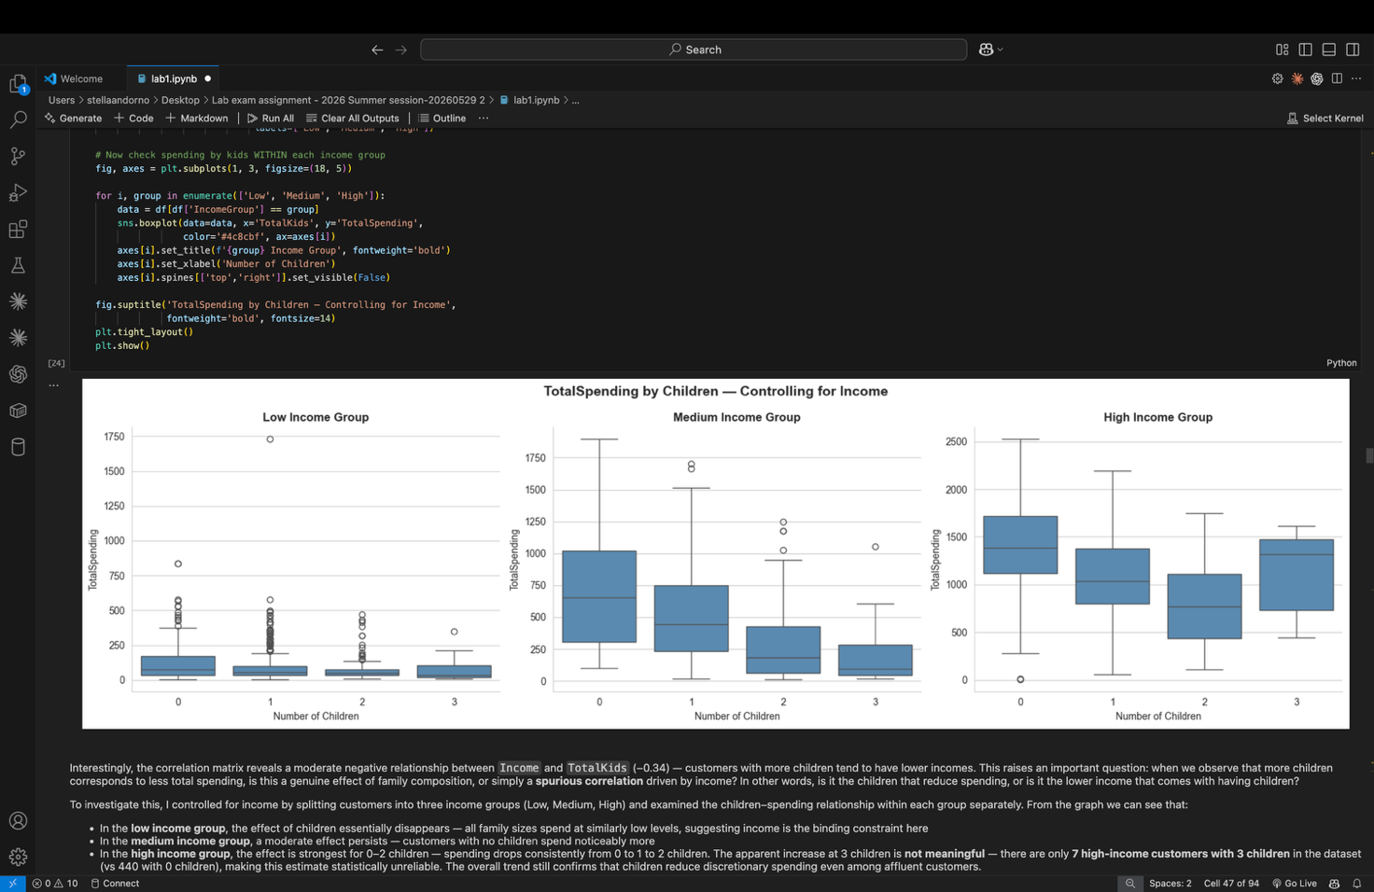

Something interesting we could see is how having more kids reduces the amount that is spent. However, something interesting is observed when one looks more closely about income group. When looking at incomes, we see that in low income, it seems that there is not much difference among the number of children. It seems that the main constraint, is actually the income itself. On another hand, instead, in medium income group, it is pretty consistent how , increasing children, the expense went down. However, what is very interesting, is that, in the high income group, going down until 2 children the spending went down, while the median of the group with 3 children, is way higher, kinda simila to 0, which is very interesting. It seems that high-income families with a big family don’t respect such rule ( more kids, less spending). Although, through furter inspection, it seems that this subgroup is made of only 7 families, which could mean it is not statistically relevant, yet interesting.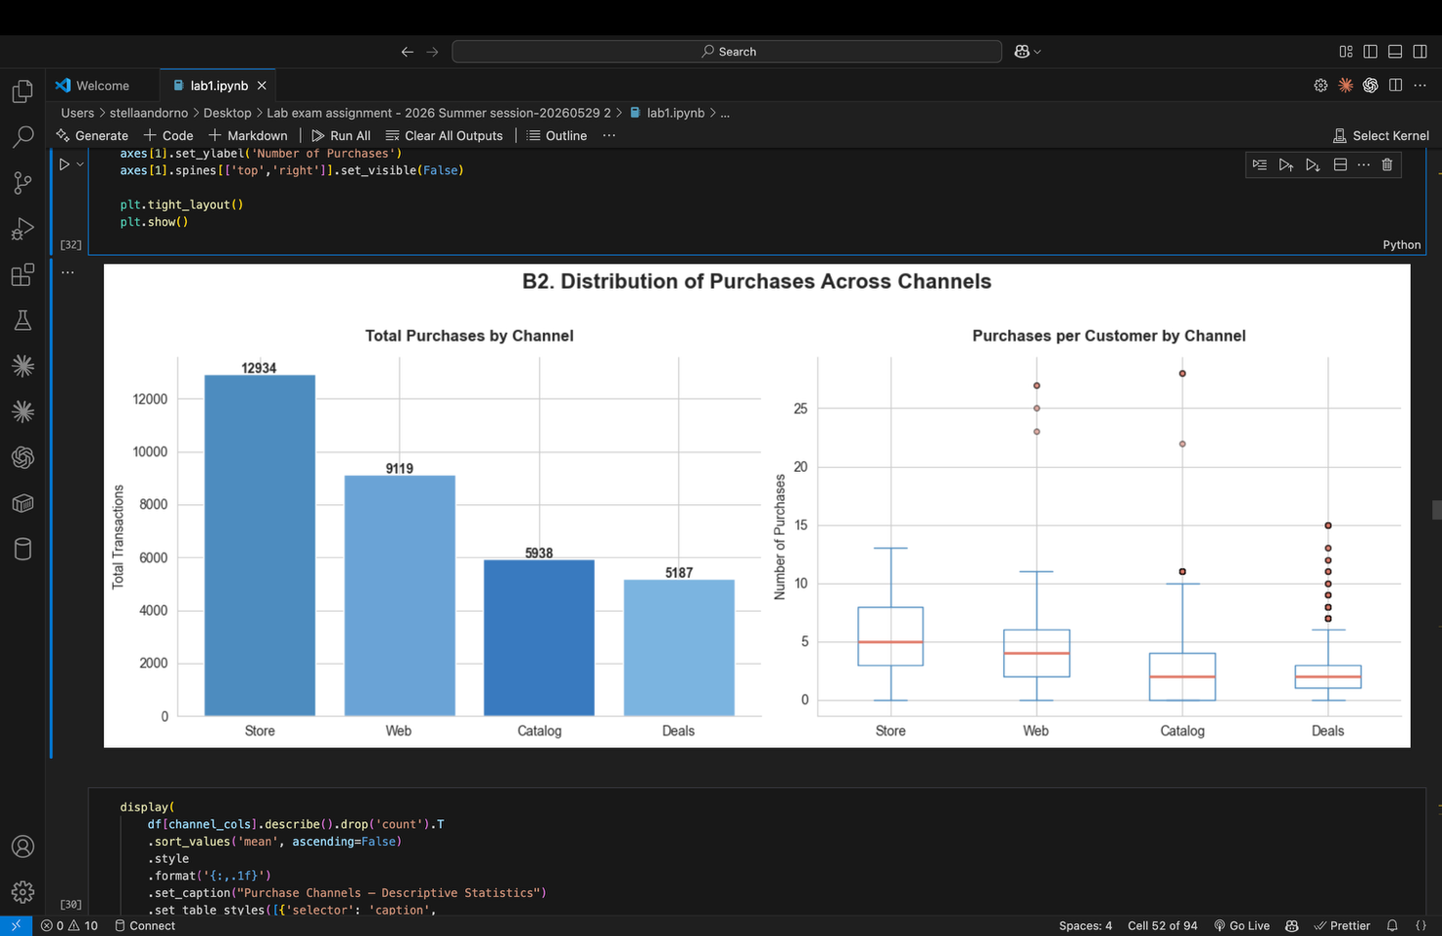

Something interesting is how our customers buy and through which channels .
**Store** is the dominant purchase channel with **12,934 total transactions**
(39% of all purchases), followed by **Web** (9,119 — 27%), **Catalog**
(5,938 — 18%) and **Deals** (5,187 — 15% — note: excluded from `TotalPurchases`
as deals represent a pricing mechanism, not a channel).

