|  |  |  |  |  |
| --- | --- | --- | --- | --- |
| * Results of ML techniques before applying Genetic Algorithm | | | | |
|  |  |  |  |  |
| ML algorithms | accuracy | precision | recall | f1score |
| SVM | 0.74 | 0.75 | 0.74 | 0.74 |
| Naïve bayes | 0.50 | 0.20 | 0.45 | 0.28 |
| KNN | 0.78 | 0.78 | 0.78 | 0.78 |
| XGBoost | 0.73 | 0.73 | 0.73 | 0.73 |
| Random Forest | 0.73 | 0.71 | 0.70 | 0.70 |

|  |  |  |
| --- | --- | --- |
| ML algorithms | Training Error | Testing Error |
| SVM | 0.00 | 0.26 |
| Naïve bayes | 0.00 | 0.54 |
| KNN | 0.23 | 0.21 |
| XGBoost | 0.00 | 0.26 |
| Random Forest | 0.00 | 0.26 |

* ROC of ML techniques before applying Genetic Algorithm

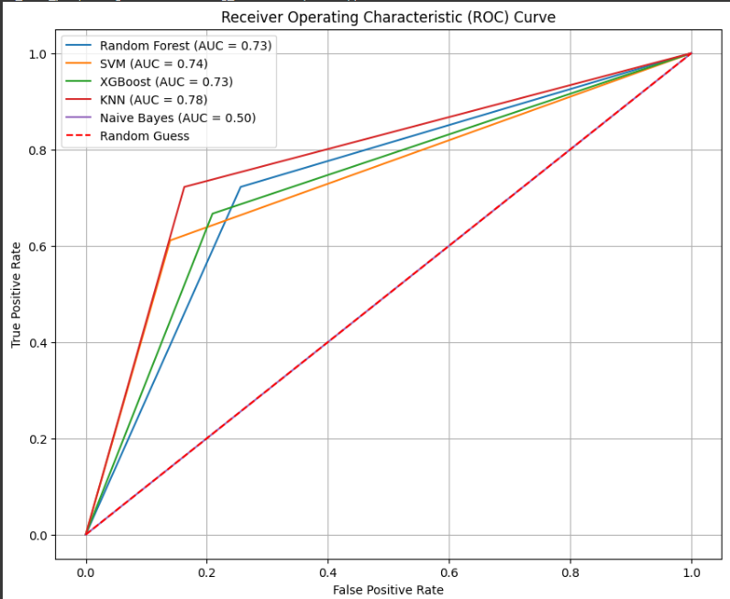

* Plot graph for Random Forest after applying genetic algorithm

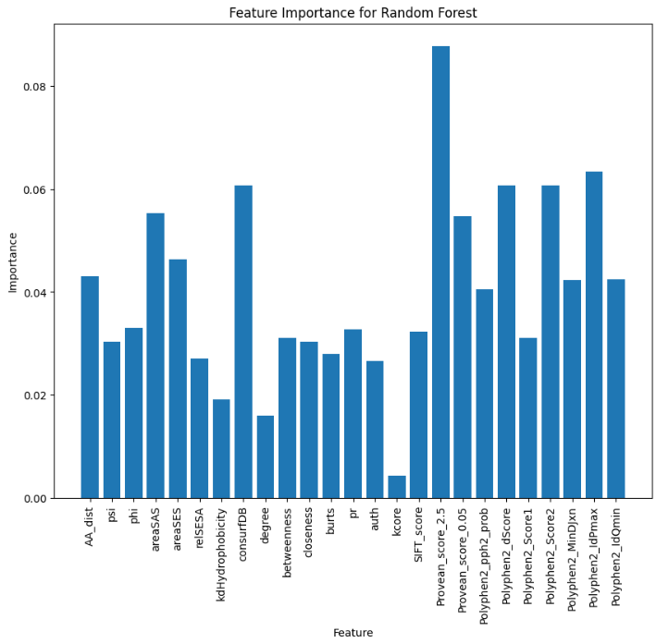

* Plot graph for XGBoost after applying genetic algorithm

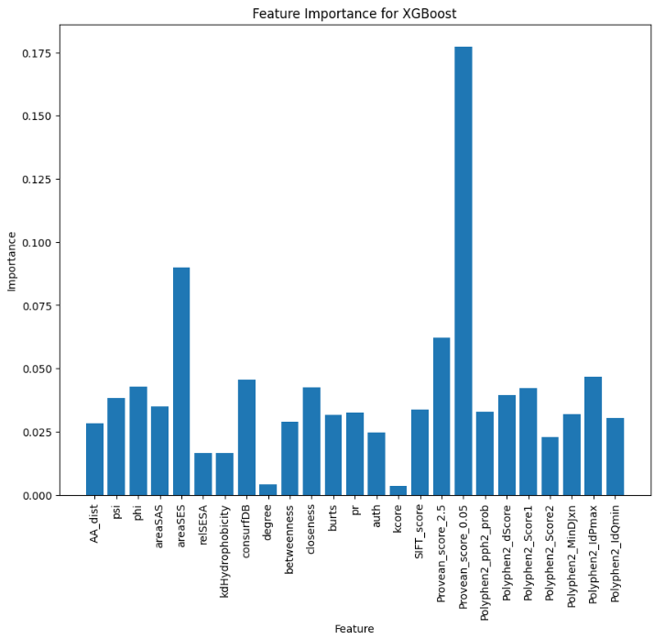

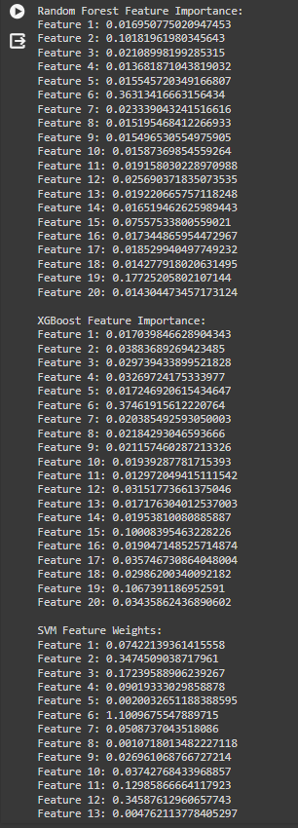

|  |  |  |  |  |
| --- | --- | --- | --- | --- |
| * Results of ML techniques after applying Genetic Algorithm | | | | |
|  |  |  |  |  |
| ML algorithms | accuracy | precision | recall | f1score |
| SVM | 0.74 | 0.78 | 0.61 | 0.68 |
| Naïve bayes | 0.50 | 0.45 | 1.0 | 0.62 |
| KNN | 0.74 | 0.78 | 0.72 | 0.75 |
| XGBoost | 0.82 | 0.72 | 0.66 | 0.69 |
| Random Forest | 0.87 | 0.74 | 0.72 | 0.73 |
|  |  |  |  |  |

|  |  |  |
| --- | --- | --- |
| ML algorithms | Training Error | Testing Error |
| SVM | 0.00 | 0.26 |
| Naïve bayes | 0.27 | 0.50 |
| KNN | 0.26 | 0.26 |
| XGBoost | 0.00 | 0.18 |
| Random Forest | 0.00 | 0.13 |

* ROC after applying Genetic Algorithm

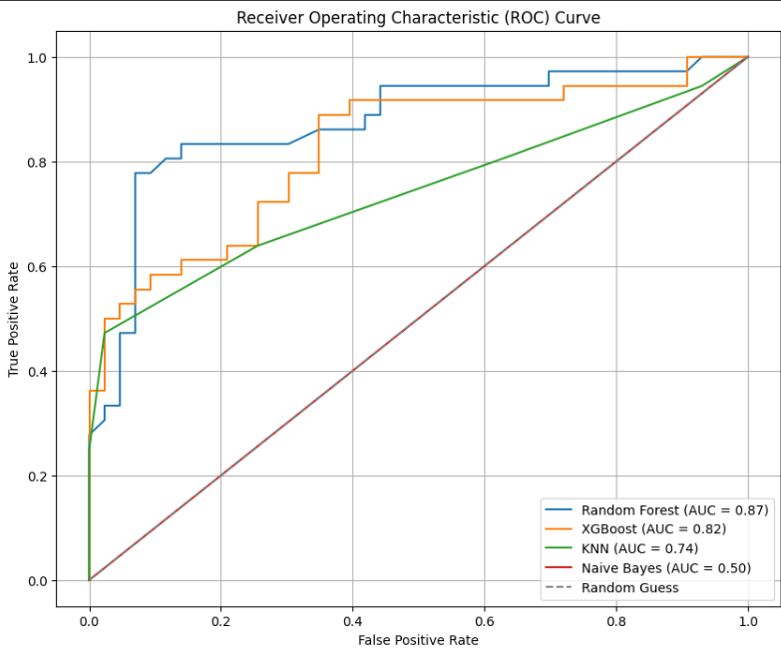

* Plot graph of Random Forest before applying genetic algorithm

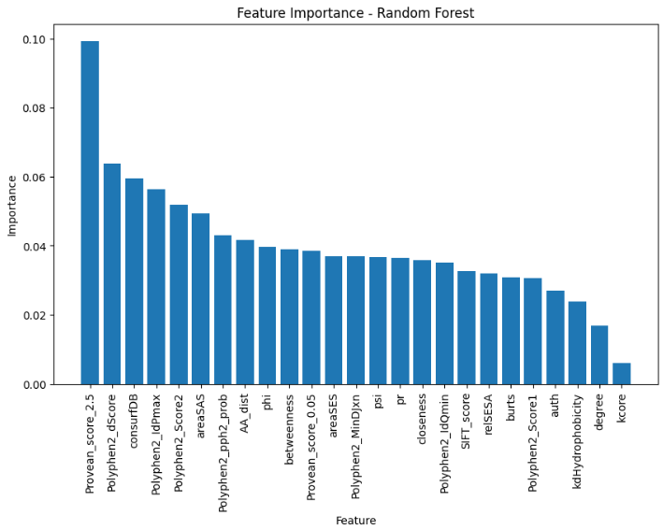

* Plot graph of Random Forest before applying genetic algorithm

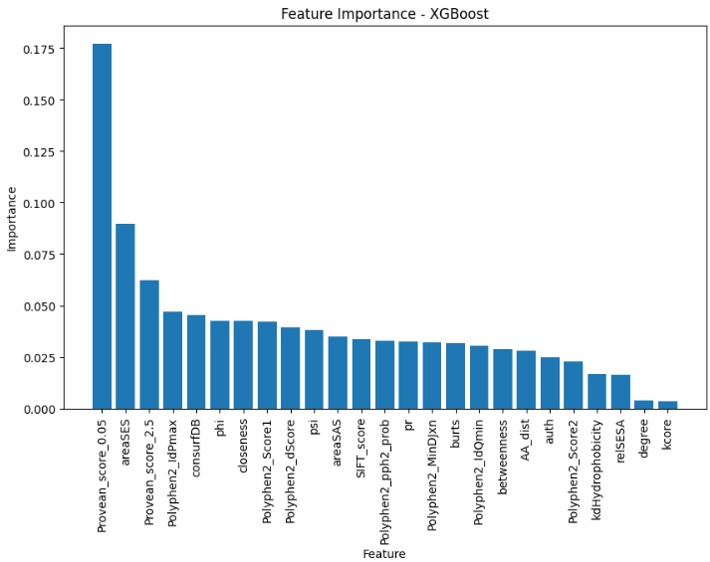

* Feature importance score of Genetic algorithm

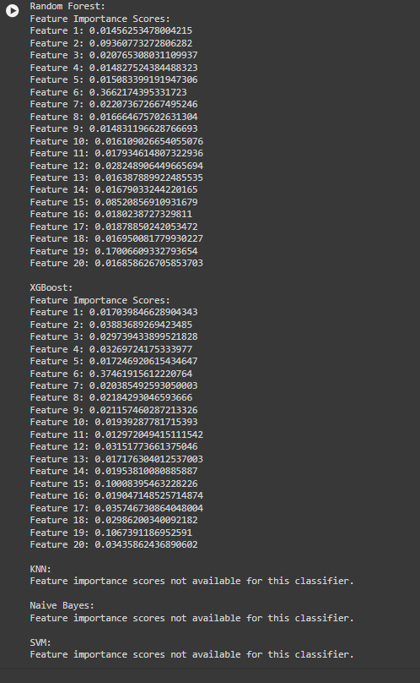

* Explainable AI outputs

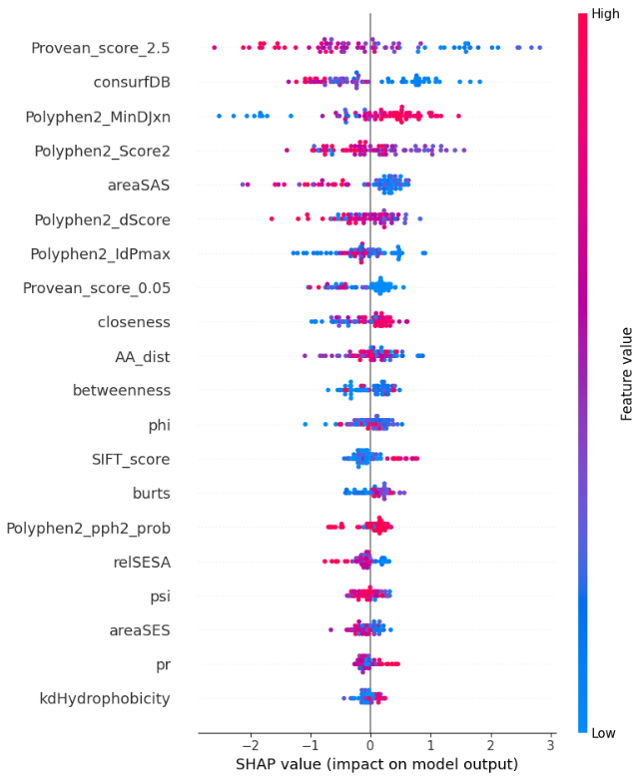

|  |  |  |
| --- | --- | --- |
| Sl.no | Classifier | Hyperparameter |
| 1 | Random Forest | BestHyperparameters: 'n':1000,'max_depth': 10,'min_samples_split':2,'min_samples_leaf': 1,'max_features': 'sqrt'} |
| 2 | KNN | Best Hyperparameters: {'algorithm': 'auto', 'n_neighbors': 11, 'weights': 'distance'} |
| 3 | Xgboost | best_params = {'n_estimators': 1000,'learning_rate': 0.01,'max_depth': 10,'min_child_weight': 0.1,'subsample': 0.8,'colsample_bytree': 1.0,'gamma': 0,'reg_alpha': 0,'reg_lambda': 1  } |
| 4 | svm | Best Hyperparameters: {'C': 2.0, 'degree': 2, 'kernel': 'rbf'} |

* Graph of accuracy Before and after Applying GA

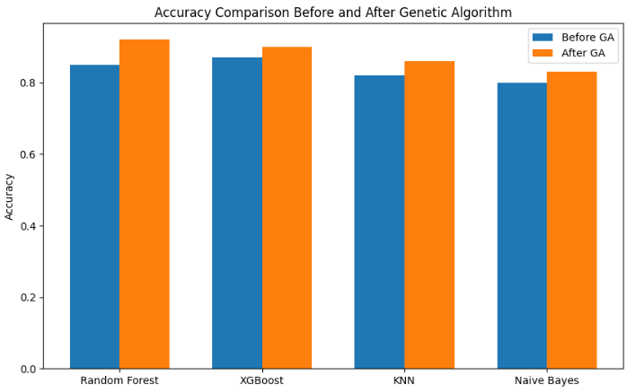

* Pie chart of class distributions before & after  applying GA

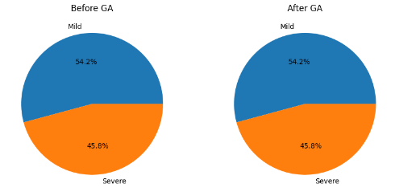

* Correlation analysis between numerical attribute

