**MAVEN**

**Resources**

1. [**http://maven.apache.org/guides/**](http://maven.apache.org/guides/)
2. [**https://www.sonatype.com/ebooks**](https://www.sonatype.com/ebooks)

**What is Maven?**

* Maven is a project management tool.
* Most popular use of Maven is for build management and dependencies.

**What problems does Maven solve?**

Maven will download the required JAR files asked for without downloading them manually each time.

**How Maven works?**

* Maven reads the config file
* Will check the Maven Local Repository
* If not found, will get them from the Remote Repo.
* Save them in local repo
* Build and Run.

**Handling JAR Dependencies**

* When Maven retrieves a project dependency
  + It will also download supporting dependencies
  + For example: Spring depends on commons-logging
* Maven will handle this for the user automatically.

**Building and Running**

When we build and run our app, Maven will handle class/ build path for us. Based on config file, Maven will add JAR files accordingly.

Standard Directory Structure

|  |  |
| --- | --- |
| Directory | Description |
| src/main/java | Java source code |
| src/main/resources | Properties/config files used by the app |
| src/main/webapp | JSP Files and web config files; other web assets (images, css, js etc) |
| src/test | Unit Testing code and properties |
| target | Destination directory for compiled code. Automatically created by Maven. |

**Advantages of Maven**

* Dependency Management
  + Maven will find JAR files.
  + No more missing JARs.
* Building and Running your project
  + No more build path/ classpath issues.
* Standard Directory Structure.

**Maven Key concepts**

* POM File – pom.xml
* Project Coordinates.

**POM File – pom.xml**

* **Project Object Model file: POM file**
* **Configuration file for the project.**
* **Located in the root of the Maven Project.**

**POM File Structure**

* **Project meta data**  - Project name, version etc. Output file type: JAR, WAR…
* **Dependencies** – List of projects we depend on Spring, Hibernate, etc.…
* **Plug ins** – Additional Custom tasks to run: Generate Junit test reports etc.

**Project Coordinates**

* Project Coordinates unique identify a project
  + Similar to GPS coordinates for location: latitude/longitude
  + Precise information for finding the location (city, street, house #)

**Elements**

|  |  |
| --- | --- |
| **Version** | **Description** |
| **Group ID** | Name of company, group, or organization.  Convention is to use reverse domain name: com.sayantan |
| **Artifact ID** | Name for the project |
| **Version** | A specific release version like: 1.0, 1.6, 2.0. …..  If project is under active development then: 1.0-SNAPSHOT |

**Dependency Coordinates**

* **To add given dependency, we need**
  + **Group ID, Artifact ID**
  + **Version is optional**
    - **Best practice is to include the version (repeatable builds)**
* **May see this referred to as: GAV**
  + **G**roup ID, **A**rtifact ID, **V**ersion

**How to find dependency coordinates?**

* Option 1: Visit the project page
* Option 2: Visit <http://search.maven.org> (easiest approach)

**Maven Archetypes**

**Archetype = starter project**

* Archetypes can be used to create new Maven projects
* Contains template files for a given Maven project
* Think of it as a collection of “starter files” for a project
  + Java Project, Web Project, etc.

**Common Archetypes**

|  |  |
| --- | --- |
| **Archetype Artifact ID** | **Description** |
| maven-archetype-quickstart | An archetype to generate a sample Maven project – Good for standalone projects |
| maven-archetype-webapp | An archetype to generate a sample Maven Webapp project – Good for web projects |

**Others are also there –** [**http://maven.apache.org/archetypes**](http://maven.apache.org/archetypes)

How to Install the m2eclipse Plugin

**How To Install Maven m2eclipse Plugin**

*Note: Recent releases of Eclipse (Mar, Neon, Oxygen) already have the m2eclipse plugin installed. Only follow these steps if you don't have the plugin installed.*

1. In Eclipse, select **Help > Install New Software**

This will display the Install dialog

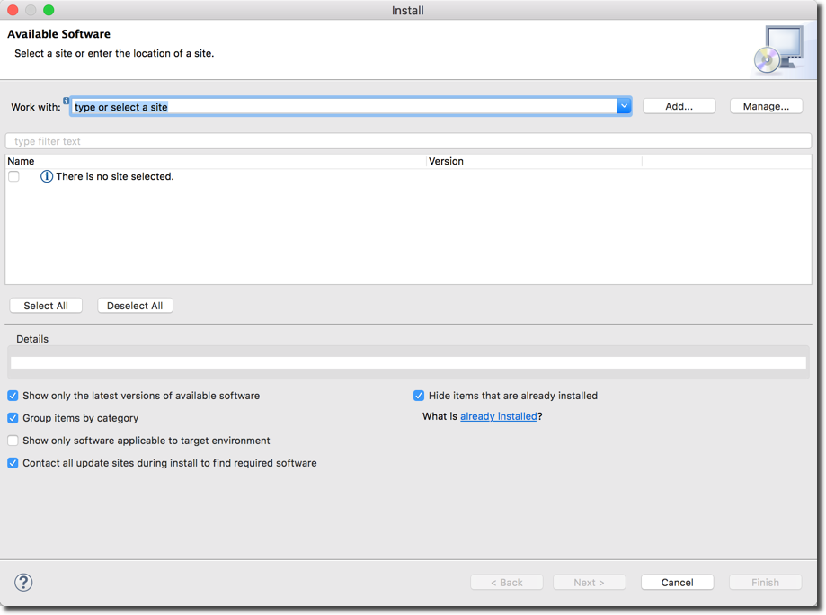

2. Click the **"Add..."** button.

3. In the dialog, enter the following from the screenshow below:

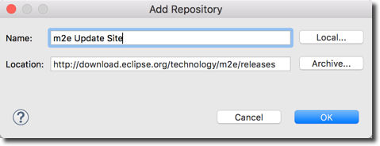

4. Wait for a couple of minutes while Eclipse fetches the files

5. In the dialog, check the box for **"Maven Integration for Eclipse"**

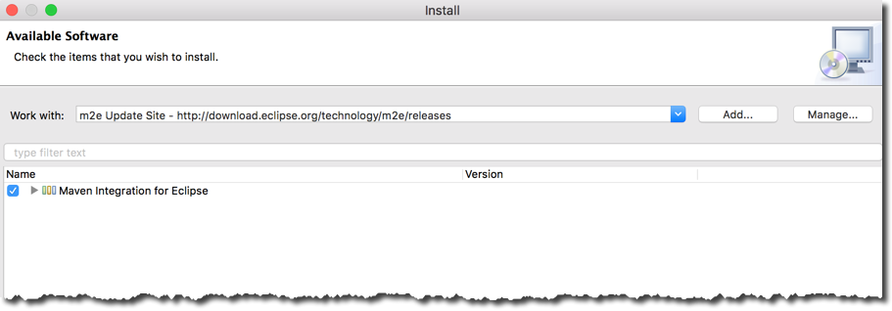

6. Click Next

7. It will show a dialog to review components, Click **Next**

8. Accept the License Agreement, Click **Finish**

9. Once installation is complete, restart Eclipse.

---

**Verify Installation**

10. In Eclipse, select **Help > Install New Software**

11. In bottom right of dialog, you will see a blue link: **What is already installed?**

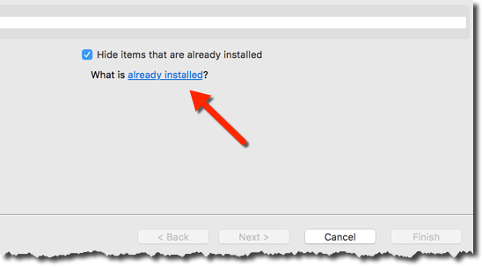

12. Click the link

13. In the dialog, filter on the text: **m2e**

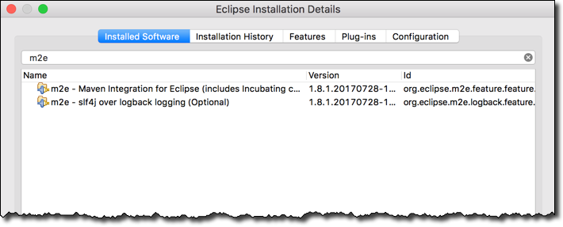  
  
14. If you see the m2e entries, then the plugin was installed successfully :-)

**Edit the pom.xml to let Eclipse know in which runtime environment should the project run**

**Change the version according to the Java version used in the respective computer.**

**Add the highlighted lines.**

**Archetype – maven-archetype-quickstart**



**Archetype – maven-archetype-webapp**

**Index.jsp is showing error stating that javax-servlet-api is missing**

**So, adding dependency in the pom.xml**



**Repository Type**

* Local Repository
* Central Repository

**Local Repository**

* Located on developer’s computer
  + Windows: C:\Users\<users-home-dir>\.m2\repository
  + Mac and Linux: ~/.m2/repository
* Maven will search this repository first before going to Maven Central Repository.
* Local Cache.

**Central Repository**

* By default, Maven will search Maven’s Central Repository (remote)
  + <https://repo.maven.apache.org/maven2>
* Requires an Internet connection
* Once files are downloaded, they are stored in local repository.

UNCLEAR

**Private Repositories – Use Case**

|  |  |  |
| --- | --- | --- |
| **Product** | **Company** | **Website** |
| Archiva | Apache | Archiva.apache.org |
| Artifactory | JFrog | [www.jfrog.com](http://www.jfrog.com) |
| Nexus | Sonatype | www.sonatype.com |