**Abstract**

The meticulous environmental standards in textiles and garments imposed by countries cautious about nature and health protection are reviving interest in the application of natural dyes in dyeing of textile materials. The toxic and allergic reactions of synthetic dyes are compelling the people to think about natural dyes. Natural dyes are renewable source of colouring materials. Besides textiles it has application in colouration of foods, medicine and in handicraft items. Though natural dyes are ecofriendly, protective to skin and pleasing colour to eyes, they are having very poor bonding with textile fibre materials, which necessitate mordanting with metallic mordants, some of which are not eco friendly, for fixation of natural dyes on textile fibres. So the supremacy of natural dyes is somewhat subdued. This necessitates newer research on application of natural dyes on different natural fibres for completely eco friendly textiles. The fundamentals of natural dyes chemistry and some of the important research work are therefore discussed in this review article.

Keywords

* colour fastness
* dyeing
* extraction of natural dyes
* natural dyes

Author Information

Show +

**1. Introduction**

After the advent of mauveine by Henry Perkin in 1856 and subsequent commercialization of synthetic dyes had replaced natural dyes, and since then consumption and application of natural dyes for textiles got reduced substantially. In present scenario environmental consciousness of people about natural products, renewable nature of materials, less environmental damage and sustainability of the natural products has further revived the use of natural dyes in dyeing of textile materials. Natural dyes are having some inherent advantages:

* No health hazard
* Easy extraction and purification
* No effluent generation
* Very high sustainability
* Mild dyeing conditions
* Renewable sources

There are some technical issues and disadvantages related to the application of natural dyes which reduced its applications that are:

* Mostly applicable to natural fibres (cotton, linen, wool and silk)
* Poor colour fastness properties
* Poor reproducibility of shades
* No standard colour recipes and methods available.
* Use of metallic mordants, some of which are not eco friendly.

Hill [[1](https://www.intechopen.com/chapters/70564#B1)] had given his views that research work with natural dyes is inadequate, and there is need of significant research work to explore the potentials of natural dyes before its important application to textile substrate.

In India initially Alps Industries Ghaziabad (Uttar Pradesh, India) and later Ama Herbals, Lucknow, and Bio Dye Goa done extensive work for industrial research and production of natural dyes and natural dyed textiles. Textile-based handicraft industries in many countries engaged local people to dye textile yarn with natural dyes and weave them to produce specialty fabrics. Printing of textile fabrics with natural dyes in India are specially done in Rajasthan and Madhya Pradesh.

Turkish carpets are recognised for their beauty made with natural dyes. The major importers of natural dyes are the USA and the EU. In the EU the major importers of natural dyes are France, Germany, Italy and the UK. Natural dyes have many advantages [[2](https://www.intechopen.com/chapters/70564#B2)] like non toxicity, eco friendliness, pleasing shade to eye and having special aroma or freshness of shade [[3](https://www.intechopen.com/chapters/70564#B3)]; however, natural dyes have some disadvantages to showing poor colour reproducibility, poor or inconsistent composition, average washing fastness [[4](https://www.intechopen.com/chapters/70564#B4)] and lesser availability in different regions, which are of great concern against its revival. Moreover natural dyes are not having any standard established dyeing [[5](https://www.intechopen.com/chapters/70564#B5)] method. The final shade depends on the type of mordant used in dyeing. Natural dyes are used in the dyeing of cotton [[6](https://www.intechopen.com/chapters/70564#B6), [7](https://www.intechopen.com/chapters/70564#B7)], linen [[8](https://www.intechopen.com/chapters/70564#B8)], wool [[9](https://www.intechopen.com/chapters/70564#B9), [10](https://www.intechopen.com/chapters/70564#B10)], silk [[11](https://www.intechopen.com/chapters/70564#B11), [12](https://www.intechopen.com/chapters/70564#B12)], nylon and polyester [[13](https://www.intechopen.com/chapters/70564#B13), [14](https://www.intechopen.com/chapters/70564#B14)] fabrics. The natural dyes can be classified in different ways such as based on origin/source type, type of hue, chemical structure [[15](https://www.intechopen.com/chapters/70564#B15), [16](https://www.intechopen.com/chapters/70564#B16)] and colour components. The classification of natural dyes based on origin/source is given below:

* Vegetable origin
* Animal origin
* Mineral origin

For vegetable origin of natural dyes, the best source of natural dyes are the different parts of plants and trees. Most natural dyes are extracted from different parts of plants and trees. Natural dyes and pigments are taken from the following parts of plants/trees:

* Seed
* Root
* Stem
* Barks
* Leaves
* Flowers

Natural dyes are having wide application in the colouration of most of the natural fibres, e.g. cotton, linen, wool and silk fibre, and to some extant for nylon and polyester synthetic fibre. However, the major issues for natural dyed textiles are reproducibility of shade, non availability of well-defined standard procedure for application and poor lasting performance of shade under water and light exposure. To achieve good colour fastness to washing and light are also a challenge to the dyer. Several researchers had proposed different dyeing methods and process parameters, but still these information are inadequate, so this calls for the need of research to develop some standard dye extraction technique and standardisation of whole process of natural dyeing on textiles. Here there are examples of few important natural dyes [[17](https://www.intechopen.com/chapters/70564#B17)] which are widely used in the dyeing of textile materials, described below.

**1.1 Jack fruits (*Artocarpus heterophyllus* Lam)**

It is a very popular fruit of south India and other parts of India. The wood of the tree is cut into small chips and crushed into dust powder and then subsequently boiled in water to extract the dye. After mordanting treatment of dyed fabrics, yellow to brown shades are obtained. The cotton and jute fabrics are dyed by this dye. It belongs to the family of Moraceae. The dye consists of morin as colouring molecule ([Figure 1](https://www.intechopen.com/chapters/70564#F1)).

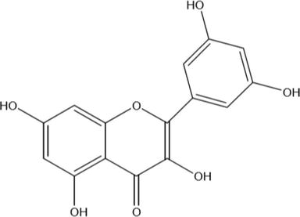

**Figure 1.**

Molecular structure of morin (3,5,7,2′,4′pentahydroxy-flavone).

**1.2 Turmeric (*Curcuma longa*)**

The dye is obtained from the root of the plant. The turmeric root is dried, crushed in powder form and boiled with water to extract the dye. It can be used in the dyeing of cotton, wool, and silk. Proper mordanting treatment improves colour fastness to wash. The brilliant yellow shade is obtained after dyeing with turmeric natural dye. Turmeric is a rich source of phenolic compounds known as curcuminoids. The colouring ingredients in turmeric are called curcumin. Curcumin is diarylheptanoid existing in keto-enol form. Turmeric is a member of *Curcuma* botanical group ([Figure 2](https://www.intechopen.com/chapters/70564#F2)).

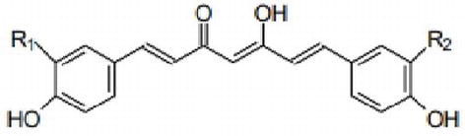

**Figure 2.**

Molecular structure of curcumin (diarylheptanoid).

**1.3 Onion (*Allium cepa*)**

The papery skin of onion is the main source of the dye. Onion skin is boiled to extract the colour and subsequently can be dyed with or without mordanting the fabric. The resulting colour is from orange to brown. It contains colouring pigments called pelargonidin (5,5,7,4 tetrahydroxy antocyanidol). The amount of colouring pigment present varies from 2.0 to 2.25% ([Figure 3](https://www.intechopen.com/chapters/70564#F3)).

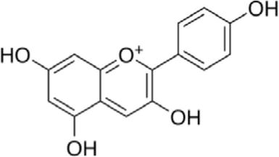

**Figure 3.**

Molecular structure of pelargonidin (5,5,7,4 tetrahydroxy antocyanidol).

**1.4 Hina (*Lawsonia inermis* L)**

It is the leaf of the plant that is traditionally used in making the coloured design on the hands of women. The leaf of the plant is dried, crushed and subsequently boiled with water to extract the dye from leaf. The mordanted fabric gives colour from brown to mustard yellow. This is the dispersed dye type colour; hence, polyester and nylon can be dyed by hina. However, it stains wool and silk giving a lighter brown colour. Hina is commonly known as lawsone. The chief constituent of hina leaves is hennotannic acid; it is a red orange pigment. Chemically hennotannic acid is 2-hydroxy-1,4-naphthoquinone. The colouring molecules have strong substantivity for protein fibre ([Figure 4](https://www.intechopen.com/chapters/70564#F4)).

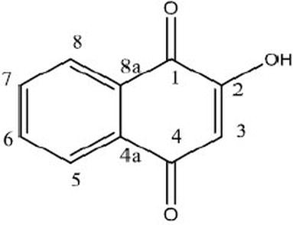

**Figure 4.**

Molecular structure of lawsone (2-hydroxyl-1,4-naphthoquinone).

**1.5 Indigo (*Indigofera tinctoria*)**

It is the seed of the plant. The full matured plant has 0.4% colour on weight of the plant. The plants are steeped in the water until the fermentation start. When the hydrolysis of glucoside is completed, the liquor is separated from the plant debris. The extract is aerated which converts indoxyl to indigotin which separates out as a precipitate. The shade of natural indigo is difficult to reproduce exactly. The variety of blue shade on cotton can be obtained by the application of natural Indigo. It is kind of vat dye and hence need reductive vatting with liquid jiggery and citric acid or dithionate.

The precursor to indigo is indican which is a colourless water-soluble compound. Indican hydrolyzes in water and releases β-D-glucose and indoxyl. The oxidation of indoxyl resulted in indigotin. The average yield of indican from an indigo plant is 0.2–0.8%. Indigo is also present in molluscs. The molluscs contain mixture of indigo and 6,6′-dibromo indigo (red), which together produce a colour known as Tyrian purple. During dyeing due to air exposure, dibromo indigo is converted into indigo blue, and the mixture produces royal blue colour ([Figure 5](https://www.intechopen.com/chapters/70564#F5)).

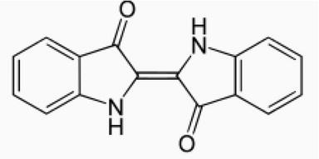

**Figure 5.**

Molecular structure of natural indigo.

**1.6 Madder or manjistha or *Rubia* (*Rubia tinctorum*)**

The dye is obtained from the root of the plant. The root is scrubbed, dried in sunlight and finally boiled in the water to extract the dye in solution. The dye has red colour. The cotton, silk and wool fibre can be dyed with madder at a temperature of 100°C for time period of 60 min, and subsequently dye solution is cooled. Bright red shade is produced on wool and silk and red violet colour on cotton. This is a mordantable type of acid dye having phenolic (-OH) groups. The colouring matter in madder is alizarin of the antharaquinone group. The root of the plant contains several polyphenolic compounds, which are 1,3-dihydroxyanthraquinone, 1,4-dihydroxyanthraquinone, 1,2,4-trihydroxyanthraquinone and 1,2-dihydroxyanthraquinone ([Figures 6](https://www.intechopen.com/chapters/70564#F6) and [7](https://www.intechopen.com/chapters/70564#F7)).

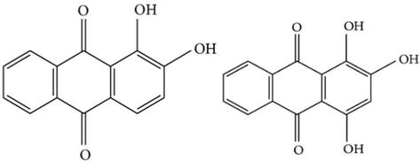

**Figure 6.**

Molecular structure of alizarin and purpurin.

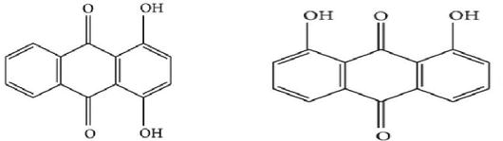

**Figure 7.**

Molecular structure of 1,4-dihydroxyanthraquinone and 1,8-dihydroxyanthaquinone.

**1.7 Tea waste (*Camellia sinensis*)**

India is one of the biggest consumer of tea. The left over waste of tea is collectable in large quantity. The extract of tea waste can be used as a natural dye in combination with different mordants, which can produce yellowish brown to brown shade. This is a mordantable dye. Flavonoids, flavonols and phenolic acids are the main colouring components in waste of the tea. Polyphenols, which are mostly flavonols, are known as catechins with epicatechin and its derivatives.

**1.8 Safflower (*Carthamus tinctorius*)**

The safflower petals are soaked in distilled water and subsequently boiled with water for more than 2 h, and it is repeated two times. The solution is filtered and the filtrate is vacuum dried. The obtained powder is having strength of 20–30%. In dyeing it produces cherry red to yellowish red shade. Safflower contains natural pigment called carthamine. The biosynthesis of carthamine takes place by chalcone (2,4,6,4-tetrahydroxy chalcone) with two glucose molecules and that resulted in the formation of safflor A and safflor B ([Figure 8](https://www.intechopen.com/chapters/70564#F8)).

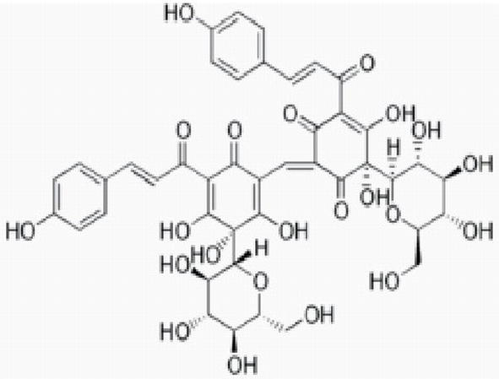

**Figure 8.**

Molecular structure of carthamine (safflower).

**1.9 Sappan wood (*Caesalpinia sappan*)**

Aqueous extraction is used to extract the dye from sappan wood. Alkali extraction can also be used. It produces bright red colour. It produces an orange colour in combination with turmeric and maroon shade with catechu. The sappan wood tree is found in India, Malaysia and the Philippines. The colouring pigment is similar to logwood. The same dye is also present in Brazil wood.

**1.10 Logwood (*Haematoxylon compechianum*)**

The dye is extracted from the stem of the tree. The stems are broken into small pieces and steepened in cold water for several hours followed by boiling. The extracted dye solution is strained. The logwood natural dye is used to produce black shade on the wool. The logwood trees are found in Mexico, Central America and the Caribbean islands. It is also known as compeachy wood. The colouring matter in logwood natural dye is haematoxylin, which after oxidation forms haematein during isolation ([Figures 9](https://www.intechopen.com/chapters/70564#F9) and [10](https://www.intechopen.com/chapters/70564#F10)).

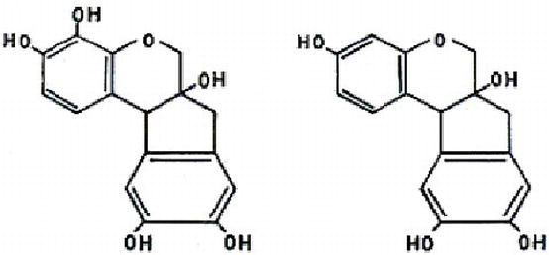

**Figure 9.**

Molecular structure of haematoxylin and brazilin.

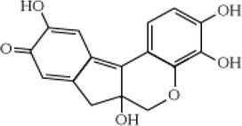

**Figure 10.**

Molecular structure of haematein.

**1.11 Saffron (*Crocus sativus*)**

The dye is extracted from the stigma of flower, which is boiled in water, and the colour is extracted. It imparts a bright yellow colour to the textile material. The wool, silk and cotton can be dyed with saffron. Alum mordant produces orange yellow shade which is also called saffron yellow. This is also used as food colouring. Saffron is a perennial plant which belongs to the Iridaceae family. The aqueous extract of saffron petals contains 12% colourant. The colouring matter of saffron contains phenolic compounds, flavonoids and anthocyanins. Anthocyanidins (pelargonidin) is responsible for the colour in saffron petals. The oxidation of anthocyanidins produces flavonol ([Figure 11](https://www.intechopen.com/chapters/70564#F11)).

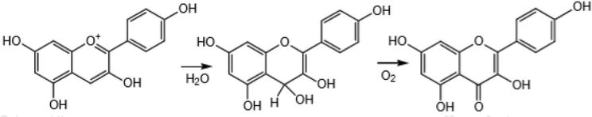

**Figure 11.**

Molecular structure of pelargonidin (anthocyanidin) purple and kaempferol (flavonol) yellow.

**1.12 Pomegranate rind (*Punica granatum*)**

Rind of pomegranate fruit waste is used as a natural dye. Pomegranate fruit is rich in natural tannins. The anar peel produces a yellow colour dye. This natural dye is used in dyeing of wool, silk and cotton fibre. The colouring molecule in pomegranate rind is flavogallol which is called granatonine. It exists in alkaloid form (N-methyl granatonine). The pomegranate rind is rich in tannin content; therefore, it is also used as tanning material ([Figure 12](https://www.intechopen.com/chapters/70564#F12)).

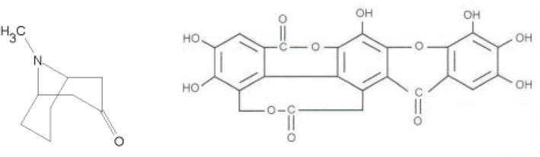

**Figure 12.**

Chemical structure of granatonine.

**1.13 Lac insect (*Laccifer Lacca* Kerr)**

It is a resinous protective secretion from the insect lac which work as a pest on a number of plants. Lac dye can be obtained by extracting stick lac (shellac) with water and sodium carbonate solution and precipitating with lime. Lac contains a water-soluble red dye. It produces scarlet to crimson red shade after dyeing. The lac dye is obtained from an insect named as coccus lacca. Resin which produced by insect is called stick lac. The lac dye contains laccaic acid A and B which are responsible for the colour of the dye. The amount of colouring matter (laccaic acid) is 0.5 to 0.75% on the weight of the resin ([Figures 13](https://www.intechopen.com/chapters/70564#F13) and [14](https://www.intechopen.com/chapters/70564#F14)).

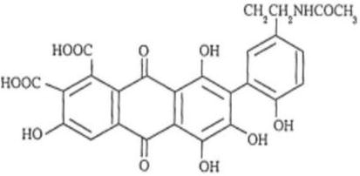

**Figure 13.**

Chemical structure of laccaic acid A.

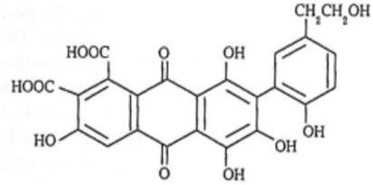

**Figure 14.**

Chemical structure of laccaic acid B.

**1.14 Cochineal (*Dactylopius coccus*)**

Cochineal is obtained from an insect. It produces beautiful crimson, scarlet and pink colour on cotton, wool and silk. After mordanting with alum, chromium, iron and copper; the colour from purple to grey are produced. Cochineal is a scale insect from which natural colourant carmine is derived. Carminic acid is extracted from female cochineal insects. The body of insect is 19–22% carminic acid ([Figure 15](https://www.intechopen.com/chapters/70564#F15)).

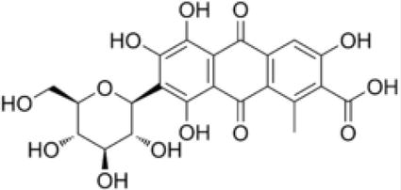

**Figure 15.**

Chemical structure of carminic acid.

**1.15 Mineral sources**

Some kinds of mineral ores, red clay and ball clay can yield light colours along with mineral salts. But colour composition is not constant and depends on source.

[Advertisement](https://ehealthcaresolutions.com/contact-us/)

**2. Classification of natural dyes**

**2.1 By chemical constitution**

**2.1.1 Indigoid class**

Two important dyes in this class are indigo blue and Tyrian purple. It occurs as glucoside indicant in the plant. Another blue dye is woad having the same chemical class. The chemical structure which belongs to indigoid class is shown in [Figure 16](https://www.intechopen.com/chapters/70564#F16).

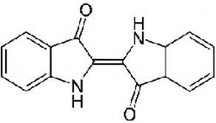

**Figure 16.**

Indigoid structure.

**2.1.2 Anthraquinone class**

Dyes that belong to this class are having anthraquinone structure and obtained from plant and insect. The red shade is specific to this class. Madder, lac, kermes and cochineal are some of the examples. The general chemical structure of this class is shown in [Figure 17](https://www.intechopen.com/chapters/70564#F17).

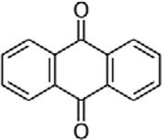

**Figure 17.**

Anthraquinoid structure.

**2.1.3 Alpha naphthoquinone**

The dyes are having alpha naphthoquinone structure such as 2-hydroxy 1-4-naphthoquinone. Hina, lawsone and juglone are examples of this class. The chemical structure of this class is shown in [Figure 18](https://www.intechopen.com/chapters/70564#F18).

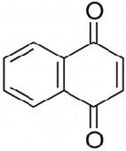

**Figure 18.**

Naphthoquinone structure.

**2.1.4 Flavones**

The dyes are having yellow shade. The natural dye weld belongs to this category. Most of the dyes are derivatives of hydroxyl and methoxy substituted flavones or isoflavones. The chemical structure of this class of dye is shown in [Figure 19](https://www.intechopen.com/chapters/70564#F19).

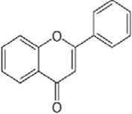

**Figure 19.**

Flavones structure.

**2.1.5 Carotenoids**

The natural dyes saffron and annatto belong to this class. The dye structure of this class has long-chain conjugated double bonds. The chemical structure of this class is as shown in [Figure 20](https://www.intechopen.com/chapters/70564#F20).

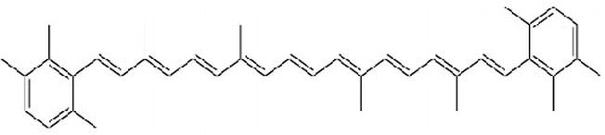

**Figure 20.**

Carotenoid structure.

**2.1.6 Dihydropyrans**

The dyes which belong to this category are logwood and sappan wood. Logwood, a natural dye, produces dark black shade on silk, wool and cotton.

**2.1.7 Anthocyanidins**

The natural dye carajurin belongs to this category. The blue and orange shades are obtained from this class.

**2.2 Chemistry of natural dyes**

Different natural colourants contain different chromophoric and auxochromic groups. Depending on the presence of a particular group in the dye structure, the chemistry of the dyes can be explained in terms of their chromophoric groups. The different dye structures and chromophoric groups are as explained.

**2.2.1 Quinoid-based structure**

The quinoid-based dye structure can be overviewed as three chemical structures (a) benzoquinone, (b) naphthoquinone and (c) anthraquinone. The natural colourant carthamine belongs to benzoquinone group, and juglone and lawsone are having naphthoquinone structure. Alizarine dye possesses anthraquinone structure.

**2.2.1.1 Benzoquinone dyes**

In this dye structure the л electron system is small, and the dye contains another unsaturated group in conjugation to л electron system ([Figure 21](https://www.intechopen.com/chapters/70564#F21)). The red colourant carthamine is present in safflower (Natural Red 26). Safflower (*Carthamus tinctorius*) is a subtropical plant and cultivated in India, China, North and South America and Europe. In dyeing, the water-soluble yellow dye (safflor yellow) is extracted [[18](https://www.intechopen.com/chapters/70564#B18)] by cold water, and then red safflorcamin is extracted by diluted sodium carbonate solution. After the neutralisation of extracted solution, it can be used in dyeing of wool, silk and cotton.

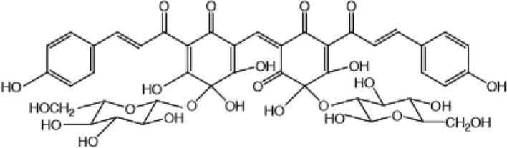

**Figure 21.**

Structure of carthamine.

**2.2.1.2 Naphthoquinone dyes**

Lawsone and juglon natural dye belongs to this category. Lawsone is extracted from hina plant; the leaves also contain flavonoid colourants lutcolin. It is cultivated in countries like India, Africa and Australia. Naphthoquinone is present in glycosidic [[19](https://www.intechopen.com/chapters/70564#B19), [20](https://www.intechopen.com/chapters/70564#B20)] form named as Hennosid A, B and C. The quantitative analysis of lawsone can be performed by high-performance liquid chromatography on reverse-phase C18 column. Chloroform extracted hina leaves were analysed by high-performance thin layer chromatography ([Figures 22](https://www.intechopen.com/chapters/70564#F22) and [23](https://www.intechopen.com/chapters/70564#F23)).

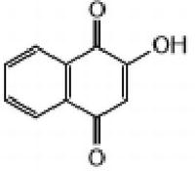

**Figure 22.**

Lawsone (2-hydroxy, 1,4 naphthalene).

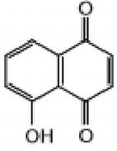

**Figure 23.**

Juglone (5-hydroxy, 1,4 naphthoquinone).

**2.2.1.2.1 Lawsone**

Lawsone form 1:2 complex with Fe(II) and Mn (II) and useful in dyeing of wool and silk fibre. The better dye uptake is obtained at pH 3.0. Agarwal et al. [[21](https://www.intechopen.com/chapters/70564#B21)] studied the effect of different mordants and different mordanting methods to get the different shades. Hina can be used for dyeing of cotton, polyester, polyamide and cellulose triacetate as the structure of dye molecules are similar to disperse dyes [[22](https://www.intechopen.com/chapters/70564#B22), [23](https://www.intechopen.com/chapters/70564#B23), [24](https://www.intechopen.com/chapters/70564#B24)].

**2.2.1.2.2 Juglone**

Juglone is representative of natural dye with naphthoquinone structure. The dyestuff is extracted from different part of nut trees. Juglone is present as a glycoside form in trees and plants. Wool dyed with juglone are having good resistance with moths and insects. Mordanting treatment further enhances the fastness properties. Dyeing of textile materials with aqueous walnut extract yields brown shade. Wide range of textile fibre, e.g. wool, silk, nylon and polyester, can be dyed with juglone.

**2.2.1.3 Antharaquinone**

It possess biggest group of anthraquinone dyes. Rhubarb (CI Natural Yellow 23) is extracted from the root of the plant. The extracted dye contains emodin, chrysophenol, aloe emodin and pyscion ([Figure 24](https://www.intechopen.com/chapters/70564#F24)). Rhubarb extract is used in dyeing of wool fibre [[25](https://www.intechopen.com/chapters/70564#B25)]. It produces yellow to orange shade after mordanting with alum. The mordanting treatment improves light fastness of dyed materials.

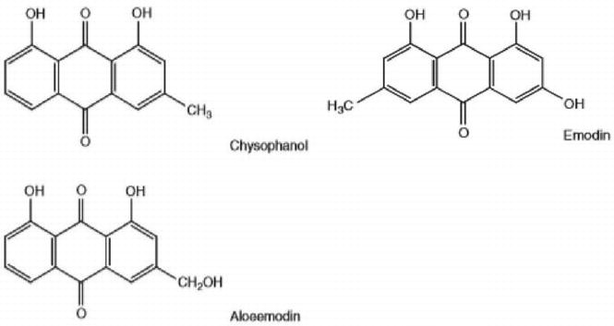

**Figure 24.**

Different representative structurers of anthraquinone group-based dye molecules.

Natural dye alizarin, pseudo purpurin and purpurin ([Figure 25](https://www.intechopen.com/chapters/70564#F25)) belongs to plant of Rubiaceae family and has an anthraquinone structure [[26](https://www.intechopen.com/chapters/70564#B26)]. The dye is obtained from the root of plant.

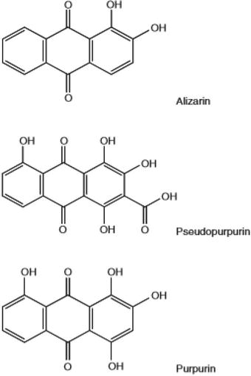

**Figure 25.**

Structures of alizarin, pseudo purpurin and purpurin.

Madder (C.I Natural Red 8) natural dye produces red colourant; the cultivation of madder is done as a source material for red colour in Europe, Asia and Northern and Southern America. The dyestuff is extracted from the dried roots of the plant. The roots of the plant contain 2–3.0% of di- and tri-hydroxyl anthraquinone glucosides.

**2.2.2 Carotenoids**

Carotenoids are red, yellow and orange pigments present in plants and animals [[17](https://www.intechopen.com/chapters/70564#B17)]. It has a polyisoprenoid structure with a series of centrally located conjugated bonds. The bright colours of many fruits and vegetables are due to carotenoids. Carotenoids are polyisoprenoid structure ([Figure 26](https://www.intechopen.com/chapters/70564#F26)) which contain conjugated double bonds, which acts as chromophore and responsible for characteristic absorption spectra. Carotenoids are divided into two parts:

1. Hydrocarbon carotenoid
2. Oxygen containing called xanthophylls

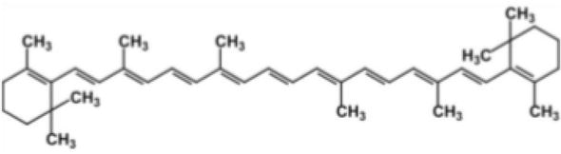

**Figure 26.**

Structure of β-carotene.

Structural changes by hydrogenation, double bond migration, isomerization and chain lengthening and shortening resulted in many carotenoid structure. Carotenoids possess strong UV light resistance, and β carotene ([Figure 26](https://www.intechopen.com/chapters/70564#F26)) is a typical structure generally found in natural colourants.

**2.2.2.1 Pyron dyes**

Pyron dyes contain flavonoids and anthocyanins having structure as shown in [Figures 27](https://www.intechopen.com/chapters/70564#F27) and [28](https://www.intechopen.com/chapters/70564#F28). The pyron structure is bound to various sugars by glycosidic bonds [[17](https://www.intechopen.com/chapters/70564#B17)]. Flavonoids are classified as flavonols, flavones, anthocyanidins, isoflavones, flavon-3,4-diols and coumarins. Yellow flavones and flavonols are used as vegetable dyes. The valuable and very popular flavonoid is yellow quercetin which possess several bio effect.

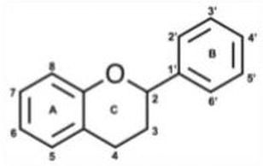

**Figure 27.**

Structure of anthocyanins.

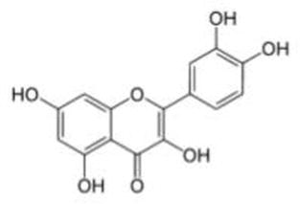

**Figure 28.**

Structure of quercetin.

**2.2.2.2 Anthocyanins**

Anthocyanins are found in fruits and vegetables; some are grape wine, sweet and sour cherries, red cabbage, hibiscus and different varieties of oranges. There are more than 500 varieties of anthocyanins that produces red, pink, violet and orange colours. There are some important anthocyanins which are cyaniding, delphinidin, pelargonidin, malvidin, peonidin and petunidin. Many plants besides anthocyanins also contain quercetin and chlorophylls, and the resulted colour is a mixture of all these.

**2.2.3 Dyes from lichens and mushrooms**

Violet and purple colours were generally obtained from molluscs and shellfish, and they were source of dyestuff from ancient to the beginning of the Middle Ages. Royale purple and Tyrian purple were the name of the colour obtained originally from molluscs [[27](https://www.intechopen.com/chapters/70564#B27)]. Lichens and mushrooms are source of natural dyes, and they produce violet and purple colours. Lichens are found in coastal areas and were easier to collect. The dyeing methods with lichens are easy; however, disadvantage associated with lichens is poor light fastness. Therefore, the dyeing of lichens are limited to cheap quality fabrics. Fungi are also used for dyeing of textiles. In America and India, red colour is obtained from fungus *Echinodontium tinctorium*. In Italy and France, fungi obtained from Polyporales were used to dye the wool.

The colourants in lichens and fungi are benzoquinone derivatives, especially terphenylquinone. Some of these species possess compounds such as *Sarcodon*, *Phellodon*, *Hydnellum* and *Thelephora* [[28](https://www.intechopen.com/chapters/70564#B28), [29](https://www.intechopen.com/chapters/70564#B29)]. Orchil and litmus are the colourants that are responsible for the colour in lichens. The lichens’ colour are produced through pre-compounds of orchil and litmus by consecutive enzymatic, hydrolysation, decarboxylation and oxidation [[30](https://www.intechopen.com/chapters/70564#B30)] reactions, respectively. Then some pre-compounds are lecanoric acid, atranorin and gyrophoric acid which take part in the formation of orchil and litmus as shown in [Figure 29](https://www.intechopen.com/chapters/70564#F29).

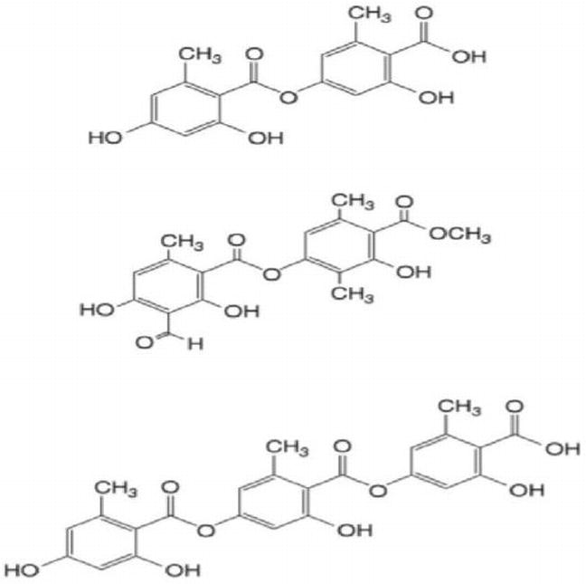

**Figure 29.**

Structures of different colourants occurring in fungi and lichens.

In the past, the extraction of colourants from lichens were performed by keeping the lichens in water with ammonia for several days. The reaction occurred through enzymatic hydrolysis in which non coloured compounds such as lecanoric acid are converted into orcinol by hydrolysis and decarboxylation. Orcinol after oxidation forms purple orceins or litmus. The colour of both litmus and orchil depend on the pH of the solution [[30](https://www.intechopen.com/chapters/70564#B30)]. In acidic pH dyestuff forms red cation, and in basic pH, it forms bluish violet anion. The lichens which belong to species *Parmelia*, *Xanthoria parietina*, *Ochrolechia tartarea* and *Lasallia pustulata* are capable to produce yellowish, brownish and reddish brown colours in dyeing of wool with lichens [[31](https://www.intechopen.com/chapters/70564#B31)]. The dyeing is done by boiling the wool with lichen solution either premordanted or without mordanted wool in presence of ammonia.

The mushrooms which belongs to species *Sarcodon*, *Phellodon* and *Hydlnellum* contain terphenylquinone compounds as a main colourants which produce blue colour in mushrooms. They are benzoquinone derivatives. The *Cortinarius* species mushrooms are richly coloured in brown, red, olive green and violet. They are anthraquinone derivatives.

**2.2.4 Tannins**

Tannins are polymeric polyphenols with typical aromatic ring structure with hydroxyl constituents and have relatively high molecular weight. In plants two different groups of tannins are found, (a) hydrolysable tannins and (b) proanthocyanidins (condensed tannin) [[32](https://www.intechopen.com/chapters/70564#B32), [33](https://www.intechopen.com/chapters/70564#B33)]. Tannins are present in plant cell and are concentrated in epidermal tissues. Tannins are found in wood, leaves, buds, stems, florals and roots [[34](https://www.intechopen.com/chapters/70564#B34)]. The hydrolysable tannins are concentrated in the roots of several plants. The plants are the source of different variety of tannins. The three major tannins (hydrolysable tannins) are grouped as gallotannins [[35](https://www.intechopen.com/chapters/70564#B35)] or ellagitannins and which are gallic acid or ellagic acids. The most widespread gallotannins are pentagalloyl glucose. Ellagitannins are esters of hexahydroxydiphenic acids. Gallic acid and hexahydroxydiphenic acid occur together in some hydrolysable tannins [[36](https://www.intechopen.com/chapters/70564#B36)].

Condensed tannins are polymers of 15-carbon polyhydroxyflavan-3-ol monomer units such as (−) epicatechin or (+) catechin. The complex chemical nature of tannins makes the biosynthesis and polymerisation a difficult task; however, there are some established pathways for bio synthesis. The precursor for biosynthesis of hydrolysable tannins is shikimic acid. The direct aromatization of 3-dehydroshikimic acid produces gallic acid, which upon esterification forms polyol.

The bio synthesis of condensed tannins occurs through two different ways (a) by phenylpropanoid and (b) by polyketide. The polyketide pathway takes malonyl moieties for aromatic ring formation in flavonoid biosynthesis. The phenylpropanoid pathway takes aromatic amino acid, L-phenylalanine, which is non-oxidatively deaminated to E-cinnamate by phenylalanine ammonia-lyase.

**2.3 By hue or colour produced**

The classification of natural dyes are also done according to the hue of the colour. Some important natural dyes giving primary and secondary colours are:

1. Red: Colour index has 32 red natural dyes. The prominent members are maddar, manjistha, Brazil wood, *Morinda*, cochineal and lac dyes.
2. Blue: There are four natural blue dyes. Some prominent colours are indigo, Kumbh and flowers of Japanese Tsuykusa. Natural indigo blue is known from very ancient time to dye cotton and wool.
3. Yellow: There are 28 yellow natural dyes available which are used in dyeing of wool, silk and cotton. Prominent examples are barberry, tesu flowers, Kamala, turmeric and marigold.
4. Green: Plants that yield green natural colour are very rare; they are made by mixing yellow and blue primary colours. Woad and Indigo produce green colour.
5. Black and brown: There are six black natural dyes. Cutch is used to produce brown shade; for getting black shade lac, carbon and caramel are used.
6. Orange: Natural dyes which produce red and yellow colour are used to produce orange shade. Barbeny and annatto are the examples of orange colour.

**2.4 Application based classification**

1. Vat dyes: Indigo is a water-insoluble dye, and before application it is solubilised in water. The solubilisation of natural indigo is done with the help of sodium hydrosulphite and sodium hydroxide. After solubilisation, it is applied on cellulosic fibre, and after dyeing the development of colour is done by oxidation with hydrogen peroxide. Indigo dye is the representative of indigoid class of vat dyes
2. Direct dyes: The natural dyes which are water soluble and have a long and planar molecular structure and presence of conjugated (single and double bonds) bonds can be applied by direct dyeing method. The dye molecules may contain amino, hydroxyl and sulphonic groups. Turmeric, Harda, pomegranate rind and annatto can be applied by direct dyeing method. Common salt is used to get better exhaustion of dyes. The dyeing temperature is kept at 100°C
3. Acid dyes: The dye molecules possess sulphonic or carboxylic groups in their structure, which produce affinity for wool and silk fibre. The dyeing is done at acidic pH of 4.5–5.5. After dyeing the fastness improvement is done with tannic acid. The dyeing of wool and silk with saffron is done by acid dyeing method. The presence of common salt in dye bath produces levelling effect
4. Basic dyes: The dye molecules produce coloured cation after dissolution in the water at acidic pH. The dye molecules contain –NH2 groups and react with –COOH groups of wool and silk. The dye bath pH is kept 4–5 by adding acetic acid

[Advertisement](https://ehealthcaresolutions.com/contact-us/)

**3. Extraction of natural dyes**

The amount of natural dyes present in natural products are very less [[11](https://www.intechopen.com/chapters/70564#B11), [37](https://www.intechopen.com/chapters/70564#B37)]. They need specific technique to remove dye from their original source. Here there are some methods which are suitable for extraction of natural dyes from their source materials [[28](https://www.intechopen.com/chapters/70564#B28)]; the different extraction methods are as follows:

**3.1 Aqueous extraction**

In this method, the dye containing materials are broken into small pieces or powdered and then soaked in water overnight. It is boiled and filtered to remove non-dye materials. Sometimes trickling filters are also used to remove fine impurities. The disadvantages of this technique are that during boiling, some of the dye decompose. Therefore, those dyes which do not decompose at boiling temperature are suitable by this method. The molecules should be water soluble.

**3.2 Acid and alkali extraction**

Most of the natural dyes are glycosides; they can be extracted under acidic or alkaline conditions. Acidic hydrolysis method is used in extraction of tesu natural dye from tesu flower. Alkaline solution are suitable for those dyes which contain phenolic groups in their structure. Dyes from annatto seeds can be extracted by this method. The extraction of lac dye from lac insect and red dye from safflower is also done by this method.

**3.3 Ultrasonic microwave extraction**

Microwave and ultrasonic waves are helpful in extraction of natural dyes. This technique is having several advantages over aqueous extraction. In this technique less quantity of solvent (water) is required in extraction. The treatment is done at lower temperature and less time as compared to aqueous extraction. Ultrasonic and microwaves are sent in aqueous solution of natural dye, which accelerate the extraction process.

**3.4 By fermentation**

In the presence of bio enzymes the fermentation of natural colour bearing substances becomes faster, and the extraction of natural dyes takes place. Indigo extraction is the best example of fermentation method of extraction. Enzymes break glucoside indican into glucose and indoxyl by the indimulsin enzyme. Amatto natural dye extraction is also done by enzyme method. Cellulose, amylose and pectinase are having application in the natural dye extraction from the bark, stem and roots.

**3.5 Solvent extraction**

There is use of organic solvents such as acetone, petroleum, ether, chloroform and ethanol in the extraction of natural dyes. It is a very viable technique as compared to aqueous extraction. The yield of dye is good, and the quantity of water requirement is less. The extraction is done at lower temperature.

[Advertisement](https://ehealthcaresolutions.com/contact-us/)

**4. Characterisation of natural dyes**

For successful commercial use of natural dyes, there is need of standardized dyeing technique for which characterisation of natural dyes is essential.

**4.1 UV-visible spectroscopy**

It is useful in characterising the colour in terms of the wavelength of maximum absorption and dominating hue. The application of UV-characterization is to identify the ability of dye molecules to absorb UV wavelength and fading characteristics of dyes. Some researchers [[38](https://www.intechopen.com/chapters/70564#B38)] had done UV analysis of natural dyes. Mathur et al. [[9](https://www.intechopen.com/chapters/70564#B9)] studied UV spectra of neem bark, and it has two absorption maxima at 275 and 374 nm. Beat sugar [[39](https://www.intechopen.com/chapters/70564#B39)] shows their absorption bands at 220, 270 and 530 nm. Gulrajani et al. [[40](https://www.intechopen.com/chapters/70564#B40)] studied the absorption bands of ratanjot and observed that at acidic pH, the absorption occurs at 520–525 nm, and in alkaline pH, it occur at 610–615 nm. Red sandal [[41](https://www.intechopen.com/chapters/70564#B41)] wood shows strong absorption peak at 288 nm and maximum absorption at 504 and 474 nm in methanol solution at pH 10. *Gomphrena globosa* flower has peak at 533 nm. The dye does not have difference in peak value at pH 4 and 7 in visible region; however it shifted towards 554 nm [[42](https://www.intechopen.com/chapters/70564#B42)]. Bhuyan et al. studied the dye absorption extracted from *Mimusops elengi* and *Terminalia arjun* and concluded that dye absorbed by the fibre varies from 21.94 to 27.46% and from 5.18 to 10.78%, respectively, depending on bath concentration [[43](https://www.intechopen.com/chapters/70564#B43), [44](https://www.intechopen.com/chapters/70564#B44), [45](https://www.intechopen.com/chapters/70564#B45)]. He also reported absorption of colour extracted from the roots of *Morinda angustifolia* Roxb using benzene extract. The colour shows absorption at 446, 299, 291, 265.5 and 232 nm.

| **Name of the dye** | **Wavelength of maximum absorption** |
| --- | --- |
| Neem bark extraction | 275 and 374 nm |
| Beet sugar | 220, 280 and 530 nm |
| Ratanjot at acidic pH | 520 and 525 nm |
| Alkaline pH | 570, 610 and 615 nm |
| Red sandal wood | 288 nm |

The value of the wavelength of the maximum absorption for a particular dye depends on the chemical constitution of the dye molecules which is variable and depends on the growth environment of a particular natural dye. The characterisation of a particular dye is helpful in deciding the hue of the dye.

**4.2 Chromatographic technique**

Thin layer chromatography is used to identify different colour components in natural dyes. Koren [[46](https://www.intechopen.com/chapters/70564#B46)] analysed insect dye, madder and indigoid. Guinot [[47](https://www.intechopen.com/chapters/70564#B47)] analysed plants containing flavonoids colour compounds. Balakina [[48](https://www.intechopen.com/chapters/70564#B48)] analysed quantitatively and qualitatively red dyes such as alizarin, purpurin and carminic acid by high-performance liquid chromatography. Mc Goven [[49](https://www.intechopen.com/chapters/70564#B49)] et al. identified the dyes stripped from wool fibre by HPLC with C18 column. Szostek [[50](https://www.intechopen.com/chapters/70564#B50)] et al. studied the retention of carminic acid, indigotin, corcetin, gambogic acid, alizarin, flavonoid, anthraquinone and purpurin. He studied examination of faded dyes through emission and absorption spectra by non destructive method. Cristea [[51](https://www.intechopen.com/chapters/70564#B51)] et al. had reported quantitative analysis of weld by HPLC and informed that after 15 min. Extraction in methanol/water mixture, 0.448% luteolin, 0.357% luteolin 7-glucoside and 0.233% luteolin 3′7 diglucoside were obtained. Son et al. [[52](https://www.intechopen.com/chapters/70564#B52)] reported analysis of longer dyeing time in indigo dyeing and their effect on structural change in dye molecules through HPLC analysis. The derivative spectroscopy and HPLC were used to analyse annatto dyestuff; the sample preparation involved extraction with acetone in the presence of HCl and removal of water by evaporation with ethanol. The residue was dissolved in chloroform and acetic acid mixture for derivatives spectroscopy or with acetone for HPLC.

[Advertisement](https://ehealthcaresolutions.com/contact-us/)

**5. Theory of dyeing**

Natural dyes are very suitable for dyeing of protein fibres as compared to cellulosic fibres. Synthetic fibres which contain polar groups such as nylon, acrylic and viscose are also accessible to natural dyes. Natural dyes are thermo unstable and have poor chemical stability, which make the natural dyes unfit for dyeing at high temperature and pressure. The presence of hydrogen bond and Van der Waals force of attraction play important role in the fixation of natural dyes on the fibre. Natural dyes are having poor exhaustion value due to subdued affinity for fibre materials, so to increase the exhaustion of dyes, common salt/Glauber’s salt are added in the dye bath. The isotherm of the natural dyes sorption obeys Nernst isotherm [[17](https://www.intechopen.com/chapters/70564#B17), [53](https://www.intechopen.com/chapters/70564#B53), [54](https://www.intechopen.com/chapters/70564#B54)].

Natural dyes are having poor affinity and substantivity [[55](https://www.intechopen.com/chapters/70564#B55), [56](https://www.intechopen.com/chapters/70564#B56)] for cellulosic fibres such as cotton and viscose. The absence of reactive groups in fibres and dyes does not allow for bond formation, so they need mordanting treatment to fix the dye on fibre surface. Protein fibres are having bond-forming groups in fibre structure, and the presence of carboxylic groups in natural dyes provides opportunity for bonding and gets bonded with fibre and shows good fastness properties. Natural dyes are having smaller molecular size, and they are not having conjugated linear structure [[57](https://www.intechopen.com/chapters/70564#B57)]. Therefore, natural dyes are having inferior exhaustion behaviour. Sometimes salt sodium chloride is also used to improve the dye exhaustion % ([Figure 30](https://www.intechopen.com/chapters/70564#F30)).

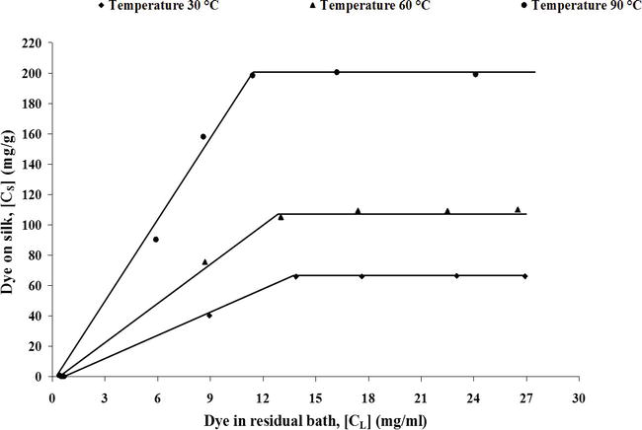

**Figure 30.**

Sorption isotherm of dyeing of silk fabric (without mordant) with eucalyptus leaves extract at three different temperature 30, 60 and 90°C [17].

[Advertisement](https://ehealthcaresolutions.com/contact-us/)

**6. Application of natural dyes**

Different researchers had proposed different methods of dyeing of natural and synthetic fibres with natural dyes. The dyeing of textile substrates depends on dyeing parameters which are fibre structure, temperature, time and pH of the dye bath and dye molecule characteristics. The fastness properties of dyes on textile substrates depend on bonding of dyes with fibre. Since natural dyes are lacking in the presence of active groups to make bonds with textile fibres, the fastness properties are not very good. The cellulosic fibres are difficult to dye with natural dyes as they have poor affinity and substantivity. The lack of bonding of natural dyes with cellulosic fibre requires mordanting treatment. Protein fibres have ionic groups and get bonded with natural dyes possessing ionic groups in dye structure.

The dyeing of proteins fibre can be done by exhaust method of dyeing. The dyeing process parameters in wool and silk dying is pH at 4.5–5.5 and dyeing temperature 80–90°C. The exhaustion % of dyes in dyeing is very poor. The longer liquor ratio may be preferred because of poor solubilities of natural dyes in water. Stainless steel-made dyeing machines are suitable in dyeing of wool and silk.

Since natural dyes are having poor affinity for cellulosic fibre and due to poor exhaustion, mordanting treatment [[29](https://www.intechopen.com/chapters/70564#B29), [58](https://www.intechopen.com/chapters/70564#B58)] is done to fix the dyes on cellulosic fibre. The dyeing of cellulosic fibre can be done at temperature of 80–90°C.The exhaustion of dyes can be increased by adding exhausting agents, sodium chloride or Glauber’s salt in dye bath. Most of the dyeing is done at neutral pH. Dyeing of cotton with natural indigo is done at alkaline pH in the presence of sodium hydrosulphite in a container made of stainless steel. The copper container gives deeper shade in dyeing of cellulosic fibre. The mordanting treatment improves the washing fastness of dyed samples. There are three methods of mordanting [[44](https://www.intechopen.com/chapters/70564#B44), [45](https://www.intechopen.com/chapters/70564#B45)].

**6.1 Conventional method of dyeing**

In the state of Maharashtra, Gujrat and Rajasthan [[59](https://www.intechopen.com/chapters/70564#B59)], the people follow conventional method of dyeing of cotton fabric with natural dyes which may be explained with the following process sequences. The fabric is pretreated before dyeing to get the absorbency. The grey fabrics are given dunging treatment followed by washing. The bleaching treatment is given to make the fabric white, after that it is steamed and stepped into alkaline solution, and finally rinsing and washing treatment is given. After thorough pretreatment the fabric is soaked into solution of harda/myrobolan and dried. The dried fabric is premordanted with alum and subsequently dipped into natural dye solution at boiling temperature. After dyeing the fabric is given washing and rinsing treatment and dried in the sun light. Water is sprayed on the fabric to brighten the shade. The process is repeated 2 to 4 days. The dyeing method differs from place to place. Here are some examples:

**6.1.1 In Bengal**

The commonly used natural dyes are haldi, babul, madder, pomegranate rind and marigold [[59](https://www.intechopen.com/chapters/70564#B59)]. In the dyeing of fabric with sappan wood, the fabric is dipped in aqueous extract of sappan wood with or without alum solution and boiled for 2–3 hours. In the dyeing of Indian madder, the madder is extracted either from the stem or root and boiled with water to extract the natural colourants. The pretreated fabric is boiled with dye extract solution. Mordanting treatment may be given either before dyeing or after dyeing with alum solution.

**6.1.2 In Orissa**

The sappan wood chips are boiled with alum and turmeric and after boiling it was cooled. In cooled solution of dye, the fabric materials are kept for 3–4 h. It is a premordanting process. At some places the cold solution of natural dye is taken with sufficient quantity of water, and the fabric is dipped in cold solution for 24 h and finally boiled for 2 h.

**6.1.3 In Uttar Pradesh**

The application of natural indigo on cotton fabric is done by two methods which are called Khari Mat and Mitha Mat.

**6.1.4 Khari Mat**

In Khari Mat’s process to dissolve natural indigo, 40 gallon of water is taken in an earthen vessel, and in that water there are addition of 2.0 lbs. indigo, 2.0 lbs. of lime, 2 lbs. of sajji mati and 1.0 ounce of gur (molasses). After 24 h of fermentation, the indigo dye became water soluble. The indigo dye solution is ready for dyeing. This technique is successful in hot weather.

**6.1.5 Mitha Mat**

In this technique, the solubilisation of natural indigo is done by taking 60 gallon of water; in that water there are addition of 4 lb. of lime, and after 1 day again 4 lb. of lime is added. After 4–5 days natural indigo dye became fully soluble. During application this mitha vat is added with old mitha vat with continuous string. The fabric is dyed in the dissolved indigo dye solution at temperature of 50–60°C.

**6.2 Dyeing of cotton fabric with natural dyes**

There is a standard recipe-based dyeing process for dyeing of cotton fibre/yarn/fabric. The important pretreatments before dyeing are desizing (acid desizing or enzyme desizing), scouring (sodium hydroxide and auxiliaries) and bleaching with hydrogen peroxide (H2O2). The fully pretreated fabric free from all impurities and absorbent is premordanted (single or double mordanting, in single either harda or aluminium sulphate in double taking both consecutively) with aluminium sulphate. After mordanting the mordanted fabric is passed through aqueous solution of natural dyes. The dyeing parameters will be:

* Dyeing time = 60–120 min. (depends on depth % of shade)
* Temperature of dyeing = 70–100°C
* M:L ratio of the bath = 1:20–1:30
* Amount of dye in bath = 10–50% (on weight of the material)
* Concentration of common salt = 5–20 g/l
* pH of the dye bath = 10–11

After dyeing, soaping treatment is given to remove any residual/unreacted dyes and auxiliary chemicals from the surface of the fabric. An after treatment with natural dye, fixing agent may be desirable.

**6.3 Dyeing of protein fibres**

Wool and silk are protein fibre; both fibres have complex chemical structure and susceptible to alkali treatment. Alkaline pH of aqueous solution damage the fibre. At isoelectric pH of 5.0, the wool is neutral and the silk is slightly positive. The wool and silk can be dyed with natural dyes through premordanting or after mordanting. Mordanting is done with tannin-rich natural source chemical like harda or metal salt aluminium sulphate or ferrous sulphate.

In premordanting, the fabric is treated with either harda or metal salt aluminium sulphate (single or double) with 5–20% (on weight of the material) mordant concentration at temperature of 80–90°C for 30–40 min. The M:L ratio is kept 1:5–1:20. After mordanting, drying treatment may be given and subsequently dipped in dye bath containing aqueous natural dye solution. The following dyeing parameters were maintained:

* The pH of the dye bath = 4–5
* Temperature of dyeing = 80–90°C.
* Time of dyeing = 50–60 min.
* M:L ratio of the bath = 1:20–1:30
* Amount of dye in bath = 10–50% (on weight of the material)

After dyeing, soaping treatment is given to remove any residual/unreacted dyes and auxiliary chemicals from the surface of the fabric. An after treatment with natural dye fixing agent may be desirable.

**6.4 Dyeing of synthetic fibres**

Different synthetic fibres like nylon, polyester and acrylic can be dyed with natural dyes like onion skin extract, babool bark extract and hina. The dyeing can be done either by padding (cold pad batch) method or exhaust method with or without mordanting. Dyeing is carried out at acidic pH. High-temperature high-pressure dyeing gives better results in terms of colour strength than other dyeing methods.

**6.5 Fixation of natural dyes**

Natural dyes are having poor affinity and substantivity for textile materials. The bonding groups are not present in natural dyes, due to that most of the natural dyes are having poor washing fastness. The fixation of natural dyes on textile materials can be done with the help of mordanting agents. Mordanting agents are dyeing auxiliaries and are salts (chlorides and sulphates) of heavy metals. The heavy metals Al, Cr, Cu and Sn are having vacant d orbitals and easily make coordinate bonds with natural dyes and fibre-active sites. The formed complex has bathochromic and hyperchromic shift. There are different types of mordanting agents such as metallic mordants, tannins and tannic acid and oil mordants. The different heavy metal salts work as complexing agent and chelate with natural dye colourants. Some metallic salts are toxic in nature, but even after that, they are having application in fixation of natural dyes. The different mordanting agents are:

1. Most controversial are lead salts and chromates (potassium, sodium, ammonium dichromate).
2. The salt SnCl2 also works as mordant. It is water soluble, having reducing agent properties. It is toxic in nature.
3. Copper sulphate (CuSO45H2O) and ferrous sulphate (FeSO47 H2O) molecules are also used as a mordant. They are good chelating agents.
4. Tannins are poly phenolic compounds and able to form complexes with metals and bind with organic substances such as proteins, alkaloids and carbohydrates. The tannins are also called bio mordants. Tannins can be used either alone or in association with metal salts. The phenolic groups of tannins can form effective bonds with fibre and natural dye molecules.

**6.5.1 Metallic mordants**

Metal salts of aluminium, chromium, iron and copper are used as a mordants. The important mordants are potassium dichromate, ferrous sulphate, copper sulphate, stannous chloride and stannic chloride.

**6.5.2 Tannins and tannic acid**

Tannins are obtained from the excretions of bark and other parts, e.g. leaves and fruits of the plant. Extractions are either used directly or in concentrated form. Large number of tannin containing substances are employed as a mordant in textile fibre dyeing.

**6.5.3 Oil mordants**

Oil mordants are used in dyeing of madder. Oil mordants make a complex with alum used in mordanting treatment. Metal atom combined with carboxylic groups of oil and bound metal then makes bond with the dye molecules, and in this way, superior wash fastness can be achieved.

**6.6 Mordanting process**

1. Premordanting: In premordanting process, mordanting is done before dyeing; subsequently the fabric is dyed with natural dye in aqueous media. It is a two-bath process in which the first bath is used for mordanting of fabric and in the second bath, dyeing is done with natural dyes. Dyeing and mordanting are done at the same temperature of 60–70°C. the mordants are complexing agents, and if they are taken in the same bath, they may react to each other, and precipitation of dyes may occur. That deteriorate fastness properties of dyed fabrics
2. Metamordanting: In metamordanting treatment, the mordant chemicals are added with natural dye in the same dye bath; dyeing and mordanting take place simultaneously. The mordanting and dyeing temperature are 80–90°C
3. After mordanting: In after mordanting treatment [[53](https://www.intechopen.com/chapters/70564#B53), [54](https://www.intechopen.com/chapters/70564#B54)], the dyeing of fabric is done first; after that in the same bath mordanting compounds are added. The temperature of chroming is 80–90°C. after chroming, the temperature is dropped to 60°C, and goods are run for 15 minutes after that liquor is drained

The application of natural dyes on cellulosic materials are done by the pad-dry-washing and pad-dry-steaming-washing method. High-temperature curing is not suggested as dye molecules are susceptible to decompose. Fibre and yarn dyeing can also be done with natural dyes similar to synthetic dye application.

[Advertisement](https://ehealthcaresolutions.com/contact-us/)

**7. Fastness properties of natural dyes**

The quality parameters in dyeing is fastness properties. Several test methods are described to access the colour fastness. The fastness properties give idea about the quality of dyeing. In natural dyes, the fastness properties are strongly related to substrate type and mordant used for dyestuff fixation. Besides the dyestuff itself, there are many factors such as water, chemicals, temperature, humidity, light, pretreatments, after treatments, dyestuff distribution in fibre and fixation of dyestuff affect the fastness properties. In natural dyeing the colour and fastness of natural dyes need special attention for careful selection of materials and process. Natural dyes were in use up to end of the nineteenth century. At that time the dyeing with natural dyes were at peak with excellent fastness properties; however, after commercialization of synthetic dyes in the nineteenth century, the proficiency in natural dyeing started to decrease. The different fastness properties of dyes show the resistance of dyes towards different external environment in which fabric containing dyes are exposed. The fastness properties of dyes depend on the structure of dyes, exposure on the environment and fastness improvers and type of mordant used. There is need to explore some natural after treatment agents to improve the light and washing fastness.

**7.1 Light fastness**

The light fastness of natural dyes is poor to medium. The poor light fastness is due to chromophoric change in dye structure after absorption of light. The chromophoric groups are not very strong to dissipate the energy absorbed through resonance. Cook [[60](https://www.intechopen.com/chapters/70564#B60)] had reported a comprehensive review on light fastness improvement of dyed textile fibres. He studied the use of tannin related after treatments on mordantable dyes to be used in cotton dyeing for improving light and wash fastness, and his findings were useful in improving fastness properties of natural dyed fabrics. Natural dyes have poor light stability as compared to synthetic dyes. Padfield and Landi [[61](https://www.intechopen.com/chapters/70564#B61)] observed the light fastness of wool dyed with nine natural dyes such as:

1. Yellow dyes (old fustic and Persian berries), light fastness rating 1–2
2. Reds (cochineal with tin mordent, alizarin with alum mordant, lac with tin mordant), rating 3–4
3. Blue (indigo depends on mordants), rating 4–5 and 5–6
4. Black (logwood), rating 4–5

Mordants highly influence the light fastness of natural dyes. Turmeric, fustic and marigold dyes faded more than any other yellow dyes; however, the application of tin and alum mordants causes more fading than chrome, iron and copper. This shows the dependency of fastness properties of natural dyes on the type of mordants. Samanta et al. [[62](https://www.intechopen.com/chapters/70564#B62)] reported the light fastness improvement in natural dyes applied on jute fabric by 1% benzotriazole. The biggest challenge in natural dyeing for colour fastness is related with light fastness. The choice of suitable mordent will improve the light stability except some iron salts which lead to shift in the resulting colour. Textile auxiliaries also improve fastness properties. To improve the light stability of natural dyes, Lee [[63](https://www.intechopen.com/chapters/70564#B63)] commended an UV absorber on protein fibre. Oda [[18](https://www.intechopen.com/chapters/70564#B18)] suggest singlet oxygen quenchers to improve the light fastness rating. Mussak [[64](https://www.intechopen.com/chapters/70564#B64)] discussed light-induced photo degradation process of natural dyes. Several attempts were made to improve the light fastness of different textile fabrics dyed with natural dyes out of which some are [[65](https://www.intechopen.com/chapters/70564#B65), [66](https://www.intechopen.com/chapters/70564#B66), [67](https://www.intechopen.com/chapters/70564#B67)]:

1. Effect of various additives on photo fading of carthamin in cellulose acetate film.
2. Critical examination of fading process of natural dyes to reproduce original colour of the fabric after fading.
3. The rate of photo fading effect is effectively suppressed in the presence of nickel hydroxyl-arylsulphonate. The addition of UV absorbers in bath has small effect in reducing photo fading effect.

**7.2 Washing fastness**

The washing fastness of natural dyes is poor to medium. The bonding of dye with fibre is very poor, and due to that dyes are not very fast with detergent solutions. Duff et al. [[29](https://www.intechopen.com/chapters/70564#B29)] studied the effect of alkalinity of washing solution in washing of natural dyes dyed fabrics. The alkaline pH of the detergent solution changes the colour value in terms of the hue and value. Logwood and indigo are having good fastness value as compared to others. The mordanting treatment improves the washing fastness of dyes. Samanta et al. [[68](https://www.intechopen.com/chapters/70564#B68)] reported some improvement in washing fastness by use of fixing agent.

**7.3 Rubbing fastness**

The rubbing fastness of most of the natural dyes are moderate to good. Samanta et al. [[8](https://www.intechopen.com/chapters/70564#B8), [58](https://www.intechopen.com/chapters/70564#B58)] reported that jackfruit wood, manjistha, red sandal wood, babool and marigold having good rubbing fastness on jute and cotton fabric.

[Advertisement](https://ehealthcaresolutions.com/contact-us/)

**8. Advantages of natural dyes**

**8.1 UV-protective fabrics**

UV-protected fabrics are required to protect the skin and body of the human being from sunburns, tannings, premature skin burns and skin ageing. Researchers had done the work on to produce fabrics which had sun-protecting effect by the application of natural dyes in dyeing. Sarkar [[69](https://www.intechopen.com/chapters/70564#B69)] evaluated ultraviolet protection factor (UPF) value of cotton fabric dyed with madder, indigo and cochineal with reference to fabric parameters. Grifani [[70](https://www.intechopen.com/chapters/70564#B70), [71](https://www.intechopen.com/chapters/70564#B71)] studied the effect of natural dyes on cotton, flax, hemp and ramie and got good results. Metallic mordants [[72](https://www.intechopen.com/chapters/70564#B72)] have potential to improve the UPF value of wool, silk and cotton. Orange peel extract natural dye applied on wool increased the UPF value of dyed wool fabric considerably.

**8.2 Insect proof**

Cellulosic materials and woollen are susceptible to moth and fungus attack in humid and warm conditions. Koto et al. [[73](https://www.intechopen.com/chapters/70564#B73)] studied the effect of natural dyes on wool. The anthraquinone-based natural dyes cochineal, indigo and madder are able to produce insect proof and repellent fabric when used as a dyes in dyeing of wool.

[Advertisement](https://ehealthcaresolutions.com/contact-us/)

**9. Summary and conclusions**

* Natural dyes due to its unique character of natural origin are known as ecofriendly dyestuff; however the bonding of dye molecules with fibre-active sites are very poor, and they need some bridging chemicals to anchor the dye molecules with fibre, and mordanting agents are helpful in bridging the dye molecules with fibre. The synthetic mordanting agents are not very eco friendly, and some are toxic which depress the efficacy of natural dyes and sometime become matter of debate.
* Natural dye does not have any shade card to match the samples or reproducing the shade. So there is need of collection of spectral data of natural dyes so that any shade can be reproduced.
* There is need of awareness about natural dyes dyed fabric in people so that it can be popular in big way. and due to that demand and consumption of natural dyed fabric will increase.
* Natural dyes are costly as compared to synthetic dyes. So some research work should be done to reduce the cost of production.
* Big production houses, technical institutions and research houses should organised workshops and symposia to spread the advantages of natural dyes.
* The government should promote the production of natural dyes by giving financial incentives to small manufactures of natural dyes.
* There must be some very strong research and development work to improve the quality of natural dyes in terms of low cost, use of natural mordent and widespread applications.

[Advertisement](https://ehealthcaresolutions.com/contact-us/)

**Acknowledgments**

I am very thankful to Prof. A.K. Samanta for inspiring me and giving very excellent suggestions for preparing this review paper. I am very thankful to the editor f