

BAY Version 2
Product and Data Blueprint
  - Melbourne marketplace launch, live parking intelligence and end-to-end operating plan
Prepared for BAY product, engineering, data and operations teams
2 November 2026
Document purpose | Decision supported
Define what exists today and what belongs in Version 2 | Align product, engineering, data, trust, operations and launch work
Design a source-accounted Melbourne data foundation | Improve coverage without claiming unsupported real-time accuracy
Show driver, host, admin and system flows | Make dependencies and release gates visible before implementation

Document status
Product and delivery blueprint. Existing, locally built and planned capabilities are labelled separately so the roadmap is not mistaken for a production claim.

Contents
1 Executive summary
2 Current BAY baseline
3 Version 2 product scope
4 End-to-end ecosystem
5 Driver journeys
6 Host journey
7 Admin and operations journey
8 Booking and payment controls
9 Data and live accuracy foundation
10 Melbourne coverage plan
11 Technical architecture
12 Scenarios and expected impact
13 Revenue model
14 Trust safety privacy and compliance
15 Delivery roadmap
16 Measures of success and release gates
Appendix A Feature inventory
Appendix B Data source matrix
Appendix C Terms and source references

How to read this blueprint
Label | Meaning
Existing | Confirmed in the current product or repository baseline.
Foundation built locally | A credible implementation foundation exists but still needs migration, review, deployment or production integration.
Version 2 planned | Approved product direction that requires implementation and release validation.
Later phase | Useful after the Melbourne marketplace proves trust, supply and transaction reliability.

Scope principle
Version 2 adds a verified private-parking marketplace without weakening BAY’s core parking-information experience. Public parking data and private bookable supply remain visibly distinct. A parking location may be discoverable without being live, priced or bookable; BAY must state that distinction clearly.

1 Executive summary
BAY Version 2 turns the current parking discovery product into a trusted parking marketplace for Melbourne. Drivers will be able to search public parking information and verified private spaces together, understand the evidence behind each option, reserve supported spaces, pay inside BAY and receive access instructions only after confirmation. Hosts will be able to publish authorized driveways, garages, apartment bays and commercial spaces, manage availability and receive payouts.
The second pillar is a governed data foundation. BAY already combines Melbourne council assets, sensor availability, parking areas, price information where available and a national map baseline. Version 2 formalizes how each source is archived, normalized, validated, classified, refreshed, published and rolled back. The product should aim for source-accounted Melbourne coverage, not an unsupported promise that every physical bay has live vacancy and price data.

Version 2 outcomes
Outcome | What changes | User impact
Faster parking decisions | Search, comparison, availability confidence, price and access details in one flow | Less uncertainty before navigation begins
New verified supply | Private hosts can make unused spaces bookable | More parking choices near high-demand destinations
Native transactions | Server quote, payment, confirmation, refund and payout states | A complete journey instead of external hand-offs
Measurable accuracy | Freshness, provenance, confidence tiers and field audits | Clearer evidence and safer wording
Operational control | Moderation, incidents, support, versioned data and rollback | Fewer unsafe listings and faster recovery

Recommended Melbourne launch shape
- Start with one high-demand corridor or destination cluster rather than the whole metropolitan area at once.
- Recruit and verify 50–100 host spaces before enabling paid bookings.
- Keep public parking discovery available across Melbourne while labelling the confidence of each result.
- Measure field accuracy, booking completion, cancellations, disputes and repeat use before expanding.
- Use a server-configurable marketplace fee. A 12% host fee is a starting hypothesis, not a permanent policy.

2 Current BAY baseline
The existing product gives drivers a mobile-first map and list for nearby parking. It includes location restoration, destination search, distance filters, parking details, map navigation, saved places, history and parking-sign guidance. It also contains a Melbourne-specific live sensor path and broader mapped parking catalogs for Australia, India and the United States.
Capability | Current behavior | Important limitation
Location and return flow | Uses current location, saved destinations and refreshes when returning from Maps | Permission, GPS and background timing can still affect freshness
Search and explore | Map/list, 500 m default, destination search and 1/2/5 km radii | Mapped presence is not the same as verified legal availability
Parking details | Distance, source, restrictions, directions and price when supplied | Many sources do not publish a usable price
Melbourne sensors | Exact source identifiers with a five-minute freshness rule | Only sensor-covered bays can show live vacancy
National baseline | Australia, India and US OSM-derived records | Baseline coverage is not a complete rule, price or vacancy inventory
Saved activity and guide | Saved places, history, support and country parking-sign education | Content and image coverage need ongoing review
Booking | Verified external booking links for supported operators | No complete BAY-owned checkout and payout flow yet

Current driver flow
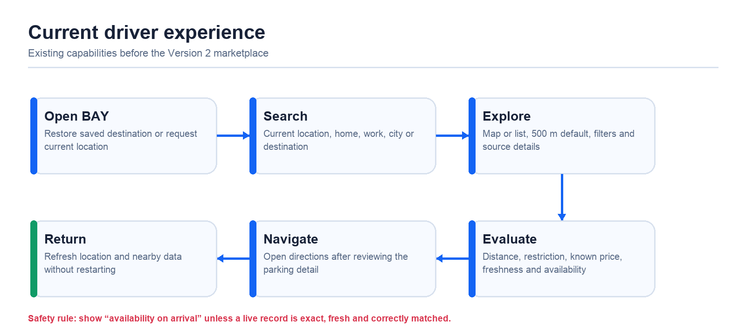
Figure 1 Existing driver discovery and navigation flow

Current data snapshot
Melbourne dataset | Recorded quantity | How BAY should describe it
On-street parking bays | 29,053 | Mapped bay inventory used by the app
Pay Stay restrictions | 6,270 | Published restrictions; some temporal assumptions require validation
Pay Stay zones | 935 | Zone links to street segments
Parking zones | 926 | Council zone geometry and rules
Sign plates in parking zones | 1,821 | Evidence layer; not automatically an exact bay rule
Live sensor rows | 6,324 | Potential live source; display requires exact match and freshness
Off-street commercial car parks | 143 | Curated 2024 off-street subset
Greater Melbourne mapped bays | 46,002 | Regional catalog, not all live or priced

3 Version 2 product scope
Version 2 is a marketplace and data-quality release, not simply a visual redesign. The key product change is that BAY becomes the transaction and trust layer between drivers and verified hosts while preserving the existing public parking map.
Area | Version 2 capability | Status
Driver marketplace | Search private spaces by location and time; compare photo, vehicle fit, price, access and cancellation terms | Planned
Host onboarding | Identity, payout, address, photos, authority, strata and safety declarations | Foundation built locally
Listing management | Draft, review, active, paused and removed states; availability and pricing | Foundation built locally
Booking | Quote, hold, payment, confirmation, check-in/out, cancellation and review | Planned
Payments and payouts | Marketplace checkout, application fee, refund, settlement and reconciliation | Planned
Trust and support | Moderation, evidence, duplicate checks, disputes, reports and refunds | Planned
Data confidence | Source, freshness and confidence class on every parking result | Planned
Operations | Admin queue, incident handling, versioned data and rollback | Partially existing; expand for V2

Private spaces that may be listed
- A private driveway, garage or allocated apartment bay controlled by the host.
- A commercial or institutional parking area where the host has written authority to offer spaces.
- A long-term space offered weekly or monthly after the legal and recurring-payment terms are reviewed.

Spaces that must not be listed
- Public roads, kerbs, clearways, loading zones, accessible bays or council-managed spaces without written authority.
- Visitor or common-property apartment bays without owners-corporation or authorized-manager approval.
- Any space that blocks access, creates a safety risk or cannot legally accommodate the nominated vehicle.

Feature boundaries
Public parking data remains informational. Private listings become bookable only after verification. Exact private access details stay hidden until a confirmed booking. Long-duration reservations and business fleets should follow after the Melbourne short-stay marketplace demonstrates reliable supply, payments and incident handling.

4 End-to-end ecosystem
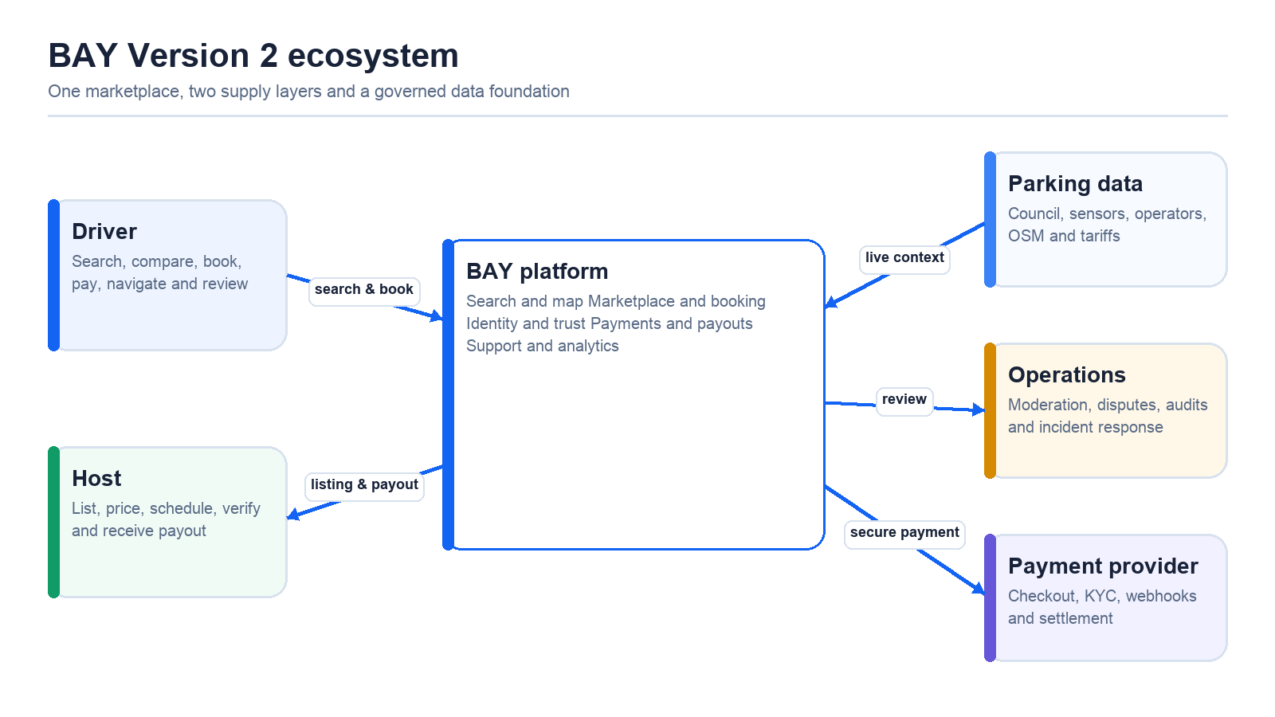
Figure 2 Version 2 actors and platform services

System responsibilities
Actor or service | Primary responsibility | Must not do
Driver | Provide destination, time and vehicle fit; follow access and parking terms | Assume a mapped location is bookable or live
Host | Provide truthful authority, photos, access, availability and pricing | List public or unauthorized space
BAY client | Search, explain evidence, collect intent and show confirmed states | Confirm a booking from client state alone
BAY server | Create quotes, lock availability, enforce policy and record status | Trust totals or confirmation supplied by the client
Payment provider | Collect payment, verify identity and settle payouts | Expose sensitive payment credentials to the app
Operations | Moderate, investigate, refund and handle incidents | Override evidence without an audit trail
Data platform | Publish source-accounted releases and freshness status | Fabricate vacancy, rules or price

Experience principle
A driver should understand the nature of an option before tapping directions: public or private, bookable or arrival-only, known or unknown price, live or non-live availability, vehicle fit, access restrictions and evidence confidence. BAY reduces uncertainty by explaining what is known and what is not.

5 Driver journeys

Version 2 booking flow
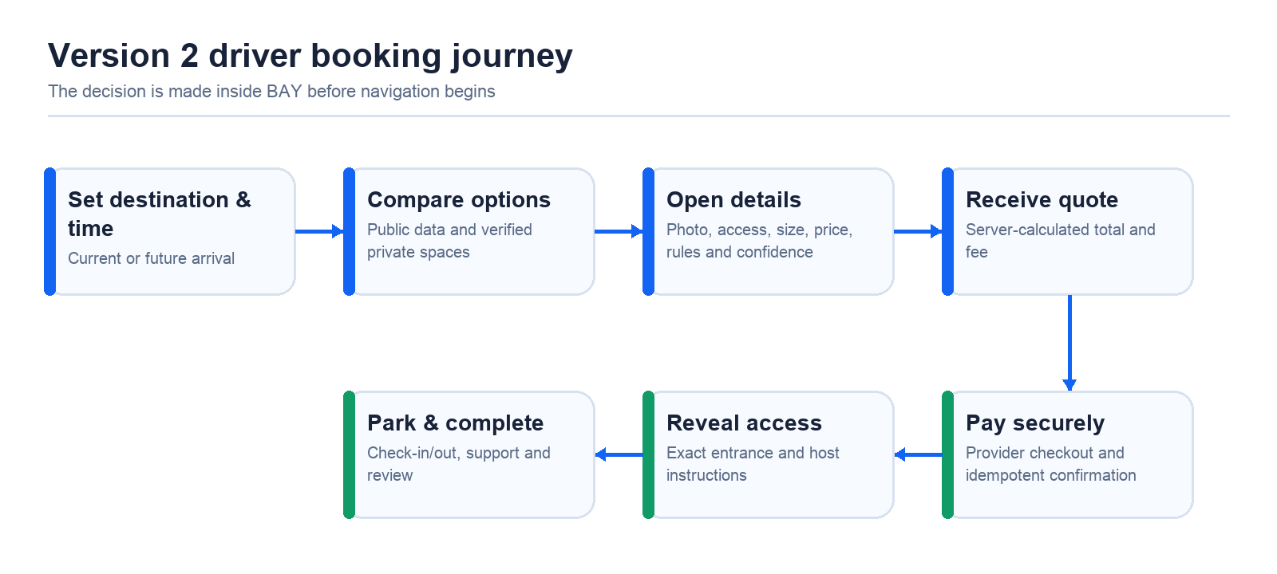
Figure 3 Driver journey from destination to completed booking

Detailed driver flow
Step | Screen or action | Decision and system behavior
1 | Open BAY | Restore the last destination and request a fresh current location without forcing a new search.
2 | Set destination and arrival time | Search address, saved home/work, current location or map area.
3 | Browse combined results | Separate public information from verified bookable private supply.
4 | Compare | Show photo, walking distance, total price, vehicle fit, access type, cancellation terms and confidence.
5 | Select | Run availability check and server quote; never rely on a stale list price.
6 | Pay | Use secure provider checkout; record an idempotency key and booking hold.
7 | Confirm | Accept only a verified server/provider event, then reveal exact entrance and instructions.
8 | Park | Provide navigation, check-in window, support and evidence capture if required.
9 | Complete | Check out, settle payout, record review and return the space to availability.

Returning from navigation
- Preserve the selected destination, filter, map viewport and chosen parking option.
- Refresh current location and time-sensitive data when the app becomes active.
- Do not automatically replace a confirmed destination with a GPS reading unless the driver requests it.
- Show a clear recenter action and a compact “resume booking” or “view booking” state.

Accessibility and driving safety
- Require major choices before the vehicle is moving; keep on-route actions large and minimal.
- Use screen-reader labels, high contrast, 44-point touch targets and status text in addition to color.
- Avoid claiming a time saving until field trials measure it. The primary claim is clearer parking evidence before arrival.

Driver experience acceptance criteria
Moment | Required behavior | Test evidence
Open or resume | Restore the intended destination and selected option; request fresh location without erasing intent | Cold start, warm return and permission-state tests
Explore | 500 m default, responsive zoom, public and private results clearly distinguished | Mobile viewport and map interaction tests
Open a result | Show source, confidence, price state, access and availability wording before directions | Content assertions across each confidence tier
Quote and pay | Recheck availability, calculate the total on the server and prevent duplicate submission | Concurrency, retry and payment-provider tests
Navigate and return | Keep the booking and destination visible; refresh time-sensitive data when active | Maps hand-off and lifecycle tests
Accessibility | Keyboard and screen-reader labels, readable contrast and large touch targets | Automated audit plus device review

6 Host journey
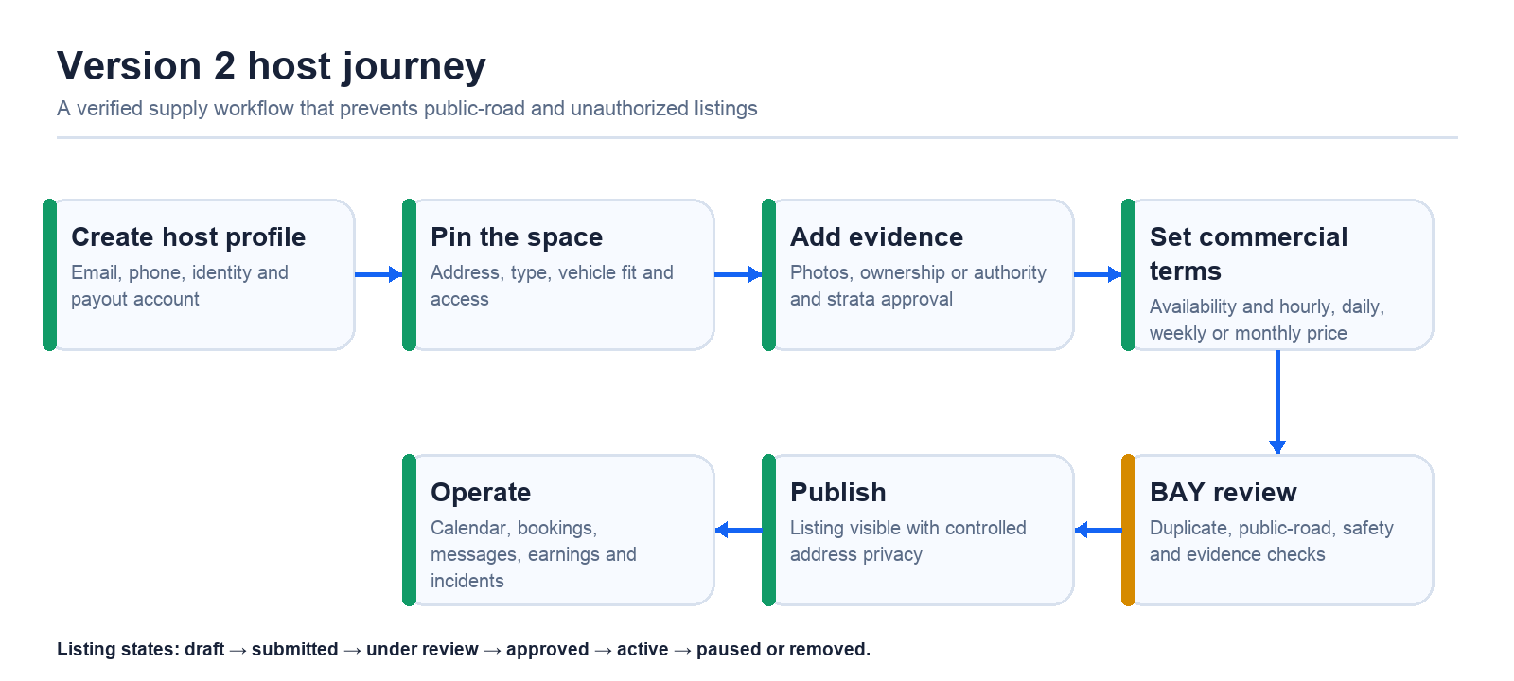
Figure 4 Host onboarding, verification and operating flow

Listing information
Group | Required fields | Reason
Identity and payout | Verified email, phone, legal identity and provider payout account | Fraud control, settlement and support
Space | Pin, address, type, dimensions, vehicle limit, access type and photos | Fit, navigation and driver confidence
Authority | Ownership or written authority; strata or owners-corporation approval where required | Prevent unauthorized supply
Availability | Days, hours, blackout periods and minimum notice | Avoid double booking and surprise access
Commercial terms | Hourly, daily, weekly or monthly price; cancellation and deposit policy | Transparent quote and refund logic
Safety | Lighting, access hazards, restricted areas and contact process | Reduce incidents and disputes

Host operating view
- Calendar of upcoming, active, completed and cancelled bookings.
- Availability override, temporary pause and price editing with effective dates.
- Gross earnings, BAY fee, payment processing, refunds and expected payout.
- Driver and support contact that protects personal contact details.
- Incident evidence, booking history and listing-quality recommendations.

Moderation states
State | Host sees | BAY action
Draft | Incomplete and private | Validate required fields locally
Submitted | Awaiting review | Run automated checks and queue manual review
Changes required | Reason and corrective actions | Hold publication
Approved | Ready to activate | Enable only after payout and availability checks
Active | Searchable and bookable | Monitor bookings, reports and data quality
Paused or removed | Reason and appeal path | Block new bookings; preserve audit history

7 Admin and operations journey
Version 2 needs a small but complete operations console. Marketplace trust cannot be managed entirely from the consumer app or through direct database edits.
Queue | Inputs | Decision or action
Listing review | Identity, authority, map pin, photos, duplicate and public-road checks | Approve, request changes or reject with reason
Booking support | Booking state, payment state, messages, timestamps and evidence | Assist, cancel, refund or escalate
Incident and safety | Location, severity, people involved and supporting evidence | Pause listing, contact parties and record outcome
Data quality | Source, release, record ID, reported error and field evidence | Correct, downgrade confidence, roll back or republish
Payout review | Provider status, refund risk, dispute and settlement date | Hold, release or reconcile payout
Privacy request | Identity verification, data inventory and request type | Access, correct or delete according to policy

Operations audit trail
- Record who changed a listing, booking, refund, source classification or release pointer and when.
- Keep previous values, evidence and reason codes for moderation and financial actions.
- Separate routine support permissions from refund, payout, data-publish and privacy-administration permissions.
- Use protected staging and production environments with explicit approval for data and application releases.

Service targets for Melbourne pilot
Event | Initial target | Escalation
New listing review | Within one business day | Safety or authority ambiguity to senior reviewer
Active booking support | First response within 10 minutes during service hours | Safety incidents immediately
Refund decision | Within one business day after evidence is complete | Payment dispute or fraud to finance/risk
Live-data outage | Safe degradation within five minutes of detection | Rollback if source or release is incorrect
Incorrect restriction or price | Remove or downgrade claim promptly | Field validation before restoration

8 Booking and payment controls
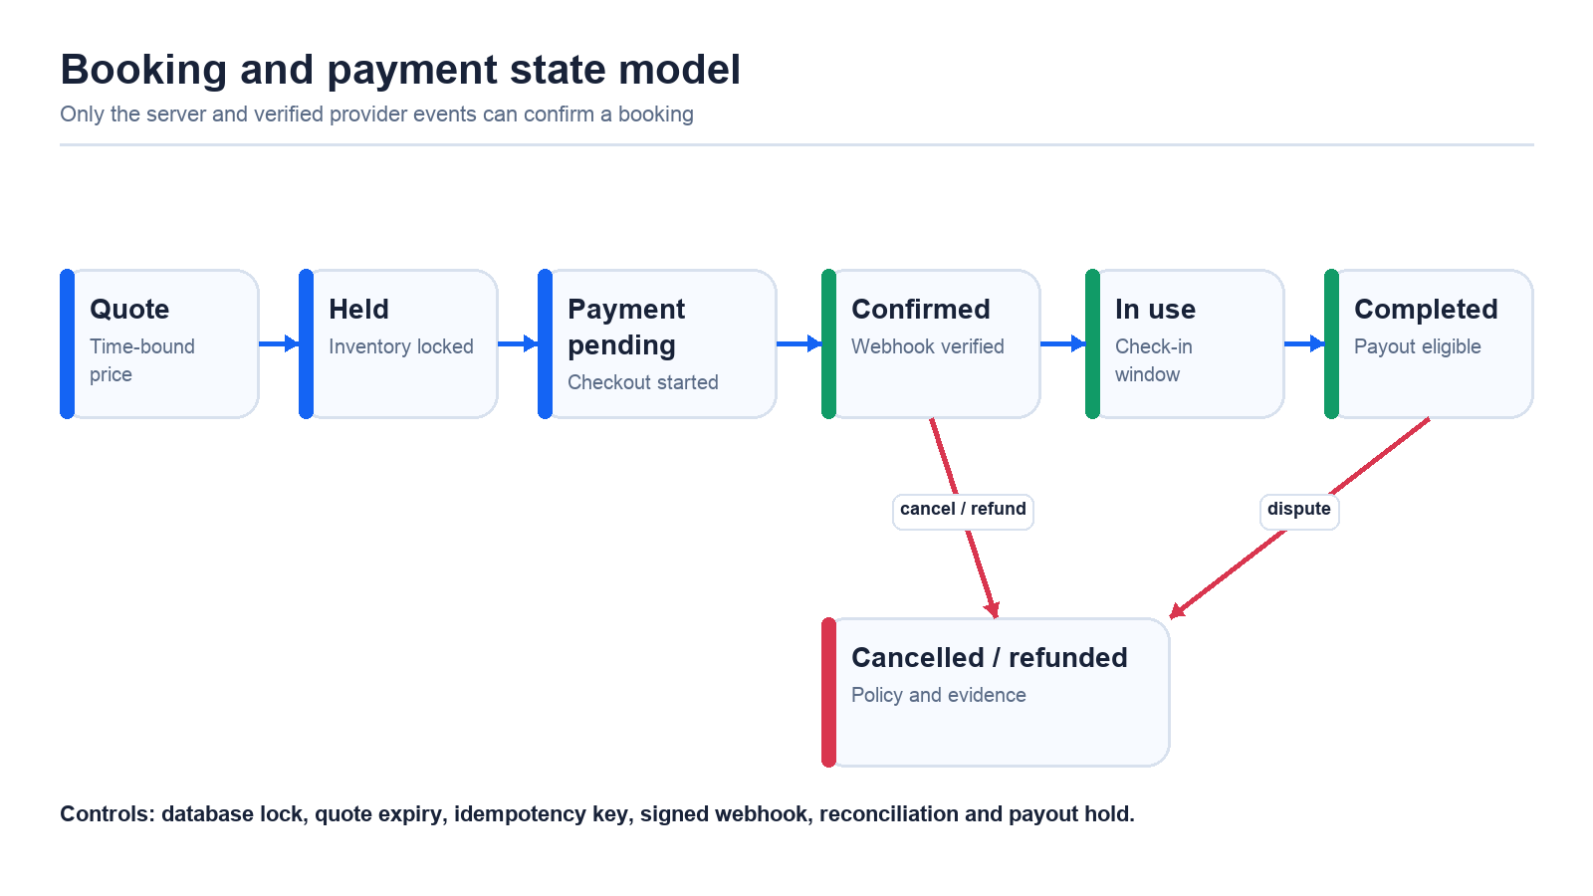
Figure 5 Booking and payment state transitions

Required transaction controls
Control | Implementation requirement | Failure prevented
Server quote | Calculate space, duration, fee, tax and deposit on the server | Client price tampering
Inventory hold | Lock the listing and time interval before checkout | Double booking
Idempotency | Unique key for quote, payment and confirmation attempts | Duplicate charges or bookings
Signed webhook | Verify provider signature and event type | Fake confirmation
Reconciliation | Compare BAY records with provider charges, refunds and payouts | Financial drift
Payout delay | Release only after completion and dispute window rules | Unrecoverable payout after a valid refund

Illustrative fee model
A 12% host fee is a test hypothesis and should be configurable without a client release. Example: for a A$30 booking, the BAY fee is A$3.60 and the host amount is A$26.40 before provider processing, tax treatment, refunds or adjustments. The checkout must show the driver’s total and the host dashboard must show gross, fee and net separately.

Booking policy decisions before launch
- Instant book versus host approval by listing type.
- Minimum lead time, grace period, overstay handling and no-show rules.
- Cancellation windows, refunds, deposits and evidence requirements.
- Recurring weekly or monthly stays and the legal terms for longer occupancy.
- Tax invoices, GST treatment and host income information.

9 Data and live accuracy foundation
Parking data is the foundation of BAY. Version 2 should treat every public record, live reading, tariff and host listing as a governed data product with provenance, freshness, confidence and release history.
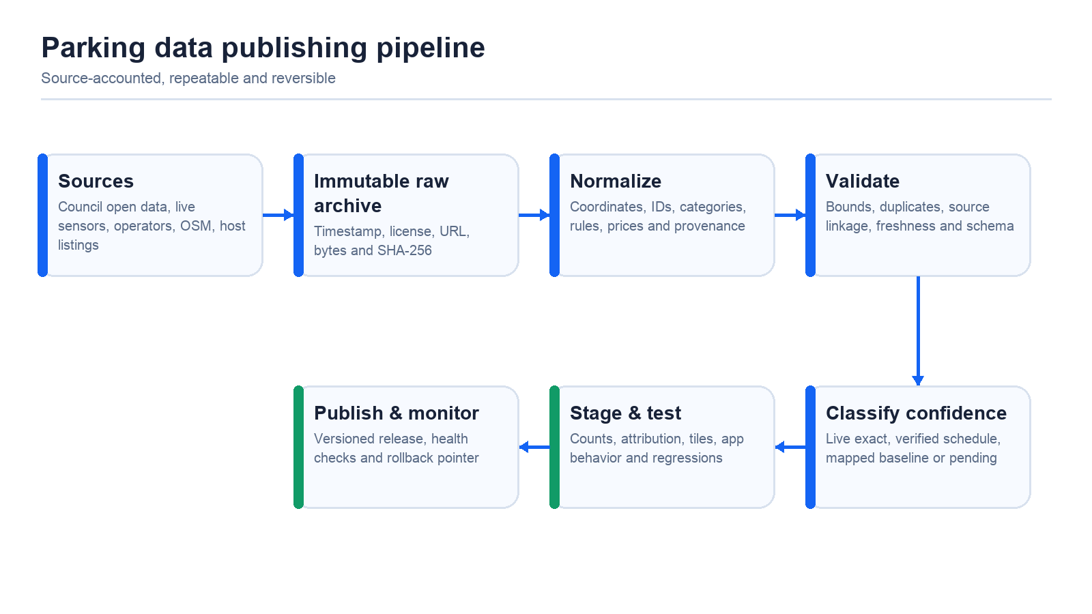
Figure 6 Data ingestion, validation, publishing and rollback pipeline

Refresh cadence
Data class | Recommended cadence | User-facing rule
Melbourne live sensors | Poll about every minute; mark stale after five minutes | Show live vacancy only when exact match and fresh
Licensed operator availability or price | One to five minutes if the contract and API support it | Show provider name and update time
Council restrictions and tariffs | Daily change detection, weekly review and monthly full snapshot | Show effective date and confidence
OSM mapped baseline | Monthly regional rebuild; weekly diffs when operationally stable | Availability on arrival unless another verified source exists
Host availability and bookings | Transactionally in real time; calendar sync near real time | A confirmed booking immediately blocks the interval
Listing photos and moderation state | Event driven | Only approved assets and public fields are visible
Source URL, license and manifest health | Daily automated checks and scheduled human review | Downgrade or remove unsupported claims
Field audit | Weekly launch-corridor sample; monthly broader sample | Use evidence to correct matching and confidence

Mandatory record metadata
- Stable internal ID and original source ID.
- Latitude and longitude with source geometry and match method.
- Source name, URL, license, retrieved time and immutable snapshot hash.
- Restriction, tariff and availability fields with independent update times.
- Confidence class, validation result, publication release and last field verification when available.

10 Melbourne coverage plan
“Fully covered in Melbourne” should mean that BAY has an explicit source and confidence status for the parking inventory it presents across the agreed geography. It should not mean that every physical space has a live sensor, published price or exact legal restriction. The launch plan must define geography, source coverage and measurable gaps municipality by municipality and corridor by corridor.

Coverage tiers
Tier | Evidence | BAY may show | BAY must not imply
1 Live exact | Exact source ID, current reading and freshness within threshold | Live status, update time and source | That all nearby bays are sensor covered
2 Verified rule or price | Council or operator publication with effective date and location match | Restriction, tariff and evidence confidence | Live vacancy unless a live source exists
3 Mapped baseline | Source-backed geometry such as OSM or council catalog | Parking location and known attributes | Verified legality, price or availability
4 Marketplace listing | Approved host, authority evidence, availability and booking state | Bookable time, total price, access and terms | Public access before confirmation or unrestricted right to list

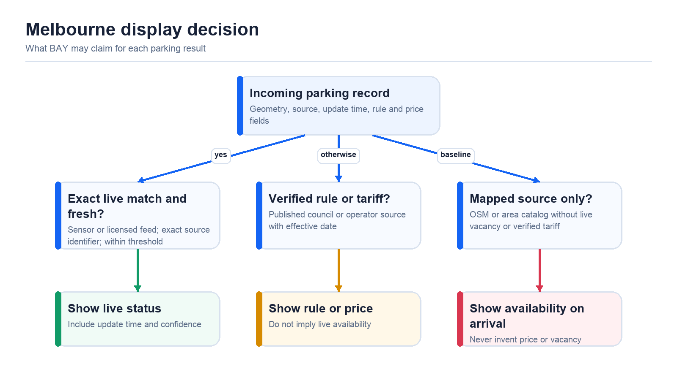
Figure 7 Decision logic for user-facing claims

Melbourne work program
- Define the launch boundary and priority destinations, then inventory every source used inside it.
- Repair exact bay-to-rule matching, especially mixed-sign streets where segment-level rules can be misleading.
- Measure sensor identifier coverage, last-update distribution and false vacancy through paired field observations.
- Ingest published operator tariffs only when the facility and effective price can be linked unambiguously.
- Audit neighbouring councils separately; City of Melbourne coverage is not Greater Melbourne coverage.
- Recruit private hosts near demand gaps and keep marketplace supply distinct from public data.
- Publish a monthly coverage report with gaps, confidence mix, field-audit results and incident history.

11 Technical architecture
The recommended foundation keeps the React/TypeScript client and Capacitor mobile shells, retains Supabase for identity and transactional data, and moves static application and dataset delivery toward versioned private object storage behind a CDN. Marketplace payments are server controlled and integrated through a compliant provider such as Stripe Connect.
Layer | Recommended responsibility | Key controls
Web and mobile clients | Search, map, forms, local state, accessibility and safe deeplinks | No service-role keys; no client-confirmed booking
CDN and object storage | Versioned app shell, regional tiles, images and data manifests | Private bucket, origin access control and cache policy
Supabase Auth and Postgres/PostGIS | Users, hosts, listings, bookings, reports, history and spatial search | Row-level security, migrations, audit fields and backups
Edge or server functions | Quotes, holds, payments, webhooks, moderation actions and notifications | Secret isolation, idempotency, authorization and logs
Object storage for host media | Private originals and approved derivatives | Signed upload, malware/type checks and access policy
Data pipeline | Archive, normalize, validate, tile, publish and roll back source datasets | Manifest hashes, release approval and telemetry
Operations console | Review, support, refund, incident and privacy workflows | Role separation and immutable action history

Separation of concerns
- Public parking catalogs can be cached and versioned independently from user and booking data.
- Private host addresses and access instructions remain in protected storage and are revealed by authorization rules.
- Live sensor failure does not take down the parking catalog; the client degrades to a neutral availability state.
- A dataset release can be rolled back without rolling back the application binary, and vice versa.
- Analytics should use pseudonymous identifiers and record consent or policy basis for each event family.

Release environments
Environment | Purpose | Promotion gate
Development | Feature and schema work with synthetic or approved test data | Unit and local integration tests
Staging | Production-like app, data and provider test modes | Counts, schema, attribution, mobile release and journey tests
Production | Approved application, datasets and payment configuration | Explicit approval, signed artifacts, rollback pointer and monitoring

Data reliability and incident response
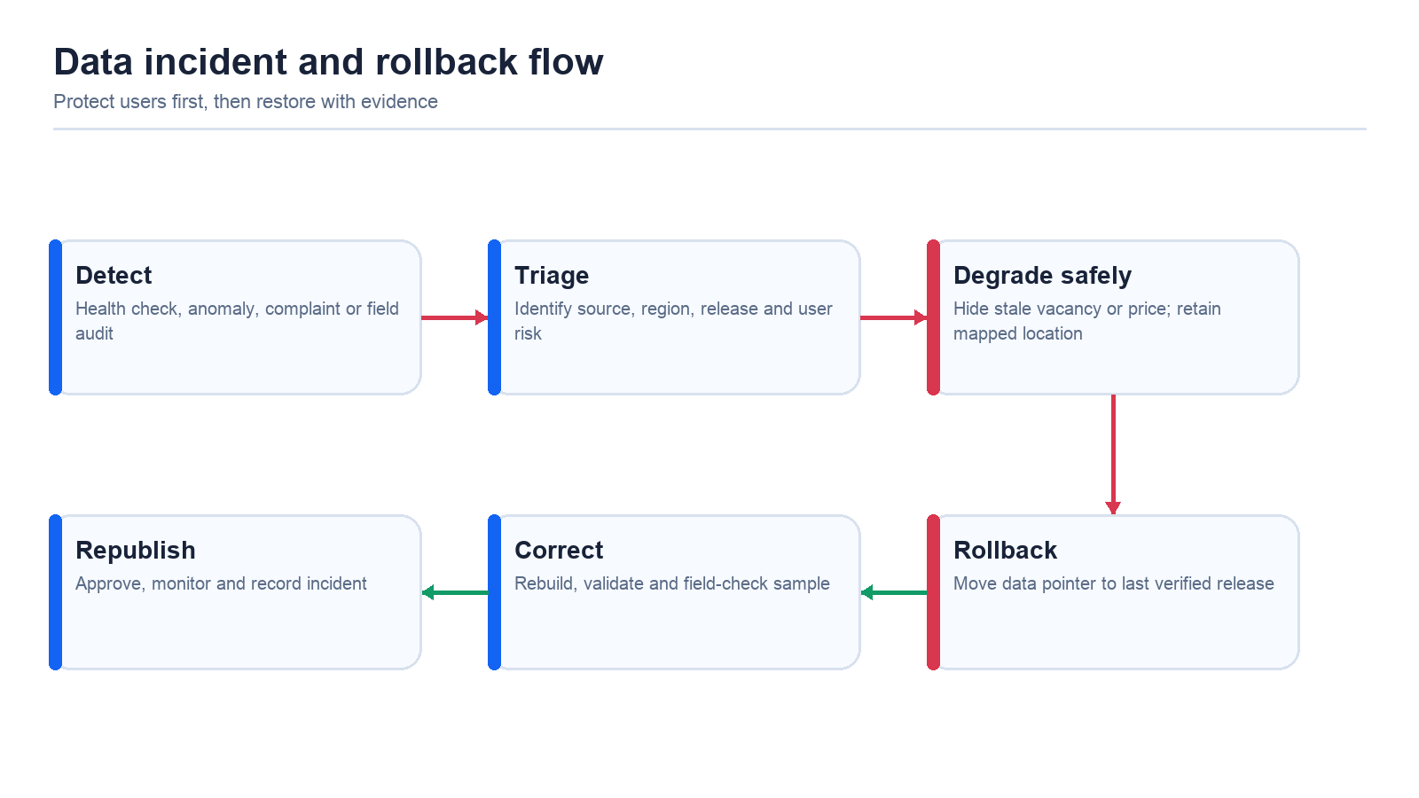
Figure 8 Safe degradation and release rollback

Detection signals
- Sensor freshness, missing-row rate, source HTTP health and abnormal count changes.
- Coordinate outliers, duplicates, impossible prices and rule-date conflicts.
- User reports, host reports, support tickets and structured field-audit observations.
- Booking failures, quote-versus-charge mismatches and double-booking attempts.
- Directions opened to a location that does not correspond to the selected record.

Rollback standard
Every public dataset release should have a manifest containing source URL, retrieval time, byte count, SHA-256 hash, schema version, record counts and attribution. Production should point to a versioned release prefix. Recovery is a pointer change to the last verified release, followed by cache invalidation and a recorded incident review.

12 Scenarios and expected impact
Scenario | Current friction | Version 2 response | Expected impact and measure
CBD commuter before arrival | Does not know which option is live, priced or suitable | Compare public and verified private options with confidence and total price | Higher detail-to-navigation conversion; lower abandoned searches
Driver returns from Maps | Old viewport or location forces a new search | Restore destination and selection, refresh current location and time-sensitive data | Fewer repeated searches; higher session completion
Apartment host lists an idle bay | No trusted way to prove authority, price it and receive payment | Identity, photos, strata approval, moderation, calendar and payout | Verified supply and host earnings; low unauthorized-listing rate
Live sensor source stops updating | A stale result could look available | Freshness rule removes live claim while preserving mapped location | Lower false-vacancy rate and faster safe degradation
Two drivers try the same space | Both may see an available slot | Server hold, transaction lock and idempotent confirmation | Zero confirmed overlapping bookings
Cancellation or access dispute | Evidence and payment status are fragmented | Booking timeline, photos, policy, refund and payout hold in one case | Shorter resolution time; lower chargeback rate
Long-term weekly parking | Short-stay flow may not fit recurring access | Request or recurring booking after legal and payment review | New demand segment without premature tenancy-like risk

Impact chain
Product input | Behavior change | Business effect | Proof required
Clear evidence and total price | Driver compares before navigation | More qualified navigation and bookings | Funnel analytics and field interviews
Verified private supply | More choices near destination | Booking revenue and improved coverage gaps | Active listings and completed bookings
Accurate availability state | Fewer misleading decisions | Trust and repeat use | False-vacancy field audit and complaints
Reliable return flow | Less rework after Maps | Higher completed journeys | Return-to-app completion rate
Moderation and support | Faster correction and safer supply | Lower dispute and removal cost | Review time, incident rate and resolution SLA

Claim discipline
BAY should not market guaranteed availability, complete price coverage, perfect legal interpretation or time savings until measured evidence supports those claims. A defensible message is: BAY brings nearby parking evidence, verified private supply and clearer access information together before the driver arrives.

13 Revenue model
The first direct revenue stream is a fee on completed private-space bookings. The fee must be visible, server configured and separated from provider processing and taxes. Public parking discovery should remain useful even when no bookable private space is available.
Revenue stream | Launch role | Dependencies
Host marketplace fee | Primary Version 2 revenue on completed bookings | Supply density, pricing, payment provider, refunds and payouts
Driver service fee | Optional only if transparent and tested | Price sensitivity and consumer-law review
Operator or commercial supply | Later partner channel | Contracts, inventory API, settlement and support model
Long-term parking | Later weekly or monthly revenue | Recurring payments, access terms and legal review
Business accounts | Later managed parking for teams or properties | Admin controls, invoicing and service commitments

Unit economics to measure
- Gross booking value, BAY fee, provider cost, refunds, support cost and host payout.
- Supply acquisition cost, listing approval rate, time to first booking and active host retention.
- Search-to-detail, detail-to-quote, quote-to-payment and completed-booking conversion.
- Cancellation, no-show, dispute, chargeback and refund rates by listing and acquisition channel.
- Repeat driver and repeat host activity by corridor.

Marketplace liquidity rule
Do not launch paid demand broadly until a defined destination cluster has enough verified, available supply at the times drivers search. A small dense market gives better learning than a large map with isolated listings.

14 Trust safety privacy and compliance
Risk | Preventive control | Response
Unauthorized listing | Identity, authority evidence, strata declaration and moderation | Pause, investigate, remove and preserve audit record
Public-road listing | Map and imagery checks plus explicit prohibited-space policy | Reject or remove immediately
Unsafe or inaccessible space | Vehicle fit, access type, hazards, photos and host declaration | Refund or relocate; investigate repeat reports
Address exposure | Hide exact private entrance until confirmation | Revoke access after cancellation; log sensitive views
Payment fraud | Provider KYC, server quotes, idempotency and risk signals | Hold payout, refund and investigate
Incorrect public data | Provenance, confidence, freshness and field audit | Downgrade claim, roll back or correct release
Privacy request | Purpose limitation, retention schedule and verified request workflow | Access, correct or delete as required

Australian launch checklist
- Confirm host authority, owners-corporation or lease restrictions and insurance responsibilities.
- Publish marketplace terms, cancellation and refund policy, privacy policy and prohibited listings.
- Explain host income and tax responsibilities without giving personal tax advice.
- Complete a privacy impact assessment for exact addresses, identity evidence, photos, payments and location history.
- Define emergency, safety, law-enforcement and data-breach response procedures.
- Review Australian Consumer Law representations for availability, price, fees and refunds.

Data minimization
Store only what is required for identity, booking, access, safety, support, finance and legal obligations. Separate public listing information from private address and access instructions. Apply retention schedules to location history, identity evidence, support records and abandoned drafts.

15 Delivery roadmap
Phase | Product and data work | Exit evidence
0 Foundation hardening | Define Melbourne boundary; source inventory; confidence model; booking schema; payment test environment; admin roles | Architecture and policies approved; no critical data gaps hidden
1 Supply and trust | Host onboarding, evidence, moderation, availability, pricing, photos and 50–100 verified spaces in one corridor | Listings verified; field inspection sample passes; support workflow staffed
2 Closed paid pilot | Driver search, quote, payment, confirmation, access, cancellation, payout and reviews | No overlapping confirmed bookings; reconciled transactions; acceptable incident rate
3 Melbourne launch | Expand corridor coverage, operator sources, field audits and public marketplace discovery | Coverage report published; release gates met; monitoring and rollback exercised
4 Greater Melbourne expansion | Add councils and demand clusters one by one; improve tariff and live-source partnerships | Each geography meets source and field-audit threshold
5 Scale and partnerships | Commercial operators, long-term parking, business accounts and additional Australian cities | Unit economics and operational capacity demonstrated

Implementation workstreams
Workstream | First deliverables | Owner profile
Product and design | Marketplace journeys, states, accessibility and policies | Product and design
Marketplace backend | Listings, availability, quotes, bookings, payments, webhooks and payouts | Backend and payments
Data platform | Source registry, pipeline, confidence, manifests, monitoring and rollback | Data engineering
Mobile and web | Unified search, details, checkout, return flow and activity | Frontend and mobile
Trust and operations | Moderation, support, disputes, privacy and incident process | Operations and legal
Field validation | Launch-corridor audits and source comparison | Data operations

16 Measures of success and release gates

Data and coverage measures
Measure | Definition | Launch use
Source-accounted coverage | Share of displayed records with current provenance, license and release metadata | Must be 100% for published records
Exact live match rate | Live-source records linked by stable exact identifier | Controls whether live status can be shown
Stale live rate | Live records beyond the freshness threshold | Triggers safe degradation and incident review
Price completeness | Results with an unambiguous, effective published tariff | Reported by source and geography, not inflated
Rule confidence mix | Results by exact, verified, baseline and unknown classification | Shows where deeper validation is needed
False vacancy rate | Field observations where BAY showed vacant but the bay was not usable | Primary trust signal for live claims
Unmapped search rate | Destination searches with no useful nearby result | Guides source and host acquisition

Marketplace measures
Measure | Why it matters | Initial interpretation
Verified active supply | Shows usable inventory, not submitted drafts | Track by corridor and time band
Search-to-quote conversion | Shows relevance and price transparency | Segment public versus private options
Quote-to-confirmed conversion | Shows checkout confidence | Investigate drop-off by price, access and trust
Completed booking rate | Shows operational reliability | Exclude test and cancelled bookings
Overlapping confirmed bookings | Core inventory integrity | Target zero
Cancellation, dispute and refund rate | Shows listing and policy quality | Review by host, reason and time-to-arrival
Repeat use | Shows durable value | Measure drivers and hosts separately

Production release gates
- All critical journeys pass on Android, iOS and mobile web release builds.
- Payment test suite covers success, decline, retry, duplicate webhook, cancellation, refund and payout hold.
- No client path can activate a listing or confirm a booking without server authorization.
- Melbourne data release has counts, attribution, hash manifest, staging comparison and rollback verification.
- Field audit sample meets the approved false-vacancy and directions thresholds.
- Support, safety, privacy and incident procedures are staffed and rehearsed.
- Analytics definitions and dashboards are validated before public marketing claims are made.

Appendix A Feature inventory
Feature | Existing | Foundation built locally | Version 2 planned | Later phase
Map and list discovery | Yes
Current location and recenter | Yes
Saved home and work | Yes
Return-from-Maps refresh | Yes
500 m default and filters | Yes
Public parking details and sources | Yes
Melbourne sensor freshness | Yes |  | Expand confidence display
Parking sign guide | Yes |  | Expand content and review
Saved activity and history | Yes
External operator links | Yes
Private-space discovery |  | Yes | Production integration
Host listing form |  | Yes | Production integration
Host verification and moderation |  |  | Yes
Availability calendar |  |  | Yes
Server quote and inventory hold |  |  | Yes
In-app payment and host payout |  |  | Yes
Booking access and check-in |  |  | Yes
Reviews, disputes and refunds |  |  | Yes
Admin operations console |  |  | Yes
Long-term recurring stays |  |  |  | Yes
Business and operator accounts |  |  |  | Yes

Version 2 definition of done
Version 2 is complete when a verified Melbourne host can publish an authorized space, a driver can find it beside clearly classified public parking information, receive a server quote, pay, obtain access, complete or cancel the booking, and both parties can obtain support—while BAY can audit every transaction and roll back incorrect public data without inventing availability or price.

Appendix B Data source matrix
Source family | Purpose | Refresh | Validation | Display rule
City of Melbourne bay catalog | Street-bay geometry and identifiers | On source change; monthly full snapshot | Bounds, IDs, duplicates and spatial outliers | Mapped bay; not necessarily live
Melbourne sensor feed | Current sensor status where supported | About every minute | Exact ID, timestamp and freshness | Live only within threshold
Council signs, restrictions and zones | Legal and temporal context | Daily change detection and monthly snapshot | Effective dates, joins and mixed-sign review | Show verified rule with evidence
Council and operator tariffs | Published price | Daily or contract cadence | Facility or zone match, currency and effective time | Show only unambiguous price
Off-street facility catalog | Parking-area discovery | Monthly or source change | Location, access, duplicates and current operation | Availability on arrival unless live source
OpenStreetMap baseline | Regional mapped coverage | Monthly; weekly diff later | Country/state bounds, tags, access and duplicates | Mapped baseline with attribution
Host listings | Private bookable supply | Event driven | Identity, authority, photos, availability and moderation | Bookable only when approved and active
Bookings and payments | Transactional availability | Real time | Locks, idempotency, webhooks and reconciliation | Confirmed state from server only
Field audits and user reports | Verification and correction | Weekly launch sample and event driven | Evidence quality and reviewer action | Update confidence or release after review

Known Melbourne data limitations
- Some bay-level restriction archives lack a reliable coordinate bridge to the mapped bay inventory.
- Mixed-sign streets can be misrepresented when a rule is broadcast to a whole segment instead of matched to the correct bay and arrow direction.
- A facility capacity value is not live vacancy.
- Historical sensor events are not current availability.
- City of Melbourne is one municipality; neighbouring councils require separate source and license audits.
- An OSM fee tag can indicate paid parking without publishing a usable amount.

Appendix C Terms and source references

Selected terms
Term | Meaning in BAY
Availability on arrival | A parking location is known, but live vacancy is not verified.
Exact live match | A stable source identifier links the displayed place to a fresh live record.
Published price | A source explicitly provides an amount, units, currency and effective conditions.
Confidence class | A controlled description of what evidence supports a displayed claim.
Immutable snapshot | A source file stored with retrieval metadata and hash so a release can be reproduced.
Private listing | A host-controlled space whose exact access information is protected.
Inventory hold | A short server-side reservation that prevents two checkouts for the same interval.
Idempotency | A control that makes a retried request produce one intended financial or booking result.

Repository evidence used
- Architecture, deployment, migration, security and operations documents in the BAY repository.
- Dataset inventory, national coverage, Melbourne coverage audit, field-test findings and coverage release notes.
- Current React and Capacitor product flows for location, search, map, activity, guide and booking foundations.
- BAY Marketplace MVP plan covering driver, host, moderation, payments, privacy and phased rollout.

External reference categories for implementation review
- City of Melbourne open data and live parking sensor source documentation.
- OpenStreetMap licensing and attribution requirements.
- Victorian parking, road, owners-corporation and consumer guidance.
- Office of the Australian Information Commissioner privacy principles.
- Australian Taxation Office guidance on parking-space income and marketplace reporting.
- Payment-provider marketplace documentation for connected accounts, application fees, refunds and webhooks.

Final product rule
When BAY cannot prove a claim, it should say less—not guess. Version 2 succeeds when it adds verified supply and transactions while making the evidence behind every parking decision clearer.

