**1.Create a Spring Web Project using Maven**

**Steps:**

1. Creating a Spring Boot Project Using Spring Initializr

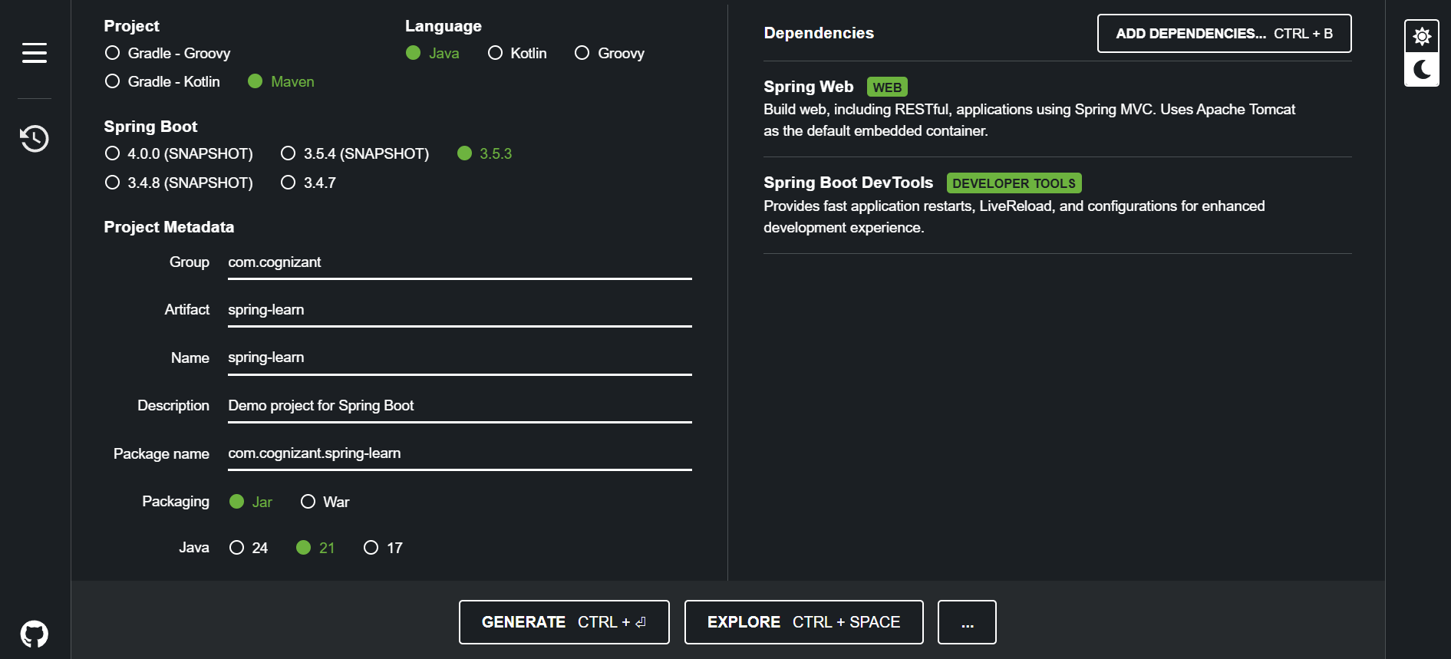

Click generate a zip with name spring-learn will be downloaded.

1. Extract the zip in a proper work location.
2. Open any editor

I am using intellij select open option to open the project.

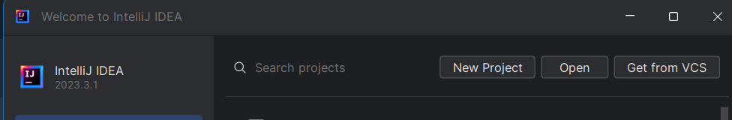

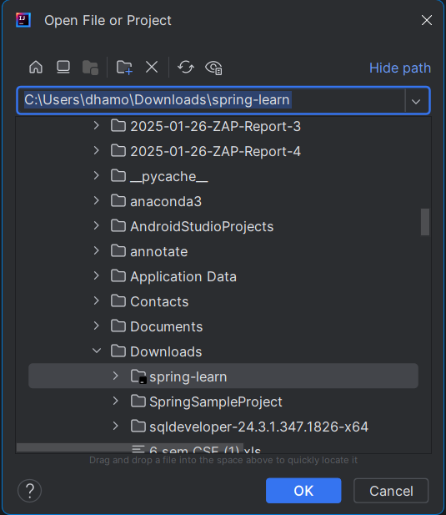

Select the project and open. Rebuild the maven and build the project with proper JDK. Here I am using java 21.

1. Run the SpringLearnApplication.java from the following path

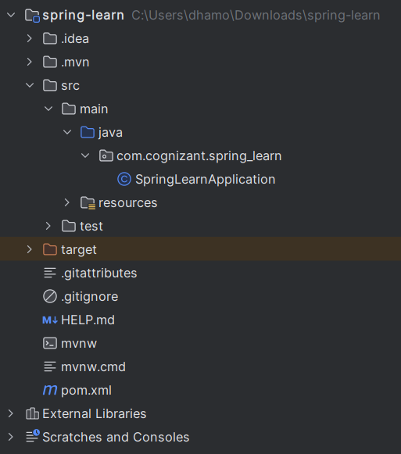

1. The application run at the port number 8080 at localhost in tomcat server.

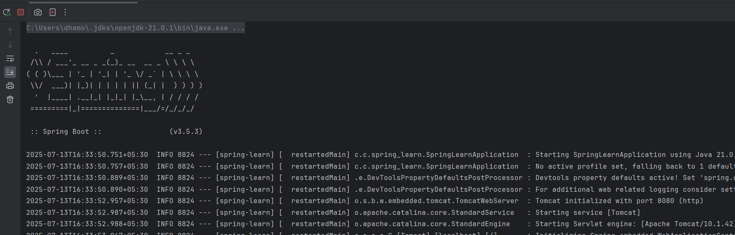  
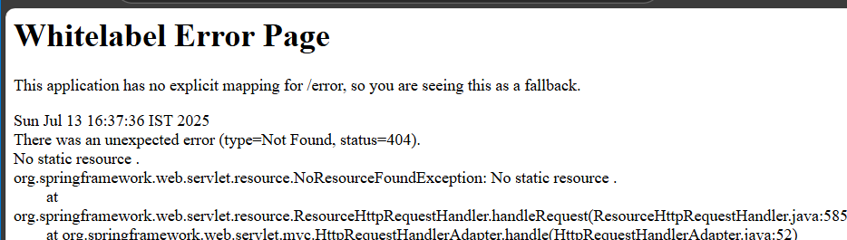

The above is a custom error shown by SpringBoot at port 8080.

SME to walk through the following aspects related to the project created:

1. src/main/java - Folder with application code.
2. src/main/resources - Folder for application configuration.
3. src/test/java - Folder with code for testing the application.

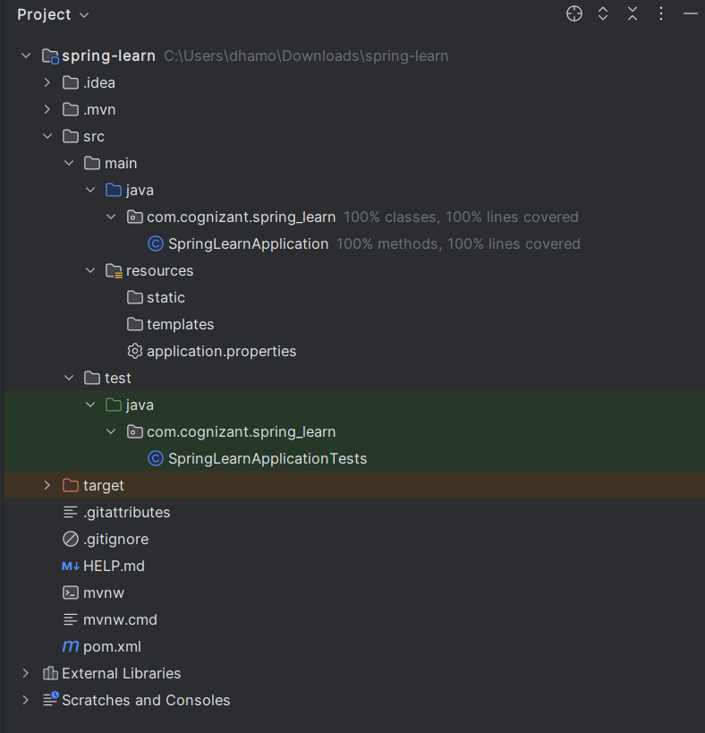

Project structure.

1. SpringLearnApplication.java - Walkthrough the main() method.

package com.cognizant.spring_learn;  
  
import org.springframework.boot.SpringApplication;  
import org.springframework.boot.autoconfigure.SpringBootApplication;  
  
@SpringBootApplication  
public class SpringLearnApplication {  
  
 public static void main(String[] args) {  
 SpringApplication.*run*(SpringLearnApplication.class, args);  
 }  
  
}

1. Purpose of @SpringBootApplication annotation

The @SpringBootApplication annotation is a **convenience annotation** that is used to mark the **main class** of a Spring Boot application. It enables several key Spring Boot features through meta-annotations.

1. pom.xml
   1. Walkthrough all the configuration defined in XML file
   2. Open 'Dependency Hierarchy' and show the dependency tree.

pom.xml

<?xml version="1.0" encoding="UTF-8"?>  
<project xmlns="http://maven.apache.org/POM/4.0.0" xmlns:xsi="http://www.w3.org/2001/XMLSchema-instance"  
 xsi:schemaLocation="http://maven.apache.org/POM/4.0.0 https://maven.apache.org/xsd/maven-4.0.0.xsd">  
 <modelVersion>4.0.0</modelVersion>  
 <parent>  
 <groupId>org.springframework.boot</groupId>  
 <artifactId>spring-boot-starter-parent</artifactId>  
 <version>3.5.3</version>  
 <relativePath/> <!-- lookup parent from repository -->  
 </parent>  
 <groupId>com.cognizant</groupId>  
 <artifactId>spring-learn</artifactId>  
 <version>0.0.1-SNAPSHOT</version>  
 <name>spring-learn</name>  
 <description>Demo project for Spring Boot</description>  
 <url/>  
 <licenses>  
 <license/>  
 </licenses>  
 <developers>  
 <developer/>  
 </developers>  
 <scm>  
 <connection/>  
 <developerConnection/>  
 <tag/>  
 <url/>  
 </scm>  
 <properties>  
 <java.version>21</java.version>  
 </properties>  
 <dependencies>  
 <dependency>  
 <groupId>org.springframework.boot</groupId>  
 <artifactId>spring-boot-starter-web</artifactId>  
 </dependency>  
  
 <dependency>  
 <groupId>org.springframework.boot</groupId>  
 <artifactId>spring-boot-devtools</artifactId>  
 <scope>runtime</scope>  
 <optional>true</optional>  
 </dependency>  
 <dependency>  
 <groupId>org.springframework.boot</groupId>  
 <artifactId>spring-boot-starter-test</artifactId>  
 <scope>test</scope>  
 </dependency>  
 </dependencies>  
  
 <build>  
 <plugins>  
 <plugin>  
 <groupId>org.springframework.boot</groupId>  
 <artifactId>spring-boot-maven-plugin</artifactId>  
 </plugin>  
 </plugins>  
 </build>  
  
</project>

**2.Spring Core – Load Country from Spring Configuration XML**

For this experiment we need to modify and create 3 files

**Country.java**

package com.cognizant.spring_learn;  
  
public class Country {  
 private String code;  
 private String name;  
  
 // Getters and Setters  
 public String getCode() {  
 return code;  
 }  
 public void setCode(String code) {  
 this.code = code;  
 }  
 public String getName() {  
 return name;  
 }  
 public void setName(String name) {  
 this.name = name;  
 }  
  
 @Override  
 public String toString() {  
 return "Country [code=" + code + ", name=" + name + "]";  
 }  
}

**country.xml**

<?xml version="1.0" encoding="UTF-8"?>  
<beans xmlns="http://www.springframework.org/schema/beans"  
 xmlns:xsi="http://www.w3.org/2001/XMLSchema-instance"  
 xsi:schemaLocation="http://www.springframework.org/schema/beans  
 http://www.springframework.org/schema/beans/spring-beans.xsd">  
  
 <bean id="countryUS" class="com.cognizant.spring_learn.Country">  
 <property name="code" value="US"/>  
 <property name="name" value="United States"/>  
 </bean>  
  
 <bean id="countryDE" class="com.cognizant.spring_learn.Country">  
 <property name="code" value="DE"/>  
 <property name="name" value="Germany"/>  
 </bean>  
  
 <bean id="countryIN" class="com.cognizant.spring_learn.Country">  
 <property name="code" value="IN"/>  
 <property name="name" value="India"/>  
 </bean>  
  
 <bean id="countryJP" class="com.cognizant.spring_learn.Country">  
 <property name="code" value="JP"/>  
 <property name="name" value="Japan"/>  
 </bean>  
  
 <bean id="countryList" class="java.util.ArrayList">  
 <constructor-arg>  
 <list>  
 <ref bean="countryUS"/>  
 <ref bean="countryDE"/>  
 <ref bean="countryIN"/>  
 <ref bean="countryJP"/>  
 </list>  
 </constructor-arg>  
 </bean>  
  
</beans>

**SpringLearnApplication.java**

package com.cognizant.spring_learn;  
  
import org.slf4j.Logger;  
import org.slf4j.LoggerFactory;  
import org.springframework.context.ApplicationContext;  
import org.springframework.context.support.ClassPathXmlApplicationContext;  
import java.util.List;  
  
public class SpringLearnApplication {  
  
 private static final Logger *LOGGER* = LoggerFactory.*getLogger*(SpringLearnApplication.class);  
  
 public static void main(String[] args) {  
 *LOGGER*.debug("START");  
 *displayCountries*();  
 *LOGGER*.debug("END");  
 }  
  
 public static void displayCountries() {  
 ApplicationContext context = new ClassPathXmlApplicationContext("country.xml");  
 List<Country> countryList = (List<Country>) context.getBean("countryList");  
  
 // Printing countries  
 for (Country country : countryList) {  
 System.*out*.println("Country: " + country);  
 *LOGGER*.debug("Country: {}", country);  
 }  
 }  
}

**Output:**

**3.Hello World RESTful Web Service**

**SpringLearnApplication.java**

package com.cognizant.springlearn;

import org.springframework.boot.SpringApplication;

import org.springframework.boot.autoconfigure.SpringBootApplication;

@SpringBootApplication

public class SpringLearnApplication {

public static void main(String[] args) {

SpringApplication.run(SpringLearnApplication.class, args);

}

}

**HelloController.java**

package com.cognizant.springlearn.controller;

import org.slf4j.Logger;

import org.slf4j.LoggerFactory;

import org.springframework.web.bind.annotation.GetMapping;

import org.springframework.web.bind.annotation.RestController;

@RestController

public class HelloController {

private static final Logger LOGGER = LoggerFactory.getLogger(HelloController.class);

@GetMapping("/hello")

public String sayHello() {

LOGGER.info("START: sayHello()");

String response = "Hello World!! Welcome to CTS Training";

LOGGER.info("END: sayHello()");

return response;

}

}

**Application.properties**

server.port=8083

**pom.xml**

<project xmlns="http://maven.apache.org/POM/4.0.0"

xmlns:xsi="http://www.w3.org/2001/XMLSchema-instance"

xsi:schemaLocation="http://maven.apache.org/POM/4.0.0

http://maven.apache.org/xsd/maven-4.0.0.xsd">

<modelVersion>4.0.0</modelVersion>

<groupId>com.cognizant</groupId>

<artifactId>spring-learn</artifactId>

<version>0.0.1-SNAPSHOT</version>

<name>spring-learn</name>

<description>Hello World Spring Boot App</description>

<packaging>jar</packaging>

<parent>

<groupId>org.springframework.boot</groupId>

<artifactId>spring-boot-starter-parent</artifactId>

<version>3.2.5</version>

</parent>

<dependencies>

<dependency>

<groupId>org.springframework.boot</groupId>

<artifactId>spring-boot-starter-web</artifactId>

</dependency>

</dependencies>

<properties>

<java.version>17</java.version>

</properties>

</project>

**OUTPUT:**

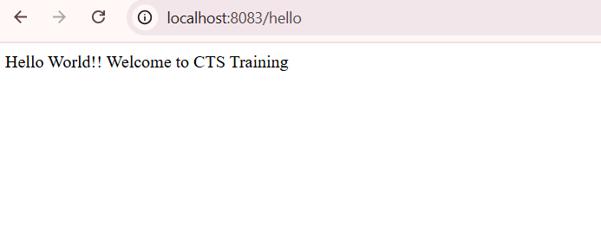

**4.REST - Country Web Service**

**SpringLearnApplication.java**

package com.cognizant.springlearn;

import org.springframework.boot.SpringApplication;

import org.springframework.boot.autoconfigure.SpringBootApplication;

@SpringBootApplication

public class SpringLearnApplication {

public static void main(String[] args) {

SpringApplication.run(SpringLearnApplication.class, args);

}

}

**CountryController.java**

package com.cognizant.springlearn.controller;

import com.cognizant.springlearn.model.Country;

import org.springframework.context.ApplicationContext;

import org.springframework.context.support.ClassPathXmlApplicationContext;

import org.springframework.web.bind.annotation.RequestMapping;

import org.springframework.web.bind.annotation.RestController;

@RestController

public class CountryController {

@RequestMapping("/country")

public Country getCountryIndia() {

ApplicationContext context = new ClassPathXmlApplicationContext("country.xml");

Country country = (Country) context.getBean("in");

return country;

}

}

**Country.java**

package com.cognizant.springlearn.model;

public class Country {

private String code;

private String name;

public Country() {}

public Country(String code, String name) {

this.code = code;

this.name = name;

}

public String getCode() {

return code;

}

public void setCode(String code) {

this.code = code;

}

public String getName() {

return name;

}

public void setName(String name) {

this.name = name;

}

@Override

public String toString() {

return "Country [code=" + code + ", name=" + name + "]";

}

}

**Application.properties**

server.port=8083

**county.xml**

<?xml version="1.0" encoding="UTF-8"?>

<beans xmlns="http://www.springframework.org/schema/beans"

xmlns:xsi="http://www.w3.org/2001/XMLSchema-instance"

xsi:schemaLocation="http://www.springframework.org/schema/beans

http://www.springframework.org/schema/beans/spring-beans.xsd">

<bean id="in" class="com.cognizant.springlearn.model.Country">

<property name="code" value="IN" />

<property name="name" value="India" />

</bean>

</beans>

**pom.xml**

<project xmlns="http://maven.apache.org/POM/4.0.0"

xmlns:xsi="http://www.w3.org/2001/XMLSchema-instance"

xsi:schemaLocation="http://maven.apache.org/POM/4.0.0

http://maven.apache.org/xsd/maven-4.0.0.xsd">

<modelVersion>4.0.0</modelVersion>

<groupId>com.cognizant</groupId>

<artifactId>spring-learn</artifactId>

<version>1.0.0</version>

<packaging>jar</packaging>

<name>spring-learn</name>

<description>Spring Boot REST project with XML config</description>

<parent>

<groupId>org.springframework.boot</groupId>

<artifactId>spring-boot-starter-parent</artifactId>

<version>3.2.2</version>

<relativePath/>

</parent>

<dependencies>

<dependency>

<groupId>org.springframework.boot</groupId>

<artifactId>spring-boot-starter-web</artifactId>

</dependency>

<dependency>

<groupId>org.springframework</groupId>

<artifactId>spring-context</artifactId>

</dependency>

<dependency>

<groupId>com.fasterxml.jackson.core</groupId>

<artifactId>jackson-databind</artifactId>

</dependency>

<dependency>

<groupId>org.springframework.boot</groupId>

<artifactId>spring-boot-starter-test</artifactId>

<scope>test</scope>

</dependency>

</dependencies>

<build>

<plugins>

<plugin>

<groupId>org.springframework.boot</groupId>

<artifactId>spring-boot-maven-plugin</artifactId>

</plugin>

</plugins>

</build>

</project>

**OUTPUT:**

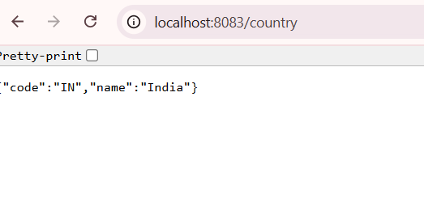

**5.REST - Get country based on country code**

**Country.java**

package com.cognizant.springlearn.model;

import javax.validation.constraints.NotNull;

import javax.validation.constraints.Size;

public class Country {

@NotNull

@Size(min = 2, max = 2, message = "Country code should be 2 characters")

private String code;

private String name;

public Country() {}

public Country(String code, String name) {

this.code = code;

this.name = name;

}

public String getCode() {

return code;

}

public void setCode(String code) {

this.code = code;

}

public String getName() {

return name;

}

public void setName(String name) {

this.name = name;

}

}

**CountryController.java**

package com.cognizant.springlearn.controller;

import org.springframework.web.bind.annotation.*;

import org.springframework.http.HttpStatus;

import org.springframework.web.server.ResponseStatusException;

import com.cognizant.springlearn.model.Country;

import java.util.*;

@RestController

@RequestMapping("/countries")

public class CountryController {

private static Map<String, Country> countryMap = new HashMap<>();

static {

countryMap.put("IN", new Country("IN", "India"));

countryMap.put("US", new Country("US", "United States"));

countryMap.put("CN", new Country("CN", "China"));

}

@GetMapping("/{code}")

public Country getCountry(@PathVariable String code) {

Country country = countryMap.get(code.toUpperCase());

if (country == null) {

throw new ResponseStatusException(HttpStatus.NOT_FOUND, "Country not found");

}

return country;

}

}

**OUTPUT:**

