**Exercise 1: Create a new React Application**

**Steps 1:** Install Nodejs and Npm

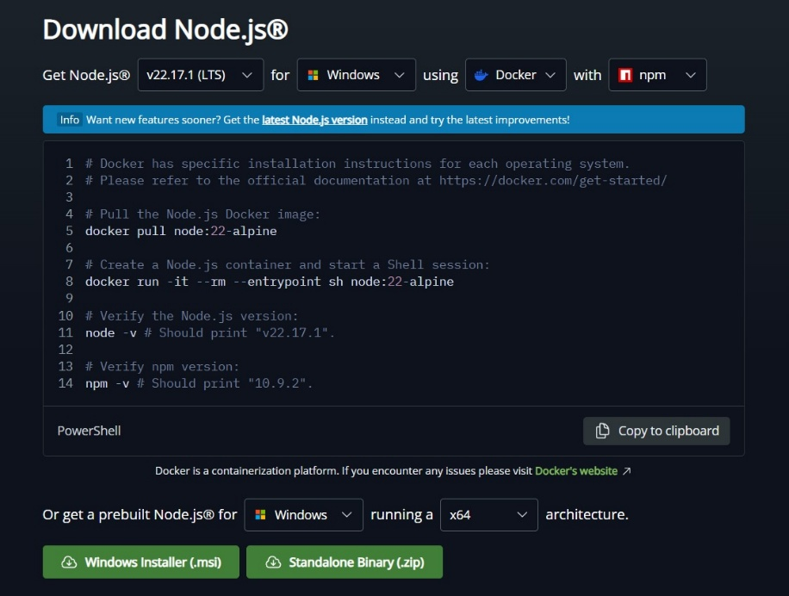

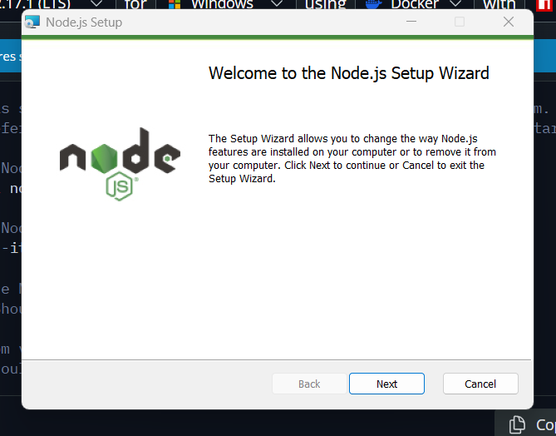 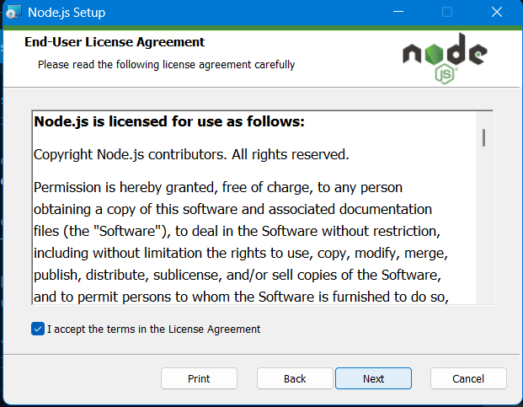

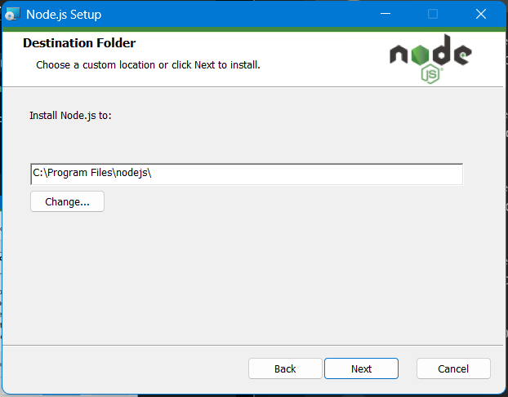 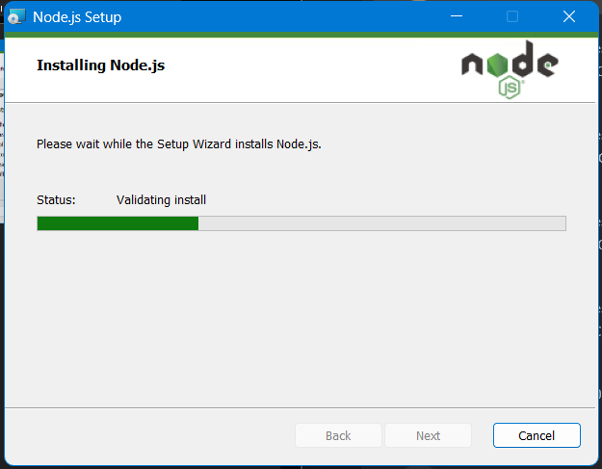

**Step 2: Setup the project**

* Install create-react-app using command prompt.

*npm install -g create-react-app*

* Create React application with name of “*myfirstreact*” by using following command

*npx create-react-app myfirstreact*

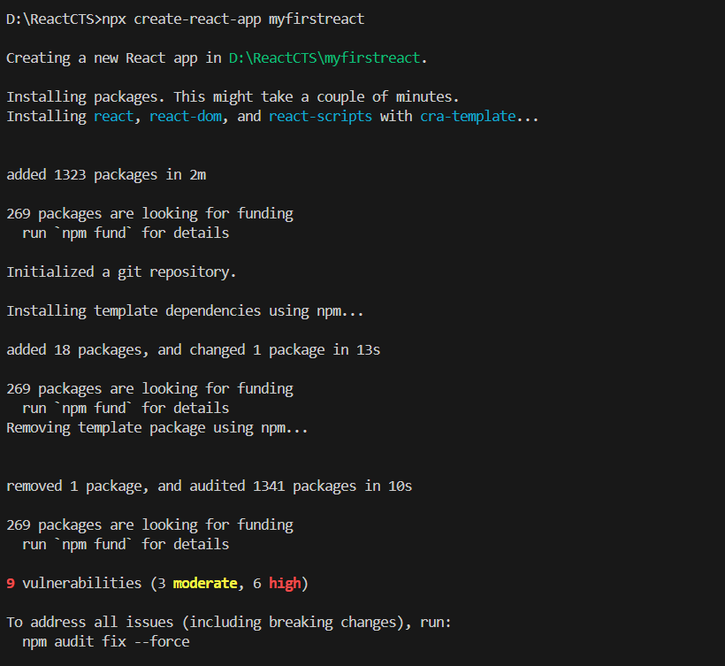

* Navigate to react app and run the app using following command

*cd myfirstreact*

*npm start*

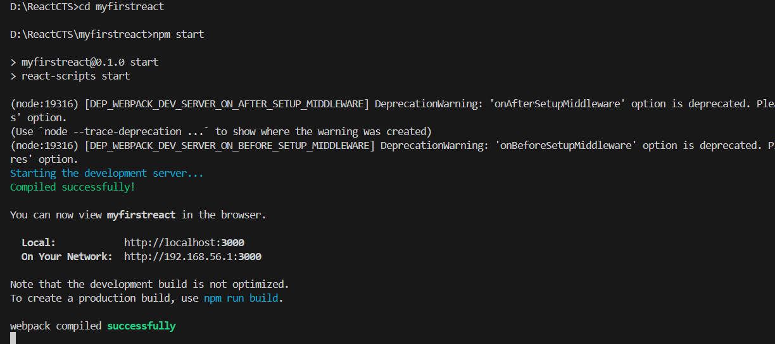

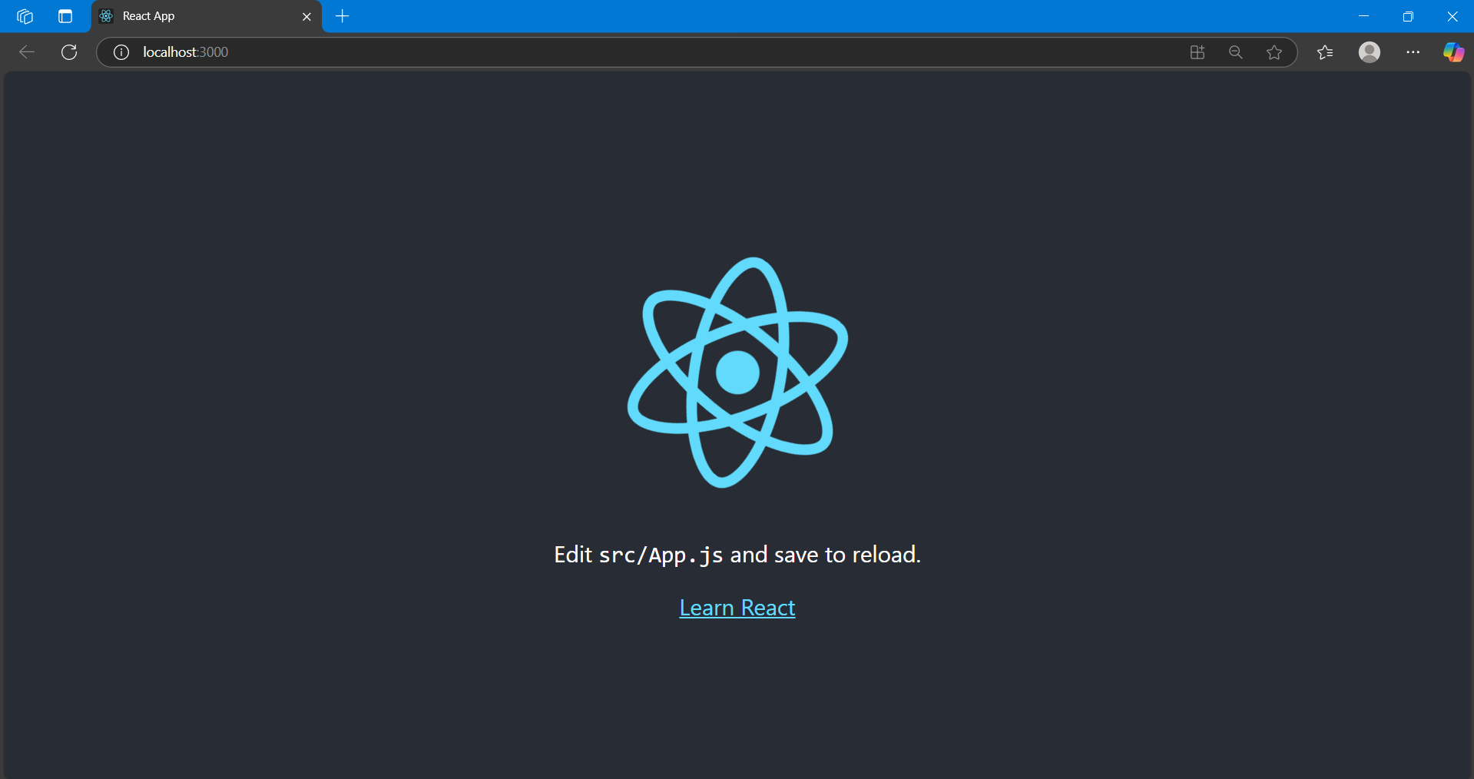

**Step 3: Modify the App.js file**

Open App.js in created react project in VS code.

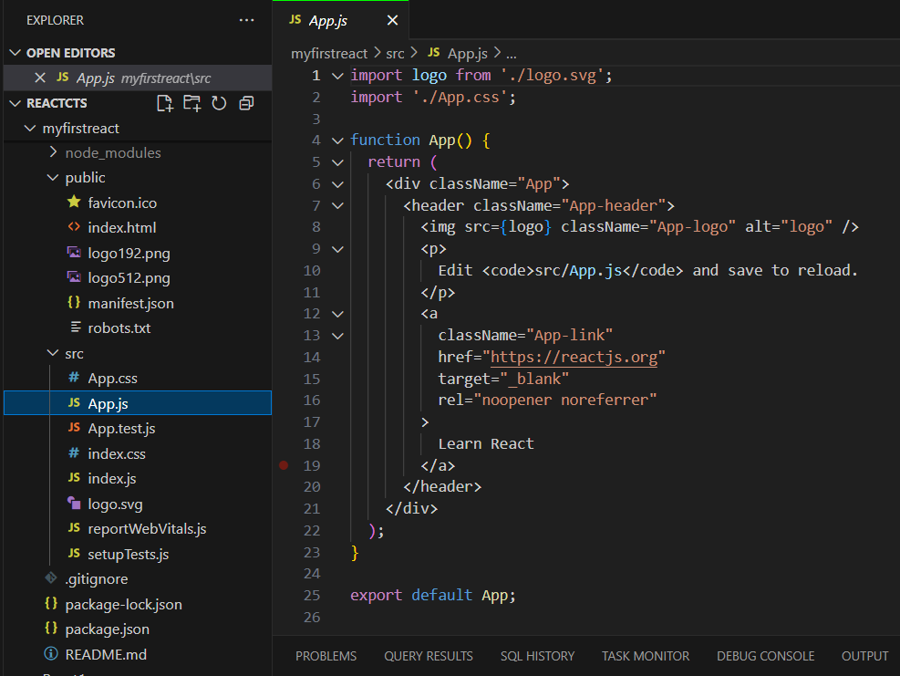

* Remove the content of App.js and type the following code.

*function App(){*

*return (*

*<h1> Welcome the first session of React </h1>*

*);*

*}*

*export default App;*

**Step 4: Run the Application**

Save the App.js and run the react application using the following command

* *npm start*

