**Exercise 2: Create a React application “*student-app*”**

**Steps:**

1. Create a React project named *“student-app”* using the following command.

*npx create-react-app student-app*

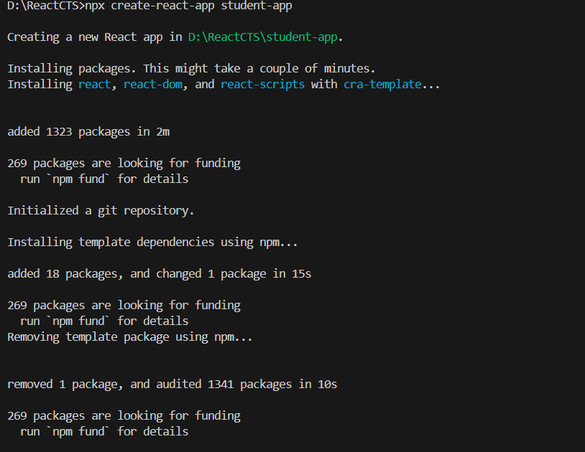

1. Create 3 components named Home.js , About.js and Contact.js in the src folder.

**Home.js**

import { Component } from 'react';

class Home extends Component {

    render() {

        return(

            <div>

                <h3>Welcome to the Home Page of Student Management Portal</h3>

            </div>

        )

    }

};

export default Home;

**About.js**

import { Component } from 'react';

class About extends Component {

    render() {

        return(

            <div>

                <h3>Welcome to the About Page of Student Management Portal</h3>

            </div>

        )

    }

};

export default About;

**Contact.js**

import { Component } from 'react';

class Contact extends Component {

    render() {

        return(

            <div>

                <h3>Welcome to the Contact Page of Student Management Portal</h3>

            </div>

        )

    }

};

export default Contact;

**App.js**

import About from './About';

import './App.css';

import Contact from './Contant';

import Home from './Home';

function App() {

  return (

    <div className='container'>

      <Home/>

      <About/>

      <Contact/>

    </div>

  );

}

export default App;

1. Run the following command “*npm start*”
2. The output of the program will be like this in this I coded the container in App.css

