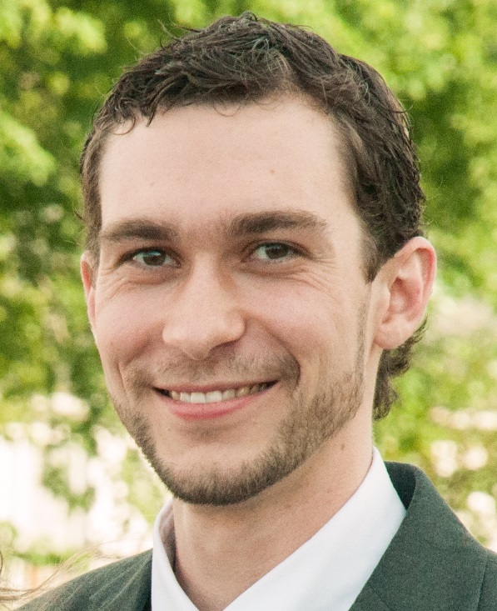

**Contact Information**

(573)466-3428

[Jdh26c@mst.edu](mailto:Jdh26c@mst.edu)

**Location**

Office- Toomey Hall 342

**Resume- Next Page**

**Joshua Heck**

www.linkedin.com/in/joshuadheck

1519 Timbercreek Rd Apt 3 (573) 466-3428

Rolla, MO 65401 jdh26c@mst.edu

OBJECTIVE Obtain a full time mechanical engineering position, emphasis in engery, thermal, and fluid sciences.

EDUCATION Graduate: Missouri University of Science and Technology (MS&T) Expected: May 2017

**M.S. Mechanical Engineering (ME) GPA: 4.0/4.0**

Thesis: Design Methodology for PEMFC Flow Fields Using Inspiration from Natural Flow Structures

Undergraduate: Missouri University of Science and Technology May 2015

**B.S. Mechanical Engineering (ME) GPA: 4.0/4.0**

Specialty Courses:

Fuel Cell Principals Combustion Theory Intermediate Thermofluid Mechanics

Convection Heat Transfer Applied Numerical Methods Computational Fluid Dynamics

Internal Combustion Engines Micro/Nano Thermophysics Principles and Practices of CAD

EXPERIENCE Mechanical Engineering Department (MS&T) Rolla, MO

**Graduate Research Assistant**  May 2015-Present

* Researched the impact of flow structure design and operating conditions on hydrogen fuel cells in context of system level performance.
* Used commercial CFD software package with parallel computing to simulate fuel cell performance on the campus FORGE computing cluster via Linux command line interface.
* Developed design principles for producing flow channel geometries in fuel cells of varying sizes to improve reactant supply distribution and product removal capabilities.

Mechanical Engineering Department (MS&T) Rolla, MO

**Graduate Teaching Assistant- Mechanical Engineering Design** Aug 2015- Present

* Coordinated design projects between sponsors and student teams.
* Provided design guidance and performance feedback to students.

Show Me Controls and Automation Grain Valley, MO

**Summer Intern** July- Aug 2014

* Analyzed heat loss through a sensor casing for low temperature operation.
* Recommended insulation materials and thicknesses and heating element power requirements.

Self Employed/Volunteer Kansas City, MO

**Construction/Renovation/Home Improvement** 2005-2013

* Assisted in ground up construction of my parents’ house.
* Remodeled a house for my sister and brother in law.
* Projects included framing, roofing, plumbing, electrical, flooring, and finishing work.

SKILLS COMPUTER

SolidWorks MATLAB Ansys Fluent (CFD) Ansys Workbench Meshing

Siemens NX MS Excel MS Word MS Power Point

HONORS, Chancellor’s Fellowship Recipient (Graduate)

ACTIVITIES Missouri S&T 3MT (Three Minute Thesis) 2nd Place- Fall 2015 (Graduate)

Missouri S&T Dean’s List (Undergraduate)

Mary Lou Castleman and Mathew’s Endowed Scholarship awards (ME Departmental, Undergraduate)

Burns and McDonnell Student Success Center– Peer Tutoring (Undergraduate)