**Liwen Hu**

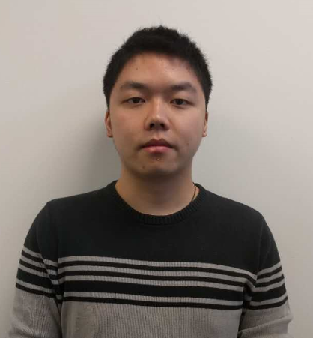

Contact Number: (+01) 5732017474

E-mail: lhqz6@met.edu

**Education Background**

**Xihua University (XHU)**   **09/2011-07/2015**

Degree: Bachelor of Engineering

Major: Mechanical and Electronic Engineering

**Missouri University of Science and Technology (MST)**

**08/2015-Current**

Degree: Master of Science

Major: Mechanical Engineering

**Project Experiences**

**Cyber-Physical:**

Machine Virtualization for Cloud Manufacturing 11/2015 - current

Description: This project is dedicated to developing a method of virtualization of manufacturing machines, which makes the manufacturing resources to corporate easily with cyber-physical manufacturing systems in cyberspace.

**Mechatronics:**

Electrostatic Precipitation Blackboard Suite Based on Chain Drive 05/2014

Description:Took machinery as carrier, employed triple-drive system, used buttons to send information to AVR328p single chip microcomputer, utilized electrical machine to drive the chain so as to realize the shift of the front and back blackboard, and conducted erasing and electrostatic precipitation in the process of transposition

Intelligent Curtain 10/2013

Description:Took advantage of photosensitive sensor to sense the outdoor illumination intensity so as to realize the automatic judgment of whether the curtain should be closed to ensure proper illumination intensity indoor

Electronic Lamp of Automobile Based on Single Chip Micyoco (SCM) (Patented) 10/2012 -05/2013

Description:Gathered optical signals with sensors, used the signals as signal source, judged whether there was a car on the opposite by using single chip computer, automatically changed the high beam to the low beam if there was a car on the opposite

**Electronic:**

Barcode Scanning System Based on SCM 10/2012 - 03/2013

Description:Scanned the barcodes representing phone numbers, transmitted the phone numbers to the SCM by serial port, and then send messages to the phone numbers through connected GSM module

Automatic Defogger System of Automobile with RBF Neural Network (Patented) 12/2011 - 09/2012

Description:Detected the air humidity and temperature difference inside or outside an automobile, calculated functions to decide whether the car’s windshields is going to generate dew or not, and finally executed the demisting or standby.

**Mechanical Design:**

Carbon-free Car 09/2012 - 01/2013

Description:Aimed tocreate a car that doesn’t rely on any electromechanical device like circuit control or electrical machine, etc., but goes forward only by the driving force of heavy items and uses a conversion of mechanical structures to operate the car turning on the road, and finally marks an S-curve

**Extracurricular Activities**

**Robot Soccer Association**  **President**  **09/2013 - 05/2014**

* Arranged daily work, organized various activities, developed and expanded the association

**4th Intelligent Vehicle Contest of Robot Soccer Association President**  **05/2013**

* Schemed and carried out the weekly technical training for the contestants, involving the circuit explanation of hunting cars and the algorithm analysis, etc.; communicated with the school the Student Union; coordinated weekly activity space, appropriation application, etc.

**Research Assistant 11/2015 - current**

* The research is mainly focused on developing a method of virtualization of manufacturing machines, which makes the manufacturing resources to corporate easily with cyber-physical manufacturing systems in cyberspace.

**Honors & Awards**

* Third Prize of Information Technology Application Training (ITAT) (Provincial Level) **10/2013**
* Sichuan Undergraduate Association Exchange Conference 100 Best Associations Awarded for Robot Soccer Association with me as the President (Provincial Level) **03/2013**
* Second Prize of National Undergraduate Engineering Training Competition (Provincial Level)

**01/2013**

* Second Prize of “Meixin” Chinese Undergraduate Internet of Things Innovation & Entrepreneurship Competition, Chinese International NEMS Society (Provincial Level) **09/2012**
* Merit Student (School and Hospital levels) & Award for Excellent Performance in a Certain Subject

**Others**

* Proficient in C language programming of SCM, programming of CNC milling machine and machining center, numerical control lathe, modeling and simulation of PRO/E, NX, Ansys, Comsol etc. software
* Skilled at C++, Python, XML, HTML programming
* Good at dealing with issues such as mechanical and electronic control problem, Mechanical system design