Project Delivery Templates — Workflow Guide
Reusable templates for any software project that follows this delivery workflow. Copy the set into a new project folder, replace every [placeholder], and delete the guidance notes (lines starting with Guidance:) before sharing.

The workflow
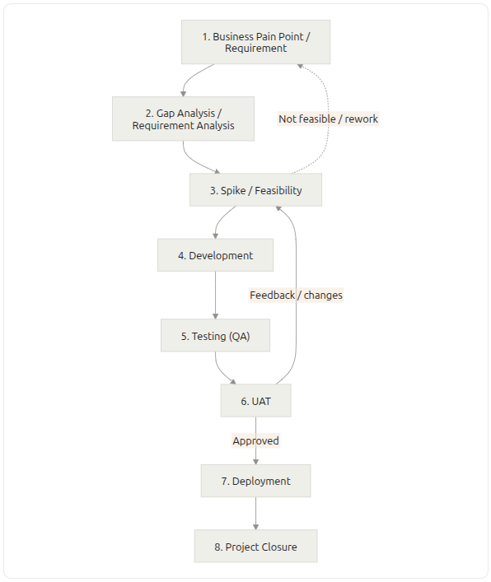
Step | Name | Template | Moves on when
1 | Business pain point / requirement | 01-BRD-Template | BRD approved by the product owner
2 | Gap analysis / requirement analysis | 02-Gap-Analysis-Template | Every requirement has a feasibility rating and an action
3 | Spike / feasibility | 03-Spike-Feasibility-Template | Go / no-go rules say Go
3 → 1 | Not feasible / rework | 03a-Rework-Plan-Template | BRD updated, spike re-run, or project stopped
4 | Development | 04-Development-Plan-Template | Handoff checklist to QA complete
5 | Testing (QA) | 05-Test-Plan-QA-Template | QA exit criteria met
6 | UAT | 06-UAT-Plan-Template | Users accept the release candidate
6 → 3 | Feedback / changes | 06a-Feedback-Change-Management-Template | Each change request routed, done and verified
6 → 7 | Approved | 06b-Release-Approval-Template | Approval record signed
7 | Deployment | 07-Deployment-Plan-Template | Deployment record signed
8 | Project closure | 08-Project-Closure-Template | Closure record signed

Loops in the workflow
- Not feasible / rework (3 → 1): the spike shows an approach cannot meet a requirement. Change the BRD (scope, priority, target) and run the spike again, or stop the project.
- Feedback / changes (6 → 3): UAT finds something that needs a new technical approach. Raise a change request; it goes back to the spike for that component only, then through development, QA and a UAT re-check.

How to use the templates
- One document per step. Keep the step number in the file name so the set stays in order.
- Requirement IDs everywhere. Number requirements in the BRD (BR-01, NFR-01) and use those IDs in every later document, so each test, change and decision traces back to a requirement.
- Version every document. Each template ends with a change log. Minor updates add 0.1 (1.0 → 1.1); a scope change adds 1.0.
- Update in flow order. When something changes, update the BRD first, then each later document it affects.
- Delete what does not apply. A small project can merge steps 2 and 3, or skip the early-access stage in deployment. Note any skipped section with one line saying why.

Document control (use at the top of every template)
Field | Entry
Project | [Project name]
Document | [Document name]
Version | [1.0]
Date | [YYYY-MM-DD]
Author | [Name]
Approver | [Name, role]
Status | Draft / In review / Approved

Placeholder conventions
Placeholder | Meaning
[Project name] | Replace with your text
[BR-xx] | A requirement ID from the BRD
[YYYY-MM-DD] | A date
[n] | A number or target value
Guidance: | Instruction for the author; delete before sharing

