PROJECT WALKTHROUGH · BANYAN M&A SCREENING

How the Banyan screen was built, and why it looks the way it does
A guided tour of the thinking behind the pipeline: which sources were trusted, how the data was pulled without a single paid database, which agents, skills and hooks did the work, and how every number was checked before it reached a deliverable.
Companies discovered | Curated & scored | Deep dossiers | Triangulated universe | Multi-agent workflows | Unit tests | Paid data sources
333 | 250 | 25 | 602 | 4 | 53 | 0

Four constraints that shaped every decision
- Public web + registries only. No PitchBook, Crunchbase or Grata. Every fact traces to a company site, a filed government record, or a cited search result.
- Uncertainty must be visible. Private-company financials are mostly unknowable from outside. The design carries a confidence on every signal and discounts scores instead of guessing.
- Discovery-first. There was no seed list. The system had to find the universe before it could rank it.
- Four audiences, four entitlements. Sales, Finance, Data Science and Leadership each see a different slice. Access control is part of the output, not an afterthought.

STAGE 1 · FRAME

Turn the thesis into a rubric before touching any data
Banyan's buy criteria are public and specific. Writing them down as weighted, gated criteria first meant every later step had a fixed target to score against — and the LLM never got to decide what "good" means.
The work opened with the superpowers:brainstorming skill (scope the pipeline and the IAM model with the user, one question at a time) and superpowers:writing-plans (a task-by-task plan for the scoring core). The rubric became config/banyan.yaml: seven criteria with weights derived from banyansoftware.com's stated FAQ, two hard gates, a confidence floor and tier thresholds. A second, contrasting rubric (config/growth.yaml) exists purely to catch companies that look impressive but are the wrong shape — VC-backed, scaling, unprofitable.
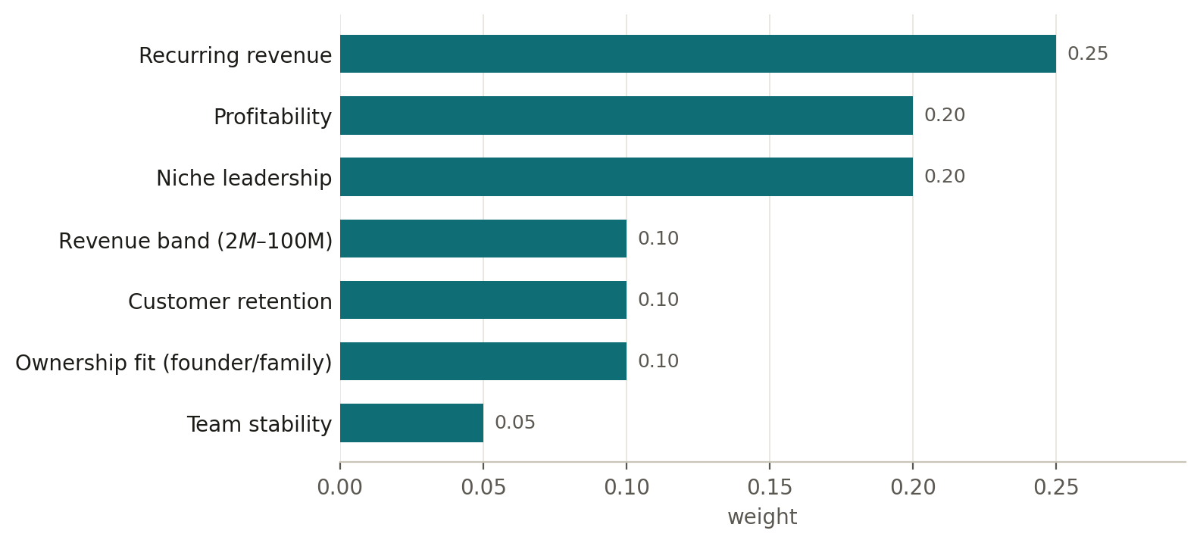
Figure 1 — The Banyan rubric as weights. Gates apply before the tier: loss evidence → rejected; revenue under $2M → capped at tier C.

STAGE 2 · SOURCES

Three independent ways of finding companies
One discovery method has blind spots. Three methods that do not share a source can be cross-checked against each other — that is where "founder-owned" claims get verified rather than believed.
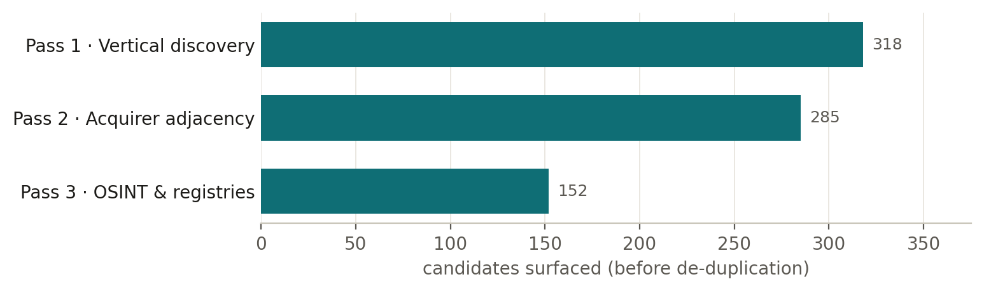
Figure 2 — Candidates per discovery pass. The union across all three is 602 companies.
- Pass 1 searched the public web vertical by vertical — 12 batches: construction, healthcare practice management, K-12 systems, manufacturing ERP and so on.
- Pass 2 asked a different question: what do Constellation, Valsoft and Everfield already own, and who are the peers of those companies? 10 angles.
- Pass 3 avoided search engines altogether and went to primary records — registries, filed accounts, GitHub, hiring pages, product directories.
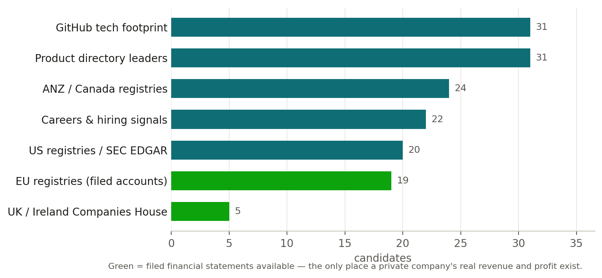
Figure 3 — Inside pass 3: the 7 OSINT angles. Pass 3 also ran 34 ownership verifications against registers, which caught 11 companies described as "founder-owned" on their own websites that are actually PE- or VC-controlled.

What was deliberately not used
Tool | Role | Status
PitchBook · Crunchbase · Grata | Paid private-company databases | Excluded by design
perplexity-research | Attempted as a discovery engine | Failed — no API key
firecrawl-scrape | Attempted as a scraping engine | Failed — CLI not authenticated
WebSearch (built-in) | Blocked in the sandboxed environment | Failed — unavailable

STAGE 3 · MECHANISM

How the data was actually pulled
The engine is the OpenAI Codex CLI with web search turned on, driven by Claude Code's multi-agent Workflow tool. Every research call returns cited findings that a second agent turns into structured JSON under a schema — so the raw research is kept as an audit trail and the structured record can be checked against it later.
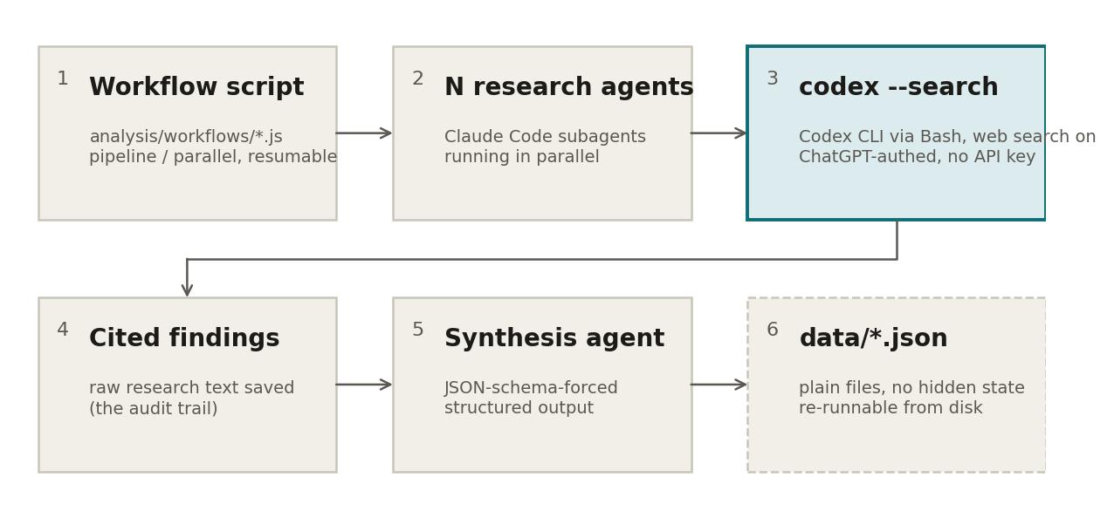
Figure 4 — One research workflow, end to end. The same shape ran for every research stage with different prompts and fan-out sizes.
The ai-hub-web-search:codex-websearch skill supplied the pattern (dispatch search from a subagent, sanitise the query, cite sources). Its shipped script was bypassed — it hard-coded invalid model ids and a blocked /tmp path — so the CLI was called directly with corrected flags, in the foreground with the sandbox disabled. workflow-authoring was loaded before every workflow was written.

The workflows
Workflow | Fan-out | Question it answered | Output
vertical discovery (12 batches) | 12 batches | Which vertical software companies exist in each niche, with per-criterion signals and confidence? | data/records/*.json (333)
independent_discovery_wf.js | 10 angles | Who do the permanent-hold consolidators already own, and who are their peers? | independent_results.json (285)
osint_discovery_wf.js | 7 angles + verify | What do registries, filed accounts, GitHub and hiring data say — and is "founder-owned" true? | osint_results.json (152 + 34 checks)
market_synthesis_wf.js | 29 agents | What does each of the 14 macro-segments look like as a hunting ground? | market_synthesis.json
banyan25_dossiers_wf.js | 50 agents | For each top-25 target: business model, ownership, moat, risks, sources — and a thesis-appropriate outreach email. | raw_dossiers_banyan.json

STAGE 4 · SCORE

A deterministic core the LLM cannot touch
The research agents propose signals with confidence; a hand-written, unit-tested Python package (banyan_screen/) turns them into scores and tiers. No model call happens inside the scoring — so the same record always produces the same tier, and every result carries a rationale you can audit.
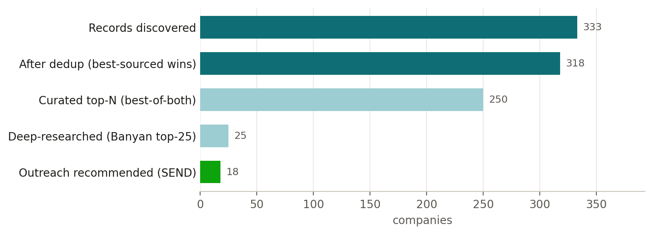
Figure 5 — From discovery to the ranked list. Each bar is a step in banyan_screen.run.
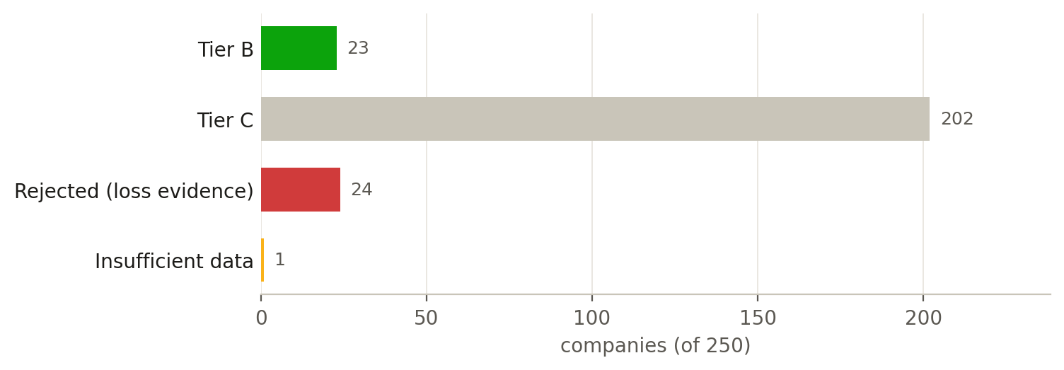
Figure 6 — Where the 250 landed under the Banyan rubric. Tier C is the expected home of a genuine private target whose books are not public — it means "verify", not "reject".
adjusted = composite × (0.5 + 0.5 × confidence) — a company nobody can verify loses at most half its composite score, never all of it.

STAGE 5 · TRIANGULATE

Cross-match the three passes
Matching by domain and normalised name, build_crossmatch.py sorts the 602-company union into what is corroborated, what is new, and where the ownership story changes.
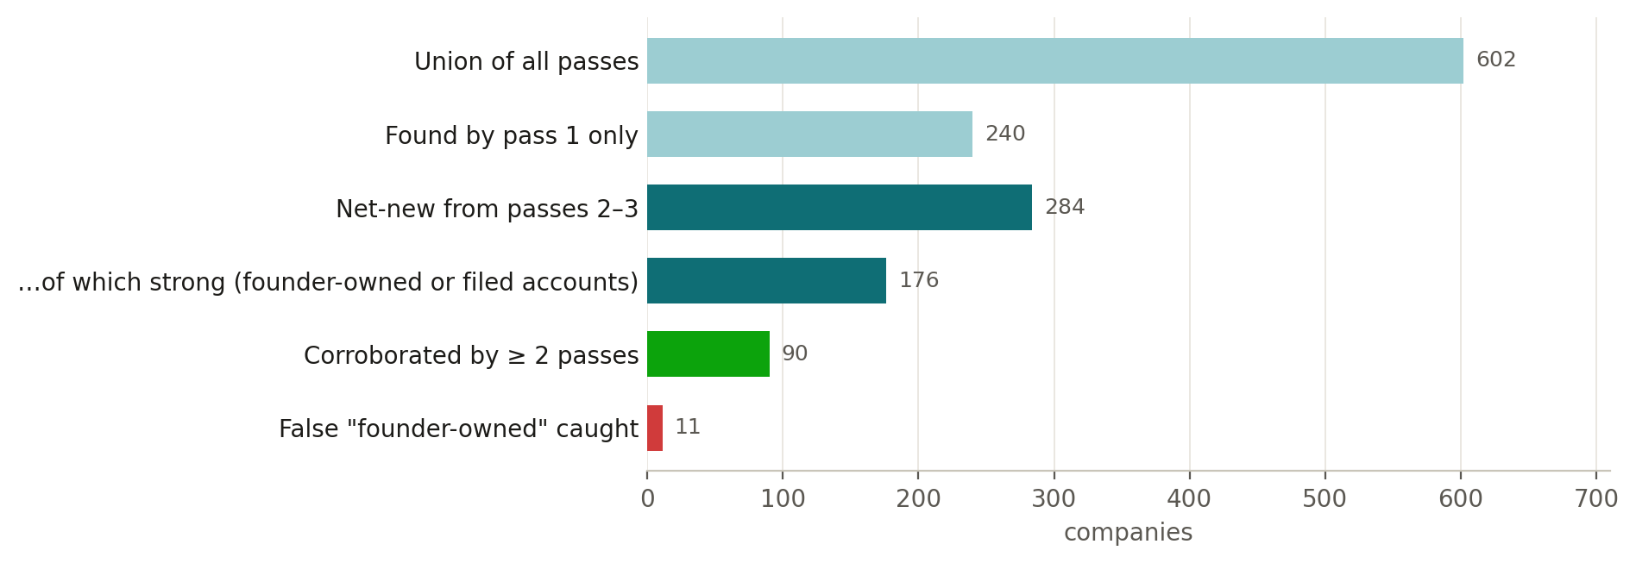
Figure 7 — Outcome of the cross-match (data/research/crossmatch.json).
The 176 strong net-new names (Bromcom, CDL Group, Open Dental, Planning Center, GIRO, Maptek and the EU registry names among them) are the highest-value unfinished work: they have not yet been scored through the rubric.

STAGE 6 · GATE

Decide who sees what, in code
The IAM model was designed conceptually first — 5 classification tiers, 14 roles, red-teamed from three angles — and then written as a real filter, banyan_screen/policy.py, that every artifact passes through. Deny by default: an unknown role or an unrecognised field gets nothing.
Role | Receives | Never receives
Data Science | Aggregates only | Per-record output (refused outright), contacts, financials, deal intent
Finance | Financials, identity, signals | Contacts, deal intent, outreach copy
Sales / BD | Identity, signals, contacts (masked), the outreach pitch | Financials, deal intent
Leadership | Deal intent; contacts and financials masked | Outreach copy, raw financials
Governance / platform | Nothing above Public | Business content of any tier

The companion page Layered Data Access Architecture shows the live policy per role and explains what a Claude user needs to sit behind this wall: an SSO identity and an enforcement point in front of the data — nothing inside the model.

STAGE 7 · VALIDATE

Check the work with a different model, then check the model against the sources
Two independent checks close the loop. A second-model QC judge scores the session's changes; a grounding script confirms that what the dossiers say actually appears in the raw research text.
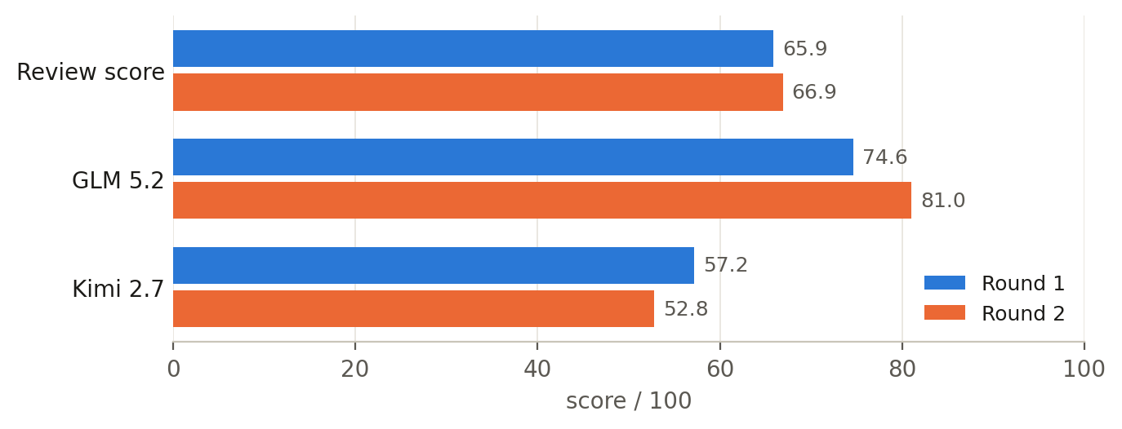
Figure 8 — Second-model QC, two rounds (validation-loop:validate; GLM 5.2 primary, Kimi 2.7 tie-breaker). Round 2 followed fixes to a cross-match bug, the ownership classifier and the runtime IAM gate. The judges disagreed by 28 points in round 2, so the composite is low-confidence — the disagreement is reported, not averaged away.
Check | Result | What it means
Grounding (analysis/validate_grounding.py) | 409 / 415 facts (98.6%) | Dossier claims trace to the raw research; the 6 unmatched were extractor false-positives, not invention
Unit tests | 53 in the suite | Scoring core, policy layer and page builders
Page re-derivation (analysis/qc_consolidated_pages.py) | 0 mismatches | Every figure on the consolidated pages recomputed from data/ and policy.py
Cross-pass name check | 1 discrepancy caught | A founder's name (QT9) was wrong in the OSINT pass — never trust a single-pass ownership name

STAGE 8 · TOOLING

The skills, agents, hooks and tools behind it
Everything below is from docs/TOOLING_LOG.md and the consolidation session. Status is honest: some things were used, some supplied only a pattern, some failed, and some were available but never called.

Skills (invoked through Claude Code's Skill tool)
Skill | Purpose | Status
superpowers:brainstorming | Scoped the pipeline and the IAM model before any code | used
superpowers:writing-plans | Task-by-task plan for the scoring core | used
workflow-authoring | Reference for every multi-agent Workflow script (~10 loads) | used
ai-hub-web-search:codex-websearch | The research-dispatch pattern; its script was bypassed | pattern only
banyan-sales-pitch | The project's own skill: thesis-branched, IAM-gated outreach | built here
validation-loop:validate | Second-model QC, two rounds (plus one in the consolidation session) | used
handoff | Produced docs/HANDOFF.md | used
artifact-design · dataviz | Design and chart rules for the consolidated pages | this session

Agents and orchestration
Component | Role | Status
Workflow tool | ~10 runs: pipeline/parallel fan-out with cached resume | used
Agent (general-purpose) | Subagents executing the codex search pattern | used
validation-loop:qc-reviewer | Independent second-model review of the consolidated pages | this session
codex CLI (gpt-5.6-sol, --search) | The discovery engine — an external CLI, not a Claude tool | load-bearing

Hooks (automation that fired without being asked)
Hook | Role | Status
Stop-hook goal | Nudged for visible build progress when the session goal was unmet | fired
PostToolUse marker (validation-loop) | Tracks changed files so /validate reviews only this session's work | silent
ai-qc-guardrails auto-review | Workspace-wide automatic Stop-hook QC; manual /validate used instead | available, unused

Built-in tools and MCP
Tool | Role | Status
Bash | Every codex call, pytest, file operations — sandbox off where network was needed | used
Read · Write · Edit | All source, config and docs | used
AskUserQuestion | Scope decisions at each fork: sources, depth, rubric choice | used
MCP servers (original build) | None — zero mcp__ calls; all external access via the codex CLI | none
playwright · context-mode MCP | Screenshots for layout review; large-output analysis kept out of context | this session
Artifact tool | Publishing the hub, the access page and the walkthrough | this session

STAGE 9 · LESSONS

What the build taught us
The decisions that mattered most were not technical — they were about which question to ask and how much to trust an answer.
- The rubric decides the outreach list. Ranked best-of-both, the top-25 produced 2 SEND recommendations — dominated by VC-backed AI infrastructure. Ranked by the Banyan rubric alone, the same pipeline produced 18. The scoring lens is the product.
- Tier C is not a bad grade. Genuine private targets land at C by construction: their financials cannot be verified from outside, so confidence is low and the score is discounted. Low verified density in a segment is a verification artifact, not absence of fit.
- "Privately held" is not "founder-owned". Eleven companies said one thing on their websites and another in the registers. Ownership must be checked against a second source before anyone sends an email.
- Keep the raw research. Because every dossier's source text was saved, a script could later prove 98.6% of dossier facts were grounded — and show the 6 flags were the extractor's fault, not invention.
- Record the failures. Perplexity and Firecrawl failed on authentication and were abandoned for codex. The pivot is in the tooling log so the next person does not repeat it.
- Separate judgment from arithmetic. The LLM proposes signals with confidence; deterministic code computes the tier. That split is what makes every score reproducible and every rationale auditable.

Where everything lives
Path | What it is
banyan_screen/ | The deterministic core — models, rubric engine, ingest, run CLI, and policy.py (IAM). 53 tests in tests/.
config/banyan.yaml · config/growth.yaml | The two rubrics: weights, gates, thresholds.
data/records/ | 333 discovered company records from the 12 vertical batches.
data/screen/ | The scored, curated top-250 (results.json, ranked.csv).
data/research/ | Passes 2–3, cross-match, dossiers, market synthesis, grounding results, and the verbatim codex research audit trail.
analysis/ | Reporting scripts and the four multi-agent workflow scripts; templates/ for the consolidated pages.
outcome/ | The consolidated deliverables: intelligence hub, access architecture, this walkthrough (HTML + Word).
reports/ | Earlier self-contained HTML dashboards (screen, market synthesis, dossiers, cross-match, IAM model).
skills/banyan-sales-pitch/ | The reusable outreach skill (rules, templates, playbook).
docs/ | HLD, LLD, tooling log, session handoff, this document, and the original design spec and plan.

Companion pages: Banyan Target Intelligence (the one-stop hub) and Layered Data Access Architecture. Figures in this document are taken from the repository's data files and docs as of 2026-09-14; Banyan's "120+ acquired, 0 sold" is self-reported positioning, not audited.

