Comparative Evaluation of Traditional Machine Learning and BERT for 24-Class News Article Classification
Shreyansh Jain

Abstract
This paper presents an experimental comparison of three traditional machine learning classifiers and a fine-tuned transformer for multi-class news article classification using the N24News dataset. The task contains 24 topical categories. Multinomial Naive Bayes, Logistic Regression, and Linear Support Vector Machine (Linear SVM) use TF-IDF representations constructed from concatenated headlines and article text. The transformer approach fine-tunes bert-base-uncased using a maximum sequence length of 384 tokens. The notebook records 48,984 training examples after duplicate removal, 6,123 validation examples, and 6,124 test examples. On the held-out test set, Linear SVM obtains the highest accuracy (87.12%), weighted F1 (86.88%), and macro F1 (86.00%). BERT is a close second with 86.81% accuracy and 85.25% macro F1. Logistic Regression reaches 85.99% accuracy, while Naive Bayes obtains 82.02%. The results show that a TF-IDF-based linear classifier can remain competitive with a fine-tuned transformer on this dataset. The report describes the data preparation, model configurations, evaluation metrics, comparative results, implementation workflow, and limitations of the experiment.

1. Introduction
News platforms publish large volumes of articles across topics such as technology, sports, business, health, entertainment, and travel. Organizing these articles into topical categories helps readers navigate content and supports search, recommendation, and content-management systems. Manual categorization can become expensive and inconsistent as the volume of published material grows. Automatic text classification offers a way to assign a category to an article based on its language and content.
This project investigates supervised multi-class news classification using the N24News dataset. Each input consists of a headline and the corresponding article body, and the output is one of 24 predefined sections. The experiment compares three conventional machine learning classifiers—Multinomial Naive Bayes, Logistic Regression, and Linear SVM—with a fine-tuned BERT model. The traditional models operate on sparse TF-IDF features, while BERT processes token sequences and learns contextual representations.

The central research question is whether a fine-tuned transformer provides a measurable improvement over well-established TF-IDF classifiers for this dataset. Rather than assuming that a more complex architecture must perform better, the experiment evaluates all models using a common held-out test set and multiple classification metrics.

  - Objectives
The objectives are to prepare a reproducible 24-class dataset split; build three TF-IDF- based baselines; fine-tune BERT for the same label set; compare accuracy, weighted precision, weighted recall, weighted F1, and macro F1; and provide an inference interface that displays the four model predictions for a user-supplied headline and article.

Background and Related Work
Text categorization assigns documents to one or more predefined classes using features extracted from text. Traditional supervised approaches commonly represent a document as a vector of term weights and learn a decision rule from labelled examples. Although this representation does not explicitly model word order over long spans, it can be effective when category-specific vocabulary and phrases are informative.

TF-IDF representations
Term frequency–inverse document frequency (TF-IDF) weights a term according to its importance in a document relative to its occurrence across a collection. Terms that appear frequently in one document but are less common across the corpus receive higher weights than terms that occur almost everywhere. The representation can be extended with n-grams so that short word sequences, not only individual words, become features. In this project, unigram and bigram features are retained.
The TF-IDF matrix is sparse: each document activates only a small fraction of the vocabulary. This makes linear classifiers practical for high-dimensional text data. The vectorizer is fitted only on the training text; validation and test examples are transformed using the already learned vocabulary and inverse-document frequencies. This avoids allowing held-out text to influence feature construction.

Traditional classifiers
Multinomial Naive Bayes is a probabilistic classifier that applies Bayes' rule with a conditional-independence assumption between features given the class. It is widely used for text categorization because word occurrence statistics often provide useful evidence for document topics. Its simplifying assumptions make it efficient, though correlated words and complex decision boundaries can limit its performance.
Logistic Regression is a discriminative linear classifier. In a multi-class setting, it estimates class probabilities from a weighted combination of input features. The learned coefficients indicate how strongly individual terms contribute to each class score. Regularization controls model complexity and can reduce overfitting in high-dimensional feature spaces.
A Linear SVM learns separating hyperplanes with the objective of maximizing the margin between classes. In multi-class classification, the implementation combines binary decision functions. Linear SVMs are particularly suitable for sparse, high-dimensional text vectors and are a strong baseline in document classification.

Transformer-based language models
BERT (Bidirectional Encoder Representations from Transformers) uses transformer encoder layers to build contextual representations. Unlike a bag-of-words representation, a contextual model can represent a token in relation to surrounding tokens. The pretrained encoder is adapted to a downstream classification task by adding a classification layer and fine-tuning model parameters using labelled examples [1].
The present work uses bert-base-uncased. The model receives tokenized headline-plus-article text and produces logits over the 24 categories. The predicted category is the class with the highest output logit. This provides a common prediction interface for comparison with the traditional classifiers.

Dataset Description
The notebook loads three JSON files: nytimes_train.json, nytimes_dev.json, and nytimes_test.json. The records include fields such as section, headline, article URL, article text, abstract, article identifier, image, caption, and image identifier. The target variable is the section field. The input text is formed by concatenating the headline and article body with a space separator.

Dataset split and cleaning checks
The initial training split contains 48,988 records, the validation split contains 6,123 records, and the test split contains 6,124 records. A duplicate check based on the pair (headline, article) identifies four duplicate training records and no duplicates in validation or test. The four training duplicates are removed, leaving 48,984 training examples. The split-overlap check reports zero shared article identifiers between training and validation, training and test, and validation and test.
Split | Examples | Role
Training | 48,984 | Fit vectorizer and train models
Validation | 6,123 | Compare/monitor model performance
Test | 6,124 | Final held-out evaluation
Total | 61,231 | After training duplicate removal
Table 1: Dataset sizes used in the project after duplicate removal from training.

Category distribution
The training data contain 24 categories, but their frequencies are not uniform. Opinion has 2,437 examples and Art & Design has 2,431, while the smallest categories are Well (529) and Education (672). Global Business has 955 examples and Your Money has 1,020. This variation motivates reporting macro F1 in addition to weighted metrics: macro F1 gives each category equal importance, whereas weighted metrics are influenced more strongly by categories with more examples.
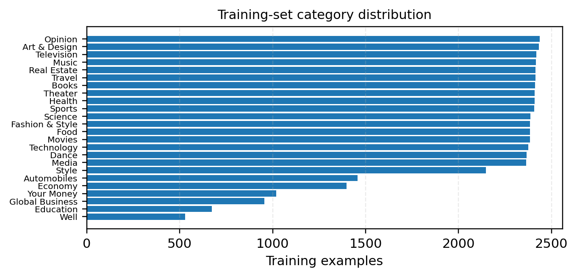
Figure 1: Number of training examples in each N24News category.

Data quality observations
The notebook's missing-value check reports zero missing values in the inspected source columns. It also displays example headlines and article bodies for manual inspection. Duplicate checks are carried out separately for each split, followed by an article-identifier overlap check. These checks reduce the risk that identical records or shared article identifiers occur across the partitions. They do not, by themselves, prove that all semantically similar or near-duplicate articles have been removed.
The dataset is therefore suitable for the project's supervised classification experiment, while its uneven category counts should be kept in mind when interpreting aggregate scores.

Text Preprocessing and Feature Extraction

Combining headline and article
For every record, the project creates a text field by concatenating the headline and article body. This allows the classifiers to use both the short topical signal in the headline and the additional context available in the article. The concatenated string is used by both the traditional models and BERT, although the two model families process it differently.

Cleaning for traditional models
A cleaning function converts text to lowercase, replaces characters other than lowercase English letters and whitespace with spaces, collapses repeated whitespace, and strips leading and trailing spaces. The same function is applied to training, validation, and test text. This produces the clean_text field used by the TF-IDF vectorizer.
The cleaning operation is intentionally simple. It reduces variation caused by capitalization and punctuation and produces a consistent input format. At the same time, removing non-alphabetic characters can discard information such as numbers, symbols, abbreviations, and punctuation patterns. This is a design trade-off of the implemented preprocessing pipeline.

TF-IDF configuration
The project uses scikit-learn's TfidfVectorizer with max_features=20,000, English stop-word removal, ngram_range=(1, 2), min_df=2, and max_df=0.95. The maximum vocabulary size limits the feature space to 20,000 terms. Unigrams represent individual tokens and bigrams represent adjacent two-token sequences. The min_df threshold removes terms occurring in fewer than two documents, while max_df removes terms appearing in more than 95% of documents.
The vectorizer is fitted on the cleaned training text and then applied to validation and test sets through transform. The resulting matrices have 20,000 columns: 48,984 rows for training, 6,123 for validation, and 6,124 for test. Keeping the feature extraction fitted on training data is important for a fair evaluation because held-out data must not influence the vocabulary or feature weights.

BERT input preparation
BERT uses the original concatenated text rather than the alphabet-only clean_text representation. The BertTokenizer associated with bert-base-uncased converts text into token IDs and attention masks. The notebook applies truncation and fixed-length padding to a maximum of 384 tokens. Text longer than this limit is truncated, while shorter sequences are padded. Consequently, the BERT input may not contain every word in a long article; this is an explicit constraint of the selected sequence length.
A LabelEncoder maps the 24 section names to integer class IDs for BERT training. The same encoder is used to transform the labels in all data splits and to map predicted IDs back to category names during inference.

Traditional Machine Learning Models

Multinomial Naive Bayes
Multinomial Naive Bayes estimates the probability of a class given a document's feature vector. For a class c and feature vector x, the decision is based on the prior probability of c and the likelihood of the observed feature values under that class. The conditional-independence assumption treats features as independent once the class is known. In text applications, this assumption is rarely exact, but word-frequency patterns can still provide useful class evidence.
The notebook initializes MultinomialNB with its library defaults and fits it on the TF-IDF training matrix and section labels. Validation predictions are then generated and evaluated. The model is computationally lightweight and provides a useful probabilistic baseline against which the stronger linear classifiers can be compared.

Logistic Regression
The Logistic Regression model is configured with max_iter=1000, C=1.0, and random_state=42. It is fitted on the same TF-IDF matrix used by Naive Bayes. The parameter C controls the inverse strength of regularization: smaller values impose stronger regularization, while larger values permit a less constrained fit. The maximum iteration setting gives the solver additional iterations to converge.
Because the task has 24 classes, the estimator performs multi-class classification and returns one of the known section labels. The use of the same input matrix and data split makes the comparison with Naive Bayes and Linear SVM more direct.

Linear Support Vector Machine
The Linear SVM is implemented with LinearSVC using C=1.0, random_state=42, and max_iter=2000. LinearSVC learns linear decision functions over the TF-IDF features. The margin-based objective is well suited to sparse text representations, where many features may be present but only a subset are informative for a particular class.
The validation results show that Linear SVM is the strongest of the three traditional models. Its performance is also the strongest on the final test set. This finding is specific to the current dataset, preprocessing choices, and hyperparameters; it should not be interpreted as a universal ranking of classifiers.

Common training and evaluation protocol
All three traditional classifiers use the same training TF-IDF matrix and the same target labels. The validation split is used to inspect performance during model development. Final test predictions are generated from the saved models and the saved TF-IDF vectorizer, ensuring that the feature mapping used at evaluation is the one learned during training.

BERT Fine-tuning Methodology

Model and classification head
The transformer model is initialized from bert-base-uncased with num_labels=24. The pretrained BERT encoder supplies contextual token representations, and the sequence-classification head maps the representation of the input sequence to 24 class logits. The label IDs are generated by fitting a LabelEncoder on the training section labels and applying the same mapping to validation and test labels.

Tokenization and batching
The tokenizer uses padding='max_length', truncation=True, and max_length=384. The tokenized datasets retain input_ids, attention_mask, token_type_ids, and labels as tensors. The attention mask distinguishes actual tokens from padding. The per-device training batch size is 8 and the per-device evaluation batch size is 16. Gradient accumulation is set to 2, so two training mini-batches contribute to an optimizer update; this increases the effective batch size without requiring all examples to fit in GPU memory at once.

Optimization configuration
The notebook configures three training epochs, a learning rate of 1e-5, weight decay of 0.01, and a linear learning-rate scheduler. Warmup is set to 918 steps, corresponding to approximately 10% of the configured total 9,186 training steps. Gradient clipping uses max_grad_norm=1.0. Mixed-precision training is enabled with fp16=True, and the random seed is 42.
Setting | Configured value
Pretrained model | bert-base-uncased
Number of labels | 24
Maximum sequence length | 384 tokens
Epochs | 3
Train / eval batch size | 8 / 16
Gradient accumulation | 2
Learning rate | 1 × 10⁻⁵
Weight decay | 0.01
Warmup steps | 918
Precision / seed | FP16 / 42
Table 2: BERT fine-tuning configuration recorded in the notebook.

Validation and checkpoint selection
Evaluation and checkpoint saving are configured at the end of each epoch. The Trainer is instructed to load the best model at the end of training and to select it according to weighted F1, with larger values preferred. Only one checkpoint is retained by the configured save_total_limit. The reported validation result is obtained by evaluating the selected model after training.
The notebook reports BERT validation accuracy of 87.13%, weighted precision of 87.14%, weighted recall of 87.13%, weighted F1 of 87.10%, and macro F1 of 85.29%. The final test metrics are reported separately in Section 8.

Experimental Setup and Evaluation

Runtime environment
The notebook records PyTorch 2.11.0+cu130, CUDA availability, and an NVIDIA Tesla T4 GPU with approximately 15 GB of reported memory. The BERT implementation uses the Hugging Face Transformers library and Trainer interface, together with the Datasets library. The traditional classifiers and TF-IDF vectorizer are implemented using scikit-learn.

Evaluation metrics
Accuracy is the fraction of all examples for which the predicted category equals the true category. It is intuitive, but it can be dominated by frequent categories when class counts are uneven. Precision measures the fraction of predictions assigned to a category that are correct. Recall measures the fraction of the true examples of a category that the model successfully identifies. The F1-score is the harmonic mean of precision and recall.
Weighted precision, weighted recall, and weighted F1 aggregate category-level values using each category's support (number of true examples) as its weight. Macro F1 computes the F1-score independently for each category and takes the unweighted mean. Macro F1 therefore gives a small category the same contribution as a large category. In this project, both weighted F1 and macro F1 are reported to show overall performance and average category-level performance.
For a class c, precision is TP_c/(TP_c+FP_c), recall is TP_c/(TP_c+FN_c), and F1 is 2 × precision_c × recall_c/(precision_c+recall_c). Accuracy is the number of correct predictions divided by the total number of evaluated examples. The implementation uses zero_division=0 when computing precision, recall, and F1 to handle cases in which a class receives no predicted examples.

Validation versus test evaluation
The validation split is used during model development and BERT checkpoint selection. The test split is held out for final comparison. The final evaluation code loads the saved Naive Bayes, Logistic Regression, and Linear SVM estimators, the saved TF-IDF vectorizer, the saved BERT model and tokenizer, and the saved test CSV. It produces predictions for all four models and computes the same five metrics against the test labels.
The test set contains 6,124 records. The reported results in this paper are taken from the completed evaluation output supplied for this project. The test set should not be repeatedly used to tune hyperparameters; any further tuning should be conducted with training and validation data.

Reproducibility artifacts
The project export folder contains traditional model joblib files, the TF-IDF vectorizer, label encoders, BERT model configuration and weights, tokenizer files, training checkpoints, CSV files for the three data splits, and result metadata. The final test comparison is also saved as final_test_comparison.csv. These artifacts support loading the trained models for inference without repeating the complete training process.

Results
Table 3 summarizes the final test-set performance. All metrics are percentages. Linear SVM obtains the highest value for each of the five reported measures. BERT ranks second on every metric, while Logistic Regression ranks third and Naive Bayes fourth.
Model | Accuracy | W. Prec. | W. Recall | W. F1 | Macro F1
Naive Bayes | 82.02 | 81.09 | 82.02 | 81.17 | 78.26
Logistic Reg. | 85.99 | 85.96 | 85.99 | 85.81 | 84.68
Linear SVM | 87.12 | 86.89 | 87.12 | 86.88 | 86.00
BERT | 86.81 | 86.72 | 86.81 | 86.71 | 85.25
Table 3: Final test-set comparison across all four models (percentage).
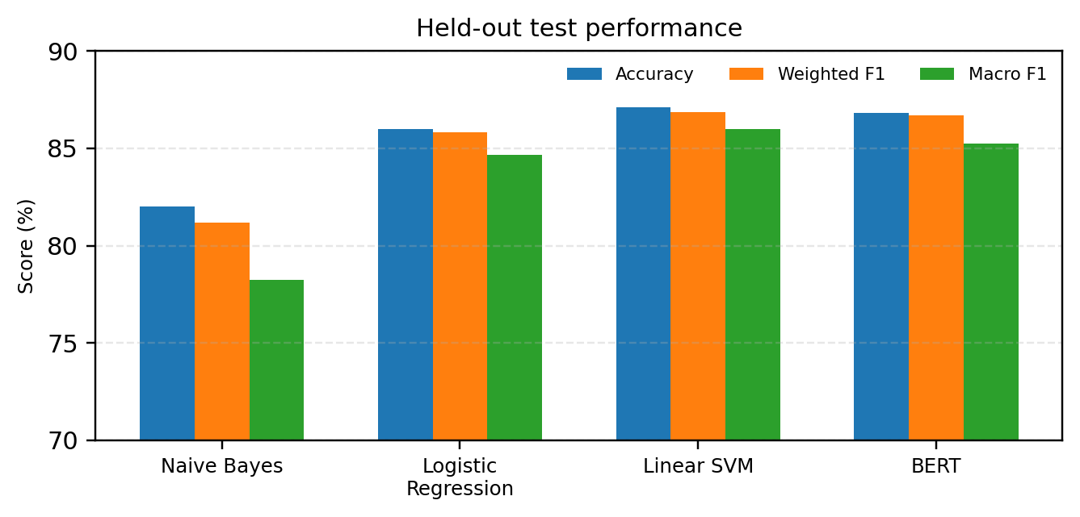
Figure 2: Accuracy, weighted F1, and macro F1 on the held-out test set.

Validation accuracy context
Model | Validation accuracy
Naive Bayes | 82.33%
Logistic Regression | 86.72%
Linear SVM | 87.93%
BERT | 87.13%
Table 4: Validation accuracy recorded during model development.
Validation accuracy and test accuracy serve different purposes and should not be interchanged. Linear SVM records 87.93% validation accuracy and 87.12% test accuracy. Logistic Regression records 86.72% on validation and 85.99% on test. Naive Bayes records 82.33% on validation and 82.02% on test. BERT records 87.13% validation accuracy and 86.81% test accuracy. The small differences between validation and test scores indicate that the final test results are broadly consistent with the validation observations.

Metric interpretation
The weighted metrics are close to accuracy for all four models, which is common when a model's aggregate precision and recall are calculated over the same multi-class dataset. Macro F1 is lower than weighted F1 for every model. The gap is largest for Naive Bayes (2.91 percentage points) and smaller for Logistic Regression (1.13 points), Linear SVM (0.88 points), and BERT (1.46 points). These gaps suggest that category-level performance is less uniform than the weighted scores alone might imply.

Comparative Analysis

Naive Bayes versus Logistic Regression
Logistic Regression improves test accuracy over Naive Bayes from 82.02% to 85.99%, a gain of 3.97 percentage points. Its weighted F1 rises from 81.17% to 85.81%, and macro F1 rises from 78.26% to 84.68%, a gain of 6.42 percentage points. The larger improvement in macro F1 indicates that the gain is not limited to the more frequent categories. This result suggests that the discriminative linear decision boundary of Logistic Regression is more effective than the conditional-independence approximation of Naive Bayes for the selected feature representation.

Linear SVM versus Logistic Regression
Linear SVM improves accuracy over Logistic Regression by 1.13 percentage points and improves macro F1 by 1.32 points. Its weighted F1 is also higher by 1.07 points. Both models are linear classifiers over the same TF-IDF features, but they optimize different objectives. The observed advantage is consistent with the effectiveness of margin-based linear classifiers for sparse text classification, although the experiment does not isolate the reason for the difference.

Linear SVM versus BERT
The central comparison is between Linear SVM and BERT. Linear SVM achieves 87.12% accuracy, compared with 86.81% for BERT, a difference of 0.31 percentage points. Linear SVM also leads BERT by 0.17 points in weighted precision, 0.31 points in weighted recall, 0.17 points in weighted F1, and 0.75 points in macro F1. These are relatively small differences, particularly in accuracy and weighted F1. Without repeated runs or confidence intervals, the small gap should not be treated as evidence of a statistically significant advantage.

BERT versus Logistic Regression
BERT exceeds Logistic Regression by 0.82 percentage points in accuracy and 0.57 points in macro F1. BERT also has higher weighted precision, recall, and F1. This indicates that the fine-tuned transformer is competitive and improves on the Logistic Regression baseline in the present configuration, even though it does not surpass Linear SVM.

Overall ranking
The overall ranking by test accuracy is Linear SVM (87.12%), BERT (86.81%), Logistic Regression (85.99%), and Naive Bayes (82.02%). The same ranking holds for weighted F1 and macro F1. Thus, the selected Linear SVM is the strongest model among those evaluated, while BERT is a close alternative with contextual language representations.

Practical considerations
The traditional models use a fixed sparse feature representation and are generally simpler to load and run than a transformer. BERT has a larger model footprint and requires tokenization and neural inference. This report does not claim measured training-time or latency advantages because a controlled timing comparison was not included in the supplied evaluation output. A future experiment could record training time, inference throughput, memory use, and model size under a common hardware and batch-size protocol.

Error Analysis and Interpretation
Aggregate metrics summarize performance but do not identify which category pairs are confused. The notebook generates a BERT confusion matrix on the validation split, and its validation classification report shows variation across categories. For example, the Naive Bayes validation report records a very low F1-score for Style and zero recall for Well, while categories such as Dance and Automobiles receive much stronger scores. Logistic Regression and Linear SVM improve the overall validation scores and show stronger class-level results in the displayed reports.
The category distribution provides one possible context for these differences: Well has 529 training examples, Education has 672, Global Business has 955, and Your Money has 1,020, whereas several categories contain around 2,400 examples. Lower support can make it harder for a classifier to learn a stable decision boundary, especially when the vocabulary overlaps with other categories. However, category frequency alone cannot explain all errors; semantic overlap and the quality of the article text may also matter.

Potential sources of confusion
Some news categories are naturally related. Health and Well may share vocabulary about medicine, nutrition, and personal wellness. Fashion & Style and Style may overlap in clothing, design, and lifestyle language. Media, Television, and Movies may share names of programmes, actors, production companies, and entertainment terminology. Technology and Science may both contain technical terms. Such overlaps can make a single-label classification decision difficult when an article covers more than one subject.
These examples are plausible sources of ambiguity based on the category names and task design; they are not presented as measured top confusion pairs from the final test confusion matrix. The supplied notebook's confusion matrix is generated for BERT validation, not for the final test set, and the final test evaluation output provided here contains aggregate metrics only.

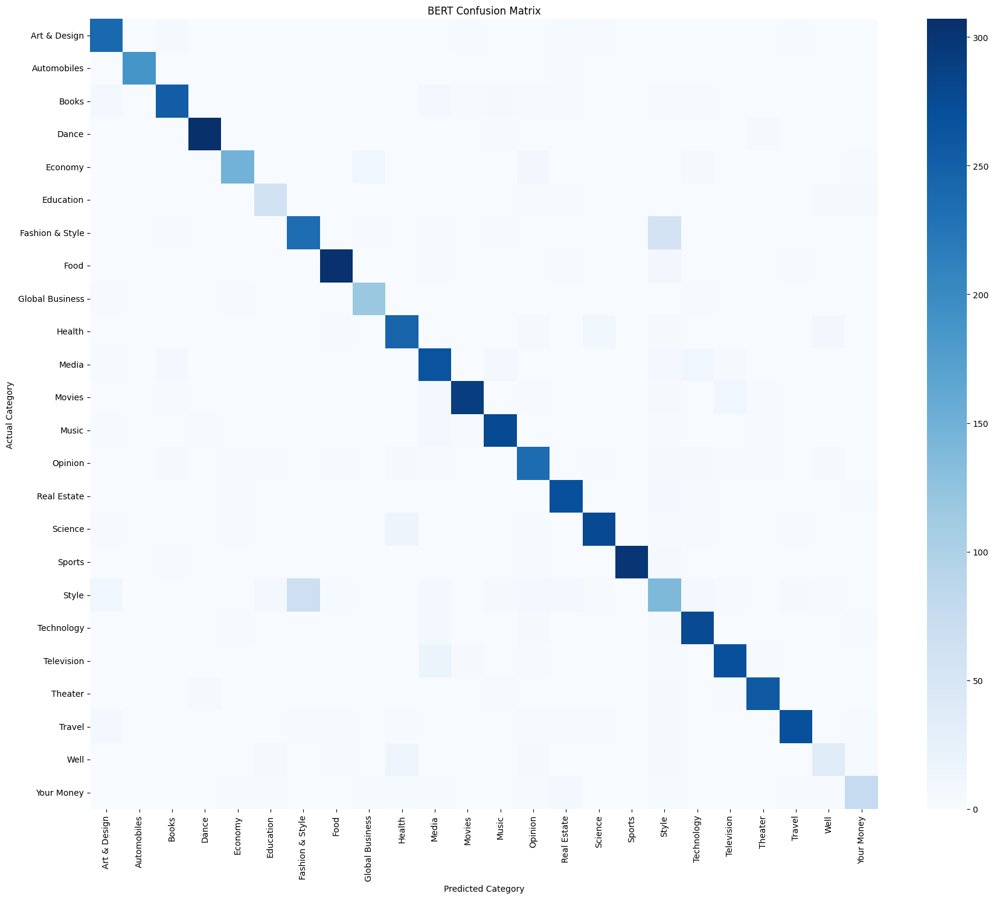
Figure 3: BERT confusion matrix on the validation set.
The confusion matrix shows that most predictions lie along the main diagonal, indicating correct classification for many examples across the 24 categories. The visible off-diagonal cells indicate category-level confusions. In particular, the Fashion & Style and Style categories show notable mutual overlap in the displayed matrix. This is consistent with the semantic similarity of these labels. The figure is used as validation-set diagnostic evidence and is not presented as a test-set confusion matrix.

Recommended detailed analysis
A useful extension is to compute a per-class classification report and confusion matrix for each model on the validation split. The analysis can identify classes with low recall, low precision, or frequent mutual confusion. For final reporting, the validation split is preferable for exploratory error analysis if it will guide further changes. If test-set per-class results are reported, they should be treated as final descriptive evaluation rather than a basis for tuning.

Human-facing interpretation
A classifier's output is a predicted topic label, not a verification of an article's truth, quality, or reliability. The model may select one category even when an article discusses multiple topics. A prediction interface should therefore present the result as an automated suggestion and, where appropriate, allow human review.

Detailed Interpretation of the BERT Confusion Matrix
The confusion matrix provides a category-level view of the BERT classifier's performance on the validation dataset. Unlike accuracy, which summarizes the proportion of correct predictions across all examples, a confusion matrix helps identify the categories that the model distinguishes successfully and those between which it makes classification errors.
The most noticeable feature of the matrix is the strong diagonal pattern. Each diagonal cell represents examples whose actual category matches the predicted category. The relatively dark diagonal cells across most categories indicate that BERT correctly identifies a substantial proportion of articles from different sections. This visual observation is consistent with the model's validation accuracy of approximately 87.13%.
However, some off-diagonal cells indicate confusion between semantically related categories. One noticeable example is the relationship between Fashion & Style and Style. Articles belonging to these categories may contain overlapping vocabulary related to clothing, fashion trends, designers, lifestyle, and personal appearance. Consequently, distinguishing between them using article text alone can be challenging.
Another interesting aspect is that categories such as Health and Science, as well as Media, Movies, and Television, may share terminology depending on the subject of an article. For example, a news article discussing scientific research related to healthcare may contain terms associated with both Health and Science. Similarly, entertainment articles may discuss films, television programmes, and media personalities together.
The category distribution also provides useful context for interpreting these observations. The training dataset contains 48,984 examples across 24 categories, but the number of examples is not uniform. For instance, Well contains 529 training examples, whereas Opinion contains 2,437. Categories with fewer examples may provide less training information, potentially making it more difficult for the model to learn their distinguishing characteristics.
The confusion matrix should therefore be interpreted alongside macro F1 rather than relying exclusively on accuracy. Macro F1 gives equal importance to each category and helps reveal whether the model performs consistently across both frequent and less frequent classes.
Overall, the confusion matrix demonstrates that BERT learns useful contextual patterns for news classification, while also highlighting the difficulty of separating categories with overlapping meanings. Future improvements could investigate class weighting, additional training examples for underrepresented categories, and more detailed analysis of misclassified articles. These observations are based on the validation confusion matrix and should not be interpreted as measurements of the final test-set error distribution.

Implementation and Demonstration

Saved project structure
The notebook exports a structured project directory named N24News_Complete_Project. The Traditional_ML directory contains the Naive Bayes, Logistic Regression, and Linear SVM estimators, the TF-IDF vectorizer, and a label encoder. The BERT directory contains the model configuration, weights, tokenizer files, label encoder, and training checkpoints. The Datasets directory stores train.csv, validation.csv, and test.csv. The Results directory stores model comparison and training-related outputs, while metadata.json records the model family, number of labels, sequence length, and selected BERT training parameters.
Directory | Principal contents
Traditional_ML | Three estimators, TF-IDF vectorizer, label encoder
BERT | Model weights/configuration, tokenizer, checkpoints, label encoder
Datasets | train.csv, validation.csv, test.csv
Results | Comparison and training/validation result files
Table 5: Exported project artifacts and their purpose.

Inference workflow
The notebook includes an interactive interface built with ipywidgets. It provides a headline text field, an article text area, a classification button, and an output area. When the user submits an example, the headline and article are concatenated. The traditional models receive the cleaned text transformed by the saved TF-IDF vectorizer. BERT receives the original text after tokenization to 384 tokens.
Each model returns one category prediction. The interface displays the four model outputs in a table and counts how many models agree on the most frequent predicted category. This majority label is a simple agreement summary; it is not a separately trained ensemble model and should not be interpreted as a calibrated probability.

Reproducing the evaluation
To reproduce the final test evaluation, mount the Google Drive folder containing N24News_Complete_Project, load the saved joblib estimators and vectorizer, load the saved BERT tokenizer and model, and read Datasets/test.csv. Generate traditional predictions from the TF-IDF transformation of clean_text. Generate BERT predictions from tokenized text using the saved model and the same 384-token maximum sequence length. Convert BERT class IDs back to category names with the saved label encoder, then compute all five metrics against the section column.
The final comparison should be saved as a CSV file so that the report table can be regenerated directly from the recorded output. The code should preserve the saved model artifacts and avoid fitting a new vectorizer on the test data.

Demonstration scenarios
A live demonstration can use a small set of newly written sample headlines and article passages. Examples should cover clearly separated topics such as sports, technology, health, and travel, as well as more ambiguous pairs such as Fashion & Style versus Style or Science versus Technology. The expected category for a demonstration example should be stated in advance, but model disagreement should be shown honestly rather than hidden.
For a clear presentation, first explain the input fields, then submit one straightforward example, one ambiguous example, and finally show the four-model agreement summary. These examples demonstrate the user interface; they are not additional quantitative test-set results.

Limitations
This experiment has several limitations. First, it uses one dataset and one fixed train/validation/test split. The results may vary under a different split, sampling strategy, or random seed. Repeated runs and confidence intervals would help determine whether small score differences are stable. In particular, the 0.31 percentage-point accuracy difference between Linear SVM and BERT is small and should be interpreted cautiously.
Second, the traditional models and BERT use different input representations and preprocessing paths. The TF-IDF models use a cleaned alphabetic text field and a vocabulary limited to 20,000 features. BERT uses the original concatenated text, tokenized to a maximum length of 384. Long articles may be truncated, and the transformer may not observe all article content. This is a practical constraint rather than an identical feature representation across model families.
Third, the report's final test comparison contains aggregate metrics. The notebook contains a BERT validation confusion matrix and validation classification reports for traditional models, but the supplied final test output does not include complete per-category test metrics or a confusion matrix for every model. Therefore, the report does not claim that a particular category pair is the most frequent test error.
Fourth, no controlled comparison of training time, inference latency, throughput, energy use, or model size is included. These would be valuable practical metrics when comparing sparse linear classifiers with a transformer. Fifth, the dataset's category frequencies are uneven, and the current report does not evaluate alternative approaches such as class weighting, resampling, or hierarchical classification.

Conclusion
This project compared Multinomial Naive Bayes, Logistic Regression, Linear SVM, and fine-tuned BERT for 24-class N24News article classification. The experiment combines headline and article text, uses TF-IDF unigram/bigram features for traditional classifiers, and fine-tunes bert-base-uncased with a 384-token input length for the transformer model. The final evaluation covers 6,124 held-out test examples.
Linear SVM achieves the best reported test results: 87.12% accuracy, 86.89% weighted precision, 87.12% weighted recall, 86.88% weighted F1, and 86.00% macro F1. BERT is close behind with 86.81% accuracy and 85.25% macro F1. Logistic Regression obtains 85.99% accuracy, and Naive Bayes obtains 82.02%. These results show that TF-IDF with a linear SVM is a strong baseline for this dataset and that a fine-tuned transformer is competitive but does not achieve the highest score in this experiment.
The project also provides a saved-artifact workflow and an interactive interface for comparing predictions from the four models. Future work should include per-category test reporting, repeated-seed evaluation, systematic hyperparameter tuning on validation data, and controlled efficiency measurements.

Ethical Considerations
The system assigns topical labels to news text. It does not assess factual accuracy, source credibility, political neutrality, or the social impact of an article. Automated labels may oversimplify articles that cover several topics, and model errors may affect how content is organized or discovered. The predictions should be treated as decision-support suggestions with human oversight where classification has meaningful consequences.

References
[1] Jacob Devlin, Ming-Wei Chang, Kenton Lee, and Kristina Toutanova. 2019. BERT: Pre-training of Deep Bidirectional Transformers for Language Understanding. In Proceedings of NAACL-HLT 2019, pages 4171–4186.
[2] Thorsten Joachims. 1998. Text Categorization with Support Vector Machines: Learning with Many Relevant Features. In Proceedings of the 10th European Conference on Machine Learning, pages 137–142.
[3] Andrew McCallum and Kamal Nigam. 1998. A Comparison of Event Models for Naive Bayes Text Classification. In AAAI-98 Workshop on Learning for Text Categorization, pages 41–48.
[4] Gerard Salton and Christopher Buckley. 1988. Term-weighting approaches in automatic text retrieval. Information Processing & Management, 24(5):513–523.
[5] scikit-learn developers. scikit-learn: Machine Learning in Python. Official documentation for TfidfVectorizer, MultinomialNB, LogisticRegression, LinearSVC, and classification metrics.
[6] Hugging Face. Transformers documentation. Official documentation for BERT sequence classification, tokenization, and Trainer.

Appendix A: Reproducibility and Execution Guide
The exported project separates model training from final inference. Training is computationally more expensive, especially for BERT. After the trained artifacts have been exported, the final comparison and interactive demonstration can load the saved models without repeating training. The project directory is named N24News_Complete_Project.

A.1 Required files
The Datasets directory contains train.csv, validation.csv, and test.csv. The Traditional_ML directory contains naive_bayes.joblib, logistic_regression.joblib, linear_svm.joblib, tfidf_vectorizer.joblib, and label_encoder.joblib. The BERT directory contains config.json, model.safetensors, tokenizer files, and label_encoder.joblib. The Results directory contains the model comparison and training/validation records.

A.2 Recommended execution order
First, install pandas, NumPy, scikit-learn, matplotlib, joblib, PyTorch, Transformers, Datasets, and ipywidgets. Next, mount the Google Drive location containing N24News_Complete_Project and verify that the three CSV files and model directories are accessible. Load the saved traditional estimators and TF-IDF vectorizer, then load the saved BERT tokenizer, model, and label encoder. Read test.csv and generate traditional predictions from its saved clean_text column. Tokenize the original text with truncation and padding to max_length=384, run BERT inference in evaluation mode, and map predicted class IDs back to category names. Finally, calculate accuracy, weighted precision, weighted recall, weighted F1, and macro F1, and save the comparison as final_test_comparison.csv.

A.3 Reproducing a single prediction
For a new headline and article, concatenate the two fields using the same separator used during training. For Naive Bayes, Logistic Regression, and Linear SVM, apply the training-time cleaning function and transform the result with the saved TF-IDF vectorizer. Do not fit a new vectorizer on the new text. For BERT, pass the original concatenated text to the saved tokenizer with truncation, padding, and max_length=384, then run the saved model in evaluation mode. Convert the predicted class ID back to its section name using the saved BERT label encoder. Display all four model predictions together so that agreement and disagreement can be inspected.

A.4 Reproducibility cautions
Update file paths if the project folder is stored in a different Drive location. Keep the saved label encoder paired with the BERT model and tokenizer, and keep the saved TF-IDF vectorizer paired with the traditional estimators trained from it. Do not use the test set for additional hyperparameter tuning. If preprocessing or model configurations are changed, report the resulting metrics as a new experiment.

Appendix B: Category-Level Dataset Profile
The training split contains 48,984 examples distributed across 24 categories. The largest categories include Opinion (2,437), Art & Design (2,431), Television (2,419), Music (2,416), and Real Estate and Travel (2,413 each). Several categories contain approximately 2,400 examples, while a smaller group has substantially fewer records. Well contains 529 examples, Education 672, Global Business 955, and Your Money 1,020. This imbalance is relevant when interpreting macro F1 and when deciding whether future experiments should investigate class weighting or resampling.
Category | Training examples
Opinion | 2437
Art & Design | 2431
Television | 2419
Music | 2416
Real Estate | 2413
Travel | 2413
Books | 2412
Theater | 2409
Health | 2409
Sports | 2407
Science | 2387
Fashion & Style | 2385
Food | 2385
Movies | 2384
Technology | 2376
Dance | 2365
Media | 2363
Style | 2147
Automobiles | 1456
Economy | 1398
Your Money | 1020
Global Business | 955
Education | 672
Well | 529
The category counts are taken from the training data inspection in the project notebook. They sum to the post-deduplication training size. This table describes the training split only; it should not be interpreted as the class distribution of the validation or test split.

Appendix C: Configuration and Metric Reference
The traditional models share the same TF-IDF feature matrix. The vectorizer uses a maximum of 20,000 features, English stop-word removal, unigrams and bigrams, min_df=2, and max_df=0.95. Logistic Regression uses max_iter=1000, C=1.0, and random_state=42. LinearSVC uses C=1.0, max_iter=2000, and random_state=42. Multinomial Naive Bayes uses the estimator defaults recorded in the notebook.
BERT uses bert-base-uncased with 24 output labels and a maximum sequence length of 384 tokens. The recorded training configuration uses three epochs, a learning rate of 1e-5, weight decay of 0.01, per-device training batch size 8, evaluation batch size 16, gradient accumulation of two steps, 918 warmup steps, maximum gradient norm 1.0, mixed precision, and random seed 42. The validation checkpoint is selected according to weighted F1.
Accuracy is the fraction of correct predictions. Weighted precision, recall, and F1 aggregate per-class scores using class support as weights. Macro F1 is the unweighted mean of per-class F1 scores. Macro F1 is particularly useful here because the training categories vary substantially in size. All five reported test metrics are computed from predictions on the same 6,124 held-out examples.

Appendix D: Scope of the Reported Evidence
The final test comparison contains aggregate scores for all four models. The supplied confusion matrix is a BERT validation-set diagnostic. The report therefore avoids claiming that a specific off-diagonal pair is the most common test error. Likewise, no measured training-time or inference-latency comparison is reported because a controlled timing experiment was not part of the provided final evaluation.

Appendix E: End-to-End Experimental Workflow

E.1 Data preparation
The data preparation stage begins by reading the training, development, and test JSON records. The section field is retained as the target label, while the headline and article body are combined to create the document input. The notebook checks missing values and duplicate records, removes duplicate training records, and verifies that article identifiers do not overlap across the three partitions. These checks are important because duplicate or shared records can make evaluation scores appear more optimistic than they would be on genuinely unseen articles.
After the split checks, a cleaning function is applied to the concatenated text for the traditional classifiers. Lowercasing and whitespace normalization provide consistent input to the TF-IDF vectorizer. The BERT pipeline retains the original text and delegates token normalization and subword segmentation to its tokenizer. Keeping the two paths separate is intentional: the TF-IDF models require a normalized term vocabulary, whereas BERT was pretrained with its own tokenizer.

E.2 Traditional-model training
The TF-IDF vectorizer is fitted using training text only. This step creates a fixed mapping from terms and bigrams to feature indices and calculates inverse-document-frequency weights. The training matrix is then passed to each of the three traditional estimators. After fitting, the estimators and vectorizer are serialized to disk. During validation and test evaluation, the same vectorizer transforms new text; it is not fitted again. This ensures that the meaning of each feature column remains consistent between training and inference.
The three classifiers provide different learning assumptions over the same feature space. Naive Bayes estimates class-conditional feature likelihoods, Logistic Regression learns class scores and probabilities, and Linear SVM learns margin-based decision functions. Comparing them under a shared feature representation helps isolate the effect of the classifier choice more clearly than comparing models that use unrelated inputs.

E.3 BERT training and inference
The BERT path first converts section labels to integer IDs and tokenizes the concatenated text. The maximum input length of 384 tokens bounds memory use and computation, but it also means that text beyond the truncation point is not visible to the model. The model is initialized from the pretrained bert-base-uncased checkpoint and adapted to the 24-class task. The Trainer evaluates the model after each epoch and selects the best checkpoint according to weighted F1. The selected model, tokenizer, and label encoder are saved for later use.
For inference, the model is placed in evaluation mode and predictions are generated without gradient computation. The highest-scoring output class is converted back to its original category name. BERT inference is performed in batches to reduce memory pressure. The same procedure is applied to the held-out test data so that each test example receives one BERT prediction.

E.4 Final comparison
The final comparison uses the same test rows and true section labels for all four models. Traditional predictions are obtained from the saved TF-IDF pipeline, while BERT predictions are obtained from the saved tokenizer and fine-tuned model. Each prediction list is evaluated against the same target sequence. This shared test set is essential: a model comparison would be misleading if the models were evaluated on different examples or if their label mappings were inconsistent.

Appendix F: Interpretation of Model Complexity and Performance
The traditional models and BERT represent different trade-offs. TF-IDF converts text into a sparse vector whose dimensions correspond to vocabulary items and short phrases. The resulting model can assign strong weights to terms that are useful for distinguishing categories. This is effective when topical categories are associated with characteristic vocabulary, as is often the case in news articles. Linear models can also handle high-dimensional sparse inputs efficiently.
BERT uses contextual representations produced by transformer layers. A token representation depends on surrounding tokens, which allows the model to represent context and some forms of word ambiguity that a simple bag-of-words representation cannot capture. Fine-tuning adapts the pretrained parameters to the target categories. However, contextual modeling requires more computation and memory, and the selected maximum sequence length limits how much of a long article is processed.
The test results show that BERT is competitive, but the selected Linear SVM achieves a slightly higher score. This does not mean that TF-IDF is generally superior to transformers. The result may depend on dataset size, category definitions, text length, preprocessing, model hyperparameters, and the train/validation/test split. A different dataset or a different fine-tuning configuration could produce a different ranking.
For a practical news-classification tool, the choice of model should therefore consider more than the highest accuracy value. The TF-IDF plus Linear SVM pipeline is a strong candidate when fast inference, compact artifacts, and straightforward deployment are priorities. BERT may be preferred when contextual understanding is especially important or when future experiments show that additional fine-tuning improves class-level performance. A controlled measurement of latency, memory, and throughput would be required before making a definitive efficiency comparison.

Appendix G: Future Work
Several extensions could strengthen the experiment. First, repeated runs with different random seeds could estimate variability in the results. Second, per-category precision, recall, and F1 could be reported for all four models to reveal which categories benefit most from each approach. Third, a confusion matrix for each model on the validation split could support a more systematic comparison of category-level errors. Fourth, hyperparameter searches could be performed using validation data, while keeping the test split reserved for final evaluation.
Additional experiments could investigate class weighting or resampling for categories with fewer training examples. The BERT sequence length could also be studied systematically, including a comparison of 256- and 384-token inputs, provided that the experiments are selected using validation results. Finally, a controlled efficiency evaluation could record training time, inference time per example, throughput at different batch sizes, peak memory use, and saved model size. These measurements would complement the classification metrics and help determine which model is most suitable for deployment.

Appendix H: Qualitative Demonstration Plan
The interactive prediction interface can be demonstrated with short, manually prepared headline-and-article pairs. The purpose of these examples is to show how a user supplies text, how the four saved models return category predictions, and how the interface summarizes agreement. These examples should be kept separate from the quantitative test results: they are illustrative inputs and do not increase the test-set sample size.

H.1 Clearly defined topical examples
A sports example can describe a cricket match, player performance, and a tournament result. A technology example can describe the release of an artificial intelligence model, software system, or computing product. A health example can describe a clinical study or a treatment investigation. A travel example can describe tourist arrivals, destinations, and transport services. Such examples are useful for a first demonstration because their vocabulary is relatively strongly associated with one topic.

H.2 Semantically overlapping examples
A second group should test category boundaries. An article about clothing designers and seasonal collections may be related to both Fashion & Style and Style. An article about a scientific discovery involving a new computing technique may contain terms associated with both Science and Technology. An entertainment article discussing a television adaptation of a film may contain vocabulary related to Movies, Television, and Media. These cases are useful for showing that news categories are not always mutually exclusive in meaning, even though the classification task requires one output label.

H.3 Interpreting model agreement
When all four models predict the same category, the interface can display that agreement as a convenient summary. When predictions differ, the disagreement should be treated as a prompt for inspection rather than proof that one model is correct. The majority category is not a separately trained ensemble and does not represent a calibrated confidence score. A user should compare the headline and article content with the predicted label and consider whether the article genuinely covers more than one topic.

H.4 Suggested demonstration sequence
A concise presentation can begin by introducing the 24 available labels and the headline/article input fields. The presenter can then submit one straightforward example, show the four predictions, and explain why the models agree. Next, a semantically overlapping example can be submitted to illustrate possible disagreement. The final screen can show the saved test comparison table and the BERT validation confusion matrix. The presenter should state clearly that the confusion matrix is from validation data and that the aggregate comparison metrics are from the held-out test data.

