Lab 2: Containerization & Kubernetes Orchestration
Session 3 - Question 1: Docker Storage (5 marks)
Name | Sachin Kumar
Roll No. / Reg. No. | 2301010366
Course | Btech(cse)
Date of Experiment | 06-10-2026
Tools Used | Docker Desktop (Docker Engine 29.3.1), images alpine:3.20 and nginx:alpine, Windows 11

Problem Statement
Demonstrate: (1) loss of container-layer data after container deletion; (2) permanent storage using a Docker named volume and a bind mount.

Aim
To show that data written inside a container's writable layer is lost when the container is deleted, and that data stored in a named volume or a bind mount survives container deletion.

Theory
Storage type | Where data lives | Lifetime | Typical use
Container writable layer | Thin read-write layer on top of the image, inside the container | Deleted with the container (docker rm) | Temporary files
Named volume | Managed by Docker (/var/lib/docker/volumes/<name>/_data) | Until 'docker volume rm' | Databases, app data
Bind mount | Any folder on the host, mapped into the container | As long as the host folder exists | Source code, config, sharing files with the host

Part A: Loss of container-layer data

Commands
docker run -d --name temp-box alpine:3.20 sleep 3600
docker exec temp-box sh -c 'echo "important data written inside the container" > /data.txt; cat /data.txt'
docker diff temp-box
docker rm -f temp-box
docker run --name temp-box2 alpine:3.20 cat /data.txt
docker rm temp-box2

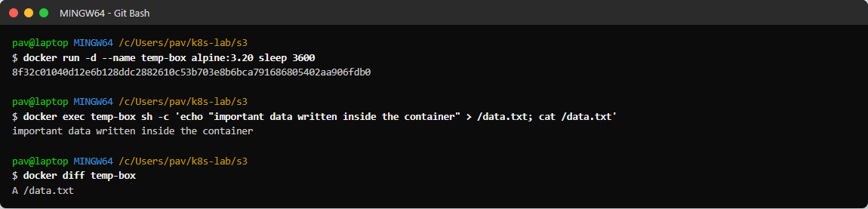
Figure 1.1: File written inside the container; docker diff shows 'A /data.txt' (added in the container layer)
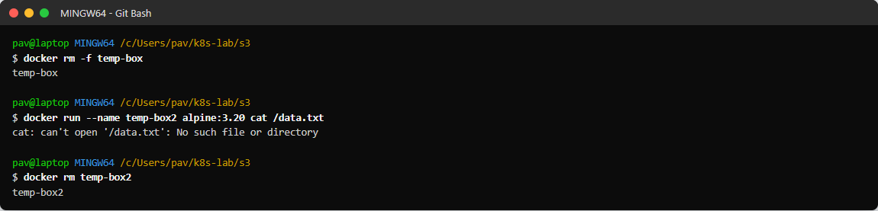
Figure 1.2: After docker rm the file is gone - a new container from the same image cannot find /data.txt
Observation: the file existed only in the writable layer of temp-box. Deleting the container deleted that layer, so the data was lost. Images are read-only, so a new container always starts clean.

Part B: Persistent storage with a named volume

Commands
docker volume create lab-vol
docker volume ls --filter name=lab-vol
docker volume inspect lab-vol
docker run --name vol-writer -v lab-vol:/data alpine:3.20 sh -c 'echo "saved in named volume at $(date)" > /data/notes.txt; cat /data/notes.txt'
docker rm vol-writer
docker ps -a --filter name=vol-
docker run --rm --name vol-reader -v lab-vol:/data alpine:3.20 sh -c 'ls -l /data; cat /data/notes.txt'
docker run --rm -v lab-vol:/data alpine:3.20 sh -c 'echo "second line from another container" >> /data/notes.txt; cat /data/notes.txt'

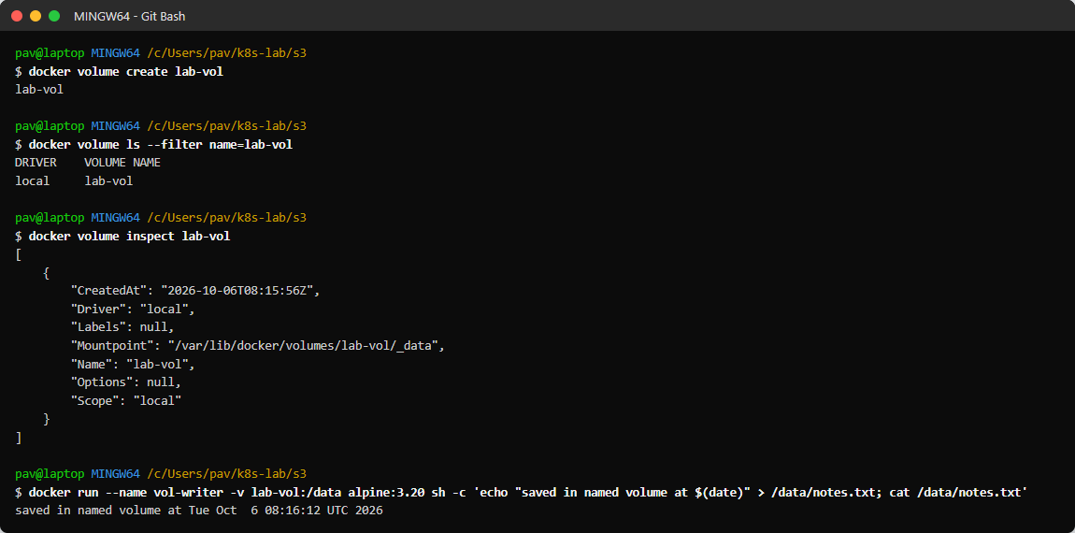
Figure 1.3: Creating and inspecting the named volume lab-vol, and writing data to it
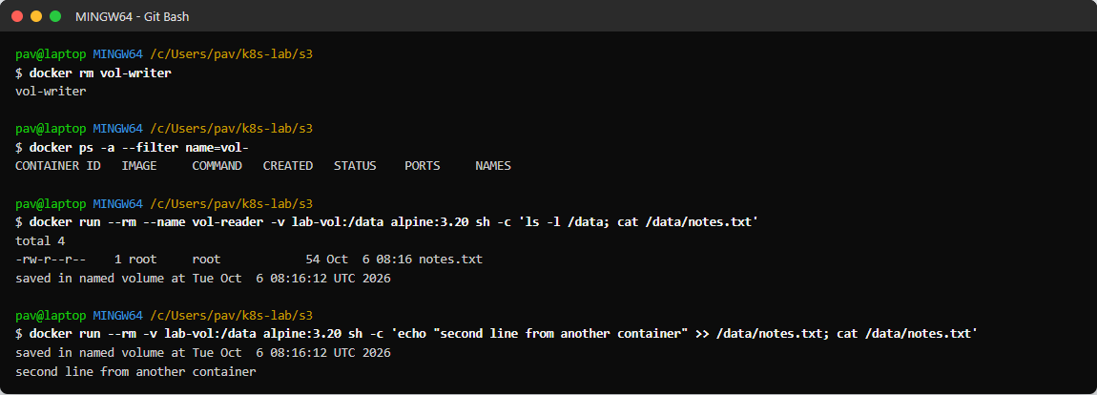
Figure 1.4: Writer container deleted - a new container still reads the data and can add to it
Observation: the volume exists independently of any container. After vol-writer was removed, two new containers mounted lab-vol and the file was still there; the second one appended a line.

Part C: Persistent storage with a bind mount

Commands
ls -la hostdata
docker run -d --name bind-box -v C:/Users/pav/k8s-lab/s3/hostdata:/app/data alpine:3.20 sleep 3600
docker exec bind-box sh -c 'echo "written by the container" > /app/data/from-container.txt; ls -l /app/data'
cat hostdata/from-container.txt
echo 'written on the host (Windows)' > hostdata/from-host.txt
docker exec bind-box sh -c 'ls -l /app/data; cat /app/data/from-host.txt'
docker inspect bind-box --format '{{range .Mounts}}{{.Type}}: {{.Source}} -> {{.Destination}}{{end}}'
docker rm -f bind-box
ls -la hostdata
cat hostdata/*.txt
docker run --rm -v C:/Users/pav/k8s-lab/s3/hostdata:/app/data alpine:3.20 ls -l /app/data

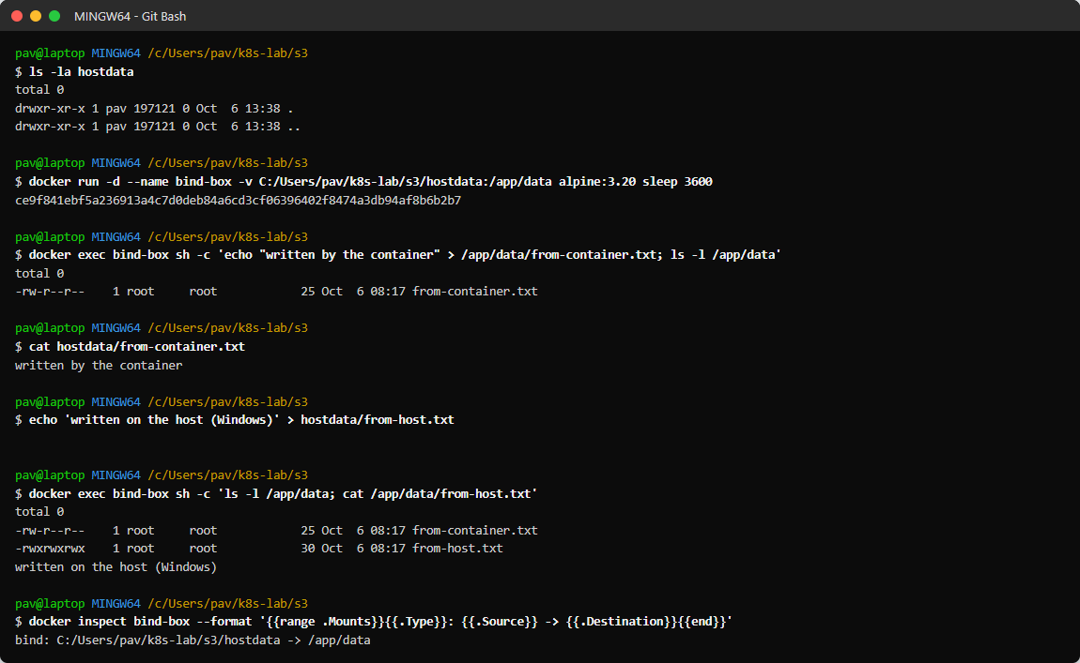
Figure 1.5: Bind mount: host folder hostdata mapped to /app/data - files written on either side are visible on both
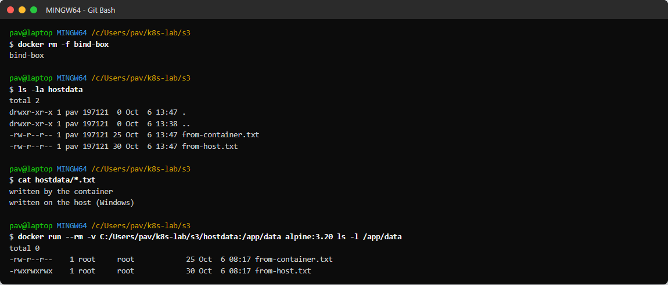
Figure 1.6: Container deleted - files remain on the host and are visible again in a new container
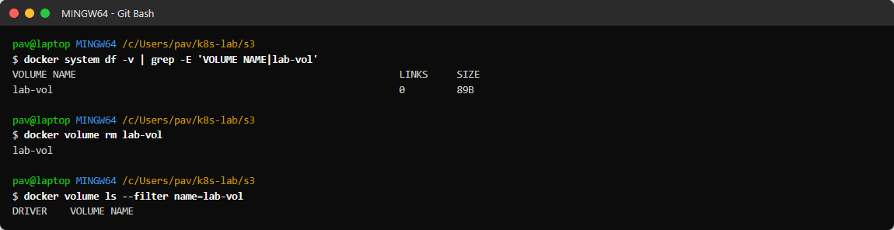
Figure 1.7: Volume size reported by docker system df, then cleanup with docker volume rm

Results
Test | After container deletion | Persistent?
Container writable layer (/data.txt) | cat: can't open '/data.txt': No such file or directory | No
Named volume lab-vol (/data/notes.txt) | File still readable from new containers | Yes
Bind mount hostdata (/app/data) | Files still on the host and in new containers | Yes

Observations
- Containers are disposable: anything not written to a volume or bind mount is lost on docker rm.
- Named volumes are managed by Docker, portable between containers and are the recommended way to persist application data.
- Bind mounts give two-way, real-time sharing with the host (a file created in Windows appeared in the container immediately).
- A volume is removed only explicitly with docker volume rm (or docker volume prune).

Conclusion
Container-layer data was lost after the container was deleted, while data in the named volume and in the bind mount persisted across containers.

