Lab 2: Containerization & Kubernetes Orchestration
Session 3 - Question 2: Docker Network (5 marks)
Name | Sachin kumar
Roll No | 2301010366
Course | Btech(cse)
Date of Experiment | 06-10-2026
Tools Used | Docker Desktop (Docker Engine 29.3.1), images alpine:3.20 and nginx:alpine, Windows 11

Problem Statement
Demonstrate communication between two containers through a Docker network, using container names and container IP addresses.

Aim
To create a user-defined Docker bridge network, connect two containers to it, and show that they communicate both by container name (Docker DNS) and by IP address.

Theory
- Bridge network: a private virtual network on the host; containers on it get an IP from its subnet.
- User-defined bridge: has an embedded DNS server (127.0.0.11), so containers can reach each other by name.
- Default bridge: no name resolution between containers; containers on different networks are isolated.
- docker network connect: attaches a running container to an extra network.

Setup
Item | Value
Network | lab-net (bridge), subnet 172.28.0.0/16, gateway 172.28.0.1
Container 'web' | nginx:alpine web server - 172.28.0.2
Container 'client' | alpine:3.20 - 172.28.0.3
Container 'outsider' | alpine:3.20 on the default bridge (172.17.0.2), later also connected to lab-net (172.28.0.4)

Step 1: Create the network
docker network create --driver bridge --subnet 172.28.0.0/16 lab-net
docker network ls
docker network inspect lab-net --format 'Name={{.Name}} Driver={{.Driver}} Subnet={{(index .IPAM.Config 0).Subnet}} Gateway={{(index .IPAM.Config 0).Gateway}}'

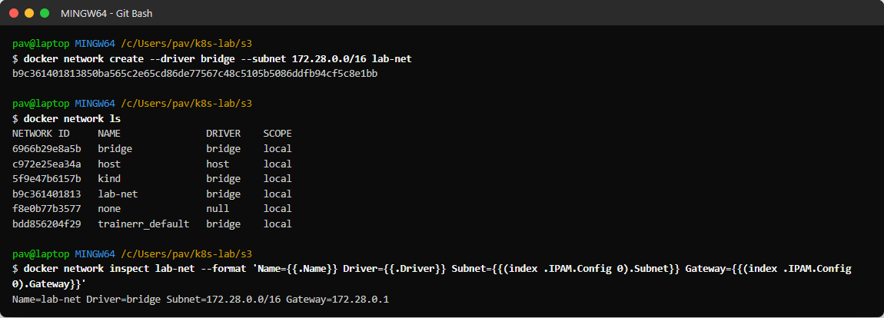
Figure 2.1: User-defined bridge network lab-net

Step 2: Run two containers on the network
docker run -d --name web --network lab-net nginx:alpine
docker run -d --name client --network lab-net alpine:3.20 sleep 3600
docker ps --filter network=lab-net --format 'table {{.Names}}\t{{.Image}}\t{{.Status}}\t{{.Networks}}'
docker network inspect lab-net --format '{{range .Containers}}{{.Name}} -> {{.IPv4Address}}{{println}}{{end}}'

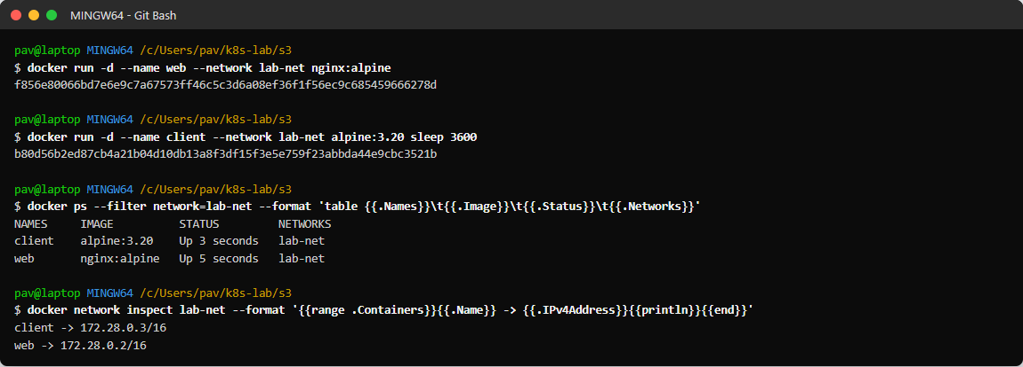
Figure 2.2: web and client containers on lab-net with their IP addresses

Step 3: Communication using the container name
docker exec client ping -c 3 web
docker exec client wget -qO- http://web | head -4
docker exec client nslookup web 127.0.0.11 2>&1 | tail -3
docker exec client cat /etc/resolv.conf | grep nameserver

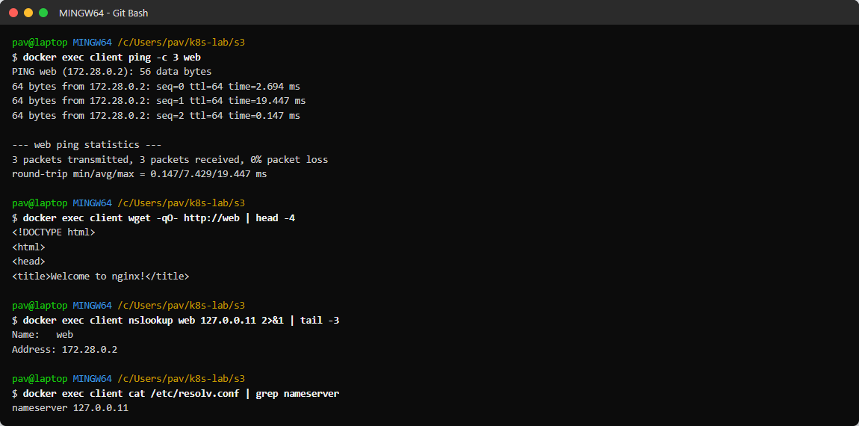
Figure 2.3: client pings 'web' and downloads its page by name; Docker DNS (127.0.0.11) resolves web -> 172.28.0.2

Step 4: Communication using the container IP address
WEB_IP=$(docker inspect -f '{{range .NetworkSettings.Networks}}{{.IPAddress}}{{end}}' web); echo "web IP = $WEB_IP"
docker exec client ping -c 3 $(docker inspect -f '{{range .NetworkSettings.Networks}}{{.IPAddress}}{{end}}' web)
docker exec client wget -qO- http://$(docker inspect -f '{{range .NetworkSettings.Networks}}{{.IPAddress}}{{end}}' web) | grep -i title
CLIENT_IP=$(docker inspect -f '{{range .NetworkSettings.Networks}}{{.IPAddress}}{{end}}' client); docker exec web ping -c 2 $CLIENT_IP

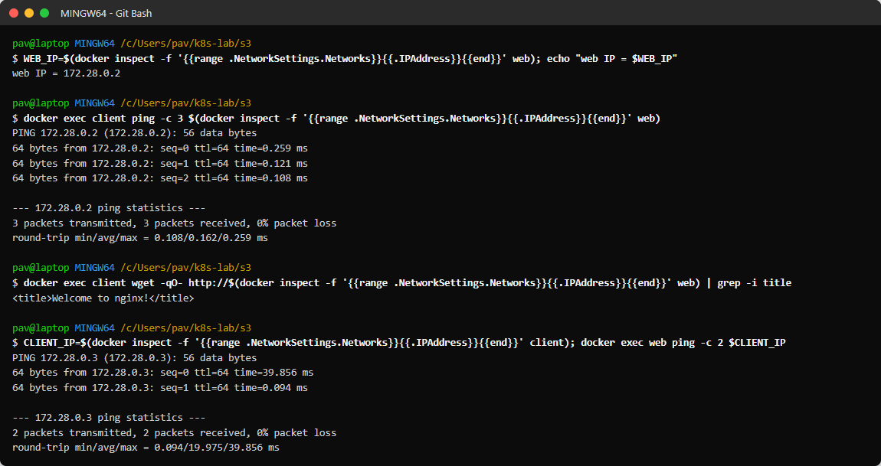
Figure 2.4: client reaches web by IP 172.28.0.2, and web reaches client by IP 172.28.0.3

Step 5: Network isolation
docker run -d --name outsider alpine:3.20 sleep 3600
docker inspect -f '{{range $k,$v := .NetworkSettings.Networks}}{{$k}} {{$v.IPAddress}}{{end}}' outsider
docker exec outsider ping -c 2 web
docker exec outsider ping -c 2 -W 2 $(docker inspect -f '{{range .NetworkSettings.Networks}}{{.IPAddress}}{{end}}' web)

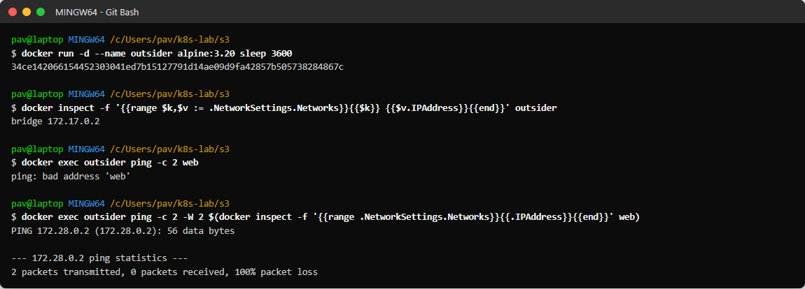
Figure 2.5: A container on the default bridge cannot resolve 'web' and cannot reach its IP (100% packet loss)

Step 6: Connecting a container to the network
docker network connect lab-net outsider
docker inspect -f '{{range $k,$v := .NetworkSettings.Networks}}{{$k}}={{$v.IPAddress}} {{end}}' outsider
docker exec outsider ping -c 2 web
docker exec outsider wget -qO- http://web | grep -i title

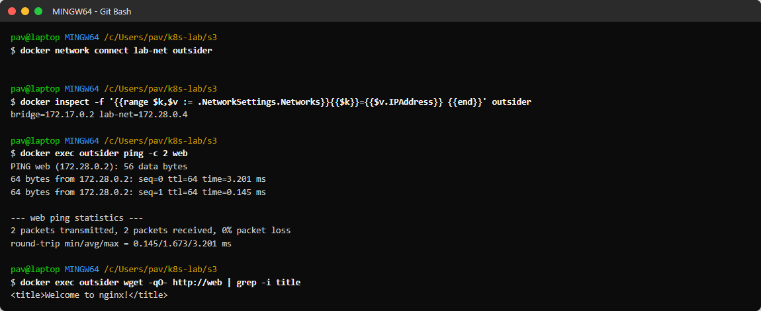
Figure 2.6: After docker network connect, outsider reaches web by name

Step 7: Verification and cleanup
docker logs web 2>/dev/null | grep GET | tail -4
docker rm -f web client outsider
docker network rm lab-net
docker network ls

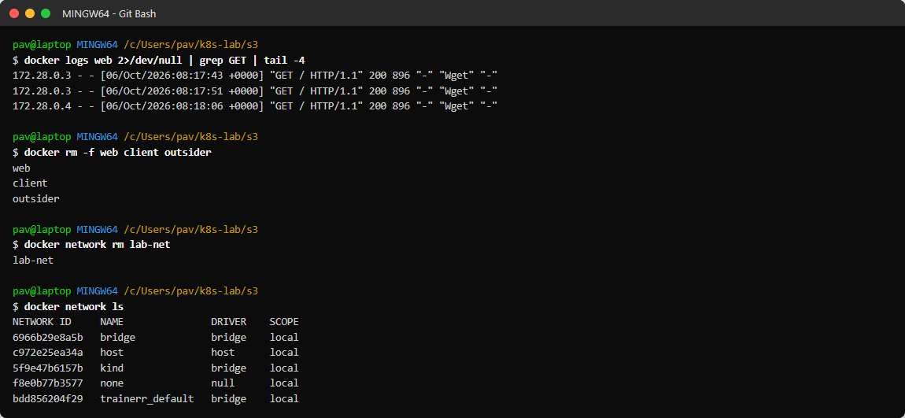
Figure 2.7: nginx access log shows requests from 172.28.0.3 (client) and 172.28.0.4 (outsider); cleanup

Results
Test | Result
client -> web by name (ping, HTTP) | Success - 0% packet loss, nginx page returned
client -> web by IP 172.28.0.2 | Success
web -> client by IP 172.28.0.3 | Success
outsider (default bridge) -> web | Failed: 'bad address web' and 100% packet loss - networks are isolated
outsider after network connect | Success by name

Observations
- On a user-defined network, containers find each other by name through Docker's embedded DNS - no IP needs to be hard-coded.
- IP addresses work too, but they can change when a container is recreated, so names are more reliable.
- Containers on different networks cannot talk to each other, which isolates applications.
- One container can be attached to several networks at once (outsider had bridge and lab-net addresses).

Conclusion
Two containers communicated over a user-defined Docker bridge network using both container names and IP addresses, and network isolation was demonstrated.

