Lab 2: Containerization & Kubernetes Orchestration
Session 1 - Question 1: Containerization and orchestration report (10 marks)
Name | Sachin kumar
Roll No. | 2301010366
Course | Sachin Kumar
Date of Experiment | 06-10-2026
Tools Used | Docker 29.3.1, Kubernetes v1.34 (kind v0.30), kubectl 1.34, Python 3.12, Windows 11

Problem Statement
Prepare a containerization and orchestration report describing the architecture, deployment strategy, scaling results, and observations with screenshots.

1. Introduction
Containerization packages an application with everything it needs (runtime, libraries, configuration) into a portable image that runs the same everywhere. Kubernetes is a container orchestrator: it schedules containers on a cluster of machines, keeps the desired number of copies running, exposes them through a service, and updates them without downtime. In this lab a small Python web application was containerized with Docker and deployed, scaled and updated on a Kubernetes cluster.

Objectives
- Build a Docker image for a web application and run it as a container.
- Create a multi-node Kubernetes cluster and deploy the application with a Deployment and a Service.
- Scale the application up and down and observe load balancing.
- Demonstrate self-healing, a zero-downtime rolling update and a rollback.

2. Tools and Environment
Component | Details
Operating system | Windows 11 Home (64-bit)
Container engine | Docker Desktop - Docker Engine 29.3.1
Kubernetes | kind v0.30.0 - cluster 'lab2': 1 control-plane + 2 worker nodes, Kubernetes v1.34.0
CLI | kubectl v1.34.1
Application | Python 3.12 web app (lab2-webapp) - / , /api , /health on port 5000

3. Architecture
The cluster was created with kind (Kubernetes in Docker): every Kubernetes node is a Docker container on the laptop.
Browser / curl ---> localhost:30080 (kind port mapping)
|
Service webapp-service (NodePort 30080 -> port 5000, load balancer)
|
+-----------------+------------------+
| |
Node lab2-worker Node lab2-worker2 (control-plane: lab2-control-plane)
Pod webapp-xxxx Pod webapp-xxxx Pod webapp-xxxx
(container lab2-webapp:1.0, port 5000)

Deployment 'webapp' -> ReplicaSet -> 3 Pods ConfigMap 'webapp-config' -> env APP_MESSAGE

Component | Role
Dockerfile / image lab2-webapp | Packages app.py on python:3.12-alpine; runs as non-root user 'nobody'; image size about 20.6 MB
Deployment webapp | Declares 3 replicas, rolling-update strategy (maxSurge 1, maxUnavailable 0), resource requests/limits, readiness and liveness probes on /health
Service webapp-service | NodePort 30080; load-balances traffic across all ready pods using the label app=webapp
ConfigMap webapp-config | Supplies APP_MESSAGE to the containers without rebuilding the image
kind cluster lab2 | 1 control-plane + 2 worker nodes; port 30080 mapped to the host

4. Containerization with Docker

Dockerfile
# Dockerfile for the lab web app
FROM python:3.12-alpine
WORKDIR /app
COPY app.py .
ARG APP_VERSION=1.0
ARG APP_COLOR=#1f6feb
ENV APP_VERSION=$APP_VERSION \
APP_COLOR=$APP_COLOR
EXPOSE 5000
USER nobody
CMD ["python", "app.py"]

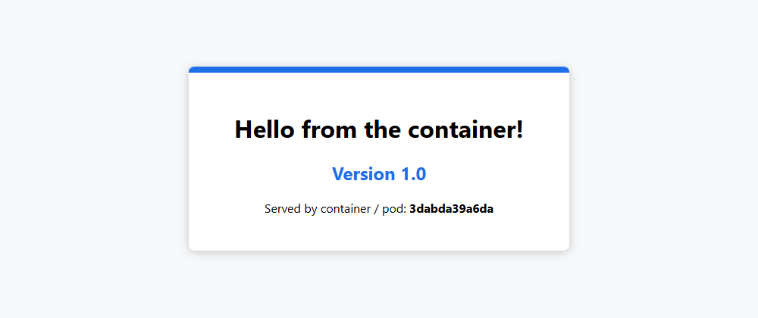
Figure 1.1: Application running in a Docker container (port 8081)
The image was built with 'docker build -t lab2-webapp:1.0 .', started with 'docker run -d --name web1 -p 8081:5000 lab2-webapp:1.0' and tested with curl on /api and /health. A second container was started with different environment variables (-e APP_MESSAGE=...) to show that configuration is separate from the image. Full commands and outputs are in Question 2.

5. Deployment Strategy
- Declarative deployment: all resources are described in YAML (k8s/*.yaml) and applied with kubectl apply -f.
- Rolling update: new pods are created one at a time (maxSurge 1) and old pods are removed only after the new ones are ready (maxUnavailable 0), so the service never goes down.
- Health checks: readinessProbe stops traffic going to a pod that is not ready; livenessProbe restarts a pod that hangs.
- Resource limits: requests 50m CPU / 32 Mi, limits 200m CPU / 64 Mi per pod so that one pod cannot starve the others.
- Configuration: ConfigMap injected as environment variables.
- Rollback: kubectl rollout undo returns to the previous ReplicaSet in seconds.

Manifests
apiVersion: apps/v1
kind: Deployment
metadata:
name: webapp
labels:
app: webapp
spec:
replicas: 3
selector:
matchLabels:
app: webapp
strategy:
type: RollingUpdate
rollingUpdate:
maxSurge: 1
maxUnavailable: 0
template:
metadata:
labels:
app: webapp
spec:
containers:
- name: webapp
image: lab2-webapp:1.0
imagePullPolicy: IfNotPresent
ports:
- containerPort: 5000
envFrom:
- configMapRef:
name: webapp-config
resources:
requests:
cpu: 50m
memory: 32Mi
limits:
cpu: 200m
memory: 64Mi
readinessProbe:
httpGet:
path: /health
port: 5000
initialDelaySeconds: 2
periodSeconds: 5
livenessProbe:
httpGet:
path: /health
port: 5000
initialDelaySeconds: 5
periodSeconds: 10

apiVersion: v1
kind: Service
metadata:
name: webapp-service
spec:
type: NodePort
selector:
app: webapp
ports:
- port: 80
targetPort: 5000
nodePort: 30080

apiVersion: v1
kind: ConfigMap
metadata:
name: webapp-config
data:
APP_MESSAGE: "Hello from Kubernetes!"

6. Deployment Results
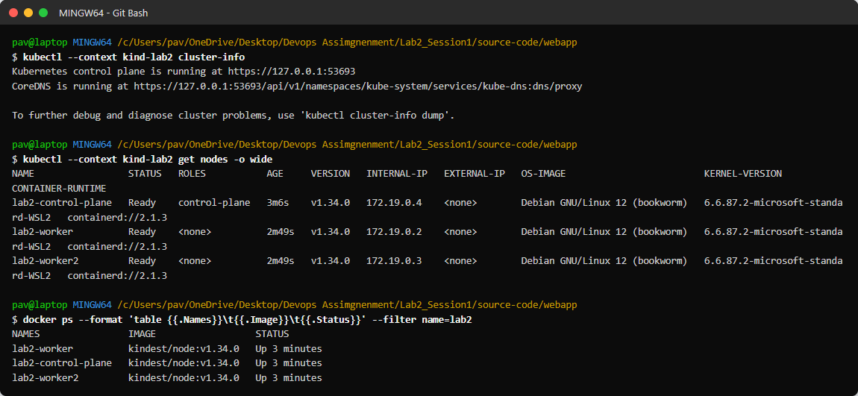
Figure 1.2: Kubernetes cluster - 3 nodes (1 control-plane, 2 workers) running as Docker containers
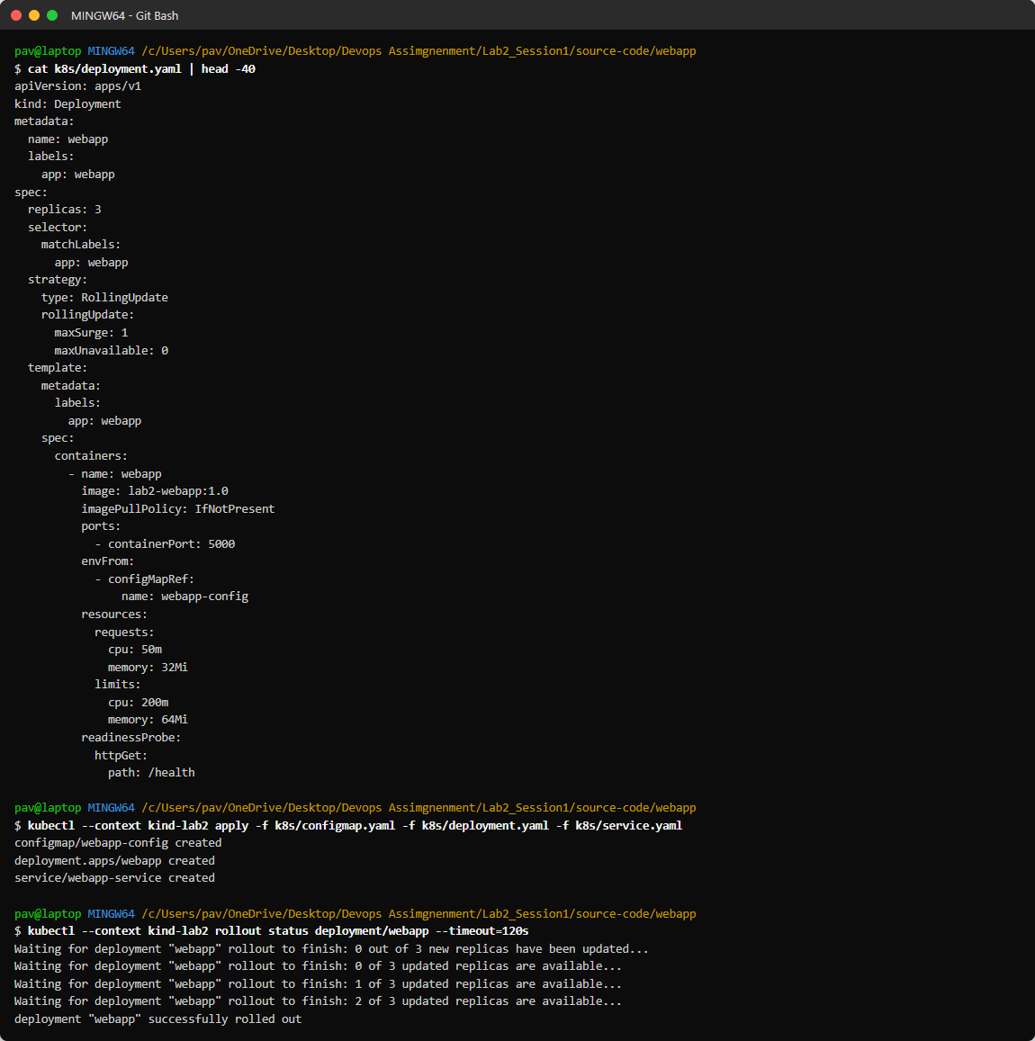
Figure 1.3: Applying the manifests and waiting for the rollout to finish
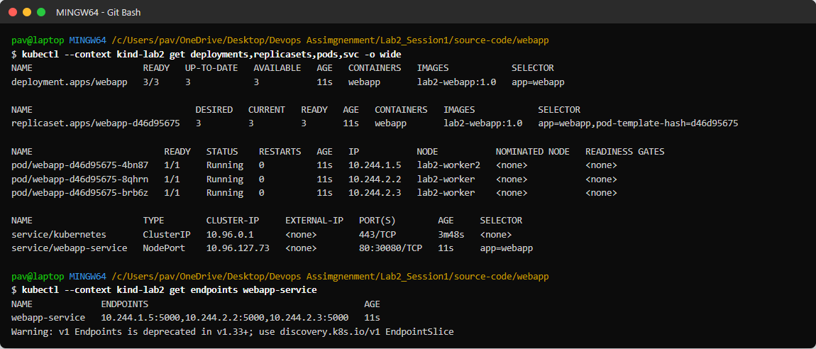
Figure 1.4: Deployment, ReplicaSet, 3 pods spread over the two worker nodes, and the NodePort service
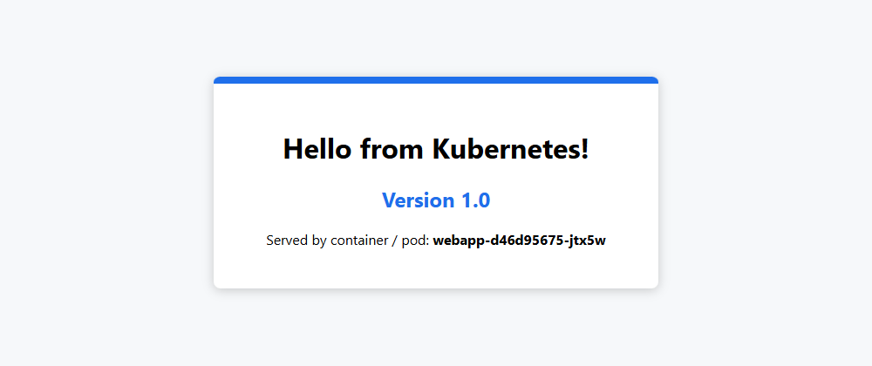
Figure 1.5: Application reached through the Service on http://localhost:30080
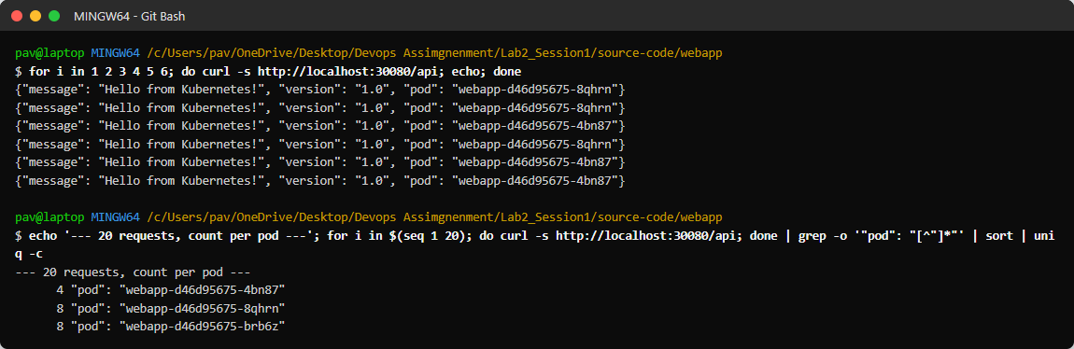
Figure 1.6: 20 requests are load-balanced across the 3 pods

7. Scaling Results
Action | Command | Result
Scale up | kubectl scale deployment webapp --replicas=6 | 6 pods Running within about 10 seconds; traffic spread across all 6 pods
Scale down | kubectl scale deployment webapp --replicas=2 | 4 pods Terminating, 2 remain
Scale back | kubectl scale deployment webapp --replicas=3 | 3 pods Running
Self-healing | kubectl delete pod <name> | A replacement pod was created automatically within seconds; replica count stayed at 3

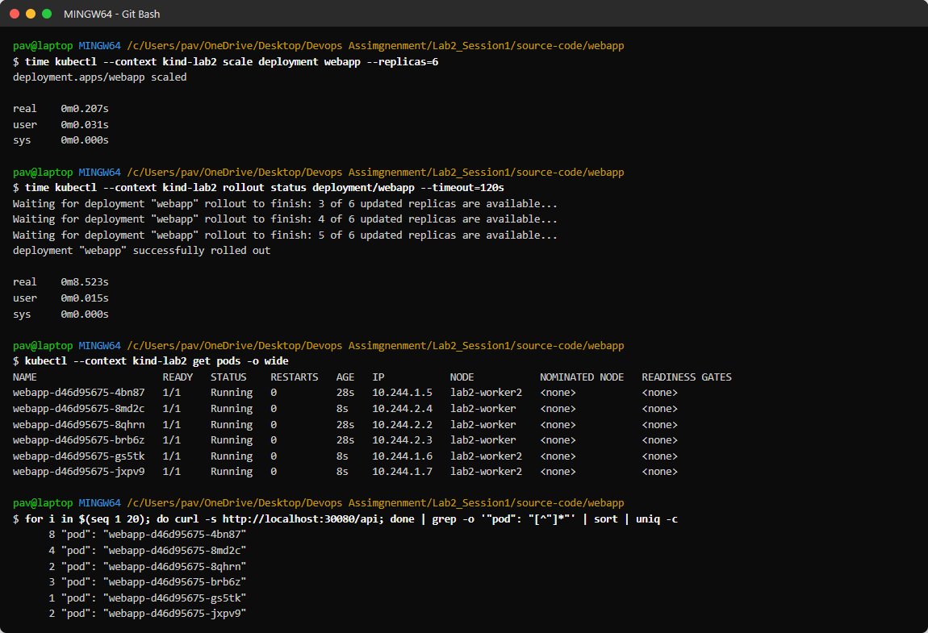
Figure 1.7: Scaling to 6 replicas - pods placed on both worker nodes, requests distributed to all pods
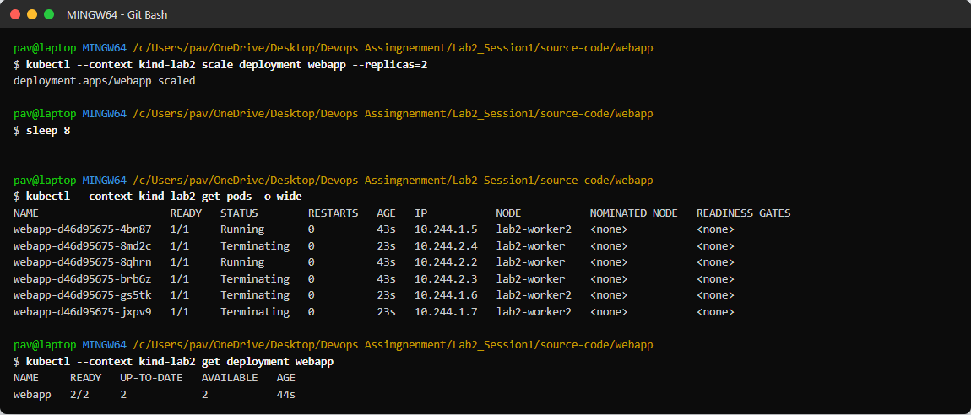
Figure 1.8: Scaling down to 2 replicas
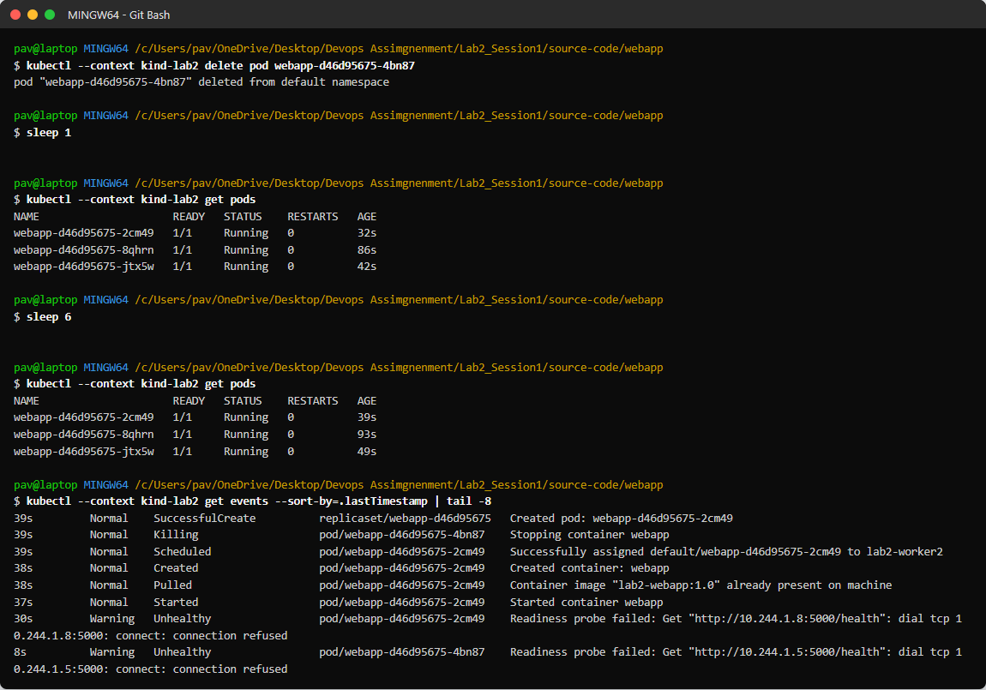
Figure 1.9: Self-healing - a deleted pod is replaced automatically

8. Rolling Update and Rollback
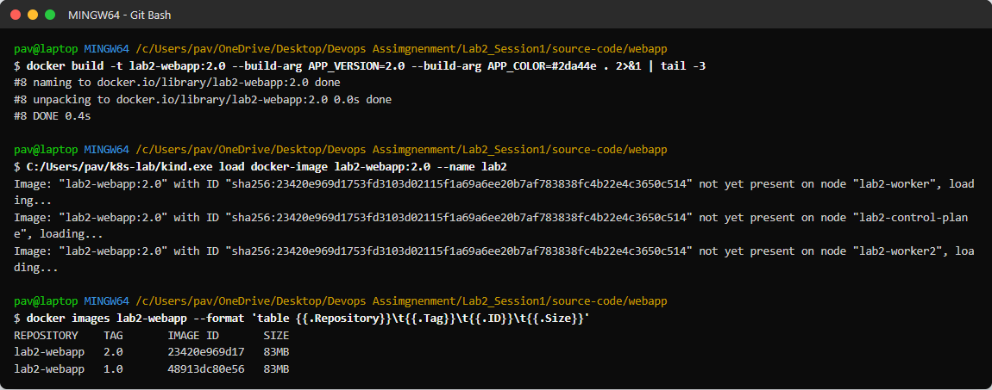
Figure 1.10: Building version 2.0 of the image and loading it into the cluster
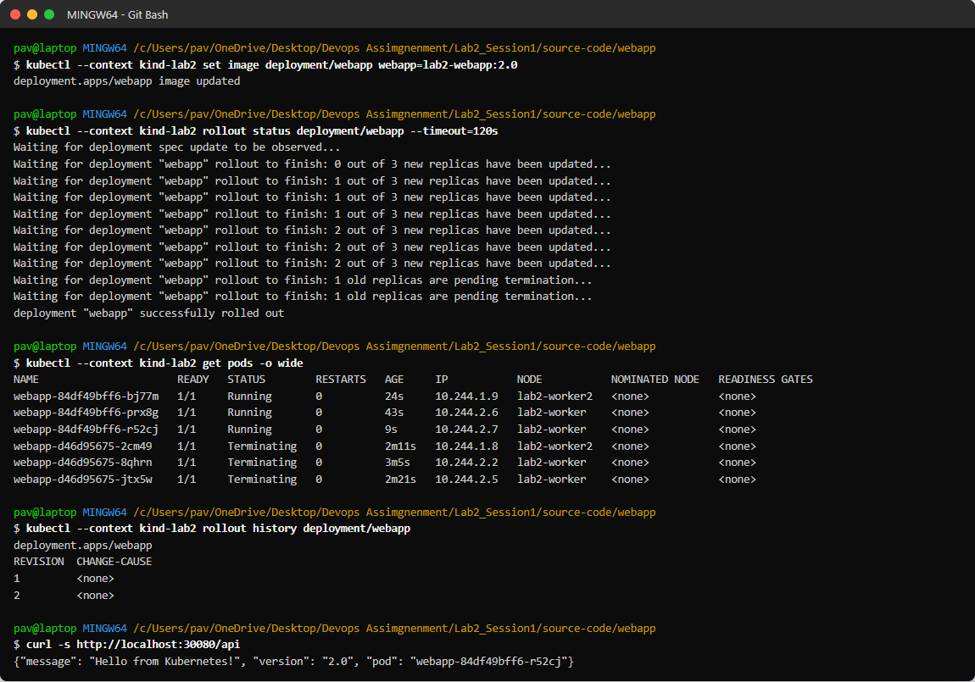
Figure 1.11: Rolling update to lab2-webapp:2.0 - new pods created, old pods removed, rollout history
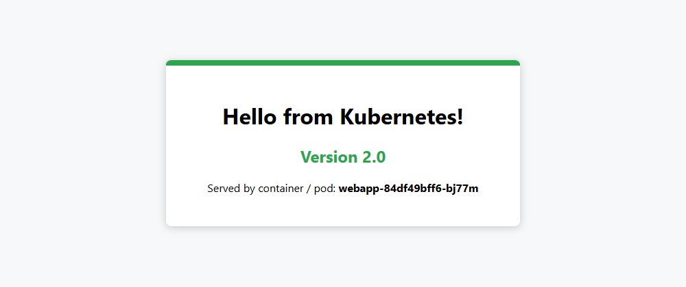
Figure 1.12: Version 2.0 served after the update (green theme)
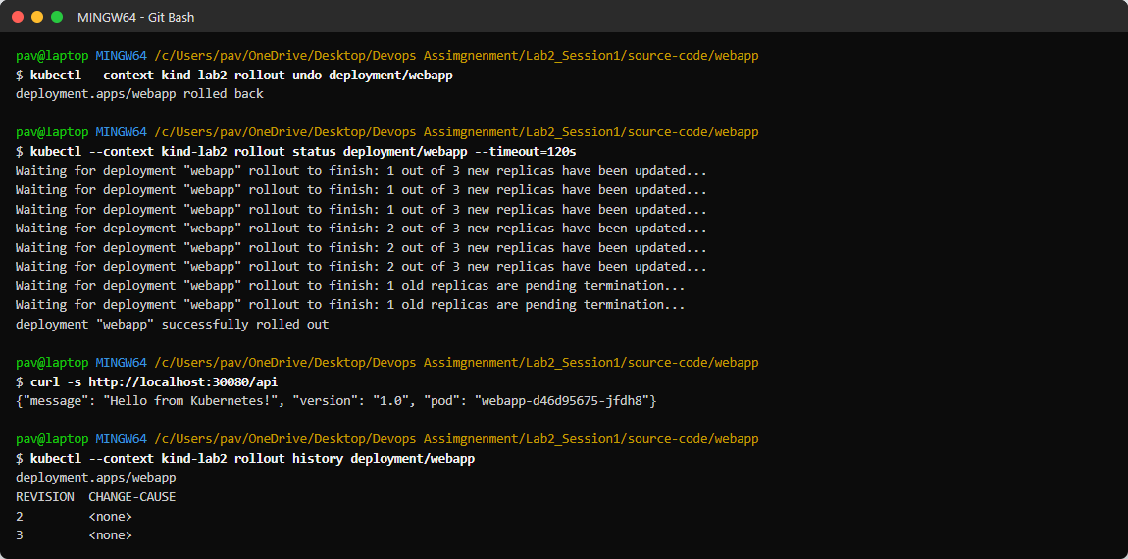
Figure 1.13: Rollback with kubectl rollout undo - version 1.0 serves again

9. Observations
- The Service distributed requests across all ready pods (for 20 requests every pod received traffic), so adding replicas increases capacity.
- Scaling from 3 to 6 replicas took only a few seconds because the image was already present on the nodes.
- When a pod was deleted, the Deployment/ReplicaSet recreated it immediately - the desired state (3 replicas) is always restored.
- During the rolling update the application stayed available because maxUnavailable was 0 and readiness probes gated traffic.
- Rollback to the previous version completed in a few seconds because the old ReplicaSet is kept.
- A Docker image of only about 20 MB (Alpine base, no extra dependencies) starts in about a second.
- kind images are not pulled from a registry; they must be loaded with 'kind load docker-image', otherwise pods fail with ImagePullBackOff.

10. Challenges and Solutions
Challenge | Solution
No Kubernetes cluster on the laptop | Created a 3-node cluster with kind on Docker Desktop
Cluster reachable only inside Docker | Mapped NodePort 30080 to the host with extraPortMappings in kind-config.yaml
Local image not found by Kubernetes | imagePullPolicy: IfNotPresent and kind load docker-image
Metrics server not installed (no HPA) | Scaled manually with kubectl scale; HPA can be added later with metrics-server

11. Conclusion
The application was containerized with Docker and orchestrated on a three-node Kubernetes cluster. Scaling, load balancing, self-healing, zero-downtime rolling updates and rollbacks were demonstrated successfully, showing the benefits of containers and Kubernetes for reliable, scalable deployments.

