Lab 2: Containerization & Kubernetes Orchestration
Session 1 - Question 2: Record all Dockerfiles, manifests, commands and observations (5 marks)
Name | Sachin kumar
Roll No. | 2301010366
Course | Btech(cse)
Date of Experiment | 06-10-2026
Tools Used | Docker 29.3.1, Kubernetes v1.34 (kind v0.30), kubectl 1.34, Python 3.12, Windows 11

Problem Statement
Record all Dockerfiles, Kubernetes manifests, commands, screenshots, and observations for each experiment.

Experiment 1: Environment check
Aim: verify Docker, kubectl and kind. Observation: all tools installed (Docker 29.3.1, kubectl 1.34.1, kind 0.30.0).
docker --version
docker version
kubectl version --client
kind version

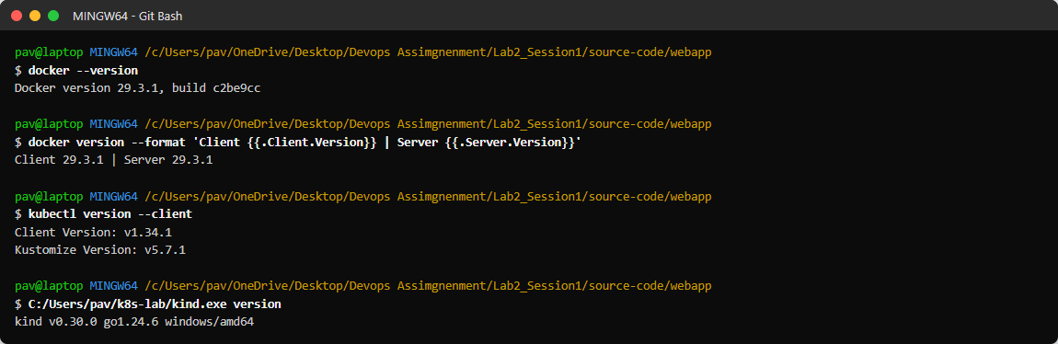
Figure 2.1: Tool versions

Experiment 2: Dockerfile and application

app.py
"""Tiny web app used for the Docker / Kubernetes lab (standard library only)."""
import json
import os
import socket
from http.server import BaseHTTPRequestHandler, HTTPServer

VERSION = os.environ.get("APP_VERSION", "1.0")
MESSAGE = os.environ.get("APP_MESSAGE", "Hello from the container!")
COLOR = os.environ.get("APP_COLOR", "#1f6feb")

class Handler(BaseHTTPRequestHandler):
def do_GET(self):
if self.path == "/health":
self._send(200, "application/json", json.dumps({"status": "ok"}))
elif self.path == "/api":
self._send(200, "application/json", json.dumps(
{"message": MESSAGE, "version": VERSION, "pod": socket.gethostname()}))
else:
page = (f"<html><body style='font-family:Segoe UI,Arial;background:#f6f8fa;text-align:center;padding-top:80px'>"
f"<div style='display:inline-block;background:white;border-top:8px solid {COLOR};padding:30px 60px;"
f"box-shadow:0 2px 12px #0003;border-radius:8px'><h1>{MESSAGE}</h1>"
f"<h2 style='color:{COLOR}'>Version {VERSION}</h2>"
f"<p>Served by container / pod: <b>{socket.gethostname()}</b></p></div></body></html>")
self._send(200, "text/html", page)

def _send(self, code, ctype, body):
data = body.encode()
self.send_response(code)
self.send_header("Content-Type", ctype)
self.send_header("Content-Length", str(len(data)))
self.end_headers()
self.wfile.write(data)

if __name__ == "__main__":
print(f"Starting web app v{VERSION} on port 5000", flush=True)
HTTPServer(("0.0.0.0", 5000), Handler).serve_forever()

Dockerfile
# Dockerfile for the lab web app
FROM python:3.12-alpine
WORKDIR /app
COPY app.py .
ARG APP_VERSION=1.0
ARG APP_COLOR=#1f6feb
ENV APP_VERSION=$APP_VERSION \
APP_COLOR=$APP_COLOR
EXPOSE 5000
USER nobody
CMD ["python", "app.py"]

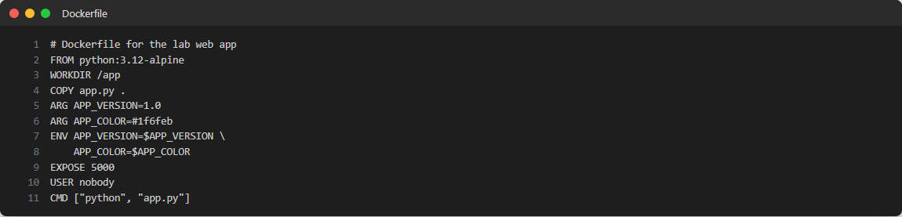
Figure 2.2: Dockerfile
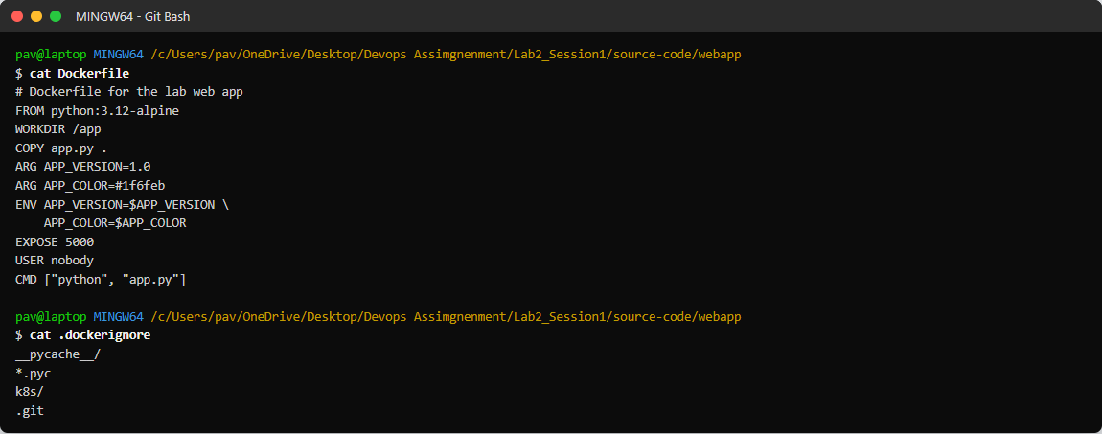
Figure 2.3: Dockerfile and .dockerignore as stored in the project
Observation: python:3.12-alpine keeps the image small; USER nobody avoids running as root; ARG values allow different versions to be built from the same Dockerfile.

Experiment 3: Build the image
docker build -t lab2-webapp:1.0 .
docker images lab2-webapp

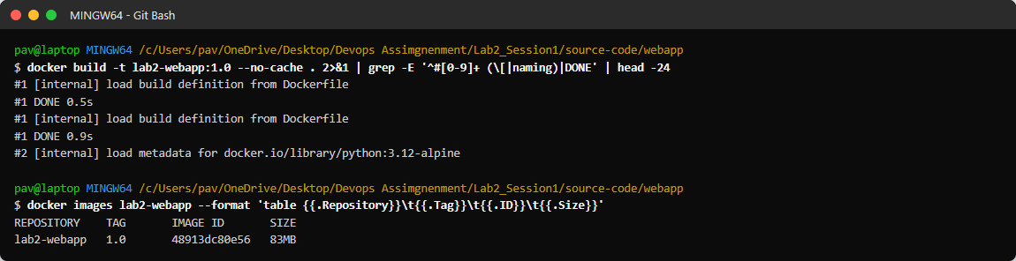
Figure 2.4: Docker build steps and resulting image

Experiment 4: Run containers
docker run -d --name web1 -p 8081:5000 lab2-webapp:1.0
docker ps
curl http://localhost:8081/api
curl http://localhost:8081/health

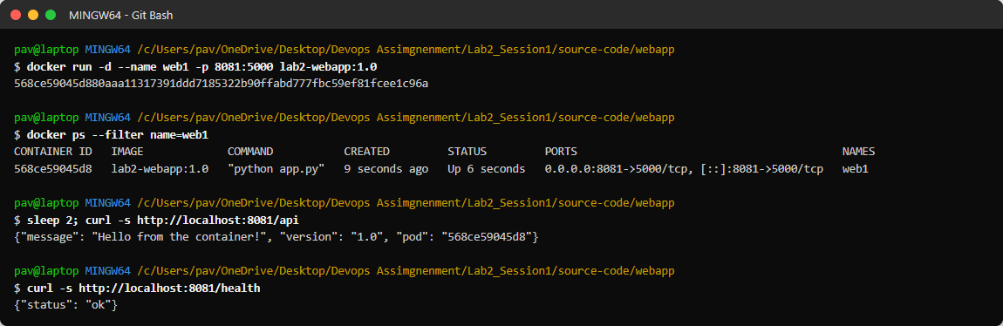
Figure 2.5: Running the container and testing the endpoints
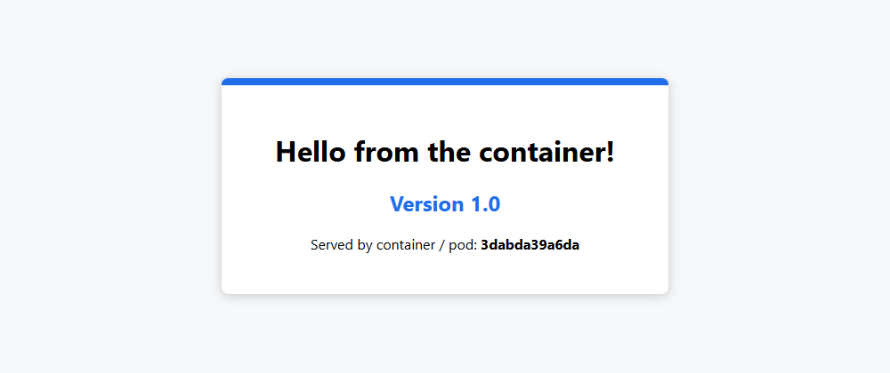
Figure 2.6: Application in the browser (container)

Experiment 5: Inspect, logs and environment variables
docker logs web1
docker exec web1 hostname
docker stats web1 --no-stream
docker inspect web1
docker run -d --name web2 -p 8082:5000 -e APP_MESSAGE='Custom message via env' -e APP_VERSION=1.0-custom lab2-webapp:1.0

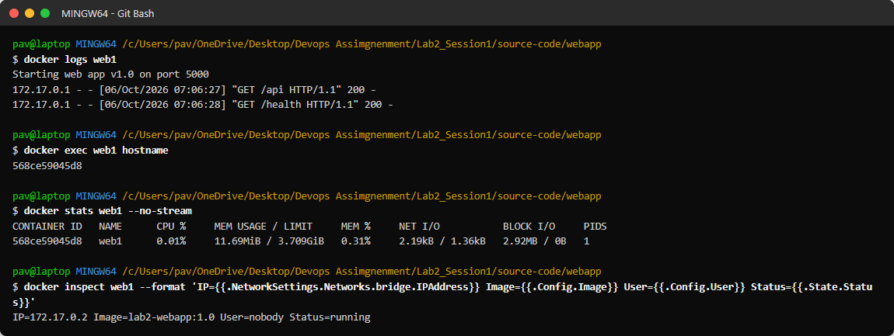
Figure 2.7: Logs, exec, stats and inspect
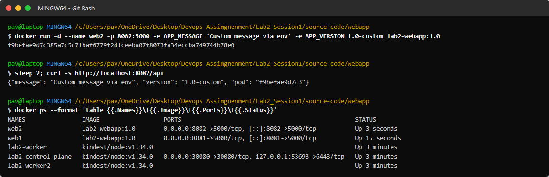
Figure 2.8: Second container configured with environment variables
Observation: the container uses only about 12 MiB of memory; the same image behaves differently depending on environment variables.

Experiment 6: Cleanup
docker stop web2 web1
docker rm web2 web1

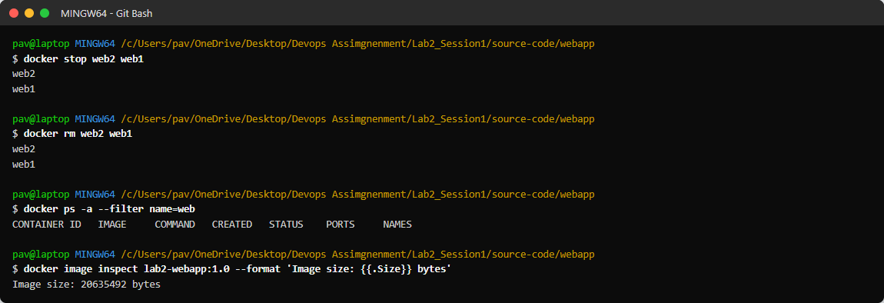
Figure 2.9: Stopping and removing the containers

Experiment 7: Create the Kubernetes cluster

kind-config.yaml
kind: Cluster
apiVersion: kind.x-k8s.io/v1alpha4
name: lab2
nodes:
- role: control-plane
extraPortMappings:
- containerPort: 30080
hostPort: 30080
protocol: TCP
- role: worker
- role: worker

kind create cluster --config kind-config.yaml
kubectl cluster-info --context kind-lab2
kubectl get nodes -o wide

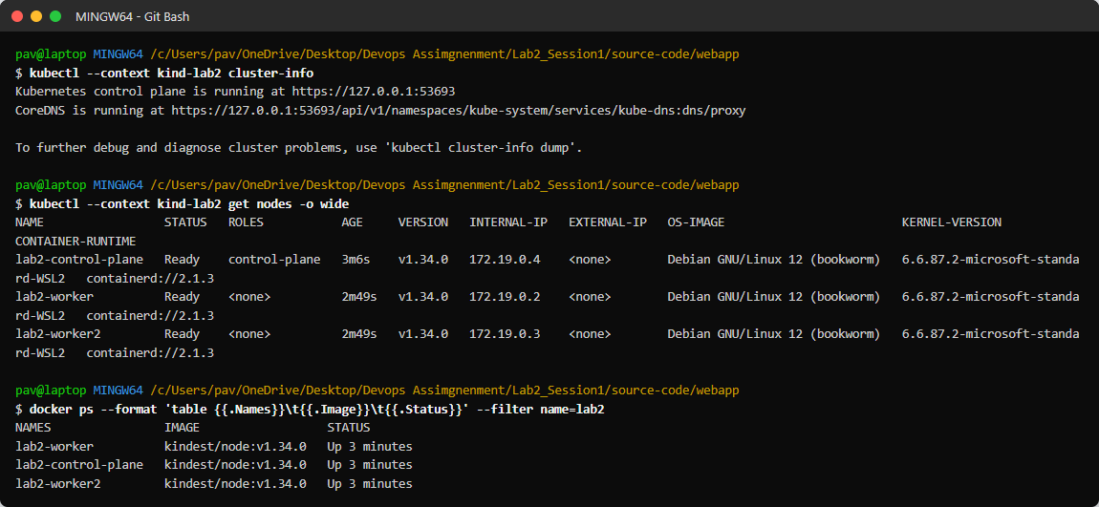
Figure 2.10: Three-node cluster

Experiment 8: Load image and deploy

Manifests
apiVersion: v1
kind: ConfigMap
metadata:
name: webapp-config
data:
APP_MESSAGE: "Hello from Kubernetes!"

apiVersion: apps/v1
kind: Deployment
metadata:
name: webapp
labels:
app: webapp
spec:
replicas: 3
selector:
matchLabels:
app: webapp
strategy:
type: RollingUpdate
rollingUpdate:
maxSurge: 1
maxUnavailable: 0
template:
metadata:
labels:
app: webapp
spec:
containers:
- name: webapp
image: lab2-webapp:1.0
imagePullPolicy: IfNotPresent
ports:
- containerPort: 5000
envFrom:
- configMapRef:
name: webapp-config
resources:
requests:
cpu: 50m
memory: 32Mi
limits:
cpu: 200m
memory: 64Mi
readinessProbe:
httpGet:
path: /health
port: 5000
initialDelaySeconds: 2
periodSeconds: 5
livenessProbe:
httpGet:
path: /health
port: 5000
initialDelaySeconds: 5
periodSeconds: 10

apiVersion: v1
kind: Service
metadata:
name: webapp-service
spec:
type: NodePort
selector:
app: webapp
ports:
- port: 80
targetPort: 5000
nodePort: 30080

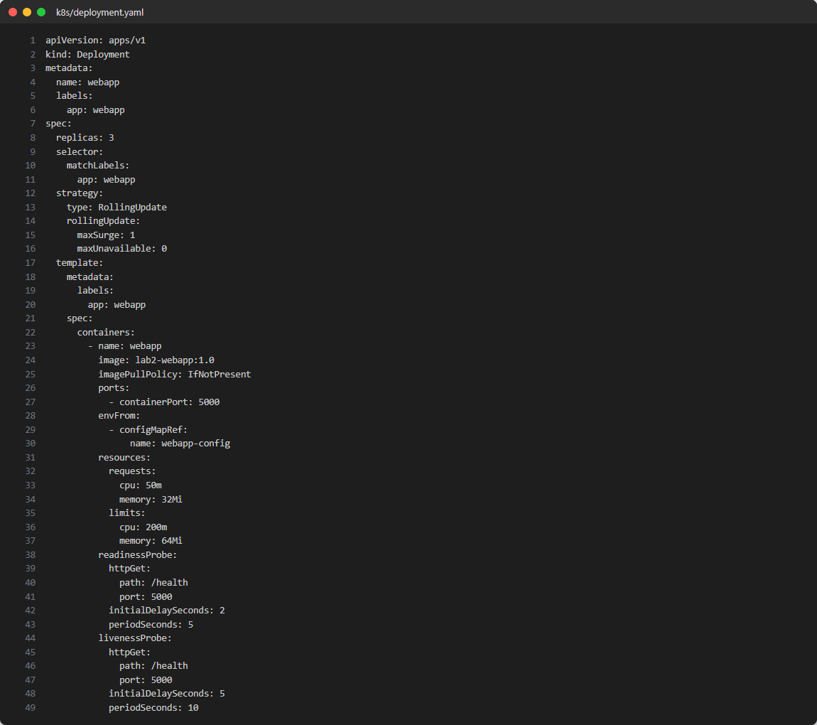
Figure 2.11: deployment.yaml
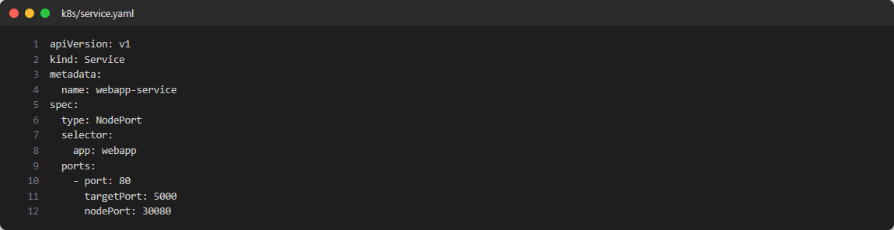
Figure 2.12: service.yaml
kind load docker-image lab2-webapp:1.0 --name lab2
kubectl apply -f k8s/configmap.yaml -f k8s/deployment.yaml -f k8s/service.yaml
kubectl rollout status deployment/webapp
kubectl get all -o wide

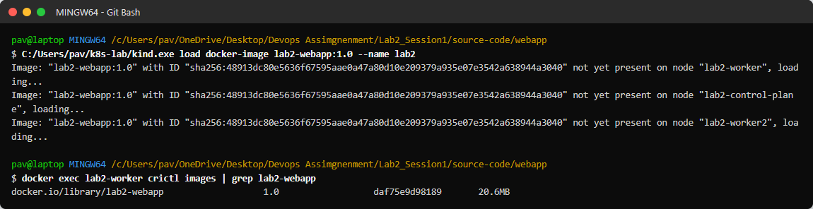
Figure 2.13: Image loaded into the cluster nodes
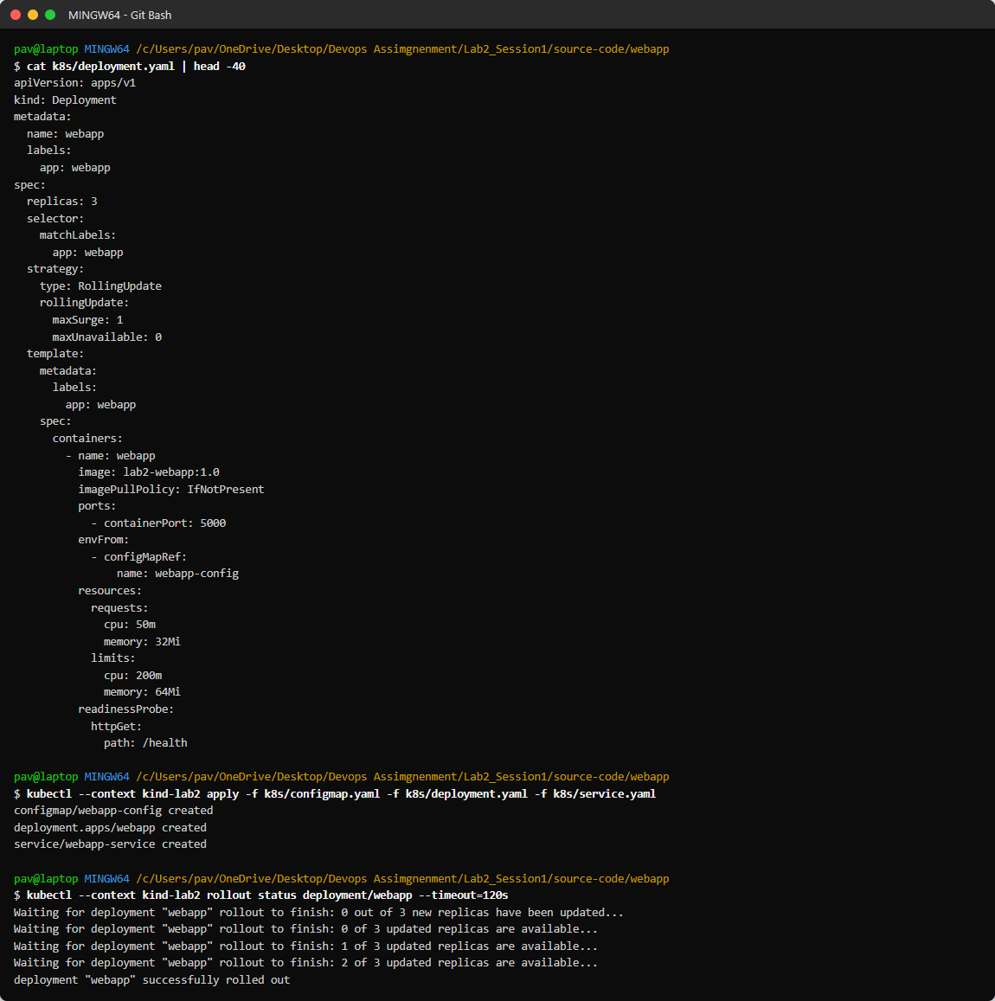
Figure 2.14: Applying the manifests
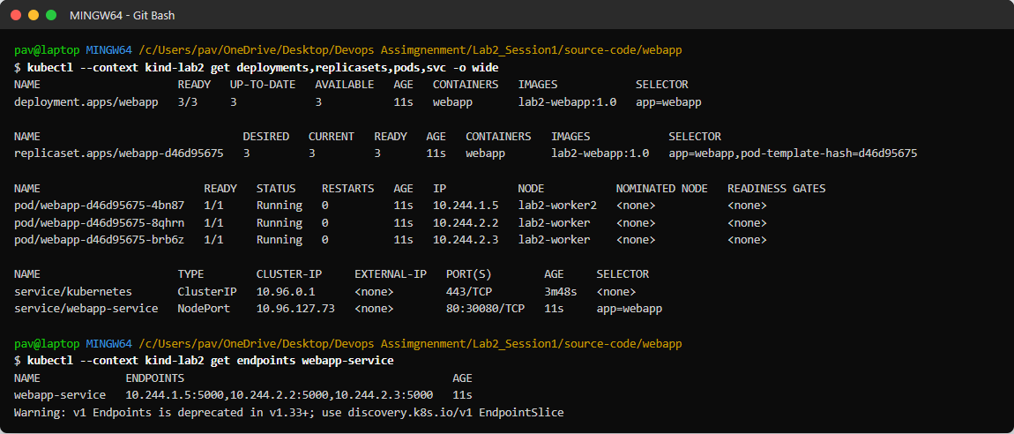
Figure 2.15: Deployment, ReplicaSet, pods and service

Experiment 9: Access and load balancing
curl http://localhost:30080/api # repeated
for i in $(seq 1 20); do curl -s localhost:30080/api; done | sort | uniq -c

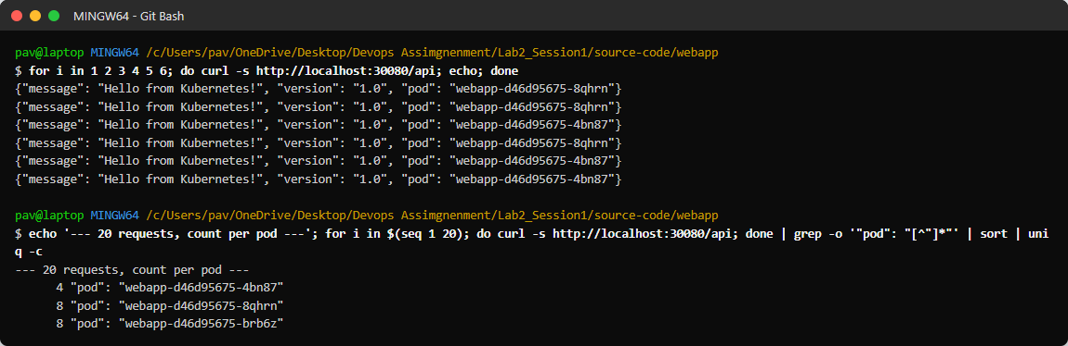
Figure 2.16: Requests distributed across the pods
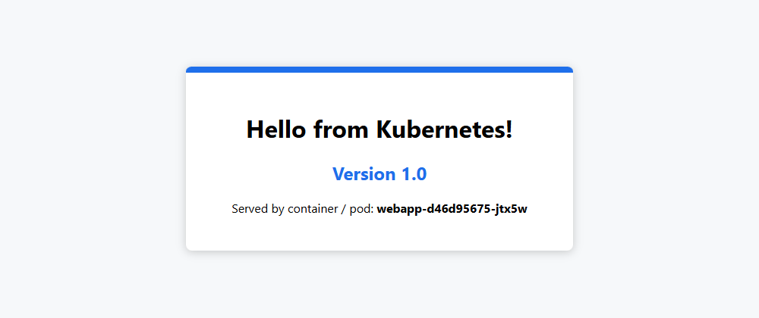
Figure 2.17: Browser view through the NodePort service

Experiment 10: Scaling
kubectl scale deployment webapp --replicas=6
kubectl get pods -o wide
kubectl scale deployment webapp --replicas=2
kubectl scale deployment webapp --replicas=3

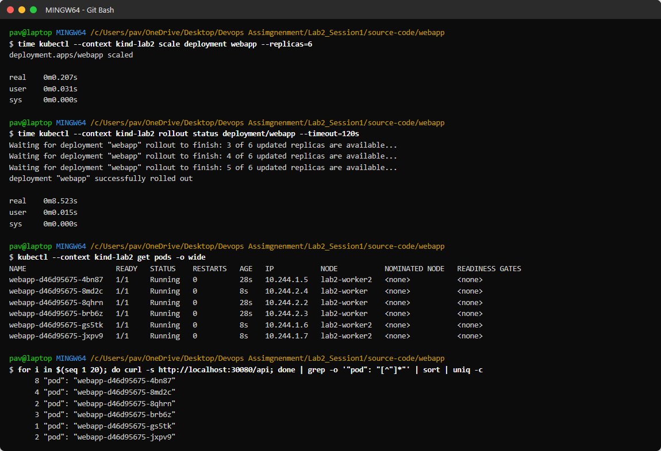
Figure 2.18: Scale up to 6
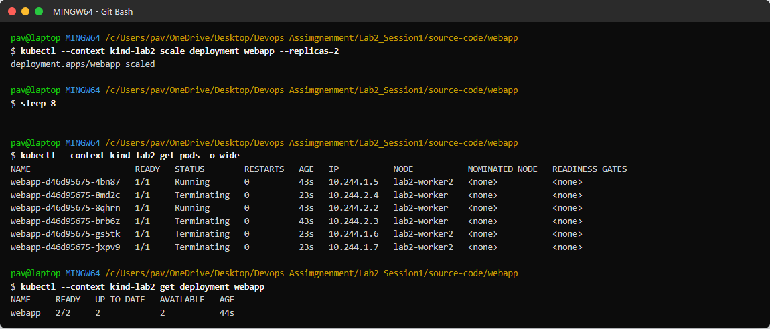
Figure 2.19: Scale down to 2
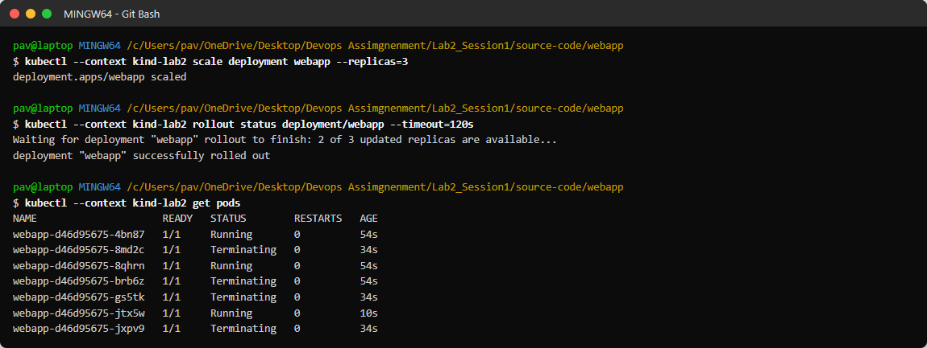
Figure 2.20: Back to 3 replicas

Experiment 11: Self-healing
kubectl delete pod <pod-name>
kubectl get pods
kubectl get events --sort-by=.lastTimestamp

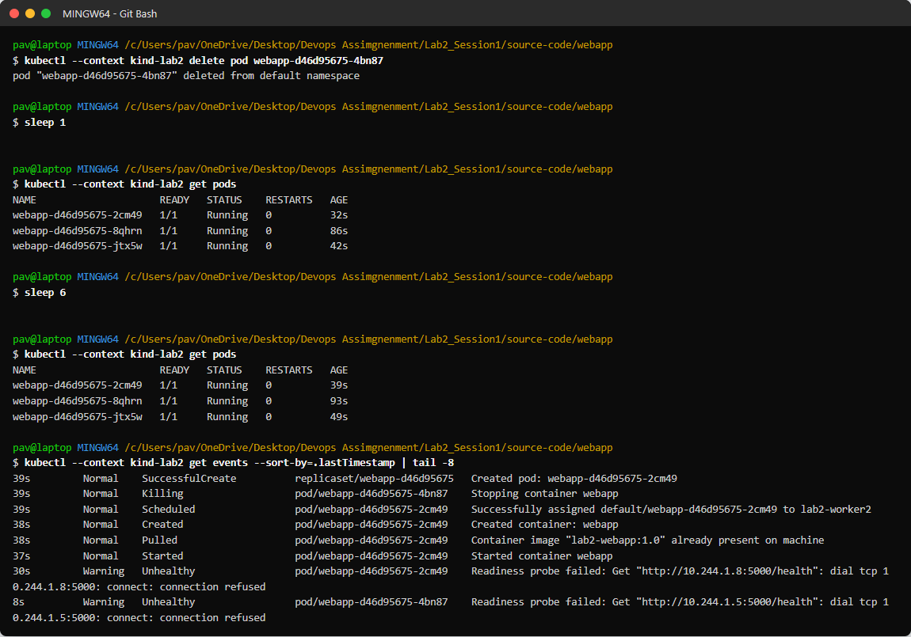
Figure 2.21: Deleted pod replaced automatically

Experiment 12: Rolling update
docker build -t lab2-webapp:2.0 --build-arg APP_VERSION=2.0 --build-arg APP_COLOR=#2da44e .
kind load docker-image lab2-webapp:2.0 --name lab2
kubectl set image deployment/webapp webapp=lab2-webapp:2.0
kubectl rollout status deployment/webapp
kubectl rollout history deployment/webapp

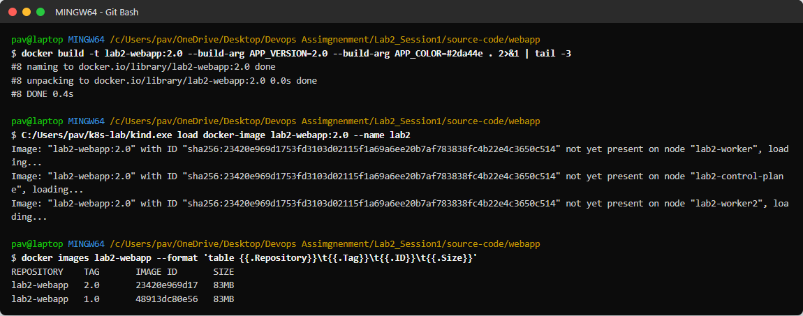
Figure 2.22: Version 2.0 image
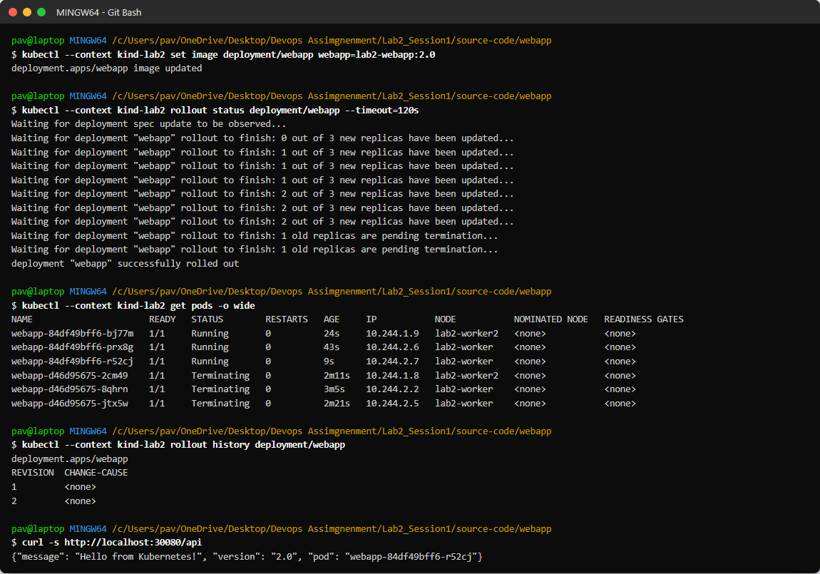
Figure 2.23: Rolling update
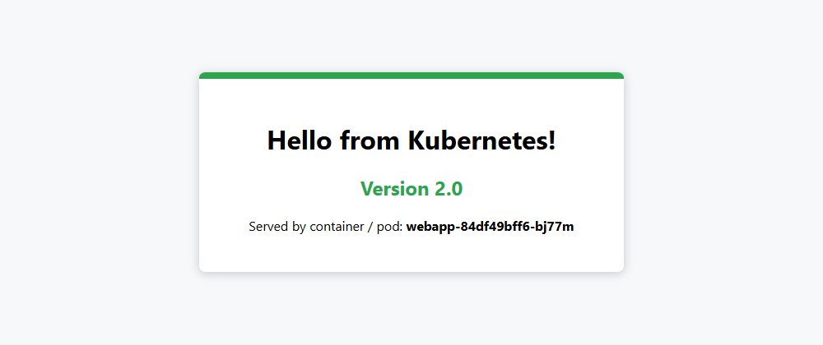
Figure 2.24: Version 2.0 in the browser

Experiment 13: Rollback
kubectl rollout undo deployment/webapp
kubectl rollout status deployment/webapp
kubectl rollout history deployment/webapp

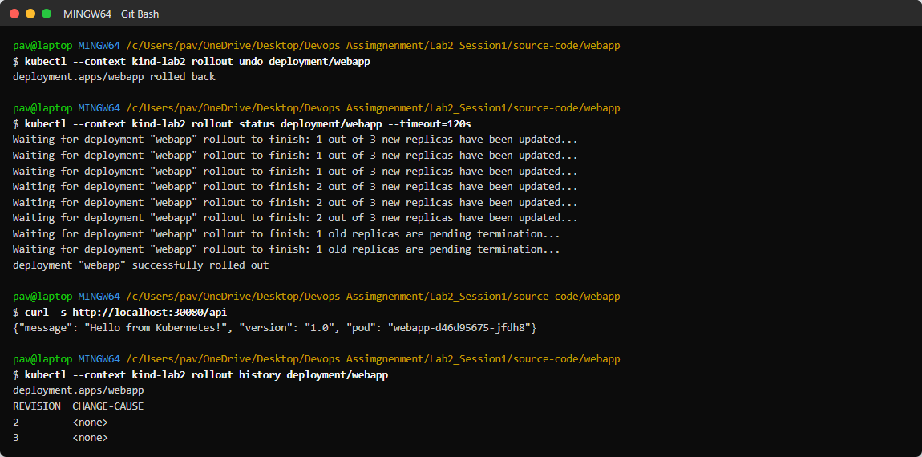
Figure 2.25: Rollback to version 1.0

Experiment 14: Describe, logs and ConfigMap
kubectl describe deployment webapp
kubectl logs deployment/webapp --tail=5
kubectl get configmap webapp-config -o yaml

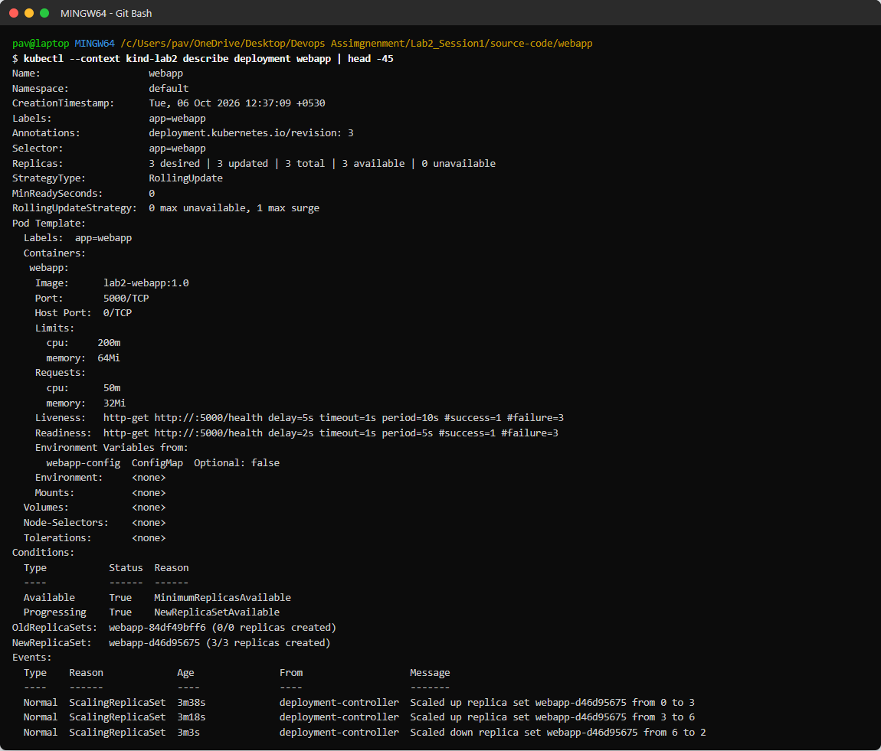
Figure 2.26: kubectl describe deployment
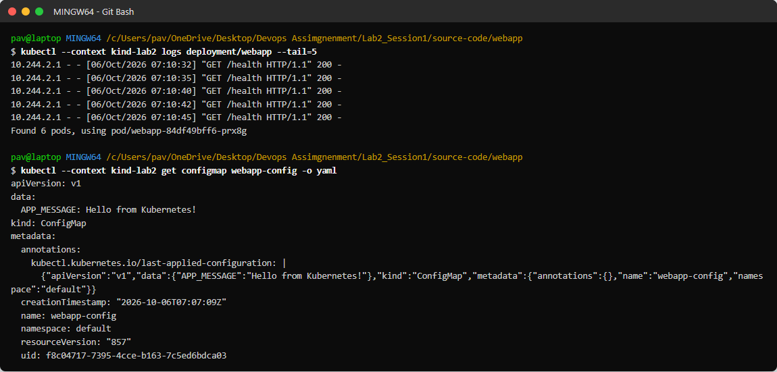
Figure 2.27: Pod logs and ConfigMap

Command Summary
Command | Purpose
docker build -t name:tag . | Build an image from a Dockerfile
docker run -d -p H:C --name n image | Run a container
docker ps / logs / exec / stats / inspect | Monitor containers
kind create cluster --config f | Create the Kubernetes cluster
kind load docker-image img | Copy a local image into the cluster
kubectl apply -f file | Create/update resources from YAML
kubectl get pods,svc -o wide | List resources
kubectl scale deployment d --replicas=N | Scale
kubectl set image deployment/d c=img | Rolling update
kubectl rollout status/history/undo | Track or revert a rollout
kubectl describe / logs | Troubleshoot

Overall Observations
- Containers start in about a second and use very little memory.
- Kubernetes keeps the desired state: deleted pods are recreated, scaling is one command.
- The service load-balances across pods; rolling updates caused no downtime; rollback is instant.
- Kind needs images loaded into the nodes because it has no access to local Docker images.

Conclusion
All Dockerfiles, Kubernetes manifests, commands, screenshots and observations for the containerization and orchestration experiments were recorded.

