Lab 2: Containerization & Kubernetes Orchestration
Session 2 - Question 1: Implement Kubernetes deployment strategies (5 marks)
Name | Sachin kumar
Roll No. | 2301010366
Course | Btech(cse)
Date of Experiment | 06-10-2026
Tools Used | Docker 29.3.1, Kubernetes v1.34 (kind v0.30, 3 nodes), kubectl 1.34, Jenkins 2.580.1, Git 2.53, Windows 11

Problem Statement
Implement Kubernetes deployment strategies such as rolling updates and rollbacks, and demonstrate scaling of the application replicas.

Aim
To deploy a containerized web application on Kubernetes and demonstrate a zero-downtime rolling update, rollback of a failed release, rollback to a specific revision, the Recreate strategy, and scaling of replicas.

Environment
Component | Details
Cluster | kind cluster 'lab2' - 1 control-plane + 2 worker nodes, Kubernetes v1.34.0
Application | lab2-webapp (Python 3.12 Alpine image) - versions 1.0 (blue), 2.0 (green), 3.0 (orange)
Access | NodePort Service webapp-service on http://localhost:30080
Tools | Docker 29.3.1, kubectl 1.34.1, kind 0.30.0

Theory
Strategy / feature | How it works | Downtime
RollingUpdate (default) | Replaces pods gradually. maxSurge = extra pods allowed, maxUnavailable = pods that may be down | None (with maxUnavailable 0 + readiness probe)
Recreate | Deletes all old pods first, then creates new ones | Yes - short outage
Rollback | kubectl rollout undo returns to the previous (or a chosen) ReplicaSet revision | None
Scaling | kubectl scale changes spec.replicas; the ReplicaSet adds or removes pods | None

Deployment manifest (rolling-update strategy)
apiVersion: apps/v1
kind: Deployment
metadata:
name: webapp
labels:
app: webapp
spec:
replicas: 3
selector:
matchLabels:
app: webapp
strategy:
type: RollingUpdate
rollingUpdate:
maxSurge: 1
maxUnavailable: 0
template:
metadata:
labels:
app: webapp
spec:
containers:
- name: webapp
image: lab2-webapp:1.0
imagePullPolicy: IfNotPresent
ports:
- containerPort: 5000
envFrom:
- configMapRef:
name: webapp-config
resources:
requests:
cpu: 50m
memory: 32Mi
limits:
cpu: 200m
memory: 64Mi
readinessProbe:
httpGet:
path: /health
port: 5000
initialDelaySeconds: 2
periodSeconds: 5
livenessProbe:
httpGet:
path: /health
port: 5000
initialDelaySeconds: 5
periodSeconds: 10

Experiment 1: Initial deployment (v1.0)
kubectl apply -f k8s/configmap.yaml -f k8s/deployment.yaml -f k8s/service.yaml
kubectl get deployment webapp -o wide
kubectl get pods -o wide

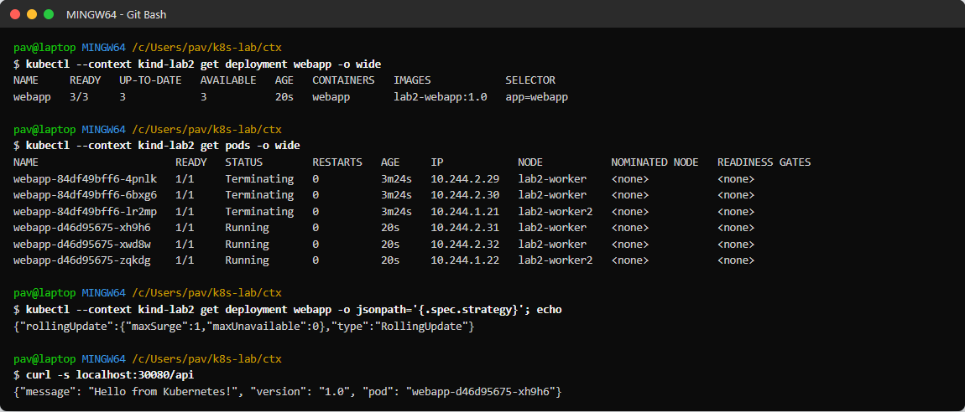
Figure 1.1: Version 1.0 running with 3 replicas and the RollingUpdate strategy

Experiment 2: Rolling update v1.0 -> v3.0
docker build -t lab2-webapp:3.0 --build-arg APP_VERSION=3.0 --build-arg APP_COLOR=#d29922 .
kind load docker-image lab2-webapp:3.0 --name lab2
kubectl set image deployment/webapp webapp=lab2-webapp:3.0
kubectl annotate deployment webapp kubernetes.io/change-cause='v3.0 rolling update'
kubectl rollout status deployment/webapp

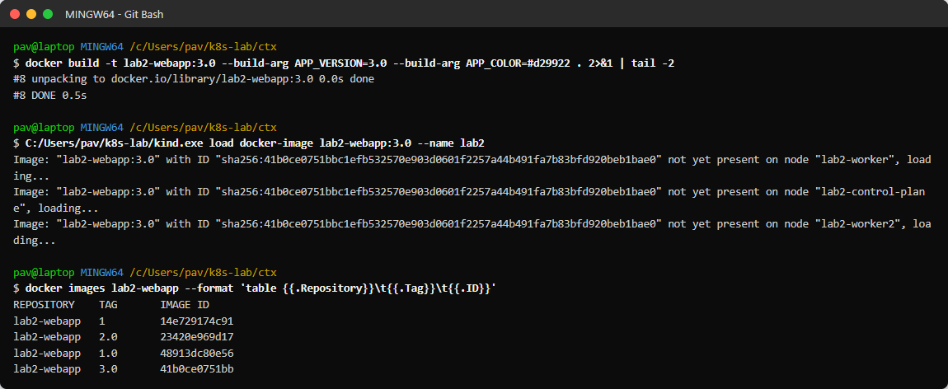
Figure 1.2: Building version 3.0 and loading it into the cluster
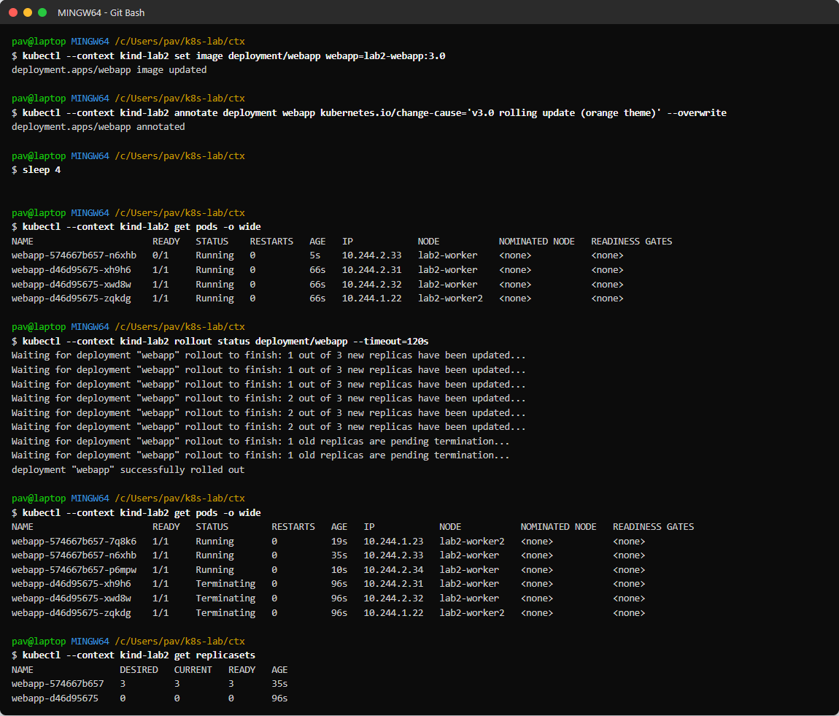
Figure 1.3: Rolling update in progress - new pods created one at a time, old ReplicaSet scaled to 0
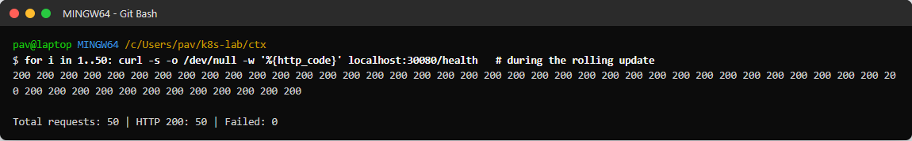
Figure 1.4: Availability test - /health requested every 0.4 s during the whole rolling update
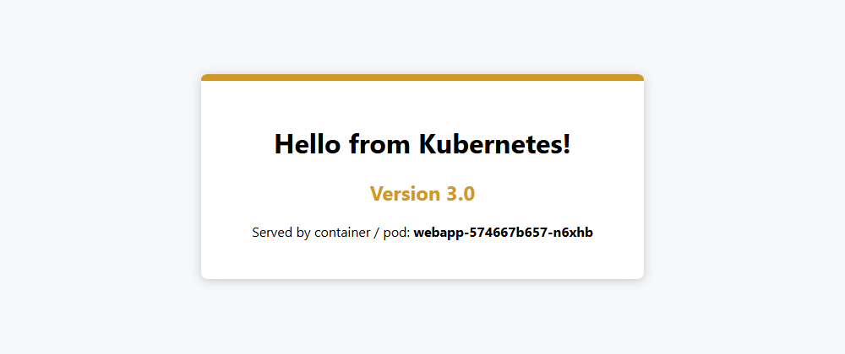
Figure 1.5: Version 3.0 served after the update
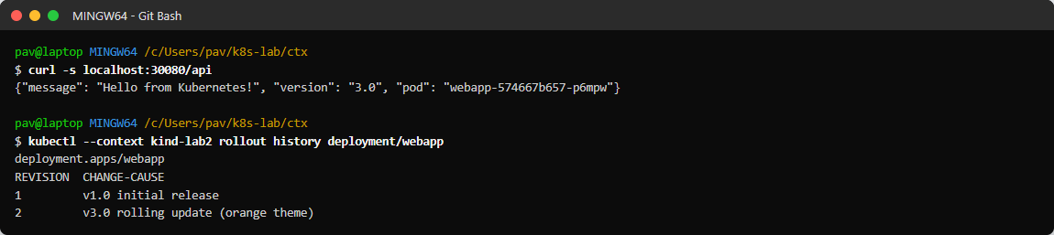
Figure 1.6: Rollout history with change-cause annotations

Experiment 3: Failed release and rollback
kubectl set image deployment/webapp webapp=lab2-webapp:broken # image does not exist
kubectl rollout status deployment/webapp --timeout=25s # times out
kubectl get pods; kubectl describe pod <new-pod>
kubectl rollout undo deployment/webapp

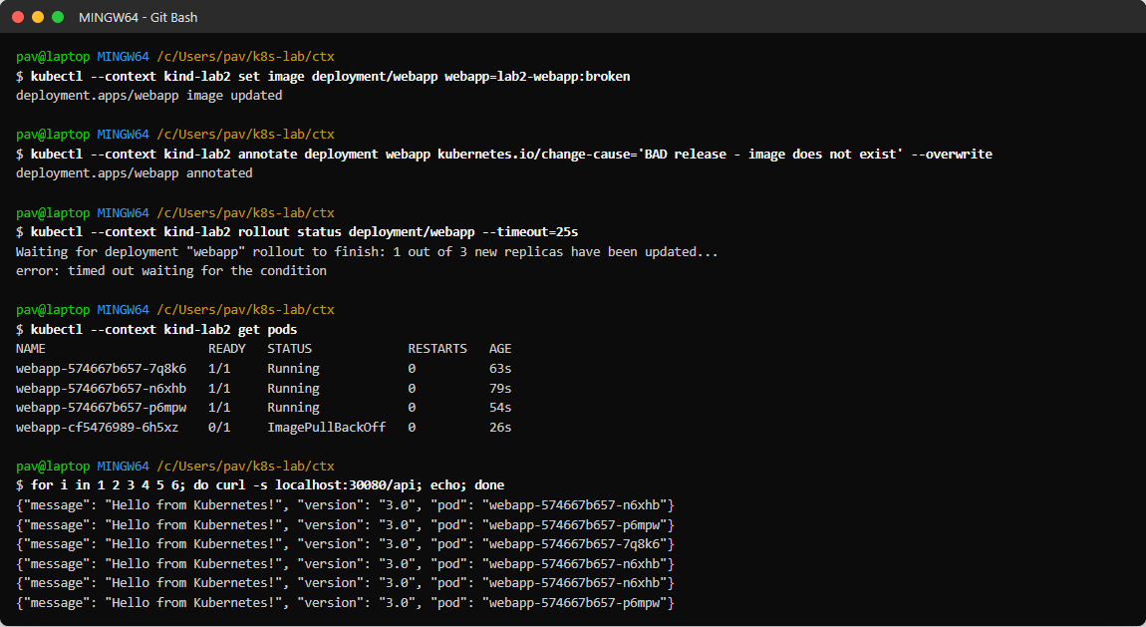
Figure 1.7: Bad release - new pod stuck in ErrImagePull while old v3.0 pods keep serving traffic
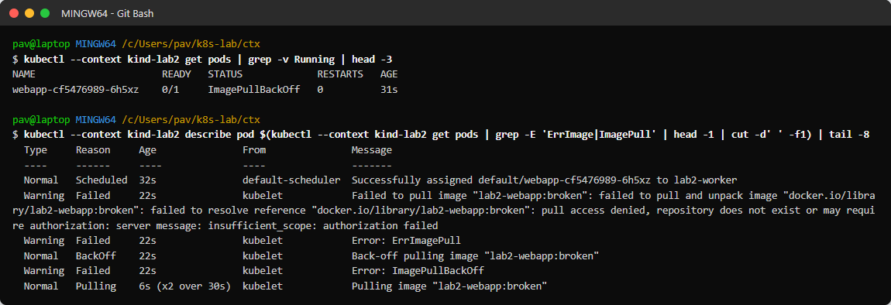
Figure 1.8: Diagnosing the failure with kubectl describe pod
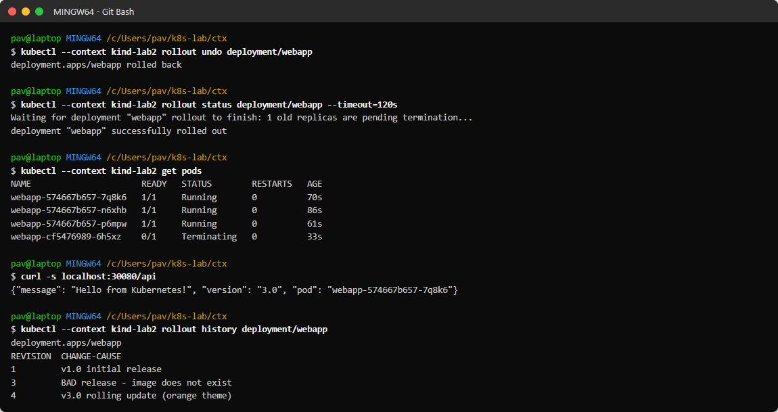
Figure 1.9: kubectl rollout undo - back to v3.0, broken pod removed

Experiment 4: Rollback to a specific revision
kubectl rollout undo deployment/webapp --to-revision=1

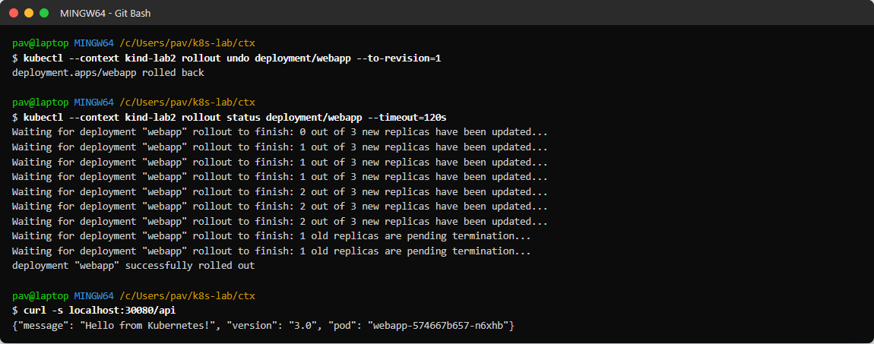
Figure 1.10: Rollback to revision 1 (v1.0)
Note: the single curl immediately after the rollout reached an old v3.0 pod that was still terminating; the next experiment shows all traffic served by the v1.0 pods (ReplicaSet webapp-d46d95675).
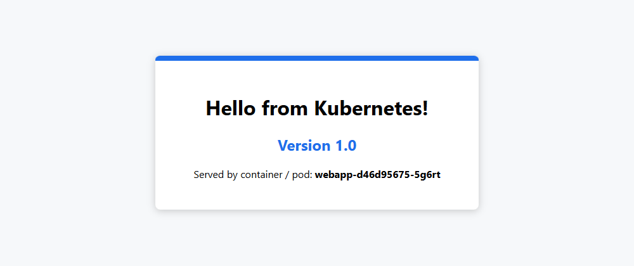
Figure 1.11: Application after rollback to v1.0

Experiment 5: Scaling replicas
kubectl scale deployment webapp --replicas=8
kubectl get pods -o wide
kubectl scale deployment webapp --replicas=2

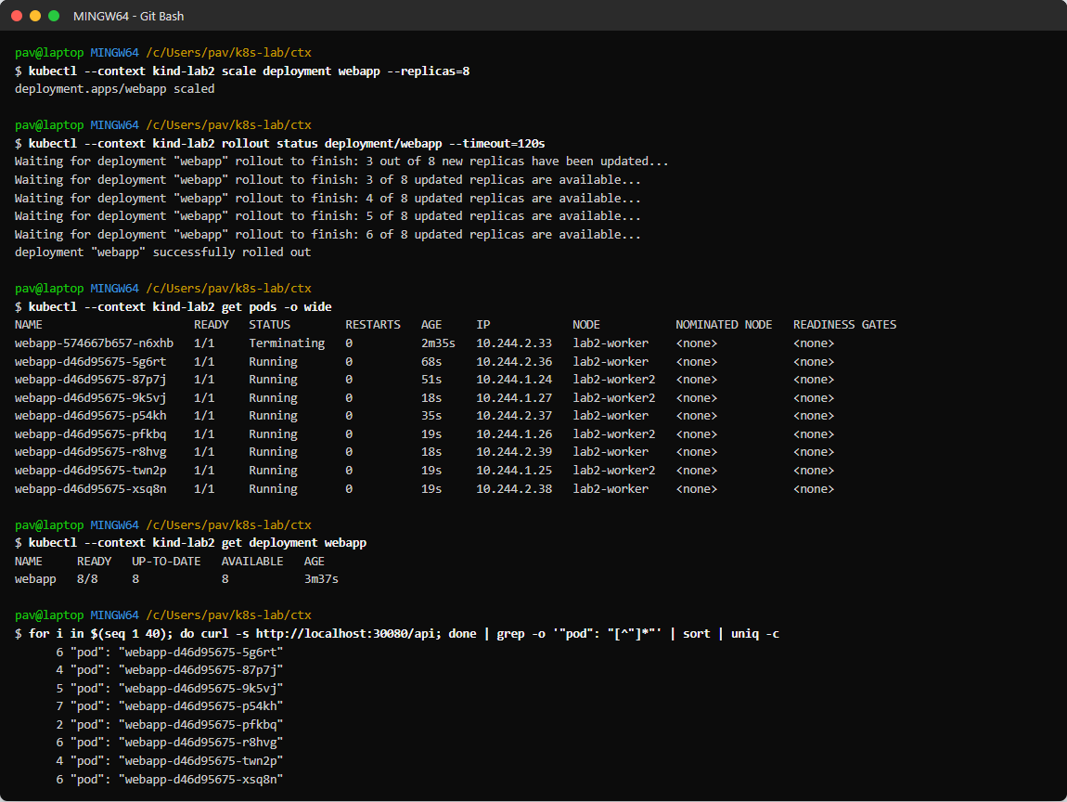
Figure 1.12: Scaled to 8 replicas on both worker nodes - 40 requests spread over all 8 pods
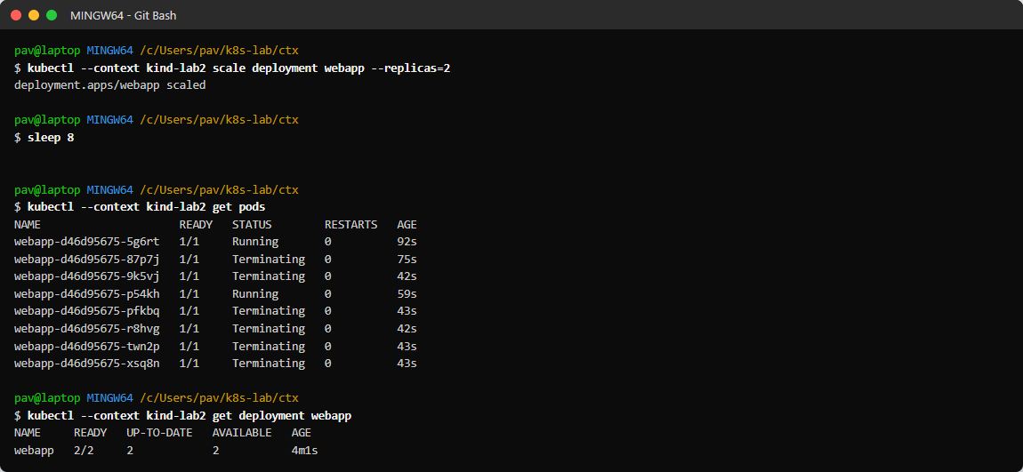
Figure 1.13: Scaled down to 2 replicas - extra pods terminated

Experiment 6: Recreate strategy
kubectl patch deployment webapp -p '{"spec":{"strategy":{"type":"Recreate","rollingUpdate":null}}}'
kubectl set image deployment/webapp webapp=lab2-webapp:2.0
kubectl get pods # all old pods Terminating before new ones start
kubectl patch deployment webapp -p '{"spec":{"strategy":{"type":"RollingUpdate",...}}}'

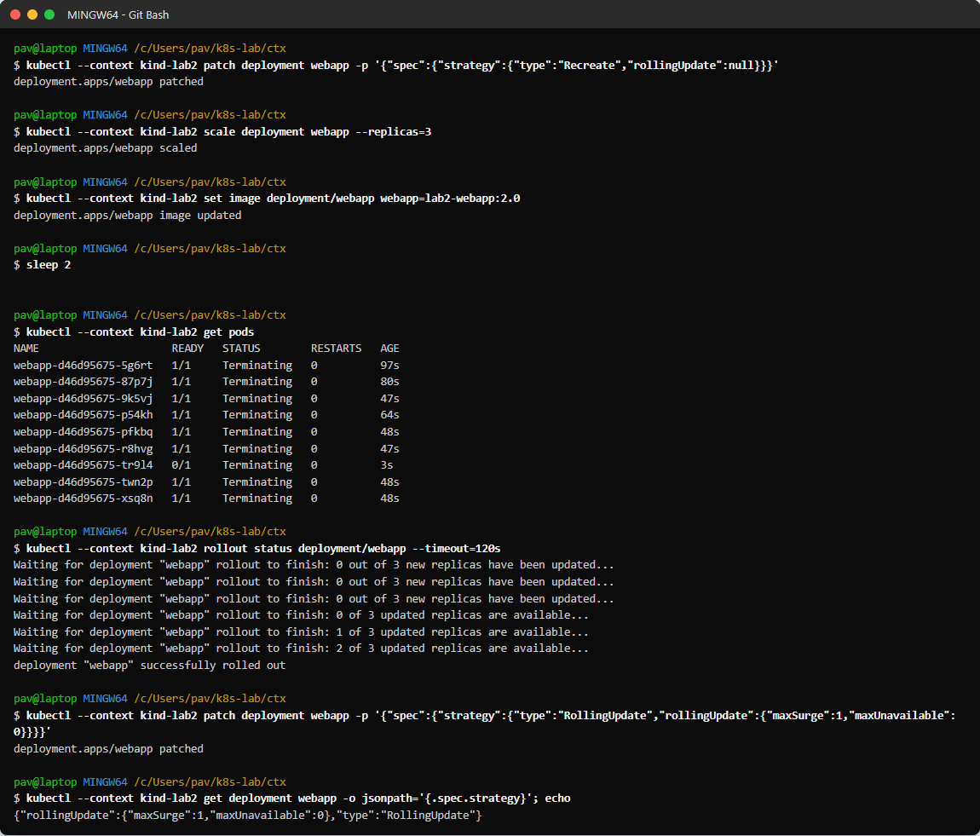
Figure 1.14: Recreate strategy - all old pods terminated at once, then strategy restored to RollingUpdate

Results
Experiment | Result
Rolling update v1.0 -> v3.0 | Completed; Total requests: 50 | HTTP 200: 50 | Failed: 0
Failed release (missing image) | Rollout timed out, new pod in ErrImagePull, old pods kept serving v3.0 - users not affected
rollout undo | Returned to v3.0 in a few seconds
undo --to-revision=1 | Returned to v1.0
Scale 3 -> 8 -> 2 | 8 pods ready on 2 nodes, load spread over all 8; scale-down removed 6 pods
Recreate strategy | All pods replaced at once (brief downtime), suitable only when versions cannot run side by side

Observations
- With maxSurge 1 / maxUnavailable 0 and a readiness probe, the rolling update caused zero failed requests.
- A bad release does not take the application down: the old ReplicaSet stays up because the new pods never become ready.
- Every change creates a revision; change-cause annotations make the history readable and rollback targets easy to choose.
- Scaling is immediate when the image is already on the nodes; the Service load-balances to new pods automatically.
- Recreate is simpler but causes downtime - RollingUpdate is the better default for stateless web apps.

Conclusion
Rolling updates, rollbacks (previous and specific revision), the Recreate strategy and scaling of replicas were implemented and verified on a Kubernetes cluster.

