Lab 2: Containerization & Kubernetes Orchestration
Session 2 - Question 2: Configure continuous deployment with Kubernetes (5 marks)
Name | Sachin Kumar
Roll No. | 2301010366
Course | DevOps
Date of Experiment | 06-10-2026
Tools Used | Docker 29.3.1, Kubernetes v1.34 (kind v0.30, 3 nodes), kubectl 1.34, Jenkins 2.580.1, Git 2.53, Windows 11

Problem Statement
Configure continuous deployment using Kubernetes by integrating the deployment with the CI/CD pipeline and automating manifest application.

Aim
To build a continuous deployment (CD) pipeline in Jenkins that, on every Git commit, tests the code, builds a Docker image, loads it into the Kubernetes cluster, applies the Kubernetes manifests automatically and verifies the rollout.

Environment
Component | Details
CI/CD server | Jenkins 2.580.1 LTS (Pipeline, Git plugins) on http://localhost:8080
Repository | webapp-cd (Git, branch main): app.py, Dockerfile, VERSION, k8s/*.yaml, Jenkinsfile
Cluster | kind cluster 'lab2' (kubectl context kind-lab2), 1 control-plane + 2 workers
Trigger | Poll SCM every minute (a GitHub webhook can be used instead)

CD Architecture
Developer --git push--> Git repo (main) --Poll SCM--> Jenkins pipeline
Checkout -> Test (py_compile + kubectl apply --dry-run) -> Build Image (lab2-webapp:<BUILD_NUMBER>)
-> Load Image to Cluster (kind load) -> Deploy (kubectl apply -f k8s/ ; kubectl set image)
-> Verify Rollout (rollout status, get pods, curl) post failure: kubectl rollout undo
|
Kubernetes Deployment webapp -> pods -> Service :30080

Jenkinsfile
// Continuous Deployment pipeline: Git commit -> Jenkins -> Docker image -> Kubernetes
pipeline {
agent any

environment {
KUBE_CTX = 'kind-lab2'
KIND_BIN = 'C:/Users/pav/k8s-lab/kind.exe'
IMAGE = "lab2-webapp:${env.BUILD_NUMBER}"
}

triggers {
pollSCM('* * * * *')
}

options {
timestamps()
buildDiscarder(logRotator(numToKeepStr: '10'))
}

stages {
stage('Checkout') {
steps {
checkout scm
bat 'git log --oneline -3'
}
}
stage('Test') {
steps {
// fail fast: syntax check and manifest validation before anything is built or deployed
bat 'python -m py_compile app.py'
bat 'kubectl --context %KUBE_CTX% apply --dry-run=client -f k8s/'
}
}
stage('Build Image') {
steps {
script { env.APP_VERSION = readFile('VERSION').trim() }
bat 'docker build -t %IMAGE% --build-arg APP_VERSION=%APP_VERSION% .'
}
}
stage('Load Image to Cluster') {
steps {
bat '%KIND_BIN% load docker-image %IMAGE% --name lab2'
}
}
stage('Deploy to Kubernetes') {
steps {
bat 'kubectl --context %KUBE_CTX% apply -f k8s/'
bat 'kubectl --context %KUBE_CTX% set image deployment/webapp webapp=%IMAGE%'
bat 'kubectl --context %KUBE_CTX% annotate deployment webapp kubernetes.io/change-cause="Jenkins build %BUILD_NUMBER% - version %APP_VERSION%" --overwrite'
}
}
stage('Verify Rollout') {
steps {
bat 'kubectl --context %KUBE_CTX% rollout status deployment/webapp --timeout=120s'
bat 'kubectl --context %KUBE_CTX% get pods -o wide'
bat 'curl -s http://localhost:30080/api'
}
}
}

post {
success {
echo "Deployed ${env.IMAGE} (version ${env.APP_VERSION}) to Kubernetes."
}
failure {
echo 'Pipeline FAILED - nothing new was released (or the rollout is being rolled back).'
bat(returnStatus: true, script: 'kubectl --context %KUBE_CTX% rollout undo deployment/webapp')
}
}
}

Kubernetes manifests applied by the pipeline
apiVersion: apps/v1
kind: Deployment
metadata:
name: webapp
labels:
app: webapp
spec:
replicas: 3
selector:
matchLabels:
app: webapp
strategy:
type: RollingUpdate
rollingUpdate:
maxSurge: 1
maxUnavailable: 0
template:
metadata:
labels:
app: webapp
spec:
containers:
- name: webapp
image: lab2-webapp:1.0 # replaced by the pipeline with lab2-webapp:<build number>
imagePullPolicy: IfNotPresent
ports:
- containerPort: 5000
envFrom:
- configMapRef:
name: webapp-config
resources:
requests:
cpu: 50m
memory: 32Mi
limits:
cpu: 200m
memory: 64Mi
readinessProbe:
httpGet:
path: /health
port: 5000
initialDelaySeconds: 2
periodSeconds: 5
livenessProbe:
httpGet:
path: /health
port: 5000
initialDelaySeconds: 5
periodSeconds: 10

apiVersion: v1
kind: Service
metadata:
name: webapp-service
spec:
type: NodePort
selector:
app: webapp
ports:
- port: 80
targetPort: 5000
nodePort: 30080

apiVersion: v1
kind: ConfigMap
metadata:
name: webapp-config
data:
APP_MESSAGE: "Version 2 released by the CD pipeline!"

Procedure
- Created the repository webapp-cd with the app, Dockerfile, VERSION file, k8s/ manifests and the Jenkinsfile; pushed it to the remote (origin).
- Jenkins > New Item > 'Lab2-CD-Kubernetes-Pipeline' > Pipeline. Triggers: Poll SCM (* * * * *). Pipeline script from SCM: Git, branch */main, Script Path Jenkinsfile.
- Jenkins runs as the same user as kubectl, so it uses the kind-lab2 kubeconfig context (in a real cluster a kubeconfig credential would be added in Jenkins).
- Pushed commits and observed Jenkins build and deploy each one automatically.

Output / Screenshots
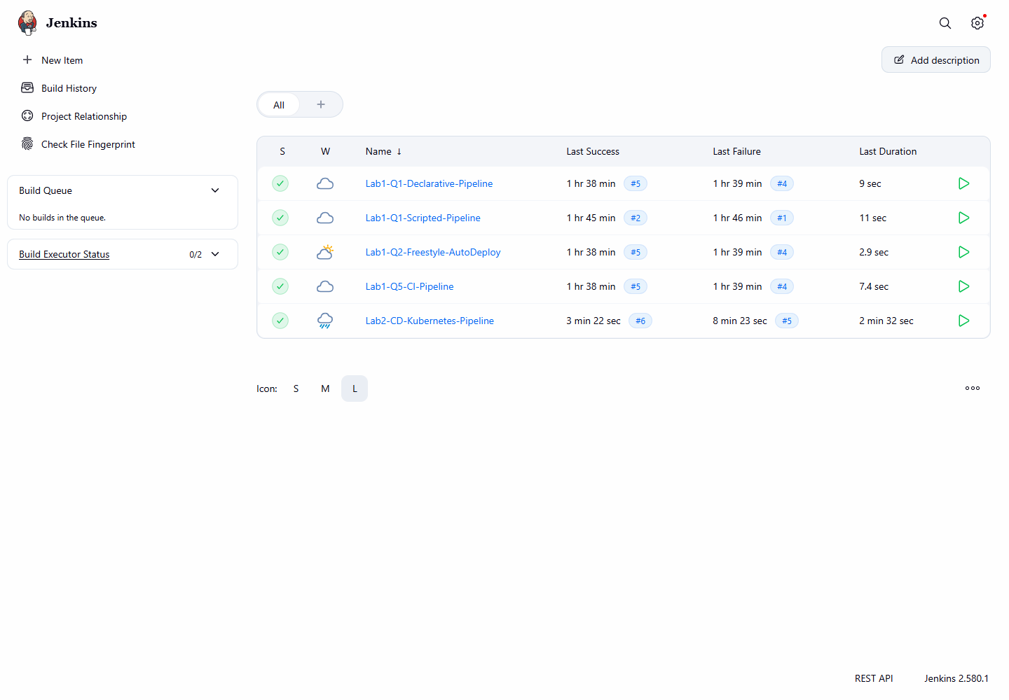
Figure 2.1: Jenkins dashboard with the CD job
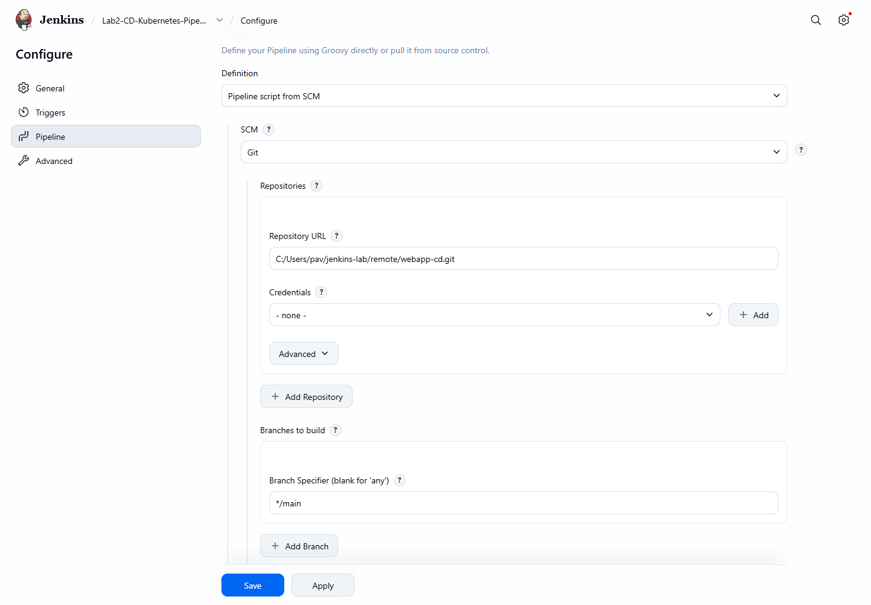
Figure 2.2: Pipeline script from SCM (Git repository)
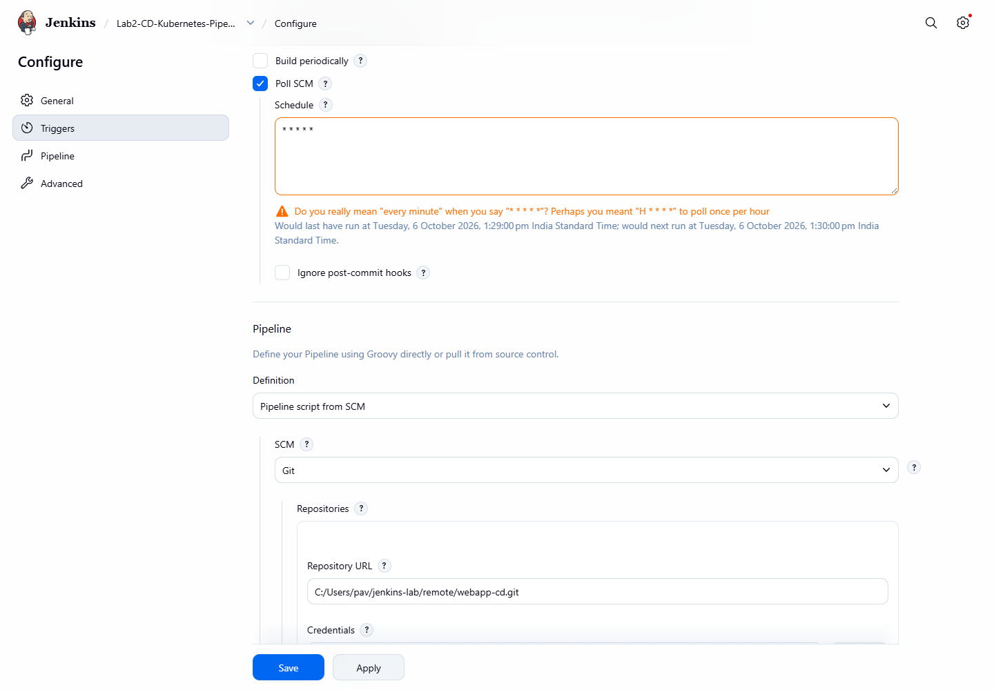
Figure 2.3: Poll SCM trigger
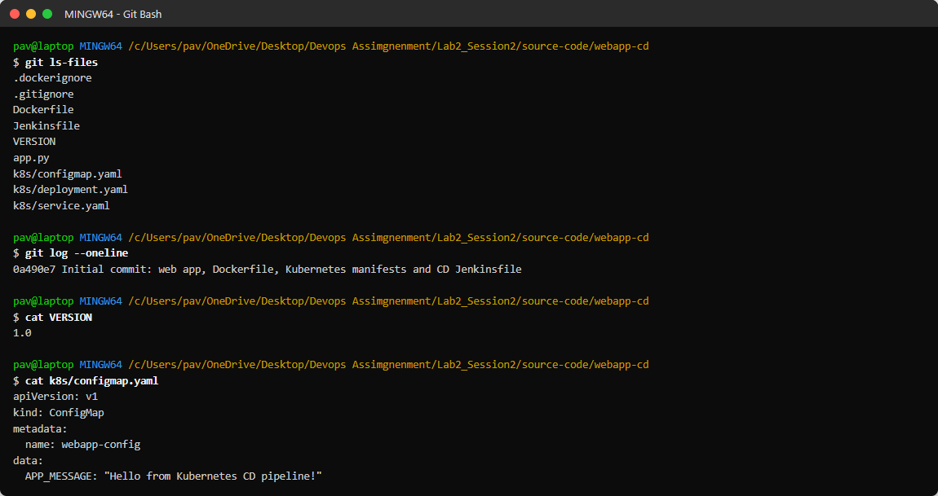
Figure 2.4: Repository content and initial commit

Commit 1: Release 2.0 (code + ConfigMap change)
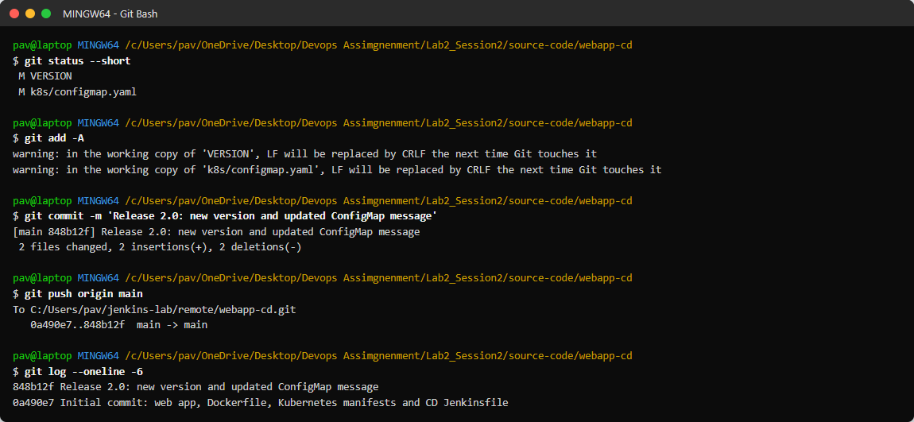
Figure 2.5: Commit and push
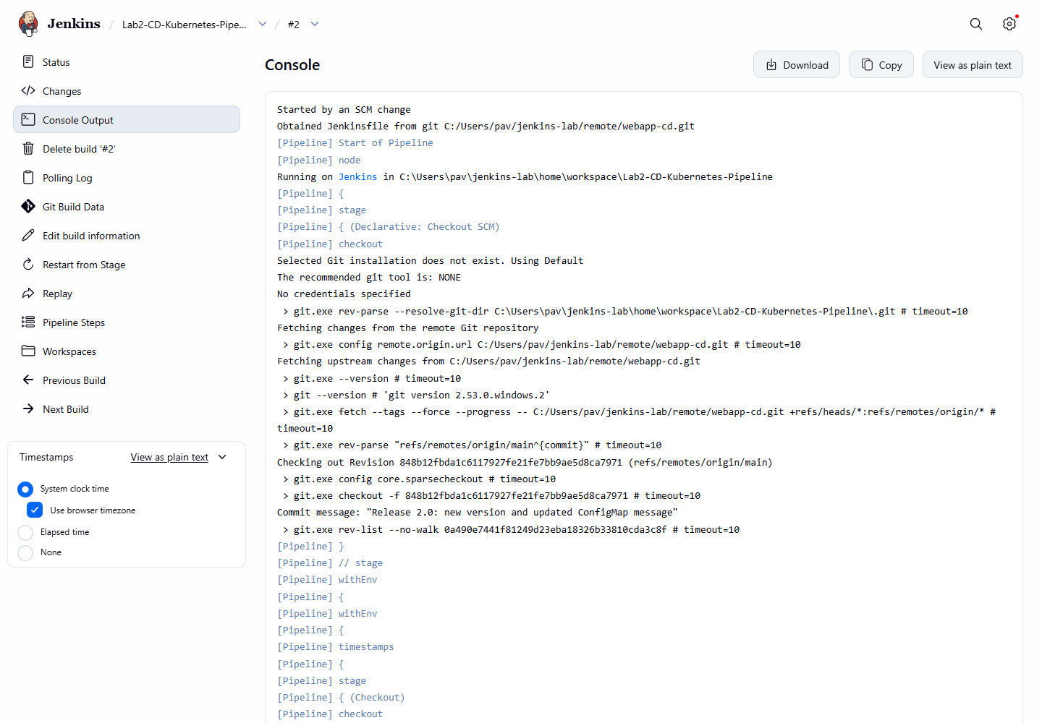
Figure 2.6: Build #2 'Started by an SCM change' - checkout of the new commit
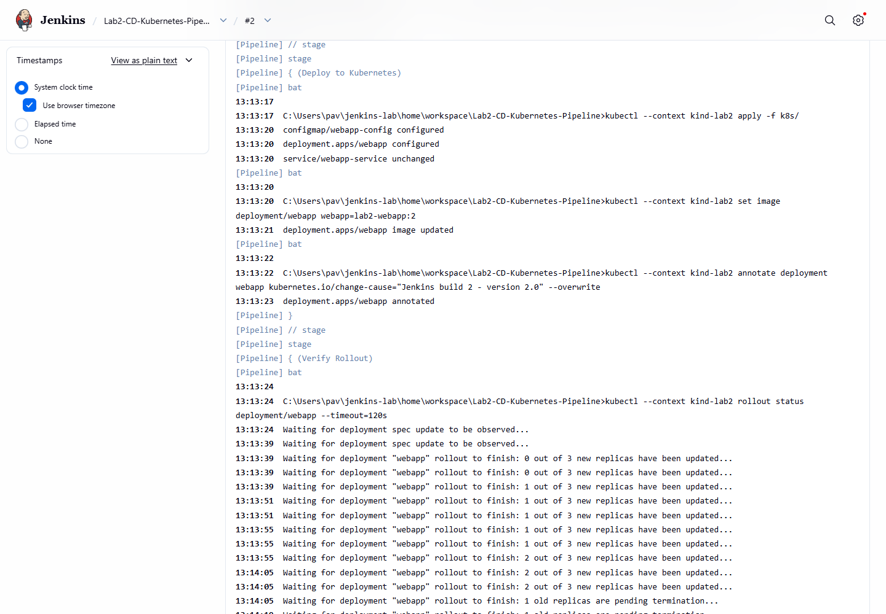
Figure 2.7: Deploy stage - kubectl apply -f k8s/ and kubectl set image
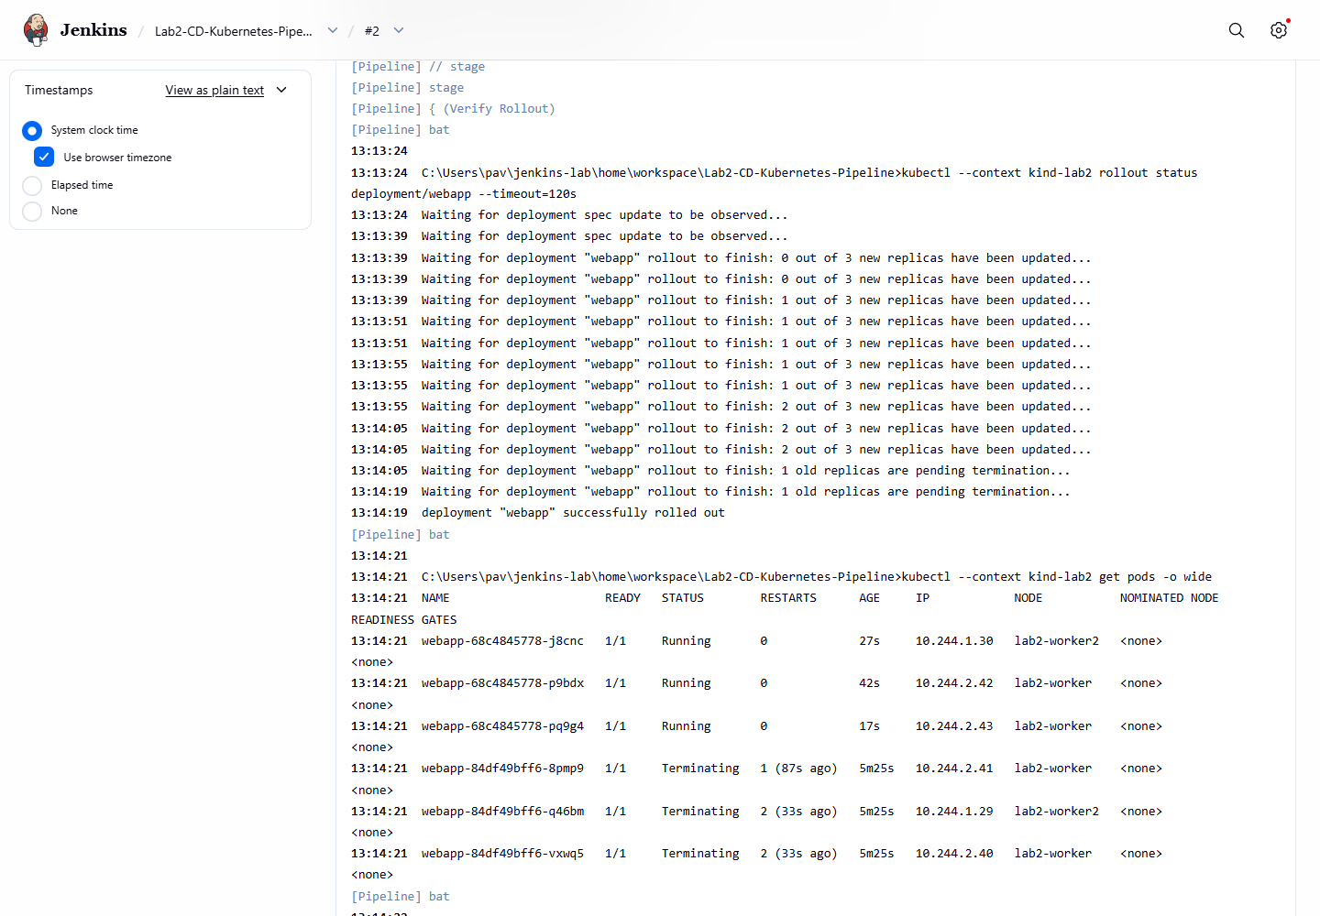
Figure 2.8: Verify stage - rollout status, pods and curl
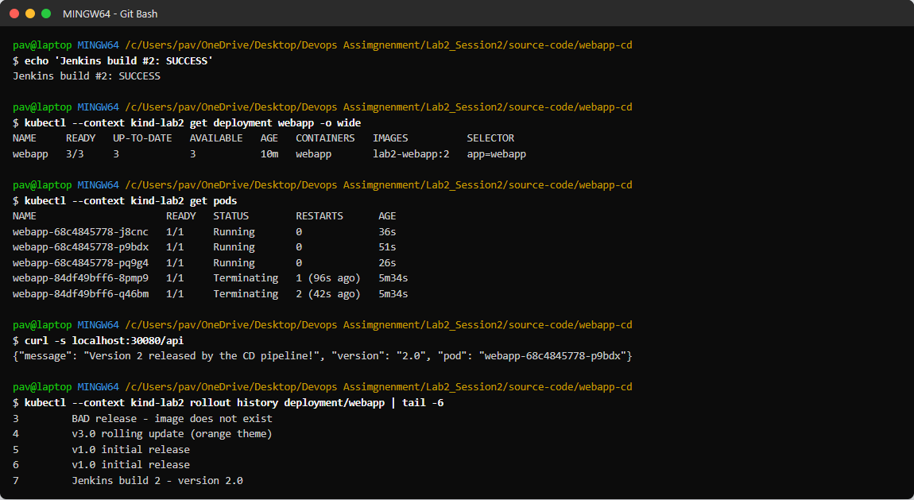
Figure 2.9: Cluster after build #2 - version 2.0 with the new ConfigMap message

Commit 2: Manifest-only change (replicas 3 -> 5)
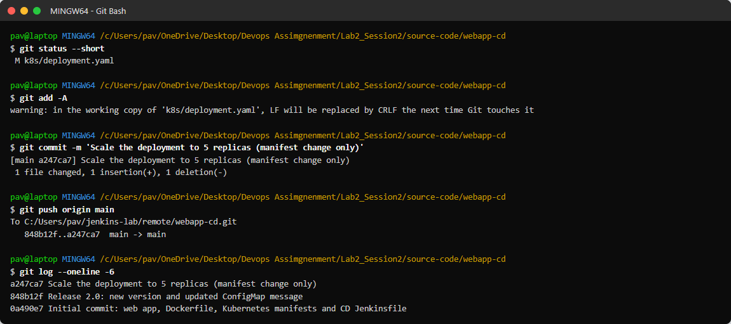
Figure 2.10: Changing replicas in deployment.yaml
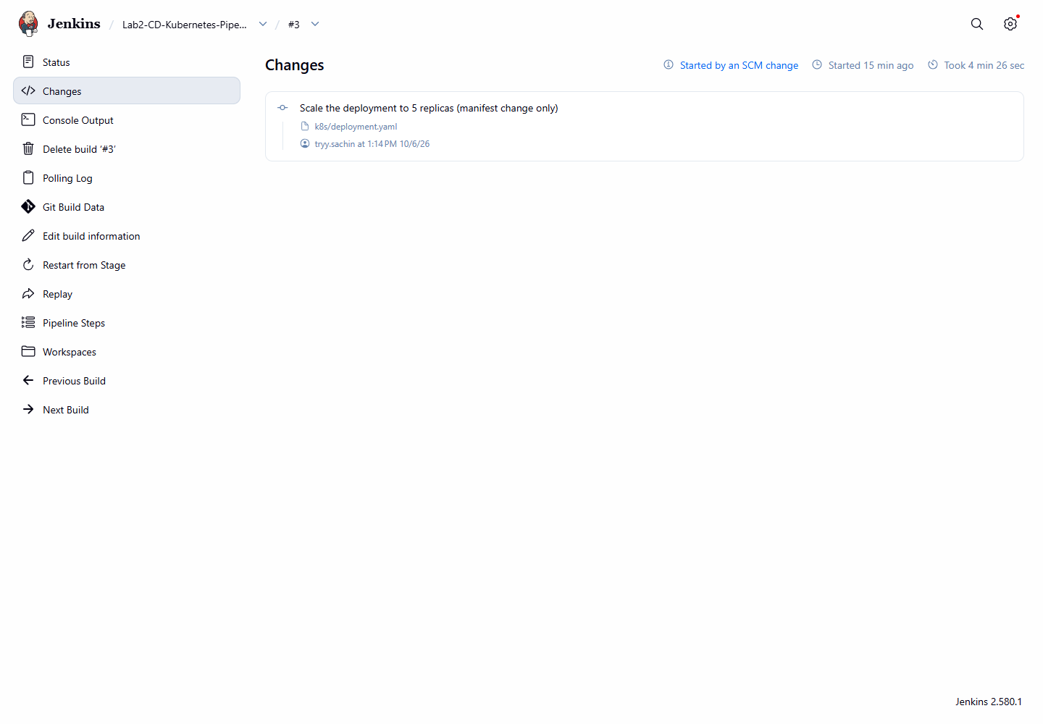
Figure 2.11: Build #3 changes - the manifest commit
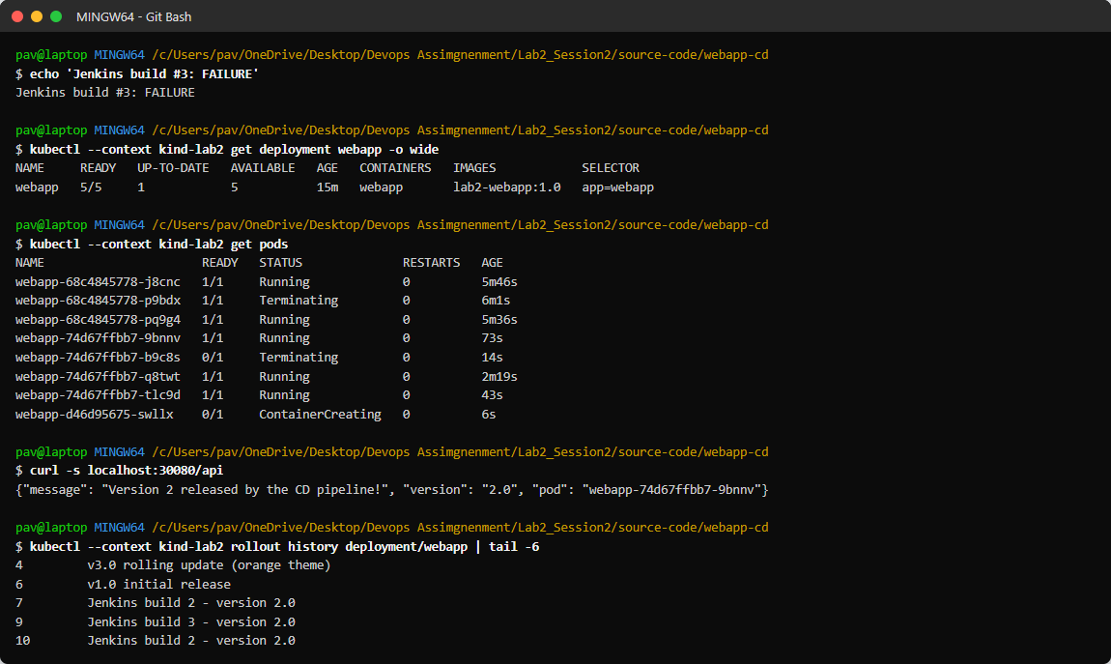
Figure 2.12: State after build #3: the pipeline applied replicas: 5, but rolling 5 pods took longer than the 120 s rollout timeout on this laptop, so the failure handler ran kubectl rollout undo (pods being replaced)

Commit 3: Bad commit (syntax error)
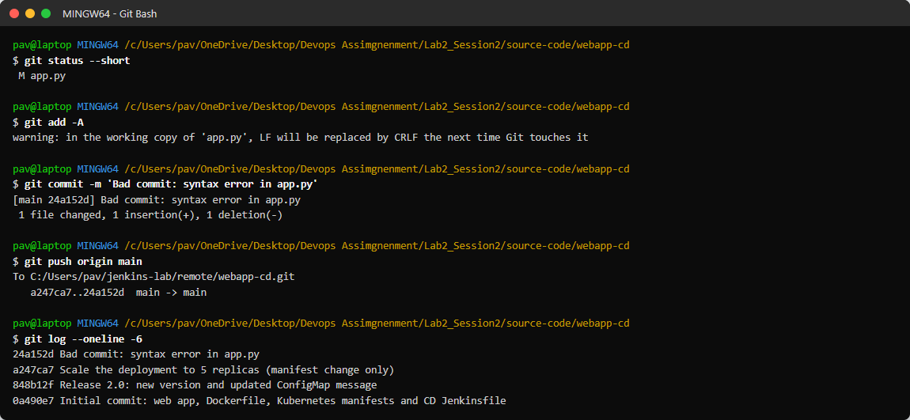
Figure 2.13: Pushing a broken app.py
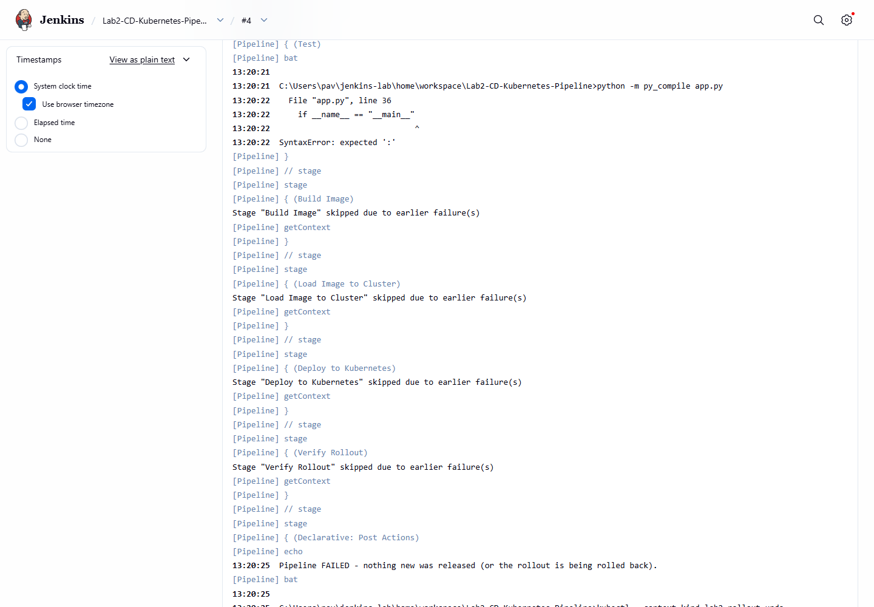
Figure 2.14: Build #4 fails in the Test stage - nothing is deployed
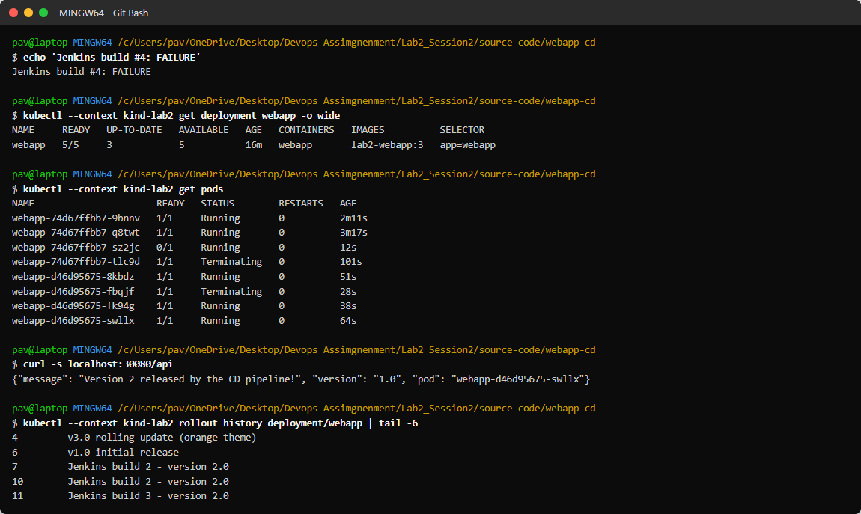
Figure 2.15: After build #4: the broken code never reached Kubernetes (no image lab2-webapp:4 was built); the pods shown are still settling from the build #3 rollback

Commit 4 and 5: Revert, then Release 3.0
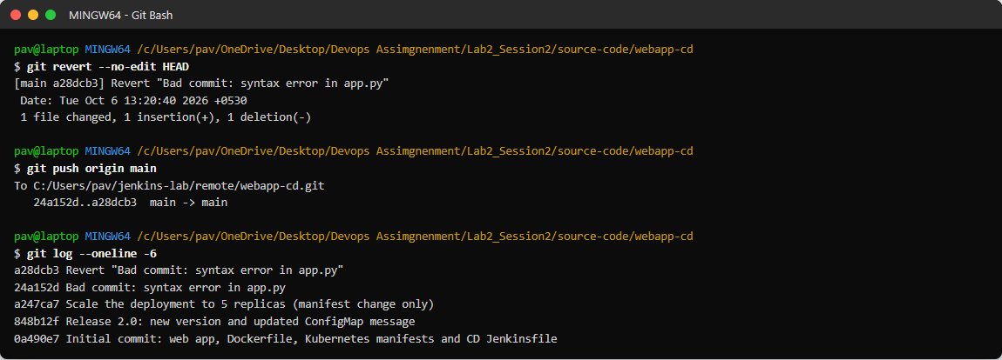
Figure 2.16: git revert of the bad commit
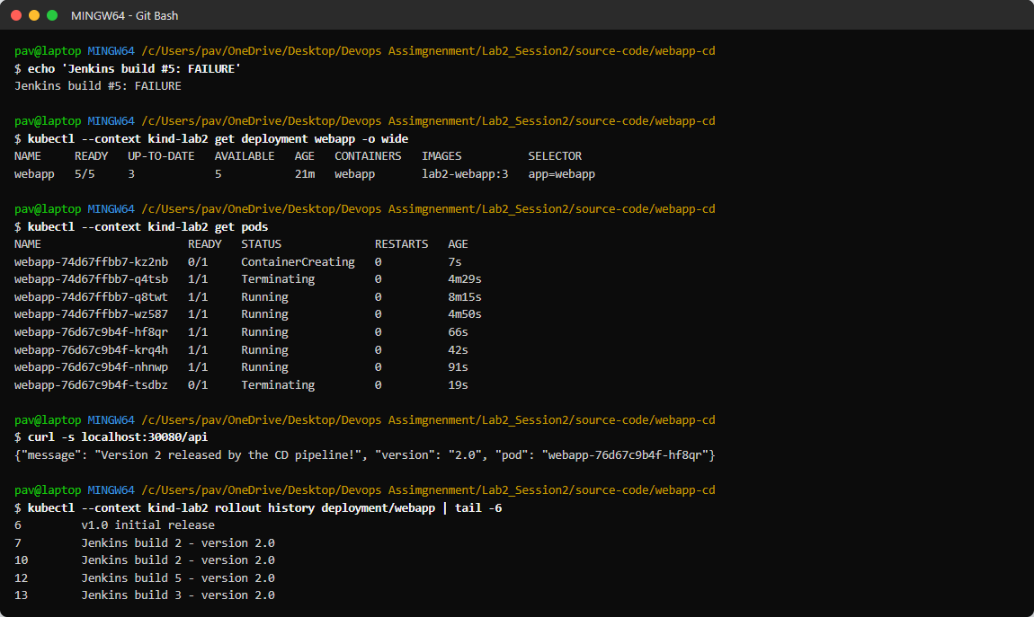
Figure 2.17: Build #5 (revert, still 5 replicas) - same rollout timeout, automatically rolled back again
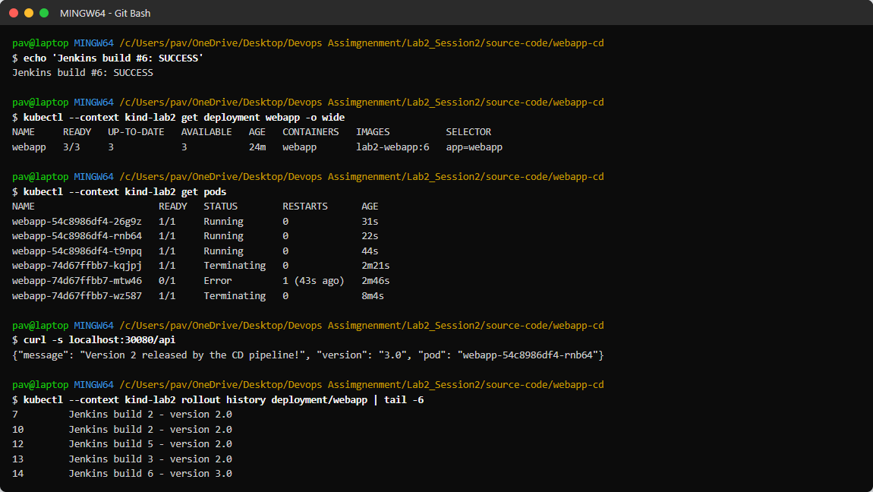
Figure 2.18: Build #6 - version 3.0 deployed and scaled back to 3 replicas
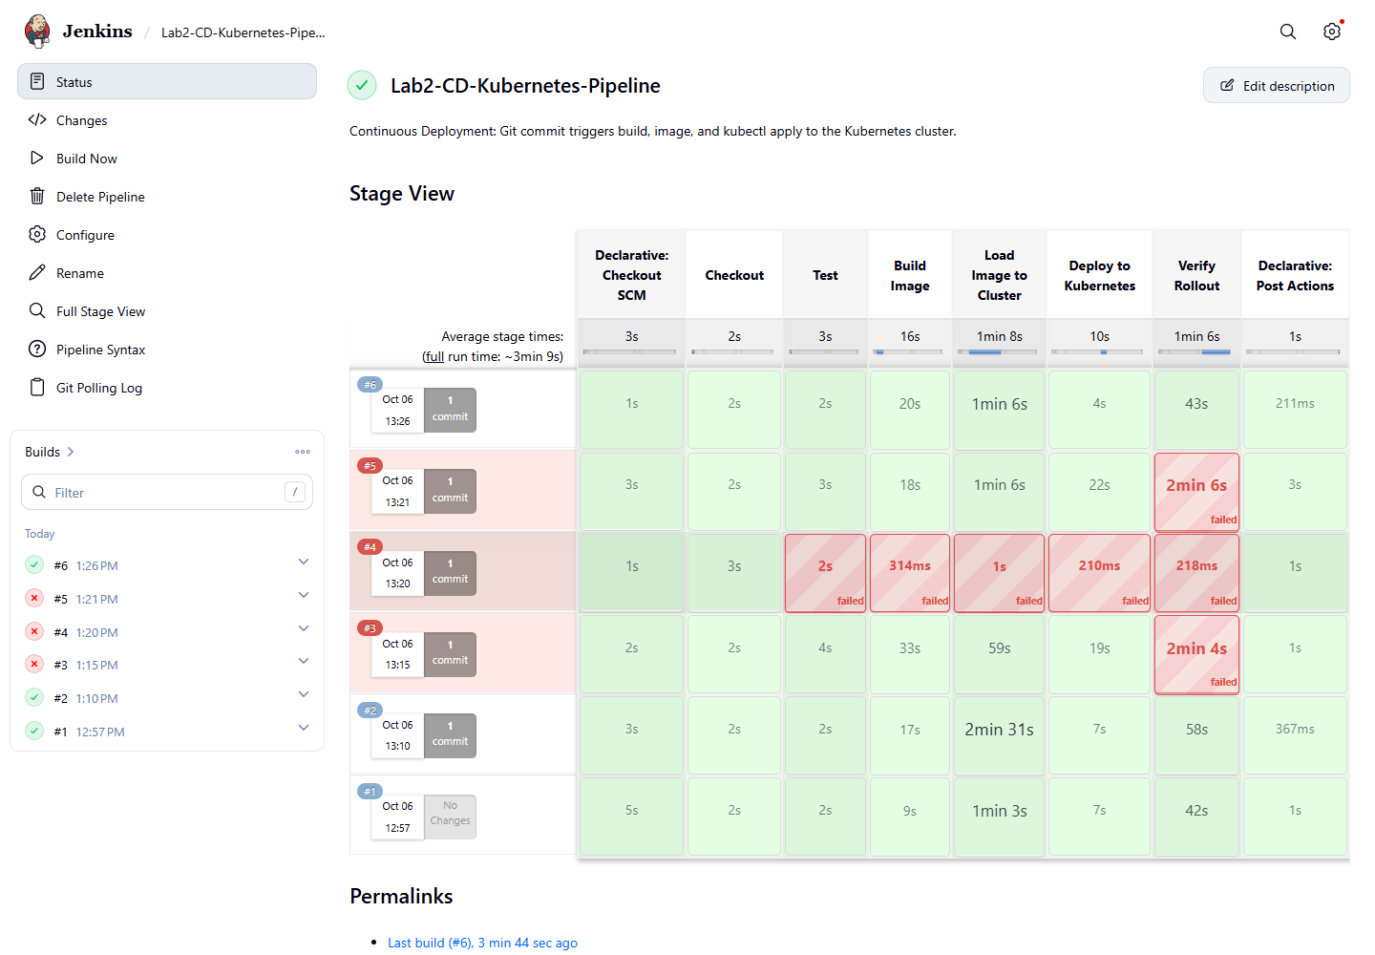
Figure 2.19: Stage View of all CD builds
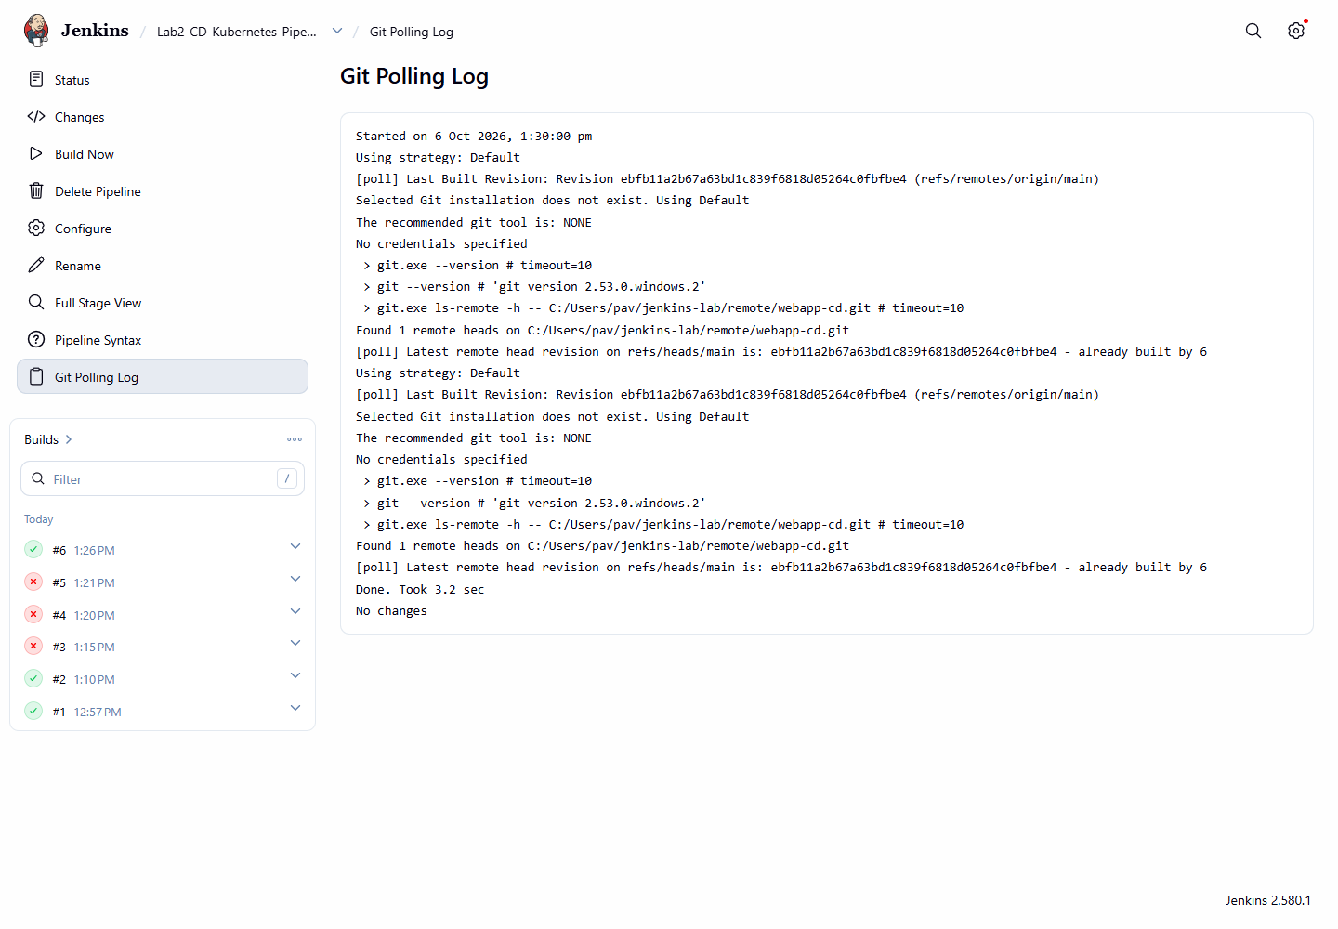
Figure 2.20: Git polling log
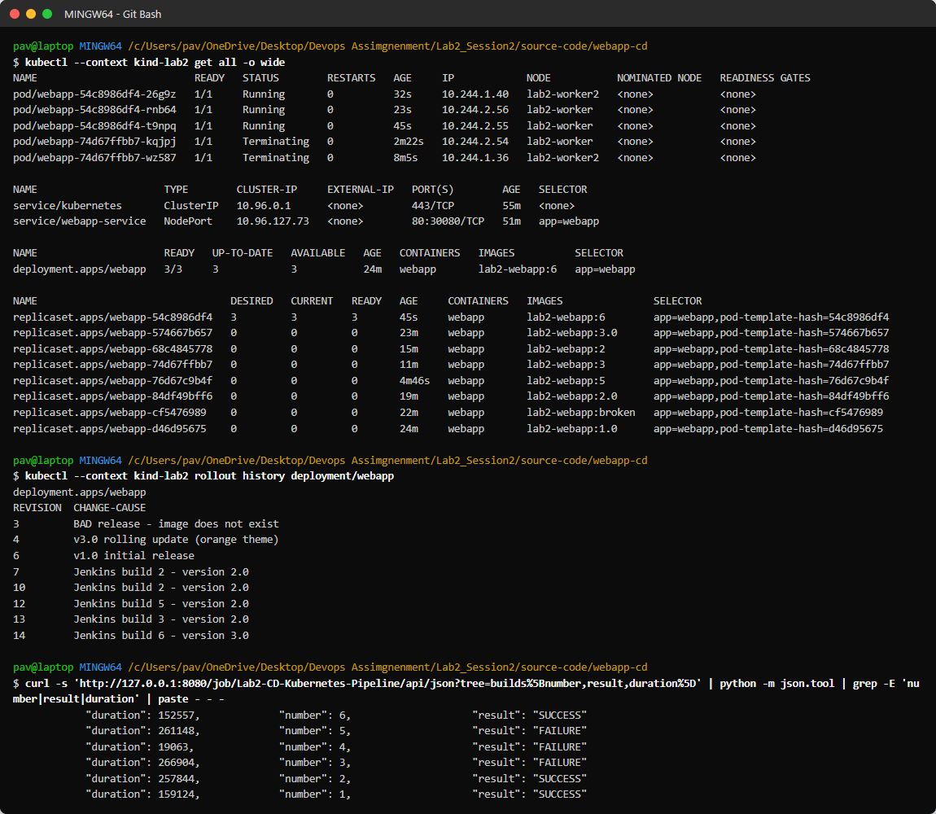
Figure 2.21: Final cluster state, rollout history (one revision per Jenkins build) and build results
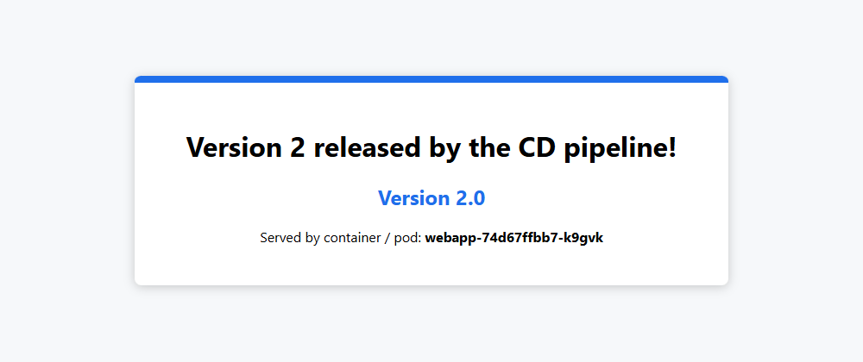
Figure 2.22: Application in the browser after continuous deployment

Results
Build | Trigger | Commit | Result | Duration
#1 | Poll SCM (SCM change) | 0a490e7 Initial commit | SUCCESS | 159 s
#2 | Poll SCM (SCM change) | 848b12f Release 2.0: new version and updated ConfigMap message | SUCCESS | 258 s
#3 | Poll SCM (SCM change) | a247ca7 Scale the deployment to 5 replicas (manifest change only) | FAILURE | 267 s
#4 | Poll SCM (SCM change) | 24a152d Bad commit: syntax error in app.py | FAILURE | 19 s
#5 | Poll SCM (SCM change) | a28dcb3 Revert "Bad commit: syntax error in app.py" | FAILURE | 261 s
#6 | Poll SCM (SCM change) | ebfb11a Release 3.0 and scale back to 3 replicas | SUCCESS | 153 s

Observations
- Every push started a pipeline automatically (Poll SCM) - 6 builds, all 'Started by an SCM change'. Successful deployments took about 2.5-4.5 minutes on this laptop.
- Because the pipeline runs kubectl apply -f k8s/, a change to the YAML alone (replicas 3 -> 5) was applied by the pipeline with no manual kubectl - the manifests in Git are the source of truth.
- Each image is tagged with the Jenkins build number, so every Kubernetes revision can be traced back to a build and commit.
- The Test stage (syntax check + kubectl apply --dry-run) stopped the bad commit before an image was built; the running application was not affected.
- Builds #3 and #5 failed in Verify Rollout: with 5 replicas the rollout took longer than the 120 s timeout on this (slow) laptop. The post { failure } block automatically ran kubectl rollout undo, so a release that could not be verified was reverted without human action. Lesson: the rollout timeout must match the cluster speed (e.g. 300 s) - build #6 with 3 replicas finished in time.
- Successive rollbacks and new builds overlapped on the slow cluster, so intermediate snapshots show pods still being replaced; the final state after build #6 is clean (3/3 pods, lab2-webapp:6, version 3.0).

Conclusion
Continuous deployment to Kubernetes was configured: Jenkins detects each commit, tests it, builds and loads the image, applies the manifests and verifies the rollout automatically, and stops bad commits before they reach the cluster.

