Lab 3: Monitoring, Logging & DevSecOps
Session 1 - Question 1: Set up monitoring using Prometheus and Grafana (5 marks)
Name | Sachin kumar
Roll No. | 2301010366
Course | Bthech(cse)
Date of Experiment | 06-10-2026
Tools Used | Docker Compose, Prometheus v2.55.1, Grafana 11.3.0, Node Exporter v1.8.2, Python 3.12 (prometheus_client), Windows 11

Problem Statement
Set up monitoring using Prometheus and visualize metrics using Grafana dashboards for a target application or system.

Aim
To set up Prometheus to collect metrics from a target application and from the host system, and to visualize those metrics on Grafana dashboards.

Theory
- Prometheus: an open-source monitoring system that pulls (scrapes) metrics over HTTP from targets at a fixed interval, stores them as time series and lets you query them with PromQL.
- Exporters / instrumentation: targets expose metrics on a /metrics endpoint. Node Exporter exposes host CPU, memory, disk and network metrics; the demo app exposes its own metrics using the prometheus_client library.
- Metric types: Counter (only increases, e.g. requests), Gauge (goes up and down, e.g. requests in progress), Histogram (distribution, e.g. latency buckets).
- Grafana: a visualization tool that connects to Prometheus as a data source and shows PromQL queries as graphs, stats and dashboards.
- Alert rules: PromQL conditions evaluated by Prometheus, e.g. error rate > 5% or a target down.

Architecture
+-------------------- Docker Compose network --------------------+
| |
loadgen --HTTP--> demo-app :8000 node-exporter :9100 |
| /metrics :8001 /metrics |
| ^ ^ |
| +------ scrape every 5s ---+ |
| Prometheus :9090 (TSDB + alert rules) |
| ^ PromQL |
| Grafana :3000 (provisioned data source + |
| dashboard) |
+----------------------------------------------------------------+

Component | Image | Port | Purpose
demo-app | python:3.12-alpine + prometheus_client | 8000 / 8001 | Target application; exposes app_requests_total, app_request_duration_seconds, app_requests_in_progress, app_orders_total
loadgen | busybox:1.36 | - | Sends continuous traffic (/, /order, /missing) so metrics change
node-exporter | prom/node-exporter:v1.8.2 | 9100 | System metrics (CPU, memory, network)
prometheus | prom/prometheus:v2.55.1 | 9090 | Scrapes all targets every 5 s, evaluates alert rules
grafana | grafana/grafana:11.3.0 | 3000 | Dashboards; data source and dashboard provisioned from files

Configuration Files

docker-compose.yml
services:
demo-app:
build: ./app
container_name: demo-app
ports:
- "8000:8000"
- "8001:8001"

loadgen:
image: busybox:1.36
container_name: loadgen
command: ["sh", "/loadgen.sh"]
volumes:
- ./app/loadgen.sh:/loadgen.sh:ro
depends_on: [demo-app]

node-exporter:
image: prom/node-exporter:v1.8.2
container_name: node-exporter
ports:
- "9100:9100"

prometheus:
image: prom/prometheus:v2.55.1
container_name: prometheus
volumes:
- ./prometheus:/etc/prometheus:ro
- prometheus-data:/prometheus
ports:
- "9090:9090"
depends_on: [demo-app, node-exporter]

grafana:
image: grafana/grafana:11.3.0
container_name: grafana
environment:
- GF_SECURITY_ADMIN_USER=admin
- GF_SECURITY_ADMIN_PASSWORD=admin123
- GF_AUTH_ANONYMOUS_ENABLED=true
- GF_AUTH_ANONYMOUS_ORG_ROLE=Viewer
volumes:
- ./grafana/provisioning:/etc/grafana/provisioning:ro
- ./grafana/dashboards:/var/lib/grafana/dashboards:ro
- grafana-data:/var/lib/grafana
ports:
- "3000:3000"
depends_on: [prometheus]

volumes:
prometheus-data:
grafana-data:

prometheus/prometheus.yml
global:
scrape_interval: 5s
evaluation_interval: 5s

rule_files:
- /etc/prometheus/alert-rules.yml

scrape_configs:
- job_name: prometheus
static_configs:
- targets: ["localhost:9090"]

- job_name: node-exporter # host / system metrics
static_configs:
- targets: ["node-exporter:9100"]

- job_name: demo-app # application metrics
static_configs:
- targets: ["demo-app:8001"]

prometheus/alert-rules.yml
groups:
- name: demo-app-alerts
rules:
- alert: HighErrorRate
expr: sum(rate(app_requests_total{status=~"5.."}[1m])) / sum(rate(app_requests_total[1m])) > 0.05
for: 30s
labels:
severity: warning
annotations:
summary: "More than 5% of requests are failing"
- alert: TargetDown
expr: up == 0
for: 30s
labels:
severity: critical
annotations:
summary: "Target {{ $labels.job }} is down"

grafana/provisioning/datasources/prometheus.yml
apiVersion: 1
datasources:
- name: Prometheus
uid: prometheus
type: prometheus
access: proxy
url: http://prometheus:9090
isDefault: true

Instrumented application (app/app.py)
"""Demo web app instrumented with Prometheus metrics (prometheus_client)."""
import random
import time
from http.server import BaseHTTPRequestHandler, HTTPServer

from prometheus_client import Counter, Gauge, Histogram, start_http_server

REQUESTS = Counter("app_requests_total", "Total HTTP requests", ["endpoint", "status"])
LATENCY = Histogram("app_request_duration_seconds", "Request latency in seconds", ["endpoint"],
buckets=(0.01, 0.025, 0.05, 0.1, 0.25, 0.5, 1.0))
IN_PROGRESS = Gauge("app_requests_in_progress", "Requests currently being processed")
ORDERS = Counter("app_orders_total", "Business metric: orders placed")

class Handler(BaseHTTPRequestHandler):
def do_GET(self):
endpoint = self.path.split("?")[0]
IN_PROGRESS.inc()
start = time.time()
if endpoint == "/order":
time.sleep(random.uniform(0.05, 0.3))
status = 500 if random.random() < 0.1 else 200
if status == 200:
ORDERS.inc()
elif endpoint == "/":
time.sleep(random.uniform(0.005, 0.05))
status = 200
else:
status = 404
LATENCY.labels(endpoint).observe(time.time() - start)
REQUESTS.labels(endpoint, str(status)).inc()
IN_PROGRESS.dec()
body = f"status={status}\n".encode()
self.send_response(status)
self.send_header("Content-Length", str(len(body)))
self.end_headers()
self.wfile.write(body)

def log_message(self, *args):
pass

if __name__ == "__main__":
start_http_server(8001) # /metrics endpoint for Prometheus
print("App on :8000, metrics on :8001/metrics", flush=True)
HTTPServer(("0.0.0.0", 8000), Handler).serve_forever()

Procedure / Commands
- Wrote the demo application with Prometheus instrumentation and its Dockerfile.
- Wrote prometheus.yml with three scrape jobs (prometheus, node-exporter, demo-app) and alert rules.
- Wrote Grafana provisioning files so the Prometheus data source and the dashboard are created automatically.
- Started the stack: docker compose up -d --build
- Verified the targets in Prometheus (Status > Targets) and ran PromQL queries.
- Opened Grafana (http://localhost:3000, admin / admin123) and viewed the 'Lab 3 - Application & System Monitoring' dashboard.
docker compose up -d --build
docker compose ps
curl http://localhost:8001/metrics
curl http://localhost:9090/api/v1/targets
# Prometheus UI : http://localhost:9090
# Grafana UI : http://localhost:3000

Output / Screenshots
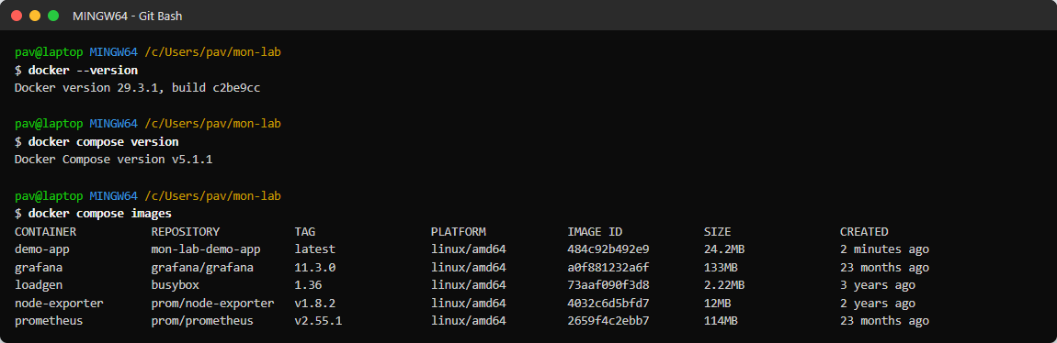
Figure 1.1: Docker / Compose versions and images used
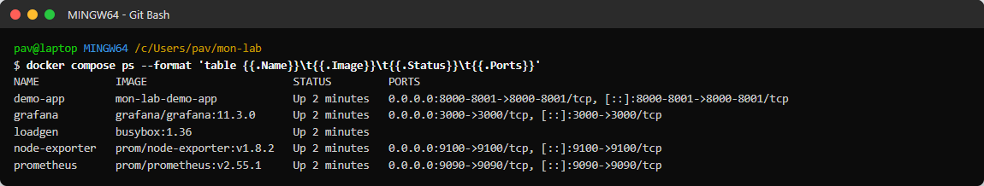
Figure 1.2: All five containers running
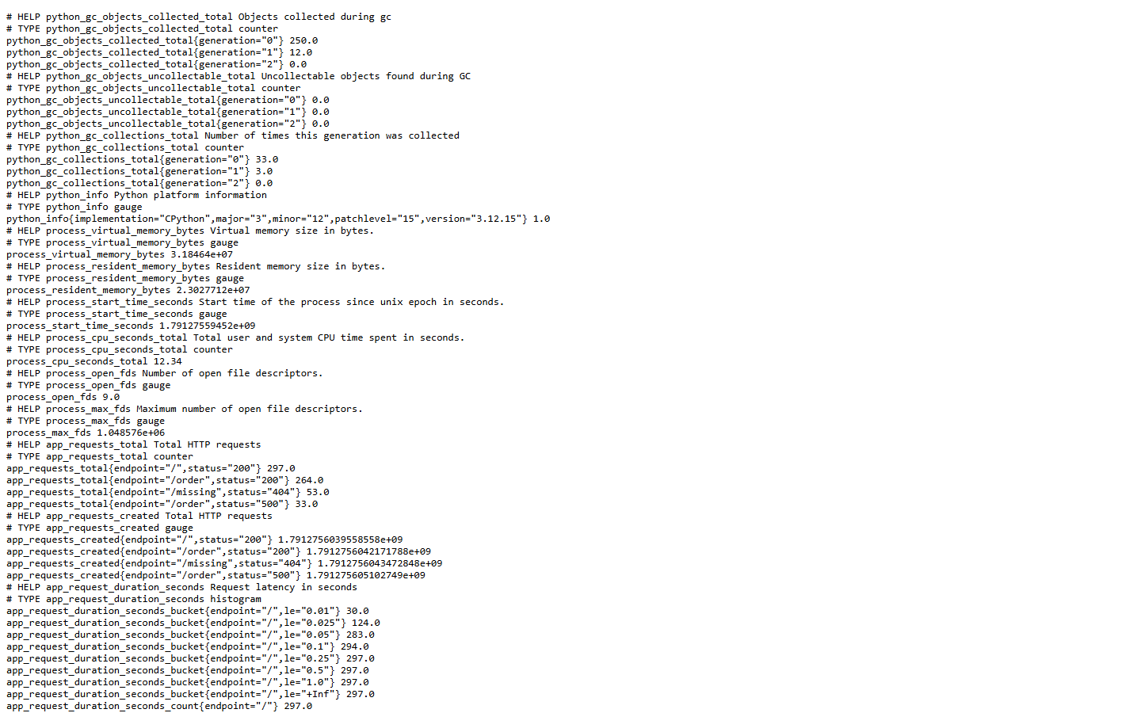
Figure 1.3: Raw metrics exposed by the demo app at /metrics
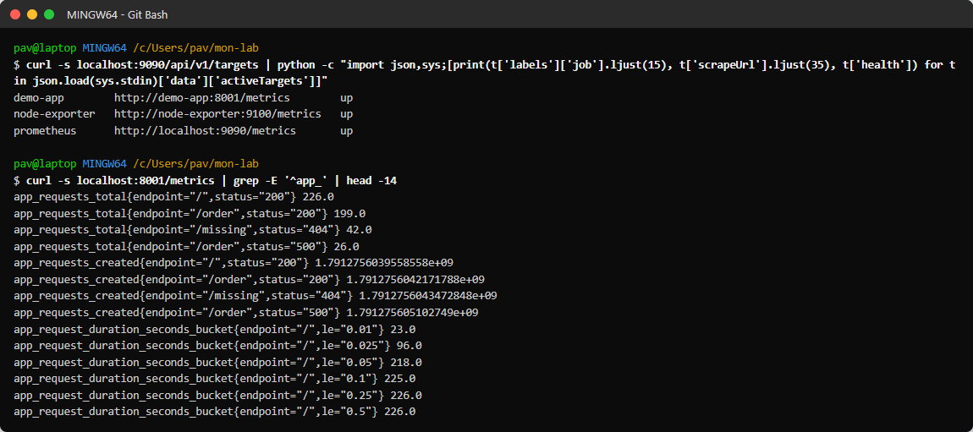
Figure 1.4: Targets and sample application metrics from the command line
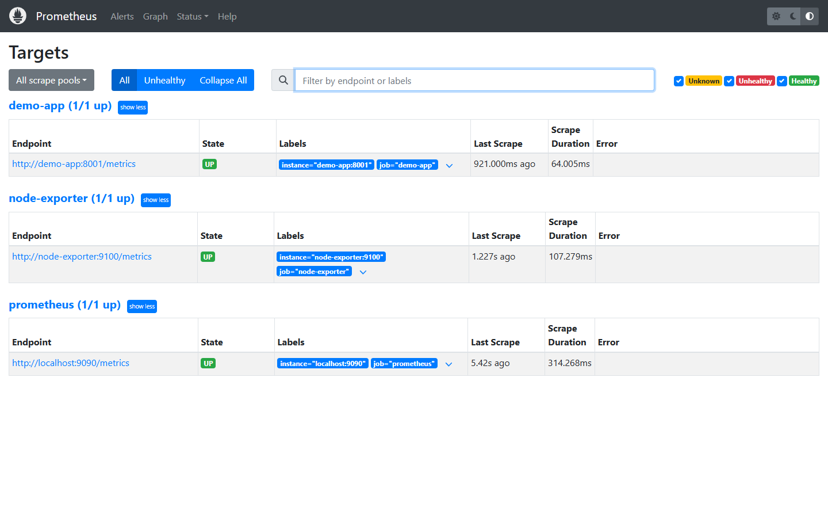
Figure 1.5: Prometheus Targets page - demo-app, node-exporter and prometheus are all UP
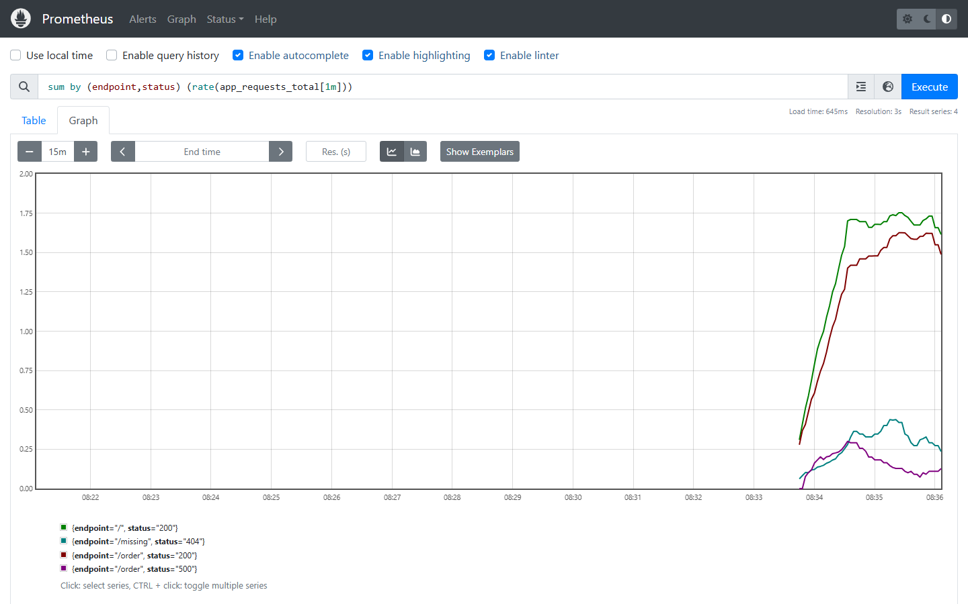
Figure 1.6: PromQL: request rate by endpoint and status
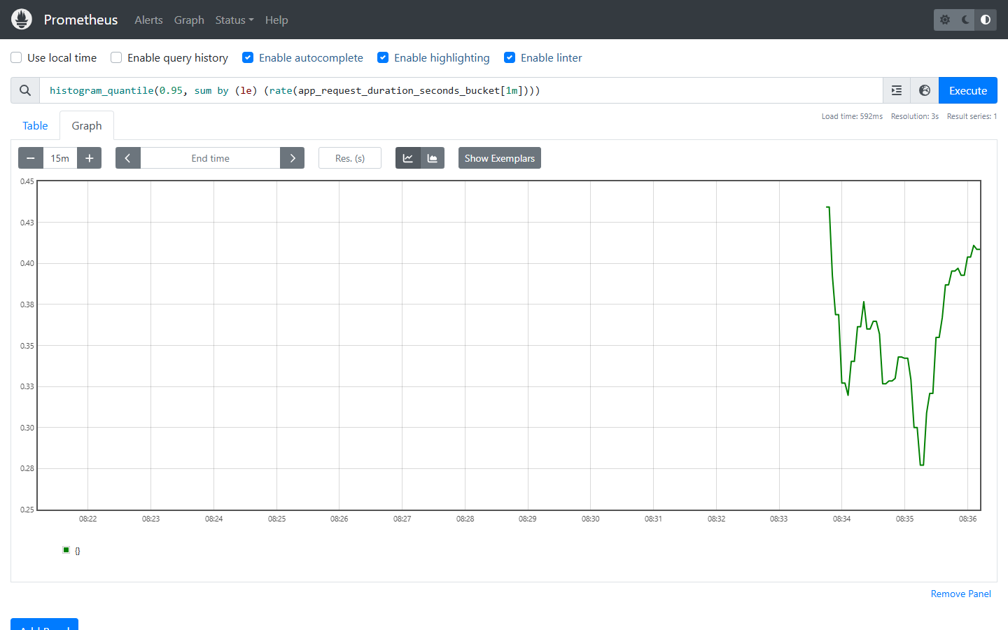
Figure 1.7: PromQL: 95th percentile latency from the histogram
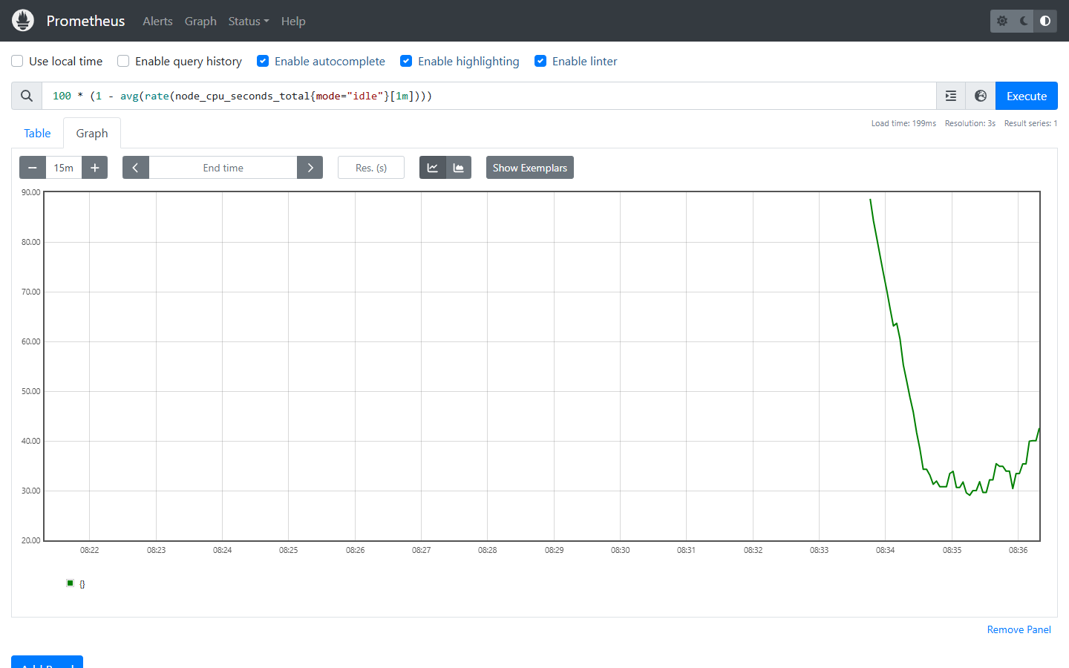
Figure 1.8: PromQL: host CPU usage from node-exporter
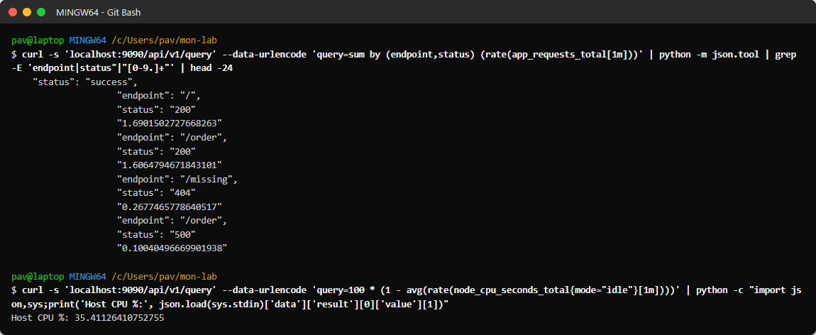
Figure 1.9: PromQL queries through the HTTP API
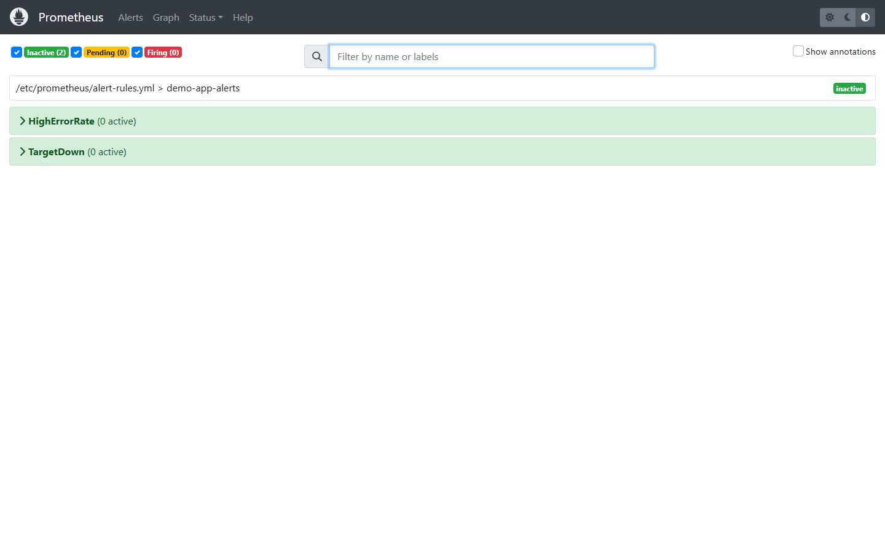
Figure 1.10: Alert rules loaded in Prometheus (HighErrorRate, TargetDown)
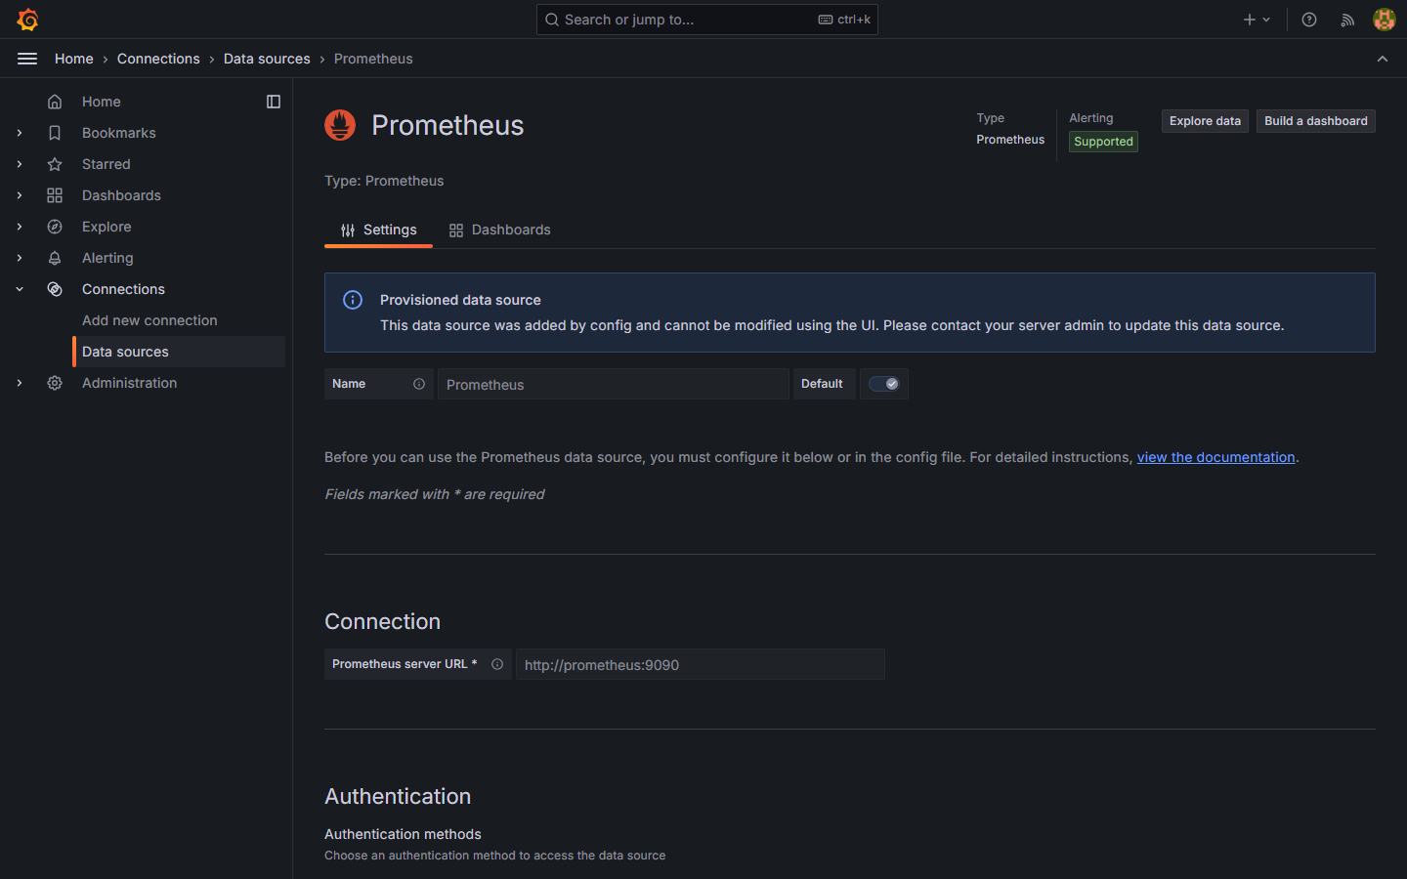
Figure 1.11: Grafana - Prometheus data source (provisioned)
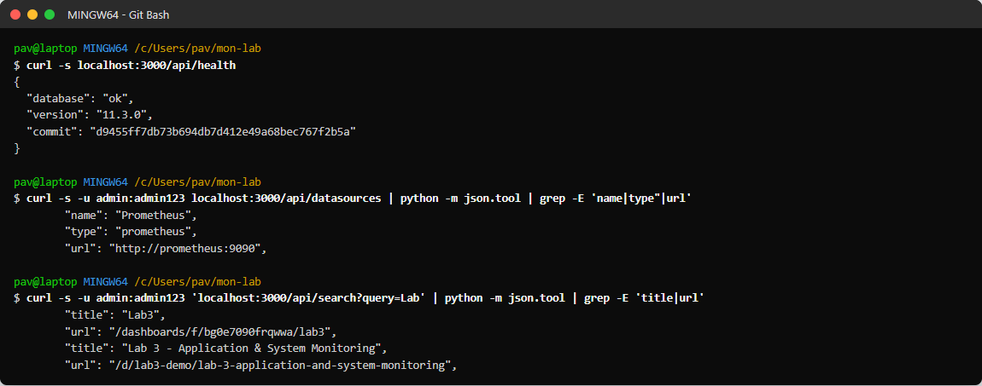
Figure 1.12: Grafana health, data source and dashboard via the API
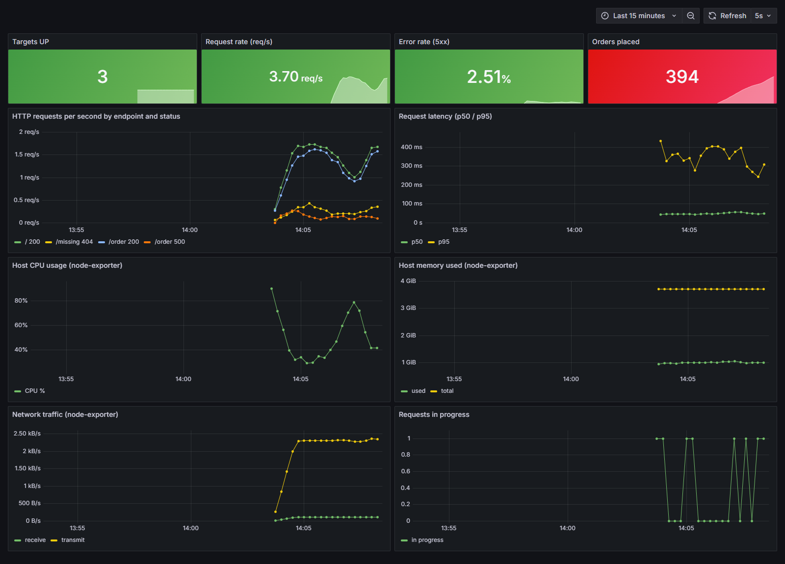
Figure 1.13: Grafana dashboard - application and system metrics (live)
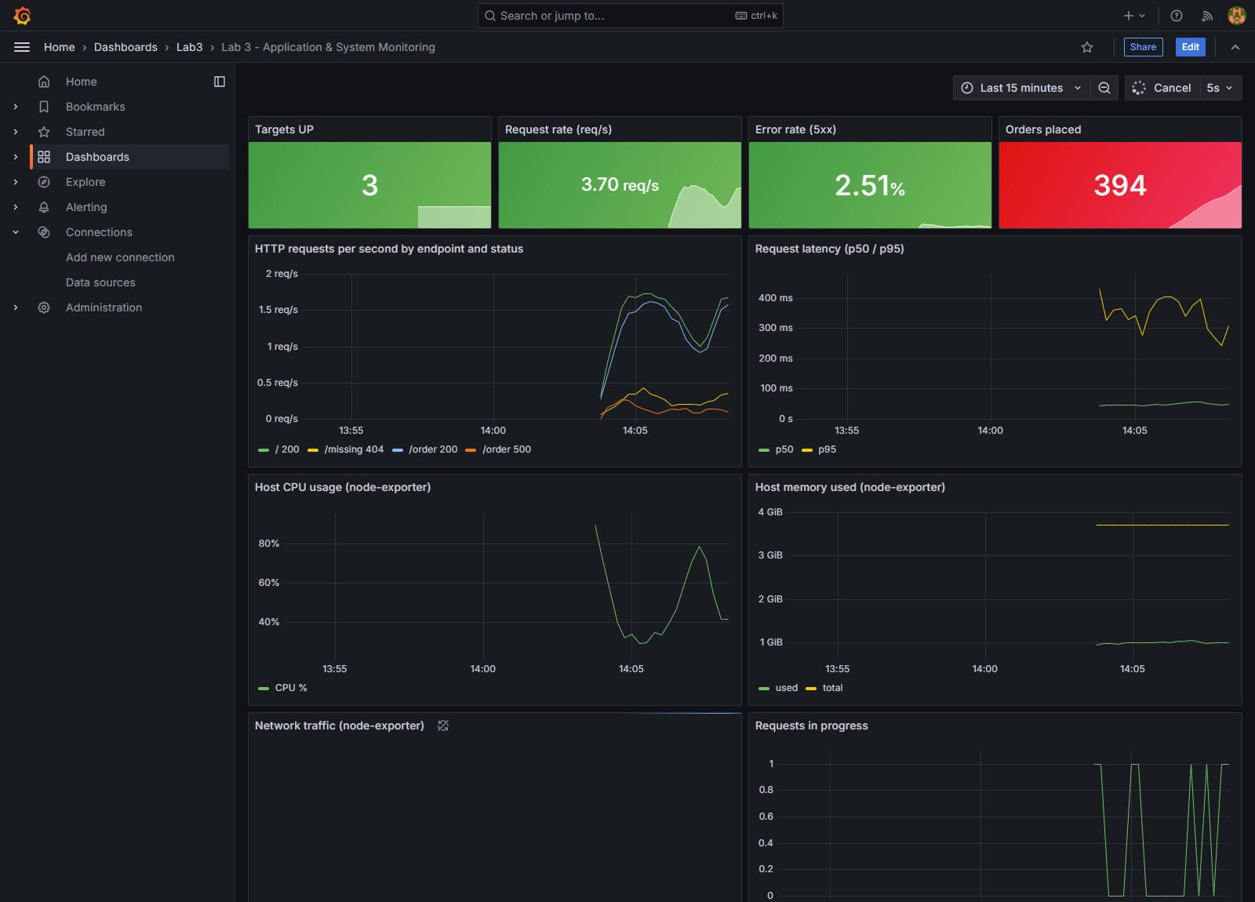
Figure 1.14: Dashboard inside the Grafana UI
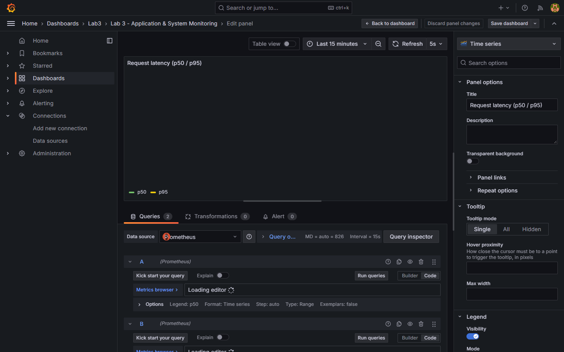
Figure 1.15: Editing a panel - the PromQL query behind the latency graph
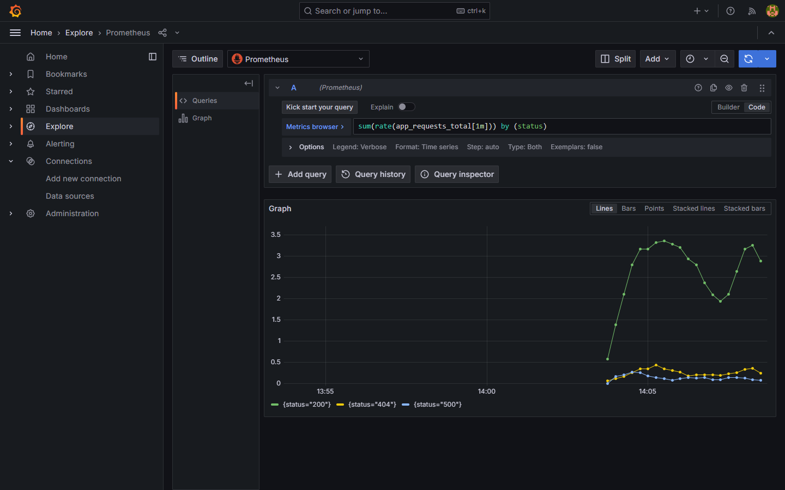
Figure 1.16: Grafana Explore - ad-hoc PromQL query

Dashboard Panels
Panel | PromQL
Targets UP | sum(up)
Request rate | sum(rate(app_requests_total[1m]))
Error rate (5xx) | sum(rate(app_requests_total{status=~"5.."}[1m])) / sum(rate(app_requests_total[1m]))
Orders placed | sum(app_orders_total)
Requests by endpoint/status | sum by (endpoint,status) (rate(app_requests_total[1m]))
Latency p50 / p95 | histogram_quantile(0.95, sum by (le) (rate(app_request_duration_seconds_bucket[1m])))
Host CPU % | 100 * (1 - avg(rate(node_cpu_seconds_total{mode="idle"}[1m])))
Host memory used | node_memory_MemTotal_bytes - node_memory_MemAvailable_bytes
Network traffic | sum(rate(node_network_receive_bytes_total[1m])), ..._transmit_...
Requests in progress | app_requests_in_progress

Results
- All 3 scrape targets were UP; Prometheus scraped them every 5 seconds.
- The dashboard showed about 3.7 requests/s, an error rate of about 2.5% (the /order endpoint returns HTTP 500 for ~10% of calls), p95 latency of about 300-400 ms on /order, and 394 orders placed at the time of the screenshot.
- Host metrics (CPU, memory around 1 GiB used of about 3.7 GiB, network traffic) were visible from node-exporter.

Observations
- Prometheus uses a pull model: adding a new target only needs a scrape_config entry.
- Counters must be viewed with rate() to get per-second values; histograms with histogram_quantile() to get percentiles.
- Provisioning the data source and dashboard as files makes the monitoring setup reproducible (monitoring as code).
- The p95 latency is much higher than p50, which an average alone would hide - percentiles are important for user experience.
- Error-rate and target-down alert rules turn the metrics into actionable alerts.

Conclusion
Prometheus was set up to monitor a containerized application and the host system, and Grafana dashboards were built to visualize request rate, errors, latency and system resources in real time.

