Lab 1: DevOps Foundations & Continuous Integration
Session 1 - Question 1: Create a Jenkinsfile defining pipeline stages (5 marks)
Name | Sachin kumar
Roll No. | 2301010366
Course | Btech(cse)
Date of Experiment | 06-10-2026
Tools Used | Jenkins 2.580.1 LTS, Git 2.53, Java 24, Python 3.11, pytest 9.1, Windows 11

Problem Statement
Create a Jenkinsfile defining pipeline stages (build, test, deploy) and demonstrate a declarative or scripted pipeline execution.

Aim
To write a Jenkinsfile (Pipeline-as-Code) that defines Build, Test and Deploy stages for a sample application, and to execute it in Jenkins using both the Declarative and the Scripted pipeline syntax.

Environment
Component | Details
Operating system | Windows 11 Home (64-bit)
CI/CD server | Jenkins 2.580.1 LTS (jenkins.war) on http://localhost:8080
Plugins | Pipeline (workflow-aggregator), Git, Pipeline Stage View, JUnit, Timestamper, Workspace Cleanup
Version control | Git 2.53.0 - repository devops-lab1-app (branch main)
Runtime / tests | Java 24.0.2 (for Jenkins), Python 3.11.1, pytest 9.1.1
Sample application | Student Grade Calculator (Python) - app/, tests/, scripts/, Jenkinsfile

Theory
A Jenkinsfile is a text file, committed to the source repository, that describes a Jenkins pipeline. Keeping the pipeline in version control (Pipeline-as-Code) makes the build process reviewable, repeatable and versioned together with the application.
- Declarative pipeline: structured syntax starting with pipeline { }, with agent, environment, triggers, options, stages and post blocks. Easier to read and validated before running.
- Scripted pipeline: Groovy code starting with node { }. More flexible (loops, try/finally), but less structured.
- Stage: a logical phase (Build, Test, Deploy) shown as a column in the Stage View.
- Post section: actions that run after the stages - always, success, failure.

Procedure
- Installed Jenkins LTS (jenkins.war) and the Pipeline, Git, Stage View and JUnit plugins, then started Jenkins on port 8080 (commands are recorded in Question 3).
- Created the sample application devops-lab1-app (Python Student Grade Calculator) with unit tests, a build script (packages dist/app-<build>.zip) and a deploy script (deploys + smoke test).
- Wrote the declarative Jenkinsfile below in the root of the repository and committed it to Git.
- Created the Jenkins job Lab1-Q1-Declarative-Pipeline: New Item > Pipeline > Definition: 'Pipeline script from SCM' > SCM: Git > Repository URL > Branch */main > Script Path: Jenkinsfile.
- Clicked Build Now and observed the stages in the Stage View and Console Output.
- Created a second job Lab1-Q1-Scripted-Pipeline using the scripted syntax (node { stage ... }) and executed it.

Jenkinsfile (Declarative pipeline)
// Declarative pipeline for DevOps Lab 1 - Student Grade Calculator
pipeline {
agent any

environment {
APP_NAME = 'student-grade-calculator'
DEPLOY_ROOT = 'C:/Users/pav/jenkins-lab/deploy'
}

triggers {
// Poll the Git repository every minute for new commits
pollSCM('* * * * *')
}

options {
timestamps()
buildDiscarder(logRotator(numToKeepStr: '10'))
}

stages {
stage('Checkout') {
steps {
checkout scm
bat 'git log --oneline -5'
}
}
stage('Build') {
steps {
echo "Building ${env.APP_NAME} #${env.BUILD_NUMBER}"
bat 'python --version'
bat 'python scripts/build.py'
}
}
stage('Test') {
steps {
bat 'python -m pytest tests -v --junitxml=reports/junit.xml'
}
}
stage('Deploy') {
steps {
echo "Deploying ${env.APP_NAME} to staging"
bat 'python scripts/deploy.py staging'
}
}
}

post {
always {
junit 'reports/*.xml'
}
success {
archiveArtifacts artifacts: 'dist/*.zip', fingerprint: true
echo 'Pipeline completed successfully - application deployed to staging.'
}
failure {
echo 'Pipeline FAILED - check the console output.'
}
}
}

Scripted pipeline (Lab1-Q1-Scripted-Pipeline)
// Scripted pipeline - DevOps Lab 1
node {
stage('Checkout') {
git branch: 'main', url: 'C:/Users/pav/jenkins-lab/remote/devops-lab1-app.git'
}
stage('Build') {
bat 'python scripts/build.py'
}
stage('Test') {
try {
bat 'python -m pytest tests -v --junitxml=reports/junit.xml'
} finally {
junit 'reports/*.xml'
}
}
stage('Deploy') {
withEnv(['DEPLOY_ROOT=C:/Users/pav/jenkins-lab/deploy']) {
bat 'python scripts/deploy.py dev'
}
}
}

Stage description
Stage | What it does | Command / step
Checkout | Pulls the latest code from the Git repository | checkout scm, git log --oneline -5
Build | Byte-compiles all Python files and packages them as an artifact | python scripts/build.py
Test | Runs 11 unit tests and writes a JUnit XML report | python -m pytest tests -v --junitxml=...
Deploy | Extracts the artifact to the staging folder and runs a smoke test | python scripts/deploy.py staging
Post | Publishes test results, archives dist/*.zip, prints status | junit, archiveArtifacts, echo

Output / Screenshots
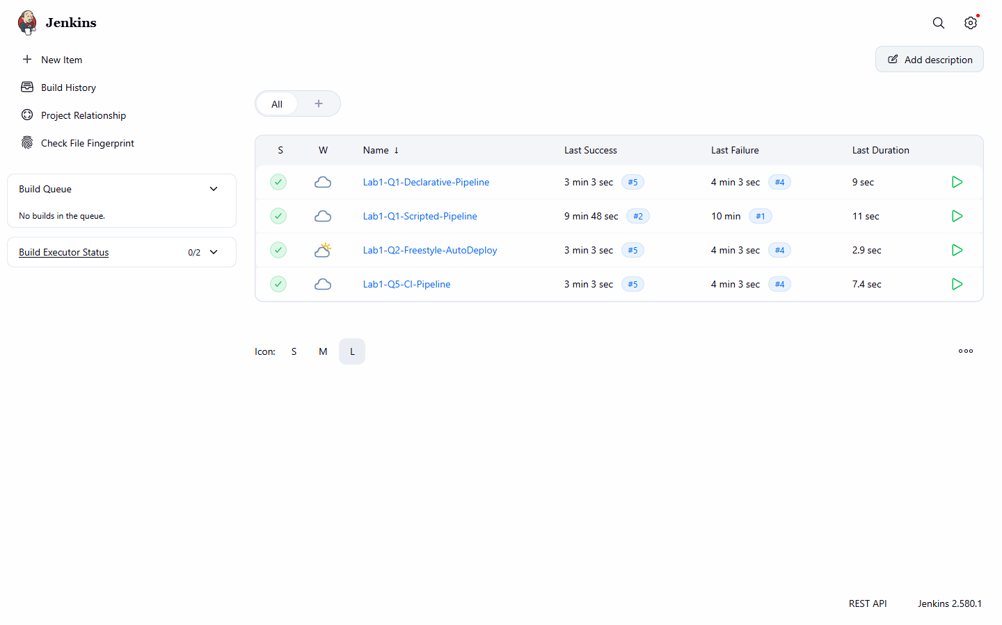
Figure 1.1: Jenkins dashboard showing all Lab 1 jobs
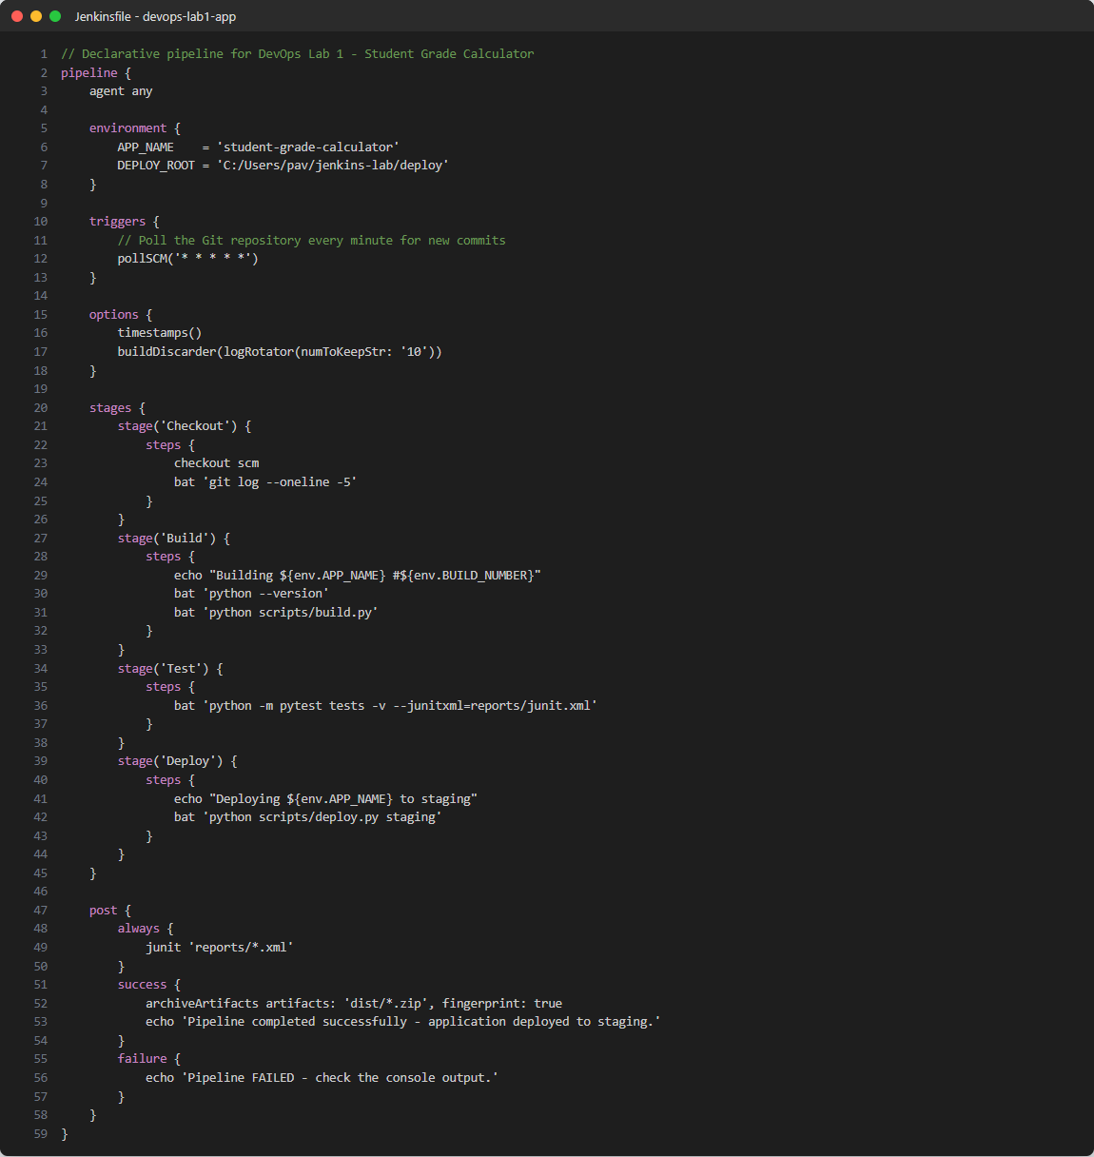
Figure 1.2: Jenkinsfile in the repository with Checkout, Build, Test and Deploy stages
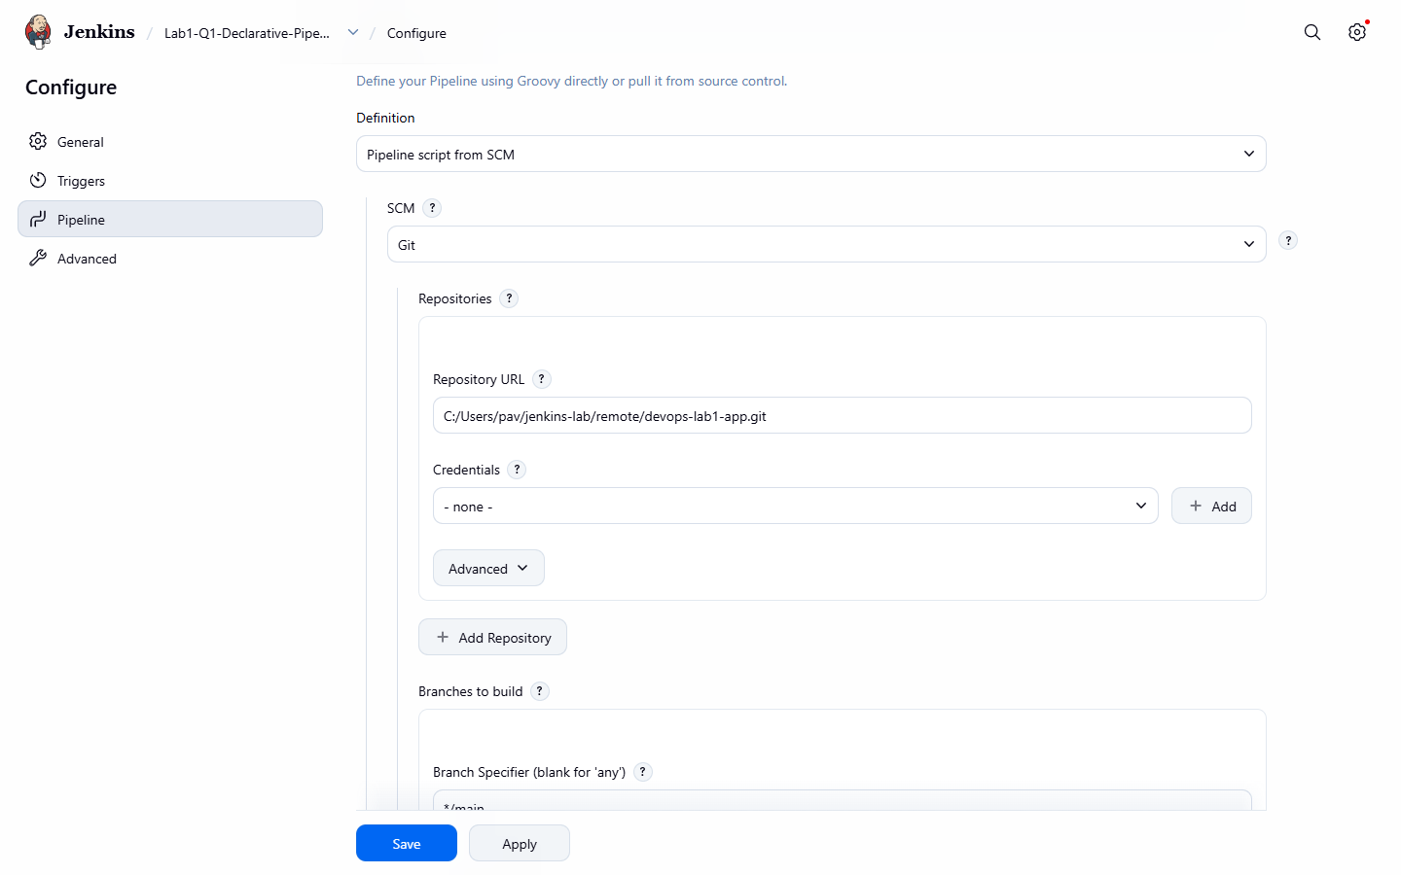
Figure 1.3: Job configuration - Pipeline script from SCM (Git)
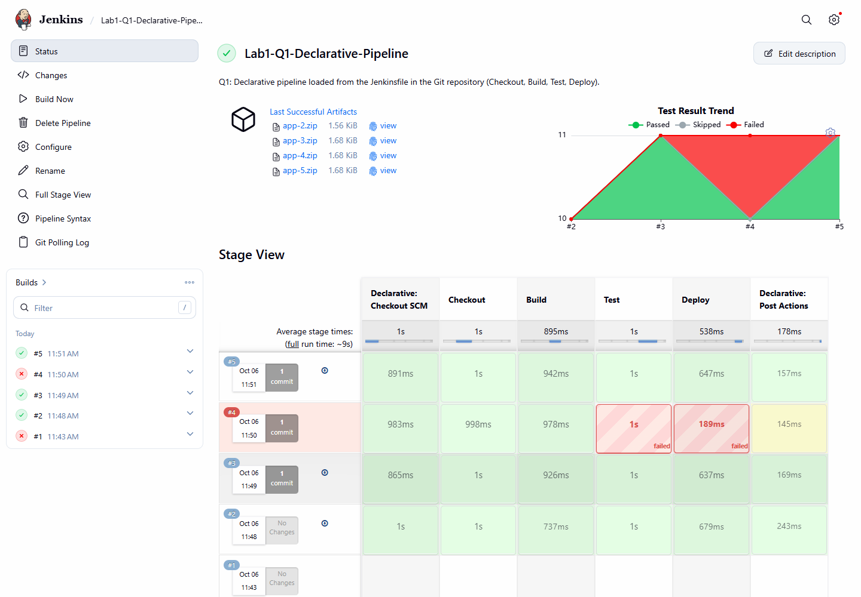
Figure 1.4: Stage View of the declarative pipeline with all builds
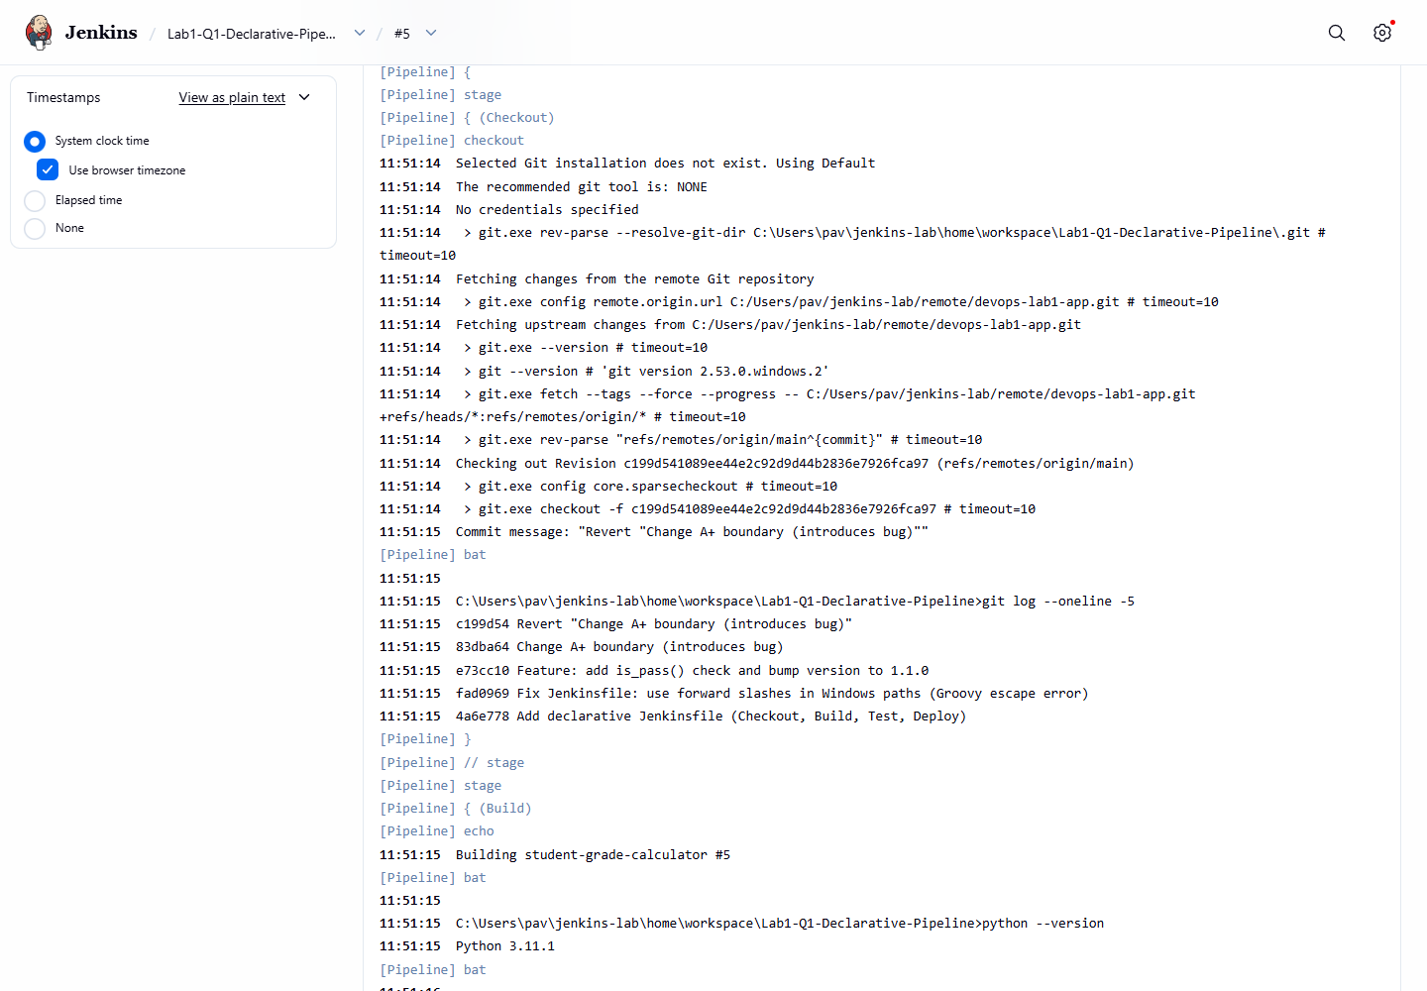
Figure 1.5: Console output - Checkout and Build stages
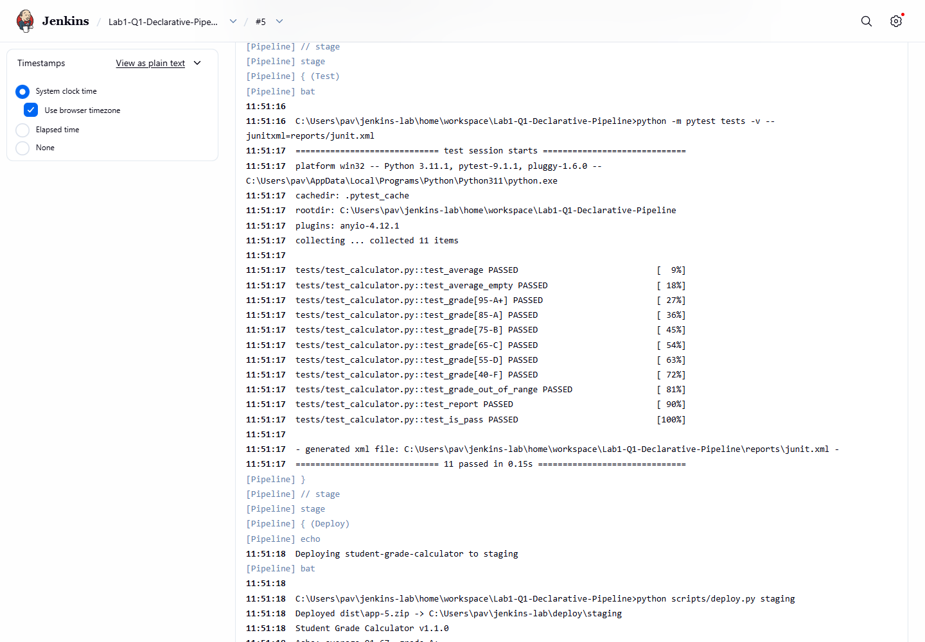
Figure 1.6: Console output - Test stage (all tests passed)
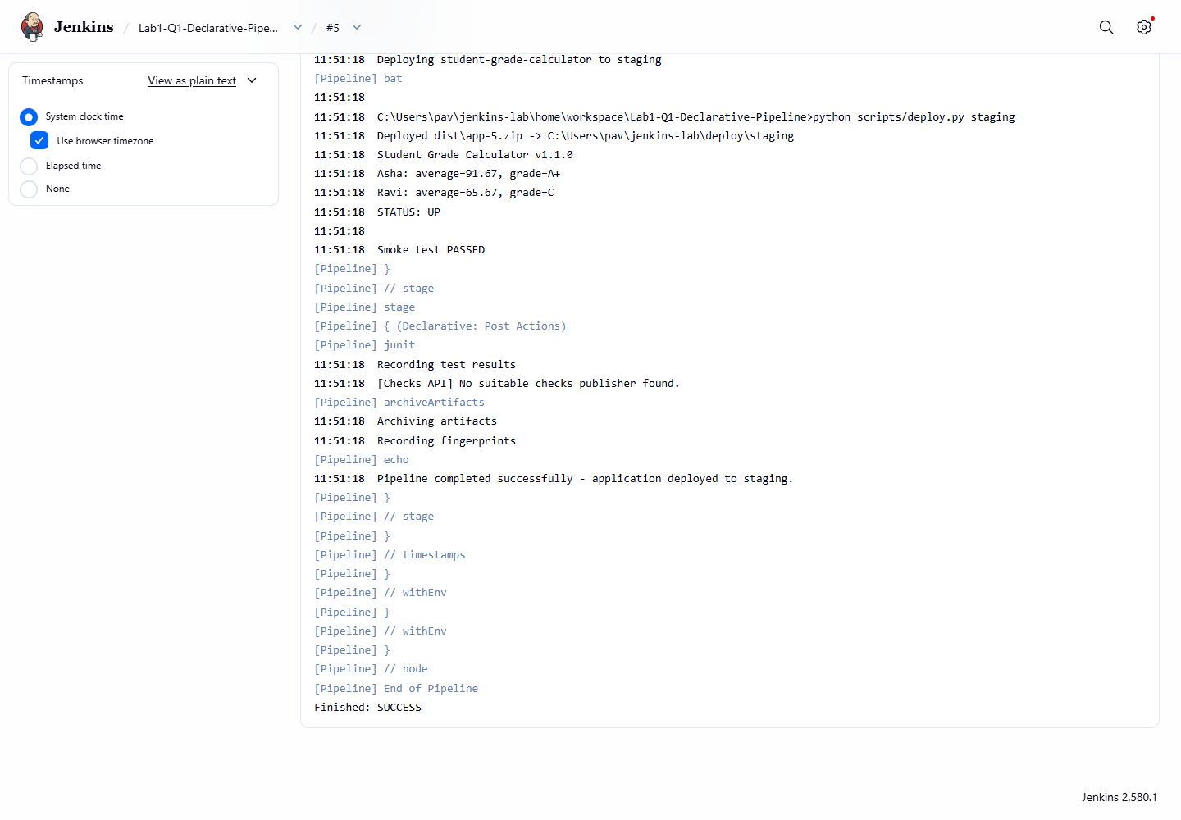
Figure 1.7: Console output - Deploy stage, smoke test and post actions (SUCCESS)
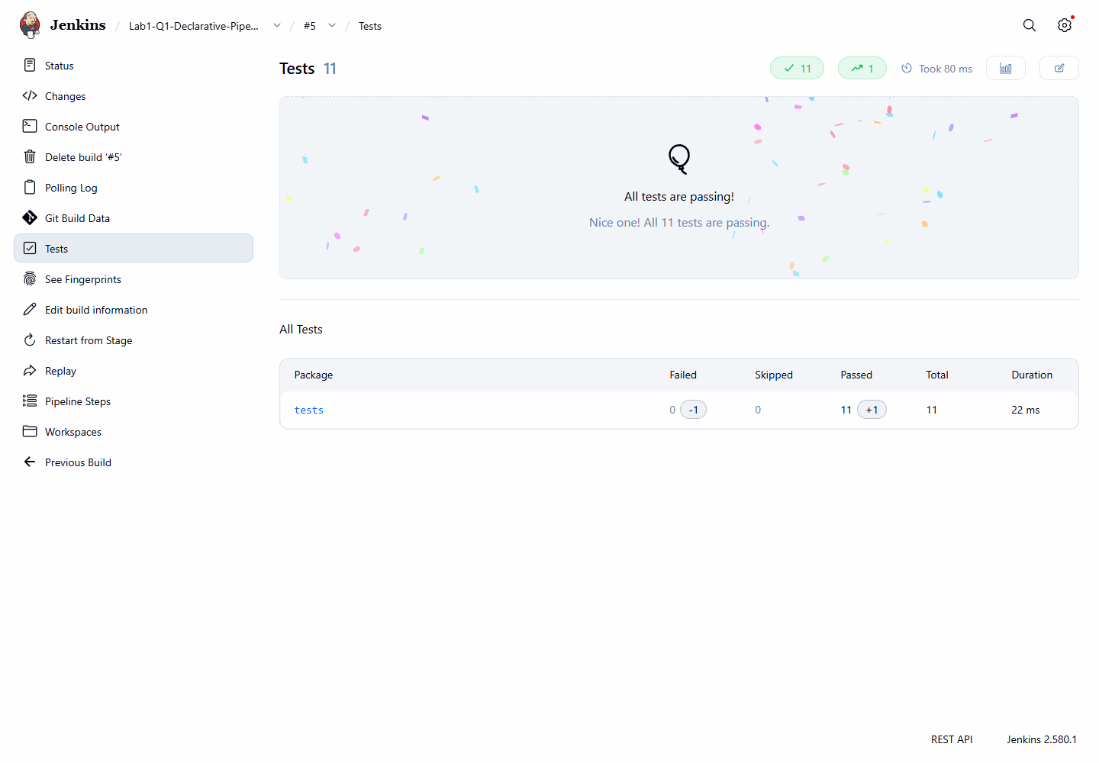
Figure 1.8: JUnit test report published by the post { always { junit } } block
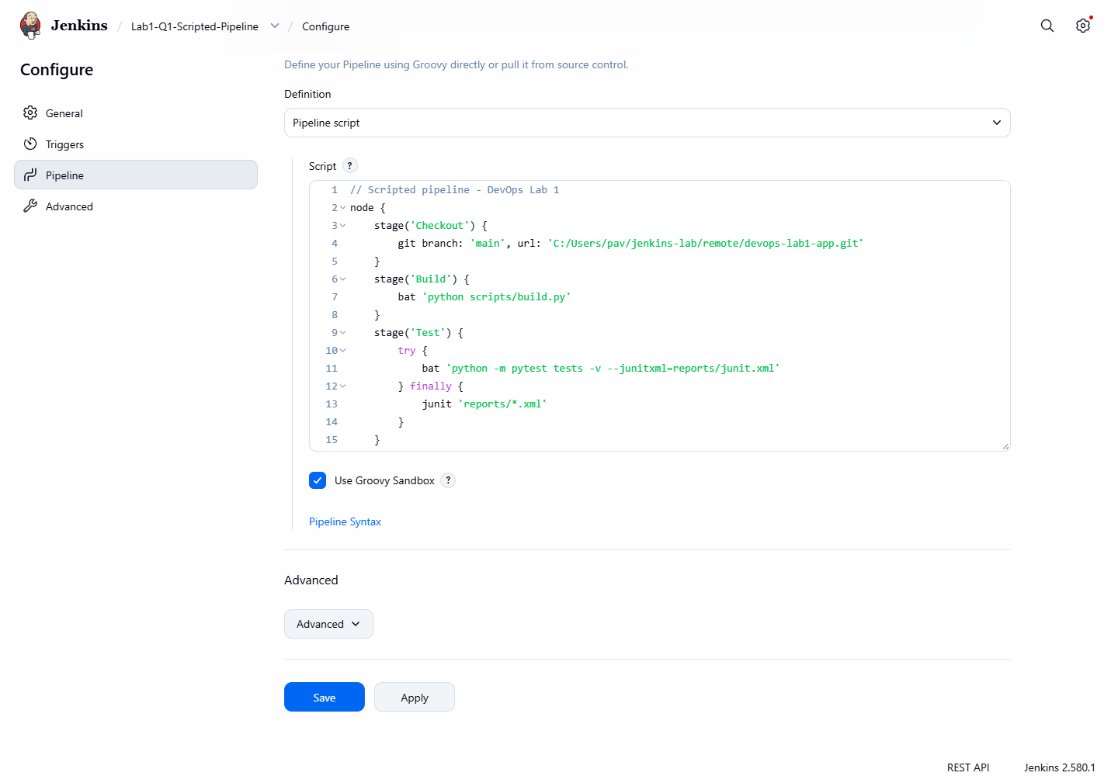
Figure 1.9: Scripted pipeline written in the job configuration
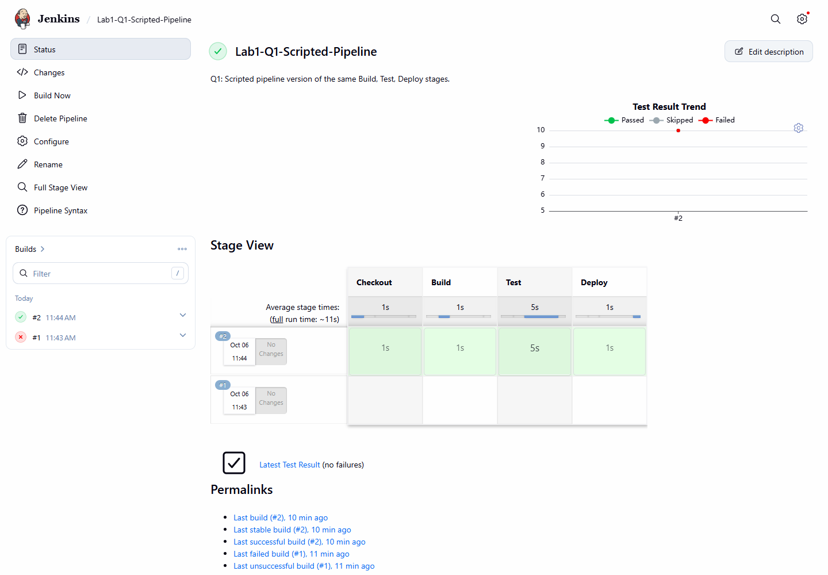
Figure 1.10: Scripted pipeline execution - Stage View

Result
Build | Trigger (cause) | Commit | Result | Duration
#1 (11:43:19) | Manual (Build Now) | - | FAILURE | 2.2 s
#2 (11:48:09) | Manual (Build Now) | - | SUCCESS | 12.3 s
#3 (11:49:09) | Poll SCM (SCM change) | e73cc10 Feature: add is_pass() check and bump version to 1.1.0 | SUCCESS | 8.3 s
#4 (11:50:09) | Poll SCM (SCM change) | 83dba64 Change A+ boundary (introduces bug) | FAILURE | 6.9 s
#5 (11:51:09) | Poll SCM (SCM change) | c199d54 Revert "Change A+ boundary (introduces bug)" | SUCCESS | 9.1 s

The declarative pipeline ran all four stages successfully (builds #2, #3, #5); the scripted pipeline also completed successfully (build #2, deployed to the dev environment).

Observations
- Build #1 failed during compilation with 'unexpected char: \' because Groovy treats a single backslash in Windows paths as an escape character. Using forward slashes (C:/Users/...) fixed it.
- The Stage View shows the time taken by every stage, which makes slow stages easy to spot.
- When the Test stage failed (build #4) the Deploy stage was automatically skipped, so broken code was not deployed. The post { always } block still published the test report.
- The declarative syntax was easier to read; the scripted syntax needed an explicit try/finally to publish test results.

Conclusion
A Jenkinsfile defining Build, Test and Deploy stages was created and stored in Git, and both a declarative and a scripted pipeline were executed successfully in Jenkins.

