Lab 1: DevOps Foundations & Continuous Integration
Session 1 - Question 2: Automate application deployment (5 marks)
Name | Sachin kumar
Roll No. | 2301010366
Course | Btech(cse)
Date of Experiment | 06-10-2026
Tools Used | Jenkins 2.580.1 LTS, Git 2.53, Java 24, Python 3.11, pytest 9.1, Windows 11

Problem Statement
Automate application deployment using Jenkins by configuring build triggers, post-build actions, and deployment steps.

Aim
To configure a Jenkins job that automatically builds, tests and deploys the application whenever new code is committed, using build triggers, build (deployment) steps and post-build actions.

Environment
Component | Details
Operating system | Windows 11 Home (64-bit)
CI/CD server | Jenkins 2.580.1 LTS (jenkins.war) on http://localhost:8080
Plugins | Pipeline (workflow-aggregator), Git, Pipeline Stage View, JUnit, Timestamper, Workspace Cleanup
Version control | Git 2.53.0 - repository devops-lab1-app (branch main)
Runtime / tests | Java 24.0.2 (for Jenkins), Python 3.11.1, pytest 9.1.1
Sample application | Student Grade Calculator (Python) - app/, tests/, scripts/, Jenkinsfile

Theory
- Build triggers: decide when a job runs - Poll SCM (Jenkins checks Git on a cron schedule), Build periodically, GitHub hook trigger (webhook), or after other projects are built.
- Build steps: commands run by the job - here, Windows batch commands for build, test and deploy.
- Post-build actions: run after the build steps - publish JUnit test results, archive artifacts, send notifications or trigger other jobs.
- Deployment: copying the tested artifact to the target environment and verifying it with a smoke test.

Job Configuration (Lab1-Q2-Freestyle-AutoDeploy)
Section | Setting
Source Code Management | Git - C:/Users/pav/jenkins-lab/remote/devops-lab1-app.git, branch */main
Build Triggers | Poll SCM, schedule: * * * * * (check for new commits every minute)
Build step 1 - Build | python scripts\build.py -> creates dist/app-<BUILD_NUMBER>.zip
Build step 2 - Test | python -m pytest tests -v --junitxml=reports\junit.xml
Build step 3 - Deploy | set DEPLOY_ROOT=C:\Users\pav\jenkins-lab\deploy  python scripts\deploy.py production
Post-build action 1 | Publish JUnit test result report: reports/*.xml
Post-build action 2 | Archive the artifacts: dist/*.zip (only if successful, with fingerprint)

Procedure
- Jenkins > New Item > name 'Lab1-Q2-Freestyle-AutoDeploy' > Freestyle project > OK.
- Source Code Management: selected Git and entered the repository URL and branch */main.
- Triggers: ticked 'Poll SCM' and entered the schedule * * * * *.
- Build Steps: added three 'Execute Windows batch command' steps - Build, Test and Deploy to production.
- Post-build Actions: added 'Publish JUnit test result report' and 'Archive the artifacts'.
- Saved the job and ran it once with Build Now (build #1).
- Committed and pushed new code to Git. Without clicking anything, Jenkins detected the commit within a minute and started builds #2 - #5 automatically ('Started by an SCM change').
- Verified the deployment folder and ran the deployed application.

Deployment script (scripts/deploy.py)
"""Deploy step: extract the build artifact into the target environment and run a smoke test."""
import glob
import os
import shutil
import subprocess
import sys
import zipfile

env = sys.argv[1] if len(sys.argv) > 1 else "staging"
target = os.path.join(os.environ.get("DEPLOY_ROOT", "deploy"), env)
artifact = sorted(glob.glob("dist/app-*.zip"), key=os.path.getmtime)[-1]

shutil.rmtree(target, ignore_errors=True)
os.makedirs(target)
zipfile.ZipFile(artifact).extractall(target)
with open(os.path.join(target, "DEPLOYED_VERSION.txt"), "w") as f:
f.write(f"artifact={artifact}\nbuild={os.environ.get('BUILD_NUMBER', 'local')}\n")
print(f"Deployed {artifact} -> {os.path.abspath(target)}")

out = subprocess.run([sys.executable, "-m", "app.main"], cwd=target,
capture_output=True, text=True)
print(out.stdout)
if "STATUS: UP" not in out.stdout:
sys.exit("Smoke test FAILED")
print("Smoke test PASSED")

Output / Screenshots
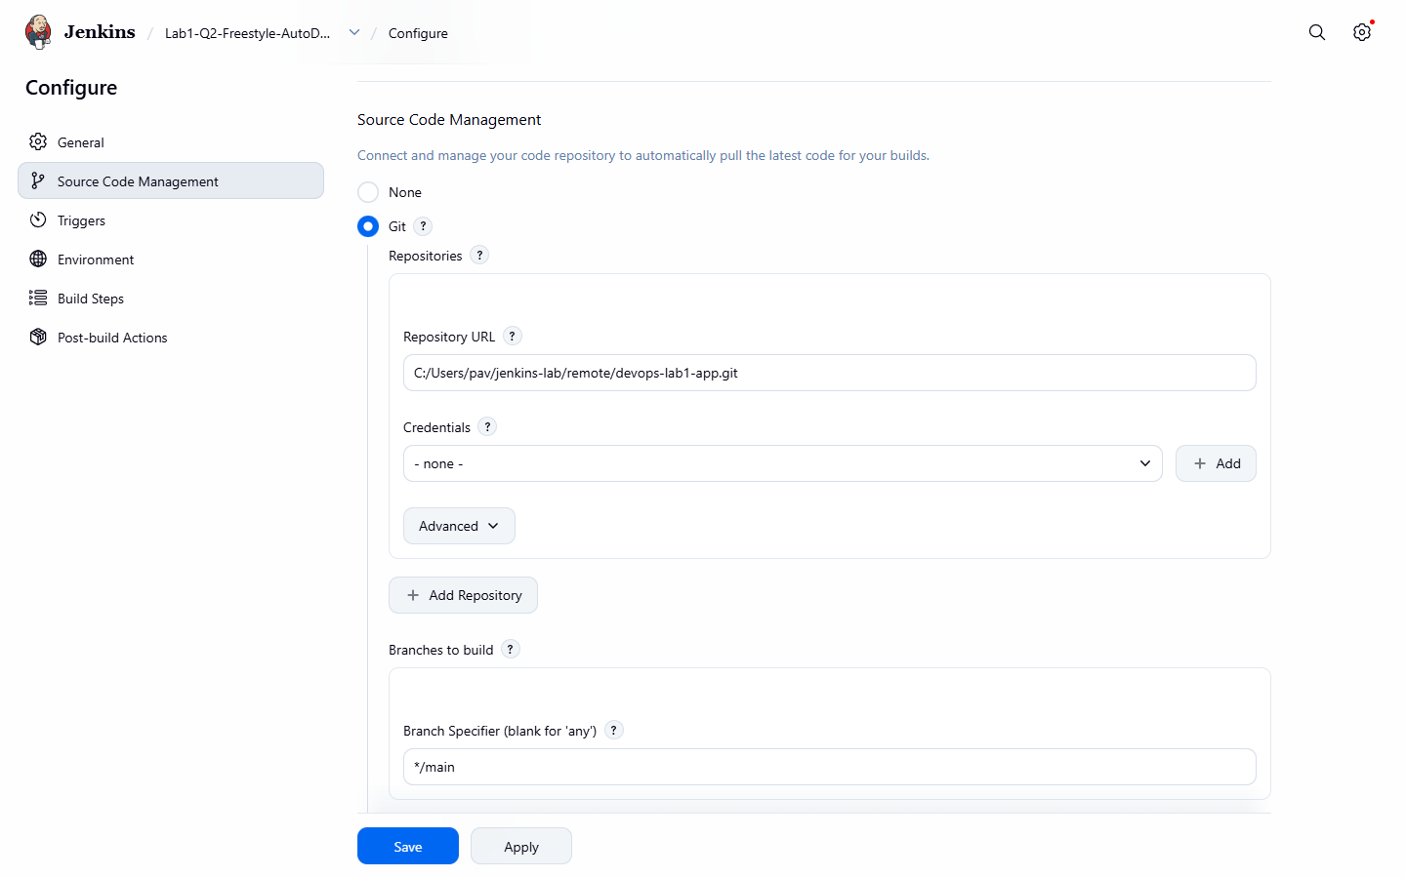
Figure 2.1: Source Code Management - Git repository and branch
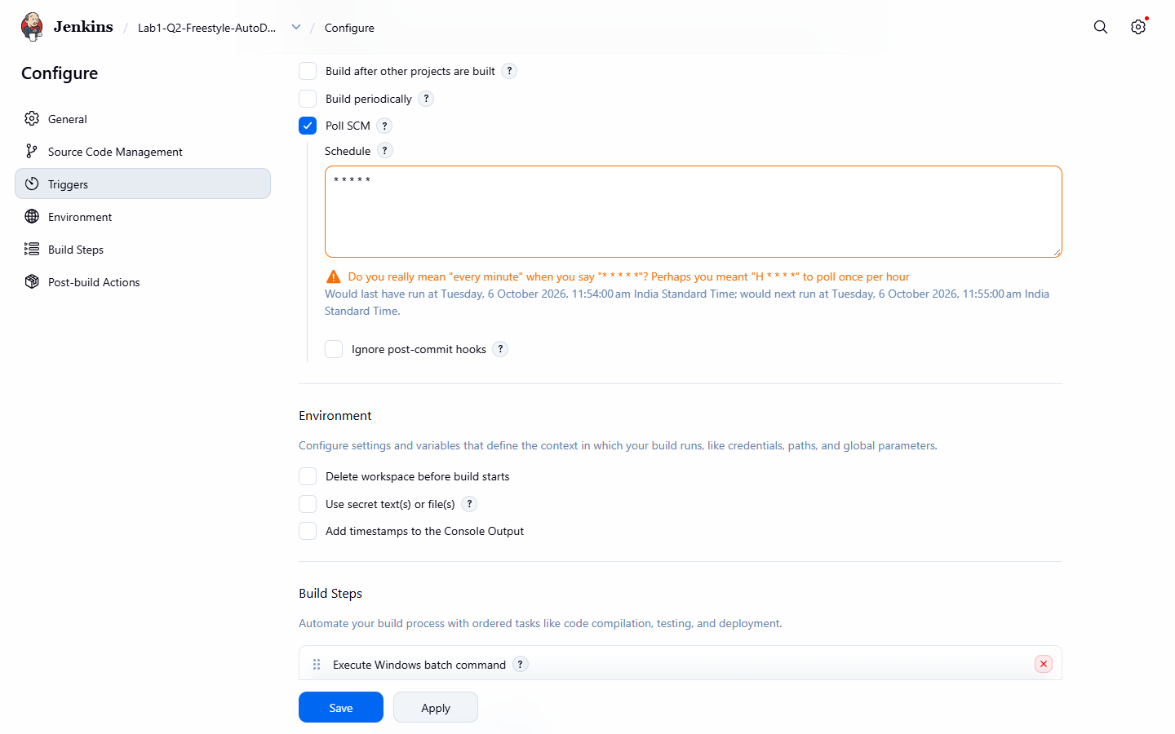
Figure 2.2: Build Triggers - Poll SCM every minute
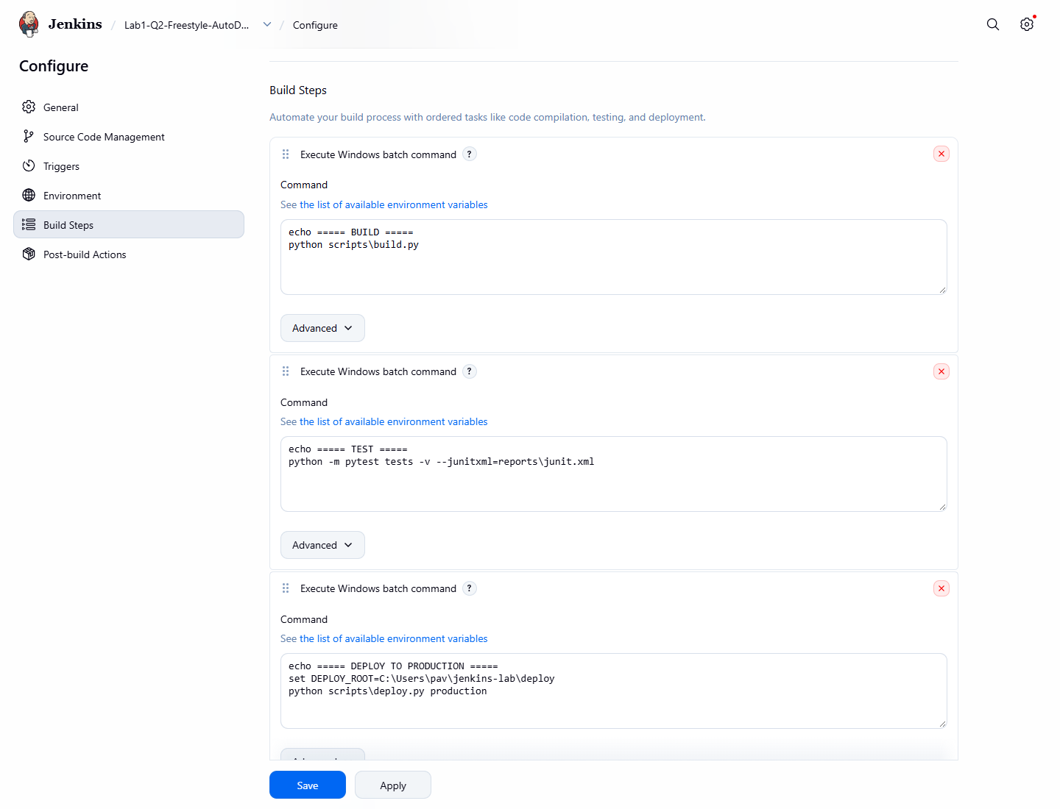
Figure 2.3: Build Steps - Build, Test and Deploy commands
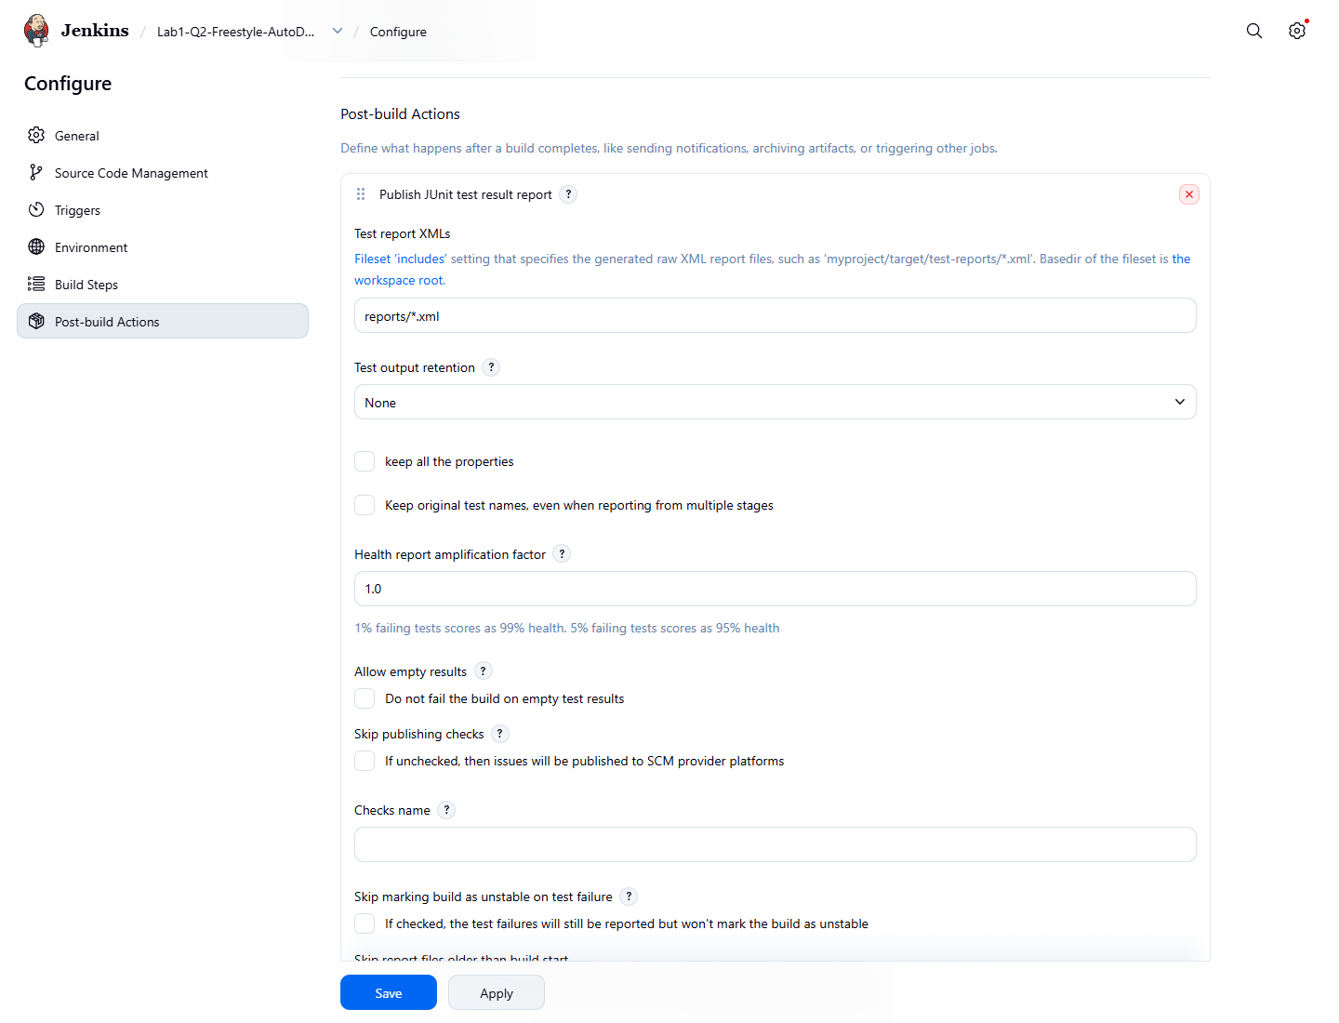
Figure 2.4: Post-build Actions - Publish JUnit test result report (archive artifacts below it)
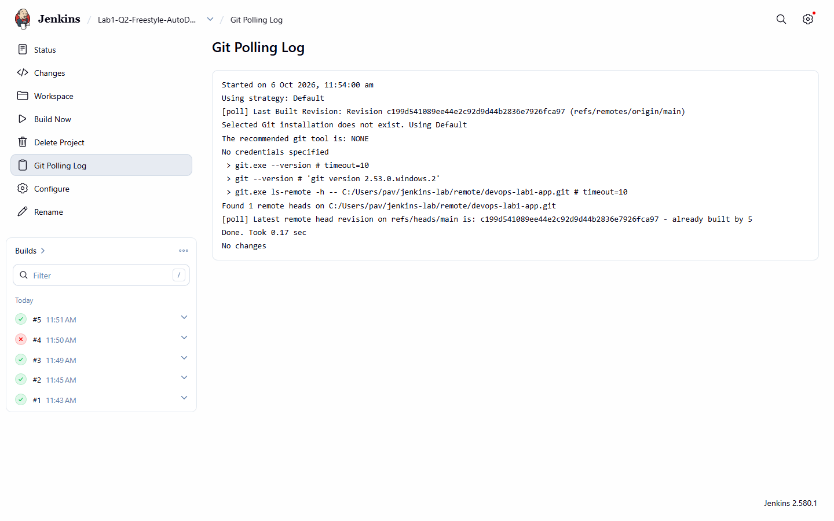
Figure 2.5: Git Polling Log - Jenkins checking the repository for changes
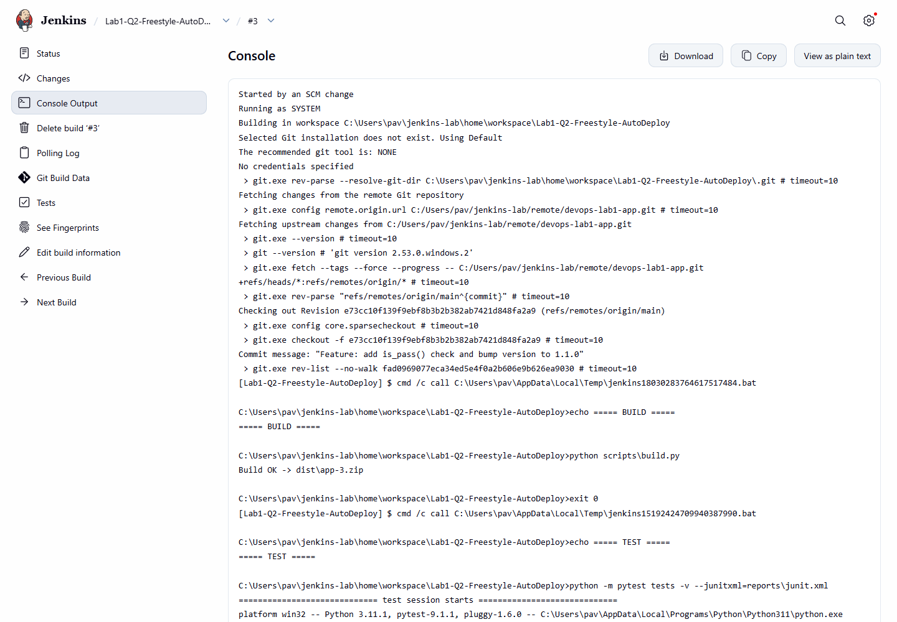
Figure 2.6: Build #3 'Started by an SCM change' - triggered automatically by a commit
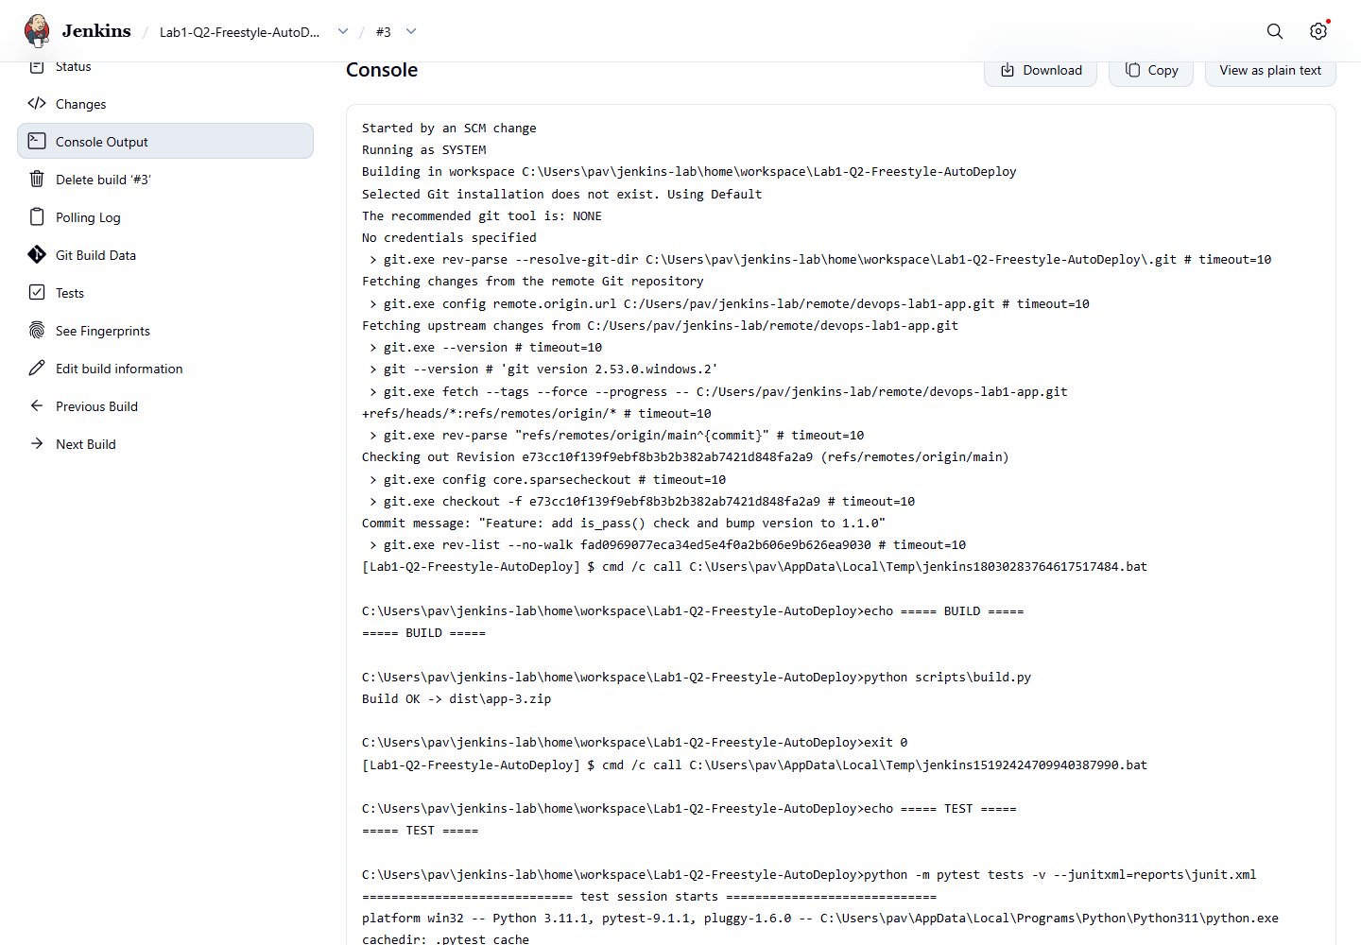
Figure 2.7: Deploy step, smoke test and post-build actions in the console
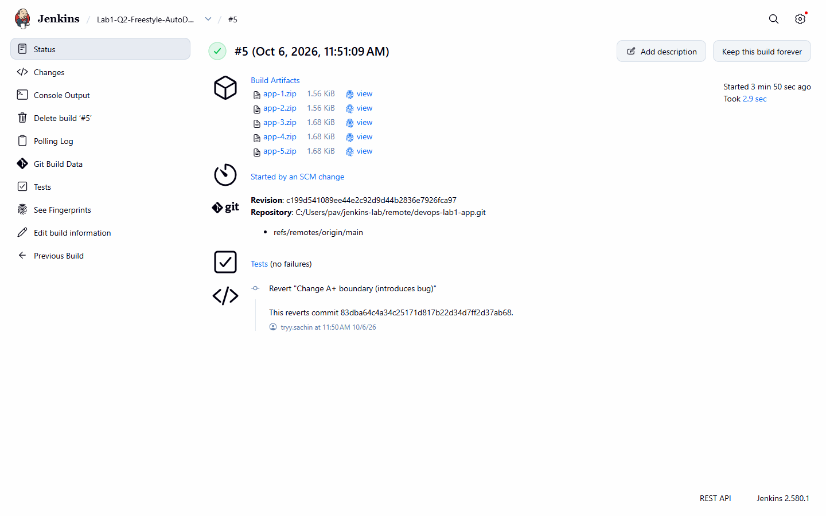
Figure 2.8: Build page with archived artifact and test results
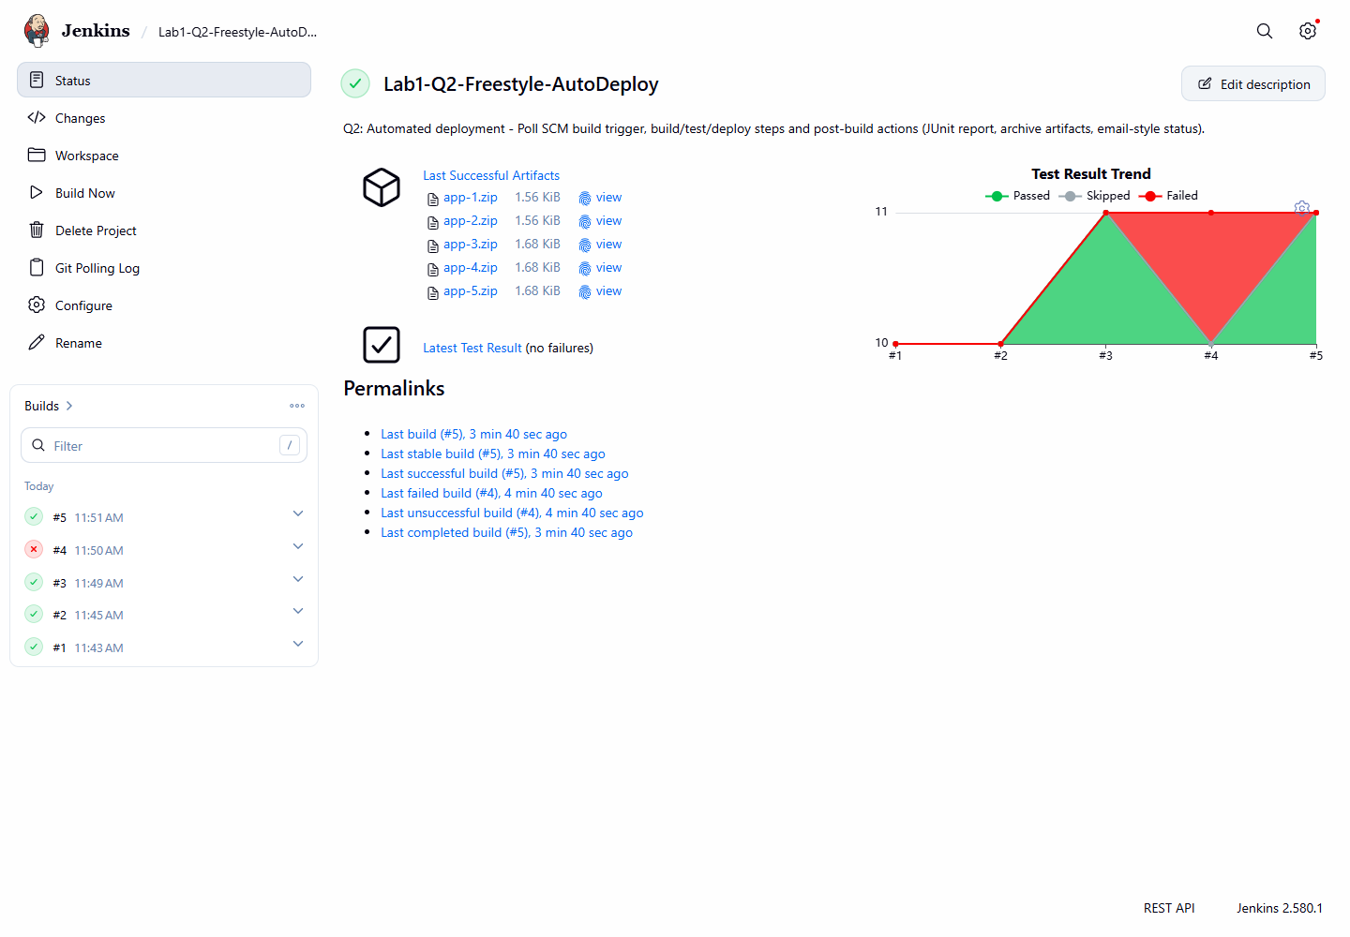
Figure 2.9: Job page - build history and Test Result Trend
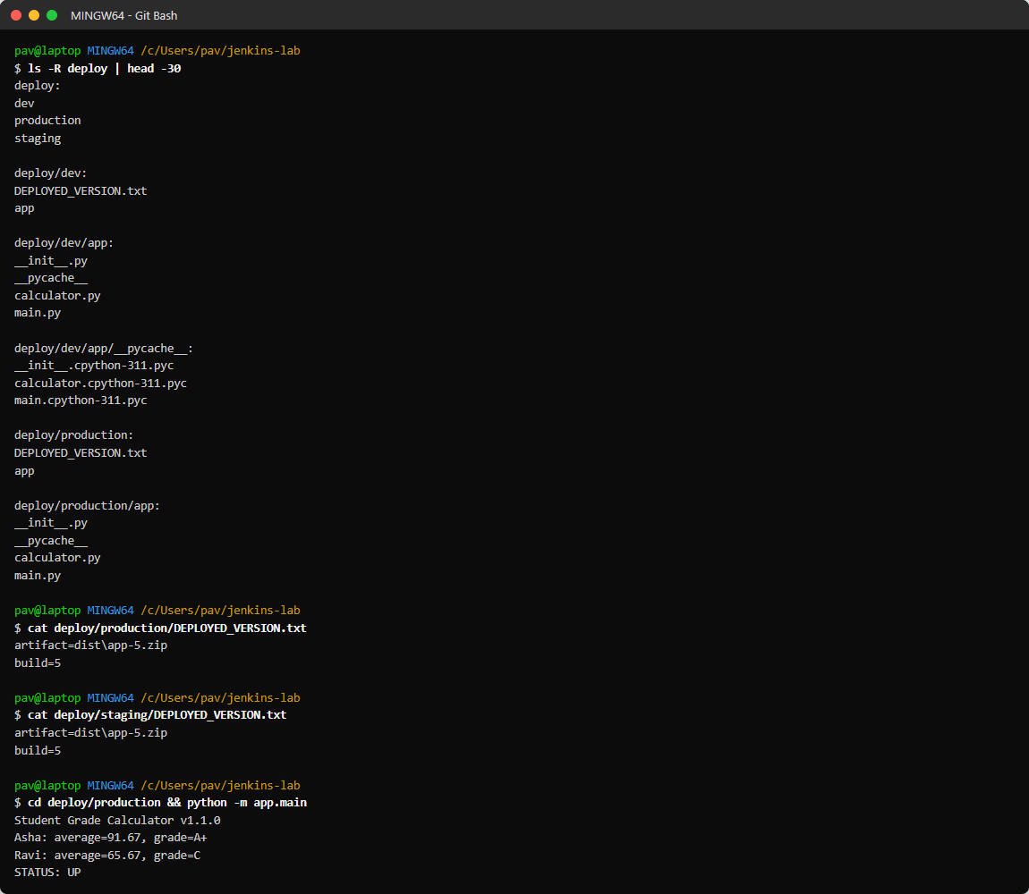
Figure 2.10: Deployed application in deploy/production (version file + running app)

Result
Build | Trigger (cause) | Commit | Result | Duration
#1 (11:43:19) | Manual (Build Now) | - | SUCCESS | 7.0 s
#2 (11:45:09) | Poll SCM (SCM change) | fad0969 Fix Jenkinsfile: use forward slashes in Windows paths | SUCCESS | 2.4 s
#3 (11:49:09) | Poll SCM (SCM change) | e73cc10 Feature: add is_pass() check and bump version to 1.1.0 | SUCCESS | 2.9 s
#4 (11:50:09) | Poll SCM (SCM change) | 83dba64 Change A+ boundary (introduces bug) | FAILURE | 2.7 s
#5 (11:51:09) | Poll SCM (SCM change) | c199d54 Revert "Change A+ boundary (introduces bug)" | SUCCESS | 3.0 s

Every push to the main branch was automatically built, tested and deployed to production. The deployed application reports 'Student Grade Calculator v1.1.0 ... STATUS: UP'.

Observations
- Builds #2 to #5 were started by Poll SCM with no manual action - deployment is fully automated.
- Build #4 (a commit that introduced a bug) failed at the Test step; Jenkins stopped there, so the Deploy step never ran and production kept the last good version.
- Jenkins shows a warning for * * * * * and suggests H * * * * to spread load; every minute was kept for the lab demonstration. In production a webhook (GitHub hook trigger) is better than polling.
- Archiving with fingerprints lets you trace which build produced each app-N.zip.

Conclusion
Automatic deployment was achieved by combining a Poll SCM build trigger, build/test/deploy build steps and post-build actions (JUnit report and artifact archiving) in a Jenkins job.

