Lab 1: DevOps Foundations & Continuous Integration
Session 1 - Question 3: Record all commands (5 marks)
Name | Sachin kumar
Roll No. | 2301010366
Course | Btech(cse)
Date of Experiment | 06-10-2026
Tools Used | Jenkins 2.580.1 LTS, Git 2.53, Java 24, Python 3.11, pytest 9.1, Windows 11

Problem Statement
Record all commands, pipeline configurations, screenshots, commit history, and observations for each experiment.

Aim
To keep a complete record of the commands, pipeline configurations, screenshots, Git commit history and observations for the Lab 1 experiments.

1. Environment Verification Commands
java -version
python --version
git --version
python -m pytest --version

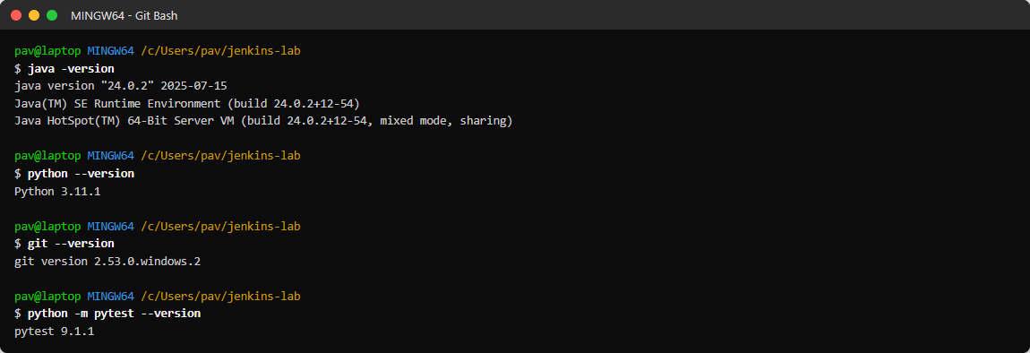
Figure 3.1: Versions of the tools used

2. Jenkins Installation Commands
mkdir C:\Users\pav\jenkins-lab && cd C:\Users\pav\jenkins-lab
curl -L -o jenkins.war https://get.jenkins.io/war-stable/latest/jenkins.war
curl -L -o pm.jar <jenkins-plugin-manager release jar from GitHub>
java -jar pm.jar --war jenkins.war --plugin-download-directory home/plugins ^
--plugins workflow-aggregator git pipeline-stage-view junit timestamper ws-cleanup
set JENKINS_HOME=C:\Users\pav\jenkins-lab\home
java -Djenkins.install.runSetupWizard=false ^
-Dhudson.plugins.git.GitSCM.ALLOW_LOCAL_CHECKOUT=true ^
-jar jenkins.war --httpPort=8080 --httpListenAddress=127.0.0.1 --enable-future-java

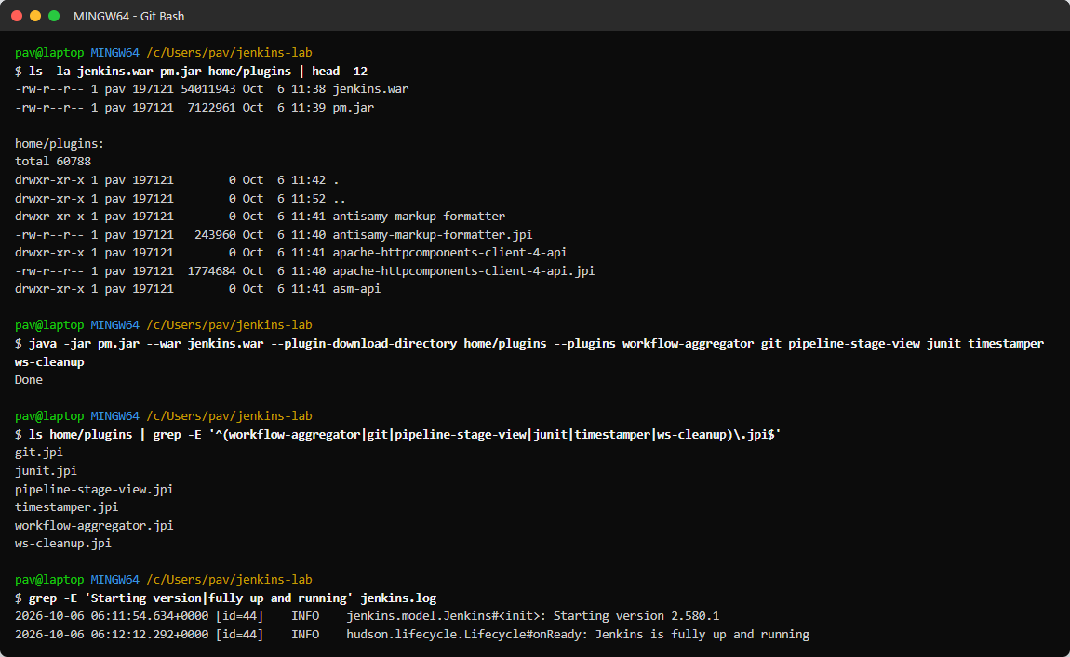
Figure 3.2: Jenkins WAR, plugin installation and startup log

3. Git Commands
git init -b main
git add app/ README.md .gitignore && git commit -m "Initial commit: Student Grade Calculator app"
git add tests && git commit -m "Add unit tests with pytest"
git add scripts && git commit -m "Add build and deploy scripts"
git add Jenkinsfile && git commit -m "Add declarative Jenkinsfile (Checkout, Build, Test, Deploy)"
git init --bare C:/Users/pav/jenkins-lab/remote/devops-lab1-app.git
git remote add origin C:/Users/pav/jenkins-lab/remote/devops-lab1-app.git
git push -u origin main
git add Jenkinsfile && git commit -m "Fix Jenkinsfile: use forward slashes ..." && git push
git add -A && git commit -m "Feature: add is_pass() check and bump version to 1.1.0" && git push
git commit -am "Change A+ boundary (introduces bug)" && git push
git revert --no-edit HEAD && git push
git status | git remote -v | git log --oneline --graph --decorate | git show --stat HEAD~2

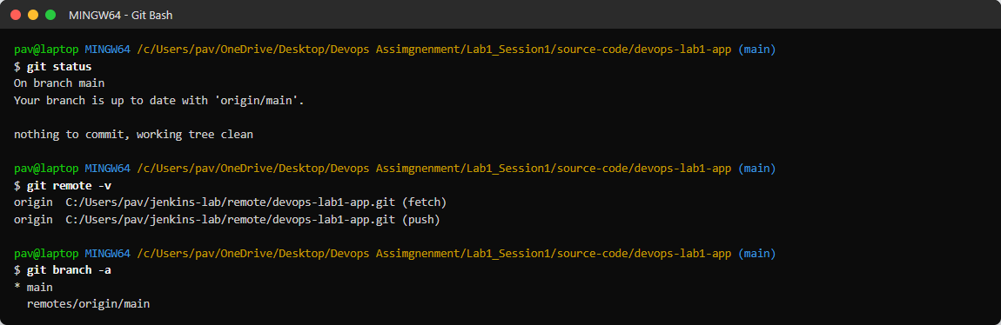
Figure 3.3: git status, git remote -v and git branch -a

Commit history
Commit | Message | Effect in Jenkins
261d91b | Initial commit: Student Grade Calculator app | -
6d321bc | Add unit tests with pytest | -
511dd38 | Add build and deploy scripts | -
4a6e778 | Add declarative Jenkinsfile (Checkout, Build, Test, Deploy) | Build #1 FAILED (Groovy path escape)
fad0969 | Fix Jenkinsfile: use forward slashes in Windows paths | Pipelines #2 SUCCESS, freestyle #2 auto
e73cc10 | Feature: add is_pass() check and bump version to 1.1.0 | Auto build #3 SUCCESS in all jobs
83dba64 | Change A+ boundary (introduces bug) | Auto build #4 FAILED at Test
c199d54 | Revert "Change A+ boundary (introduces bug)" | Auto build #5 SUCCESS, redeployed

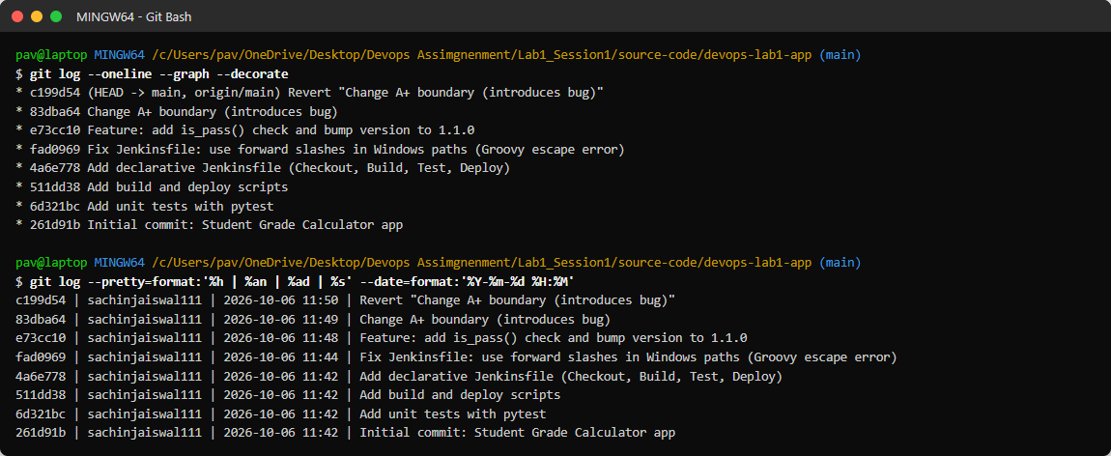
Figure 3.4: Commit history (git log)
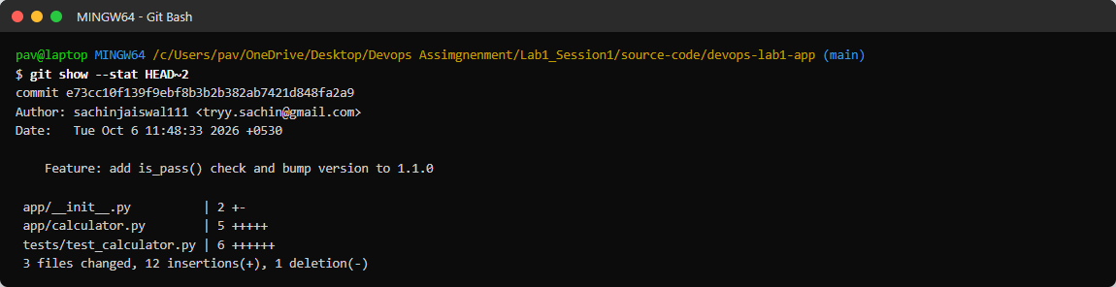
Figure 3.5: Details of the feature commit (git show --stat)

4. Local Build & Test Commands
python -m pytest tests -v
python scripts/build.py
python scripts/deploy.py staging

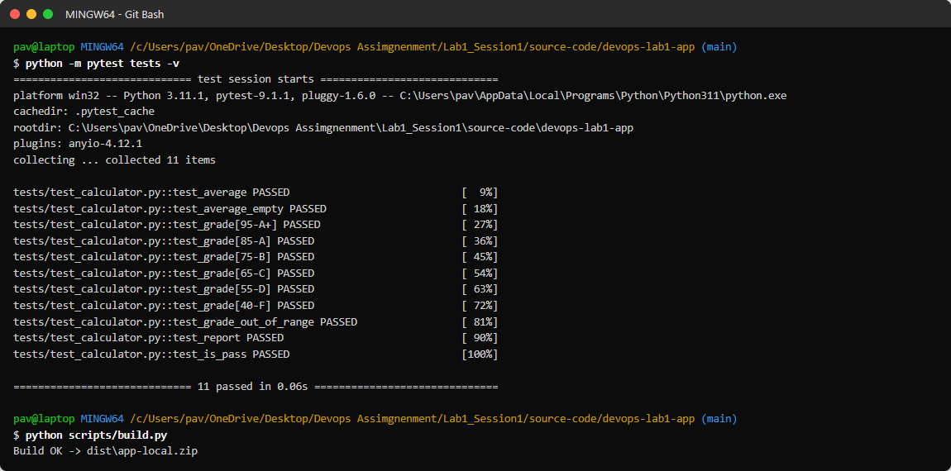
Figure 3.6: Running the tests and build locally before pushing

5. Pipeline Configurations

Jenkinsfile (declarative)
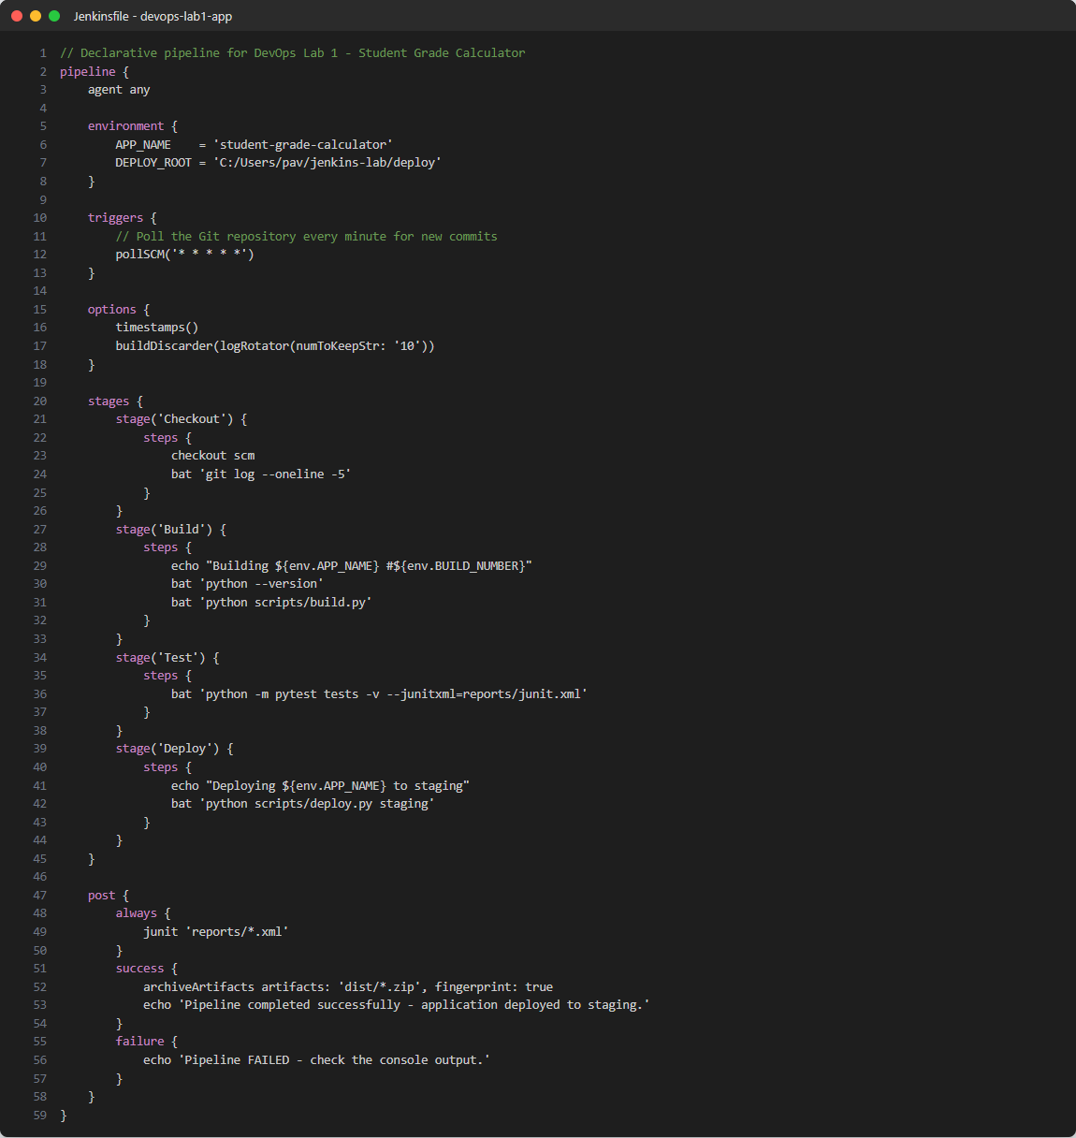
Figure 3.7: Jenkinsfile stored in the repository

Jenkins jobs
Job | Type | Definition | Trigger
Lab1-Q1-Declarative-Pipeline | Pipeline | Pipeline script from SCM (Jenkinsfile) | Poll SCM * * * * *
Lab1-Q1-Scripted-Pipeline | Pipeline | Inline scripted pipeline (node { }) | Manual
Lab1-Q2-Freestyle-AutoDeploy | Freestyle | Git SCM + 3 batch build steps + 2 post-build actions | Poll SCM * * * * *
Lab1-Q5-CI-Pipeline | Pipeline | Pipeline script from SCM (Jenkinsfile) | Poll SCM * * * * *

Jenkins REST API commands used
curl -s http://127.0.0.1:8080/crumbIssuer/api/json # CSRF crumb
curl -X POST -H "Content-Type: application/xml" --data-binary @q5.xml \
"http://127.0.0.1:8080/createItem?name=Lab1-Q5-CI-Pipeline" # create job
curl -X POST http://127.0.0.1:8080/job/Lab1-Q5-CI-Pipeline/build # Build Now
curl -s "http://127.0.0.1:8080/job/Lab1-Q5-CI-Pipeline/api/json?tree=builds[number,result,duration]"
curl -s http://127.0.0.1:8080/job/Lab1-Q5-CI-Pipeline/lastBuild/consoleText

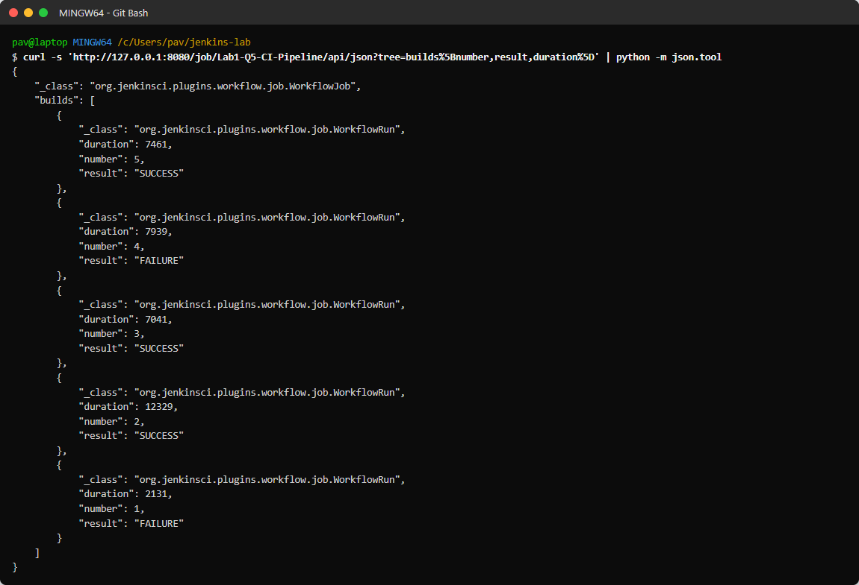
Figure 3.8: Build results queried through the Jenkins REST API
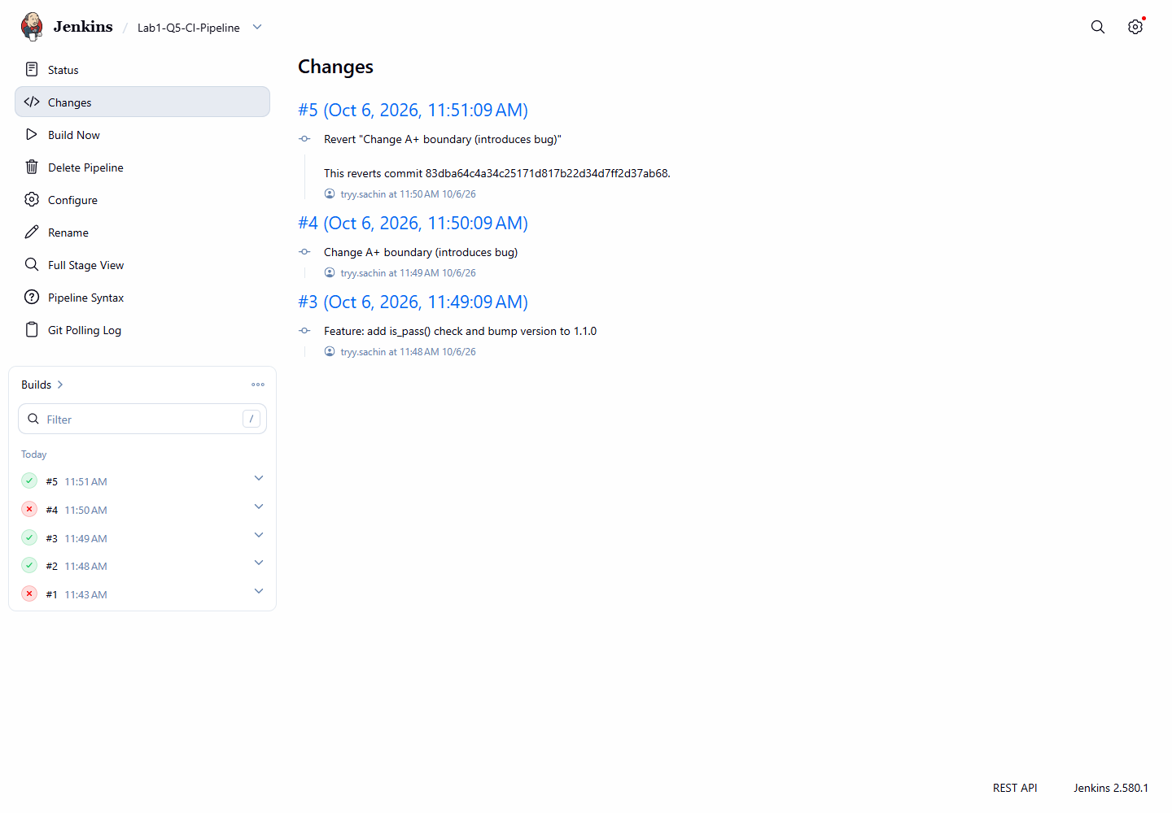
Figure 3.9: Jenkins 'Changes' page - commits included in every build
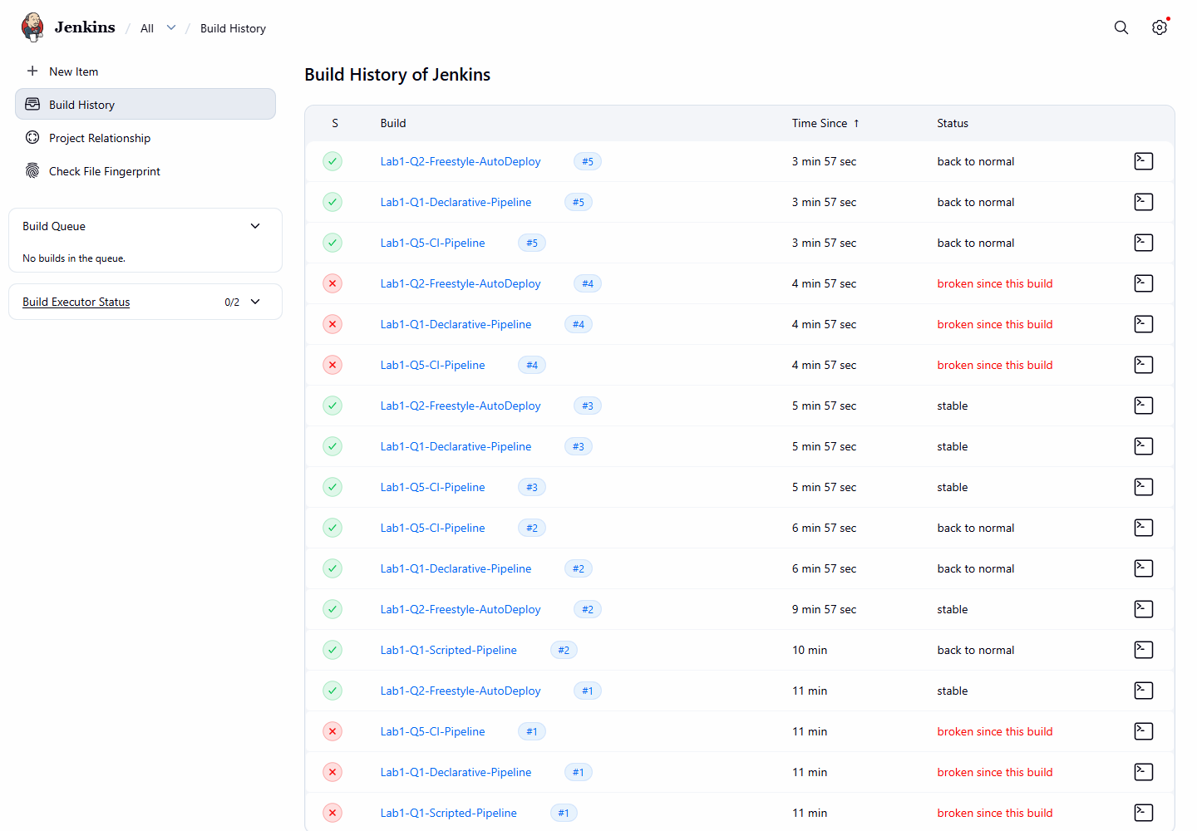
Figure 3.10: All builds of all Lab 1 jobs

6. Observations for Each Experiment
Experiment | Observation
Jenkins setup | Java 24 is newer than the officially supported versions, so Jenkins was started with --enable-future-java. Setup wizard was skipped for the local lab.
Q1 - Jenkinsfile | First build failed: Groovy treats '\' as an escape character. Fixed by using '/' in paths. Declarative and scripted pipelines both succeeded afterwards.
Q2 - Auto deployment | Poll SCM detected every push within one minute; the freestyle job deployed to production automatically. A failing test stopped the deployment.
Q4 - CI/CD workflow | Average pipeline time was about 7-12 s; the Test stage acts as a quality gate.
Q5 - Git CI pipeline | A pipeline job only starts polling after one build has checked out the repo; after that every commit triggered a build automatically.

Conclusion
All commands, configurations, screenshots, commit history and observations for the Lab 1 experiments were recorded in this document.

