Lab 1: DevOps Foundations & Continuous Integration
Session 1 - Question 4: Prepare a CI/CD workflow report (10 marks)
Name | Sachin kumar
Roll No. | 2301010366
Course | Btech(cse)
Date of Experiment | 06-10-2026
Tools Used | Jenkins 2.580.1 LTS, Git 2.53, Java 24, Python 3.11, pytest 9.1, Windows 11

Problem Statement
Prepare a CI/CD workflow report describing the pipeline architecture, stages, automation results, and observations with supporting screenshots.

1. Introduction
Continuous Integration (CI) means every code change is automatically built and tested as soon as it is committed. Continuous Delivery/Deployment (CD) extends this by automatically releasing the tested build to an environment. In this lab, Jenkins was used to build a CI/CD workflow for a Python 'Student Grade Calculator' application stored in a Git repository.

Objectives
- Store the pipeline as code (Jenkinsfile) in the repository.
- Trigger a build automatically on every commit.
- Build, test and deploy the application with no manual steps.
- Stop the release when tests fail, and publish test results and artifacts.

2. Tools and Environment
Component | Details
Operating system | Windows 11 Home (64-bit)
CI/CD server | Jenkins 2.580.1 LTS (jenkins.war) on http://localhost:8080
Plugins | Pipeline (workflow-aggregator), Git, Pipeline Stage View, JUnit, Timestamper, Workspace Cleanup
Version control | Git 2.53.0 - repository devops-lab1-app (branch main)
Runtime / tests | Java 24.0.2 (for Jenkins), Python 3.11.1, pytest 9.1.1
Sample application | Student Grade Calculator (Python) - app/, tests/, scripts/, Jenkinsfile

3. Pipeline Architecture
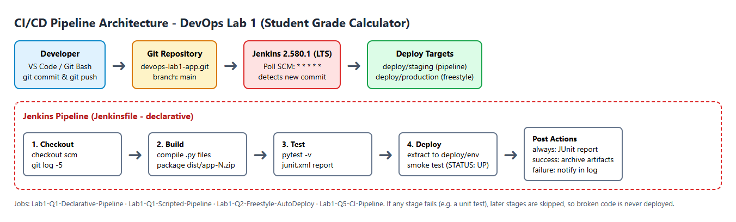
Figure 4.1: CI/CD pipeline architecture
Flow: the developer commits and pushes code to the Git repository (branch main). Jenkins polls the repository every minute (Poll SCM). When it finds a new commit it starts the pipeline defined in the Jenkinsfile: Checkout, Build, Test and Deploy. Post actions publish the JUnit report and archive the build artifact. The deployed application is verified with a smoke test.

Repository structure
devops-lab1-app/
|-- app/ __init__.py (version), calculator.py (logic), main.py (entry point)
|-- tests/ test_calculator.py (11 pytest unit tests)
|-- scripts/ build.py (compile + zip), deploy.py (deploy + smoke test)
|-- Jenkinsfile declarative pipeline
|-- README.md, .gitignore

4. Pipeline Stages
# | Stage | Description | Output
0 | Trigger | pollSCM('* * * * *') detects a new commit on main | Build queued
1 | Checkout | checkout scm - fetches the commit; git log shows last 5 commits | Workspace with source
2 | Build | Byte-compiles app/*.py and packages dist/app-<N>.zip | Build artifact
3 | Test | pytest runs 11 unit tests, writes reports/junit.xml | Test report
4 | Deploy | Extracts artifact to deploy/staging, writes DEPLOYED_VERSION.txt, runs smoke test | Running app
5 | Post | always: junit; success: archiveArtifacts; failure: error message | Report + archive

Jenkinsfile
// Declarative pipeline for DevOps Lab 1 - Student Grade Calculator
pipeline {
agent any

environment {
APP_NAME = 'student-grade-calculator'
DEPLOY_ROOT = 'C:/Users/pav/jenkins-lab/deploy'
}

triggers {
// Poll the Git repository every minute for new commits
pollSCM('* * * * *')
}

options {
timestamps()
buildDiscarder(logRotator(numToKeepStr: '10'))
}

stages {
stage('Checkout') {
steps {
checkout scm
bat 'git log --oneline -5'
}
}
stage('Build') {
steps {
echo "Building ${env.APP_NAME} #${env.BUILD_NUMBER}"
bat 'python --version'
bat 'python scripts/build.py'
}
}
stage('Test') {
steps {
bat 'python -m pytest tests -v --junitxml=reports/junit.xml'
}
}
stage('Deploy') {
steps {
echo "Deploying ${env.APP_NAME} to staging"
bat 'python scripts/deploy.py staging'
}
}
}

post {
always {
junit 'reports/*.xml'
}
success {
archiveArtifacts artifacts: 'dist/*.zip', fingerprint: true
echo 'Pipeline completed successfully - application deployed to staging.'
}
failure {
echo 'Pipeline FAILED - check the console output.'
}
}
}

5. Automation Results
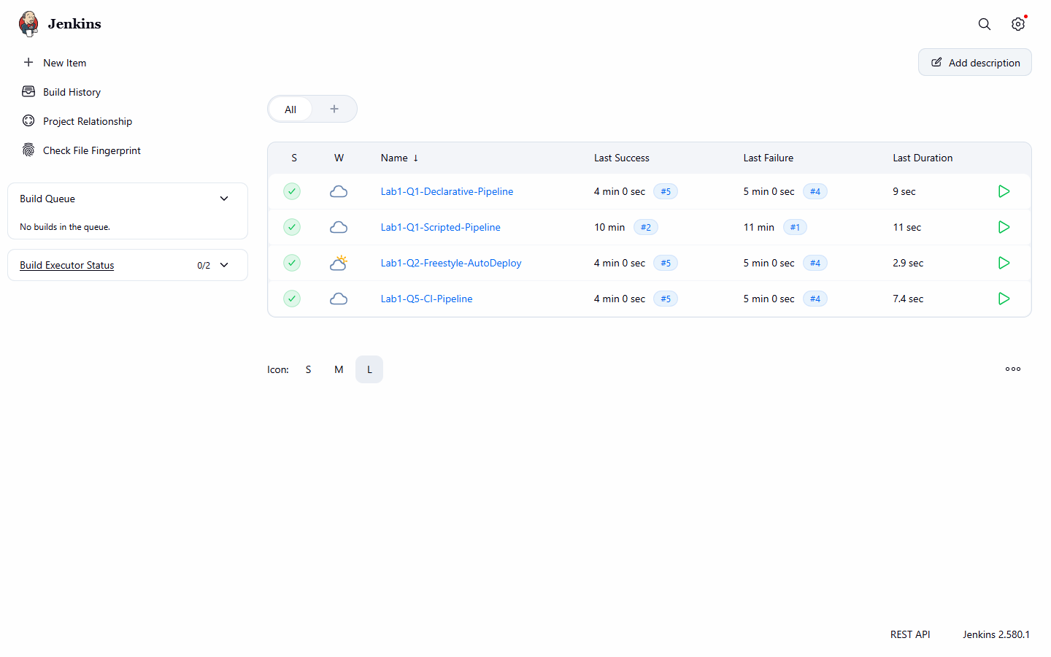
Figure 4.2: Jenkins dashboard - status of all CI/CD jobs

Lab1-Q5-CI-Pipeline build history
Build | Trigger (cause) | Commit | Result | Duration
#1 (11:43:19) | Manual (Build Now) | - | FAILURE | 2.1 s
#2 (11:48:09) | Manual (Build Now) | - | SUCCESS | 12.3 s
#3 (11:49:09) | Poll SCM (SCM change) | e73cc10 Feature: add is_pass() check and bump version to 1.1.0 | SUCCESS | 7.0 s
#4 (11:50:09) | Poll SCM (SCM change) | 83dba64 Change A+ boundary (introduces bug) | FAILURE | 7.9 s
#5 (11:51:09) | Poll SCM (SCM change) | c199d54 Revert "Change A+ boundary (introduces bug)" | SUCCESS | 7.5 s

Lab1-Q2-Freestyle-AutoDeploy build history
Build | Trigger (cause) | Commit | Result | Duration
#1 (11:43:19) | Manual (Build Now) | - | SUCCESS | 7.0 s
#2 (11:45:09) | Poll SCM (SCM change) | fad0969 Fix Jenkinsfile: use forward slashes in Windows paths | SUCCESS | 2.4 s
#3 (11:49:09) | Poll SCM (SCM change) | e73cc10 Feature: add is_pass() check and bump version to 1.1.0 | SUCCESS | 2.9 s
#4 (11:50:09) | Poll SCM (SCM change) | 83dba64 Change A+ boundary (introduces bug) | FAILURE | 2.7 s
#5 (11:51:09) | Poll SCM (SCM change) | c199d54 Revert "Change A+ boundary (introduces bug)" | SUCCESS | 3.0 s

Summary
Metric | Value
Total builds (4 jobs) | 17
Successful builds | 11 (65%)
Builds started automatically by a commit | 10
Unit tests per run | 11
Typical pipeline duration | 7 - 12 seconds
Bad commits stopped before deployment | 1 (83dba64 - caught by unit test)

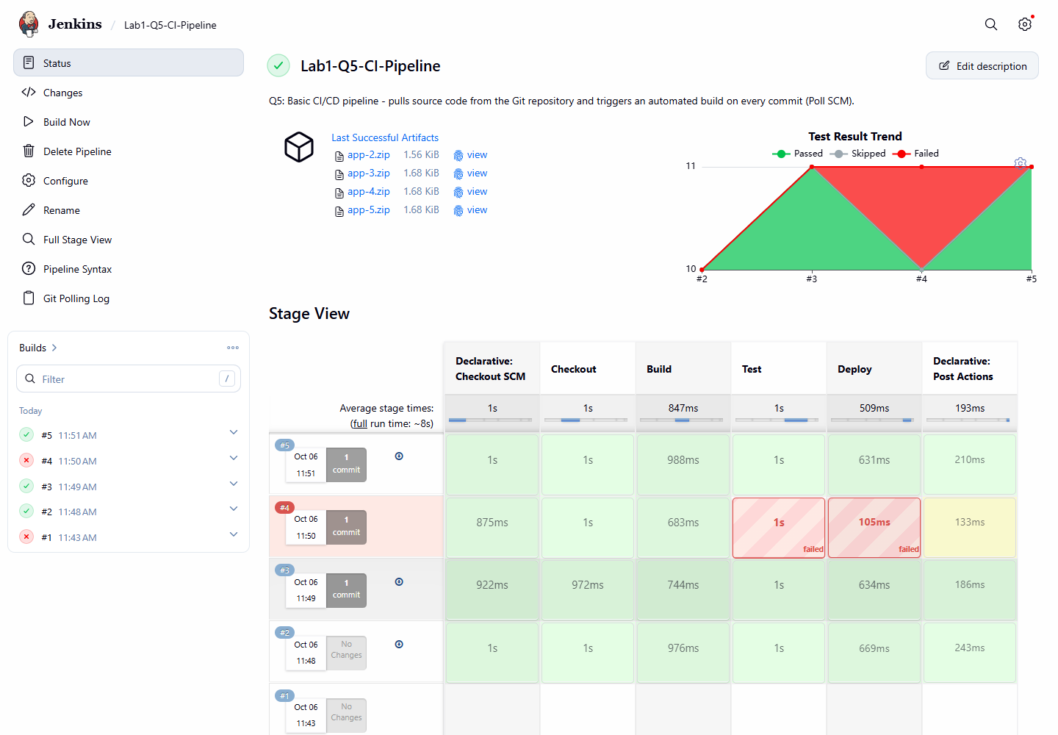
Figure 4.3: Stage View - build #4 failed at Test, Deploy skipped; #5 green again
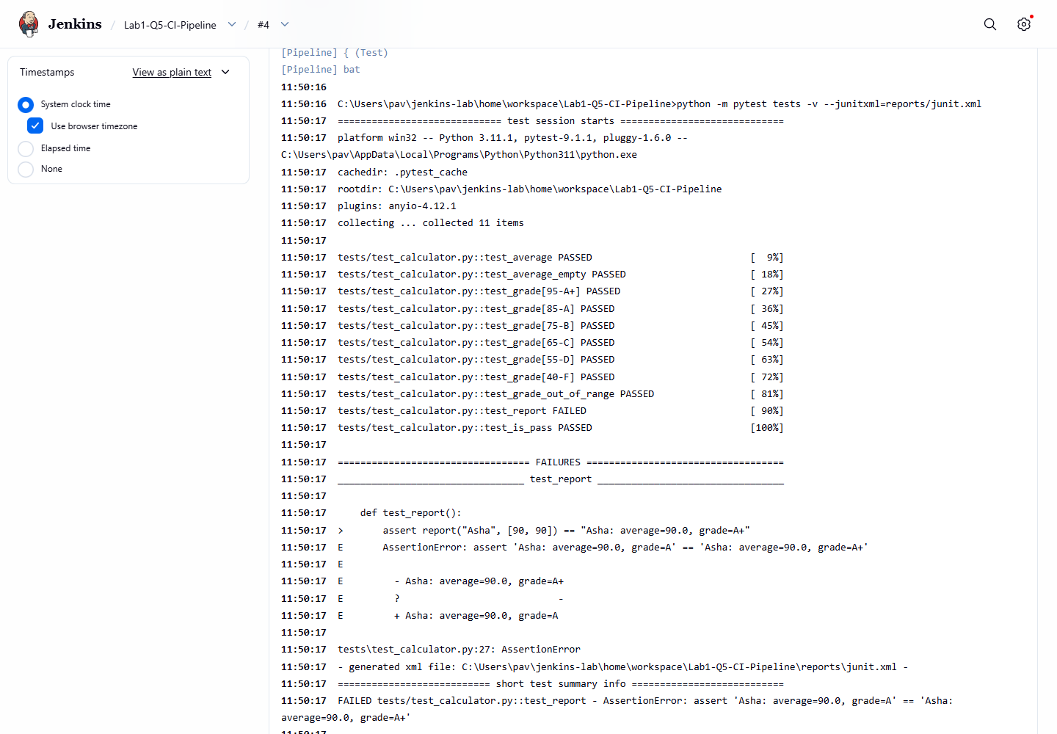
Figure 4.4: Console of build #4 - unit test caught the bug
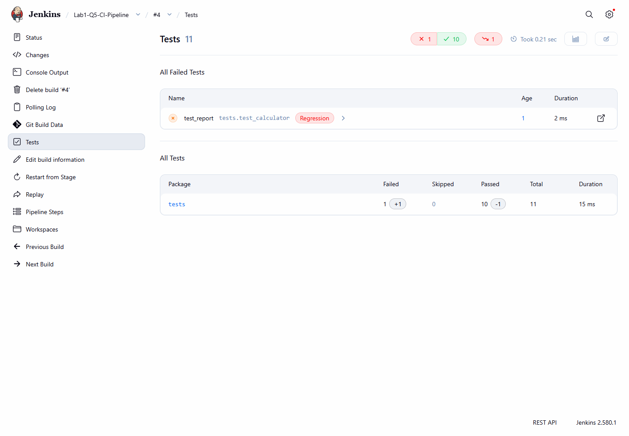
Figure 4.5: Test report of the failed build
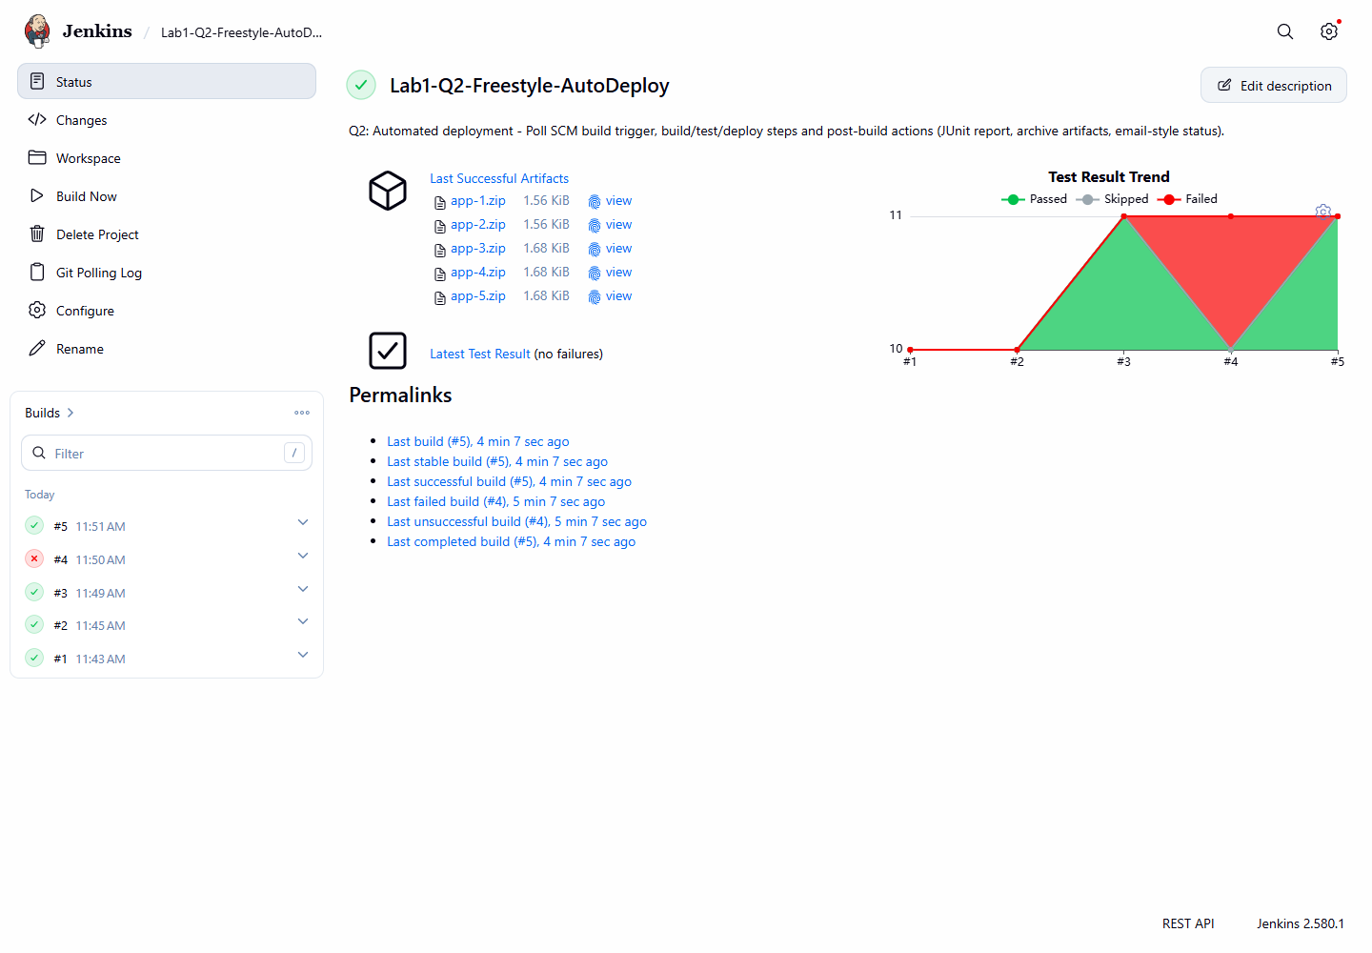
Figure 4.6: Test Result Trend and build history of the auto-deploy job
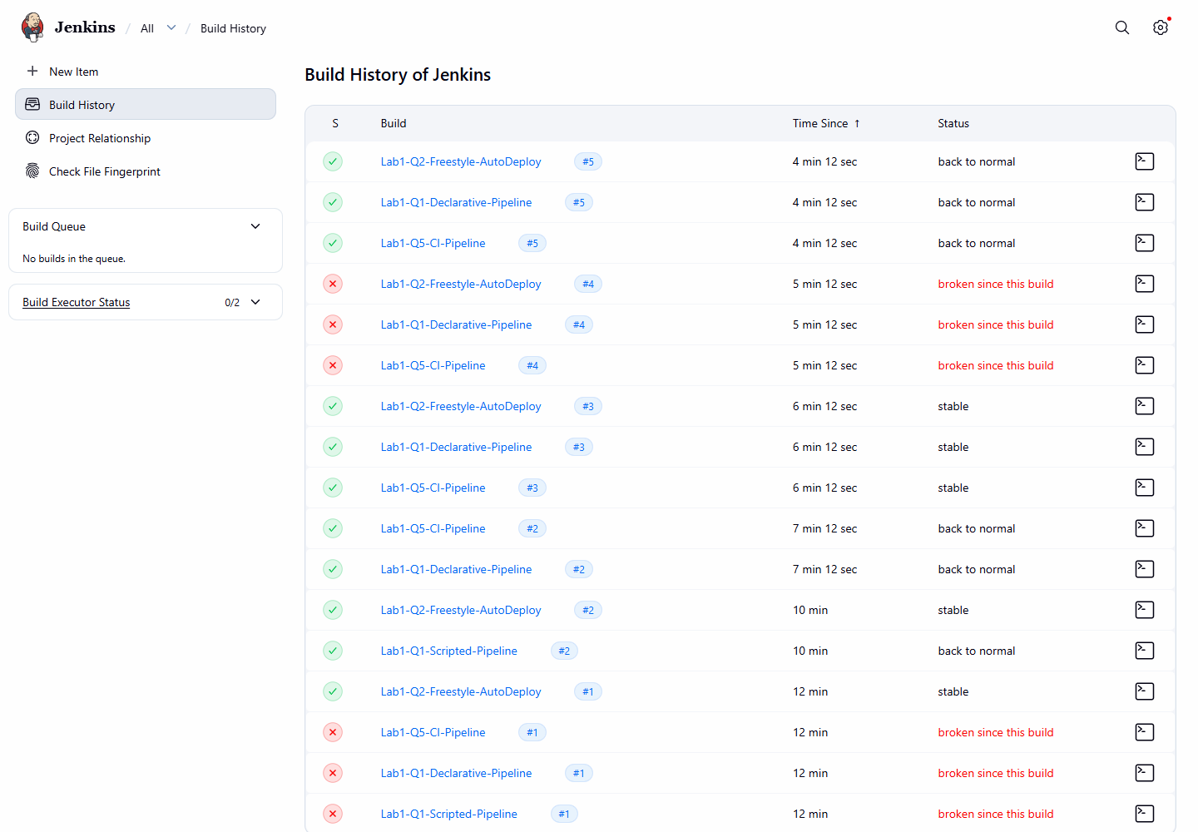
Figure 4.7: Build history of all jobs
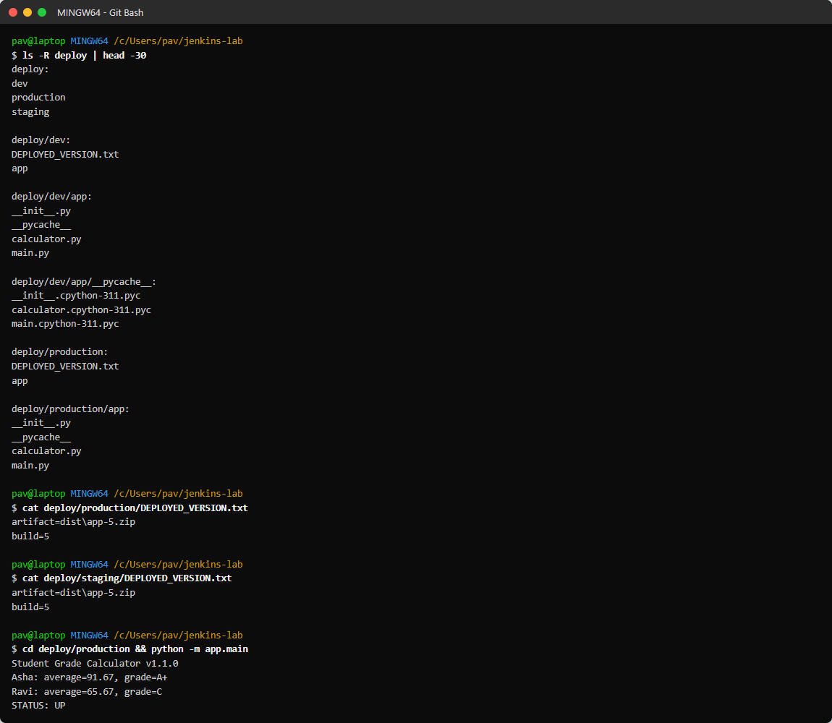
Figure 4.8: Deployment result - staging and production folders and running app

6. Observations
- Automation: after the first successful run, every git push started a build within about one minute without any manual action.
- Quality gate: the faulty commit 83dba64 changed the A+ grade boundary; test_report failed, the pipeline stopped and Deploy was skipped. Reverting the commit (c199d54) produced a green build and re-deployed automatically.
- Pipeline-as-Code: because the Jenkinsfile is in Git, the fix to the pipeline itself (fad0969) was versioned like any other code change.
- Jenkins pipelines only poll repositories they have checked out before, so the first build of a new pipeline job must be started manually.
- Polling every minute is fine for a lab, but a webhook from GitHub is more efficient in real projects.

7. Challenges and Solutions
Challenge | Solution
Groovy compile error 'unexpected char: \' on Windows paths | Used forward slashes in paths in the Jenkinsfile
Java 24 not officially supported by Jenkins | Started Jenkins with --enable-future-java
Pipeline did not poll after a failed first build | Started one build manually; polling worked afterwards
Local repository checkout blocked by Git plugin | Started Jenkins with -Dhudson.plugins.git.GitSCM.ALLOW_LOCAL_CHECKOUT=true

8. Conclusion
A working CI/CD workflow was built with Jenkins. Code pushed to Git is automatically checked out, built, tested and deployed. Test results and artifacts are published after every build, and failing code is stopped before deployment. This shows the main DevOps benefits: fast feedback, repeatable builds and safe, automated releases.

