Lab 1: DevOps Foundations & Continuous Integration
Session 1 - Question 5: Implement a basic Jenkins CI/CD pipeline (5 marks)
Name | Sachin kumar
Roll No. | 2301010366
Course | Btech(cse)
Date of Experiment | 06-10-2026
Tools Used | Jenkins 2.580.1 LTS, Git 2.53, Java 24, Python 3.11, pytest 9.1, Windows 11

Problem Statement
Implement a basic Jenkins CI/CD pipeline that pulls source code from the GitHub repository and triggers an automated build.

Aim
To implement a Jenkins pipeline that pulls the source code from a Git repository and automatically starts a build whenever a new commit is pushed.

Environment
Component | Details
Operating system | Windows 11 Home (64-bit)
CI/CD server | Jenkins 2.580.1 LTS (jenkins.war) on http://localhost:8080
Plugins | Pipeline (workflow-aggregator), Git, Pipeline Stage View, JUnit, Timestamper, Workspace Cleanup
Version control | Git 2.53.0 - repository devops-lab1-app (branch main)
Runtime / tests | Java 24.0.2 (for Jenkins), Python 3.11.1, pytest 9.1.1
Sample application | Student Grade Calculator (Python) - app/, tests/, scripts/, Jenkinsfile

Theory
- SCM integration: Jenkins' Git plugin clones/fetches the repository and checks out the requested branch (*/main) into the job workspace.
- Automated trigger: Poll SCM checks the remote for new commits on a schedule; a GitHub webhook ('GitHub hook trigger for GITScm polling') notifies Jenkins immediately on push.
- Pipeline script from SCM: Jenkins reads the Jenkinsfile from the same repository, so the pipeline and the code always match.

Procedure
- Pushed the application and Jenkinsfile to the remote Git repository (branch main).
- Jenkins > New Item > 'Lab1-Q5-CI-Pipeline' > Pipeline > OK.
- Triggers: ticked 'Poll SCM' with schedule * * * * *.
- Pipeline: Definition = 'Pipeline script from SCM', SCM = Git, Repository URL = remote repository, Branch Specifier = */main, Script Path = Jenkinsfile. Saved.
- Clicked Build Now once so Jenkins records the repository for polling (build #2).
- Made a code change (new is_pass() function, version 1.1.0), committed and pushed it.
- Jenkins detected the new commit and started build #3 automatically ('Started by an SCM change'), pulled the code, then built, tested and deployed it.

Commands
git remote add origin <repository-url>
git push -u origin main
# code change
git add -A
git commit -m "Feature: add is_pass() check and bump version to 1.1.0"
git push origin main # -> Jenkins Poll SCM detects commit e73cc10 and starts a build

Using a GitHub repository
The same job works with a GitHub repository - only the Repository URL changes:
git remote set-url origin https://github.com/<username>/devops-lab1-app.git
git push -u origin main
Jenkins job > Pipeline > Repository URL: https://github.com/<username>/devops-lab1-app.git
(optional) Triggers: 'GitHub hook trigger for GITScm polling' + GitHub webhook
http://<jenkins-host>:8080/github-webhook/

Output / Screenshots
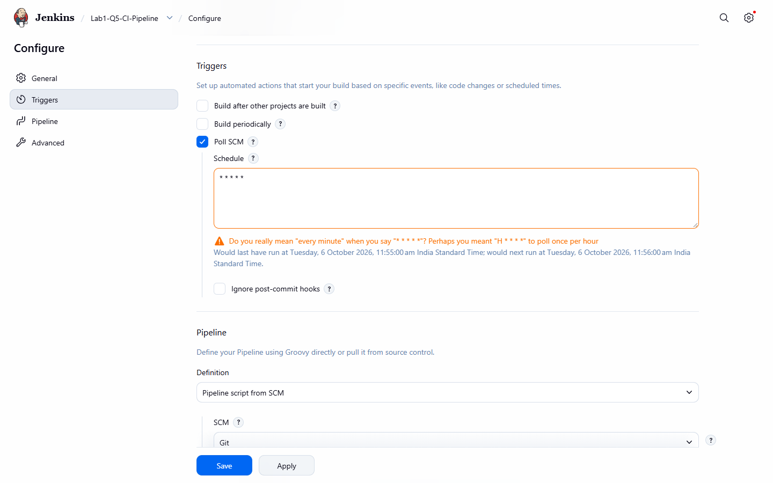
Figure 5.1: Job trigger - Poll SCM
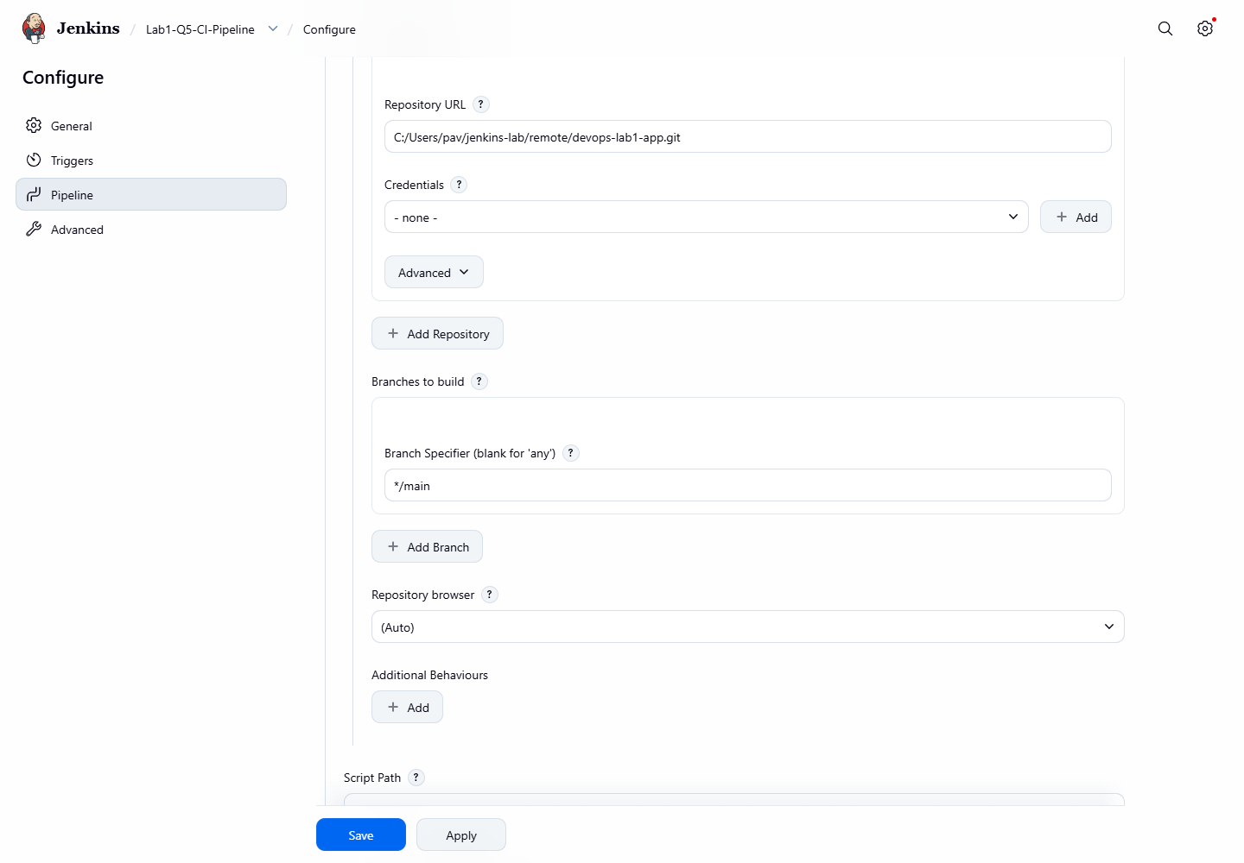
Figure 5.2: Pipeline script from SCM - repository URL and branch */main
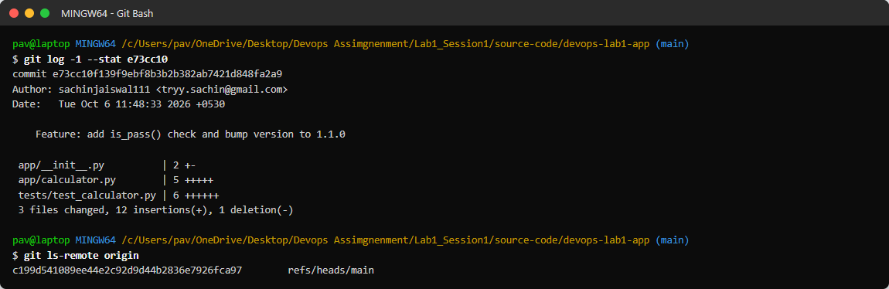
Figure 5.3: New commit pushed to the remote repository
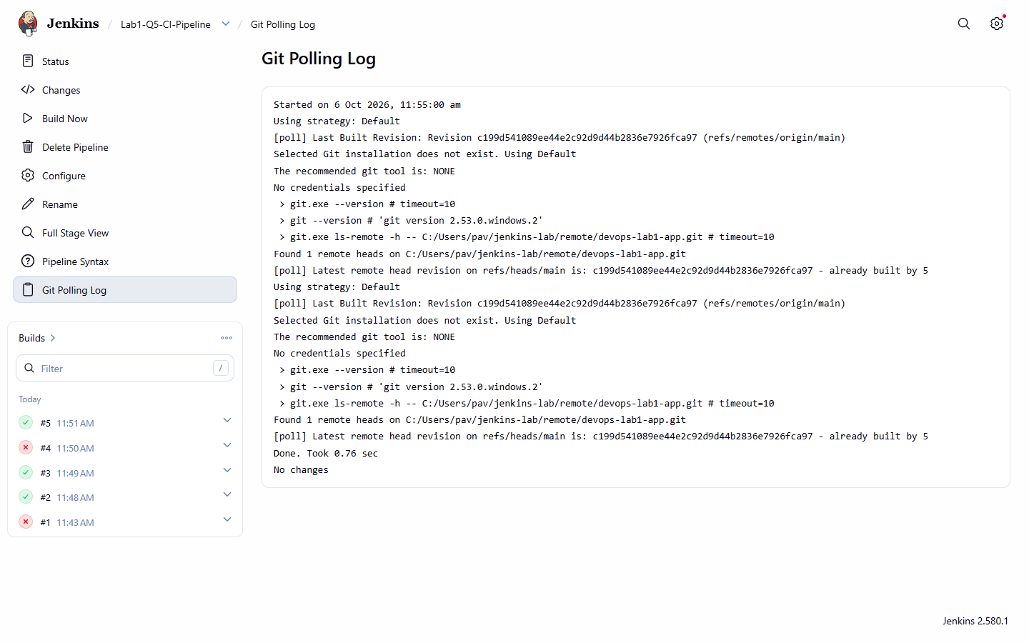
Figure 5.4: Git Polling Log
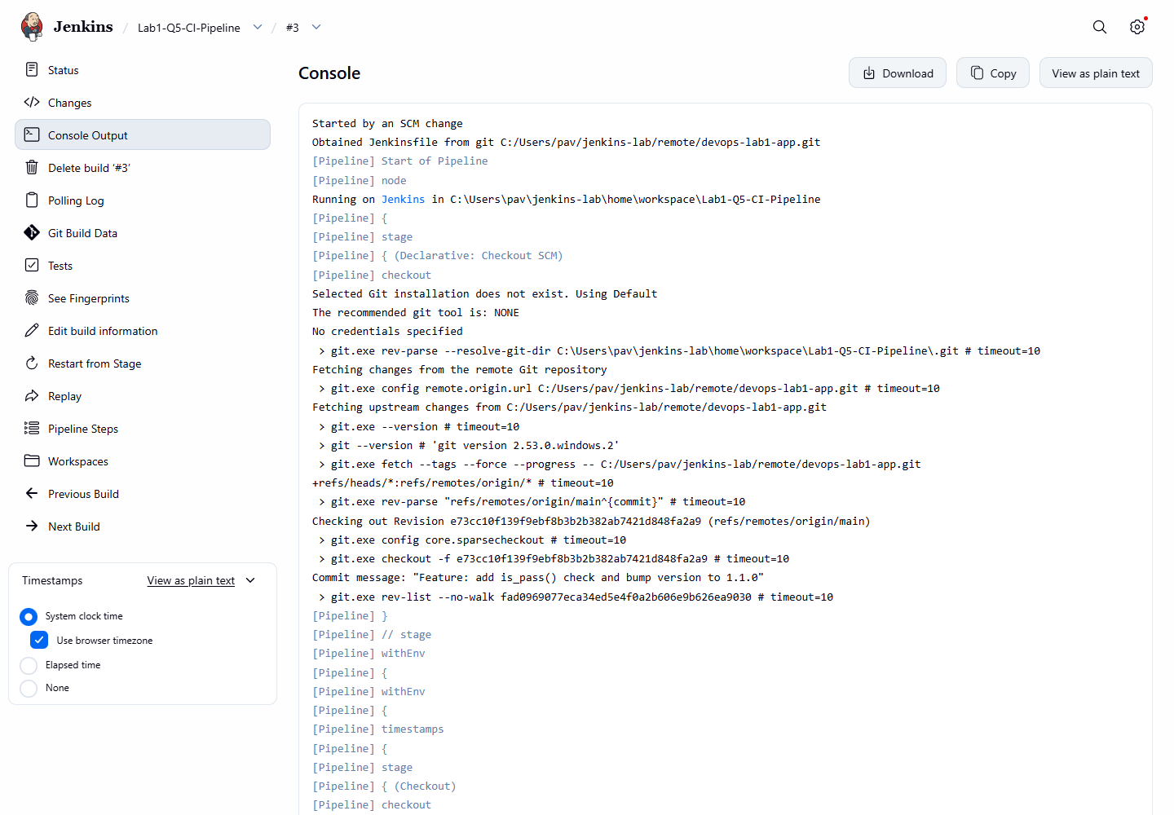
Figure 5.5: Build #3 'Started by an SCM change' - Jenkins fetches and checks out commit e73cc10
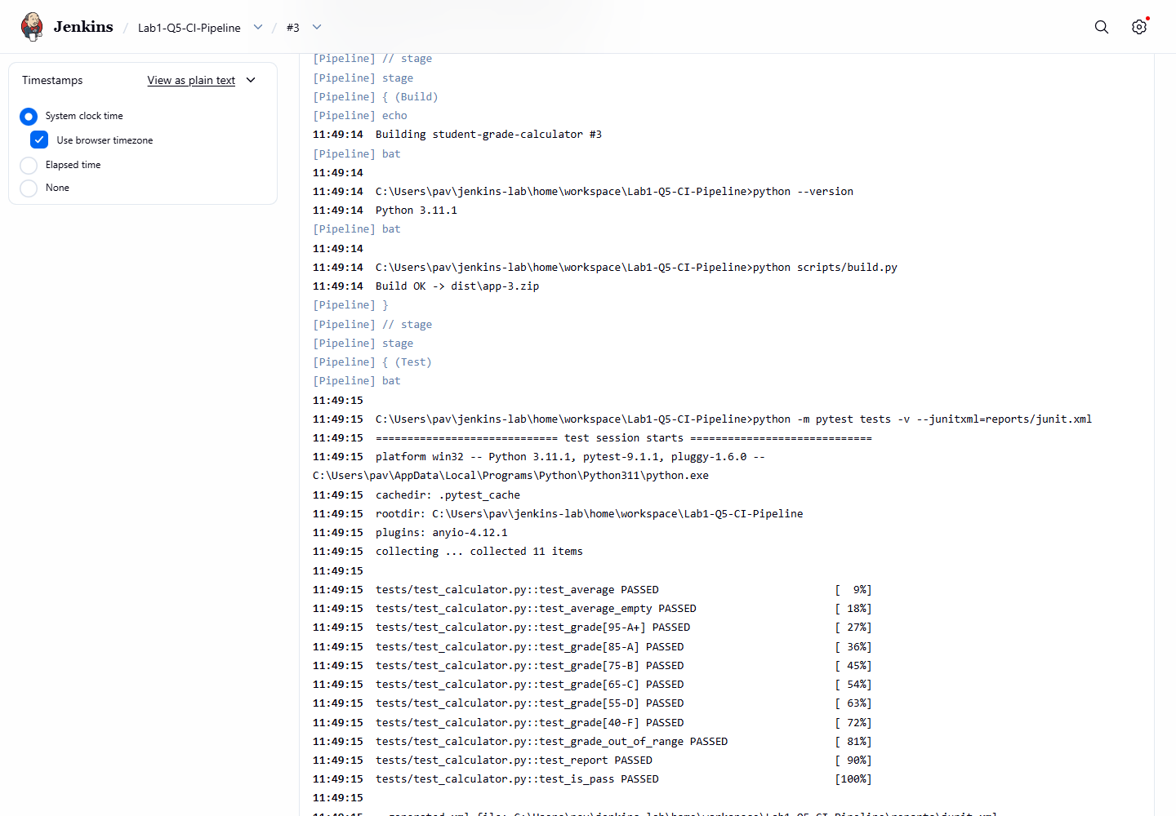
Figure 5.6: Automated build and test in the same run
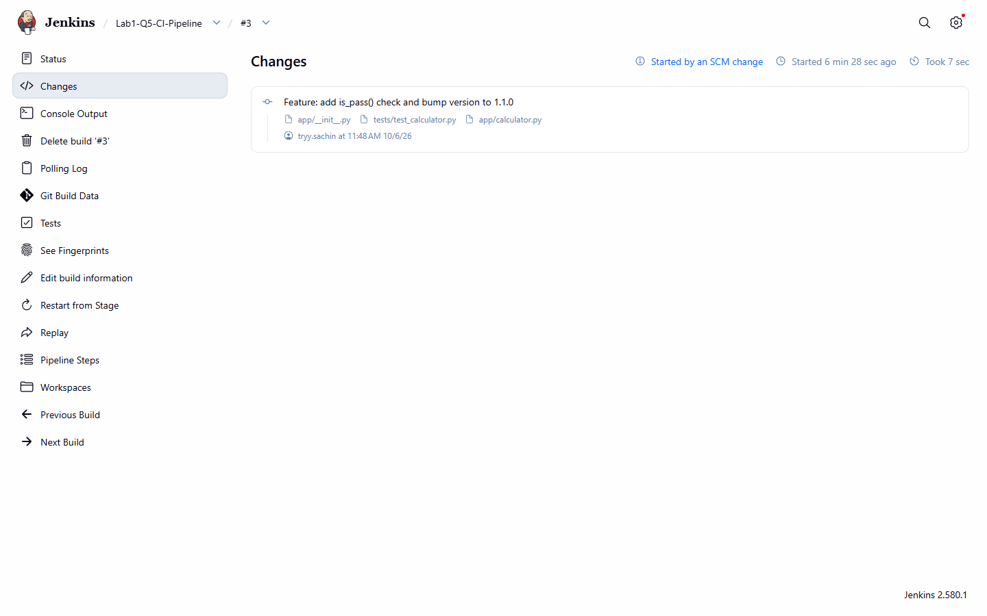
Figure 5.7: Changes page - the commit that triggered the build
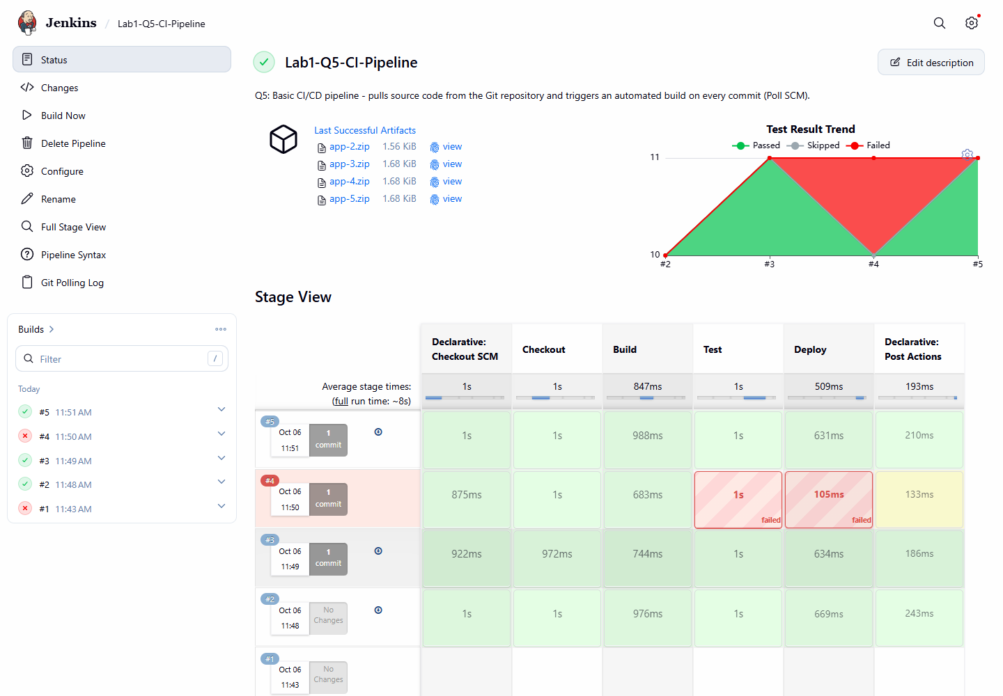
Figure 5.8: Stage View of the CI/CD pipeline

Result
Build | Trigger (cause) | Commit | Result | Duration
#1 (11:43:19) | Manual (Build Now) | - | FAILURE | 2.1 s
#2 (11:48:09) | Manual (Build Now) | - | SUCCESS | 12.3 s
#3 (11:49:09) | Poll SCM (SCM change) | e73cc10 Feature: add is_pass() check and bump version to 1.1.0 | SUCCESS | 7.0 s
#4 (11:50:09) | Poll SCM (SCM change) | 83dba64 Change A+ boundary (introduces bug) | FAILURE | 7.9 s
#5 (11:51:09) | Poll SCM (SCM change) | c199d54 Revert "Change A+ boundary (introduces bug)" | SUCCESS | 7.5 s

Builds #3, #4 and #5 were triggered automatically by commits. Jenkins pulled the exact commit each time (shown in the Changes page and 'Checking out Revision' line) and ran Build, Test and Deploy.

Observations
- Jenkins found new commits within about one minute of the push.
- The checkout log shows git fetch and 'Checking out Revision <sha>', proving the code is pulled from the repository on every build.
- A pipeline job must run once before polling works, because Jenkins polls only repositories it has already checked out.
- In this lab the remote was a Git repository on the same machine; switching to GitHub only needs a different URL (and credentials for a private repository).

Conclusion
A basic Jenkins CI/CD pipeline was implemented that pulls source code from the Git repository and automatically triggers a build, test and deployment on every commit.

