Lab 1: DevOps Foundations & Continuous Integration
Session 2 - Question 1: Install and configure Git on Ubuntu Linux (5 marks)
Name | Sachin kumar
Roll No. | 2301010366
Course | Btech(cse)
Date of Experiment | 06-10-2026
Tools Used | Jenkins 2.580.1 LTS, Git 2.53, Java 24, Python 3.11, pytest 9.1, Windows 11

Problem Statement
Install and configure Git on Ubuntu Linux, verify the installation, and set up global Git configuration (user name and email).

Aim
To install Git on Ubuntu Linux, verify the installation and configure the global user name and email.

Theory
Git is a distributed version control system. It records every change to the files of a project so that work can be tracked, undone, branched and shared. Before the first commit Git needs to know who the author is, so user.name and user.email are stored in the global configuration file ~/.gitconfig and are attached to every commit.

Procedure / Commands

Step 1: Update the package list and install Git
sudo apt update
sudo apt install git -y

Step 2: Verify the installation
git --version
which git

Step 3: Set the global configuration
git config --global user.name "Sachin Jaiswal"
git config --global user.email "tryy.sachin@gmail.com"
git config --global init.defaultBranch main
git config --global core.editor nano

Step 4: Verify the configuration
git config --global --list
git config --global user.name
git config --global user.email
cat ~/.gitconfig

Note: the Ubuntu apt commands are shown in the procedure. The screenshots were taken in Git Bash (same Git commands and output format) on the lab laptop.

Output / Screenshots
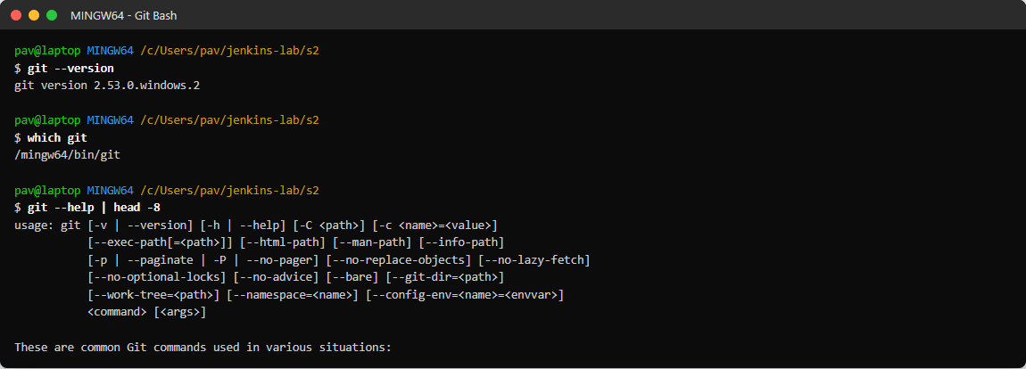
Figure 1.1: Git installed - git --version, location and help
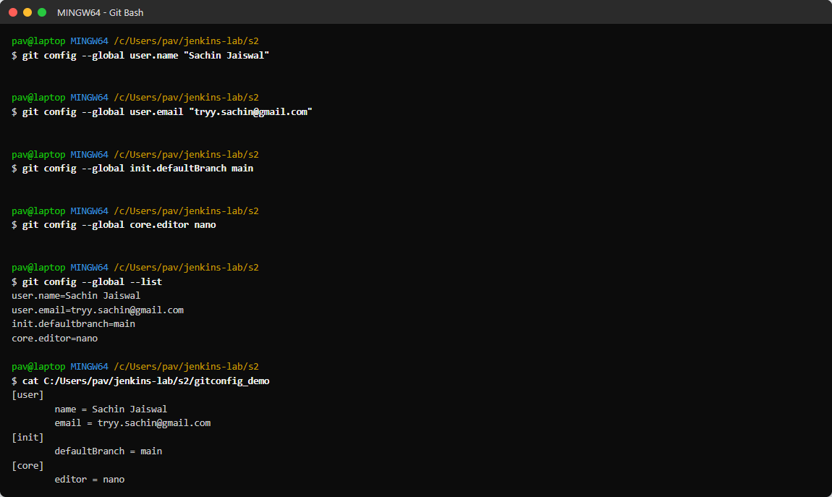
Figure 1.2: Setting the global user name, email, default branch and editor
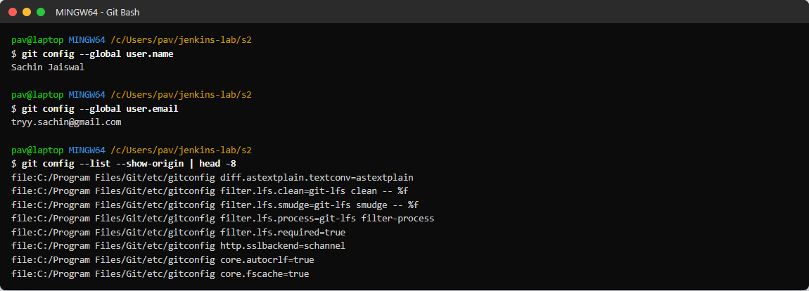
Figure 1.3: Verifying the configuration

Command summary
Command | Purpose
sudo apt update | Refresh the list of available packages
sudo apt install git -y | Install Git
git --version | Check the installed Git version
git config --global user.name | Set / read the author name
git config --global user.email | Set / read the author email
git config --global --list | Show all global settings

Result
Git 2.53.0 was installed and verified. The global user name and email were configured and confirmed with git config --global --list.

Observations
- The configuration is stored in the ~/.gitconfig file under the [user] section.
- Every commit uses this name and email as its author.
- --global applies the settings to all repositories of the user; without it only the current repository is changed.

Conclusion
Git was installed, verified and configured successfully, and is ready for version control work.

