Lab 1: DevOps Foundations & Continuous Integration
Session 2 - Question 2: Set up version control using Git (5 marks)
Name | Sachin kumar
Roll No | 2301010366
Course | Btech(cse)
Date of Experiment | 06-10-2026
Tools Used | Jenkins 2.580.1 LTS, Git 2.53, Java 24, Python 3.11, pytest 9.1, Windows 11

Problem Statement
Initialize a repository, stage and commit changes, create branches, merge branches, and push the repository to GitHub.

Aim
To perform the complete Git workflow: initialize a repository, stage and commit changes, create and merge branches, resolve a merge conflict and push the repository to a remote (GitHub).

Theory
- Repository: a project folder tracked by Git (.git directory).
- Staging area: git add selects the changes that go into the next commit.
- Commit: a snapshot of the staged changes with a message.
- Branch: an independent line of development, e.g. feature-login.
- Merge: combines one branch into another. A merge commit is created when both branches have new commits.
- Remote / push: a copy of the repository on a server such as GitHub; git push uploads commits to it.

Procedure and Output

1. Initialize the repository
mkdir lab-repo && cd lab-repo
git init
git branch -M main

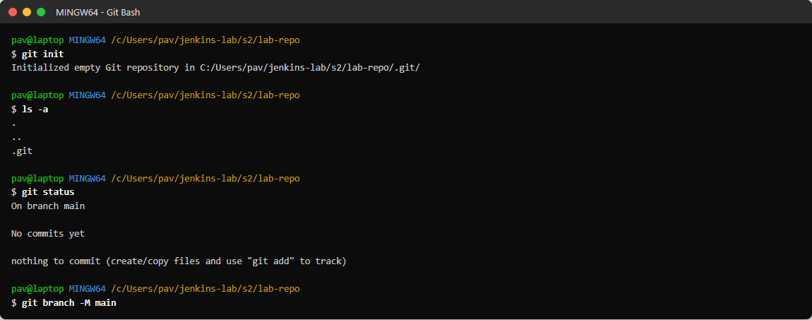
Figure 2.1: git init creates the .git folder

2. Stage and commit changes
git status
git add README.md hello.py
git commit -m "Initial commit: add README and hello.py"
git log --oneline

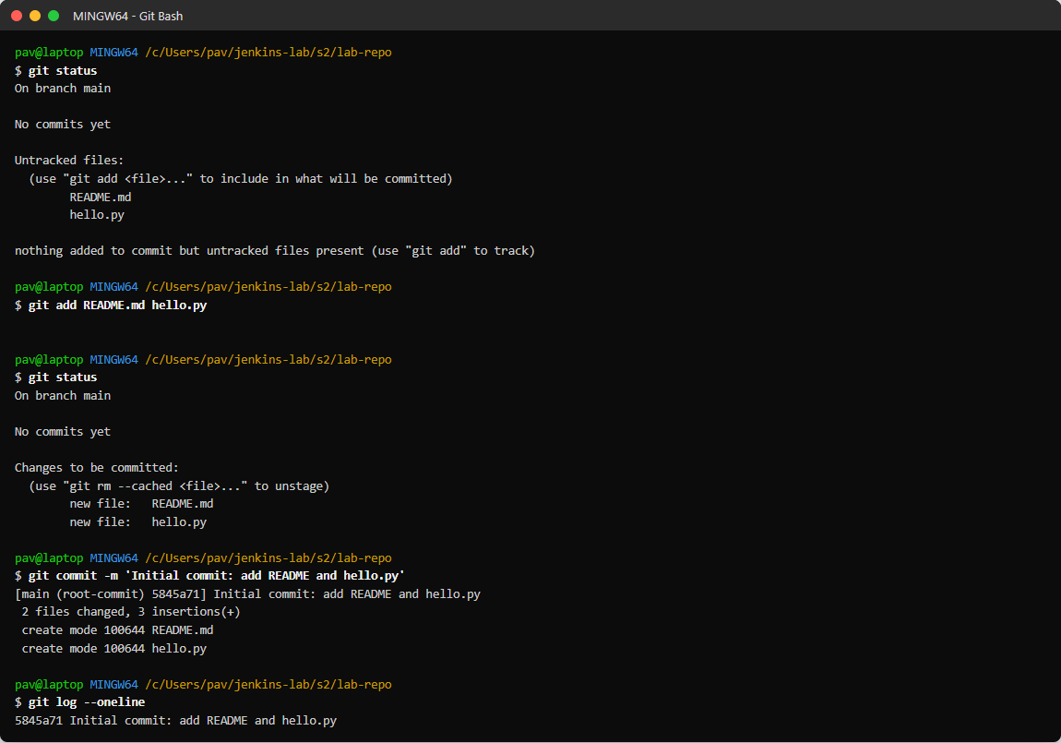
Figure 2.2: Staging and committing the first files

3. Create a branch
git branch feature-login
git checkout feature-login
git branch

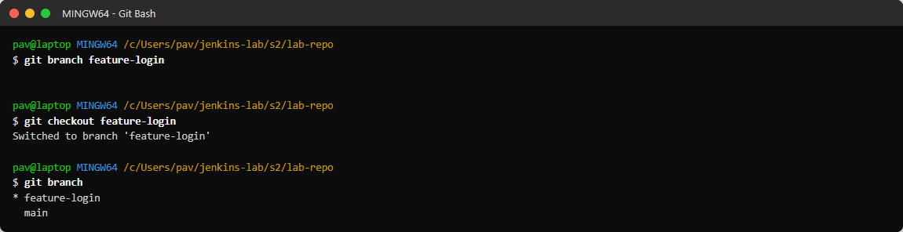
Figure 2.3: Creating and switching to the feature-login branch

4. Commit on the branch
git add login.py
git commit -m "Add login feature"
git commit -am "Use login in hello.py"

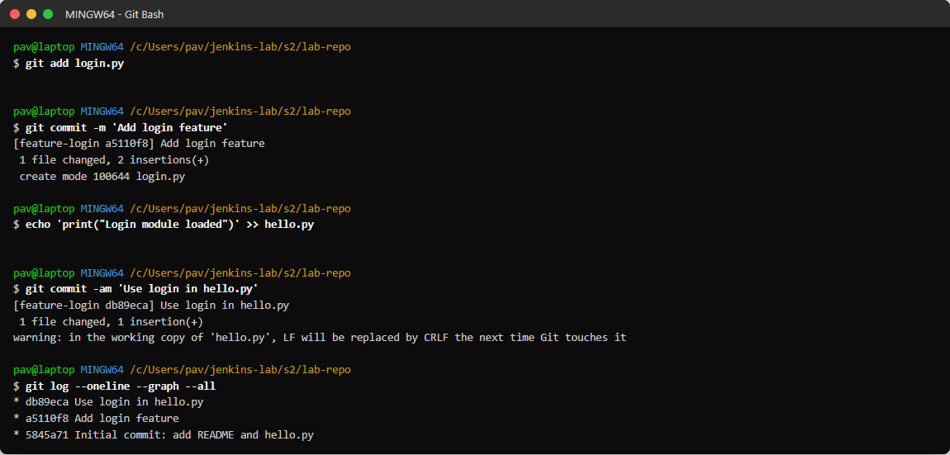
Figure 2.4: Two commits made on feature-login

5. Commit on main (so the branches diverge)
git checkout main
git commit -am "Update README with usage"

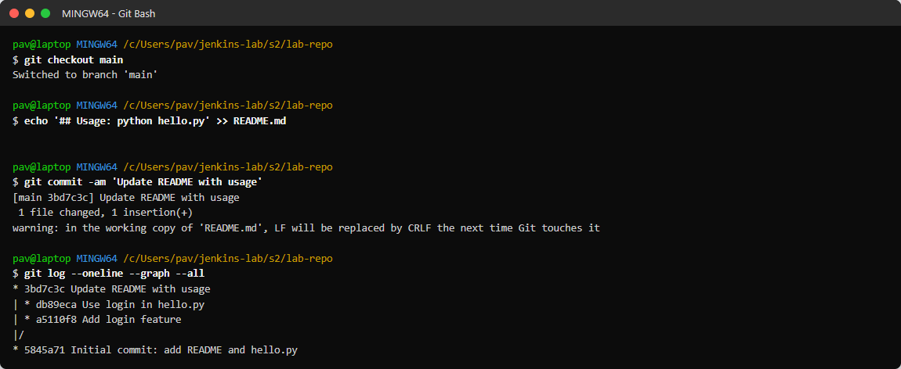
Figure 2.5: A new commit on main; the graph shows two lines of work

6. Merge the branch
git merge feature-login -m "Merge branch feature-login into main"
git branch -d feature-login

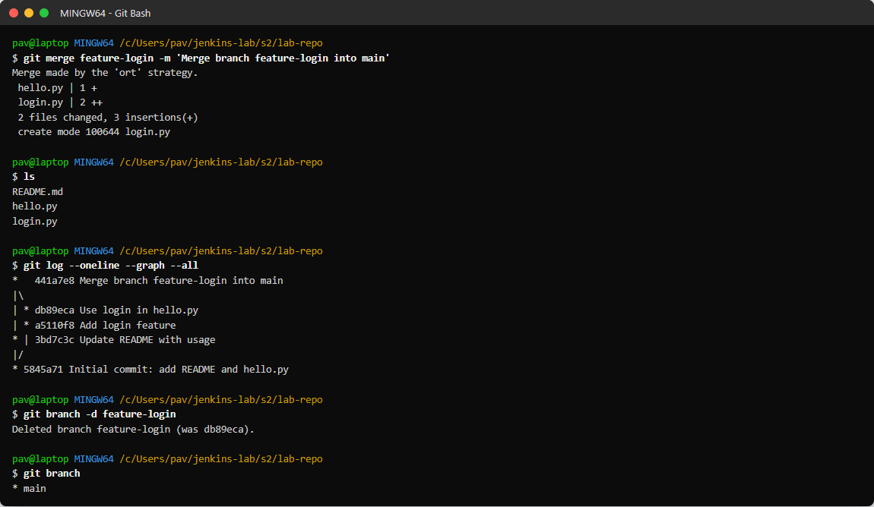
Figure 2.6: Merge commit created and the merged branch deleted

7. Merge conflict (both branches edit config.txt)
git checkout -b fix-a # add config.txt: version = "A"
git checkout -b fix-b # add config.txt: version = "B"
git merge fix-a
git merge fix-b # CONFLICT

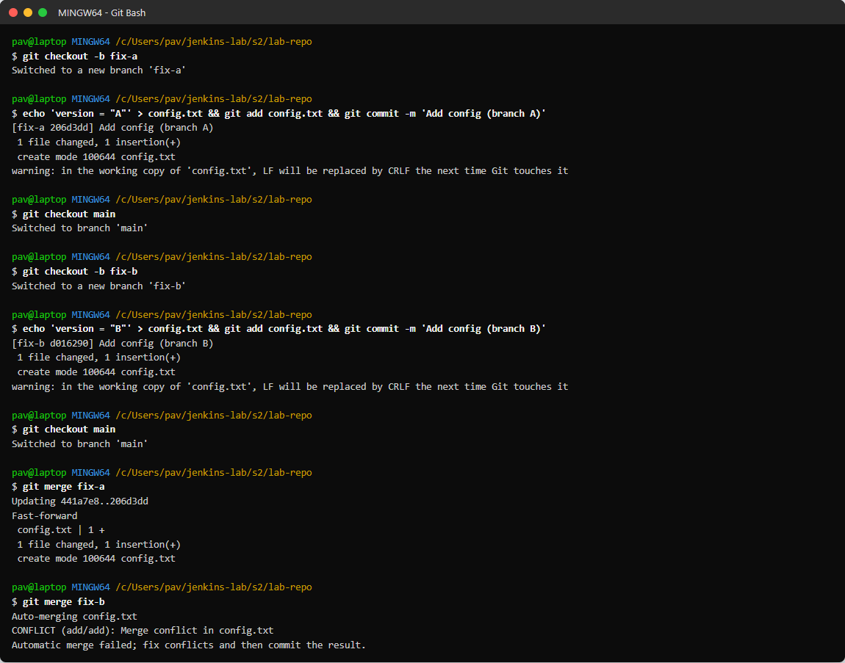
Figure 2.7: Merge of fix-b stops with a conflict

8. Resolve the conflict
git status --short
# edit config.txt and remove the <<<<<<< ======= >>>>>>> markers
git add config.txt
git commit -m "Merge fix-b: resolve conflict in config.txt"

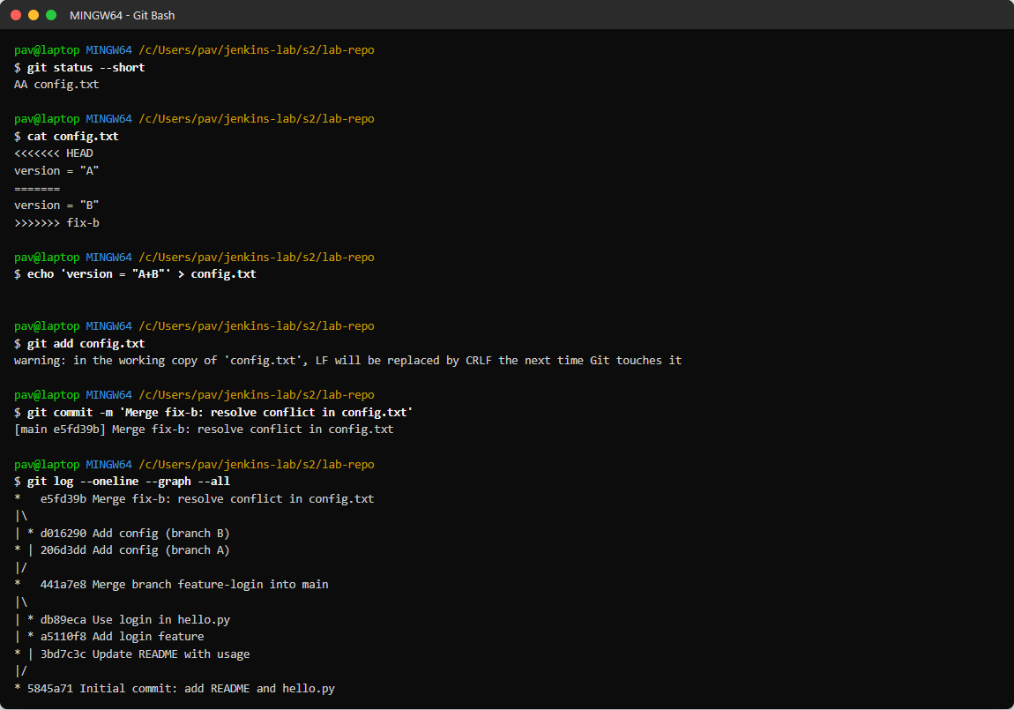
Figure 2.8: Conflict resolved and committed

9. Push to the remote repository (GitHub)
git remote add origin https://github.com/<username>/lab-repo.git
git push -u origin main
git push origin --all

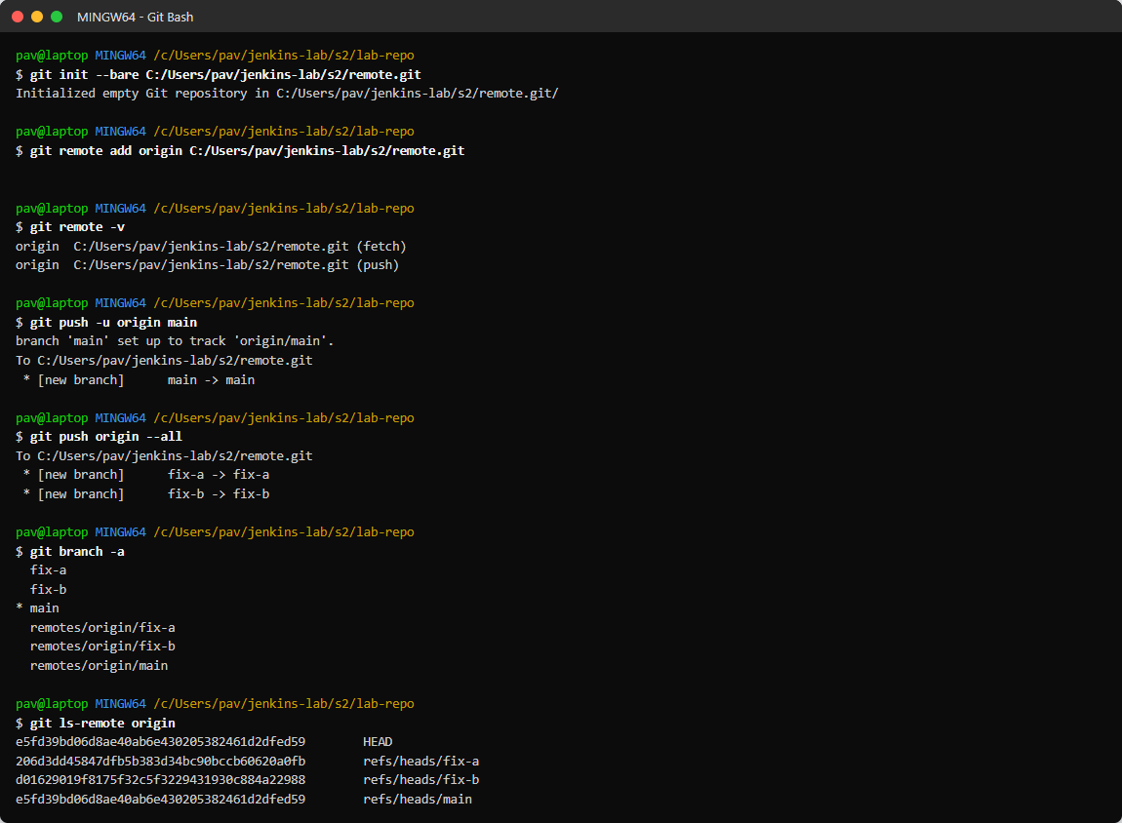
Figure 2.9: Pushing branches to the remote repository

10. Final status
git status
git log --pretty=format:'%h | %an | %s'

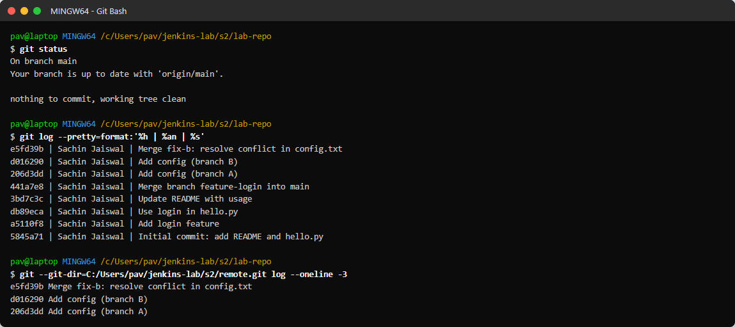
Figure 2.10: Working tree clean and remote contains the same commits
Note: in the screenshots the remote 'origin' is a Git repository on the lab laptop (C:/Users/pav/jenkins-lab/s2/remote.git). For GitHub only the URL changes: git remote add origin https://github.com/<username>/lab-repo.git, then git push -u origin main (sign in with a Personal Access Token).

Command summary
Command | Purpose
git init | Create a new repository
git add <file> | Stage changes
git commit -m "msg" | Save staged changes as a commit
git branch <name> | Create a branch
git checkout <name> | Switch branch
git merge <name> | Merge a branch into the current one
git remote add origin <url> | Link the remote repository
git push -u origin main | Upload commits to the remote
git log --oneline --graph --all | View history of all branches

Result
A repository was created, changes were staged and committed, a feature branch was created and merged into main with a merge commit, a merge conflict was resolved, and all branches were pushed to the remote repository.

Observations
- When both branches had new commits, the merge created a merge commit; if main has no new commits Git does a fast-forward merge instead.
- When two branches changed the same file, Git reported CONFLICT (add/add); the file had to be edited by hand, then git add and git commit finished the merge.
- git log --graph --all shows how the branches diverged and joined again.
- git push -u sets the upstream so later pushes need only git push.

Conclusion
The complete Git version-control workflow - init, add, commit, branch, merge, conflict resolution and push - was performed successfully.

