**23CSE111**

**OBJECT ORIENTED PROGRAMMING**

**LAB REPORT**



**Amrita Vishwa Vidyapeetham, Amaravati Campus**

**Department of Computer Science Engineering**   **Amrita School of Computing**

**Name***: v.yaswanth*

**Roll No:** 24344

**Verified By :**

***FIRST WEEK:***

***LAB 1:***

*PROGRAMM 1:* How to install java program in our devices

Procedure:

***Step 1:*** Go to official website of oracle java downloads

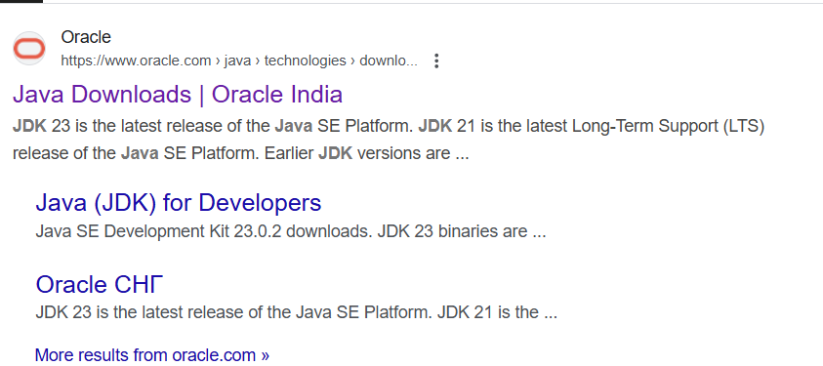

Click on the link as shown above

***Step 2:***

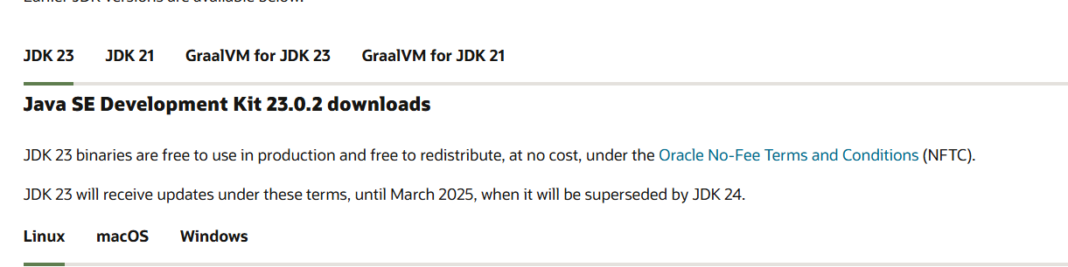

* Select JDK 21 as shown above
* Go to windows and as shown bottom in the figure
* Go to and click select x64 installer
* As shown in the down click on it
* 
* As it was not fully downloaded in the system we need set environment variables

***Step 3:***

* Setting environment variables on our system.
* Open c drive on your system
* In that open program files
* In that double click on java
* There you can see jdk 21
* And select it and then select the Bin from that.
* Now select the path or copy path
* 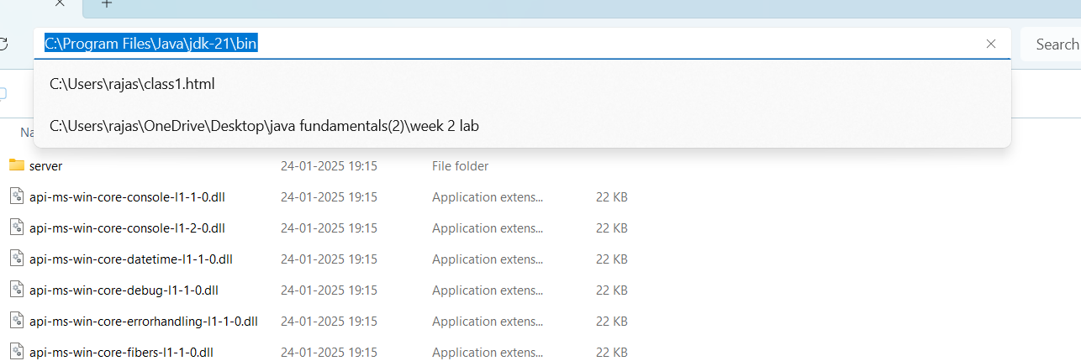
* In windows bar search edit the system enivornment variables.
* Open it and select the enivornment variables in the down as shown in the below diagram.
* 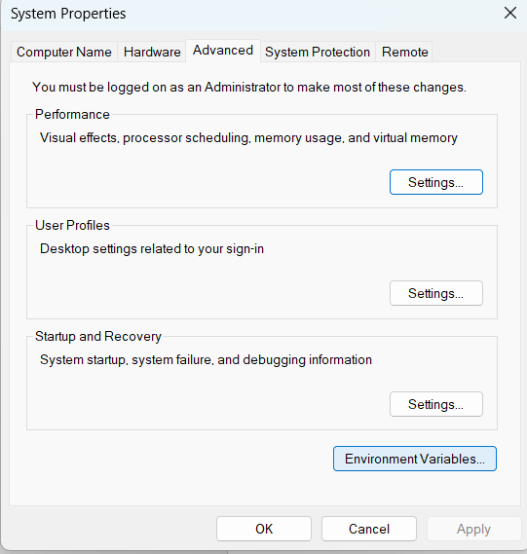
* In that select the system variables and select the on the path which is appearing and click on the new.
* And copy the path and click ok and apply as shown in the diagram.
* 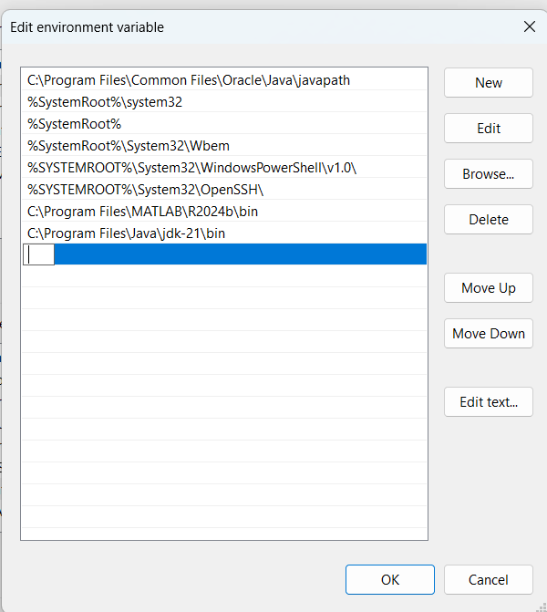
* Now your java compilation is completely downloaded.
* For verification go on command prompt and type javac –version
* It will show the version as it shown below
* 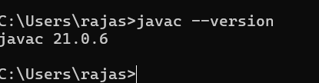

*PROGRAMME 2 :* Simple code of entering the student details.

Public class Main{

public static void main(String[] args){

System.out.println(“ Student name:YASWANTH”);

System.out.println(“Roll:no:24344”);

System.out.println(“Section:CSE-C”);

}

}

Output:

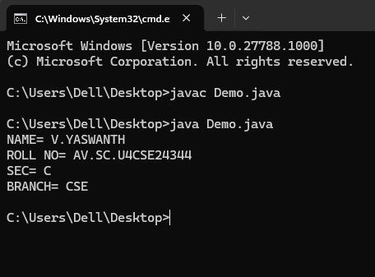

***WEEK 2 :***

*LAB 2:*

1.SIMPLE INTREST PROGRAM OF JAVA USING SCANNER CLASS.

Aim: Write a java program for simple intrest

CODE:

import java.util.Scanner;

class si{

private String amount;

private String time;

private String intrest;

private String simpleintrest;

public static void main(String[] args){

Scanner si=new Scanner(System.in);

System.out.print("enter the principal amount:");

int amount=si.nextInt();

System.out.println("amount:"+amount);

System.out.print("enter the time in terms of months:");

int time=si.nextInt();

System.out.println("time:"+time);

System.out.print("rate of intrest:");

int intrest=si.nextInt();

System.out.println("rate of intrest:"+intrest);

si.close();

if(amount<=0||time<=0||intrest<=0){

System.out.println("please enter in terms of positive numbers");

return;

}

int simpleintrest=amount*time*intrest/100;

System.out.println("simple intrest:"+simpleintrest);

}

}

OUTPUT:

1.

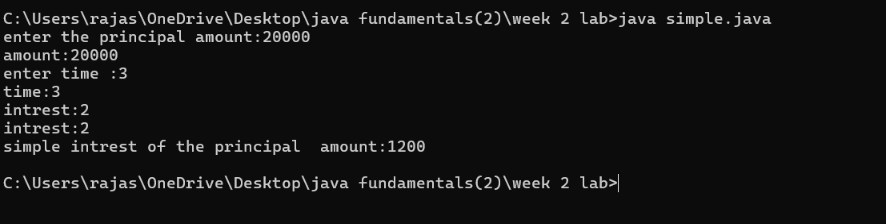

OUTPUT 2:

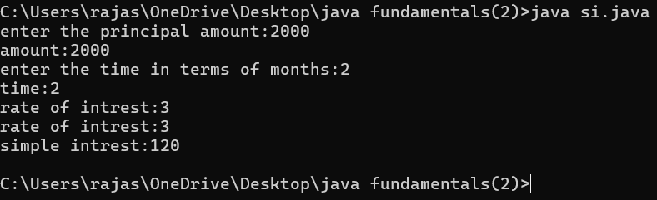

OUTPUT 3:

CHECKING FOR NEGATIVE VALUES

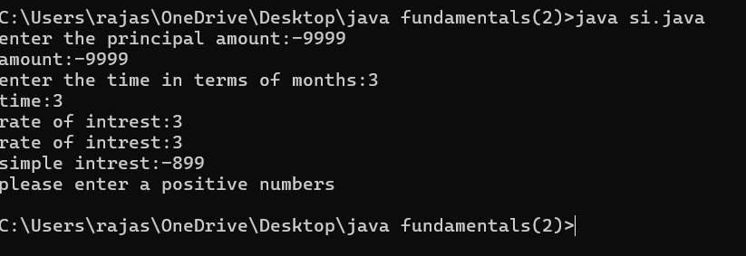

ERROR :

|  |  |  |  |
| --- | --- | --- | --- |
| Error type | Description | Impact | Solution |
| Conflicting class and variable name | The class name si conflicts with the Scanner object named si | Can cause confusion and potential conflicts | Rename the class name |
| No input validation | No check for negative or zero values in amount ,time,or intrest | May allow invalid values leading to incorrect results | Add validation if(amount<=0,t<=0,i<=0) |

ERROR OUTPUT:

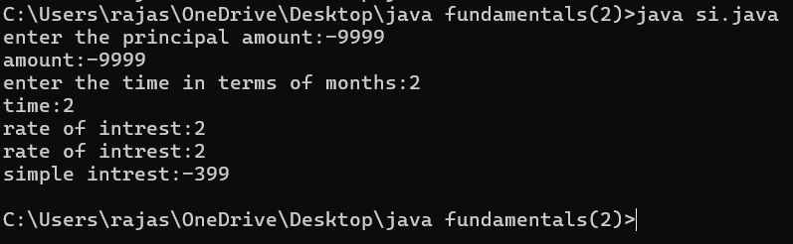

2.CONVERTING TEMPERATURE FROM CELSIUS TO FARENHEIT USING SCANNER CLASS

Aim: Writing a java program for temperature calculating

CODE:

import java.util.Scanner;

class Main{

public static void main(String[] args){

Scanner input =new Scanner(System.in);

System.out.println("enter temperature in terms of celsius:");

int c= input.nextInt();

int f=(9*c)/5+32;

System.out.println("temperature in terms of farnheit:"+f);

Input.close();

}

}

OUTPUT: for c=25

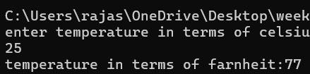

OUTPUT:FOR C=36

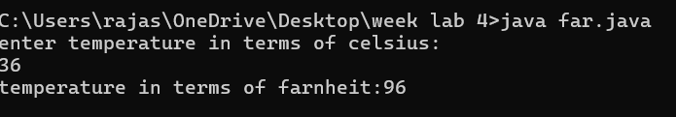

OUTPUT: FOR C=-3

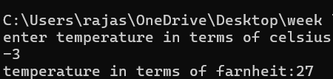

|  |  |  |  |
| --- | --- | --- | --- |
| Error type | Description | Impact | Solution |
| Resource leak waring | Scanner input not closed | May cause unnecessary memory usage | Add input.close() |

2.ii) JAVA PROGRAM FOR FARNHEIT TO CELSIUS

Aim:writing java program for temperature calculation

CODE:

import java.util.Scanner;

class Main{

public static void main(String[] args){

Scanner input =new Scanner(System.in);

System.out.println("enter temperature in terms of franheit :");

int f= input.nextInt();

double c=(f-32)*5/9;

System.out.println("temperature in celsius:"+c);

}

}

OUTPUT:

FOR F= 95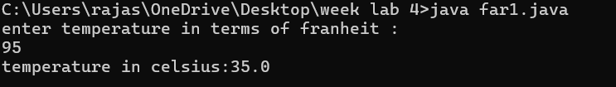

FOR F=80

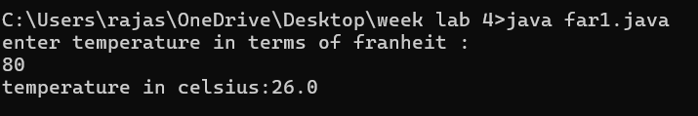

FOR F=10

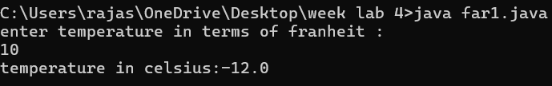

Error table:

|  |  |  |  |
| --- | --- | --- | --- |
| Error type | Description | Impact | Solution |
| Compilation error | C is used without declaration | The program won’t compile due to an undeclared variable | Declare c as a double or int |
| Logical error | Incorrect formula instead of 9/5 write 5/9 | The conversion will be given wrong output | Use the correct formula (f-32)*5/9 |

ERROR OUTPUT:

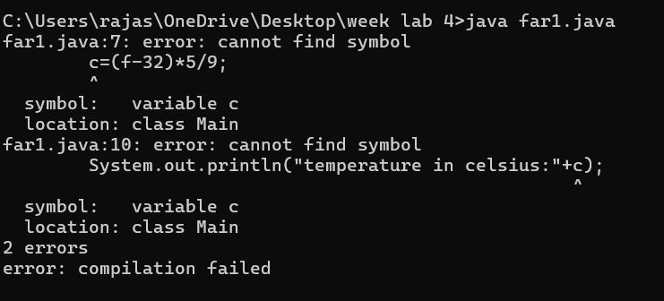

3.JAVA PROGRAM FOR FACTORIAL USING SCANNER CLASS:

Aim: Writing java program for factorial of a number.

CODE:

import java.util.Scanner;

class Main{

public static void main(String[] args){

Scanner ms=new Scanner(System.in);

System.out.println("enter factorial of n:");

int n= ms.nextInt();

int t=1;

if (n<0){

System.out.println(“enter a positive number instead of negative”);

Return;

for(int i=1;i<=n;n=n-1){

t=n*t;

}

System.out.println("factorial :"+t);

}

}

OUTPUT:for n=3

1.

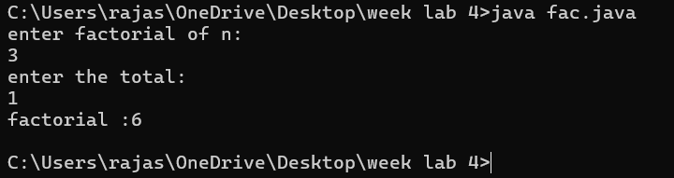

OUTPUT 2: for n=9

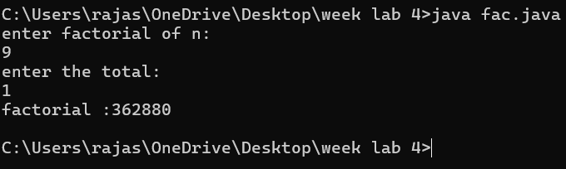

OUTPUT 3: for n=-9

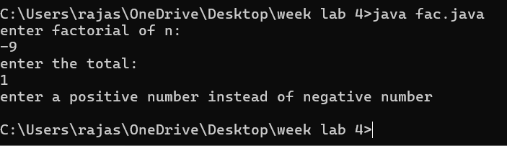

ERROR RECTIFICATION TABLE:

|  |  |  |  |
| --- | --- | --- | --- |
| Error type | Description | Impact | Solution |
| Scanner not closed | Scanner object is not closed after use | Minor resource leak | Add ms.close;at the end main() |
| Incorrect factorial calculation | The factorial is misapplied | Produce incorrect results | Initialize t=1 before the loop |

Error:

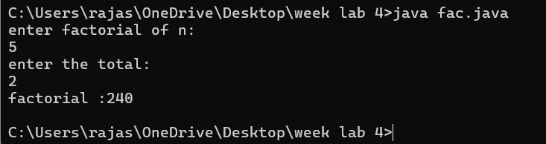

4.JAVA PROGRAM FOR AREA OF RECTANGLE:

Aim:Writing java program for area of rectangle.

CODE:

import java.util.Scanner;

class Main{

public static void main(String[] args){

Scanner ss=new Scanner(System.in);

System.out.println("enter the length of rectangle:");

int l=ss.nextInt();

System.out.println("enter the breadth of rectangle:");

Int b=ss.nextInt();

if(l<0||b<0){

System.out.println(“enter positive numbers”);

return;

}

int a=l*b;

System.out.println("area of the rectangle:"+a);

}

}

OUTPUT 1:

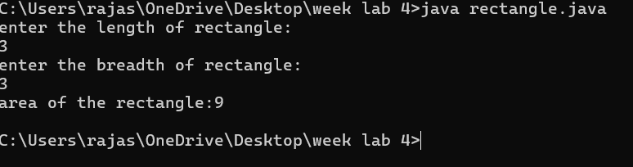

OUTPUT 2:

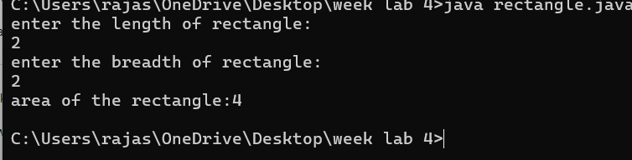

OUTPUT 3:

For negative values

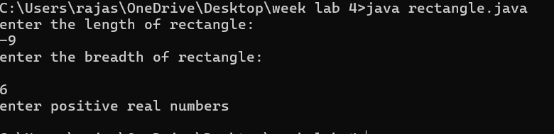

ERROR RECTIFICATION TABLE:

|  |  |  |  |
| --- | --- | --- | --- |
| Error type | Description | Impact | Solution |
| No return after error | If sides are invalid  Program still tries to compute area | May result in terms of incorrect values | Add return to the terms |
| No input validation  And unrecognized a | Program does not check for negative or zero | Incorrect output | Add if (l<=0 and b<=0) |

Error:

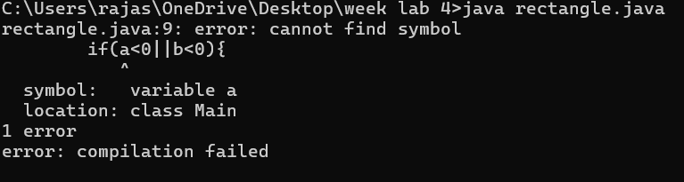

5.JAVA PROGRAM FOR AREA OF TRIANGLE USING HERON’S FORMULA:

Aim:Writing a programm for area of triangle using heron’s formula using a scanner class.

CODE:

import java.util.Scanner;

class Main {

public static void main(String[] args) {

Scanner ss = new Scanner(System.in);

System.out.println("Enter 1st side length of triangle:");

int a = ss.nextInt();

System.out.println("Enter 2nd side:");

int b = ss.nextInt();

System.out.println("Enter 3rd side:");

int c = ss.nextInt();

if (a <= 0 || b <= 0 || c <= 0) {

System.out.println("Error: Please enter positive numbers.");

return;

}

int s = (a + b + c) / 2;

double A = Math.sqrt(s * (s - a) * (s - b) * (s - c));

System.out.println("Area of triangle: " + A);

}

}

OUTPUT 1:

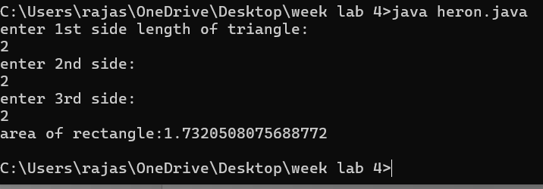

OUTPUT 2:

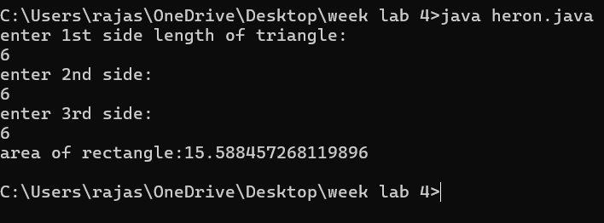

OUTPUT 3:

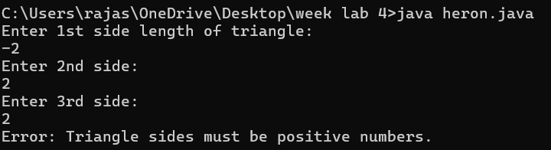

ERROR RECTIFICATION TABLE:

|  |  |  |  |
| --- | --- | --- | --- |
| Error | Description | Impact | Solution |
| Missing multiplication operators | Between (s-a),(s-b),(s-c) is missing | Compilation error  To invalid syntax | Use multiplication opertors in between those terms |
| No return after error | If sides are invalid  Program still tries to compute area | May result in terms of incorrect values | Add return to the terms |

Error:

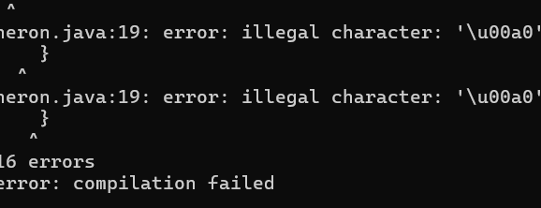

6.JAVA PROGRAM FOR FIBONACCI SERIES USING SCANNER CLASS:

Aim:Writing a java programm for Fibonacci series using scanner class.

CODE:

import java.util.Scanner;

class Main{

public static void main(String[] args){

Scanner ss=new Scanner(System.in);

System.out.println("enter Fibonacci length you want:");

int n=ss.nextInt();

if(n>0){

int f1=0;

int f2=1;

System.out.println("fibnnocai series of length:"+n);

System.out.println(f1);

System.out.println(f2);

for (int i=3;i<=n;++i){

int f3=f1+f2;

System.out.println(f3);

f1=f2;

f2=f3;

}

}

System.out.println("enter a positive number:");

}

}

OUTPUT:for n=5

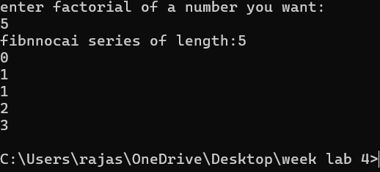

FOR n=3

Output:

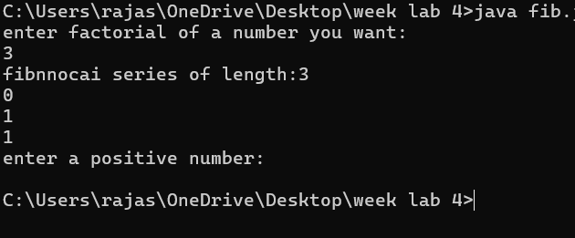

FOR n=-2;

OUTPUT:

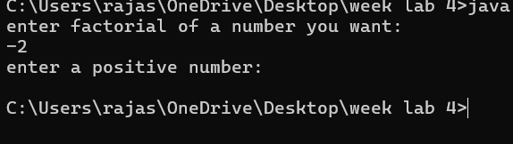

ERROR RECTIFICATION TABLE:

|  |  |  |  |
| --- | --- | --- | --- |
| Error type | Description | Impact | Solution |
| Resource leak | Scanneer input is not closed | May cause unnecessary memory usage | Add input.close();  After reading the input |

***Week 3***

*Lab 3:*

1.Write a code for method attributes of a car for three objects.

Aim: writing java code using method attributes.

Code:

class car

{

public String car_color;

public String car_brand;

public String fuel_type;

public float mileage;

public void start()

{

System.out.println("Car starts");

}

public void stop()

{

System.out.println("Car stops");

}

public void service()

{

System.out.println("Car service");

}

public static void main(String [] args){

// object one creation

car car1= new car();

car1.car_color="Red";

car1.car_brand="BMW";

car1.fuel_type="Petrol";

car1.mileage=62.5F;

//calling methods for object 1

car1.start();

car1.stop();

car1.service();

System.out.println("color of the car1 is "+car1.car_color);

System.out.println("brand of the car1 is "+car1.car_brand);

System.out.println("fuel type of the car1 is "+car1.fuel_type);

System.out.println("mileage of the car1 is"+car1.mileage);

// object two creation

car car2= new car();

car2.car_color="Blue";

car2.car_brand="Audi";

car2.fuel_type="Petrol";

car2.mileage=64.5F;

// calling methods for object 2

car2.start();

car2.stop();

car2.service();

System.out.println("color of the car2 is "+car2.car_color);

System.out.println("brand of the car2 is "+car2.car_brand);

System.out.println("fuel type of the car2 is "+car2.fuel_type);

System.out.println("mileage of the car2 is"+car2.mileage);

//object three creation

car car3= new car();

car3.car_color="Yellow";

car3.car_brand="Benz";

car3.fuel_type="Diesel";

car3.mileage=66.5F;

// calling methods for object 3

car3.start();

car3.stop();

car3.service();

System.out.println("color of the car3 is "+car3.car_color);

System.out.println("brand of the car3 is "+car3.car_brand);

System.out.println("fuel type of the car3 is "+car3.fuel_type);

System.out.println("mileage of the car3 is"+car3.mileage);

}

}

OUTPUT:

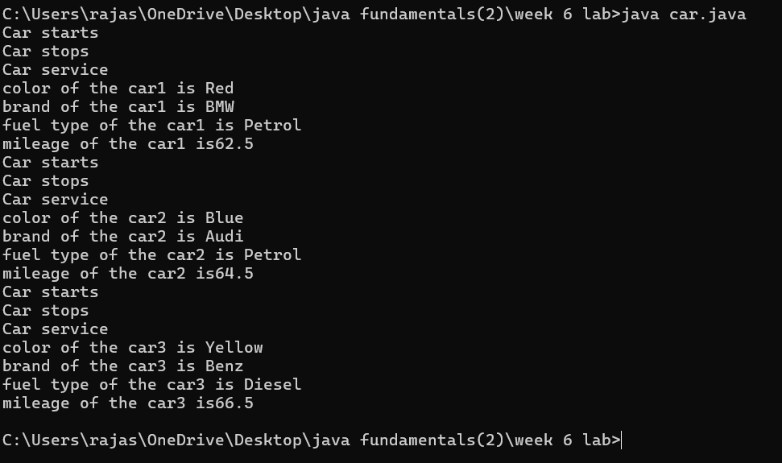

ERROR :

|  |  |  |  |
| --- | --- | --- | --- |
| Error type | Description | impact | Solution |
| Syntax error | Typo in the variable name mileage in the constructor | Compilation error ;  Constructor won’t work | Corrected to mileage |
| Mthod signature | Getter methods color,brand,fuel,mile had parameters but were expected to return instance values | Causes incorrect behaviour when  Calling methods | Removed parameters from method definition |

Error:

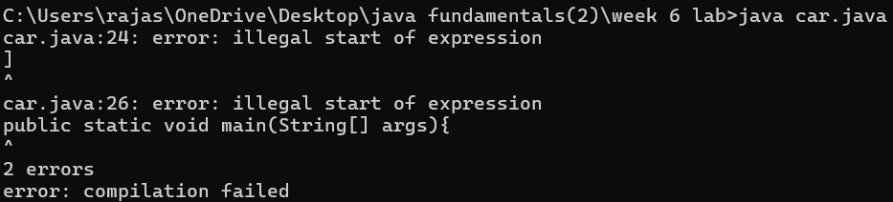

CLASS DIAGRAM :

|  |
| --- |
| Main |
| -car_color:string  -car_brand: string  - fuel_type:string  -mileage:int |
| +color():String  +brand():String  +fuel():String  +mile():int |

IMPORTANT POINTS:

1. The car class has four attributes: Car_color, Car_brand, fuel_type, and mileage.

2. It also has three methods: start(), service(), and stop().

3. The start(), service(), and stop() methods all print the same details about the car.

4. Each method prints the car's color, brand, fuel type, and mileage to the console

5. The main method creates three instances of the car class: car1, car2, and car3.

6. Each car object is assigned specific values for Car_color, Car_brand, fuel_type, and mileage.

2.WRITING JAVA CODE FOR BANK ACCOUNT

Aim:writing a java code for the bank account details

Code:

class Bank_Account {

private String accname;

private int acno;

private float balance;

public Bank_Account(String accname, int acno, float balance) {

this.accname = accname;

this.acno = acno;

this.balance = balance;

}

public void withdraw(int amount) {

if (amount <= balance) {

balance -= amount;

System.out.println("Withdrawal of " + amount + " successful. Remaining balance: " + balance);

} else {

System.out.println("Insufficient balance for " + accname);

}

}

public void deposit(int amount) {

balance += amount;

System.out.println("Deposit of " + amount + " successful. Updated balance: " + balance);

}

public void displayDetails() {

System.out.println("Account Name: " + accname);

System.out.println("Account Number: " + acno);

System.out.println("Balance: " + balance);

}

public static void main(String[] args) {

Bank_Account s = new Bank_Account("Anil", 34571, 25000);

s.withdraw(20000);

s.deposit(2000);

s.displayDetails();

System.out.println();

Bank_Account s1 = new Bank_Account("Jeevan", 333226, 25000);

s1.withdraw(2500);

s1.deposit(250000);

s1.displayDetails();

}

}

Output:

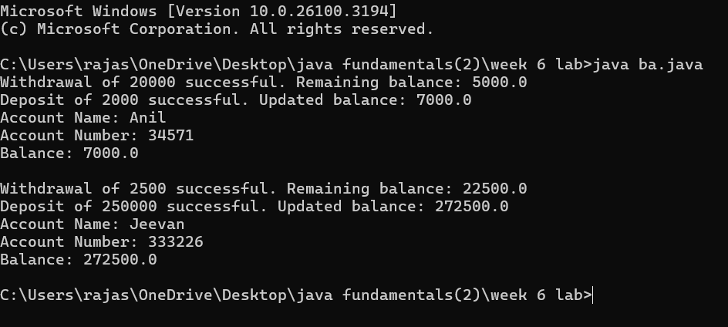

Error rectification table:

|  |  |  |  |
| --- | --- | --- | --- |
| Error type | subscription | Impact | Solution |
| Missing balance dispaly | Withdraw and deposit methods update the balance but not dispaly | User cannot see the current balance after transactions | Add system.out.println on both methods |
| No getter methods | No method to retrieve account details | Cannot account details outside of the class | Add getter methods like getBalance(), getAccName(), etc. |

Error:

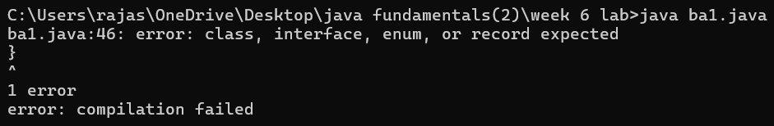

CLASS DIAGRAM:

|  |
| --- |
| Bank_Account |
| -accname:String  -acno:int  -balance:float |
| +withdraw(amount:int):void  +deposit(amount:int):void  +displaydetails():void |

IMPORTANT POINTS:

1. The Bank Account class has a private attribute balance to store the account balance.

2.The class has a constructor, BankAccount(double initialBalance), which initializes the balance. If the initial balance is not positive, it sets the balance to 0.

3.The deposit(double amount) method adds a positive amount to the balance and prints a message. If the deposit amount is not positive, it prints an error message.

4.The getBalance() method returns the current balance of the account.

5.The Main1 class contains the main method, which serves as the entry point of the program.

***WEEK 4:***

*LAB 4:*

1.AIM: WRITE A JAVA PROGRAM WITH CLASS NAMED “Book”. THE CLASS SHOUKD CONTAIN VARIOUS ATTRIBUTES SUCH AS TITLE, AUTHOR, YEAR OF PUBLICATION. IT SHOULD ALSO CONTAIN A CONSTRUCTOR WITH PARAMETERS WHICH INITIALIZES TITLE, AUTHOR, YEAR OF PUBLICATION AND CREATE A METHOD WHICH DISPLAYS THE DETAILS OF 2 BOOKS.

CODE:

class Book {

private static String title;

private static String author;

private static int year;

public static void setDetails(String title, String author, int year) {

Book.title = title;

Book.author = author;

Book.year = year;

}

public static void displayDetails() {

System.out.println("Title: " + title);

System.out.println("Author: " + author);

System.out.println("Year: " + year);

System.out.println();

}

public static void main(String[] args) {

Book.setDetails("1984", "George Orwell", 1949);

System.out.println("Details of Book 1:");

Book.displayDetails();

Book.setDetails("The Shining", "Stephen King", 1980);

System.out.println("Details of Book 2:");

Book.displayDetails();

    }

}OUTPUT:

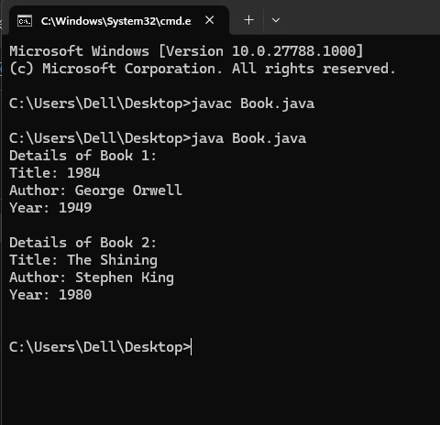

ERROR:

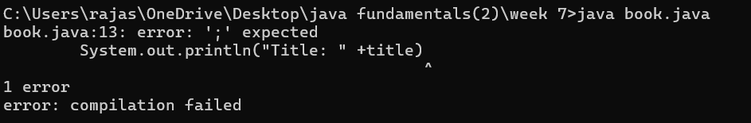

ERROR TABLE:

|  |  |  |  |
| --- | --- | --- | --- |
| ERROR TYPE | DESCRIPTION | IMPACT | SOLUTION |
| Compilation error | Missing semicolon | Code will not compile | Add semicolons at the end of the lines |
| Logical error | Missing spacing in the print statements | Output may be concatenated improperly | Add a space after year of publication in the display details () method |

CLASS DIAGRAM:

|  |
| --- |
| Book |
| - title: String  - author: String  - year: int |
| Book(String, String, int)  + displayDetails(): void |

*IMPORTANT POINTS:*

1. The Book class has three member variables: title, author, and year.
2. The constructor Book(String title, String author, int year) initializes the member variables with the values provided when a new Book object is created
3. The method displayDetails() prints the details of the book (title, author, and year of publication) to the console

2. *AIM:*

*WRITE A JAVA PROGRAM WITH CLASS NAMED “MyClass” WITH A STATIC VARIABLE COUNT OF INT TYPE. INTIALIZE IT TO ZERO AND A CONSTANT VARIABLE “Pi” OF TYPE DOUBLE INITIALIZED TO “3.14” AS ATTRIBUTES OF THAT CLASS. NOW DEFINE A CONSTRUCTOR FOR “MyClass”, THAT INCREMENTS THE COUNT VARIABLE EACH TIME AN OBJECT OF “MyClass” IS CREATED. FINALLY, PRINT THE FINAL VALUES OF ‘COUNT’ AND ‘PI’ VARIABLES AND CREATE 3 OBJECTS.*

CODE:

public class MyClass {

static int count = 0;

static final double pi = 3.14;

MyClass() {

count++;

}

public static void main(String[] args) {

MyClass obj1 = new MyClass();

MyClass obj2 = new MyClass();

MyClass obj3 = new MyClass();

System.out.println("Count: " +count);

System.out.println("Pi: " +pi);

}

}

OUTPUT:



Error:

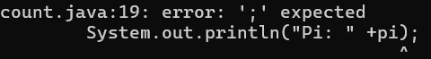

ERROR TABLE:

|  |  |  |  |
| --- | --- | --- | --- |
| Error type | Description | Impact | Solution |
| Logical error | Missing space in the println statement for count and pi | Output may be concatenated improperly. | Add a space before +count and+pi in the println statement. |

CLASS DIAGRAM:

|  |
| --- |
| MyClass |
| - count: int (static)  - pi: double (static final) |
| + MyClass()  + main(String[] args): void |

IMPORTANT POINTS:

1. The MyClass class contains two static member variables: count and pi.

2. count is initialized to 0 and increments each time a new MyClass object is instantiated.

3. pi is a constant and immutable.

4. The constructor MyClass() increases the count variable by 1 every time a new MyClass object is created.