Project Proposal

Project Title: D567

Project Members: Ryan Williams & Michael Brennock

Project Description:
D567 is a utility and API for providing run-time debugging right on the Android. D567 will provide support for trace sessions, saving/loading program state, and for capturing information on unhandled exceptions in the main thread. Later on we would like to add support for viewing and modifying values in the program.

D567 will have the following general structure:

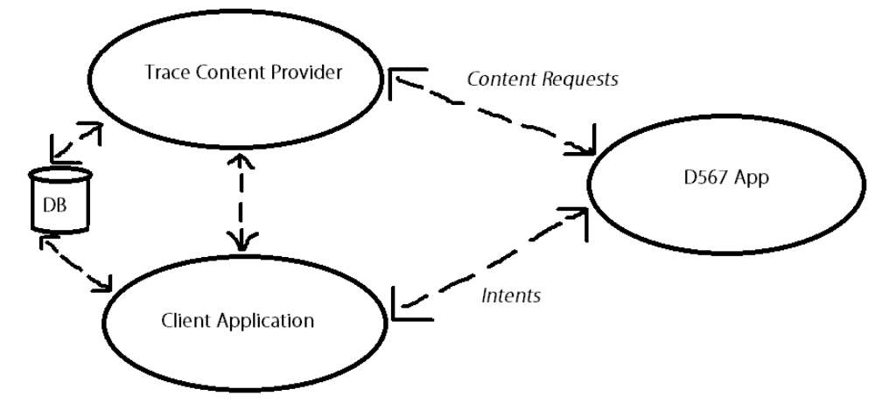
Client Application – The application to be debugged. The Client Application will need to handle intents from the D567 App for starting/stopping trace sessions and for saving/loading state. If the Client Application experiences an unhandled exception in the main thread, it will also capture that exception information and send it to the D567 App via an Intent.

Trace Content Provider – The D567 App will be able to query the Trace Content Provider in order to access any trace sessions and save states in the client applications database. This will require that the user expose the Trace Content Provider via the application manifest.

DB – The Client Application's Database is where we will store any trace session information and save states.

D567 App – The D567 App will be able to detect any running debuggable Client Applications on the users Android and list them. The user will be able to select an application to work with. From there they can start/stop/view/delete trace sessions, view saved states, save the current state of the client Application, and request that the Client Application load a saved state.

Project UI:
Our main activity will auto-detect any running, debuggable apps on the system and display them in a list for the user to select from. After selecting an app, they will be taken to another activity that allows them to select how they would like to interact with the selected app. They will be able to view, start, stop, and delete trace sessions as well as view, save, load, and delete save states for the app.

If they select to view trace sessions, they will be taken to another activity that will display so many trace results per page. There will also be filtering options to choose from. For instance: they will be able to filter by trace level (example: verbose or error) as well as by the module name. A “module” is user-defined category for trace messages, similar to the Log Tags used by Logcat.

Finally, when the D567 App detects that an app crashed, it will send out a notification. When the user selects the notification, they will be taken to an activity in the D567 App which will provide them with the details of the crash.

Project Deliverables:
- The D567 App. It will auto-detect and list any programs that are debuggable, allow the user to start/stop trace sessions, view trace sessions (with filtering), and delete trace sessions.
- The D567 API and Documentation. It will support trace sessions, saving/loading state, and capturing unhandled exceptions in the main thread.
- Example Application(s) demonstrating how to use the D567 API.

Project Organization:
- Ryan Williams will work primarily on the D567 API and associated Documentation.
- Michael Brennock will work primarily on the D567 App (including the UI design) and associated Documentation.

