**A**

**Project Report On**

**Laptop Store System**

**Prepared by:**

**Abhijit Balaji Wadkar**

**[B.C.A Semester 6]**

**Exam No.:**

**Guided by:**

**Mr. Samir Patel**

**Submitted as Partial Fulfilment of**

**BCA Degree 2023-2024**

**Submitted to**

**[Shri D . N .Institute of Computer Applications, Anand]**

**Sardar Patel University, V . V .Nagar**

**INDEX**

|  |  |  |
| --- | --- | --- |
| **Sr.** | **Description of Topic** | **Page**  **No.** |
| **1** | **Introduction To The Project** | **01** |
| **2** | **Scope Of Work** | **02** |
| **3** | **An Existing System** | **03** |
| **4** | **Problem Identification** | **04** |
| **5** | **Need of Propose System** | **07** |
| **6** | **Feasibility Study** | **09** |
| **7** | **System Features** | **10** |
| **8** | **Hardware and Software** | **11** |
| **9** | **Data Flow Diagram** | **18** |
| **10** | **Database Layout** | **24** |
| **11** | **Design of Input Screen** | **28** |
| **12** | **Testing Procedure & Implementation Phases** | **38** |
| **13** | **Limitations** | **41** |
| **14** | **Proposed Enhancement** | **42** |
| **15** | **Conclusion** | **43** |
| **16** | **References** | **44** |

Acknowledgment

The satisfaction that accompanies that the successful completion of any task would be incomplete without the mention of people whose ceaseless cooperation made it possible, whose constant guidance and encouragement crown all efforts with success.

I am grateful to our **project guide** **Mr. Samir Patel** for the guidance, inspiration and constructive suggestion that helpful us in the preparation of this project.

I am also thankful to our Head of The Department Dr. Tamanna Prajapati for her continuous guidance.

I am also obliged to our Principal Dr. Maulik Pandya for creative support.

I am also pleased to receive all facilities from our Management of C. E .Society.

I also thank my colleagues who have helped in successful completion of the project.

Student’s name: Abhijit Wadkar

**Introduction to the project:**

**Project Request:**

To manage the stocks of the Laptop, employee information and Laptop items also take

an order from customer and shows the availability of available stock.

**Purpose:**

The main purpose of this system is all employees of the organization can use the same

system through different login details to computerize the work of managing stocks,

managing employee information and to take the order from the customer.

**Objectives of the proposed system:**

Reduce the manual work.

Carry information storage and retrieval.

Manage the stocks of items.

Maintain the Information of Customer and Employees of restaurant.

Take an order from Customers.

**Main features of the proposed system:**

➢ Menu Driven Interface

➢ User Friendly.

➢ Taking care of computational time.

**Scope of Work**

This system will help the restaurant to manage stocks of particulars and information of the

customer and employees. This is the powerful automated system which will help the

management to get various kinds of information. The system is very fast and user friendly.

The scope of the proposed system is bright. This system will prove the best solution for the

problems of current system. We have used MYSQL as our backend tool and VS code

as front-end tool. VS code is very powerful for programming purpose. Visual basic is easy

to use and it provides better GUI than others. The performance of the software also increases

up to its maximum speed. The operating system is windows 10. The existing system was manual and

manual and time consuming to enter the data. It was very difficult to maintain all the records

manually and refer the records when necessary. So, we decided to make a computerized

system. Our system has tried to manage mostly all the information and forms.

**An Existing System**

The existing system is manual. The existing system maintains all the records like particular’s

information, customer & employee information. The manual system is very slow and time

consuming. The existing system contains large number of errors due to manual system. So,

we decided to make a computerized system, which is less time consuming and error prone.

The current system is developed in VS code and MYSQL. VS code is used as a front

end and MySQL as Back-end. As VS code provides better GUI and easy, fast and logical

coding. We have used VS code as front-end. The Current System is powerful and it consists

of all types of information required. We have tried to manage almost all the information

computerized. So this system is more powerful than the existing system. The current system

is user-friendly. So, it is easy to operate. Therefore, the Current System is capable of

handling all needs of the present scenario. It has more advantages over existing system.

**Problem Identification**

The Phase of system analysis process deals with problems which are affecting in the

current manual system. The problems are those which are affecting the manual system in

it daily routine work.

As the growing trend in Info-Tech world of computers need of accuracy, perfectness,

speed and high memory data storage is must. Each and every problem must be solved

with a least amount of time and energy.

The problems faced by existing system are described as below:

1. Difficulty in maintenance of records.

2. Time consuming

3. No security of data

4. Lack of efficiency and man power.

5. High data redundancy

6. Data inconsistency

1)Difficulty in maintenance of records: -

It is very difficult to maintain data record in the system as all the records are entered in

the respective record books. There are chances of the record books or files in which all

the data is kept may be torn or wearied out or some other damages which results in the

destroyed data. Also a problem occurs if the data file or register is misplaced somewhere

else and is not getting at the time of actual requirement of the data stored. It is also

difficult to maintain old files and register which have data of past years which has kept

for future references.

2)Time Consuming: -

It is very time consuming process to write each and every entry in the record book for a

company in database register. Also it takes a lot of time if all the entries are repeated. In

the system processes such as making different type of reports, and tedious calculations

are examples of time consuming process in the system.

It is also time consuming process to know the total number of eligible applicant i.e. know

the status of company is very difficult to know, when written manually but through

computerized system it takes less time as it is speedy and accurate.

3)Editing of data: -

Manual written data cannot be changed or edited once written. If there is a mistake and

if we try to rub and write it again it makes the record book very dirty and untidy, which

creates a bad impression of the applicant or company. If data is entered incorrect whole

document gets incorrect while error cannot be easily solved by editing wrongly entered

data.

If one had done some wrong entry then to edit the data one has to go through lots of

records and, again and again editing the record makes it difficult to read.

4)Data insecurity: -

As the data is stored in files or registers, it is not in a secure place. As the storage media

here are files and books or registers there are chances of getting these storage media lost,

torn, or it may go in the hand of wrong person which can destroy the record book or it

can also be destroyed accidently. Everybody should not be allowed to use all the data.

If the data goes in the hand of wrong person then he/she may take the advantage of the

data. So security is the major aspects of the resort management system.

5)High data redundancy: -

As mentioned in the current system, due to maintenance of so many registers there is a

high redundancy of data i.e. same data is recorded repeatedly.

Here as mentioned in the above step the same information is written in more than once

place that crates the problem, when there is a change or deletion in the recorded data.

This system stores the records manually. So sometimes these records are missing.

**Need of Propose System**

Main resource for the computerization of Online Laptop Store : Provide service in a

better, understandable and cost effective manner to the customers and dealers:

• To improve the efficiency to services

• To enhance customer satisfaction

• To increase the profitability of the store

• To keep the track of the stock records in a better way

• Low customer satisfaction due to delay in transactions.

# • The occupancy charts were manually prepared, and were having errors.

• Customer’s records were stored efficiently.

• Retrieving the customer records was a cumbersome job.

• No MIS was available or it was insufficient.

• Lack of updated information regarding stock position.

• No inventory control system

• Bills preparation was done manually and it contained human errors, resulting in

financial mess.

• If the physical look of the restaurant was to be changed. It could not be found in

other documents. Sometimes new documents had to be prepared for the changed

setup.

• Bills calculation was tedious jobs.

• The lead-time of bills preparation was reasonably high.

• Vendor rating system is not reliable.

• Materials reports were leading to human errors.

• Supplier and inventory management

• Customer satisfaction is fairly high.

• Customer’s records are stored efficiently, and are easily retrievable.

• Up-to-date information on stock position and is also available for MIS purpose.

• Better inventory control.

• The lead-time to procure the materials is low and the procurement process

becomes easy.

• Vendor rating system is highly reliable.

• The time taken by the computerized system for bills preparation is low.

**Feasibility Study**

Feasibility study states about the feasibility of the project. This study includes Technical

feasibility, Economic feasibility and the Operational feasibility. Technical feasibility

evaluates the system by the likelihood of the development of the new system by technical

aspect. The main thing to consider here is whether the equipment, software and personnel

will suffice the project needs. Economic feasibility asks whether the new system is going

to be more cost effective than the existing one. Operational feasibility evaluates the

system by its acceptance to the users.

➢ **Operational Feasibility**: The computerized Online Laptop Store will be

faster than the manual system. It will not be erroneous as compared to the manual

system. The in-house material department accountant will not have to worry

about the error in the bills. His fears about the complex system would be avoided.

The important documents will be secure. The system will be configurable and as

generic as possible.

➢ **Technical Feasibility:** As the necessary technology and equipment is already

available, the management would be interested in developing the project. System

would be expandable and reconfigurable. Also, the system would guarantee

accuracy reliability and data security.

➢ **Economic Feasibility:** The cost of the manual system will be reduced. The

clerical staff can also be reduced because of the efficient working of the

computerized system. The material wastage by the manual system will also be

eliminated. The cost of the computerized Online Laptop Store would not be that

much, because the Restaurant has most of the required hardware and software.

System Features

• In the present system all the activities and procedures regarding the stock is done

manually.

• Whenever stock is to be purchased, journal file is prepared about the information

of item and purchase details. All this information kept into the particular file,

which is maintained by the manager of the Online Laptop Store.

• The bills are prepared by viewing prices from the particular’s information files.

It is a time consuming process.

• The material inventory is kept into the in-house materials department. All the

information about the available stock is kept in separate files. This is the

department which generates most of the errors during the manual bill preparation

of the stock.

**Hardware requirement of the system**

This phase of the software development process deals with a brief study of different

hardware used in the computerized system. There is a list of hardware materials used

during the making and also during the use of the proposed system. As the new system to

be made into a computerized functional system, requirement of a computer is must. All

the hardware needed here are generally the basic configuration of a typical office

computer. A list of the hardware requirement used in the system given below:

|  |  |  |
| --- | --- | --- |
| **Component** | **Minimum** | **Recommended** |
| Processor | 2.5 gigahertz (GHz) | Dual processor that are each 3 GHz or faster |
| RAM | 1GB | 2GB |
| Disk | NTFS file system-formatted partition with a minimum of 3 GB of free space | NTFS file system-formatted partition with 3 GB of free space plus adequate free space for your Web Sites |
| Drive | DVD Drive | DVD drive or the source copied to a local or network-accessible drive |
| Display | 1440 x 900 | 1440 x 900 or higher |
|  |  |  |

**Software Specification**

✓ Operating System: Windows 2000 or later

✓ Front End: VS code (Html , Css, JS)

✓ Back End: MySQL

**An Overview of the Visual Studio**

Visual Studio Code is a free, open-source code editor developed by Microsoft.

It has rapidly gained popularity among developers due to its lightweight nature,

extensive features, and customization options.

**Key Features:**

• **Cross-Platform Compatibility:** Runs seamlessly on Windows, macOS,

and Linux.

• **Intelligent Code Completion (IntelliSense):** Provides suggestions for

code completion, parameter hints, and more based on variable types,

function definitions, and imported modules.

• **Debugging Support:** Built-in debugger allows you to step through code,

set breakpoints, and inspect variables.

• **Git Integration:** Easily manage Git repositories, view changes, commit,

and push code directly from the editor.

**• Extensibility:** A vast ecosystem of extensions enables customization for

various programming languages, themes, and additional functionalities.

• **Emmet Support:** Rapidly write HTML, CSS, and other code using

abbreviations.

**• Code Snippets:** Reusable code blocks for faster development.

**Popular Use Cases:**

**• Web Development:** HTML, CSS, JavaScript, TypeScript, React,

Angular, Vue.js

**• Backend Development:** Node.js, Python, Java, C#, PHP, Go

**• Data Science:** Python, R, Julia

• **Game Development:** Unity, C#

• **Mobile App Development:** React Native, Flutter

**Why Developers Love VS Code:**

• **Performance:** Lightweight and fast, even with large projects.

• Customization: Highly customizable with themes, keyboard shortcuts,

and extensions.

• **Community Support:** A large and active community provides resources,

tutorials, and extensions.

**• Free and Open Source:** Accessible to everyone without any licensing

costs.

**In essence, VS Code is a versatile tool that can be adapted to suit the needs**

**of developers across various domains.** Its combination of features,

performance, and extensibility has made it a top choice for many programmers

worldwide.

**MySQL**

Introduction

The ability to transform corporate data into meaningful and actionable information is the

single most important source of competitive advantage in today’s business world.

Harnessing the data explosion to better understand the past and get direction for the future

has turned out to be one of the most challenging ventures for enterprise Information

Technology department in global organizations. There are three board categories of

issues associated with data integration:

• Technology challenges

• Organizational issues

• Economic challenges

In this paper, we will explore these challenges in detail and discuss how to address them

with Microsoft® MySQLTM2008 Integration Services (SSIS). First you should view

them in the context of a real-world scenario.

A Real-World Scenario

A major global transportation company uses its data warehouses to both analyse the

performance of its operations and to predict variances in its scheduled deliveries.

Data Sources

The major sources of data in this company include order data from its DB2-based order

entry system, customer data from its MySQL-based customer relationship

management (CRM) system, and vendor data from its Oracle-based ERP system. In

addition to data from these major systems, you incorporate data from spreadsheets that

track “extraordinary” events into the data warehouses, which shipping supervisors have

entered by hand. Currently, you incorporate external data such as weather information,

traffic status and vendor details (for subcontracted deliveries) on a delayed basis from

text files from various sources.

Data Consumption

Not only are the sources for these data diverse, but the consumers are also diverse both

in their requirement and their geographic locations. This diversity has led to a

proliferation of local systems. One of the major efforts for the Information Technology

department is too establish a “Single version of the truth”, at least for its customer data.

Data Integration Requirement

In view of this diversity of data, business needs and user requirement, the Information

Technology department has specified the following set of data integration requirement:

• They must provide reliable and consistent historical and current data integrated

from a variety of internet and external sources.

• To reduce lags in data acquisition, data from providers and vendors must be

available via Web services or some other direct mechanism such as FTP.

• They need to cleanse and remove duplicate data and otherwise enforce data

quality.

• Increasing global regularity demands require that the company maintain clear

audit traits. It is not enough to maintain reliable data, the data needs to be tracked

and certified.

MySQL 2008 capabilities deliver on the four key areas of the data platform visions.

**• Mission-Critical Platform:** MySQL 2008 enables IT groups to be

more productive by providing a more secure, scalable, and manageable

platform. It includes a new policy-based management framework that shifts

from managing by scripts to managing by rules. MySQL 2008 also protects

valuable information in existing applications and disconnected devices. In

addition, MySQL 2008 delivers predictable query performance with an

optimized platform.

**• Dynamic Development:** - MySQL 2008 along with the .NET

Framework enables developers to build the next generation of application.

Developers are more productive because they work with business entities

instead of tables and columns. They can build application that enables users to

take their data with them and synchronize their data with back-end servers.

• **Beyond Relational Data:** - MySQL 2008 enables developers to

consume any type of data, from XML to documents, and build applications that

incorporate location awareness.

**Pervasive Business Insight** – MySQL 2008 provides a scalable infrastructure

that can manage reports and analysis of any size or complexity while at the same time

empowering users because of its close integration with the Microsoft Office System. This

enables IT to drive business intelligent throughout the organization. SQL Server 2008

makes great strides in data warehousing, enabling users to consolidate data marts in an

enterprise data warehouse.

**DATA FLOW DIAGRAM (DFD): -**

Data Flow Diagram is a graphical presentation for defining inputs, processes and outputs.

Data flow diagram is a graphical tool used to describe and analyses the movement of

data through a system-manual or automated-including the Processes stores the data, and

delays in the system.

The transformations of the data from input to output through the Processes may be

described logically and independently of the physical components Associated with the

system. They are termed logical data flow diagrams.

In contrast, physical data flow diagrams show the actual implementation and the

movement of data between people departments and workstations.

The simple notations are flow understood by users and business persons who are part of

the process being studied. Therefore, analysts can work with users and actually involve

them in the study of data flow diagram.

The data flow diagram covers all the processes and data storage area, which takes place

during any transaction in the system. The data flow diagrams are functionality divided

into context level, Zero level and First level data flow diagrams.

Rules of DFDs: -

1. Processes should be named and numbered for easy references.

2. The direction of flow from top to bottom and from left to right.

3. Data traditionally flow from the source (Upper Left Corner) to the destination

(Lower Right Corner) although they may flow back to the source.

4. When a process is exploded into lower level details, they are numbered.

Symbols used in DFDs: -

1**. Process:** - Here flow of data is transformed.

E.g. Update leave Summary File.

2. **External Entity:** - A source or destination of data which is external to the

system.

E.g. Employee, Patient, etc.

3**. Data Flow:** -It is packet of data. It may be in the form of document, letter etc.

4. Data Store: -Any store data but with no reference to the physical method of

storing.

**Context Level**

Performance Report

Product, Make Purchase

ADMIN

CUSTOMER

Update product info

Product info, order Confirmation

Product receive

Product request

WARE HOUSE

**Zero Level**

Info stored

customer register

Admin

WARE HOUSE

Product info

Customer info

Add To Cart

Customer

Product details

Product info

Order info

Cust_order

Customer For Order

Product details

Product info

Customer product

product info

Inventory_mst

stock details

Request product

WARE HOUSE

Product request

**First Level**

Cust info

customer info

WARE HOUSE

Cust_mst

login info

New customer

old customer

Customer info

New customer

old customer

Customer product

Check product order

product info

inventory_mst

WARE HOUSE

**Second Level**

**DATABASE LAYOUT-LOGIN TABLE FOR USER AND ADMIN**

customer info

Final Bill Detail

Payment Detail

Bill list

Store

Bill Detail

Payment info

Database

Payment_mst

Customer

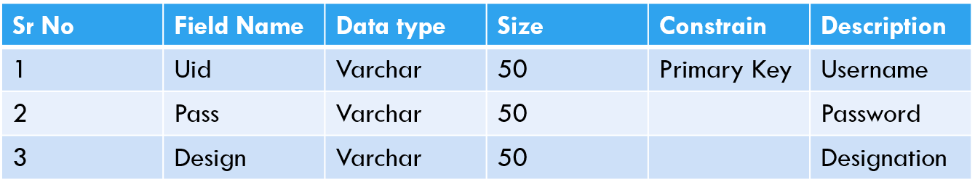

**1. For Login Detail**

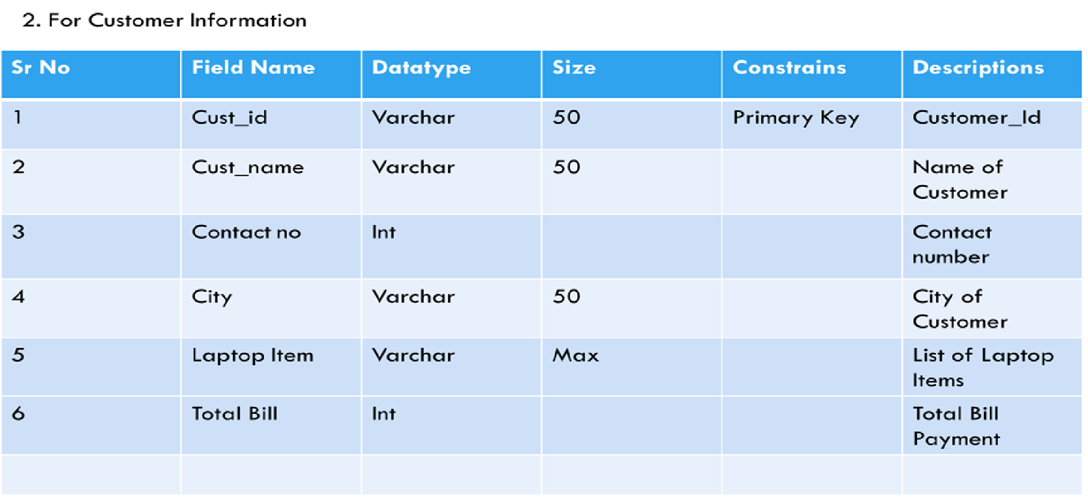

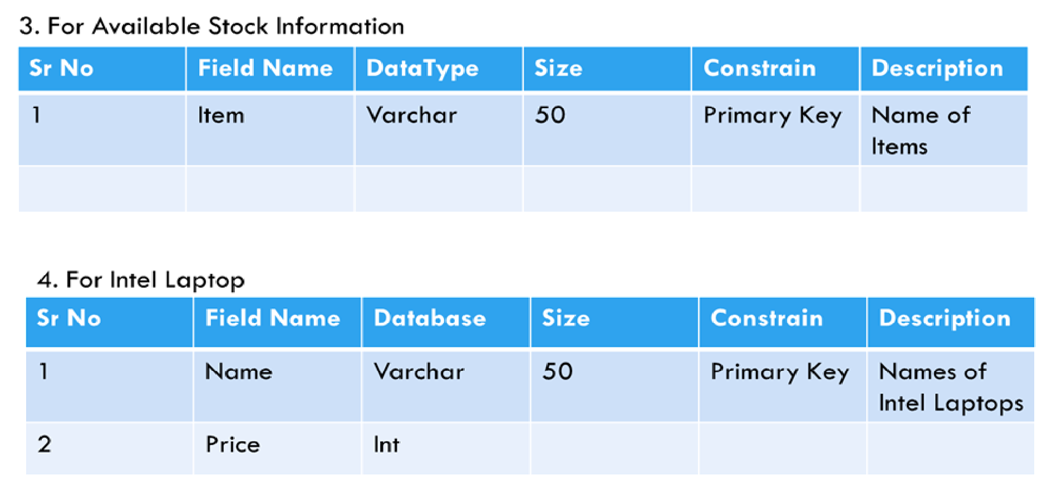

# 

**Testing Procedures and Implementation Phases**

# Software testing is a critical element of software quality assurance and represents the ultimate reviews of specification, design and coding. The testing phase involves the testing of the system using various test data; preparation of test data plays a vital role in the system testing. After preparing the test data, the system under study is tested using those test data, and errors found are corrected and correction are recorded for future references. Thus, a series of testing is performed before the system is ready for implementation.

**Various types of testing carried out on the system are:**

* Validation testing
* Output testing
* User Acceptance Testing

**Validation Testing:**

Validation and verification is major part of testing

**Validation:**

The process of evaluating software at the end of its developing process to ensure that it is free from failures and complies with its requirement.

**Verification:**

Verification approaches attempt to identify product faults or errors which give rise to failures**.**

* **Validation and Verification Techniques:**

# First, the validation and verification objectives for our project were decided. During this stage, we have to consider various aspects like constraints, complexities etc. the objectives of validation and verification is to be systematic and technical evaluation of software and their associated product of development.

For this purpose, at the end of the development process, it is very much required to do testing to ensure that the software requirements are compete.

* **Reviews:**

It is always very much required to review a project at the end of a phase to determine whether the requirements are established, design concepts and specifications have been met or not.

For example, if tax rates changes are required, then it should be possible to do so.

* **Inspection or Walkthrough:**

As inspection or walkthrough is a detailed examination of the product on a step-by-step basis. All program codes are subject to review. The purpose is to find errors. The project leader reviews the code to check its functionality.

* **Output Testing:**

# After performing validation test the next phase is the output that of the system because no system can be useful if it does not produce the desired output in the desired format. By considering the format of reports, they are generated or displayed, and tested. Here, output format is considered in two ways; one is on the screen and the other is in the printed form.

* **User Acceptance Testing:**

User Acceptance test for a system is the factor the success of the system. The system under consideration is listed for user acceptance by keeping in constant touch with the perspective user of the system at the time of design, development and making changes whenever required. This is done with regards to the following points.

* + Input screen design
  + Output design
  + Menu driven system

**Limitations: -**

* All the procedures in the restaurant are done manually using the papers. It needs a large amount of paper material.
* The files that are prepared for the procedures require a lot of space.
* Every procedure in the Restaurant Management needs documentation of the process. It is time consuming.
* The bill generations by the administration department is subject of errors, because it needs information from various departments. It is a tedious job.
* Any changes in one document or inventory does not always reflect of all related documents.
* To retrieve the old information is very tedious job**.**