Fuzzy-AHP

Fuzzy AHP is "step up" over traditional AHP as it involves making complex prediction along with comparison matrix along with fuzzy number.

Criticism with AHP:

* Still cannot really reflect the human thinking style.
* Uses an exact value to express the decision maker's opinion in a comparison of alternatives.
* Use of unbalanced scale of judgments.

To overcome this criticism, Fuzzy – AHP was introduced.

Fuzzy models are alternative approaches in cases of ill-defined data or lack of knowledge. Fuzziness of MCDM theories is a tool that aids Decision Makings to manage the uncertainty of their, sometimes subjective, judgments. Actually, when DMs evaluate an exact judgment by crisp numbers rather than qualitative expressions, MCDM uses fuzzy evaluations and presents the appropriateness of alternatives against each other.

# Implementation of Fuzzy Concept:

- Using Linguistic variables to express comparisons within a range representing criteria weights and alternatives ratings.

- Fuzzy Numbers are used to specify linguistic values within the fuzzy logic framework.

**2.1 Fuzzy Numbers**

We use Triangular Fuzzy Numbers in Fuzzy-AHP. Triangular Fuzzy Numbers is:

* Described as a triplet (l, m, u).
* The parameters l, m, and u respectively, indicates the smallest possible value, the most promising value, and the largest possible value that describe a fuzzy event.

Explain the Up And P here.

**2.2 Concept algorithm of Fuzzy-AHP**

* Fuzzification:

Here we will convert the linguistic terms into triangular membership function and fuzzy numbers (l, m, u) are being assigned.​

The crisp values of Fuzzy Scale of relative importance are replaced with the fuzzy numbers.

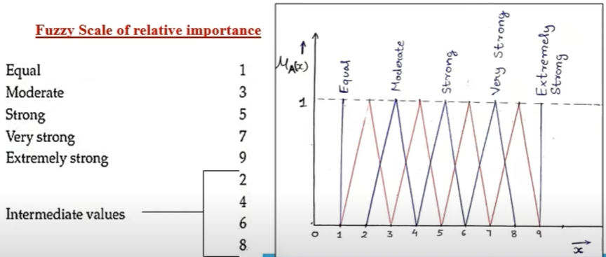

We change it form new Fuzzy ​Scale of relative importance with ​Fuzzy numbers.

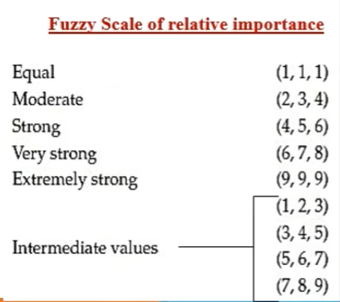

* Inference:

Firstly, we will calculate the geometric mean value.

Secondly, we will calculate the Fuzzy weights.

* De-fuzzification:

We de-fuzzified the fuzzy numbers to crisp value using​ Centre of Area formula -

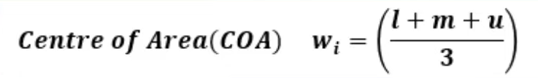

Lastly, we normalize the weights for future use.

**2.3 A Practical Example: Selecting a best Mobile phone**

**{Explain a little bit**

**of problem**

**statement.}**

1. Fuzzification –

Firstly, changing the pair-wise comparison matrix to Fuzzified pair-wise c-matrix using Fuzzy scale of relative importance.

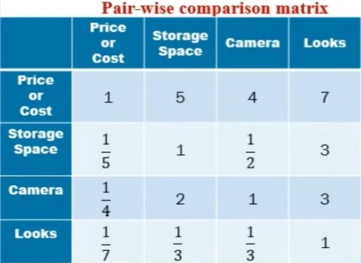 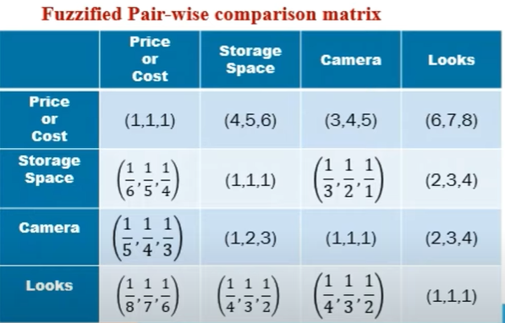

For changing reciprocal numbers to Fuzzy ​Numbers, we use formula-

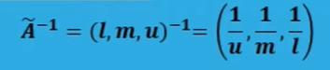

2. Inference –

First step: Calculating geometric mean.

To multiply the two fuzzy number, we use formula –

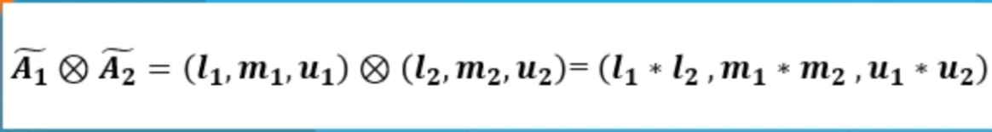

And to calculate the Geometric mean we use this way –

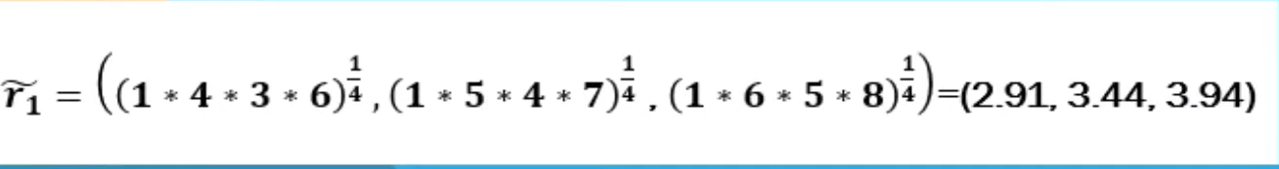

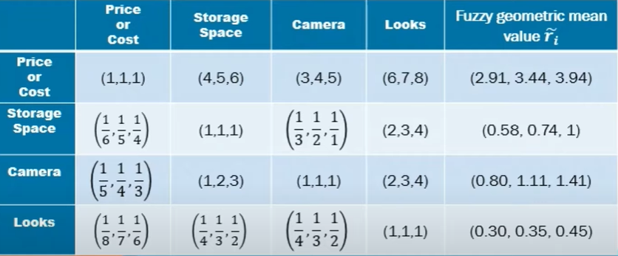

Second step: Calculating the Fuzzy weights.

Formula for calculating Fuzzy weights of each criterion-

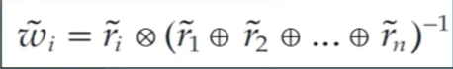

And for addition of two Fuzzy Numbers, we use formula –

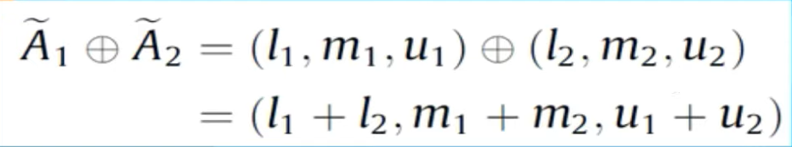

Thus, we have –

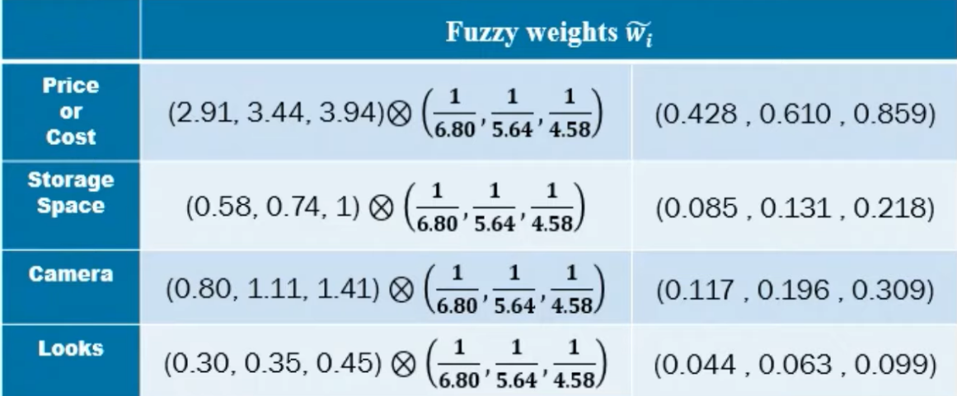

3. De-fuzzification –

De De-fuzzifying the Fuzzy value to crisp numbers using Centre of Area formula: 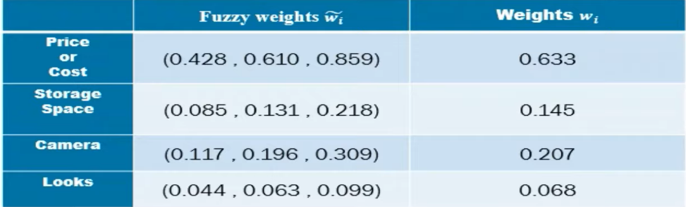

And at last we normalise the weights:

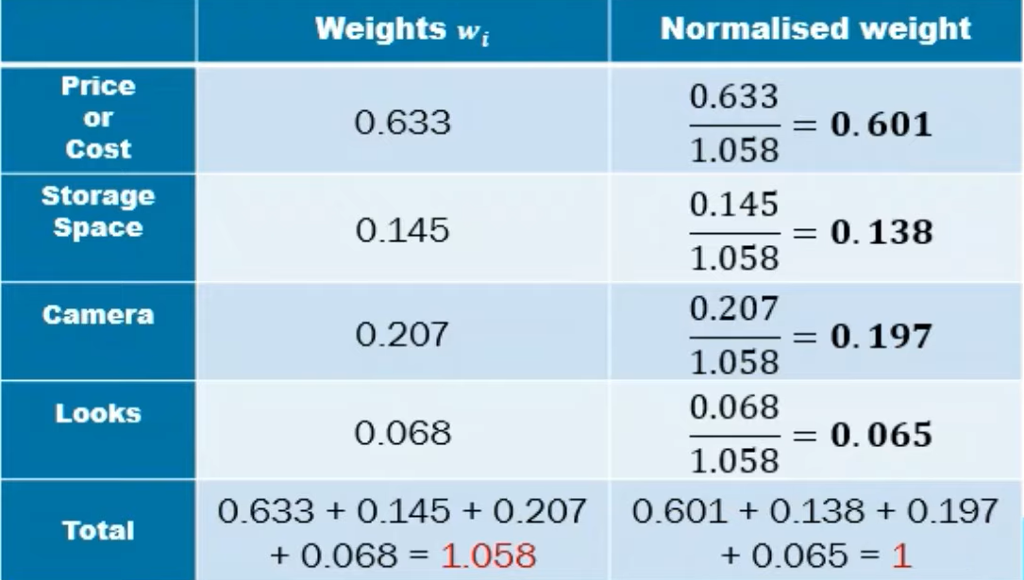

Thus, result(**{write here result}**).

**2.4 Package Code**

Code for Fuzzy-AHP is divided in two parts. First part is the parameter check and second part contains the logic of implementing AHP.

Input Field:

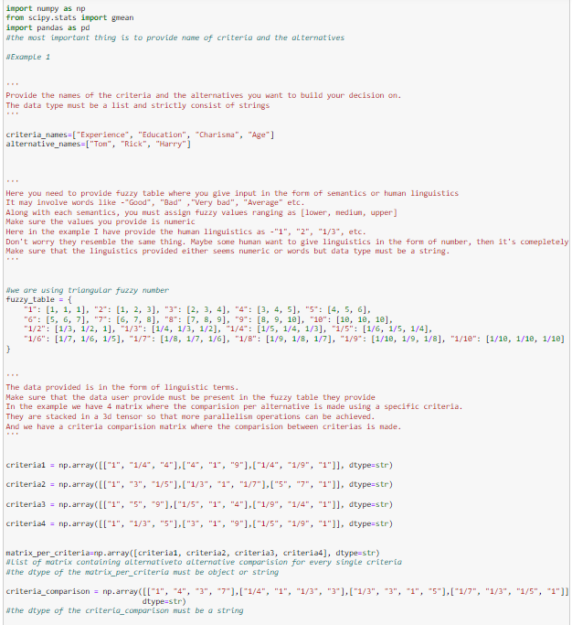



The input details are-

1. Criteria and Alternatives:

- `criteria_names`: A list containing the names of criteria used for decision-making.

- `alternative_names`: A list containing the names of alternatives to be evaluated.

2. Fuzzy Table:

- The `fuzzy_table` dictionary provides a mapping between linguistic terms (semantics) and their corresponding triangular fuzzy numbers. Each linguistic term is associated with a fuzzy value range represented as `[lower, medium, upper]`. These fuzzy values are numeric representations used for computation.

- Linguistic terms are represented as strings, and their associated fuzzy values are lists of three numeric values.

3. Comparison Matrices:

- `matrix_per_criteria`: A 3D tensor containing comparison matrices for each criterion. Each criterion has a corresponding matrix where alternatives are compared based on that criterion. The data in these matrices are linguistic terms representing the comparison between alternatives.

- `criteria_comparison`: A comparison matrix representing the relative importance of criteria. This matrix compares each criterion with every other criterion using linguistic terms.

4. Data Type Considerations:

- The dtype of `matrix_per_criteria` and `criteria_comparison` matrices is specified as string to accommodate linguistic terms.

- It's noted that the dtype of these matrices must be object or string to hold linguistic terms accurately.

The provided input details enable the Fuzzy-AHP process to be applied to evaluate the alternatives based on the defined criteria.

Parameter check:

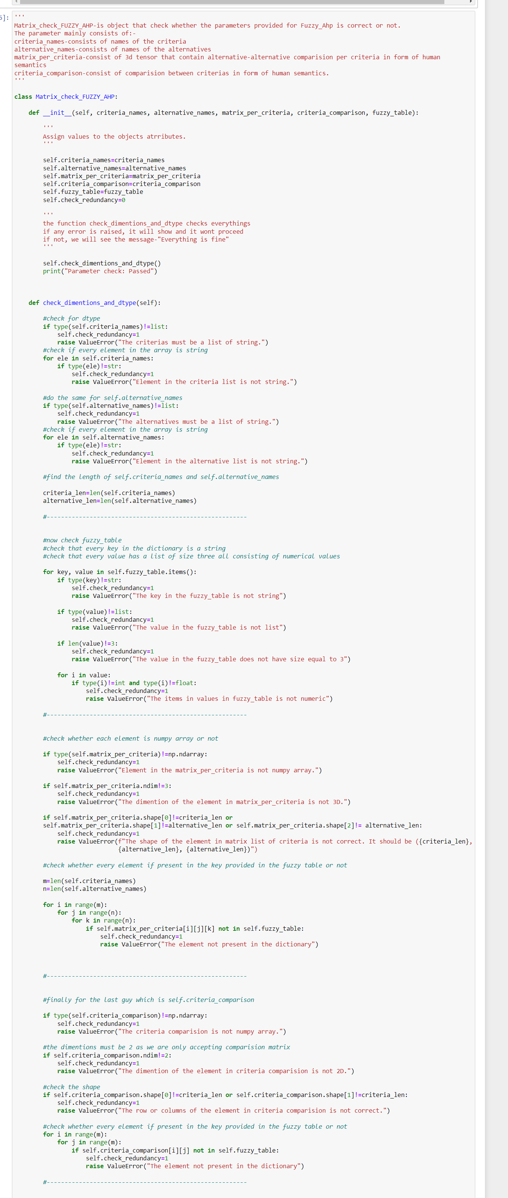



List of the checks performed in the provided code:

1. Type Check:

- Ensures that `criteria_names` and `alternative_names` are of type list.

- Ensures that every element in `criteria_names` and `alternative_names` is of type string.

- Checks if the keys in `fuzzy_table` are of type string.

- Checks if the values in `fuzzy_table` are lists.

- Ensures that the length of values in `fuzzy_table` lists is 3 and consists of numeric values.

- Checks if `matrix_per_criteria` and `criteria_comparison` are numpy ndarrays.

- Ensures that the dtype of `matrix_per_criteria` and `criteria_comparison` is either object or string.

2. Dimension Check:

- Verifies that the dimension of `matrix_per_criteria` is 3D.

- Verifies that the dimension of `criteria_comparison` is 2D.

3. Shape Check:

- Verifies the shape of `matrix_per_criteria`, ensuring it matches the expected shape.

- Verifies the shape of `criteria_comparison`, ensuring it matches the expected shape based on the number of criteria.

4. Value Check:

- Ensures that every element in `matrix_per_criteria` and `criteria_comparison` exists in the keys of `fuzzy_table`.

5. Error Reporting:

- Raises ValueError with specific error messages for each type of check that fails.

These checks ensure that the parameters provided for Fuzzy_Ahp are correct and consistent with the expected format and semantics. Any deviation from these expectations will raise a ValueError, providing insight into the nature of the error for debugging purposes.

Fuzzy-AHP code:

Here, is the final code for Fuzzy-AHP

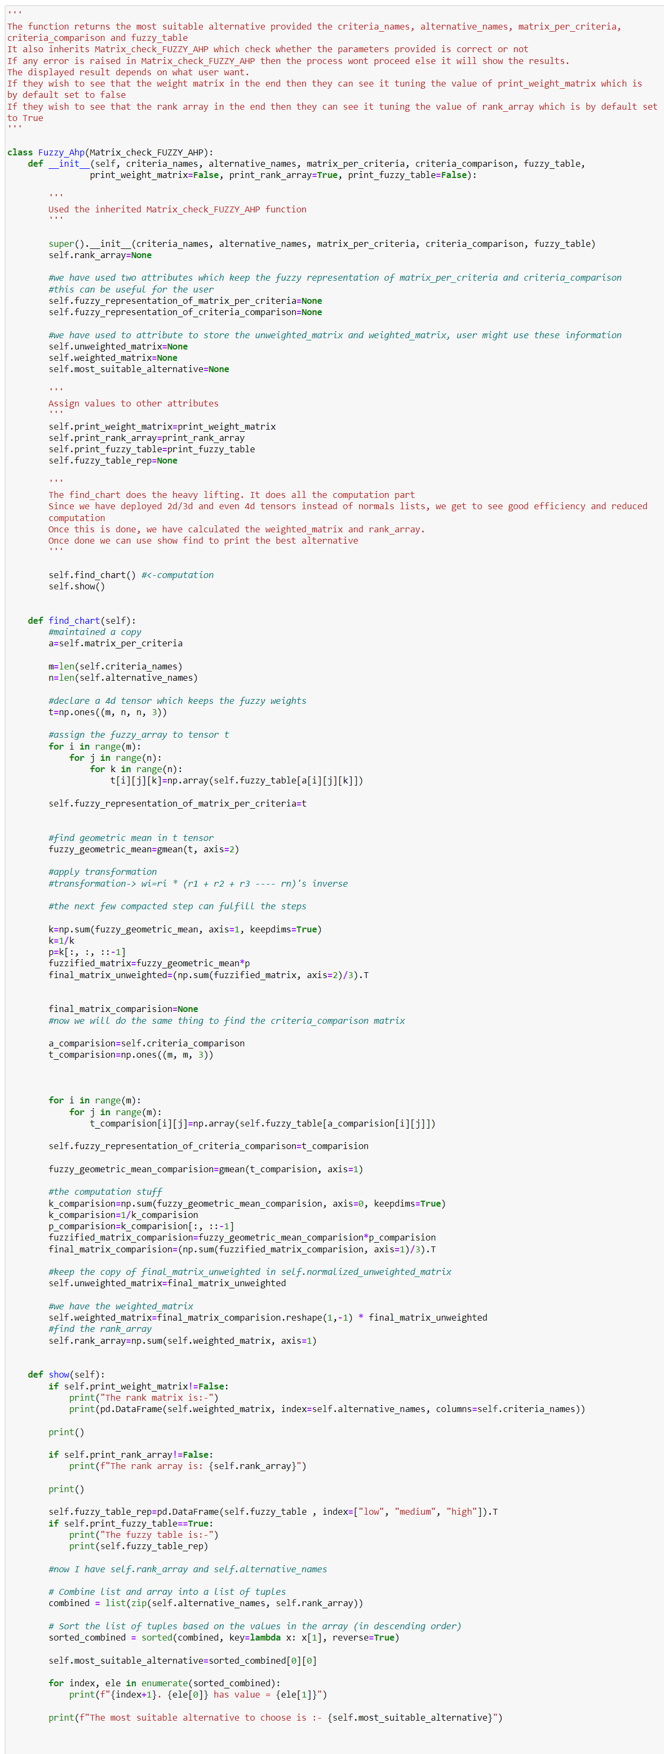



The above Python code defines a class `Fuzzy_Ahp` that implements a Fuzzy Analytic Hierarchy Process (AHP) for decision-making. Here's a breakdown of its functionality:

1. Class Definition - `Fuzzy_Ahp`:

- The code defines a Python class named `Fuzzy_Ahp`, which encapsulates the functionality for conducting Fuzzy Analytic Hierarchy Process (AHP) analysis.

2. Initialization Method - `__init__`:

- The `__init__` method serves as the class constructor, responsible for initializing the `Fuzzy_Ahp` object with necessary parameters.

- Parameters include:

- `criteria_names`: A list containing the names of criteria being evaluated.

- `alternative_names`: A list containing the names of alternatives being considered.

- `matrix_per_criteria`: A matrix representing the pairwise comparisons of alternatives for each criterion.

- `criteria_comparison`: A matrix representing the pairwise comparisons of criteria.

- `fuzzy_table`: A table mapping linguistic terms to fuzzy representations.

- Optional parameters control the display of results, such as `print_weight_matrix`, `print_rank_array`, and `print_fuzzy_table`.

3. Inheritance - `Matrix_check_FUZZY_AHP`:

- The class inherits functionality from `Matrix_check_FUZZY_AHP`, which presumably contains methods for validating input matrices.

4. Computation Method - `find_chart`:

- The `find_chart` method performs the core computations of the fuzzy AHP analysis.

- It transforms the fuzzy comparison matrices into fuzzy geometric means and applies transformations to derive unweighted and weighted matrices.

- Finally, it computes a rank array indicating the suitability of alternatives.

5. Display Method - `show`:

- The `show` method is responsible for displaying the computed results.

- It prints the weighted matrix, rank array, and the fuzzy table used in computation if specified by the user.

- Alternatives are sorted based on their ranks, and the most suitable alternative is identified and displayed.

6. Instantiation and Usage:

- Users instantiate the `Fuzzy_Ahp` class by providing the required parameters.

- Upon instantiation, computations are automatically performed, and results are displayed according to the specified preferences.

- The most suitable alternative can be accessed directly through the `most_suitable_alternative` attribute of the object.

This code streamlines the fuzzy AHP analysis process, enabling users to make informed decisions based on fuzzy comparisons and preferences. It offers flexibility in result display and provides clear insights into alternative suitability.

**1.5 Results**

Output of Matrix_check_FUZZY_AHP-

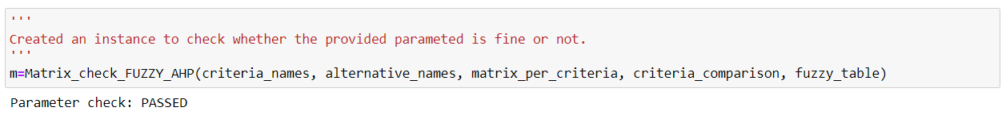

Result of FUZZY_AHP-

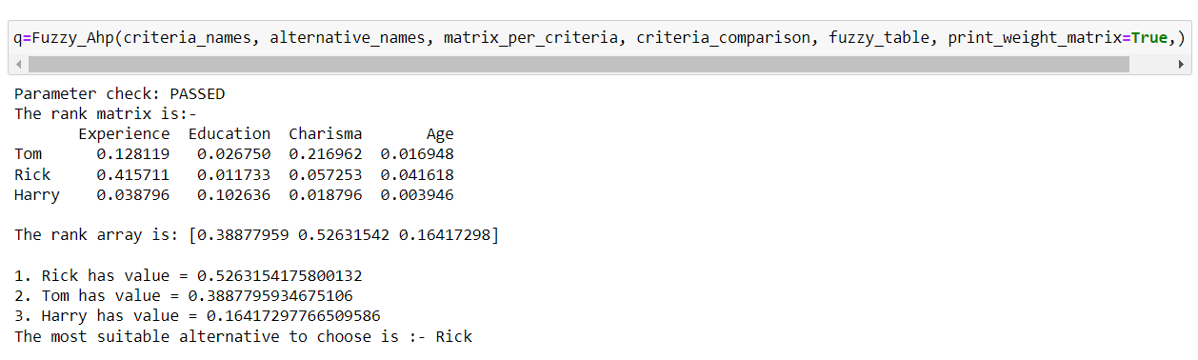

Other attributes-

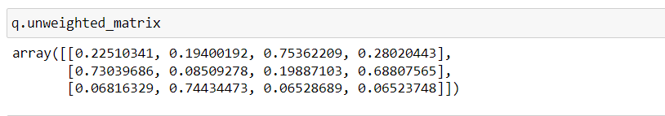

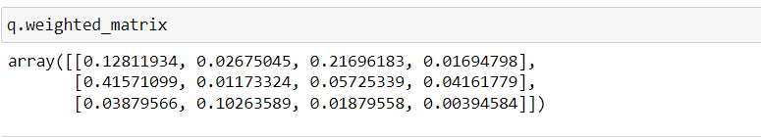

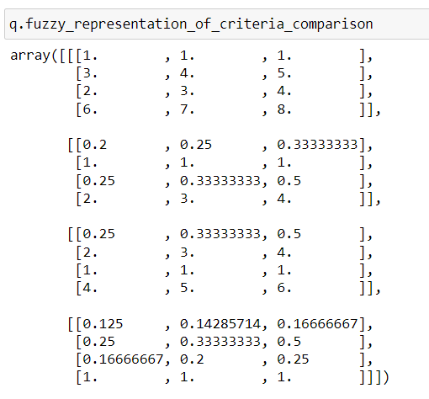

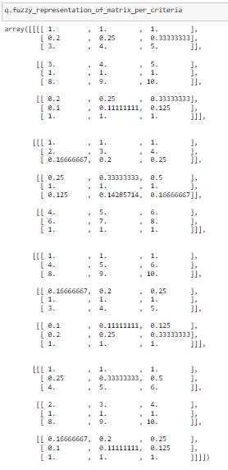

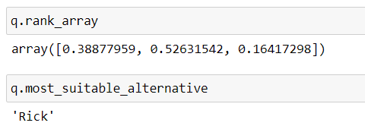

User can use these attributes for their own analysis.