Design: New Editor

The current editor has a few limitations that make it hard to create maps with it.
Among those are:

- Placement of walls: Each wall tile must be placed separately. In addition to other missing features like aligning a tile with another and too imprecise movement of types this makes placing a longer wall an annoying and time consuming work.
- User Interface (UI): The user interface is not easy to use. Selecting of tiles is done by selecting the type of tile by successively pressing F1 and afterwards scrolling with the mouse wheel through the available types. Further we don't need the extensive keypress list at the bottom on the whole screen.
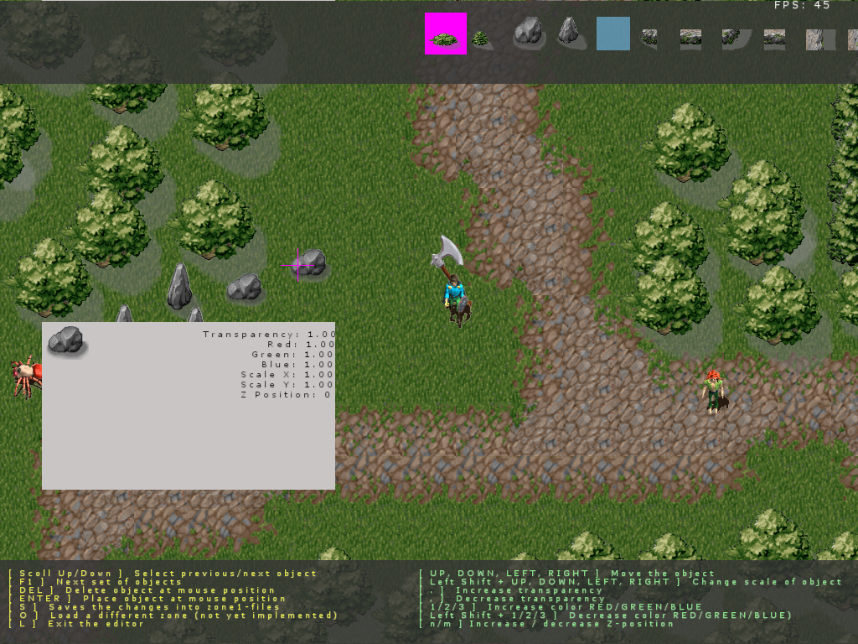
- The editor can only do very basic map creation, nothing more. I.e just placing ground and environment tiles together with collision boxes and shadows, but it has no support for monster or item placement or scripting
- The map system has no support for saying which tile is front or back which makes it hard to decide whether to place some decoration (I.e a candle on a table) in front or behind another.
- The previous point especially includes the player always being in front of all object, e.g. trees

That and the code behind the functionality is the reason we have decided a rework of the editor.

New Editor: Features

Improvements of the current behaviour
The new editor will improve on any of the above points:
- It will have a better user interface with toolboxes and buttons for each tile category
- The editor will be controllable not only by keyboard but as easy with the mouse and ideally with a combination of both
- Placing continuous walls (and other tiles belonging next to each other) will be simpler because of a new adjacency feature that lets you choose from a list of tiles that fit on a tile in a certain direction and placing them directly adjacent to the tile
- There is an option to align tiles to a grid (with the resolution of half the ground tile size) to support easier placing of tiles at fixed positions relative to each other
- Each tile will be shown in the selection tab in original size it will have when placed on the map, not in the size of a mini selection field
- When a tile is selected for placing and you move the mouse above the map the tile will be shown as preview, but transparent so you can better decide how it will look if the tile is actually placed
- If a tile is selected on the screen it is highlighted so you know which tile you are moving around. The highlighting is disabled when you are no longer in tile selection mode so you can see the map as it is
- There will be some way to place an item in front of another, but this is not designed, yet

New Features
The new editor will support some new features to support advanced map editing:
- It will support scripting interaction by adding interaction points, interaction regions and interacting characters to the map. The scripting functions called by them can be added as well.
- You can place monsters on the map and edit the basic features as respawn rate
- You can place and edit traders, stairs, teleporters, doors and door-openers and other predefined scripting objects and combine them already

Some features in more detail

The User Interface
