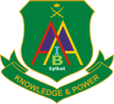 **Army Institute of Business Administration**

***Knowledge and Power***

**Admit Card**

PROGRAM NAME: Bachelor of Business Administration

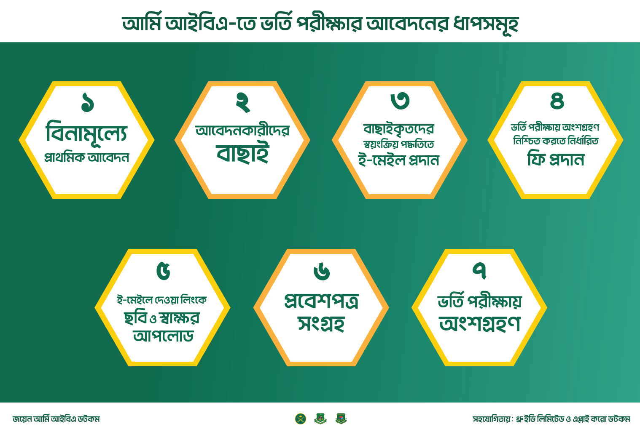

**APPLICANT’S NAME: fasasfasf**

FATHER’S NAME. : Yeamin Mahmud

MOTHER’S NAME : asffasasf

EXAM CENTER: Army Institute of Business Administration

Jalalabad Cantonment, Sylhet

EXAM DATE & TIME: 18- June-2022, 10:00: AM

ROLL NUMBER: **MK8EQMP**



**Applicant’s Signature Deputy Director (Program)**

**Important Instructions:**

1. Use black pen only.
2. Bring color print out of ADMIT CARD.
3. Cell phones, programmable calculators, watches, and other electronic devices are not permitted in the test hall.
4. You must wear a facemask before entering examination venue. You may carry your own sanitizer and other COVID safety items.
5. Arrive Thirty (30) minutes prior to the specified examination time.
6. For any query, please call 01769-176063 from 8:00 AM to 4:00 PM.