|  |  |  |  |  |
| --- | --- | --- | --- | --- |
|  | bzip2 | sjeng | wrf | sphinx3 |
| BHT预测器 | 94.7737 | 94.7507 | 94.839 | 94.8419 |
| GHR预测器 | 96.9554 | 96.9094 | 96.953 | 96.9927 |
| 锦标赛预测器 | 97.006 | 96.9704 | 97.0458 | 97.0457 |

BHT

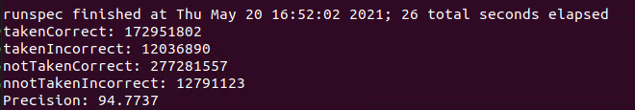

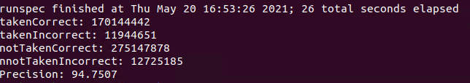

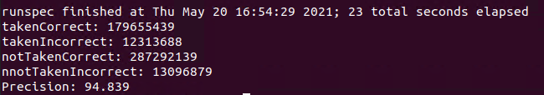

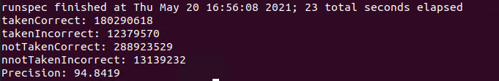

GHR

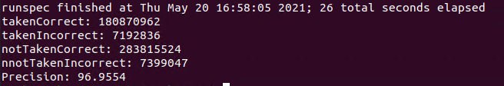

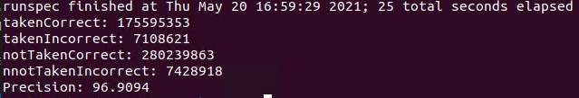

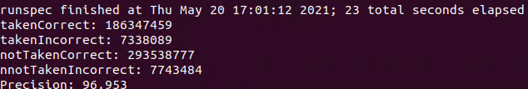

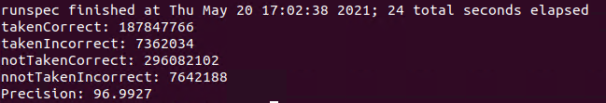

锦标赛

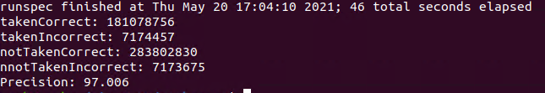

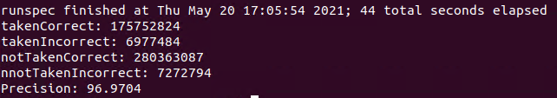

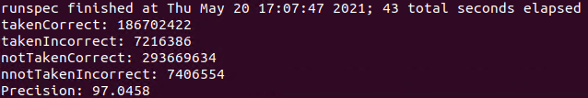

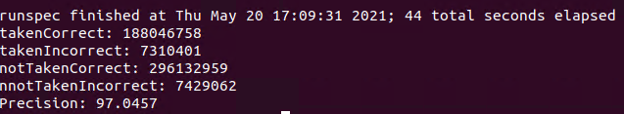

|  |  |  |  |  |
| --- | --- | --- | --- | --- |
|  | bzip2 | sjeng | wrf | sphinx3 |
| BHT预测器 | 94.5023 | 94.5025 | 94.5021 | 94.501 |
| GHR预测器 | 96.7795 | 96.8061 | 96.8067 | 96.7235 |
| 锦标赛预测器(LSHT) | 96.7743 | 96.7824 | 96.7613 | 96.7441 |

bzip2

L 10 89.3355

L 12 92.985

L 13 93.9998

L 14 94.1919

L 15 94.43

L 16 94.5023

L 18 94.5325

L 20 94.5704