**THE SUPERIOR COLLEGE LAHORE**

|  |
| --- |
| chk_captcha |

**Faculty of Computer Science & IT**

**Department of Software Engineering**

**Final Year Project**

**PROJECT REPORT (Part-1)**

**Leave Management System**

Project ID: **[write ID here Issued by FYP Manager]**

**Project Team**

|  |  |  |  |  |
| --- | --- | --- | --- | --- |
| **Student Name** | **Student ID** | **Program** | **Contact Number** | **Email Address** |
| Muhammad Saad | Bcsm-f16-529 | BSCS | 03026661234 | ms8739060@gmail.com |
| Muhammad Usama | Bcsm-f16-525 | BSCS | 03119529988 | usamajilani4050@gmail.com |
|  |  |  |  |  |
|  |  |  |  |  |
|  |  |  |  |  |

**[Sir. Ahmed Bilal]**

([Designation])

**Project Report**

**Leave Management System**

**Change Record**

|  |  |  |  |  |
| --- | --- | --- | --- | --- |
| **Author(s)** | **Version** | **Date** | **Notes** | **Supervisor’s Signature** |
|  | 1.0 |  | <Original Draft> |  |
|  |  |  | <Changes Based on Feedback from Supervisor> |  |
|  |  |  | <Changes Based on Feedback From Faculty> |  |
|  |  |  | <Added Project Plan> |  |
|  |  |  | <Changes Based on Feedback from Supervisor> |  |
|  |  |  |  |  |
|  |  |  |  |  |
|  |  |  |  |  |
|  |  |  |  |  |
|  |  |  |  |  |

**APPROVAL**

|  |  |
| --- | --- |
| **Project Supervisor** | |
| Comments: \_\_\_\_\_\_\_\_\_\_\_\_\_\_\_\_\_\_\_\_\_\_\_\_\_\_\_\_\_\_\_\_\_\_\_\_\_\_\_\_\_\_\_\_\_\_\_\_\_\_\_\_\_\_\_\_\_\_\_\_\_\_\_\_\_\_\_ | | |
| \_\_\_\_\_\_\_\_\_\_\_\_\_\_\_\_\_\_\_\_\_\_\_\_\_\_\_\_\_\_\_\_\_\_\_\_\_\_\_\_\_\_\_\_\_\_\_\_\_\_\_\_\_\_\_\_\_\_\_\_\_\_\_\_\_\_\_\_\_\_\_\_\_\_\_\_\_ | | |
| Name:\_\_\_\_\_\_\_\_\_\_\_\_\_\_\_\_\_\_\_\_\_\_\_\_\_\_\_\_\_\_ |  | |
| Date:\_\_\_\_\_\_\_\_\_\_\_\_\_\_\_\_\_\_\_\_\_\_\_\_\_\_\_\_\_\_\_ | Signature:\_\_\_\_\_\_\_\_\_\_\_\_\_\_\_\_\_\_\_\_\_\_\_\_\_\_ | |

|  |  |
| --- | --- |
| **Project Manager** | |
| Comments: \_\_\_\_\_\_\_\_\_\_\_\_\_\_\_\_\_\_\_\_\_\_\_\_\_\_\_\_\_\_\_\_\_\_\_\_\_\_\_\_\_\_\_\_\_\_\_\_\_\_\_\_\_\_\_\_\_\_\_\_\_\_\_\_\_\_\_ | |
| \_\_\_\_\_\_\_\_\_\_\_\_\_\_\_\_\_\_\_\_\_\_\_\_\_\_\_\_\_\_\_\_\_\_\_\_\_\_\_\_\_\_\_\_\_\_\_\_\_\_\_\_\_\_\_\_\_\_\_\_\_\_\_\_\_\_\_\_\_\_\_\_\_\_\_\_\_ | |
|  |  |
| Date:\_\_\_\_\_\_\_\_\_\_\_\_\_\_\_\_\_\_\_\_\_\_\_\_\_\_\_\_\_\_\_ | Signature:\_\_\_\_\_\_\_\_\_\_\_\_\_\_\_\_\_\_\_\_\_\_\_\_\_\_ |

|  |  |
| --- | --- |
| **Head of the Department** | |
| Comments: \_\_\_\_\_\_\_\_\_\_\_\_\_\_\_\_\_\_\_\_\_\_\_\_\_\_\_\_\_\_\_\_\_\_\_\_\_\_\_\_\_\_\_\_\_\_\_\_\_\_\_\_\_\_\_\_\_\_\_\_\_\_\_\_\_\_\_ | |
| \_\_\_\_\_\_\_\_\_\_\_\_\_\_\_\_\_\_\_\_\_\_\_\_\_\_\_\_\_\_\_\_\_\_\_\_\_\_\_\_\_\_\_\_\_\_\_\_\_\_\_\_\_\_\_\_\_\_\_\_\_\_\_\_\_\_\_\_\_\_\_\_\_\_\_\_\_ | |
|  |  |
| Date:\_\_\_\_\_\_\_\_\_\_\_\_\_\_\_\_\_\_\_\_\_\_\_\_\_\_\_\_\_\_\_ | Signature:\_\_\_\_\_\_\_\_\_\_\_\_\_\_\_\_\_\_\_\_\_\_\_\_\_\_ |

# Dedication

*This work is dedicated to my family, all my respected teachers, friends and everyone who showered me with their care, love and support. I am especially thankful to my father, mother and my mentor who gives me passion to achieve my dreams. I’m grateful to those who presented challenges to my work and I pray for them because without their resistance I would never have been able to achieve what I did.*

# Acknowledgement

I am really thankful to my supervisor Sir Ahmed Bilal who has guided us well throughout the semester. We consider our self very fortunate for being able to work with a very considerate and encouraging professor like him. Without his offering to accomplish this project, we would not able to finish our FYP on time. As well as the people, who helped us and coordinate our project especially in writing this report. I would also like to thank my friends and family that provided us with the opportunity and support for developing this project.

We are also thankful to our co-supervisor Sir Zaman Aziz for his guidance, help and support. We also owe many thanks to our classmate and all of our teachers that always support us in our lives. They made our life at Superior University a truly memorable experience and their friendships are invaluable for us.

# Executive Summary

An online leave management system is a web-based leave management application that automates every step of the employee leave management process without compromising on functionality. An online leave management system gives employees the freedom to apply, approve, reject, and manage leave requests from any place, any time, and from any device.

# Table of Contents

[Dedication iv](#_Toc505638416)

[Acknowledgements v](#_Toc505638417)

[Executive Summary vi](#_Toc505638418)

[Table of Contents vii](#_Toc505638419)

[List of Figures ix](#_Toc505638420)

[List of Tables x](#_Toc505638421)

[Chapter 1 1](#_Toc505638422)

[Introduction 1](#_Toc505638423)

[1.1. Background 2](#_Toc505638424)

[1.2. Motivations and Challenges 2](#_Toc505638425)

[1.3. Goals and Objectives 2](#_Toc505638426)

[1.4. Literature Review/Existing Solutions 2](#_Toc505638427)

[1.5. Gap Analysis 2](#_Toc505638428)

[1.6. Proposed Solution 2](#_Toc505638429)

[1.7. Project Plan 3](#_Toc505638430)

[1.7.1. Work Breakdown Structure 3](#_Toc505638431)

[1.7.2. Roles & Responsibility Matrix 3](#_Toc505638432)

[1.7.3. Gantt Chart 3](#_Toc505638433)

[1.8. Report Outline 3](#_Toc505638434)

# Chapter 1

# Introduction

**Chapter 1:** Introduction

In the existing paperwork related to leaving management. Leaves are maintained using the attendance register for the staff. An employee needs to submit their leaves manually to their respective authorities or department, this increases paperwork. Employees find it difficult to apply for leaves and vacations. First of all, there should be a way to determine if a specific employee has certain leave days to use. The main objective of the proposed system is to decrease the paperwork and help in easier record keeping by having a database system where data will be maintained. The system will keep the records, decrease paperwork and reduce chances of data loss.

## Background

 We all know that the world is moving so fast and there are incredible technologies that make our life easier as new technologies are introduced day by day. The best way to manage your employee leave and absence is to create and maintain an effective leave management where every process is automated. It will assist you to set up request and approval procedures. The admin can know which staff members are on leave, the ones about to go on leave and the leave time that an individual employee has applied for.

The system has two modules:

1. Staff module:

log in and applies for the leave

1. Admin module:

Admin will review about the leave and will be authorized to Accept or Reject the leave.

## Motivations and Challenges

The system is an online leave management system for leave applications review process usable in any organization and customizable to be used in different business environments. A dynamic database will be used to hold all leave applications details and keep data in a way that it can be viewed by management to make prompt informed decisions on approvals and staffing levels. A simple interface will be in place making it easy and simple to use for all employees and management. The system will only be used with employees who can get access to the internet because the system will be online. The organization will also be forced to offer training to those employees who are computer illiterate thus adding some expenses to the organization.

## Goals and Objectives

The goal of this project is to develop an online leave management system that will allow the employees to apply for leave anywhere, anytime as long as they can access the internet. Users will check the number of days remaining to complete their leave. The system should allow the employee to create accounts with the system. Allow users to check if he/she is eligible to get the leave.

## Literature Review/Existing Solutions

Employee leave management is basic human resource task and one that affects all employees. Most companies have well defined leave policies that are conveyed to employees and managers through employee handbooks. Yet the human resource is saddled with administrative management of leave, updating of leave balances and responding to queries on balances and entitlements from employees and their managers. Employees too find it a bother to have to fill paper forms and chase them up with approving managers. A significant amount of expensive employee, manager and human resource time is wasted in a very basic process of giving and attaining leave. Leave offers is a basic human resource process affecting everyone and critical as a basic input to payroll processing. Human resource faces problems of integrating request inputs from different employees and manual attendance registers across all business locations. Each month a lot of human resource time is spent collecting attendance data.

## Gap Analysis

## Anyone who apply for the leave will know the frustration of form filling and waiting as the hard copy travels up and down the approval hierarchy. With the help of online leave management system it is more easy to submit the leave.

## Proposed Solution

## Everyone in today’s world has a hectic routine, either in academic sector or corporate sector. People don’t have much time to go through the tedious way of submitting the leave application manually. Also, it is difficult to track leave application manually. So, it will be much easier for them, if they apply online leave application from anywhere and to keep record of their leaves at their own.

There are many advantages of utilizing a web-based leave tracking system:

* Eliminates paper based leave application forms
* Leave applications can be submitted online
* Leave applications can be approved online

Employees can easily:

* Apply for leaves online form any where
* View the number of remaining leave days

Admin can easily:

* Approve leave
* Reject leave
* View a list of employees going on leave within a specified time period

## Project Plan

The Methodology that is going to be adopted to develop the system is the V-Model.

This methodology is widely used today. The software development life cycle will allow the process to have testing and coding as a parallel activity which enables the changes to be made more dynamically. The V-Model is originally developed from the waterfall process model. It is a classic software development model. This model has four main phases which are requirements, specification, design, and implementation. This model also cover the steps in the verification and validation phases for each step in the SDLC. Implementation of modules is tested by unit testing, system design is tested by integration testing, system specification is tested by system testing and finally, acceptance testing verifies the requirements met. One of the interesting characteristics of the V model is the ability to move backward which is it can go back to the analysis stage even though it is halfway through the implementation stage.

## Work Breakdown Structure

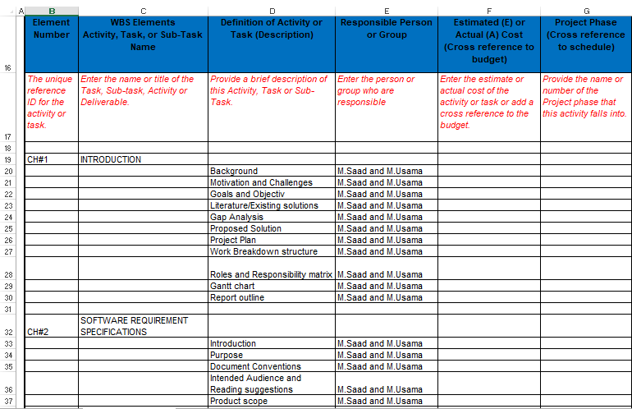

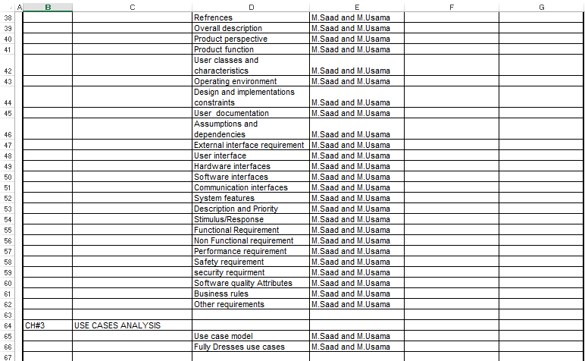

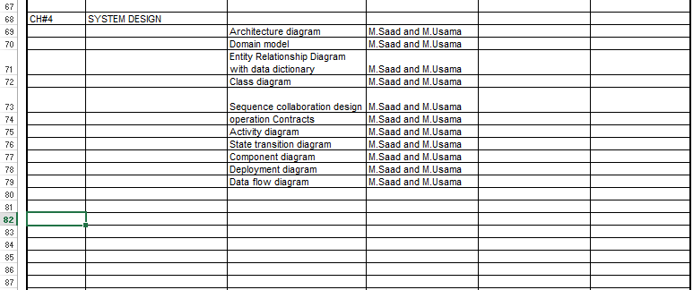

## Roles & Responsibility Matrix

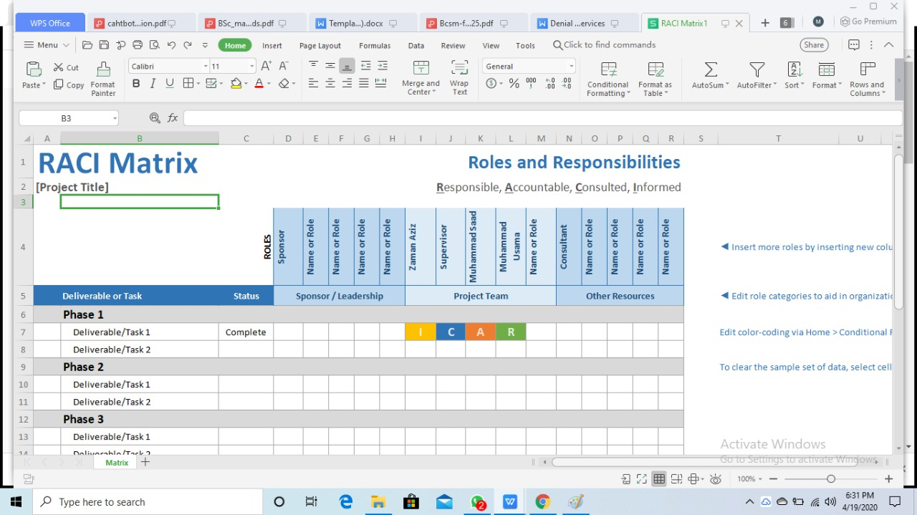

## Gantt Chart

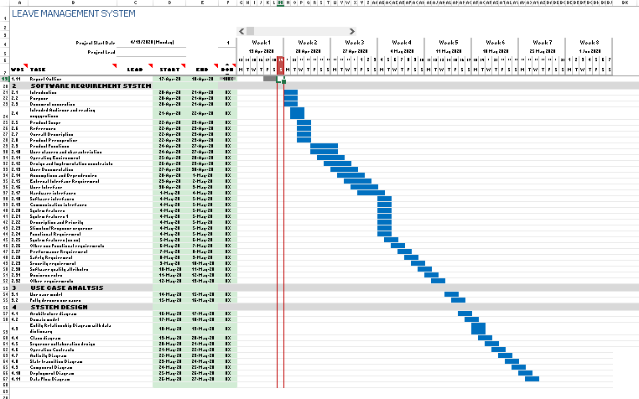

## Report Outline

Online Leave Management System is a web based application that is developed using PHP and MySQL. The objective of Leave Management System is to develop a web based application using which management of leave application and approval is done online. Faculty member of the institute can apply for leave and adjust their load directly from this application. HOD of their respective department can grant the leave application. This application can help in avoiding the leave application that needs to be given to the higher authority with great ease. This application can also help in sending the notifications to the users regarding the leaves that they have availed with great ease.

The features that can be included in this application are as follows:

* Notifications
* Reason specified
* Easy to use
* Reports
* Leave balance
* Leave approval
* Leave cancellation