**SUPERIOR UNIVERSITY LAHORE**

|  |
| --- |
| Superior Logo |

**Faculty of Computer Science & IT**

**Final Year Project**

**PROJECT REPORT (Part-1)**

**E-Shopify**

Project ID: **FYP16-GROUP-021**

**Project Team**

|  |  |  |  |  |
| --- | --- | --- | --- | --- |
| **Student Name** | **Student ID** | **Program** | **Contact Number** | **Email Address** |
| Syed Ghullam Meeran Gillani | BCSM-F16-528 | BSCS | 03116099989 | Syedghullammeeran@gmail.com |
| Haroon Ali | BCSM-F16-528 | BSCS | 03318417889 | Aharoon1000@gmail.com |

**Sir Asadullah Tariq**

Senior Lecturer

**Project Report**

**E-Shopify**

**Change Record**

|  |  |  |  |  |
| --- | --- | --- | --- | --- |
| **Author(s)** | **Version** | **Date** | **Notes** | **Supervisor’s Signature** |
| Syed Ghullam Meeran Gillani | 1.0 | 01/04/2020 | Gave idea how to start |  |
| Haroon Ali | 1.1 | 06/04/2020 | Complete info on title page |  |
| Syed Ghullam Meeran Gillani | 1.2 | 28/04/2020 | use roles and  responsibilities template |  |
| Syed Ghullam Meeran Gillani | 1.3 | 02/05/2020 | Content do not attach with other content |  |
| Haroon Ali | 1.4 | 06/06/2020 | Report outline is missing |  |
| both | 1.5 | 12/06/2020 | Give figures caption |  |
| Syed Ghullam Meeran Gillani | 1.6 | 13/06/2020 | Rearrange and correct Table of Content |  |
| Syed Ghullam Meeran Gillani | 1.7 | 13/06/2020 | Review and correcting report according to document convention |  |
| Syed Ghullam Meeran Gillani | 1.8 | 31/08/2020 | Review and correcting List of Figure |  |

**APPROVAL**

|  |  |
| --- | --- |
| **Project Supervisor** | |
| Comments: ___________________________________________________________________ | | |
| _____________________________________________________________________________ | | |
| Name: ______________________________ |  | |
| Date: _______________________________ | Signature: __________________________ | |

|  |  |
| --- | --- |
| **Project Manager** | |
| Comments: ___________________________________________________________________ | |
| _____________________________________________________________________________ | |
|  |  |
| Date: _______________________________ | Signature: __________________________ |

|  |  |
| --- | --- |
| **Head of the Department** | |
| Comments: ___________________________________________________________________ | |
| _____________________________________________________________________________ | |
|  |  |
| Date: _______________________________ | Signature: __________________________ |

# 

# 

# Dedication

We dedicate this project to our parents who help us a lot and give us a lot and give us everything we want. Also, they appreciate us they believe on ourselves. We also dedicate this project to our teacher. We can never make this project without our teachers. They make us able to do this and we are very thankful to our teachers’ big thank you to all beloved teachers. May Allah bless you all.

# Acknowledgements

All signs of recognition are to Almighty Allah, who gave us the quality, learning and bravery to finish this duty. We might want to pay huge amounts of thanks and offer my regards to our **Supervisor Mr. Asadullah Tariq** for his valuable direction, guide and support all through the learning procedure that he gave us a helpful course to finish our undertaking project. Secondly, we would also like to thank our parents and friends who helped us a lot in finalizing this project within the limited time frame.

# Executive Summary

We are developing an online ecommerce based mobile app on IOS platform in which all the system of retailing is based on online system such name as “E-Shopify” is mobile based which is allowing customers to buy best suitable items for our home through their mobile phones easily meeting the needs of many customers, without wasting their time. Online Tailoring System to enable users handle details of their clothes efficiently and effectively. Mostly people get difficulty in finding the best suitable items as it consumes a lot of time to find them. If the innovation can do these works effectively then why to waste the time.

**Table of Contents**

Dedication iv

Acknowledgements v

Executive Summary vi

List of Figures viii

Chapter 1 1

Introduction 1

1.1. Background 2

1.2. Motivations and Challenges 3

1.3. Goals and Objectives 3

1.4. Literature Review/Existing Solutions 4

1.5. Proposed Solution 4

1.6. Project Plan 4

1.6.1. Work Breakdown Structure 5

1.6.2. Roles & Responsibility Matrix 6

1.6.3. Gantt Chart 8

1.7. Report Outline 8

# List of Figures

1.1 Introduction 2

1.2 Motivational and Challenges 3

1.3 Goals and Objectives 3

1.6 Proposed Solution 4

1.6 Project Plan 4

1.6.1 Work breakdown structure 5

1.6.2 Roles and Responsibility 6

1.6.3 Gant chart 8

# Chapter 1

# Introduction

**Chapter 1:** Introduction

In this chapter, we are describing that why we build this online system. E-Shopify is an innovative online retailer and provides a great shopping experience to its users. It is a form of electronic commerce and it’s becoming very important in this era. It helps buying the products in the shop anywhere through internet. Online shopping is the process whereby consumers directly buy goods or services from a seller in real-time, without an intermediary service, over the Internet. It aims at enhancing the customer experience. The concept is derived from Amazon (World’s largest online retailer). E-Shopify is allowing customers to buy best suitable items for our home through their mobile phones easily meeting the needs of many customers, without wasting their time. Mostly people get difficulty in finding the best suitable items as it consumes a lot of time to find them. If the innovation can do these works effectively then why to waste the time.

Augmented Reality is becoming very important in this era, we need to decorate our home and many decoration accessories are available in market. It’s a hectic process to visit market and choose an item which is best suitable for our home. Some products are apparently suitable but when we place those items in our home, they didn’t look very good. Sometimes we often check these items through online stores which give us no idea how these items look after the placement.

## Background

Mobile has become a basic contact tool everyone prefers to possess and take it with them. This

has established a base to conquer the traditional desktop-based approach. With advancement in the field of technology and with the development of iPhone and phones iPhone applications are gaining popularity amongst the people. Mobile application that tend be helpful in daily life becomes the habit of user. iPhone a mobile-based operating system developed by Apple company based upon Berkeley Standard Distributions designed for mobiles with touch screens like smartphones and tablets.

Our project name is “E-Shopify”. The name demonstrating its significance is kind of hub for goods. E-Shopify is based upon iPhone application and augmented reality environment, through which we are providing and delivering the professional, helpful and high-quality services at home and in any area where customers are linked with the application. The concept is derived from Amazon (World’s largest online retailer). E-Shopify is allowing customers to buy best suitable items for our home through their mobile phones easily meeting the needs of many customers, without wasting their time. Mostly people get difficulty in finding the best suitable items as it consumes a lot of time to find them. If the innovation can do these works effectively then why to waste the time.

## Motivations and Challenges

* Idea has taken from Amazon APP
* Providing service at your place with the help of mobile application.

## Goals and Objectives

Our main objective is to provide best services to the people to save their time through the use of innovation by providing them AR based environment to choose best suitable goods held problems through IOS application.

**Effective:**

As it is stated that there is a difficulty in finding the best suitable items as it consumes a lot of time to find them. It is allowing customers to buy best suitable items for our home through their mobile phones easily meeting the needs of many customers, without wasting their time.

**Time and Energy Efficiency:**

It is well-organized and vitality sparing. Individual can without much of a bounce of login to online mobile app while sitting at home. So, by this we can say that it is to be time as vitality sparing.

**Interest Developing:**

Through the internet we see that there is only specific gender of age which are believes in online trading. Now we are developing the interest all males and females without any restriction of age in online business.

**Objective:**

The primary objective of E-Shopify is to be helps the people get difficulty in finding the best suitable items as it consumes a lot of time to find them. If the innovation can do these works effectively then why to waste the time. This Project has been intended to recreate the working of a genuine online system.

## Literature Review/Existing Solutions

In the existing system people get too much difficulty to find suitable items for their house they waste a lot of time to find best things after buying they came to know that these are not suitable and then people have to return for them to change.

## Proposed Solution

We need to decorate our home and many decoration accessories are available in market. It’s a hectic process to visit market and choose an item which is best suitable for our home. Some products are apparently suitable but when we place those items in our home, they didn’t look very good. Sometimes we often check these items through online stores which give us no idea how these items look after the placement. The AR based E-Shopify app will serve this problem. We can pick decoration items and place them in AR based environment to check whether they fit in our place. The APP uses device camera to visualize such items in an Augmented Reality Environment (ARE)

## Project Plan

E-Shopify aims at enhancing the customer experience and provides a great shopping experience to its users. It is mobile application based in which customer and admin can login & register themselves and then customer can check all the products before placing their order place them in AR based environment to check whether they fit in our place. In our project we having different phases, which are

* Firstly, we gather the requirements and analyze these requirements.
* Secondly, we make a plan how to manage all the things.
* After planning we divide our project in different small pieces

## Work Breakdown Structure

Level 1- overall project definition

* Highest level entry corresponds to the overall project deliverables e.g. Software deliverable project.

Level 2- Identity and define deliverables

* Create user interface.

Level 3- Decompose deliverables into high-level activities

* What need to be done to complete the deliverables

Level 4- Break down activities into more granular with sub-activities.

* Break down to measurable level of detail.

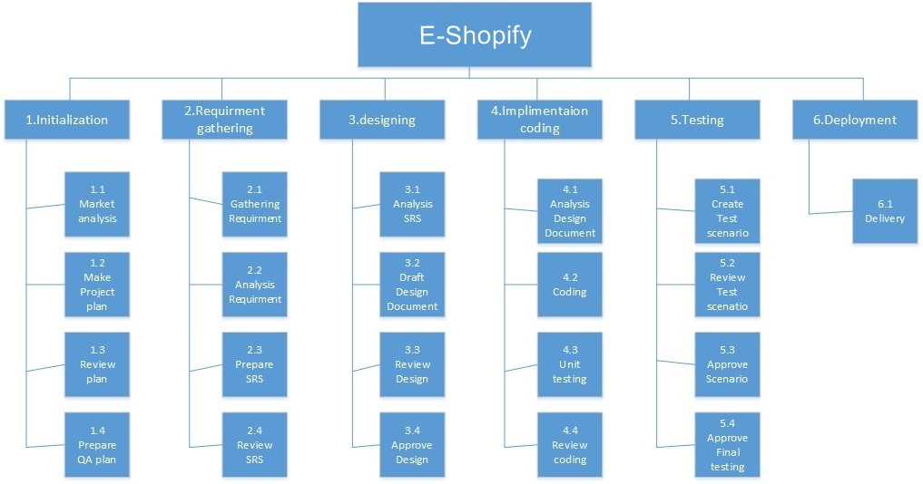

**Figure 1.6.1-WBS**

## Roles & Responsibility Matrix

|  |  |
| --- | --- |
| Role | Requirement gathering |
| Member | Syed Ghullam Meeran Gillani |
| Description | • Gather requirement from targeted market |

|  |  |
| --- | --- |
| Role | Training Session |
| Member | Syed Ghullam Meeran Gillani |
| Description | • Consultant professional |

|  |  |
| --- | --- |
| Role | Analysis |
| Member | Syed Ghullam Meeran Gillani |
| Description | • Analysis the project |

|  |  |
| --- | --- |
| Role | Documentation |
| Member | Syed Ghullam Meeran Gillani |
| Description | • Note document of whole project |

|  |  |
| --- | --- |
| Role | Architecture |
| Member | Syed Ghullam Meeran Gillani, Haroon Ali |
| Description | • Developing the Architecture |

|  |  |
| --- | --- |
| Role | Interface Designer |
| Member | Syed Ghullam Meeran Gillani, Haroon Ali |
| Description | • Sketch a final design of GUI |

|  |  |
| --- | --- |
| Role | Development |
| Member | Syed Ghullam Meeran Gillani |
| Description | • Developing IOS Mobile App |

|  |  |
| --- | --- |
| Role | Data base Interaction |
| Member | Syed Ghullam Meeran Gillani |
| Description | * Design and create a database for all necessary information that need to be store * Ensure that there are queries created for every necessary function * Create the server that allow clients to access the database |

|  |  |
| --- | --- |
| Role | Implementation |
| Member | Syed Ghullam Meeran Gillani, Haroon Ali |
| Description | * Create GUI based on the paper prototype by the interface designer * Link the GUI to the various actions that need to perform |

|  |  |
| --- | --- |
| Role | Unit Testing |
| Member | Syed Ghullam Meeran Gillani |
| Description | * test each component one by one * Ensure that all components meet the requirement |

|  |  |
| --- | --- |
| Role | System Testing |
| Member | Syed Ghullam Meeran Gillani, Haroon Ali |
| Description | * Fully test the code as components are created * Ensure that all components meet the requirements |

|  |  |
| --- | --- |
| Role | Documentation |
| Member | Syed Ghullam Meeran Gillani |
| Description | • Creating Documentation of Project |

## Gantt Chart

|  |  |  |  |  |  |  |  |  |  |  |  |  |  |  |  |  |  |  |  |  |  |  |
| --- | --- | --- | --- | --- | --- | --- | --- | --- | --- | --- | --- | --- | --- | --- | --- | --- | --- | --- | --- | --- | --- | --- |
| ID |  | Task Name | Start | Finish |  |  | | |  | | | | | | | | |  | | |  | |
| May 2020 | | | June 2020 | | | | | | | | July 2020 | | | Aug 2020 | | |
| 1 |  | Proposal Submission | 01/05/2019 | 05/05/2019 | 4d |  | | |  | | | | | | | | |  | | |  | |
|
| 2 |  | Requirement gathering | 5/05/2019 | 11/05/2019 | 6d |  |  | |  | | | | | | | | |  | | |  | |
|  |
| 3 |  | Analysis | 12/05/2019 | 17/05/2019 | 5d |  |  |  |  | | | | | | | | |  | | |  | |
|  |
| 4 |  | Architecture | 18/05/2019 | 25/05/2019 | 7d |  | |  |  |  | | | |  | | | | |  | | |  |
|  |  | | | | | | | | |  | | |  | |
| 5 |  | Designing | 26/05/2019 | 30/05/2019 | 4d |  | | |  | |  | | | | | | |  | | |  | |
|  | | | | | | | | |
| 6 |  | Unit Testing | 31/05/2019 | 03/06/2019 | 3d |  | | |  | |  |  |  | | |  | | | | | | |
|  | | |  |
| 7 |  | Documentation | 04/06/2019 | 13/06/2019 | 10d |  | | |  | |  |  |  | |  | | | | | | | |
|  | | | | | | | | | | |

## Report Outline

In this chapter we have discussed about the background of our project and then discuss the motivations and our objectives. Than we see the existing solution of the problem of which we are going to give solution then we discuss that from which gaps we are going to purpose our solution which is different from the others and how can we make it successful at last we see the three major diagrams **WBS, Roles & Responsibility Matrix, Gantt Chart,** Which make a lot of things clear about the project.