**SUPERIOR UNIVERSITY LAHORE**

|  |
| --- |
| Superior Logo |

**Faculty of Computer Science & IT**

**Final Year Project**

**PROJECT REPORT (Part-1)**

**E-Shopify**

Project ID: **FYP16-GROUP-021**

**Project Team**

|  |  |  |  |  |
| --- | --- | --- | --- | --- |
| **Student Name** | **Student ID** | **Program** | **Contact Number** | **Email Address** |
| Syed Ghullam Meeran Gillani | BCSM-F16-528 | BSCS | 03116099989 | Syedghullammeeran@gmail.com |
| Haroon Ali | BCSM-F16-528 | BSCS | 03318417889 | Aharoon1000@gmail.com |

**Sir Asadullah Tariq**

Senior Lecturer

**Project Report**

**E-Shopify**

**Change Record**

|  |  |  |  |  |
| --- | --- | --- | --- | --- |
| **Author(s)** | **Version** | **Date** | **Notes** | **Supervisor’s Signature** |
| Syed Ghullam Meeran Gillani | 1.0 | 01/04/2020 | Gave idea how to start |  |
| Haroon Ali | 1.1 | 06/04/2020 | Complete info on title page |  |
| Syed Ghullam Meeran Gillani | 1.2 | 28/04/2020 | use roles and  responsibilities template |  |
| Syed Ghullam Meeran Gillani | 1.3 | 02/05/2020 | Content do not attach with other content |  |
| Haroon Ali | 1.4 | 06/06/2020 | Report outline is missing |  |
| both | 1.5 | 12/06/2020 | Give figures caption |  |
| Syed Ghullam Meeran Gillani | 1.6 | 13/06/2020 | Rearrange and correct Table of Content |  |
| Syed Ghullam Meeran Gillani | 1.7 | 13/06/2020 | Review and correcting report according to document convention |  |
| Syed Ghullam Meeran Gillani | 1.8 | 31/08/2020 | Review and correcting List of Figure |  |

**APPROVAL**

|  |  |
| --- | --- |
| **Project Supervisor** | |
| Comments: ___________________________________________________________________ | | |
| _____________________________________________________________________________ | | |
| Name: ______________________________ |  | |
| Date: _______________________________ | Signature: __________________________ | |

|  |  |
| --- | --- |
| **Project Manager** | |
| Comments: ___________________________________________________________________ | |
| _____________________________________________________________________________ | |
|  |  |
| Date: _______________________________ | Signature: __________________________ |

|  |  |
| --- | --- |
| **Head of the Department** | |
| Comments: ___________________________________________________________________ | |
| _____________________________________________________________________________ | |
|  |  |
| Date: _______________________________ | Signature: __________________________ |

# 

# 

# Dedication

We dedicate this project to our parents who help us a lot and give us a lot and give us everything we want. Also, they appreciate us they believe on ourselves. We also dedicate this project to our teacher. We can never make this project without our teachers. They make us able to do this and we are very thankful to our teachers’ big thank you to all beloved teachers. May Allah bless you all.

# Acknowledgements

All signs of recognition are to Almighty Allah, who gave us the quality, learning and bravery to finish this duty. We might want to pay huge amounts of thanks and offer my regards to our **Supervisor Mr. Asadullah Tariq** for his valuable direction, guide and support all through the learning procedure that he gave us a helpful course to finish our undertaking project. Secondly, we would also like to thank our parents and friends who helped us a lot in finalizing this project within the limited time frame.

# Executive Summary

We are developing an online ecommerce based mobile app on IOS platform in which all the system of retailing is based on online system such name as “E-Shopify” is mobile based which is allowing customers to buy best suitable items for our home through their mobile phones easily meeting the needs of many customers, without wasting their time. Online Tailoring System to enable users handle details of their clothes efficiently and effectively. Mostly people get difficulty in finding the best suitable items as it consumes a lot of time to find them. If the innovation can do these works effectively then why to waste the time.

**Table of Contents**

Dedication iv

Acknowledgements v

Executive Summary vi

List of Figures xi

Chapter 1 1

Introduction 1

1.1. Background 2

1.2. Motivations and Challenges 3

1.3. Goals and Objectives 3

1.4. Literature Review/Existing Solutions 4

1.5. Proposed Solution 4

1.6. Project Plan 4

1.6.1. Work Breakdown Structure 5

1.6.2. Roles & Responsibility Matrix 6

1.6.3. Gantt Chart 8

1.7. Report Outline 8

Chapter 2 9

Software Requirement Specifications 9

2.1. Introduction 10

2.1.1. Purpose 10

2.1.2. Document Conventions 10

2.1.3. Intended Audience and Reading Suggestions 11

2.1.4. Product Scope 11

2.1.5. References 12

2.2. Overall Description 12

2.2.1. Product Perspective 12

2.2.2. Product Functions 13

2.2.3. User Classes and Characteristics 13

2.2.4. Operating Environment 14

2.2.5. Design and Implementation Constraints 14

2.2.6. User Documentation 14

2.2.7. Assumptions and Dependencies 14

2.3. External Interface Requirements 15

2.3.1. User Interface 15

2.3.2. Hardware Interfaces 16

2.3.3. Software Interfaces 16

2.3.4. Communications Interfaces 16

2.4. System Features 17

2.4.1. System Feature 1 17

2.4.1.1. Description and Priority 18

2.4.1.2. Stimulus/Response Sequences 18

2.4.1.3. Functional Requirements 18

2.4.2. System Feature 2 18

2.4.2.1. Description and Priority 18

2.4.2.2. Stimulus/Response Sequences 18

2.4.2.3. Functional Requirements 19

2.4.3. System Feature 3 19

2.4.3.1. Description and Priority 19

2.4.3.2. Stimulus/Response Sequences 19

2.4.3.3. Functional Requirements 19

2.4.4. System Feature 4 19

2.4.4.1. Description and Priority 19

2.4.4.2. Stimulus/Response Sequences 20

2.4.4.3. Functional Requirements 20

2.4.5. System Feature 5 20

2.4.5.1. Description and Priority 20

2.4.5.2. Stimulus/Response Sequences 20

2.4.5.3. Functional Requirements 20

2.4.6. System Feature 6 21

2.4.6.1. Description and Priority 21

2.4.6.2. Stimulus/Response Sequences 21

2.4.6.3. Functional Requirements 21

2.4.7. System Feature 7 21

2.4.7.1. Description and Priority 21

2.4.7.2. Stimulus/Response Sequences 21

2.4.7.3. Functional Requirements 22

2.4.8. System Feature 8 22

2.4.8.1. Description and Priority 22

2.4.8.2 Stimulus/Response Sequences 22

2.4.8.3. Functional Requirements 22

2.4.9. System Feature 9 23

2.4.9.2. Stimulus/Response Sequences 23

2.4.9.3. Functional Requirements 23

2.4.10. System Feature 10 23

2.4.10.1. Description and Priority 23

2.4.10.2. Stimulus/Response Sequences 23

2.4.10.3. Functional Requirements 23

2.4.11. System Feature 11 24

2.4.11.1. Description and Priority 24

2.4.11.2. Stimulus/Response Sequences 24

2.4.11.3. Functional Requirements 24

2.4.12. System Feature 12 24

2.4.12.1. Description and Priority 24

2.4.12.2. Stimulus/Response Sequences 24

2.4.12.3. Functional Requirements 24

2.4.13. System Feature 13 25

2.4.13.1. Description and Priority 25

2.4.13.2. Stimulus/Response Sequences 25

2.4.13.3. Functional Requirements 25

2.5. Other Nonfunctional Requirements 25

2.5.1. Performance Requirements 25

2.5.2. Safety Requirements 25

2.5.3. Security Requirements 26

2.5.4. Software Quality Attributes 26

2.5.5. Business Rules 26

2.6. Other Requirements 27

Chapter 3 28

Use Case Analysis 28

3.1. Use Case Model 29

3.2. Fully Dressed Use Cases 30

# List of Figures

1.1 Introduction 2

1.2 Motivational and Challenges 3

1.3 Goals and Objectives 3

1.6 Proposed Solution 4

1.6 Project Plan 4

1.6.1 Work breakdown structure 5

1.6.2 Roles and Responsibility 6

1.6.3 Gant chart 8

2.1.1 Purpose 10

2.1.2 Document Convention 10

2.1.4 Product Scope 11

2.2.2 Product Functions 13

2.3.1 User interface 15

2.4 System Feature 17

3.1 User case model 29

3.2 Fully dressed use case 30

# Chapter 1

# Introduction

**Chapter 1:** Introduction

In this chapter, we are describing that why we build this online system. E-Shopify is an innovative online retailer and provides a great shopping experience to its users. It is a form of electronic commerce and it’s becoming very important in this era. It helps buying the products in the shop anywhere through internet. Online shopping is the process whereby consumers directly buy goods or services from a seller in real-time, without an intermediary service, over the Internet. It aims at enhancing the customer experience. The concept is derived from Amazon (World’s largest online retailer). E-Shopify is allowing customers to buy best suitable items for our home through their mobile phones easily meeting the needs of many customers, without wasting their time. Mostly people get difficulty in finding the best suitable items as it consumes a lot of time to find them. If the innovation can do these works effectively then why to waste the time.

Augmented Reality is becoming very important in this era, we need to decorate our home and many decoration accessories are available in market. It’s a hectic process to visit market and choose an item which is best suitable for our home. Some products are apparently suitable but when we place those items in our home, they didn’t look very good. Sometimes we often check these items through online stores which give us no idea how these items look after the placement.

## Background

Mobile has become a basic contact tool everyone prefers to possess and take it with them. This

has established a base to conquer the traditional desktop-based approach. With advancement in the field of technology and with the development of iPhone and phones iPhone applications are gaining popularity amongst the people. Mobile application that tend be helpful in daily life becomes the habit of user. iPhone a mobile-based operating system developed by Apple company based upon Berkeley Standard Distributions designed for mobiles with touch screens like smartphones and tablets.

Our project name is “E-Shopify”. The name demonstrating its significance is kind of hub for goods. E-Shopify is based upon iPhone application and augmented reality environment, through which we are providing and delivering the professional, helpful and high-quality services at home and in any area where customers are linked with the application. The concept is derived from Amazon (World’s largest online retailer). E-Shopify is allowing customers to buy best suitable items for our home through their mobile phones easily meeting the needs of many customers, without wasting their time. Mostly people get difficulty in finding the best suitable items as it consumes a lot of time to find them. If the innovation can do these works effectively then why to waste the time.

## Motivations and Challenges

* Idea has taken from Amazon APP
* Providing service at your place with the help of mobile application.

## Goals and Objectives

Our main objective is to provide best services to the people to save their time through the use of innovation by providing them AR based environment to choose best suitable goods held problems through IOS application.

**Effective:**

As it is stated that there is a difficulty in finding the best suitable items as it consumes a lot of time to find them. It is allowing customers to buy best suitable items for our home through their mobile phones easily meeting the needs of many customers, without wasting their time.

**Time and Energy Efficiency:**

It is well-organized and vitality sparing. Individual can without much of a bounce of login to online mobile app while sitting at home. So by this we can say that it is to be time as vitality sparing.

**Interest Developing:**

Through the internet we see that there is only specific gender of age which are believes in online trading. Now we are developing the interest all males and females without any restriction of age in online business.

**Objective:**

The primary objective of E-Shopify is to be helps the people get difficulty in finding the best suitable items as it consumes a lot of time to find them. If the innovation can do these works effectively then why to waste the time. This Project has been intended to recreate the working of a genuine online system.

## Literature Review/Existing Solutions

In the existing system people get too much difficulty to find suitable items for their house they waste a lot of time to find best things after buying they came to know that these are not suitable and then people have to return for them to change.

## Proposed Solution

We need to decorate our home and many decoration accessories are available in market. It’s a hectic process to visit market and choose an item which is best suitable for our home. Some products are apparently suitable but when we place those items in our home, they didn’t look very good. Sometimes we often check these items through online stores which give us no idea how these items look after the placement. The AR based E-Shopify app will serve this problem. We can pick decoration items and place them in AR based environment to check whether they fit in our place. The APP uses device camera to visualize such items in an Augmented Reality Environment (ARE)

## Project Plan

E-Shopify aims at enhancing the customer experience and provides a great shopping experience to its users. It is mobile application based in which customer and admin can login & register themselves and then customer can check all the products before placing their order place them in AR based environment to check whether they fit in our place. In our project we having different phases, which are

* Firstly, we gather the requirements and analyze these requirements.
* Secondly, we make a plan how to manage all the things.
* After planning we divide our project in different small pieces

## Work Breakdown Structure

Level 1- overall project definition

* Highest level entry corresponds to the overall project deliverables e.g. Software deliverable project.

Level 2- Identity and define deliverables

* Create user interface.

Level 3- Decompose deliverables into high-level activities

* What need to be done to complete the deliverables

Level 4- Break down activities into more granular with sub-activities.

* Break down to measurable level of detail.

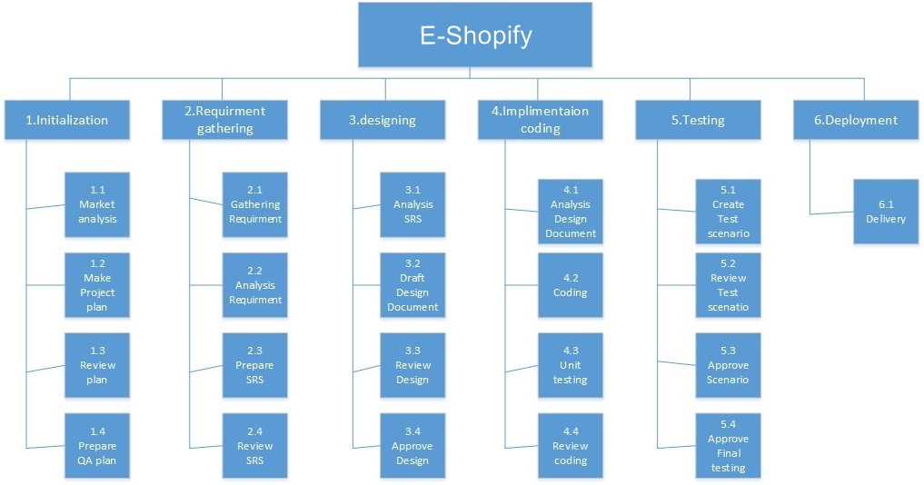

**Figure 1.6.1-WBS**

## Roles & Responsibility Matrix

|  |  |
| --- | --- |
| Role | Requirement gathering |
| Member | Syed Ghullam Meeran Gillani |
| Description | • Gather requirement from targeted market |

|  |  |
| --- | --- |
| Role | Training Session |
| Member | Syed Ghullam Meeran Gillani |
| Description | • Consultant professional |

|  |  |
| --- | --- |
| Role | Analysis |
| Member | Syed Ghullam Meeran Gillani |
| Description | • Analysis the project |

|  |  |
| --- | --- |
| Role | Documentation |
| Member | Syed Ghullam Meeran Gillani |
| Description | • Note document of whole project |

|  |  |
| --- | --- |
| Role | Architecture |
| Member | Syed Ghullam Meeran Gillani, Haroon Ali |
| Description | • Developing the Architecture |

|  |  |
| --- | --- |
| Role | Interface Designer |
| Member | Syed Ghullam Meeran Gillani, Haroon Ali |
| Description | • Sketch a final design of GUI |

|  |  |
| --- | --- |
| Role | Development |
| Member | Syed Ghullam Meeran Gillani |
| Description | • Developing IOS Mobile App |

|  |  |
| --- | --- |
| Role | Data base Interaction |
| Member | Syed Ghullam Meeran Gillani |
| Description | * Design and create a database for all necessary information that need to be store * Ensure that there are queries created for every necessary function * Create the server that allow clients to access the database |

|  |  |
| --- | --- |
| Role | Implementation |
| Member | Syed Ghullam Meeran Gillani, Haroon Ali |
| Description | * Create GUI based on the paper prototype by the interface designer * Link the GUI to the various actions that need to perform |

|  |  |
| --- | --- |
| Role | Unit Testing |
| Member | Syed Ghullam Meeran Gillani |
| Description | * test each component one by one * Ensure that all components meet the requirement |

|  |  |
| --- | --- |
| Role | System Testing |
| Member | Syed Ghullam Meeran Gillani , Haroon Ali |
| Description | * Fully test the code as components are created * Ensure that all components meet the requirements |

|  |  |
| --- | --- |
| Role | Documentation |
| Member | Syed Ghullam Meeran Gillani |
| Description | • Creating Documentation of Project |

## Gantt Chart

|  |  |  |  |  |  |  |  |  |  |  |  |  |  |  |  |  |  |  |  |  |  |  |
| --- | --- | --- | --- | --- | --- | --- | --- | --- | --- | --- | --- | --- | --- | --- | --- | --- | --- | --- | --- | --- | --- | --- |
| ID |  | Task Name | Start | Finish |  |  | | |  | | | | | | | | |  | | |  | |
| May 2020 | | | June 2020 | | | | | | | | July 2020 | | | Aug 2020 | | |
| 1 |  | Proposal Submission | 01/05/2019 | 05/05/2019 | 4d |  | | |  | | | | | | | | |  | | |  | |
|
| 2 |  | Requirement gathering | 5/05/2019 | 11/05/2019 | 6d |  |  | |  | | | | | | | | |  | | |  | |
|  |
| 3 |  | Analysis | 12/05/2019 | 17/05/2019 | 5d |  |  |  |  | | | | | | | | |  | | |  | |
|  |
| 4 |  | Architecture | 18/05/2019 | 25/05/2019 | 7d |  | |  |  |  | | | |  | | | | |  | | |  |
|  |  | | | | | | | | |  | | |  | |
| 5 |  | Designing | 26/05/2019 | 30/05/2019 | 4d |  | | |  | |  | | | | | | |  | | |  | |
|  | | | | | | | | |
| 6 |  | Unit Testing | 31/05/2019 | 03/06/2019 | 3d |  | | |  | |  |  |  | | |  | | | | | | |
|  | | |  |
| 7 |  | Documentation | 04/06/2019 | 13/06/2019 | 10d |  | | |  | |  |  |  | |  | | | | | | | |
|  | | | | | | | | | | |

## Report Outline

In this chapter we have discussed about the background of our project and then discuss the motivations and our objectives. Than we see the existing solution of the problem of which we are going to give solution then we discuss that from which gaps we are going to purpose our solution which is different from the others and how can we make it successful at last we see the three major diagrams **WBS, Roles & Responsibility Matrix, Gantt Chart,** Which make a lot of things clear about the project.

# Chapter 2

# Software Requirement Specifications

**Chapter 2:** Software Requirement Specifications



## Introduction

It is allowing customers to buy best suitable items for our home through their mobile phones easily meeting the needs of many customers, without wasting their time. Mostly people get difficulty in finding the best suitable items as it consumes a lot of time to find them. If the innovation can do these works effectively then why to waste the time. In this chapter we discussed about software specification requirements, regarding what is our purpose to do this project, what are main features? And what are audience benefits? Also describes what is our product and its scope.

## Purpose

Purpose is to facilitate people as well as theecommerce working on retailer shop.It will save the time of all the users connected to it. E-Shopify is allowing customers to buy best suitable items for our home through their mobile phones easily meeting the needs of many customers, without wasting their time. Mostly people get difficulty in finding the best suitable items as it consumes a lot of time to find them. If the innovation can do these works effectively then why to waste the time. In this SRS we covered all over the documentation each and everything related to this project. All functional & non-functional requirements, system diagrams each and everything Document.

## 

## Document Conventions

We are followed the Standard rules of documentation to make sure that E-Shopify system is creates efficient and reliable in the any premises of business system.

Main section titles

* Font: Calibri body
* Face: bold
* Size: 16

Sub selection titles

* Font: Calibri body
* Face: bold
* Size: 14

Other text explanations

* Font: Calibri body
* Face: normal
* Size: 12

## 

## Intended Audience and Reading Suggestions

Describe the different types of reader that the document is intended for, such as developers, project managers, marketing staff, users, testers, and documentation writers. Describe what the rest of this SRS contains and how it is organized. Suggest a sequence for reading the document, beginning with the overview sections and proceeding through the sections that are most pertinent to each reader type.

## Product Scope

Through our services we hope to accomplish following major goals:

Customer benefits:

* Time saving
* Quality assurance.
* Consistent and timely service.
* Customer supportive.
* Customer comfort.
* User friendly.

Worker benefits:

* Employment.
* More earning.
* Better family support.

Service provider’s benefits:

* Business startup.
* Commission based profits.
* Research based learning activity.
* **DIAGRAM:**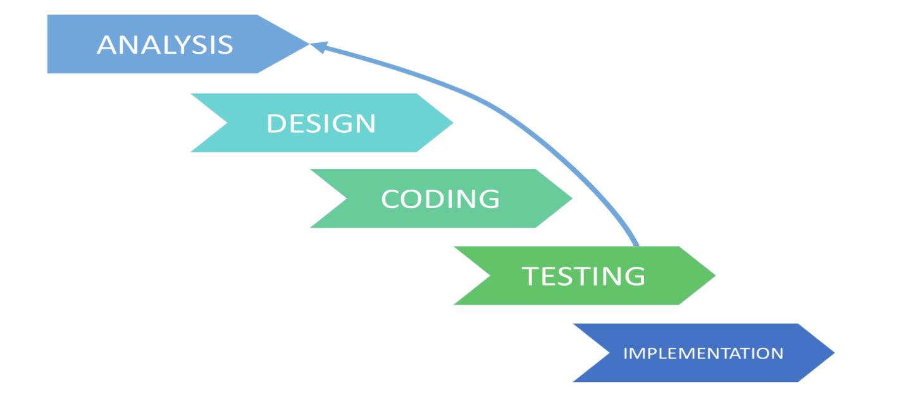

## References

• IEEE 830-1998 standard for writing SRS document.

• Summerville, Software Engineering, 8th ed, Addison- Wesley, 2007.

## 2.2. Overall Description

## 2.2.1. Product Perspective

This product is a follow up on the current system in which there is too difficult to find the best suitable items as it consumes a lot of time to find them. It is planned to replace the existing system. That will save both user time and easy to find the best suitable item at anywhere any time with the help of augmented reality environment.

## 2.2.2. Product Functions

**Mobile App: E-Shopify**

* **Register:** User can register.
* **Login:** User/admin can login.
* **Logout:** User/admin can also logout.
* **Forgot Password:** User can recover his/her password.
* **View Items:** User can see items.
* **Order:** User can place an order or orders.
* **Payment:** User can select the payment method.
* **Cash on delivery:** User can pay also his payment on delivery.
* **Manage Items Rates:** Admin can update items rates.
* **Manage Items:** Admin can manage the items by update items, add items and delete or remove items.
* **Check feedback:** Admin can check the feedback from users and response it.

## 2.2.3. User Classes and Characteristics

There would be three types of user which will interact with the application customers, general public and administrative. So, all of them would have different types of requirements. General public use the mobile app to see the products, their prices and quantity available. General users cannot buy the products. Customer are using for viewing and buying the products. Customer can also write the feedbacks for the products and services. Administrators can add, edit & delete products and provide services to the customer. Administrator can see the daily sell. Can also see the feedback. Administrator maintaining the products and mobile app.

## 2.2.4. Operating Environment

It will be iPhone-based app which must have IOS version 8.0 or greater than this. Phone should have at least 1GB of RAM and 100MB of free space or iPhone 7 to enjoy the best feature of the mobile app E-Shopify.

## Design and Implementation Constraints

The main constraints for our project implementation is integration. To integrate the whole application at the end generates too many bugs which was difficult to handle. E-Shopify is based on three tier IOS application which need proper internet connection at every time; otherwise, no one can use it.

## User Documentation

* A separate printed user manual for each user role should be delivered with this software which will document how the software should be maintained.
* Additionally, a tutorial shall be provided for the user describing the major use cases for each role.
* User can send the E-mail to the professionals for further help.
* User must know detail of our product, how to use it or how to deploy it.
* User use internet to access our product or need friendly environment.

## Assumptions and Dependencies

It is assumed that the people in Pakistan would like to work through mobile phones they would be familiar with the application and familiar with the internet usage. The whole application is internet based so there is a need of internet every time. It will be expected that the general public and clients will have fair internet.

Our project is dependent on

* Firebase DATABASE is for storing database.
* XCode for building our project.

## 2.3. External Interface Requirements

According to Richard Thayer (2002), "External interface requirements specify hardware, software, or database elements with which a system or component must interface...." This section provides information to ensure that the system will communicate properly with external components.

## 2.3.1. User Interface

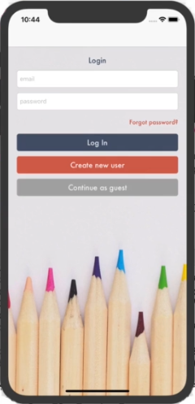 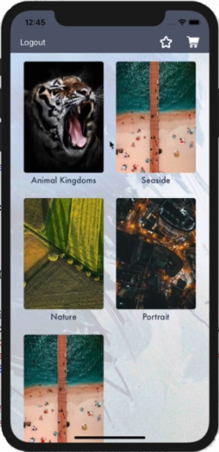

## 2.3.2. Hardware Interfaces

The application can run on any hardware which supports IOS version 8.0 to 13. The system must have a mac OS, MacBook or iPhone to load this application. All system information is stored into the server-side databases which stored the data into the server. The hardware interface of our project for the users and end user is mobile so that they can easily access it. The physical characteristics of the software with respect to hardware are follows.

• The mobile app is very easy to access.

• Once the system is online it is provided very simple and easy interface so that everyone can use it so easily.

.

## Software Interfaces

It will be iPhone-based app which must have IOS version 8.0 or greater than this. Phone should have iPhone 7 or greater and at least 1GB of RAM and 100MB of free space to enjoy the best feature of E-Shopify.

## Communications Interfaces

The communication between the different parts of the system is important since they depend on each other. The two way must to be associated through either by LAN or WAN for the communication. Sender Communication channels Receiver.

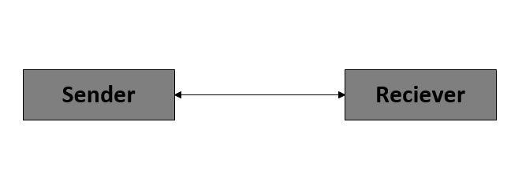

## 2.4. System Features

#### **System Features**

**Register:** User can register into the System

**Login:** User can login into the System

**Login as Guest:** User can also login as guest account.

**Forgot Password:** User can also recover password.

**Add Items:** After login end user can add the products.

**Add to Cart:** User can also add the products into the shopping cart.

**Add to Favorite:** User can also add the products into the Favorite list for later use.

**Edit items:** After login end user can edit his/her products.

**View Detail of Item:** User can also view the products details.

**Augmented Reality:** User can also view the products into the real world.

**Select payment Method:** User can select the payment method (Cash on delivery)

**Contact Us:** User can also contact us.

**Log out:** After placing the order user can logout.

**Feedback:** User can also give feedback.

**Technical Features:**

**Software Requirements:**

* Data connection device

## 2.4.1. System Feature 1

Logins of users and end users are provided so that the data of there is managed easily and provide them a better service. Login for all users including users and end user.

## 2.4.1.1. Description and Priority

This feature is developed for the safety of the data of both users and end users. By using this service, we can provide better services of our site.

## 2.4.1.2. Stimulus/Response Sequences

When the user wants to get our service, he/she should have to login with proper email and password so that he/she get our services otherwise our services are not provided.

## 2.4.1.3. Functional Requirements

For this feature the email is used first to provide the proper login and password to our user. After that user will use that email and password which must be required to get our services.

* REQ-SF1-1: Email
* REQ-SF1-2: Password

## 2.4.2. System Feature 2

Signup of customers are provided so that the data of there is managed easily and provide them a better service. Providing registration for all users including users and end user.

## 2.4.2.1. Description and Priority

This feature is developed for the safety of the data of customer. By using this service, we can provide better services of our site. Simply click on sign up and place all the required details system will verify and save the information.

## 2.4.2.2. Stimulus/Response Sequences

When the user wants to get our service, he should have to sign up with proper info that he gets our services otherwise our services are not provided.

## 2.4.2.3. Functional Requirements

For this feature the email id is used after that user will use that email and password which must be required to get our services. User can create only if he/she doesn’t already have an account.

* REQ-SF1-1: first name
* REQ-SF1-2: last name
* REQ-SF1-3: email
* REQ-SF1-4: password

## 2.4.3. System Feature 3

The app must allow users to login as a guest.

## 2.4.3.1. Description and Priority

If user do not want to register his/her account he/she simply login as a guest account no need to create an account if user don not want to create just simply clicking on the login as a guest feature to get this feature.

## 2.4.3.2. Stimulus/Response Sequences

Users will be logging in as a guest successfully.

## 2.4.3.3. Functional Requirements

Functional requirement of this feature is just simply having a fair internet connectivity to this system feature is only Internet required.

## 2.4.4. System Feature 4

The app must allow users to recover his/her password using Forget password feature.

## 2.4.4.1. Description and Priority

User can recover account if forget password. Safety and timing. By using this service, we can provide better services of our site. Simply clicking on the Forgot Password button and place his/her email then check his/her email and click on the link and create his/her new password.

## 2.4.4.2. Stimulus/Response Sequences

When user want to recover his/her password can using forget password feature and users will be able to change his/her password successfully through email.

## 2.4.4.3. Functional Requirements

Valid email required and only existing user can change password using email.

* REQ-SF1-1: valid email

## 2.4.5. System Feature 5

End user can also add their products using this feature app must allow user to add products in the system. End user can add his/her products.

## 2.4.5.1. Description and Priority

This system feature allow the end user to add their products in the system and using this system feature end user will have to login first using his/her email id and password first and then simply clicking on the add product icon and place his/her product name, price, description, and image and then click on the add product button to add product successfully.

## 2.4.5.2. Stimulus/Response Sequences

When the end user adds the products using this system feature the products will be added successfully.

## 2.4.5.3. Functional Requirements

Functional requirement of this system feature is Internet required and only existing end user can add the products.

* REQ-SF1-1: name
* REQ-SF1-2: price
* REQ-SF1-3: description

## 2.4.6. System Feature 6

The app must allow user add to cart the product. In which user can add the items into the cart.

## 2.4.6.1. Description and Priority

This feature is developed for the shopping purpose of customer. By using this service, we can provide better services of our site. User can also add the product into the shopping cart to order the product. Simply select the product and click on the add to cart button that simply add the product into the cart successfully.

## 2.4.6.2. Stimulus/Response Sequences

When user want to buy items add to cart will help. When the user wants to get our service, he should have to select with that item and users will able to add the product into the cart successfully otherwise our services are not provided.

## 2.4.6.3. Functional Requirements

Internet required and only existing user can add to cart successfully.

* REQ-SF1-1: login

## 2.4.7. System Feature 7

The app must allow user add item into the Favorite list.

## 2.4.7.1. Description and Priority

This feature is developed for the shopping purpose of customer. By using this service, we can provide better services of our site. User can also add the product into the favorite list to order the product later. Simply first user selects the product and click on the add to favorite icon button that simply add the product into the favorite list successfully.

## 2.4.7.2. Stimulus/Response Sequences

When user want to buy items add to cart will help. When the user wants to get our service, he should have to select with that item to gets our services and users will able to add the product into the cart successfully otherwise our services are not provided.

## 2.4.7.3. Functional Requirements

For this feature user’s info is used for record. After that user will use that id and password which must be required to get our services. Internet required and only existing user can add to cart successfully.

* REQ-SF1-1: login

## 2.4.8. System Feature 8

End user can also edit their products using this feature app must allow user to edit products in the system. End user can edit his/her products.

## 2.4.8.1. Description and Priority

This system feature allow the end user to edit their products in the system and using this system feature end user will have to login first using his/her email id and password first and then simply clicking on the edit product icon and place product name, price, description, and image and then click on the edit product button to save product successfully.

## 2.4.8.2 Stimulus/Response Sequences

When the end user edits the products using this system feature the products will be edited successfully.

## 2.4.8.3. Functional Requirements

Functional requirement of this system feature is Internet required and only existing end user can edit the products.

* REQ-SF1-1: name
* REQ-SF1-2: price
* REQ-SF1-3: description
* REQ-SF1-4: image

## 2.4.9. System Feature 9

The app must allow user view the detail of the product.

**2.4.9.1. Description and Priority**

This feature is developed for the shopping purpose of customer. By using this service, we can provide better services of our site. If user want to view the full detail of the product then he can also view the product detail. First user will be Login or login as a guest to view the detail of the product he/she wants then simply click on the product.

## 2.4.9.2. Stimulus/Response Sequences

When user want to view detail of item by using this service user will view the complete detail of product including product name, price and complete description.

## 2.4.9.3. Functional Requirements

Functional requirement of this system feature is only Internet required.

## 2.4.10. System Feature 10

The app must allow user to view the product in real world using augmented reality.

## 2.4.10.1. Description and Priority

This feature is developed for the shopping purpose of customer. By using this service, we can provide better services of our site. If user want to view the full product in real world using augment reality environment.

## 2.4.10.2. Stimulus/Response Sequences

When user want to view the item in real world by using this service user will view the complete product in real world through mobile camera using augmented reality feature.

## 2.4.10.3. Functional Requirements

Functional requirement of this system feature is only Internet required and iPhone7 or greater is required to get this feature.

* REQ-SF1-1: iPhone 7

## 2.4.11. System Feature 11

The app must allow user to contact us through their accounts.

## 2.4.11.1. Description and Priority

User can contact us from system. Safety and timing. By using this service, we can provide better services users will simply have to login first then just clicking on contact us feature he/she will be contact us safely from his/her account.

## 2.4.11.2. Stimulus/Response Sequences

When user want to contact us by using contact us system feature. User will be successfully contact us.

## 2.4.11.3. Functional Requirements

For this feature user have to register itself first. After that user will use that email and password to login which must be required to get our services.

* REQ-SF1-1: login
* REQ-SF1-1: login as guest

## 2.4.12. System Feature 12

The app must allow user to logout accounts.

## 2.4.12.1. Description and Priority

User can logout from system. Safety and timing. By using this service, we can provide better services users will simply using logout button just clicking on it he/she will be logout safely from his/her account.

## 2.4.12.2. Stimulus/Response Sequences

User will logout from his/her account simply by using this system feature successfully.

## 2.4.12.3. Functional Requirements

For this feature user’s info is used for record. After that user will use that email and password which must be required to get our services.

* REQ-SF1-1: login

## 2.4.13. System Feature 13

The app must allow user to give feedback through their accounts.

## 2.4.13.1. Description and Priority

User can give feedback from system. Safety and timing. By using this service, we can provide better services users will simply have to login first then just clicking on feedback feature and will be able to give feedback safely from his/her account.

## 2.4.13.2. Stimulus/Response Sequences

User will give feedback from his/her account simply by using this system feature successfully.

## 2.4.13.3. Functional Requirements

For this feature user have to register itself first. After that user will use that email and password to login which must be required to get our services.

* REQ-SF1-1: login
* REQ-SF1-1: login as guest

## Other Nonfunctional Requirements

## Performance Requirements

E-Shopify application requires an iPhone 7 device to enabled augmented reality to work with at least version 8.0 and a minimum iPhone 4 with having version 8.0 and minimum of 1GB ram.

## Safety Requirements

To ensure that the application is working effectively without any bugs the developers team updates the application after every two weeks. There is also a report bug feature available where users can report any bugs they have encountered while using the application so the developers can resolve the issue or issue.

## Security Requirements

E-Shopify does not have any security requirements and thus any type of user can use it without any additional privileges.

## Software Quality Attributes

* **Reliability**

The E-Shopify system can be utilized by different customers simultaneously. Any customer can get to the system with utilizing even a low execution.

* **Availability**

The framework is accessible amid 24 hours of the day.

* **Maintainability**

The framework should give the ability to go down the Data.

* **Portability**

Customer can sign in to the framework whenever.

* **Robustness**

The framework won't be separated effortlessly.

## Business Rules

There are mostly two kinds of Customer utilizing the framework, for example,

* User
* Administrator

**Administrator** has the full authorization of controlling the framework.

**User** has authorization to buy request or view detail of the item.

## Other Requirements

At the point undertaking the principal matter to build up is to survey the plausibility of a task or item. It is essentially utilized as a measure how down to earth or gainful the advancement of a product framework will be to you (or association). This movement repeats for the duration of the life cycle. There are numerous kinds of possibilities

* Technical
* Economic
* Specification
* Information
* Motivational

**Technical Feasibility**

**E-Shopify online system** require following advances: Server: A server will be required which will have all information of customer. It checks client name and passwords of the considerable number of clients, the areas went by the clients, an occasion created by client e.g. data about some strike in the way.

**Advantages**

24 hours accessible.

# Chapter 3

# Use Case Analysis

**Chapter 3:** System Analysis

In this Chapter we provide the whole System model that how to use the system and what work has been done by which actor. And tells us the success scenarios what is the main goal of our system or system functions and tells the actor responsibilities

## Use Case Model

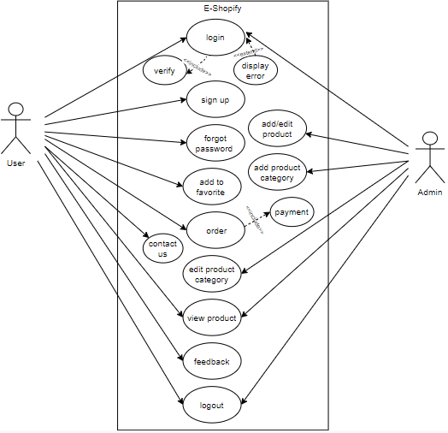

## Fully Dressed Use Cases

**Use case: 3.2.1.**

|  |
| --- |
| **Use case name:**  Sign up  **Scope:**  The Scope of registration is only Authorized person can access.  **Primary Actor:**  Admin and User/Customer  **Pre-Conditions:**  The Customer should have valid information to online register by providing his/her correct information and these criteria apply on all user’s.  **Main Scenario:**   * Firstly, the User Admin and Vendor has to login. * If they don’t register then it must be register before login. * After login the User get our services. * After successful registration the Actor providing a unique id.   **Success Scenario:**  The Admin and User/Customer will login successfully.  **Failure Scenario:**   * The actor has failed to login by providing wrong input * Failure may occur through server problem * Show the Error if the User cannot provide correct input. * If the there is no server problem or it is already register then it should be contact with the administrator. |

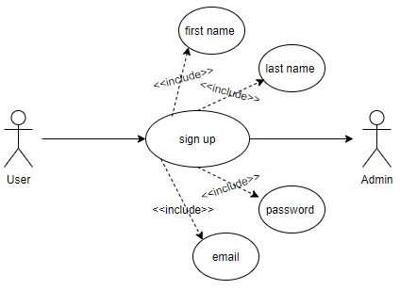

**Figure 3.2.1-SIGN UP**

**Use case: 3.2.2.**

|  |
| --- |
| **Use case name:**  Login  **Scope:**  The Scope of Login is only Authorized person can access the webpage.  **Primary Actor:**  Admin, Tailor and User/customer.  **Pre-Conditions:**  The Customer should have valid information to online register by providing his/her correct information.  **Main Scenario:**   * The user has email and password to login the website * If the user hasn’t email and want to check the rate, they can also do it.   **Success Scenario:**  The Customer will login successfully.  **Failure Scenario:**   * The user input wrong email but correct password * The user has wrong password but wrong email * The user has failed to login by providing wrong input * Failure may occur through server problem * Show the Error if the User cannot provide correct input. * If the there is no server problem or it is already register then it should be contact with the administrator |

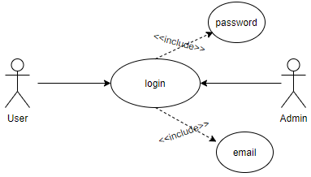

**Figure 3.2.2-LOGIN**

**Use case: 3.2.3.**

|  |
| --- |
| **Use case name:**  Forgot Password.  **Scope:**  The Scope of Forgot Password only Authorized person can only access or recover his/her account through email.  **Primary Actor:**  User/Customer.  **Pre-Conditions:**  The Customer should have valid email to online recovery of password correct information will allow to access account again otherwise not able to access it.  **Main Scenario:**   * Firstly, the User enter valid email. * If they don’t valid email then it then it will not able to recover. * After enter valid email received a password recovery link on that email. * Open his/her email open the link that is provided for password recovery able to recover password then enter the new password. * After entering new password user will able to login again with his new password successfully.   **Success Scenario:**  The Customer will recover his/her password successfully.  **Failure Scenario:**   * The user has failed to forget email service by providing wrong input * Failure may occur through server problem * Show the Error if the User cannot provide correct email. |

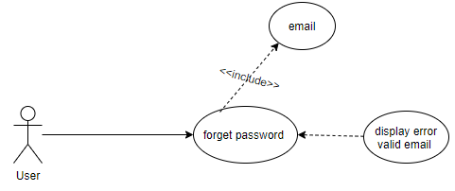

**Figure 3.2.3-FORGOT PASSWORD**

**Use case: 3.2.4.**

|  |
| --- |
| **Use case name:**  Logout  **Scope:**  The Scope of Logout is only for security that Authorized person can only access the account.  **Primary Actor:**  Admin and User/customer  **Pre-Conditions:**  The Customer should have valid information to online register by providing his/her correct information and user must have an account in the system to logout.  **Main Scenario:**   * The user has email and password to login the app. * User simply logout by just clicking on logout service.   **Success Scenario:**  The user will logout successfully.  **Failure Scenario:**   * Failure may occur through server problem * Failure may be sometime poor internet connectivity. |

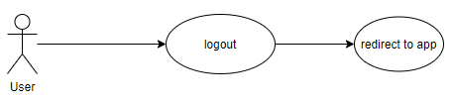

**Figure 3.2.4-LOGOUT**

**Use case: 3.2.5.**

|  |
| --- |
| **Use case name:**  Product Update  **Scope:**  The Scope of Logout is only for security that Authorized person can only access the account.  **Primary Actor:**  Admin  **Pre-Conditions:**  The Admin must have an account in the system and to update, delete or add a product.  **Main Scenario:**   * The admin has access to add the product. * The admin has access to edit the product. * The admin has access to delete the product.   **Success scenario:**  For the admin use this function and will Add, update or may be delete a product.  **Failure Scenario:**   * Failure may occur through server problem * Failure may be sometime poor internet connectivity. |

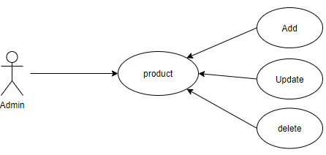

**Figure: 3.2.3-PRODUCT UPDATE**

**Use case: 3.2.6.**

|  |
| --- |
| **Use case name:**  Product Category Update  **Scope:**  The Scope of Logout is only for security that Authorized person can only access the account.  **Primary Actor:**  Admin  **Pre-Conditions:**  The Admin must have an account in the system and to update, delete or add a product.  **Main Scenario:**   * The admin has access to add the product category. * The admin has access to edit the product category. * The admin has access to delete the product category.   **Success scenario:**  Admin use this function and will Add, update or may be delete a product category.  **Failure Scenario:**   * Failure may occur through server problem |

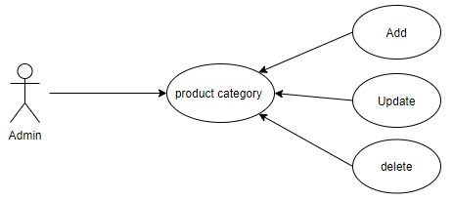

**Figure 3.2.6-UPDATE PRODUCT CATEGORY**

**Use case: 3.2.7.**

|  |
| --- |
| **Use case name:**  Contact Us  **Scope:**  The Scope of Contact is only to help.  **Primary Actor:**  User/Customer  **Pre-Conditions:**  The Customer should have to login first and can contact us by using this service.  **Main Scenario:**   * Firstly, the User has to login. * If they don’t register then it must be register before login. * After login the User get our services. * After successful registration the User/Customer can contact us.   **Success Scenario:**  The User/Customer will be contact us successfully.  **Failure Scenario:**   * The actor has failed to login by providing wrong input * Failure may occur through server problem * Show the Error if the User cannot provide correct input. |

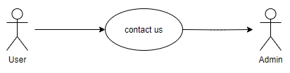

**Figure 3.2.7-CONTACT US**

**Use case: 3.2.8.**

|  |
| --- |
| **Use case name:**  Add to Favorite products.  **Scope:**  The Scope of Add to Favorite the product is to help out save products that he/she mostly like in a new favorite list.  **Primary Actor:**  User/Customer  **Pre-Conditions:**  The Customer should have to login first and can able to use this service.  **Main Scenario:**   * Firstly, the User has to login. * If they don’t register then it must be register before login. * After successful registration the User/Customer can add the products in favorite.   **Success Scenario:**  The User/Customer will be able to add products into favorite list successfully.  **Failure Scenario:**   * The actor has failed to login by providing wrong input * Failure may occur through server problem * Show the Error if the User cannot provide correct input. |

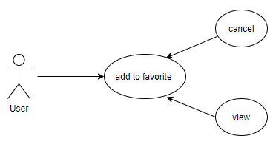

**Figure 3.2.7-ADD TO FAVORITE**

**Use case:3.2.9.**

|  |
| --- |
| **Use case name:**  Order  **Scope:**  The Scope of order is to provide better products to our User/Customer.  **Primary Actor:**  User/Customer  **Pre-Conditions:**  The Customer should have to login first and can able to use this service.  **Main Scenario:**   * Firstly, the User has to login. * If they don’t register then it must be register before login. * After login the User get our services. * After successful registration User will be able to get our service.   **Success Scenario:**  The User/Customer will be able to order products successfully.  **Failure Scenario:**   * The actor has failed to login by providing wrong input * Failure may occur through server problem * Show the Error if the User cannot provide correct input. |

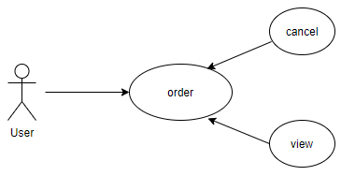

**Figure 3.2.9-ORDER**

**Use case: 3.2.10.**

|  |
| --- |
| **Use case name:**  Feedback  **Scope:**  The Scope of feedback is only to increase the usability and maintainability of the system.  **Primary Actor:**  User/Customer  **Pre-Conditions:**  The Customer should have to login first and can give feedback by using this service.  **Main Scenario:**   * Firstly, the User has to login. * If they don’t register then it must be register before login. * After login the User get our services. * After successful registration the User/Customer can give feedback.   **Success Scenario:**  The User/Customer will give feedback successfully.  **Failure Scenario:**   * The actor has failed to login by providing wrong input * Failure may occur through server problem * Show the Error if the User cannot provide correct input. |

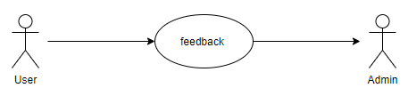

**Figure 3.2.10-FEEDBACK**