**SUPERIOR UNIVERSITY LAHORE**

|  |
| --- |
| Superior Logo |

**Faculty of Computer Science & IT**

**Final Year Project**

**PROJECT REPORT**

**[****Pet’s App]**

Project ID: **FYP-BCSM-S20-**

**Project Team**

|  |  |  |  |  |
| --- | --- | --- | --- | --- |
| **Student Name** | **Student ID** | **Program** | **Contact Number** | **Email Address** |
| Hafiza Kainat khalid | BCSM-S17-046 | BCS | 03054438203 | BCSM-S17-046@superior.edu.pk |
| Aqsa Mumtaz | BCSM-F16-198 | BCS | 03174974492 | BCSM-F16-198@superior.edu.pk |
|  |  |  |  |  |

**Prof.Zaman Aziz**

**Project Report**

**Pet’s App**

**Change Record**

|  |  |  |  |  |
| --- | --- | --- | --- | --- |
| **Author(s)** | **Version** | **Date** | **Notes** | **Supervisor’s Signature** |
|  | 1.0 |  | <Original Draft> |  |
|  |  |  | <Changes Based on Feedback from Supervisor> |  |
|  |  |  | <Changes Based on Feedback From Faculty> |  |
|  |  |  | <Added Project Plan> |  |
|  |  |  | <Changes Based on Feedback from Supervisor> |  |
|  |  |  |  |  |
|  |  |  |  |  |
|  |  |  |  |  |
|  |  |  |  |  |
|  |  |  |  |  |

**APPROVAL**

|  |  |
| --- | --- |
| **Project Supervisor** | |
| Comments: ___________________________________________________________________ | | |
| _____________________________________________________________________________ | | |
| Name:______________________________ |  | |
| Date:_______________________________ | Signature:__________________________ | |

|  |  |
| --- | --- |
| **Project Manager** | |
| Comments: ___________________________________________________________________ | |
| _____________________________________________________________________________ | |
|  |  |
| Date:_______________________________ | Signature:__________________________ |

|  |  |
| --- | --- |
| **Head of the Department** | |
| Comments: ___________________________________________________________________ | |
| _____________________________________________________________________________ | |
|  |  |
| Date:_______________________________ | Signature:__________________________ |

# Dedication

*This work is dedicated to our parents who support us to do such a great thing. And as well as our supervisor DR SHEHERYAR MALIK to help or train us to complete this work. We thankful to our parents and supervisor to help us.*

*.*

# 

# 

# Acknowledgements

I am really thankful to my supervisor who has . . . . . . . . . .

# Executive Summary

This app manages all of your pets’ details from one simple app. We are going to develop app at which we will facilitate the Pet owners to make appointment and provide collaborating environment between vet and Pet owners (chat) and house call, funerary services, disaster triage and pet’s owner create own and pet profile, medications and allergies, weight history, height history and more and pet’s owner and vet create profiles or login with face-book or google Account or scan QR code for login. The variety of customizable features make this a convenient and easy-to-use app. you can also chat with the vet tell and ask about your pet and working alongside with map vet tracking system, the map makes it easy to track where vet is if he or she near the house. Use the app view your pet’s activity levels in veterinary hospital know about your pet’s health. Pet app could save your animal’s life. This pet first aid app can help you figure out what’s wrong with your pet before rushing to the animal hospital. It also provides the information about your pet’s behavior mild, or do you need to rush him to the vet now? This app aims to solve these issues. You’ll even get access to resources like articles and videos that teach you how to care foryour pet in certain situations, such as when choking. You can also record your pet’s medical information so you have it on-hand when you go to the vet. Have you ever wondered what types of plants in and around your home are toxic to your pets? Or maybe you’ve wondered what you can feed them without them getting sick. Now you don’t have to worry so much. With the pet app, you’ll receive information of over 100 items toxic to cats and dogs. This helps you decide what flowers to plant, if it’s okay to share your leftovers, and if you should contact the vet when your pet eat some-thing you’re unsure off. The Pet app is managing everything pet related. Among its extensive list of tools, you can create profiles for any type of pet and enter birth dates, feeding and walking schedules, and vet appointments. When you hire a pet sitter, simply share your pet’s profile via email. You can also use the app to search for nearby vet clinics.

# Table of Contents

Dedication 4

Acknowledgements 5

Executive Summary 6

Table of Contents 7

List of Figures 10

List of Tables 11

Chapter 2 20

Software Requirement Specifications 20

2.1. Introduction 21

2.1.1. Purpose 21

2.1.2. Document Conventions 21

2.1.3. Intended Audience and Reading Suggestions 22

2.1.4. Product Scope 22

2.1.5. References 24

2.2. Overall Description 24

2.2.1. Product Perspective 24

2.2.2. Product Functions 25

2.2.3. User Classes and Characteristics 26

2.2.4. Operating Environment 26

Design and Implementation Constraints 27

2.2.5. User Documentation 27

2.2.6. Assumptions and Dependencies 27

2.3. External Interface Requirements 27

2.3.1. User Interfaces 27

Login and sign up page 28

2.3.2. Hardware Interfaces 29

2.3.3. Software Interfaces 29

2.3.4. Communications Interfaces 30

2.4. System Features 30

2.4.1. System Feature 1 31

2.4.1.1. Description and Priority 31

2.4.1.2. Stimulus/Response Sequences 31

2.4.1.3. Functional Requirements 31

1.1.1. Order Special Items 31

2.4.1.4. Description and Priority 32

2.4.1.5. Stimulus/Response Sequences 32

2.4.1.6. Functional Requirements 32

2.5. Other Nonfunctional Requirements 32

2.5.1. Performance Requirements 32

2.5.2. Safety Requirements 33

2.5.3. Security Requirements 33

2.5.4. Software Quality Attributes 33

3.1.1. Business Rules 34

3.2. Other Requirements 34

Chapter 3 35

Use Case Analysis 35

3.1. Use Case Model 36

3.2. Use Case Descriptions………………………………………………………………………………………….. ……..37

# 

# Chapter 2

# Software Requirement Specifications

**Chapter 2:** Software Requirement Specifications



## Introduction

## Purpose

This document presents the detailed explanation of the objective, feature, vet interface and pet owner’s interface and applications of Pet’s App in real life. It also describes how the system performs and under which condition it must operate. In this document there will be listed all the features and functions of the software and its requirements.

## Document Conventions

Table 3 Document Conventions

|  |  |
| --- | --- |
| **SHORT FORM** | **FULL FORM** |
| ERD | Entity relationship diagram |
| DB | Database |
| SRS | Software requirement specification |
| UML | Unified Modeling Language |
| DFD | Data flow diagram |
| WBS | Work breakdown structure |
| IDE | Integrated development environment |
| GUI | Graphical user interface |
| HTTP | Hypertext transfer protocol |
| FTP | File transfer Protocol |
| WAN | Wide Area network |
| LAN | Local area network |

## 

## Intended Audience and Reading Suggestions

It is restricted within the university premises. This has been implemented under the guidance of university professors. This project is useful for pet parents and as well as vet or vet clinic.

Reading suggestions are to start reading from the top till bottom and read that portion again if can’t understand what it means.

## Product Scope

This app manages all of your pets’ details from one simple app. With Phone, you can create profiles for multiple pets detailing their vet appointments, medications and allergies, weight history, height history and more and pet’s owner and vetcreateprofiles or login with face-book or google Account or scan QR code for login. The variety of customizable features make this a convenient and easy-to-use app. you can also chat with the vet tell and ask about your pet. It working alongside with map vet tracking system, the map makes it easy to track where vet is if he or she near the house.

## References

* <https://krazytech.com/projects> we used this website to get help related to SRS.

## Overall Description

## Product Perspective

This app will be a replacement of all the existing solution that is currently providing solutions for the pet’s health problems. This solution is emphasizing on all the draw backs of the solution that occurs in different homes and vet clinics. These solutions are mostly un-customizable and mostly expensive and lack future support whether our solution will be more customizable, will be free of cost and will support future possibilities. By using our system, we can make online Appointment, tell and ask about pet’s health via chat, watch videos and read blogs for pet’s happiness and health and tracking vet easily.

## Product Functions

The whole functions will perform through this order:

* Log in: This function authenticates the pet parent.
* Vet tracking: this function will display nearest vet clinic of house.
* Make appointment: this function will display vet available time.
* Create pet profile: this function gave the fields to write pet name, age, specie, breed.
* chat: tell and ask about pet health.
* Disaster triage: This feature will allow to house call and funerary services.
* Plants information: This function display required or concerned plant details forpet health uploaded from botanist.
* Blogs and videos: This function show blogs and videos for pet health and happiness uploaded by bloggers.

## User Classes and Characteristics

Table 4 User Classes and Characteristics

|  |  |  |  |
| --- | --- | --- | --- |
| **Classes** | **Functionality Privilege** | **Technical/Non-Technical** | |
| Pet Owner’s | Create profile, edit profile, chat  And upload status, View homepage, view videos, view blogs, Make-appointment, cancel appointment and create pet profile. | Technical | |
| Blogger | Create profile, edit profile, chat  And upload status, View homepage | Technical | |
| Botanist | Create profile, edit profile, chat  And upload status, View homepage | Technical | |
| Vet | Create profile, edit profile, chat, confirm Appointment,view homepage,And upload status | Technical |

## Operating Environment

* For Database (Use for Record like add profile, delete profile, update profile) We Will Use Tool: SQLite.
* In the development of this app we are following Spiral Model.
* For front end and back end coding including user interface (server side, user side) and database connectivity with front end interfaces we used Android studio and java JDK.
* We used windows 7, 8, 8.1, 10 as operating systems.
* We used firebase to setup local servers.
* For this project, we used XML and Java as programming languages.
* Used Google chrome as web browser.

## Design and Implementation Constraints

* We should follow the IEEE standards.
* Default language will be English.
* Project will follow all the copyright and cyber lines of PTA (Pakistan Telecommunication Authority).

## User Documentation

It will provide specific guidelines to a pet parents for using the Pet’s app. Further video (slide show) will be provided which will represent the whole system functions and how it works.

## Assumptions and Dependencies

Pet’s app is a self-contained project, the only explicit dependencies are those stated in the Design and Implementation Constraints.

## External Interface Requirements

## 

## User Interfaces

## User interface is a key component of any system. User interface must be made easy to understand and use. User interfaces are simple and to the point, any irrelevant information is hidden from that interface. For that we use some standards to provide our users the best interface experience possible.

## Hardware Interfaces

The server is directly connected to the client system also the client has to access the database for accessing the account details and storing the log in time.

The client access to the database in the server is read only.

* Hardware requirements for Insurance on internet will be same for both the parties which are follows:
* Processor: Any
* RAM: - 2 GB or above.
* HD: - 20 GB or above.
* Only the recommended configuration (basic requirements of a computer system) no other specific hardware is required to run the software.

Our System will work through internet connectivity. We will use all those hardware devices and configuration that will use to connect with internet. We need the modems, wires, WAN, LAN networks and Ethernet Cross cables etc.

## Software Interfaces

The system will run on SQL server so it requires any scripting language like Java, XML etc. The systems require Data Base also for the store the data of the system like SQLite. User need web browser for interact with the system. Operating system must be with GUI supportability like windows (XP and higher versions), Linux, Macintosh (leopard or OSX version or higher), android OS (jellybean or higher). To access database required SQLite. Android studio.

## Communications Interfaces

Communication function required the internet protocol version 6 and it will follow HTTPS. It will use FTP for whole system with local server.

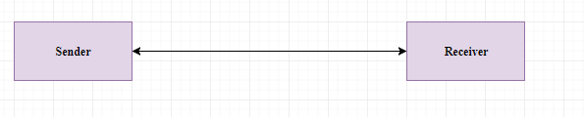

## System Features

* Log in: This function authenticates the pet’s owner.
* Vet tracking: this function will display nearest vet clinic of house.
* Make appointment: this function will display vet available time.
* Create pet profile: this function gave the fields to write pet name, age, specie, breed.
* chat: tell and ask about pet health.
* Disaster triage: This feature will allow to house call and funerary services.
* Plants information: This function display required or concerned plant details for pet uploaded from botanist.
* Blogs and videos: This function show blogs and videos for pet health and happiness uploaded by bloggers.

## System Feature 1

This feature is one of the main features listed. This will provide users to get themselves a rescue disaster and make appointment and then can order medicines.

## Vet

## Description and Priority

**User Action:** User must click on the app.

**Response:** system will be started and show the signup page.

**User Action:** If user is already registered then he will click on the login buttonotherwise he/she will have registered by entering required information.

**Response:** System will first check whether the user already registered into the system or not. If theuser already registered in then the user will login with systemotherwise system will ask the user to

login into his google account or face book account and then it will show the home page after user logged in.

**User Action:** User can change his account settings and then click on save changing button **Response:** System will first validate the data according to system policy and then checkwhether the data has been taken by the existing user are not. If the data is valid and not already taken by the existing user then it will save changes that the user made.

**User Action:** User can accept the request and then click on confirm button.

**Response:** System will first validate the appointment and then save on the server and send the confirmation message to the user. If the data is already taken by the existing user then it will not save.

**User Action:** if user want to collaborate with each other and then he/she write message and click on send button.

**Response:** System will first validate the user and then send message to the user. If the user not existing then it will not send.

**User Action:** If user is already created profile then he/she will click on the edit buttonotherwise he/she will create his/her profile by entering required information.

**Response:** System will first check whether the user already create profile into the system or not. If theuser already created then the user will edit his/her profile otherwise system will ask the user to

Create profile and then it will able to use all features of app.

**User Action:** If user is already created pet history then he/she will click on the edit buttonotherwise he/she will create pet history by entering required information.

**Response:** System will first check whether the user already create pet history into the system or not. If theuser already created then the user will edit pet history otherwise system will ask the user to

Create pet history.

## Functional Requirements

* REQ-SF1-1: Validating vet Registration
* REQ-SF1-2: Sign In
* REQ-SF1-3: confirm appointment
* REQ-SF1-4: chat
* REQ-SF1-5: create profile updateprofile
* REQ-SF1-6: Vet update history of pet

## Pet’s owner

## Description and Priority

**User Action:** User must click on the app.

**Response:** system will be started and show the signup page.

**User Action:** If user is already registered then he will click on the login buttonotherwise he/she will have registered by entering required information.

**Response:** System will first check whether the user already registered into the system or not. If theuser already registered in then the user will login with systemotherwise system will ask the user to

login into his google account or face book account and then it will show the home page after user logged in.

**User Action:** User can change his account settings and then click on save changing button **Response:** System will first validate the data according to system policy and then checkwhether the data has been taken by the existing user are not. If the data is valid and not already taken by the existing user then it will save changes that the user made.

**User Action:** User can make the appointment and then click on send button. And if user want to cancel appointment then click on the cancel button.

**Response:** System will first validate the appointment and then save on the server and send the message to the user. If the data is already taken by the existing user then it will not send. And if the appointment canceled by user in 15 min then system will not send the request to the required user otherwise it will send.

**User Action:** if user want to collaborate with each other and then he/she write message and click on send button.

**Response:** System will first validate the user and then send message to the user. If the user not existing then it will not send.

**User Action:** If user is already created profile then he/she will click on the edit buttonotherwise he/she will create his/her profile by entering required information.

**Response:** System will first check whether the user already create profile into the system or not. If theuser already created then the user will edit his/her profile otherwise system will ask the user to

Create profile and then it will able to use all features of app.

**User Action:** If user is already created pet profile then he/she will click on the edit buttonotherwise he/she will create pet profile by entering required information.

**Response:** System will first check whether the user already create pet profile into the system or not. If theuser already created then the user will edit pet profile otherwise system will ask the user to

Create pet profile.

## Functional Requirements

* REQ-SF5-1: Validating pet owner’s Registration
* REQ-SF5-2: Sign In
* REQ-SF5-3: Make appointment, cancel appointment
* REQ-SF5-4: chat
* REQ-SF5-5: create profile update profile
* REQ-SF5-6: Create pet profile, update profile

## Blogger

## Description and Priority

**User Action:** User must click on the app.

**Response:** system will be started and show the signup page.

**User Action:** If user is already registered then he will click on the login buttonotherwise he/she will have registered by entering required information.

**Response:** System will first check whether the user already registered into the system or not. If theuser already registered in then the user will login with systemotherwise system will ask the user to

login into his google account or face book account and then it will show the home page after user logged in.

**User Action:** User can change his account settings and then click on save changing button **Response:** System will first validate the data according to system policy and then checkwhether the data has been taken by the existing user are not. If the data is valid and not already taken by the existing user then it will save changes that the user made.

**User Action:** If user is already created profile then he/she will click on the edit buttonotherwise he/she will create his/her profile by entering required information.

**Response:** System will first check whether the user already create profile into the system or not. If theuser already created then the user will edit his/her profile otherwise system will ask the user to

Create profile and then it will able to use all features of app.

**User Action:** If user is already uploaded video then he/she will click on the delete buttonotherwise he/she will be upload video.

**Response:** System will first check whether the user already upload video into the system or not. If theuser already uploaded video then the user will delete video otherwise not.

## Functional Requirements

* REQ-SF6-1: Validating blogger Registration
* REQ-SF6-2: Sign In
* REQ-SF6-3: upload videos, delete videos
* REQ-SF6-4: View home page
* REQ-SF6-5: create profile update profile

## Botanist

## Description and Priority

**User Action:** User must click on the app.

**Response:** system will be started and show the signup page.

**User Action:** If user is already registered then he will click on the login buttonotherwise he/she will have registered by entering required information.

**Response:** System will first check whether the user already registered into the system or not. If theuser already registered in then the user will login with systemotherwise system will ask the user to

login into his google account or face book account and then it will show the home page after user logged in.

**User Action:** User can change his account settings and then click on save changing button **Response:** System will first validate the data according to system policy and then checkwhether the data has been taken by the existing user are not. If the data is valid and not already taken by the existing user then it will save changes that the user made.

**User Action:** If user is already created profile then he/she will click on the edit buttonotherwise he/she will create his/her profile by entering required information.

**Response:** System will first check whether the user already create profile into the system or not. If theuser already created then the user will edit his/her profile otherwise system will ask the user to

Create profile and then it will able to use all features of app.

**User Action:** If user is already uploaded images and description then he/she will click on the delete buttonotherwise he/she will be upload images and description.

**Response:** System will first check whether the user already upload images and description into the system or not. If theuser already uploaded images and description then the user will delete images and description otherwise not

## Functional Requirements

* REQ-SF7-1: Validating botanist Registration
* REQ-SF7-2: Sign In
* REQ-SF7-3: upload images, delete images
* REQ-SF7-4: View home page
* REQ-SF7-5: create profile update profile

## Other Nonfunctional Requirements

## Performance Requirements

* The product will be based on SQLite.
* The product will take the initial load time.
* App information will be fully secure through POS system.
* Faster Searching algorithms will be used to make searches appear faster.

## Safety Requirements

* The source code developed for the system shall be maintained in the Android studio.
* The whole system secured only vet or pet’sowner can access the all data.
* The system will use HTTPS because it is more secure.
* The system uses POS system.

## Security Requirements

The security feature from having a log in for all pet’sowner personal information. The log in detailed will be used in the app also. That situation the chances of app getting slow down.

## Software Quality Attributes

Correctness and reliability are the major quality attributes of this product. Correct fetching of data is high priority as everything is depending on it. Our product needs to be a reliable source as it is being used to manage a large amount of people. Even one error can play a huge role in the downfall of this project. Robustness and maintainability are also some attributes which would be kept in mind while preparing and installing this project as it has to use on daily basis.

## Business Rules

**Pet’s owner:**

APet’s owner can create profile, edit profile, chat, upload status, View homepage, view videos, view blogs, make appointment, cancel appointment and create pet profile.

**Vet:**

Vet can create profile, edit profile, chat, confirm appointment,view homepage,and upload status.

**Blogger:**

Blogger can create profile, edit profile, upload blogs and videos, View homepage.

**Botanist:**

Botanist can create profile, edit profile, upload images, View homepage.

## Other Requirements

1. Database which we will be using to save and record the data of the student should be reliable and big enough to store all the data and keep the record saved for a specified period of time.

# 

# Chapter 3

# Use Case Analysis

**Chapter 3:** System Analysis

Creating use cases to describing the whole scenario how it is going to work. Describing actors & their purposes. How users will Log In, create accounts make purchases. And users can edit order within specific time limit.

## Use Case Model

Figure 3 Use Case Model

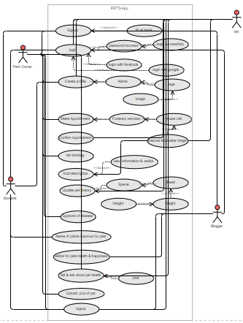

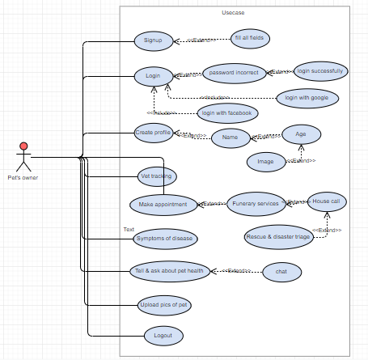

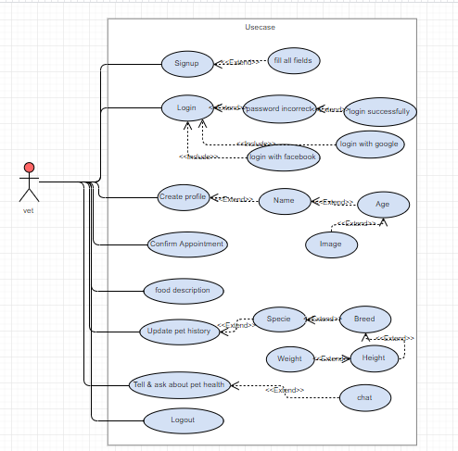

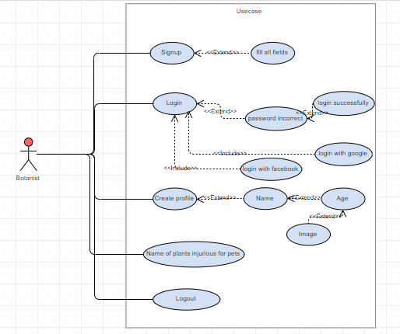

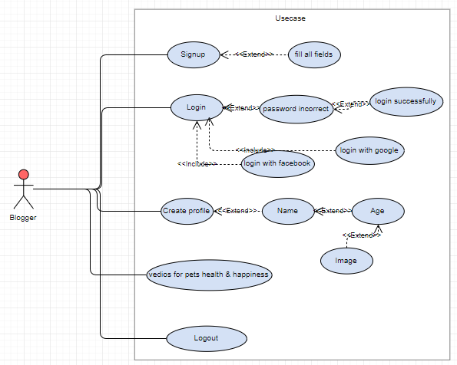

## Fully Dressed Use Cases

|  |  |
| --- | --- |
| **Use case name**  **Use case id** | Signup  UC-01 |
| **Actors**  **Trigger events** | Vet, Pet’s owner, Botanist and Blogger  Vet, Pet’s owner, Botanist and Bloggerwill login successfully. |
| **Description** | The use case describes how the Vet, Pet’s owner, Botanist, Blogger Signup with app. |
| **Steps Performed (Main Path):** | 1. System requires Actor to enter required data. 2. Actor enters required data. 3. Actors will Insert/Update the signup information. 4. The use case ends successfully. |
| **Precondition** | Requiredsignup with app or login with face book or google account. |
| **Post condition** | Actor’s login successfully. |

|  |  |
| --- | --- |
| **Use-case name**  **Use case id** | Login  UC-02 |
| **Actors**  **Trigger**  **events** | Vet, Pet’s owner, Botanist, Blogger  Vet, Pet’s owner, Botanist and Bloggerwill view the home page. |
| **Description** | This use case describes the Vet, Pet’s owner, Botanist, Blogger for not must sign up to the app it will login with google account or face book account. |
| **Steps Performed (Main Path):** | 1. System requires Actor to enter required data. 2. Actor enters required data. 3. Actors will Insert/Update the login data. 4. The use case ends successfully. |
| **Precondition** | Need login with system or login with google account or face book account. |
| **Postcondition** | Actors view the home page. |

|  |  |
| --- | --- |
| **Use case name**  **Use case id** | Chat  UC-03 |
| **Actors**  **Trigger**  **events** | Vet, Pet’s owner  Vet and pet’s owner will chat with each other. |
| **Description** | This use case describes the vet and pet’s owner chat with each other to tell and ask about pet’s health. |
| **Steps Performed (Main Path):** | 1. System requires user profile to collaborate with each other. 2. Vet and pet’s owner can tell and ask about pet’s health. 3. The use case ends successfully. |
| **Pre**  **condition** | Need create profile for chat |
| **Post condition** | Vet and pet’s owner can tell and ask about pet’s health |

|  |  |
| --- | --- |
| **Use case name**  **Use case id** | Videos and images upload  UC-04 |
| **Actors**  **Triggering events:** | Vet, Pet’s owner, Botanist and Blogger  The botanist will upload plants name, images of plants injurious for pets and blogger will upload videos,vet and pet’s owner will upload status. |
| **Description** | This use case describes the botanist upload data for pet’s health and safety and plants name, images of plants injurious for pets and blogger upload videos for pet happiness,vet and pet’s owner upload status to share daily activity of pet with eachother. |
| **Steps Performed (Main Path):** | 1. System requires profile to upload videos and images. 2. User can select videos and images in his system gallery. 3. Videos and images uploaded successfully. 4. The use case ends successfully. |
| **Precondition** | System need to create profile for upload videos and images. |
| **Post condition** | After create the profile botanist upload plants name, images of plants injurious for pets and blogger upload videos,vet and pet’s owner upload status. |

|  |  |
| --- | --- |
| **Use-case name**  **Use case id** | Make Appointment  UC-05 |
| **Actor** | Pet’s owner |
| **Triggering events** | Pet’s owner will make appointment for house call checkup of pet in vet clinic. |
| **Description** | This use case describes the pet’s owner make appointment for House call, Funerary services and rescue triage disaster. |
| **Steps Performed (Main Path):** | 1. System requires user profile. 2. Pet’s owner can make appointment for house call checkup in vet clinic. 3. The use case ends successfully. |
| **Precondition** | System need login and create profile. |
| **Post condition** | After create the profilePet’s owner make appointment. |

|  |  |
| --- | --- |
| **Use case name**  **Use case id** | View home page  UC-06 |
| **Actors**  **Triggering events:** | Vet, Pet’s owner, Botanist and Blogger.  After login the Vet, Pet’s owner, Botanist and Blogger will view the home page. |
| **Description** | This use case describes the Vet, Pet’s owner, Botanist and Blogger can view the home page. |
| **Steps Performed (Main Path):** | 1. System requires login with system. 2. Vet, Pet’s owner, Botanist and Blogger can view the home page. 3. The use case ends successfully. |
| **Precondition**  **Post condition** | System required to user login with system.  After login the Vet, Pet’s owner, Botanist and Blogger can view the home page. |

|  |  |
| --- | --- |
| **Use case name**  **Use case id** | Edit Profile  UC-07 |
| **Actors** | Vet, Pet’s owner, Botanist and Blogger |
| **Triggering events** | Vet, Pet’s owner, Botanist and Blogger will edit the profile. |
| **Description** | This use case describes the Vet, Pet’s owner, Botanist and Blogger can edit his own profile. |
| **Steps Performed (Main Path)** | 1. System requires to create profile. 2. User can edit his own profile. 3. The use case ends successfully. |
| **Precondition** | System required to user create profile. |
| **Post condition** | Vet, Pet’s owner, Botanist and Blogger can edit the profile. |

|  |  |
| --- | --- |
| **Use case name**  **Use case id** | Order Medicine  UC-08 |
| **Actor name** | Pet’s owner |
| **Triggering events** | Pet’s owner will order medicines for pet. |
| **Description** | This use case describes the pet’s owner can order medicines. |
| **Steps Performed (Main Path):** | 1. System requires user profile. 2. Pet’s owner will order medicines for pet. 3. The use case ends successfully |
| **Precondition** | System requires user profile and then view all medicines. |
| **Post condition** | Pet’s owner can order medicines for pet. |

|  |  |
| --- | --- |
| **Use case name**  **Use case id** | Edit pet profile  UC-09 |
| **Actors** | Pet’s owner |
| **Triggering events** | Pet’s owner will edit the pet profile. |
| **Description** | This use case describes the Pet’s owner can edit his pet profile. |
| **Steps Performed (Main Path)** | 1. System requires to create pet profile. 2. User can edit his pet profile. 3. The use case ends successfully. |
| **Precondition** | System required to user create pet profile. |
| **Post condition** | Pet’s owner can edit his pet profile. |

|  |  |
| --- | --- |
| **Use case name**  **Use case id** | Edit pet history  UC-10 |
| **Actor** | Vet |
| **Triggering events** | Vet will edit the pet history. |
| **Description** | This use case describes the Vet can edit pet history. |
| **Steps Performed (Main Path)** | 1. System requires to create pet history. 2. User can edit pet history. 3. The use case ends successfully. |
| **Precondition** | System required to vet create pet history. |
| **Post condition** | Vet can edit the pet history. |