**THE SUPERIOR COLLEGE LAHORE**

|  |
| --- |
| chk_captcha |

**Faculty of Computer Science & IT**

**Department of Software Engineering**

**Final Year Project**

**PROJECT REPORT (Part-1)**

**FAMILY MEDICAL HISTORY ONLINE PORTAL**

Project ID: **[write ID here Issued by FYP Manager]**

**Project Team**

|  |  |  |  |  |
| --- | --- | --- | --- | --- |
| **Student Name** | **Student ID** | **Program** | **Contact Number** | **Email Address** |
| M.Adnan Ashraf | BCSM-S17-052 | BSCS | 03039097902 | Adnanali7902@gmail.com |
| Umar Arshad | BCSM-S17-080 | BSCS | 03437857230 | Umerraza.superior@gmail.com |
| Ghulam Nabi | BCSM-S17-059 | BSCS | 03487805660 | nabi9850@gmail.com |
|  |  |  |  |  |
|  |  |  |  |  |

**Sir Fawad Naseem**

**Project Report**

**Family Madical History Online Portal**

**Change Record**

|  |  |  |  |  |
| --- | --- | --- | --- | --- |
| **Author(s)** | **Version** | **Date** | **Notes** | **Supervisor’s Signature** |
|  | 1.0 |  | <Original Draft> |  |
|  |  |  | <Changes Based on Feedback from Supervisor> |  |
|  |  |  | <Changes Based on Feedback From Faculty> |  |
|  |  |  | <Added Project Plan> |  |
|  |  |  | <Changes Based on Feedback from Supervisor> |  |
|  |  |  |  |  |
|  |  |  |  |  |
|  |  |  |  |  |
|  |  |  |  |  |
|  |  |  |  |  |

**APPROVAL**

|  |  |
| --- | --- |
| **Project Supervisor** | |
| Comments: \_\_\_\_\_\_\_\_\_\_\_\_\_\_\_\_\_\_\_\_\_\_\_\_\_\_\_\_\_\_\_\_\_\_\_\_\_\_\_\_\_\_\_\_\_\_\_\_\_\_\_\_\_\_\_\_\_\_\_\_\_\_\_\_\_\_\_ | | |
| \_\_\_\_\_\_\_\_\_\_\_\_\_\_\_\_\_\_\_\_\_\_\_\_\_\_\_\_\_\_\_\_\_\_\_\_\_\_\_\_\_\_\_\_\_\_\_\_\_\_\_\_\_\_\_\_\_\_\_\_\_\_\_\_\_\_\_\_\_\_\_\_\_\_\_\_\_ | | |
| Name:\_\_\_\_\_\_\_\_\_\_\_\_\_\_\_\_\_\_\_\_\_\_\_\_\_\_\_\_\_\_ |  | |
| Date:\_\_\_\_\_\_\_\_\_\_\_\_\_\_\_\_\_\_\_\_\_\_\_\_\_\_\_\_\_\_\_ | Signature:\_\_\_\_\_\_\_\_\_\_\_\_\_\_\_\_\_\_\_\_\_\_\_\_\_\_ | |

|  |  |
| --- | --- |
| **Project Manager** | |
| Comments: \_\_\_\_\_\_\_\_\_\_\_\_\_\_\_\_\_\_\_\_\_\_\_\_\_\_\_\_\_\_\_\_\_\_\_\_\_\_\_\_\_\_\_\_\_\_\_\_\_\_\_\_\_\_\_\_\_\_\_\_\_\_\_\_\_\_\_ | |
| \_\_\_\_\_\_\_\_\_\_\_\_\_\_\_\_\_\_\_\_\_\_\_\_\_\_\_\_\_\_\_\_\_\_\_\_\_\_\_\_\_\_\_\_\_\_\_\_\_\_\_\_\_\_\_\_\_\_\_\_\_\_\_\_\_\_\_\_\_\_\_\_\_\_\_\_\_ | |
|  |  |
| Date:\_\_\_\_\_\_\_\_\_\_\_\_\_\_\_\_\_\_\_\_\_\_\_\_\_\_\_\_\_\_\_ | Signature:\_\_\_\_\_\_\_\_\_\_\_\_\_\_\_\_\_\_\_\_\_\_\_\_\_\_ |

|  |  |
| --- | --- |
| **Head of the Department** | |
| Comments: \_\_\_\_\_\_\_\_\_\_\_\_\_\_\_\_\_\_\_\_\_\_\_\_\_\_\_\_\_\_\_\_\_\_\_\_\_\_\_\_\_\_\_\_\_\_\_\_\_\_\_\_\_\_\_\_\_\_\_\_\_\_\_\_\_\_\_ | |
| \_\_\_\_\_\_\_\_\_\_\_\_\_\_\_\_\_\_\_\_\_\_\_\_\_\_\_\_\_\_\_\_\_\_\_\_\_\_\_\_\_\_\_\_\_\_\_\_\_\_\_\_\_\_\_\_\_\_\_\_\_\_\_\_\_\_\_\_\_\_\_\_\_\_\_\_\_ | |
|  |  |
| Date:\_\_\_\_\_\_\_\_\_\_\_\_\_\_\_\_\_\_\_\_\_\_\_\_\_\_\_\_\_\_\_ | Signature:\_\_\_\_\_\_\_\_\_\_\_\_\_\_\_\_\_\_\_\_\_\_\_\_\_\_ |

# Dedication

*This work is dedicated to my . . . . . .*

# Executive Summary

This is web portal in which users are registered and enter their and own family medical history to track their fitness issues and medicinal drugs in exclusive durations. In this project we solve the major problems of every patients because we manage the whole record in his life. In every moment when he want to check up he will be able to see the previous record easily. The major things is that doctor can easily understand the patient disease with the help of this portal.

# Table of Contents

[Dedication iv](file:///C:\Users\M.Adnan%20Ashraf\Desktop\Iteration%201.docx#_Toc505638416)

[Acknowledgements v](file:///C:\Users\M.Adnan%20Ashraf\Desktop\Iteration%201.docx#_Toc505638417)

[Executive Summary vi](file:///C:\Users\M.Adnan%20Ashraf\Desktop\Iteration%201.docx#_Toc505638418)

[Table of Contents vii](file:///C:\Users\M.Adnan%20Ashraf\Desktop\Iteration%201.docx#_Toc505638419)

[List of Figures ix](file:///C:\Users\M.Adnan%20Ashraf\Desktop\Iteration%201.docx#_Toc505638420)

[List of Tables x](file:///C:\Users\M.Adnan%20Ashraf\Desktop\Iteration%201.docx#_Toc505638421)

[Chapter 1 1](file:///C:\Users\M.Adnan%20Ashraf\Desktop\Iteration%201.docx#_Toc505638422)

[Introduction 1](file:///C:\Users\M.Adnan%20Ashraf\Desktop\Iteration%201.docx#_Toc505638423)

[1.1. Background 2](file:///C:\Users\M.Adnan%20Ashraf\Desktop\Iteration%201.docx#_Toc505638424)

[1.2. Motivations and Challenges 2](file:///C:\Users\M.Adnan%20Ashraf\Desktop\Iteration%201.docx#_Toc505638425)

[1.3. Goals and Objectives 2](file:///C:\Users\M.Adnan%20Ashraf\Desktop\Iteration%201.docx#_Toc505638426)

[1.4. Literature Review/Existing Solutions 2](file:///C:\Users\M.Adnan%20Ashraf\Desktop\Iteration%201.docx#_Toc505638427)

[1.5. Gap Analysis 2](file:///C:\Users\M.Adnan%20Ashraf\Desktop\Iteration%201.docx#_Toc505638428)

[1.6. Proposed Solution 2](file:///C:\Users\M.Adnan%20Ashraf\Desktop\Iteration%201.docx#_Toc505638429)

[1.7. Project Plan 3](file:///C:\Users\M.Adnan%20Ashraf\Desktop\Iteration%201.docx#_Toc505638430)

[1.7.1. Work Breakdown Structure 3](file:///C:\Users\M.Adnan%20Ashraf\Desktop\Iteration%201.docx#_Toc505638431)

[1.7.2. Roles & Responsibility Matrix 3](file:///C:\Users\M.Adnan%20Ashraf\Desktop\Iteration%201.docx#_Toc505638432)

[1.7.3. Gantt Chart 3](file:///C:\Users\M.Adnan%20Ashraf\Desktop\Iteration%201.docx#_Toc505638433)

[1.8. Report Outline 3](file:///C:\Users\M.Adnan%20Ashraf\Desktop\Iteration%201.docx#_Toc505638434)

[Chapter 2 4](file:///C:\Users\M.Adnan%20Ashraf\Desktop\Iteration%201.docx#_Toc505638435)

[Software Requirement Specifications 4](file:///C:\Users\M.Adnan%20Ashraf\Desktop\Iteration%201.docx#_Toc505638436)

[2.1. Introduction 5](file:///C:\Users\M.Adnan%20Ashraf\Desktop\Iteration%201.docx#_Toc505638438)

[2.1.1. Purpose 5](file:///C:\Users\M.Adnan%20Ashraf\Desktop\Iteration%201.docx#_Toc505638439)

[2.1.2. Document Conventions 5](file:///C:\Users\M.Adnan%20Ashraf\Desktop\Iteration%201.docx#_Toc505638440)

[2.1.3. Intended Audience and Reading Suggestions 5](file:///C:\Users\M.Adnan%20Ashraf\Desktop\Iteration%201.docx#_Toc505638441)

[2.1.4. Product Scope 5](file:///C:\Users\M.Adnan%20Ashraf\Desktop\Iteration%201.docx#_Toc505638442)

[2.1.5. References 6](file:///C:\Users\M.Adnan%20Ashraf\Desktop\Iteration%201.docx#_Toc505638443)

[2.2. Overall Description 6](file:///C:\Users\M.Adnan%20Ashraf\Desktop\Iteration%201.docx#_Toc505638444)

[2.2.1. Product Perspective 6](file:///C:\Users\M.Adnan%20Ashraf\Desktop\Iteration%201.docx#_Toc505638445)

[2.2.2. Product Functions 6](file:///C:\Users\M.Adnan%20Ashraf\Desktop\Iteration%201.docx#_Toc505638446)

[2.2.3. User Classes and Characteristics 6](file:///C:\Users\M.Adnan%20Ashraf\Desktop\Iteration%201.docx#_Toc505638447)

[2.2.4. Operating Environment 7](file:///C:\Users\M.Adnan%20Ashraf\Desktop\Iteration%201.docx#_Toc505638448)

[2.2.5. Design and Implementation Constraints 7](file:///C:\Users\M.Adnan%20Ashraf\Desktop\Iteration%201.docx#_Toc505638449)

[2.2.6. User Documentation 7](file:///C:\Users\M.Adnan%20Ashraf\Desktop\Iteration%201.docx#_Toc505638450)

[2.2.7. Assumptions and Dependencies 7](file:///C:\Users\M.Adnan%20Ashraf\Desktop\Iteration%201.docx#_Toc505638451)

[2.3. External Interface Requirements 8](file:///C:\Users\M.Adnan%20Ashraf\Desktop\Iteration%201.docx#_Toc505638452)

[2.3.1. User Interfaces 8](file:///C:\Users\M.Adnan%20Ashraf\Desktop\Iteration%201.docx#_Toc505638453)

[2.3.2. Hardware Interfaces 8](file:///C:\Users\M.Adnan%20Ashraf\Desktop\Iteration%201.docx#_Toc505638454)

[2.3.3. Software Interfaces 8](file:///C:\Users\M.Adnan%20Ashraf\Desktop\Iteration%201.docx#_Toc505638455)

[2.3.4. Communications Interfaces 9](file:///C:\Users\M.Adnan%20Ashraf\Desktop\Iteration%201.docx#_Toc505638456)

[2.4. System Features 9](file:///C:\Users\M.Adnan%20Ashraf\Desktop\Iteration%201.docx#_Toc505638457)

[2.4.1. System Feature 1 9](file:///C:\Users\M.Adnan%20Ashraf\Desktop\Iteration%201.docx#_Toc505638458)

[2.4.1.1. Description and Priority 9](file:///C:\Users\M.Adnan%20Ashraf\Desktop\Iteration%201.docx#_Toc505638459)

[2.4.1.2. Stimulus/Response Sequences 9](file:///C:\Users\M.Adnan%20Ashraf\Desktop\Iteration%201.docx#_Toc505638460)

[2.4.1.3. Functional Requirements 9](file:///C:\Users\M.Adnan%20Ashraf\Desktop\Iteration%201.docx#_Toc505638461)

[2.4.2. System Feature 2 10](file:///C:\Users\M.Adnan%20Ashraf\Desktop\Iteration%201.docx#_Toc505638462)

[2.4.2.1. Description and Priority 10](file:///C:\Users\M.Adnan%20Ashraf\Desktop\Iteration%201.docx#_Toc505638463)

[2.4.2.2. Stimulus/Response Sequences 10](file:///C:\Users\M.Adnan%20Ashraf\Desktop\Iteration%201.docx#_Toc505638464)

[2.4.2.3. Functional Requirements 10](file:///C:\Users\M.Adnan%20Ashraf\Desktop\Iteration%201.docx#_Toc505638465)

[2.4.3. System Feature 3 (and so on) 11](file:///C:\Users\M.Adnan%20Ashraf\Desktop\Iteration%201.docx#_Toc505638466)

[2.5. Other Nonfunctional Requirements 11](file:///C:\Users\M.Adnan%20Ashraf\Desktop\Iteration%201.docx#_Toc505638467)

[2.5.1. Performance Requirements 11](file:///C:\Users\M.Adnan%20Ashraf\Desktop\Iteration%201.docx#_Toc505638468)

[2.5.2. Safety Requirements 11](file:///C:\Users\M.Adnan%20Ashraf\Desktop\Iteration%201.docx#_Toc505638469)

[2.5.3. Security Requirements 12](file:///C:\Users\M.Adnan%20Ashraf\Desktop\Iteration%201.docx#_Toc505638470)

[2.5.4. Software Quality Attributes 12](file:///C:\Users\M.Adnan%20Ashraf\Desktop\Iteration%201.docx#_Toc505638471)

[2.5.5. Business Rules 12](file:///C:\Users\M.Adnan%20Ashraf\Desktop\Iteration%201.docx#_Toc505638472)

[2.6. Other Requirements 12](file:///C:\Users\M.Adnan%20Ashraf\Desktop\Iteration%201.docx#_Toc505638473)

# Chapter 1

# Introduction

**Chapter 1:** Introduction

Family Medical portal are healthcare related to online application that is allow to patient to manage the whole record about his health , such as physicians and hospital. With the help of this application doctor can easily judge and see the previous record about his disease and easily recommend the treatment. This project solve the all kind of problem that patient face his record management. In this portal every family member can see about his family record like , ratio of diseases , physical record , family report etc. Family medical history project need to every family because this solve the all kind of problem that we face daily basis. After this project we will not lose the record and other family reports.

* 1. **Background**

The existence of many computerized systems and innovations through which we find information conveniently, justifies the old age saying “Necessity is the mother of all inventions”. The need to share information and man`s desire to communicate from long distances called for the birth of World Wide Web. With the advent of internet, many businesses that people conducted were made feasible. Family medical history are recognized as a promising mechanism to support patient engagement.

* 1. **Motivations and Challenges**

Manage the family medical history is not an easy task. To succeed in FMH should work on multiple channels and issues to overcome it.

Some of the problems related to software which exist in Family Medical History are:

* outdated user interface
* The software may not be fast and efficient enough to handle multiple operations

Family Medical history have some major features:

* User friendly interface
* Manageable accounts
* Patient medical reports
* Ratio of all diseases
* Doctor easily understand previous record
* Easily can update the record
* Use latest development technology
* Launch of user-friendly websites
  1. **Goals and Objectives**

Family medical history online portal is the most important project because in this project we will manage the whole record of any patient and family medical history which is help us in every moment like we check the family disease , physical fitness record , medical report , doctor treatment recommendations and family reports .

It will also be a time savior. Besides this, another main objective is to manage all the information regarding to the reservation. The main purpose is to reduce manual work.

Other common objectives fulfilled by online hostel reservation systems are:

* To provide a platform to manage on-desk and online Family record.
* To display organized information of family manage tables.
* To add multiple families.
* To update the family record
* View the family record to doctor and family members.
* Family information which can be accessed anytime.
* A user-friendly interface for new family record
* To provide a secure payment gateway for online transaction.
* To enable online booking via the internet.
* To enable automated data entry methods.
* Ensure efficient and reliable communication within this portal.
* Avoid data entry errors by use of input masks.
* Enable easy authorized modification of data.
* Enforce security measures to avoid unauthorized access to guest records.
* Enable fast and easy retrieval of guest records and data for fast referenceactivities.
  1. **Literature Review/Existing Solutions**

Family medical history online portal is the most important project because in this project we will manage the whole record of any patient and family medical history which is help us in every moment like we check the family disease , physical fitness record , medical report , doctor treatment recommendations and family reports .

It will also be a time savior. Besides this, another main objective is to manage all the information regarding to the reservation. The main purpose is to reduce manual work.

* 1. **Gap Analysis**

My problem tells that mostly patient faces some problem while manage the record so we provide a proper platform for them that will make booking and the staff have a proper procedure to manage every sort of things.

So, we make an easy way for family to manage their medical history like on our website and application. My website or app manage the whole record of family medical reports and other doctor recommendations. When they open our website, they set the record a and our website help the maintain the record.

* 1. **Proposed Solution**

Family Medical portal are healthcare related to online application that is allow to patient to manage the whole record about his health , such as physicians and hospital.

A patient is not depend that when he is fully healthful or not so it very important to manage the record, using various methods of keeping records. Historically, the records were saved manually but they were not reliable and efficient. Since the advance technology has taken place, all the manual work has been converted to computerized system. Present systems are not well organized and accurate. Sometimes, medical reports are being overlapped so the patient had to face in convenience. And the major issue is that what we see is not we are getting and this is because user cannot have access on medical reports. Another issue is the delay of information in collecting and processing of customer`s data.

* 1. **Project Plan**

Data gathering is the phase 1 . In the coming phases we will define the briefly project plan .Project plan is the complete overview of the project which is defined as possible when we studied all the phases .

* + 1. **Work Breakdown Structure**

We have Break down all the processes involved in the development of our project to understand the project in a better way and to develop the project on these guidelines, after all the processes we will combine them to form our functional result.

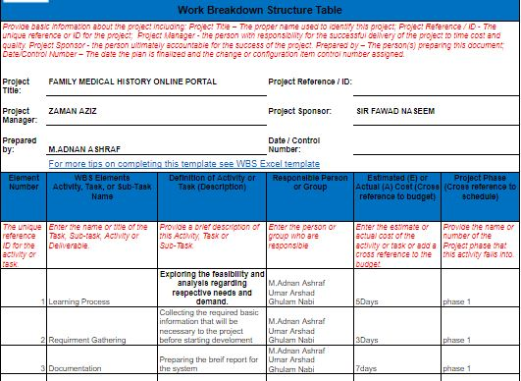

* + 1. **Roles & Responsibility Matrix**

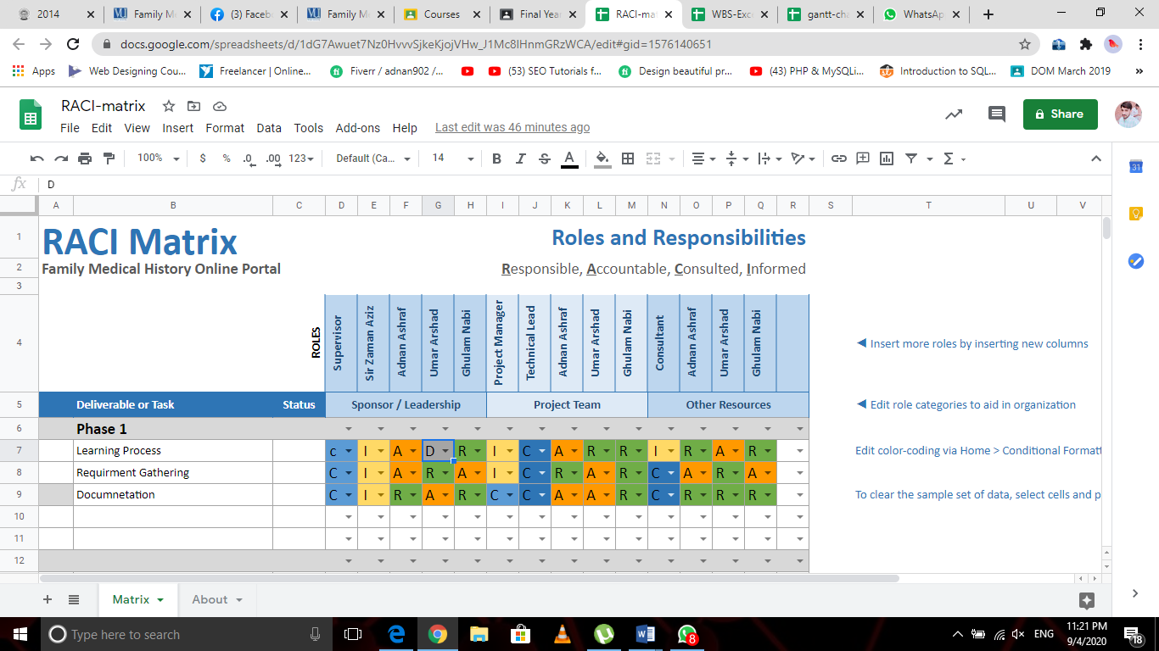

* + 1. **Gantt Chart**



