PROJECT REPORT OF CO-OP
Project at Industry (Module-2)

ON

AI-Assisted Coding and Developer Skill Development:

submitted in partial fulfilment of the requirements for the award of degree of

BACHELOR OF ENGINEERING
In
COMPUTER SCIENCE AND ENGINEERING

Submitted by: Supervised By:
Kartik Sharma (2210991758) Dr. Preeti Saini



DEPARTMENT OF COMPUTER SCIENCE AND ENGINEERING
CHITKARA UNIVERSITY INSTITUTE OF ENGINEERING AND TECHNOLOGY
CHITKARA UNIVERSITY, PUNJAB, INDIA

2025-2026

ACKNOWLEDGEMENT

I would like to express my sincere gratitude to my mentor, Dr. Preeti Saini, Department of
Computer Science and Engineering, Chitkara University, Punjab, for his valuable guidance, continuous support, and encouragement throughout this research work.

I would also like to thank my department and university for providing the resources and academic environment necessary to complete this research successfully. Special thanks to all researchers, developers, and organizations whose published studies and tools contributed to this work.

Finally, I would like to express my gratitude to my family and friends for their constant motivation and support during the completion of this project and report.

LIST OF FIGURES AND TABLES

Figures

- Productivity Comparison Between AI-Assisted and Manual Development
- Developer Dependency Score (DDS) Analysis
- Code Quality Metrics Comparison
- Research Workflow Diagram

Tables

- Comparison of Existing Studies
- Task Distribution Across Categories
- Experimental Parameters and Settings
- Developer Dependency Score Analysis
- Code Quality Comparison Between Groups

CONTENTS

S.No. | Title | Page No.
 | Acknowledgement | ii
 | List of Figures and Tables | iii
 | Abstract | v
1 | Introduction | 7
2 | Methodology | 8
3 | Tools and Technologies | 11
4 | Implementation | 12
5 | Major Findings / Outcomes / Results | 15
6 | Conclusion and Future Scope | 19
 | References | 22

ABSTRACT

Artificial Intelligence (AI) is transforming modern software development through intelligent coding assistants capable of generating code, debugging software and improving workflow efficiency. Tools such as GitHub Copilot, ChatGPT, Cursor and Amazon CodeWhisperer have significantly changed how developers approach programming tasks.

This research investigates the impact of AI-assisted coding on developer productivity, software quality, and dependency behavior. The study evaluates whether AI improves development efficiency while simultaneously affecting conceptual understanding, debugging competence, and maintainability of software systems.

A controlled experimental study was conducted using AI-assisted and non-AI development groups. Key evaluation parameters included task completion time, bug density, cyclomatic complexity, maintainability index, and Developer Dependency Score (DDS). Results indicate that AI-assisted developers completed tasks significantly faster; however, AI-generated code exhibited increased complexity and higher dependency patterns, especially among junior developers.

The findings highlight the importance of balancing AI productivity gains with strong programming fundamentals and responsible AI integration practices in software engineering.

1. Introduction
Artificial Intelligence has become one of the most influential technologies in software engineering. AI-assisted coding systems leverage Machine Learning (ML) and Natural Language Processing (NLP) to provide intelligent code suggestions, automate debugging processes, generate documentation, and improve development workflows.

Modern AI-powered coding assistants such as GitHub Copilot, ChatGPT, Cursor, and Amazon CodeWhisperer are increasingly integrated into software development environments. These tools are capable of generating complete functions, recommending optimizations, and assisting developers in solving complex programming problems.

Although AI-assisted coding significantly improves productivity and reduces repetitive work, concerns exist regarding its long-term impact on conceptual understanding, debugging skills, and software maintainability.

Developers often spend considerable time performing repetitive coding tasks, debugging applications, and learning new frameworks or technologies. Traditional development methods can reduce productivity and increase development effort.

AI-assisted coding tools offer faster development workflows through automated suggestions and intelligent code generation. However, excessive dependence on AI-generated code may reduce analytical thinking, conceptual understanding, and debugging competence.

This creates a need to evaluate the balance between productivity improvement and long-term developer skill development.

The major objectives of this research are:
- To analyze the impact of AI-assisted coding on software development productivity.
- To evaluate software quality metrics in AI-generated code.
- To measure developer dependency on AI systems using Developer Dependency Score (DDS).
- To compare AI-assisted development with traditional coding approaches.
- To study the impact of AI on conceptual understanding and debugging skills.
- To provide recommendations for responsible AI integration in software engineering.

2. Methodology

2.1 Research Design
The research follows a controlled experimental methodology involving two developer groups:
Group | Description
AI-Assisted Group | Developers used GitHub Copilot and AI coding tools
Control Group | Developers performed manual coding without AI assistance
Both groups completed identical programming tasks under controlled conditions.

2.2 Text Preprocessing
Step 1: Participant Recruitment
- Total participants: 4 developers
- Junior developers: 2
- Senior developers: 2
Step 2: Task Execution
- Developers completed 15 programming tasks categorized into:
- CRUD operations
- Data processing
- Algorithm implementation
- Concurrent programming
- Debugging challenges
- Design implementation
Step 3: Data Collection
- The following data was collected:
- Task completion time
- AI suggestion acceptance rate
- Bug density
- Complexity metrics
- Maintainability index
- Code smells
- Test coverage
Step 4: Statistical Analysis
- Collected data was analyzed using:
- Correlation analysis
- Comparative evaluation
- Dependency measurement
- Productivity analysis

2.3 Developer Dependency Score (DDS)

DDS Formula:

DDS = w₁(A) + w₂(1 - M) + w₃(1 - V)
Where:
- A = Acceptance Rate of AI Suggestions
- M = Modification Depth
- V = Verification Frequency
- w₁, w₂, w₃ = Weight coefficients
DDS Workflow
AI Suggestion → Developer Acceptance → Code Modification → Verification → Final DDS Score

Figure: DDS Dependency Model

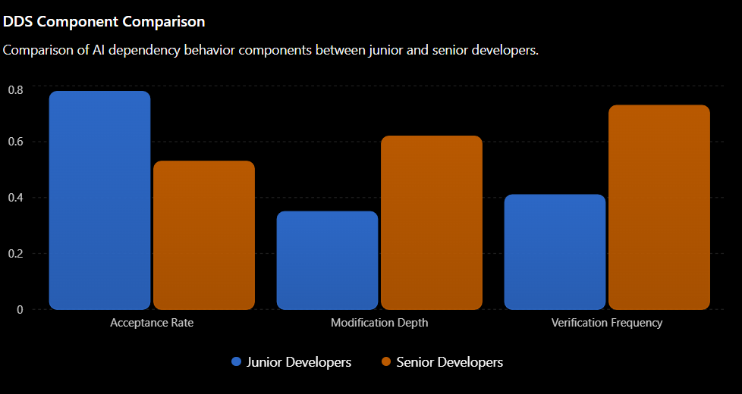

Developer Dependency Score (DDS) was introduced to measure reliance on AI-generated code suggestions.

DDS Parameters
- Acceptance Rate of AI suggestions
- Modification Depth
- Verification Frequency
DDS provides quantitative insight into how responsibly developers use AI tools.

DDS Classification
DDS Range | Dependency Level
DDS < 0.3 | Low Dependency
0.3 ≤ DDS < 0.6 | Moderate Dependency
DDS ≥ 0.6 | High Dependency

3. Tools and Technologies

3.1 AI Tools Used

GitHub Copilot

AI-powered code completion system

Generates context-aware coding suggestions

Accelerates software development workflows

ChatGPT

Assists with debugging and algorithm explanation

Generates optimized code snippets

Supports conceptual understanding

Cursor AI

AI-integrated development environment

Provides intelligent navigation and coding support

Amazon CodeWhisperer

Cloud-focused AI coding assistant

Generates secure backend code suggestions

3.2 Development Environment
Component | Technology Used
IDE | Visual Studio Code
Programming Languages | Python, JavaScript
Version Control | Git
Static Analysis | Flake8, ESLint
Code Quality Tools | SonarQube
Complexity Analysis | Radon

4. Implementation

4.1 Experimental Setup

The experimental environment was designed to evaluate productivity and software quality differences between AI-assisted and manual development approaches.

Each participant completed standardized programming tasks under identical conditions.

Task Categories

Task Type | Count
CRUD Operations | 4
Data Processing | 3
Algorithm Implementation | 3
Concurrent Programming | 2
Debugging Challenges | 2
Design Implementation | 1

4.2 Evaluation Metrics

The following parameters were used to evaluate the impact of AI-assisted coding on developer productivity, dependency, and software quality:

🔹 Task Completion Time

Measures the total time required to complete programming tasks.

Used to compare productivity between AI-assisted and manual development groups.

Lower completion time indicates higher development efficiency.

🔹 Bug Density

Represents the number of bugs identified per 100 lines of code.

Used to evaluate the reliability and correctness of generated software.

Higher bug density indicates lower software quality.

🔹 Cyclomatic Complexity

Measures the complexity of program logic and decision-making paths.

Higher complexity indicates code that is harder to understand, test, and maintain.

Used to analyze structural quality of AI-generated code.

🔹 Maintainability Index

Evaluates how easily software can be modified and maintained.

Based on factors such as complexity, code volume, and readability.

Higher maintainability values indicate better software quality.

🔹 Code Smell Count

Identifies poor coding practices and maintainability issues in source code.

Examples include duplicated code, long methods, and unnecessary complexity.

Used to assess overall code cleanliness and design quality.

🔹 Test Coverage

Measures the percentage of code executed during testing.

Higher test coverage indicates better validation and reliability of software systems.

Used to evaluate testing effectiveness in both development groups.

🔹 Developer Dependency Score (DDS)

Quantifies the level of developer reliance on AI-generated suggestions.

Calculated using:

Acceptance Rate

Modification Depth

Verification Frequency

Helps identify responsible versus excessive AI usage patterns.

Figure: Code quality metrics Comparison

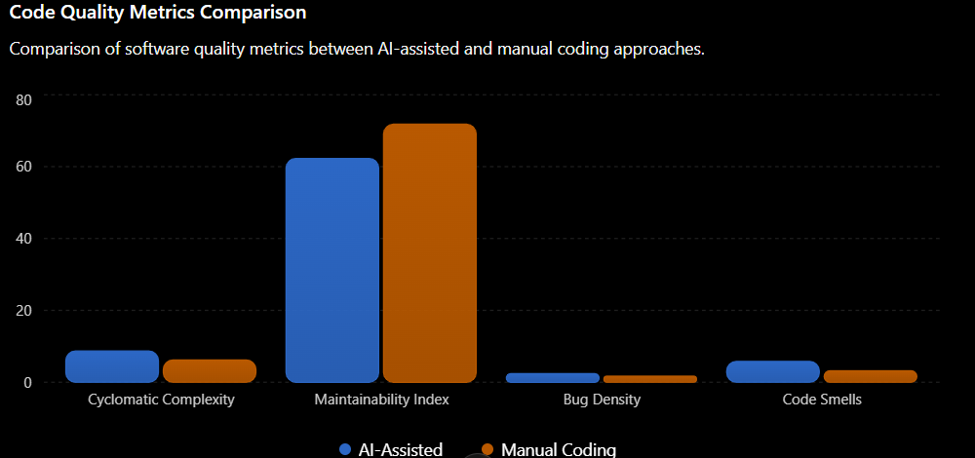
5. Major Findings / Outcomes / Results

5.1 Productivity Analysis
Figure : Productivity Comparison Between AI-Assisted and Manual Development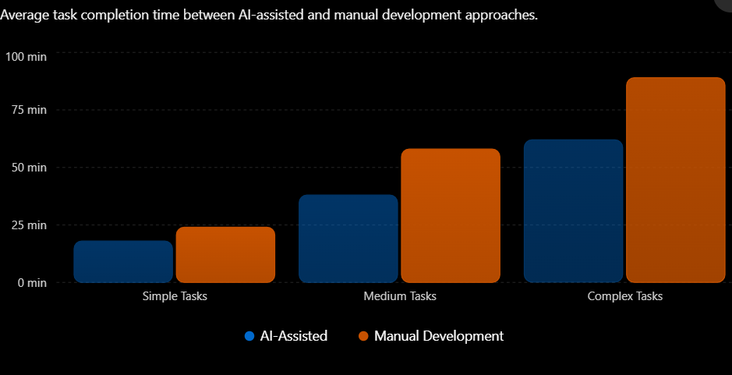

5.2 DDS Results

Figure : DDS Component Comparison

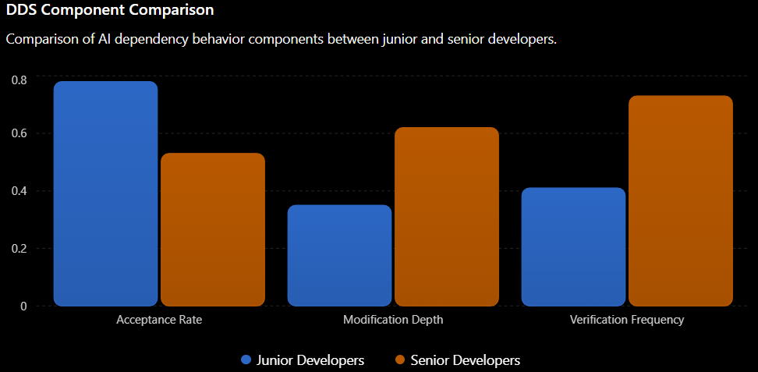

6. Conclusion and Future Scope

6.1 Conclusion
This research study analyzed the impact of AI-assisted coding on developer productivity, dependency, and software quality through a controlled experimental approach. The findings demonstrate that AI-powered coding assistants significantly improve software development efficiency by reducing task completion time and simplifying repetitive programming activities.

The experimental results showed that developers using AI-assisted tools completed tasks 35–50% faster compared to traditional manual coding approaches. AI systems such as GitHub Copilot and ChatGPT proved highly effective for boilerplate generation, debugging assistance, and rapid prototyping.

However, the study also identified several important concerns associated with excessive reliance on AI-generated code. Junior developers demonstrated higher dependency levels, lower conceptual understanding, and reduced verification behavior compared to senior developers. In addition, AI-assisted code exhibited:
- Higher cyclomatic complexity
- Lower maintainability index
- Increased bug density
- Greater code smell count

The proposed Developer Dependency Score (DDS) successfully quantified developer reliance on AI systems and provided meaningful insights into responsible AI usage behavior.

Overall, the research concludes that AI-assisted coding should function as a collaborative support system rather than a replacement for human developers. Human expertise, logical reasoning, debugging ability, and software design skills remain essential for building reliable and maintainable software systems.

6.2 Future Scope

1. Long-Term Dependency Analysis

Conduct long-term studies to analyze how continuous use of AI coding assistants affects developer learning, problem-solving ability, and skill retention.

Study the impact of AI dependency on junior and senior developers over extended periods.

2. AI-Assisted Learning Platforms

Develop intelligent learning systems that combine AI assistance with conceptual programming education.

Create AI tools that encourage logical thinking instead of directly generating complete solutions.

3. Advanced Code Verification Systems

Build AI systems capable of automatic:

Bug detection

Vulnerability analysis

Code optimization

Security validation

Improve reliability of AI-generated code.

4. Personalized AI Coding Assistants

Design adaptive AI systems that provide suggestions based on:

Developer experience level

Coding behavior

Learning progress

Reduce excessive dependency through customized assistance.

5. Comparative Analysis of AI Tools

Perform detailed comparison of different AI coding platforms such as:

GitHub Copilot

ChatGPT

Cursor AI

Amazon CodeWhisperer

Tabnine

Evaluate productivity, dependency, and software quality across multiple AI systems.

6. Integration with Software Engineering Workflows

Explore integration of AI into:

DevOps pipelines

Automated testing frameworks

Continuous Integration/Continuous Deployment (CI/CD)

Code review systems

Software maintenance processes

7. Ethical and Security Research

Investigate ethical concerns related to:

AI-generated vulnerabilities

Intellectual property ownership

Data privacy

Responsible AI usage in software development

Develop secure and transparent AI-assisted coding practices.

8. AI Dependency Monitoring Systems

Develop real-time monitoring systems based on Developer Dependency Score (DDS).

Integrate DDS tracking inside IDEs to:

Detect unhealthy AI reliance

Encourage responsible verification practices

Improve balanced AI adoption in development environments.

REFERENCES

1) Cerbos. (2025). The Productivity Paradox of AI Coding Assistants. Cerbos Blog. https://www.cerbos.dev/blog/productivity-paradox-of-ai-coding-assistants
2) Dextra Labs. (2026, March 6). Top 10 AI Code Review Tools for Developers. Dextra Labs Blog. https://dextralabs.com/blog/top-ai-code-review-tools/
3) InfoQ. (2026, February 22). Anthropic Study: AI Coding Assistance Reduces Developer Skill Formation. InfoQ News. https://www.infoq.com/news/2026/02/ai-coding-skill-formation/
4) Anthropic. (2026, January 28). How AI Assistance Impacts the Formation of Coding Skills. Anthropic Research. https://www.anthropic.com/research/AI-assistance-coding-skills
5) Peng, S., Kalliamvakou, E., Cihon, P., & Demirer, M. (2023). The Impact of AI on Developer Productivity: Evidence from GitHub Copilot. arXiv preprint arXiv:2302.06590. https://arxiv.org/abs/2302.06590
6) Barke, S., James, M., & Polikarpova, N. (2023). Examining the Use and Impact of an AI Code Assistant in Professional Software Development. arXiv preprint arXiv:2412.06603v2. https://arxiv.org/html/2412.06603v2
7) StackQuadrant. (2026, February 27). AI Developer Tool Intelligence Platform. https://stackquadrant.com
8) Synlabs. (2026, February 9). What Skills Developers Actually Need in the Age of AI-Assisted Coding. Synlabs Blog. https://www.synlabs.io/post/skills-developers-need-for-ai-assisted-coding
9) GitHub. (2023). GitHub Copilot Research: Quantifying Developer Productivity. GitHub Blog.
10) Kalliamvakou, E. (2024). Research: Quantifying GitHub Copilot's Impact on Developer Productivity and Happiness. GitHub Blog. https://github.blog/2024-quantifying-copilot-impact/

