Cairo University  
Faculty of Computers and Artificial Intelligent

**CS251 - Software Engineering I**

Software Requirements Specifications (SRS)

May, 2022

Contents

Instructions [To be removed] 3

Team 3

Document Purpose and Audience 3

Introduction 3

Software Purpose 3

Software Scope 3

Definitions, acronyms, and abbreviations 3

Requirements 4

Functional Requirements 4

Non Functional Requirements 4

System Models 4

Use Case Model 4

Use Case Tables 5

Ownership Report 6

Policy Regarding Plagiarism: 6

# 

# Team

|  |  |  |  |
| --- | --- | --- | --- |
| **ID** | **Name** | **Email** | **Mobile** |
| 20180209 | Malek Mohamed amin | malekamin40@gmail.com | 01110645891 |
| 20170454 | Zainab medhat ibrahim | zainabmustafa468@gmail.com | 01032712122 |
| 20200602 | Nou eldin Mohamed fatouh | nourlight602@gmail.com | 01015752871 |
| 20200582 | Nardeen Nazih Ghobrial | nardennazih00@gmail.com | 01275725950 |

# Requirements

1. The system must return to the best fit or(first fit)

of the car.

2. The customer can pay by credit or cash.

3. When registering, the customer must provide the dimensions

of his vehicle.

4. The system must calculate the parking fee correctly.

## Non Functional Requirements

**1. system must support 3 platforms: Android and iOS and windows.**

**2. All financial transactions and credit card info must be secured and encrypted**

**3. System must be fast and flexible**

**4. System must deal with all people and several generations and has interaction with many social accounts**

**5. The pages should load in 3 seconds with the total number of simultaneous users <5 thousand.**

**6. The system should be able to handle 900users without performance deterioration.**

# 

# System Models

## Use Case Model

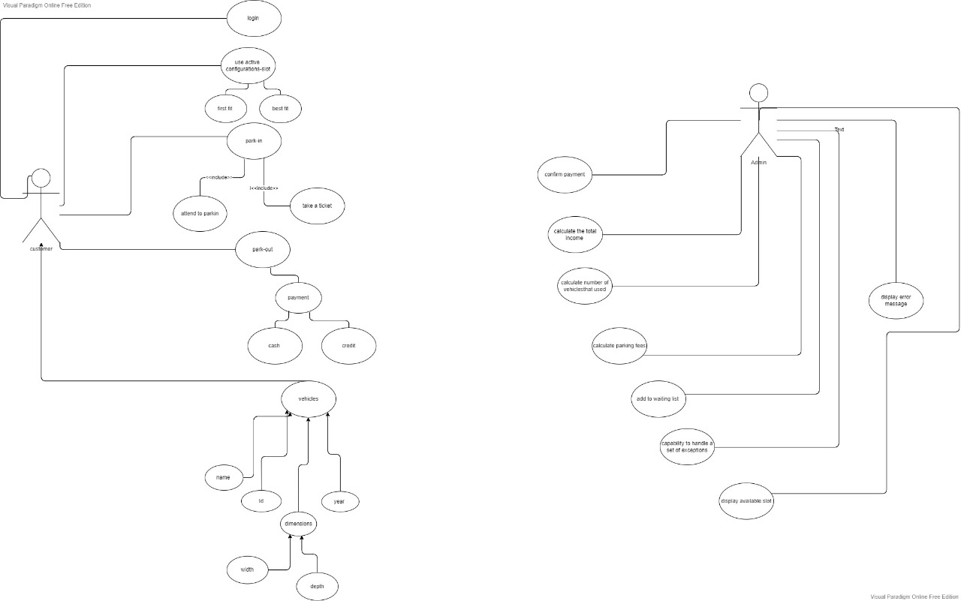

## 

## Use Case Tables

|  |  |  |
| --- | --- | --- |
| Use Case ID: | 1 | |
| Use Case Name: | Park-in | |
| Actors: | Customer ,Admin | |
| Pre-conditions: | Add information about the car and reserve a place with the appropriate specifications for the car | |
| Post-conditions: | takes a ticket if there is a suitable place for the car | |
| Flow of events: | **User Action** | **System Action** |
| 1- Register user information |  |
|  | 2- Make sure that the information already exist, saves user information if it does not already exist  3. Admin request information about the car |
| 3-Add information about the car |  |
|  | 4-Looking for a suitable place for the specifications of the car |
| 5-reservation confirmation |  |
|  | 6. Give a user a ticket |
| Exceptions: | **User Action** | **System Action** |
| 1. User Enter email and Password. 2. Putting information about the car |  |
|  | 3-That account exists  4-There is no suitable place for the car  garage full |
| Includes: |  | |
| Notes and Issues: |  | |
| Use Case ID: | 2 | |
| Use Case Name: | Park-out | |
| Actors: | Customer,Admin | |
| Pre-conditions: | Car is in garage | |
| Post-conditions: | Car out of garage | |
| Flow of events: | **User Action** | **System Action** |
| 1- Request to get the car out of the garage |  |
|  | 2. Giving the user an invoice detailing the time period for the car to be in the garage  3. A message that a user chooses to pay by cash or by Visa |
| 3-Get the bill with details and get the car out of the garage |  |
| Exceptions: | **User Action** | **System Action** |
| 1. Giving the wrong ticket number 2. Pay with visa |  |
|  | 1. message to user that his ticket number does not exist 2. A message that the visa balance is insufficient |
| Includes: |  | |
| Notes and Issues: |  | |

|  |  |  |
| --- | --- | --- |
| Use Case ID: | 3 | |
| Use Case Name: | display available slot | |
| Actors: | Admin | |
| Pre-conditions: | Request a place suitable for the specifications of the car | |
| Post-conditions: | Find a suitable place in the garage for the car | |
| Flow of events: | **User Action** | **System Action** |
| 1- Enter data and choose a location |  |
|  | 2. A message to the user at the location currently available in the garage |
| 3-Agree to a reservation |  |
| Exceptions: | **User Action** | **System Action** |
| 1. Choose the nearest location |  |
|  | 1. A message that the place is not available near the customer 2. The location is not suitable for the car |
| Includes: |  | |
| Notes and Issues: |  | |

# Ownership Report

|  |  |
| --- | --- |
| **Item** | **Owners** |
| Use case model | *All team* |
| Use case table | *All team* |

# Policy Regarding Plagiarism:

**Students have collective ownership and responsibility of their project. Any violation of academic honesty will have severe consequences and punishment for ALL team members.**

1. تشجع الكلية على مناقشة الأفكار و تبادل المعلومات و مناقشات الطلاب حيث يعتبر هذا جوهريا لعملية تعليمية سليمة
2. ساعد زملاءك على قدر ما تستطيع و حل لهم مشاكلهم فى الكود و لكن تبادل الحلول غير مقبول و يعتبر غشا.
3. أى حل يتشابه مع أى حل آخر بدرجة تقطع بأنهما منقولان من نفس المصدر سيعتبر أن صاحبيهما قد قاما بالغش.
4. قد توجد على النت برامج مشابهة لما نكتبه هنا أى نسخ من على النت يعتبر غشا يحاسب عليه صاحبه.
5. إذا لم تكن متأكدا أن فعلا ما يعد غشا فلتسأل المعيد أو أستاذ المادة.
6. فى حالة ثبوت الغش سيأخذ الطالب سالب درجة المسألة ، و فى حالة تكرار الغش سيرسب الطالب فى المقرر.