PROJECT SYNOPSIS

**MCS- 044**

Online Grievance Management Portal

**By**

**Rajat Sharma**

**INDEX**

* **Introduction 4**
* **Purpose of the project 4**
* **Requirement and Analysis 10**
* **Software Development Life Cycle (SDLC) 11**
* **SDLC Model 14**
* **Conceptual Modeling 16**
* **E-R Diagram 16**
* **DFD (Data Flow Diagram) 20**
* **First Level DFD 23**
* **Database Structure and Designing 25**
* **Reference 26**

**TITLE OF THE PROJECT:**

Online Grievance Management Portal

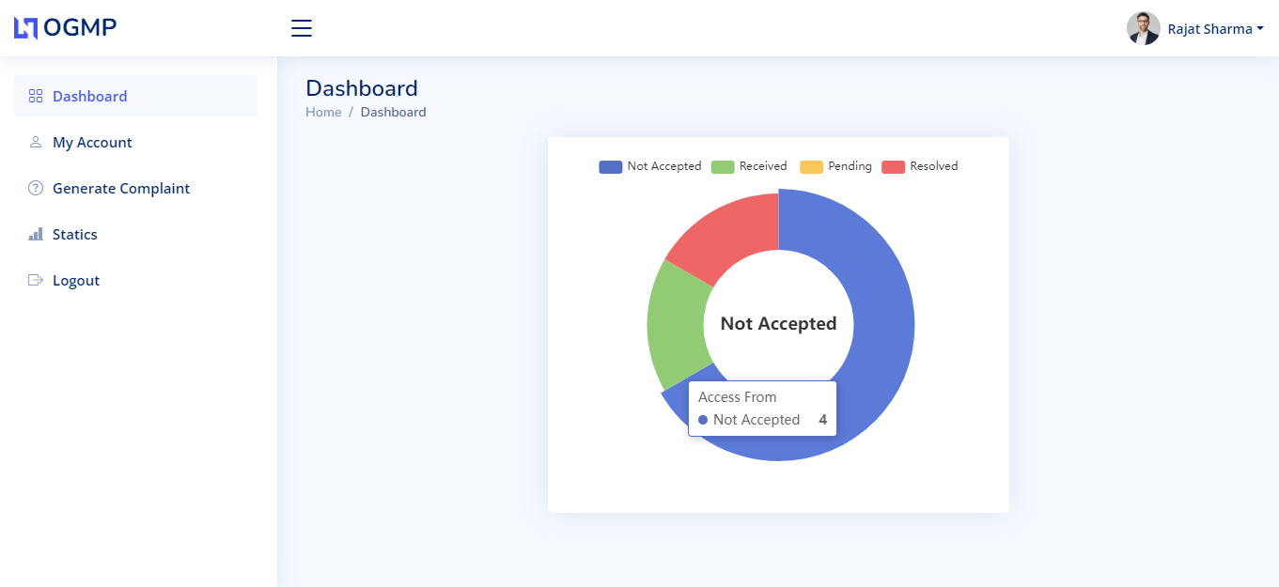

**INTRODUCTION:**

Online Complaint Management System provides an online way of solving the problems faced by the students by saving time. The objective of the complaints management system is to make complaints easier to coordinate, monitor, track and resolve, and to provide company with an effective tool to identify and target problem areas, monitor complaints handling performance.

Online Complaint Management is a management technique for assessing, analyzing and responding to students complaints. Complaints management software is used to record resolve and respond to students complaints, requests as well as facilitate any other feedback. The main purpose of this project is to help the student in knowing their place details and getting their problems solved in online without going to the Principal office regularly until the problem is solved. By this system the student can save his time and resources.

In the proposed system the students need not go to the principal office for getting his problem solved. He can get his problem solved by posting his problem in this proposed system and he can suggest a possible solution to the problems posted on the system.

There are four modules for this system are:

* Student
* Teacher

### PURPOSE OF THE PROJECT:

Online Complaint Management System provides an online way of solving the problem faced by the public by saving time and eradicate corruption and the ability of providing many of the reports on the system and add to facilitate the process of submitting a complaint.

The system should have all information about the items. Some of the tasks are as follows:

* Details of each application.
* Status of all applications.
* Perform various action like resolve, accept, pending.

**SURVEY OF TECHNOLOGY:**

PHP:

Stands for "Hypertext Preprocessor." (It is a recursive acronym, if you can understand what that means.) PHP is an HTML-embedded Web scripting language. This means PHP code can be inserted into the HTML of a Web page. When a PHP Pages is accessed, the PHP code is read or "parsed" by the server the page resides on. The output from the PHP functions on the page are typically returned as HTML code, which can be read by the browser. Because the PHP code is transformed into HTML before the page is loaded, users cannot view the PHP code on a page. This makes PHP pages secure enough to access databases and other secure information.

A lot of the syntax of PHP is borrowed from other languages such as C, Java and Perl. However, PHP has a number of unique features and specific functions as well. The goal of the language is to allow Web developers to write dynamically generated pages quickly and easily. PHP is also great for creating database-driven Web sites.

HTML:

The HyperText Markup Language, or HTML is the standard markup language for documents designed to be displayed in a web browser. It can be assisted by technologies such as Cascading Style Sheets (CSS) and scripting languages such as JavaScript.

Web browsers receive HTML documents from a web server or from local storage and render the documents into multimedia web pages. HTML describes the structure of a web page semantically and originally included cues for the appearance of the document.

HTML elements are the building blocks of HTML pages.

With HTML constructs, images and other objects such as interactive forms may be embedded into the rendered page. HTML provides a means to create structured documents by denoting structural semantics for text such as headings, paragraphs, lists, links, quotes and other items. HTML elements are delineated by tags, written using angle brackets. Tags such as <imp /> and <input /> directly introduce content into the page. Other tags such as <p> surround and provide information about document text and may include other tags as sub-elements. Browsers do not display the HTML tags, but use them to interpret the content of the page.

HTML can embed programs written in a scripting language such as JavaScript, which affects the behavior and content of web pages. Inclusion of CSS defines the look and layout of content. The World Wide Web Consortium (W3C), former maintainer of the HTML and current maintainer of the CSS standards, has encouraged the use of CSS over explicit presentational HTML since 1997.[2] A form of HTML, known as HTML5, is used to display video and audio, primarily using the <canvas> element, in collaboration with javascript.

JAVASCRIPT:

JavaScript, often abbreviated JS, is a programming language that is one of the core technologies of the World Wide Web, alongside HTML and CSS. Over 97% of websites use JavaScript on the client side for web page behavior, often incorporating third-party libraries. All major web browsers have a dedicated JavaScript engine to execute the code on the user's device.

JavaScript is a high-level, often just-in-time compiled language that conforms to the ECMAScript standard. It has dynamic typing, prototype-based object-orientation, and first-class functions. It is multi-paradigm, supporting event-driven, functional, and imperative programming styles. It has application programming interfaces (APIs) for working with text, dates, regular expressions, standard data structures, and the Document Object Model (DOM).

The ECMAScript standard does not include any input/output (I/O), such as networking, storage, or graphics facilities. In practice, the web browser or other runtime system provides JavaScript APIs for I/O.

JavaScript engines were originally used only in web browsers, but are now core components of some servers and a variety of applications. The most popular runtime system for this usage is Node.js.

Although Java and JavaScript are similar in name, syntax, and respective standard libraries, the two languages are distinct and differ greatly in design.

CSS (Cascading Style Sheets):

Cascading Style Sheets (CSS) is a style sheet language used for describing the presentation of a document written in a markup language such as HTML. CSS is a cornerstone technology of the World Wide Web, alongside HTML and JavaScript.

CSS is designed to enable the separation of presentation and content, including layout, colors, and fonts. This separation can improve content accessibility; provide more flexibility and control in the specification of presentation characteristics; enable multiple web pages to share formatting by specifying the relevant CSS in a separate .CSS file, which reduces complexity and repetition in the structural content; and enable the .CSS file to be cached to improve the page load speed between the pages that share the file and its formatting.

Separation of formatting and content also makes it feasible to present the same markup page in different styles for different rendering methods, such as on-screen, in print, by voice (via speech-based browser or screen reader), and on Braille-based tactile devices. CSS also has rules for alternate formatting if the content is accessed on a mobile device.

The name cascading comes from the specified priority scheme to determine which style rule applies if more than one rule matches a particular element. This cascading priority scheme is predictable.

The CSS specifications are maintained by the World Wide Web Consortium (W3C). Internet media type (MIME type) text/CSS is registered for use with CSS by RFC 2318 (March 1998). The W3C operates a free CSS validation service for CSS documents.

In addition to HTML, other markup languages support the use of CSS including XHTML, plain XML, SVG, and XUL.

MYSQL:

MySQL is an open-source relational database management system (RDBMS). Its name is a combination of "My", the name of co-founder Michael Widenius's daughter, and "SQL", the abbreviation for Structured Query Language. A relational database organizes data into one or more data tables in which data types may be related to each other; these relations help structure the data. SQL is a language programmers use to create, modify and extract data from the relational database, as well as control user access to the database. In addition to relational databases and SQL, an RDBMS like MySQL works with an operating system to implement a relational database in a computer's storage system, manages users, allows for network access and facilitates testing database integrity and creation of backups.

MySQL is free and open-source software under the terms of the GNU General Public License, and is also available under a variety of proprietary licenses. MySQL was owned and sponsored by the Swedish company MySQL AB, which was bought by Sun Microsystems (now Oracle Corporation). In 2010, when Oracle acquired Sun, Widenius forked the open-source MySQL project to create MariaDB.

MySQL has stand-alone clients that allow users to interact directly with a MySQL database using SQL, but more often, MySQL is used with other programs to implement applications that need relational database capability. MySQL is a component of the LAMP web application software stack (and others), which is an acronym for Linux, Apache, MySQL, Perl/PHP/Python. MySQL is used by many database-driven web applications, including Drupal, Joomla, phpBB, and WordPress. MySQL is also used by many popular websites, including Facebook, Flickr, MediaWiki, Twitter, and YouTube.

APACHE:

The Apache HTTP Server is a free and open-source cross-platform web server software, released under the terms of Apache License 2.0. Apache is developed and maintained by an open community of developers under the auspices of the Apache Software Foundation.

The vast majority of Apache HTTP Server instances run on a Linux distribution, but current versions also runon Microsoft Windows, OpenVMS, and a wide variety of Unix-like systems. Past versions also ran on NetWare, OS/2 and other operating systems, including ports to mainframes.

Originally based on the NCSA HTTP server, development of Apache began in early 1995 after work on the NCSA code stalled. Apache played a key role in the initial growth of the World Wide Web, quickly overtaking NCSA HTTP as the dominant HTTP server. In 2009, it became the first web server software to serve more than 100 million websites.

As of January 2021, Net craft estimated that Apache served 24.63% of the million busiest websites, while Nginx served 23.21% and Microsoft is in third place at 6.85% (for some of Netcraft's other stats Nginx is ahead of Apache), while according to W3Techs, Apache is ranked first at 35.0% and Nginx second at 33.0% and Cloudflare Server third at 17.3%.

BOOTSTRAP:

Bootstrap is an HTML, CSS & JS Library that focuses on simplifying the development of informative web pages (as opposed to web apps). The primary purpose of adding it to a web project is to apply Bootstrap's choices of color, size, font and layout to that project. As such, the primary factor is whether the developers in charge find those choices to their liking. Once added to a project, Bootstrap provides basic style definitions for all HTML elements. The result is a uniform appearance for prose, tables and form elements across web browsers. In addition, developers can take advantage of CSS classes defined in Bootstrap to further customize the appearance of their contents. For example, Bootstrap has provisioned for light- and dark-colored tables, page headings, more prominent pull quotes, and text with a highlight.

Bootstrap also comes with several JavaScript components in the form of jQuery plugins. They provide additional user interface elements such as dialog boxes, tooltips, and carousels. Each Bootstrap component consists of an HTML structure, CSS declarations, and in some cases accompanying JavaScript code. They also extend the functionality of some existing interface elements, including for example an auto-complete function for input fields.

Example of a webpage using Bootstrap framework rendered in Firefox.

The most prominent components of Bootstrap are its layout components, as they affect an entire web page. The basic layout component is called "Container", as every other element in the page is placed in it. Developers can choose between a fixed-width container and a fluid-width container. While the latter always fills the width of the web page, the former uses one of the five predefined fixed widths, depending on the size of the screen showing the page:

* Smaller than 576 pixels
* 576–768 pixels
* 768–992 pixels
* 992–1200 pixels
* Larger than 1200 pixels

**REQUIREMENTS AND ANALYSIS:**

HARDWARE AND SOFTWARE:

### Language and Tool

**Language:** PHP

**Tools**:

**Frontend –** HTML, CSS, BOOTSTRAP, JAVASCRIPT

**Backend** – MYSQL

### Platform required:

* WINDOWS 10
* Windows 7

### Hardware Requirements:

* PROCESSOR: DUAL CORE 2.0
* RAM: 1 GB
* HARD DISK: 160 GB
* MOUSE: OPTICAL
* KEBOARD
* MONITOR

**Software Requirements:**

* XAMPP
* PhpMyAdmin
* SQL Server

**SDLC (Software Development Life Cycle):**

SDLC is a process followed for a software project, within a software organization. It consists of a detailed plan describing how to develop, maintain, replace and alter or enhance specific software. The life cycle defines a methodology for improving the quality of software and the overall development process.

The following figure is a graphical representation of the various stages of a typical SDLC.

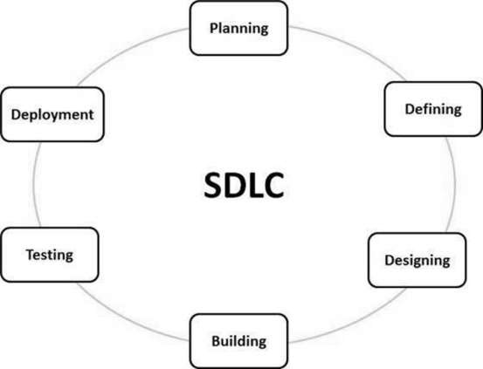

A typical Software Development Life Cycle consists of the following stages –

### Planning and Requirement Analysis

Requirement analysis is the most important and fundamental stage in SDLC. It is performed by the senior members of the team with inputs from the customer, the sales department, market surveys and domain experts in the industry. This information is then used to plan the basic project approach and to conduct product feasibility study in the economical, operational and technical areas.

Planning for the quality assurance requirements and identification of the risks associated with the project is also done in the planning stage. The outcome of the technical feasibility study is to define the various technical approaches that can be followed to implement the project successfully with minimum risks.

### Defining Requirements

Once the requirement analysis is done the next step is to clearly define and document the product requirements and get them approved from the customer or the market analysts. This is done through an **SRS (Software Requirement Specification)** document which consists of all the product requirements to be designed and developed during the project life cycle.

### Designing the Product Architecture

SRS is the reference for product architects to come out with the best architecture for the product to be developed. Based on the requirements specified in SRS, usually more than one design approach for the product architecture is proposed and documented in a DDS - Design Document Specification.

This DDS is reviewed by all the important stakeholders and based on various parameters as risk assessment, product robustness, design modularity, budget and time constraints, the best design approach is selected for the product.

A design approach clearly defines all the architectural modules of the product along with its communication and data flow representation with the external and third party modules (if any). The internal design of all the modules of the proposed architecture should be clearly defined with the minutest of the details in DDS.

### Building or Developing the Product

In this stage of SDLC the actual development starts and the product is built. The programming code is generated as per DDS during this stage. If the design is performed in a detailed and organized manner, code generation can be accomplished without much hassle.

Developers must follow the coding guidelines defined by their organization and programming tools like compilers, interpreters, debuggers, etc. are used to generate the code. Different high level programming languages such as C, C++, Pascal, Java and PHP are used for coding. The programming language is chosen with respect to the type of software being developed.

### Testing the Product

This stage is usually a subset of all the stages as in the modern SDLC models, the testing activities are mostly involved in all the stages of SDLC. However, this stage refers to the testing only stage of the product where product defects are reported, tracked, fixed and retested, until the product reaches the quality standards defined in the SRS.

### Deployment in the Market and Maintenance

Once the product is tested and ready to be deployed it is released formally in the appropriate market. Sometimes product deployment happens in stages as per the business strategy of that organization. The product may first be released in a limited segment and tested in the real business environment (UAT- User acceptance testing).

Then based on the feedback, the product may be released as it is or with suggested enhancements in the targeting market segment. After the product is released in the market, its maintenance is done for the existing customer base.

**SDLC MODELS:**

There are many conceptual models available for the software development such as:

* [Waterfall Model](https://ca.insight.com/en_CA/content-and-resources/2016/07152016-types-of-software-development-models.html#waterfall-model)
* [V-Model](https://ca.insight.com/en_CA/content-and-resources/2016/07152016-types-of-software-development-models.html#v-model)
* [Incremental Model](https://ca.insight.com/en_CA/content-and-resources/2016/07152016-types-of-software-development-models.html#incremental-model)
* [RAD Model](https://ca.insight.com/en_CA/content-and-resources/2016/07152016-types-of-software-development-models.html#rad-model)
* [Agile Model](https://ca.insight.com/en_CA/content-and-resources/2016/07152016-types-of-software-development-models.html#agile-model)
* [Iterative Model](https://ca.insight.com/en_CA/content-and-resources/2016/07152016-types-of-software-development-models.html#iterative-model)
* [Spiral Model](https://ca.insight.com/en_CA/content-and-resources/2016/07152016-types-of-software-development-models.html#spiral-model)
* [Prototype Model](https://ca.insight.com/en_CA/content-and-resources/2016/07152016-types-of-software-development-models.html#prototype-model)

Waterfall Model:

The Waterfall Model is a linear sequential flow, often used with projects that have a defined set of requirements. Reflective of its name, the model’s process flows steadily downwards through the phases of software implementation.

This model relies on the completion of the previous phase for the following to begin. Because the model does not support going back to previously completed phases, the Waterfall Model should be used with projects that do not anticipate unforeseen changes mid-development.

This approach was one of the earliest models used for software development.

#### **Advantages and Disadvantages of Waterfall**

**Advantages**: Simple and understandable, the Waterfall Model is a manageable method ideal for lifecycle management of smaller projects where the requirements are established and finalized upfront.

**Disadvantages**: Because of its rigid structure, the Waterfall Model does not work well for complex projects where there is a chance of a change in requirements and/or significant

impromptu testing throughout the software development stage.

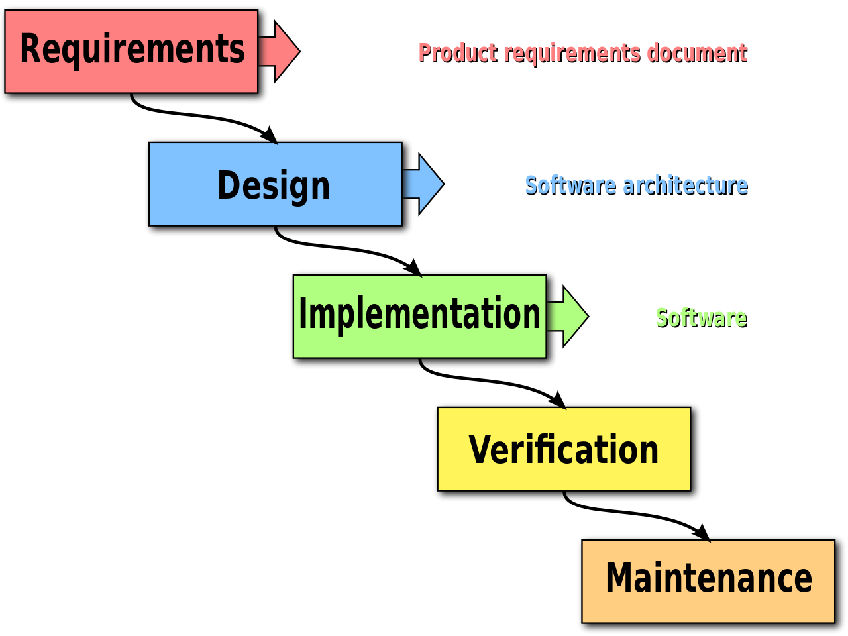

**CONCEPTUAL MODELING:**

A conceptual model is a representation of a system. It consists of concepts used to help people know, understand, or simulate a subject the model represents. It is also a set of concepts. In contrast, physical models are physical objects, such as a toy model that may be assembled and made to work like the object it represents.

The term may refer to models that are formed after a conceptualization or generalization process. Conceptual models are often abstractions of things in the real world, whether physical or social. Semantic studies are relevant to various stages of concept formation. Semantics is basically about concepts, the meaning that thinking beings give to various elements of their experience.

**ER-Diagram (Entity Relationship Diagram):**

An entity–relationship model (or ER model) describes interrelated things of interest in a specific domain of knowledge. A basic ER model is composed of entity types (which classify the things of interest) and specifies relationships that can exist between entities (instances of those entity types).

In software engineering, an ER model is commonly formed to represent things a business needs to remember in order to perform business processes. Consequently, the ER model becomes an abstract data model, that defines a data or information structure which can be implemented in a database, typically a relational database.

Entity–relationship modeling was developed for database and design by Peter Chen and published in a 1976 paper, with variants of the idea existing previously. Some ER models show super and subtype entities connected by generalization-specialization relationships, and an ER model can be used also in the specification of domain-specific ontologies.

**DFD diagram for Students**

New Complaint

Student

View All Complaints

Generate New Complaint

has

**DFD diagram for Teacher**

has

Teacher

View All Complaints

Profile

**DFD (Data Flow Diagram):**

A data-flow diagram is a way of representing a flow of data through a process or a system (usually an information system). The DFD also provides information about the outputs and inputs of each entity and the process itself. A data-flow diagram has no control flow — there are no decision rules and no loops. Specific operations based on the data can be represented by a flowchart.

There are several notations for displaying data-flow diagrams. The notation presented above was described in 1979 by Tom DeMarco as part of structured analysis.

For each data flow, at least one of the endpoints (source and / or destination) must exist in a process. The refined representation of a process can be done in another data-flow diagram, which subdivides this process into sub-processes.

The data-flow diagram is a tool that is part of structured analysis and data modeling. When using UML, the activity diagram typically takes over the role of the data-flow diagram. A special form of data-flow plan is a site-oriented data-flow plan.

Data-flow diagrams can be regarded as inverted Petri nets, because places in such networks correspond to the semantics of data memories. Analogously, the semantics of transitions from Petri nets and data flows and functions from data-flow diagrams should be considered equivalent.

**CONTEXT LEVEL DFD:**

**Teacher Level:**

Dashboard

My Account

View Complaint /Status

Logout

Complaint Action

Resolve/Pending/

Accept

**Student Level:**

Dashboard

My Account

View Complaint Status

Logout

Create New Complaint

**FIRST LEVEL DFD:**

**DFD diagram for Students**

Student

New Complaint

View All

Complaints

Resolve Date

**DFD diagram for Teacher**

Teacher

Update Profile

View All

Complaints

Resolve Date

**DATABASE DESIGN:**

Database design is the organization of data according to a database model. The designer determines what data must be stored and how the data elements interrelate. With this information, they can begin to fit the data to the database model. Database management system manages the data accordingly.

Database design involves classifying data and identifying interrelationships. This theoretical representation of the data is called an ontology. The ontology is the theory behind the database's design.

The different tables that the project “ONLINE GRIEVANCE MANAGEMENT PORTAL” is using can be enlisted as follows:

* **Courses**
* **Queries**
* **Subjects**
* **Users**

**COURSES:**

|  |  |  |
| --- | --- | --- |
| FIELD NAME | DATA TYPE | KEY |
| Id | Int | Primary key, Autoincrement |
| Subject_name | Varchar (55) | Not null |

**SUBJECTS:**

|  |  |  |
| --- | --- | --- |
| FIELD NAME | DATA TYPE | KEY |
| Id | Int | Primary key, Autoincrement |
| Sub | Text | Not null |
| Teacher_name | Varchar (250) | Not null |
| Teacher_email | Varchar (250) | Not null |

**USERS:**

|  |  |  |
| --- | --- | --- |
| FIELD NAME | DATA TYPE | KEY |
| User_id | Int | Primary key, Autoincrement |
| Name | Varchar (55) | Not null |
| Email | Varchar (55) | Not null |
| Password | Varchar (55) | Not null |
| Mobile | Varchar (55) | Not null |
| Flag | Varchar (55) | Not null |

**QUERIES:**

|  |  |  |
| --- | --- | --- |
| FIELD NAME | DATA TYPE | KEY |
| Id | int | Primary key, Autoincrement |
| Name | Varchar (250) | Not null |
| Email | Varchar (250) | Not null |
| Subject | Text | Not null |
| Message | Text | Not null |
| T_name | Varchar (250) | Not null |
| T_email | Varchar (250) | Not Null |
| Q_date | Varchar (25) | Not Null |
| Q_time | Varchar (25) | Not Null |
| Update_date | Varchar (25) | Not Null |
| Status | Int | Not Null |

**REFERENCES:**

* Book name – Introduction to the database system (MCS-023) Author – IGNOU
* Book name – Software engineering (MCS-034) Author – IGNOU
* Book name – Object oriented technology and java programming (MCS-024) Author – IGNOU
* Book name – Object oriented Analysis and design (MCS-032) Author – IGNOU
* [www.goggle.com](http://www.goggle.com)