WORKOUT & NUTRITION GUIDE

Personalized for a 55-Year-Old Male

Back-Safe Training | Mediterranean Nutrition | 16:8 Intermittent Fasting

5 Days/Week  Training Frequency | 2 Sessions  Weekly Swim | 4 Days  Gym Days | 16:8 IF  Eating Window

SECTION 1 — HOW THIS PLAN WORKS
Philosophy: Maximum Stimulus, Zero Unnecessary Spinal Load
Every decision in this plan — exercise selection, loading, posture, and sequence — is filtered through one question: does this create spinal risk? If yes, we find a better tool. The goal is to build muscle, burn fat, and move well for decades. Swimming stays. Barbell back squats don't.
Weekly Structure
Monday  Chest + Core | Tuesday  Legs — Quad & Glute | Wednesday  Swim | Thursday  Biceps + Shoulders + Core | Friday  Legs — Posterior Chain | Saturday  Swim (Longer) | Sunday  Active Recovery
Lower Back Rules — Non-Negotiable
- No barbell back squats or conventional deadlifts
- All dumbbell work seated or supported — never standing under load with free spine
- 5-minute core activation warm-up before every session: dead bug + bird-dog + glute bridge
- Brace core on every rep of every exercise — treat your trunk like a lifting belt
- STOP IMMEDIATELY if lower back recruits — no pushing through it. This rule saves years

SECTION 2 — WORKOUT PLAN
MONDAY — Chest + Core
Core activation warm-up (5 min) before lifting. See Section 4 for protocol.
Image | Exercise | Sets × Reps | Form Cue
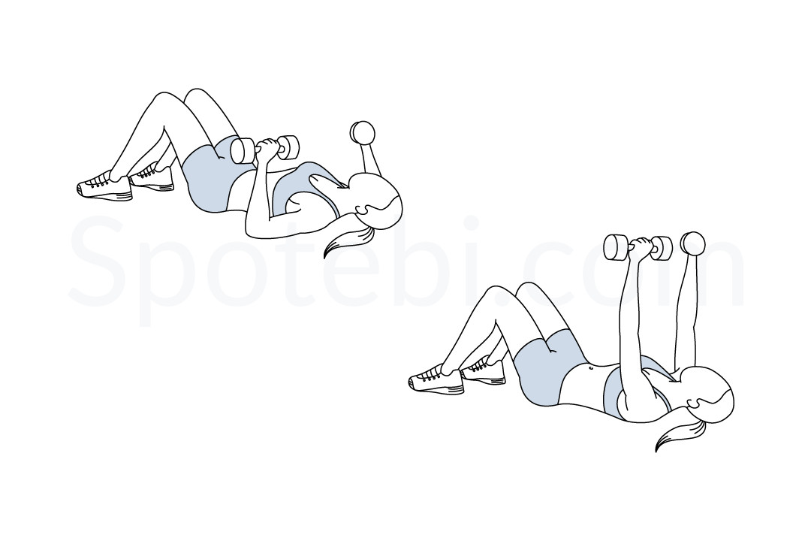 | Incline Dumbbell Press  ▶ Watch on YouTube | 4 × 10-12 | Controlled range, back flat to bench, no shoulder impingement
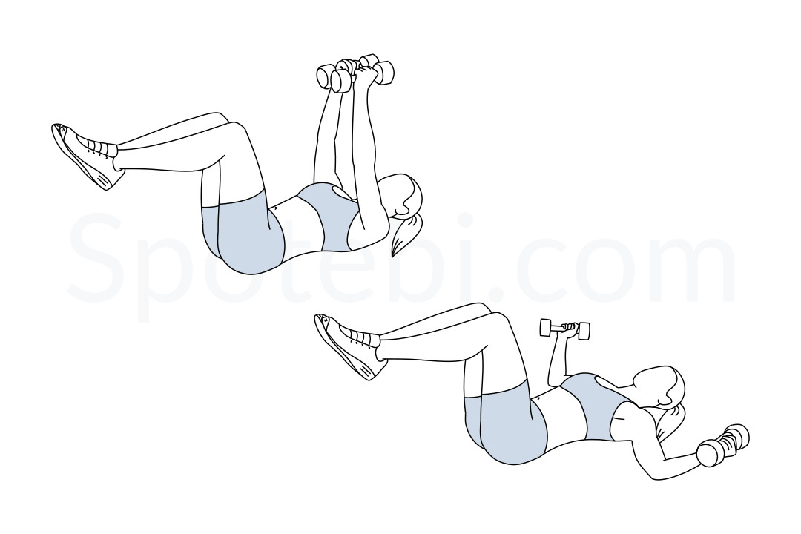 | Cable Chest Fly (Low Pulley)  ▶ Watch on YouTube | 3 × 12-15 | Arms slightly bent, squeeze chest at center, constant tension
 | Machine Chest Press  ▶ Watch on YouTube | 3 × 10-12 | Seat height so handles at mid-chest, back fully supported
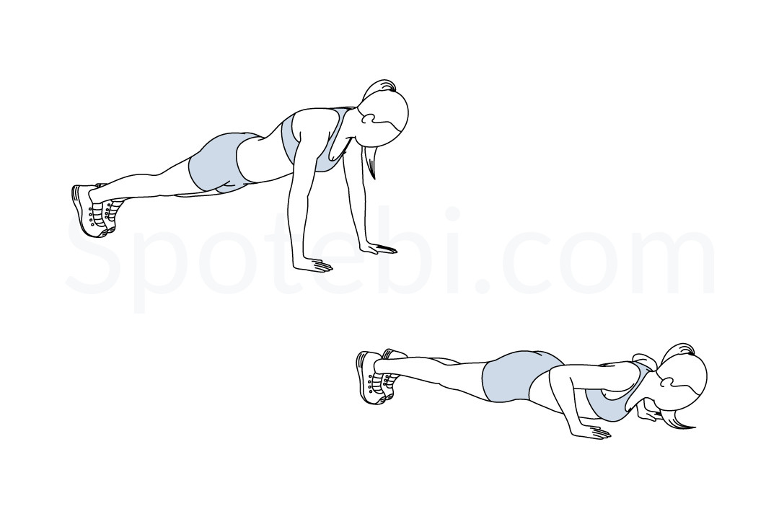 | Push-Ups  ▶ Watch on YouTube | 3 × max | Straight body line, don't let hips sag
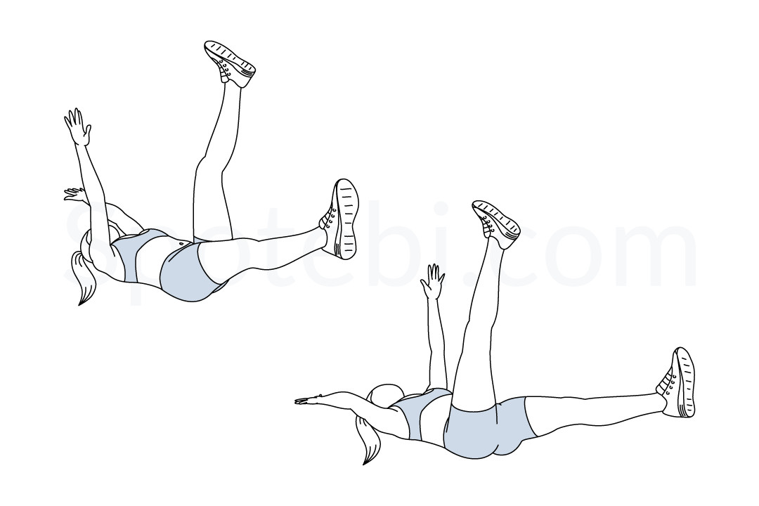 | Dead Bug  ▶ Watch on YouTube | 3 × 10/side | Lower back FLAT on floor the entire time — non-negotiable
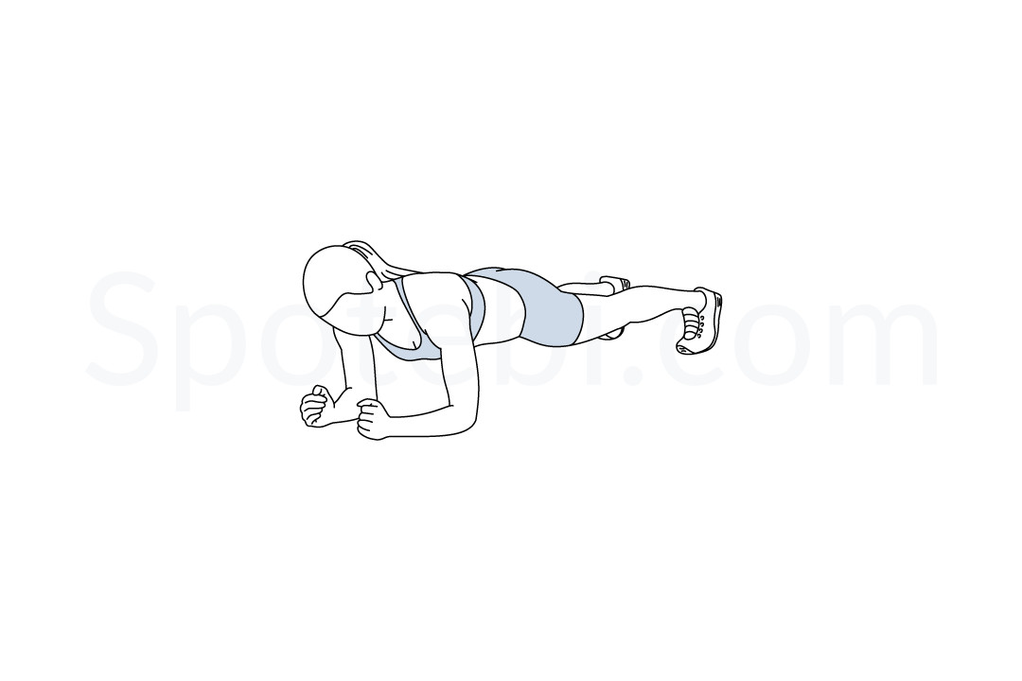 | Forearm Plank  ▶ Watch on YouTube | 3 × 30-45s | Neutral spine, glutes squeezed, breathe steadily

TUESDAY — Legs: Quad & Glute Focus
Core activation warm-up (5 min) before lifting. Focus on controlled range — these muscles are being rebuilt from scratch.
Image | Exercise | Sets × Reps | Form Cue
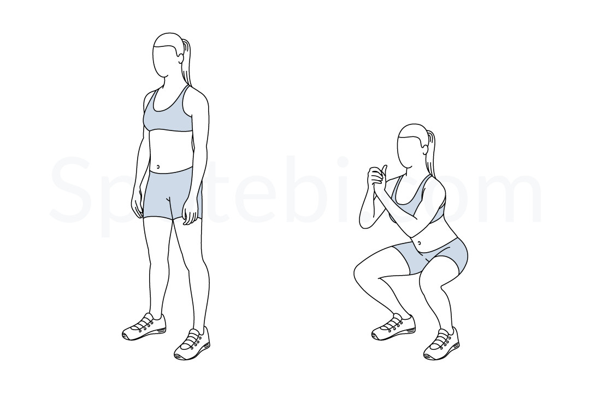 | Leg Press (Machine)  ▶ Watch on YouTube | 4 × 12-15 | Feet mid-plate shoulder-width, never let lower back peel off pad
 | Goblet Squat  ▶ Watch on YouTube | 3 × 12 | DB at chest, sit back and down, torso upright, knees track over toes
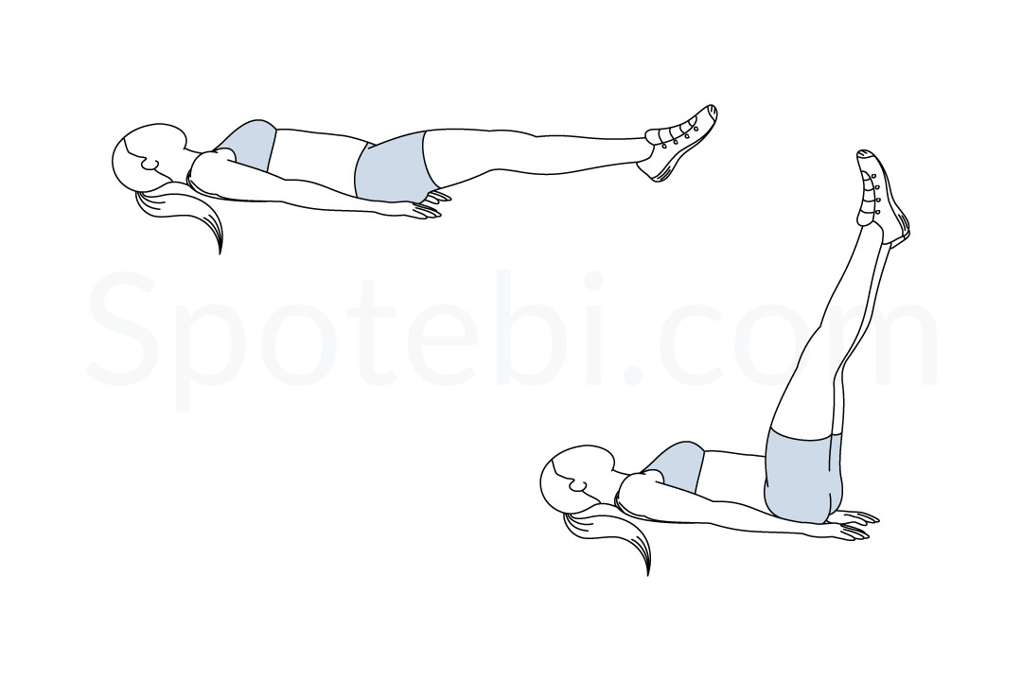 | Seated Leg Extension  ▶ Watch on YouTube | 3 × 15 | Full range, pause at top, slow lower
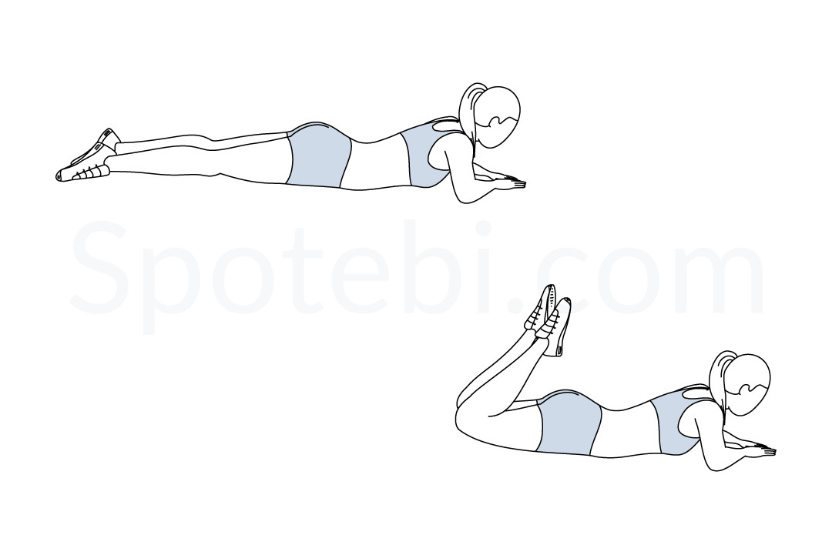 | Lying Leg Curl  ▶ Watch on YouTube | 3 × 12 | Hips stay on pad, slow eccentric
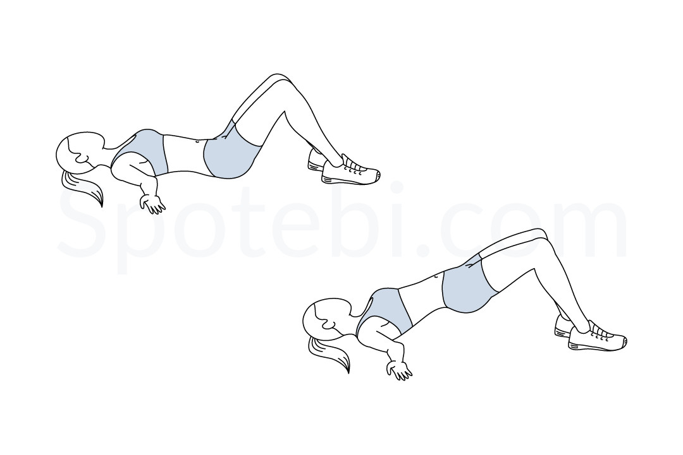 | Hip Thrust (Bench)  ▶ Watch on YouTube | 3 × 15 | Upper back on bench edge, drive through heels, squeeze glutes 1 sec at top
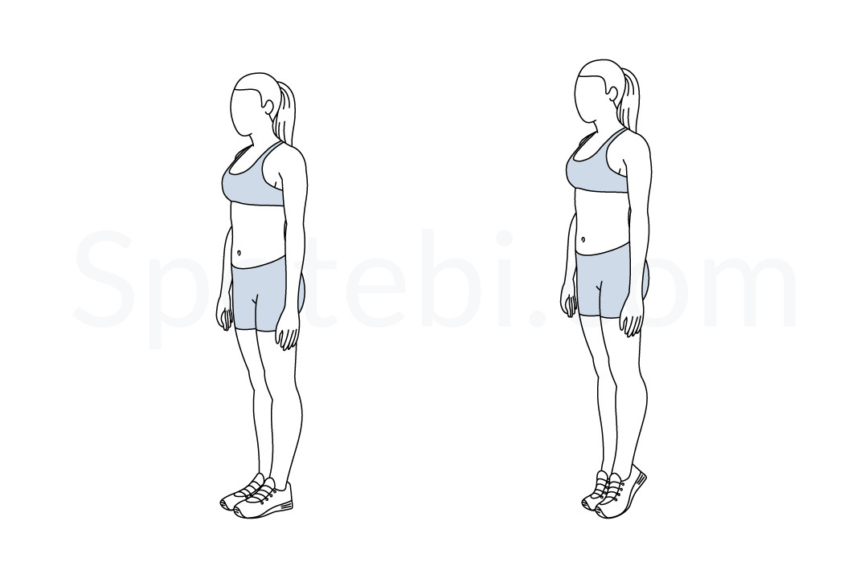 | Standing Calf Raise  ▶ Watch on YouTube | 3 × 20 | Heel below platform, full extension at top

WEDNESDAY — Swim
30-45 minutes of lap swimming.
Mix freestyle and backstroke. Backstroke is particularly valuable here — it decompresses the lumbar spine and opens the thoracic region in the opposite direction from sitting. On high back-sensitivity days, use a pull buoy for the entire session to take legs out of the equation and keep all rotation gentle.
This session is cardio, active recovery, and back therapy simultaneously. Don't skip it.

THURSDAY — Biceps + Shoulders + Core
Core activation warm-up (5 min). All curls are SEATED — this eliminates the temptation to swing through the lower back.
Image | Exercise | Sets × Reps | Form Cue
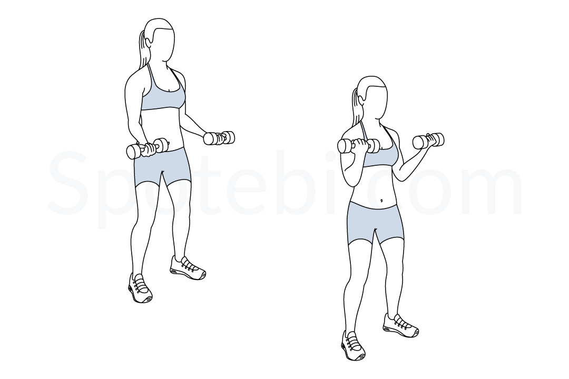 | Seated Dumbbell Curl  ▶ Watch on YouTube | 4 × 12 | SEATED eliminates back stress, full range, don't swing
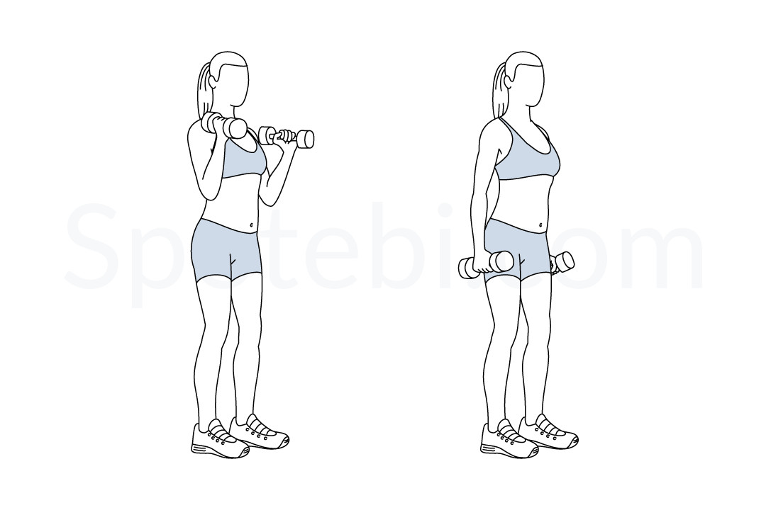 | Cable Hammer Curl  ▶ Watch on YouTube | 3 × 12 | Neutral grip, elbows pinned at sides
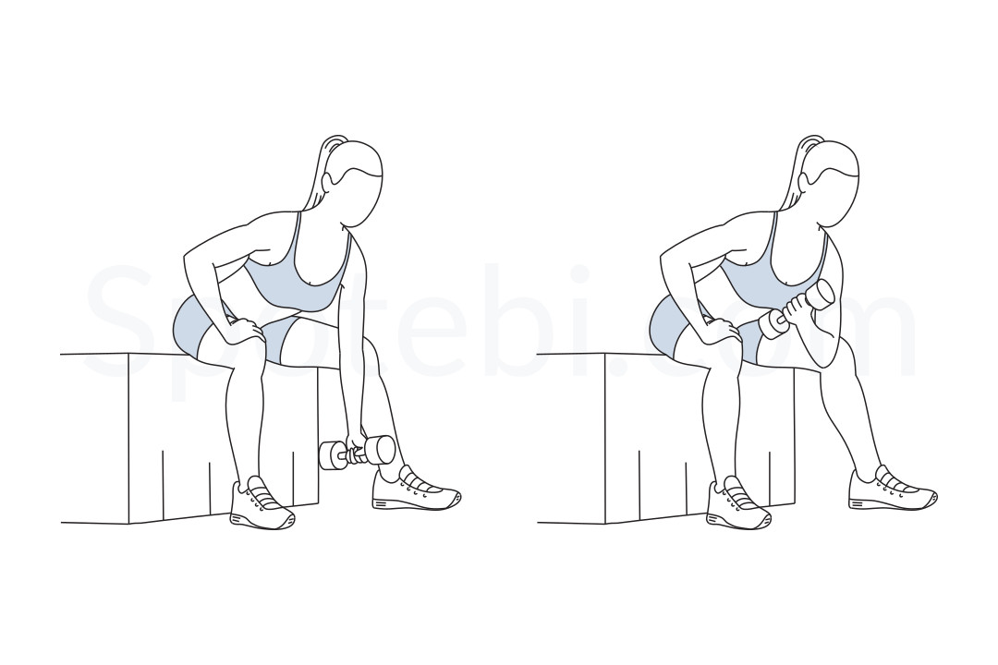 | Machine Preacher Curl  ▶ Watch on YouTube | 3 × 10-12 | Arms fully supported, don't hyperextend at bottom
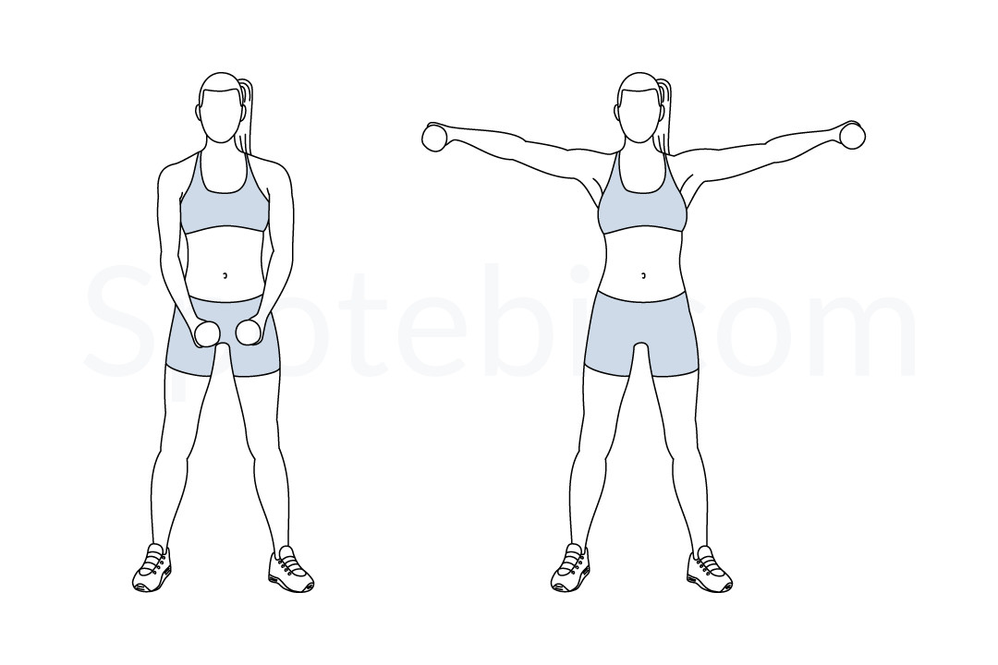 | Seated Lateral Raise (Light)  ▶ Watch on YouTube | 3 × 15 | Lead with elbows, raise to shoulder height only
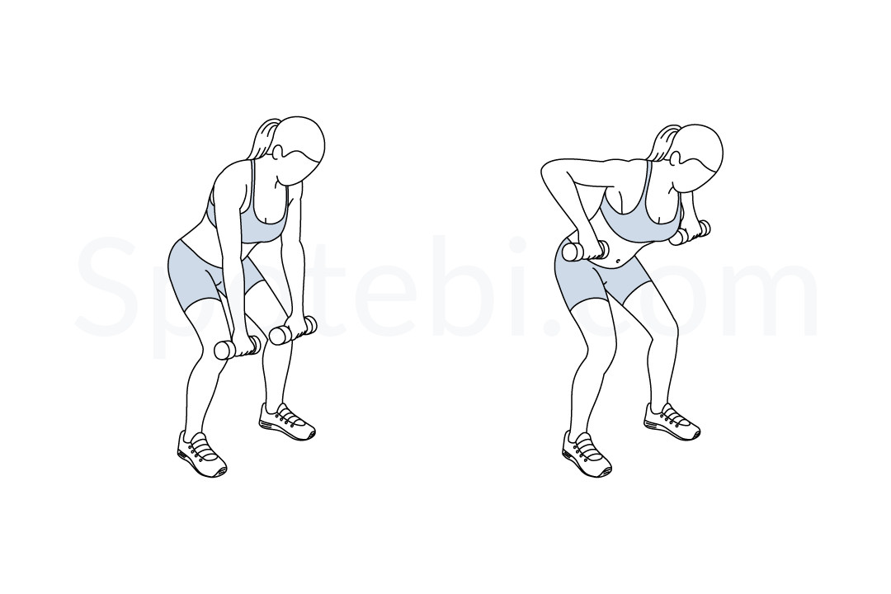 | Cable Face Pull  ▶ Watch on YouTube | 3 × 15 | Cable at face height, elbows FLARED HIGH AND WIDE — this is not a row
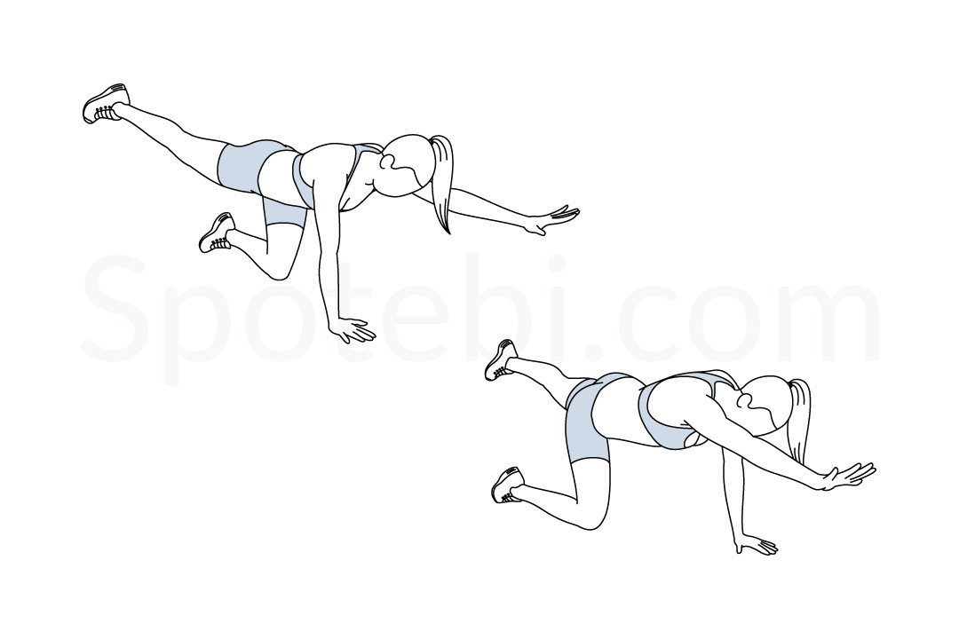 | Bird-Dog  ▶ Watch on YouTube | 3 × 10/side | Opposite arm and leg, spine neutral, hold 2 sec, no rotation

FRIDAY — Legs: Posterior Chain & Hinge
Core activation warm-up (5 min). The Romanian Deadlift is included but keep weights LIGHT — this is a hinge pattern, not a strength test. Technique first, always.
Image | Exercise | Sets × Reps | Form Cue
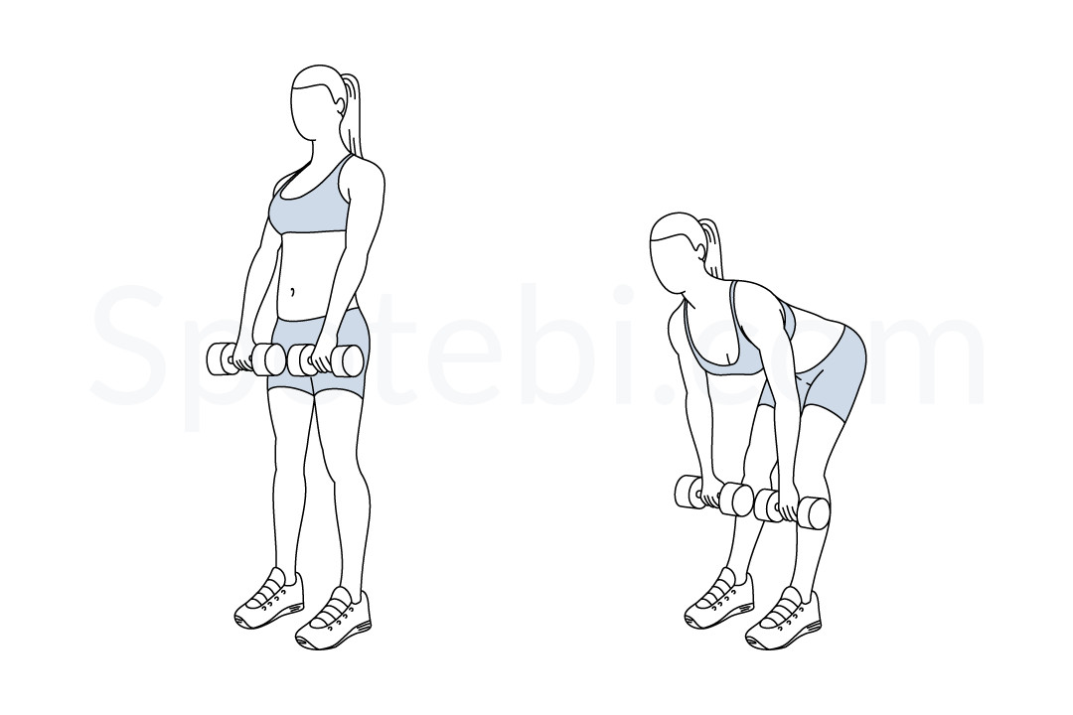 | Romanian Deadlift (Light DBs)  ▶ Watch on YouTube | 3 × 10 | Hinge at HIPS not waist, DBs close to legs, stop at hamstring stretch
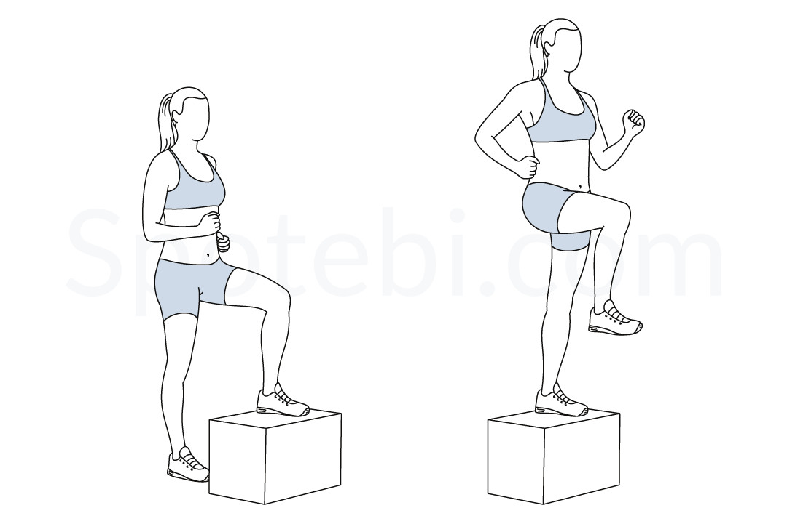 | Step-Ups (Box or Bench)  ▶ Watch on YouTube | 3 × 12/leg | Drive through heel of elevated foot, don't push off back foot
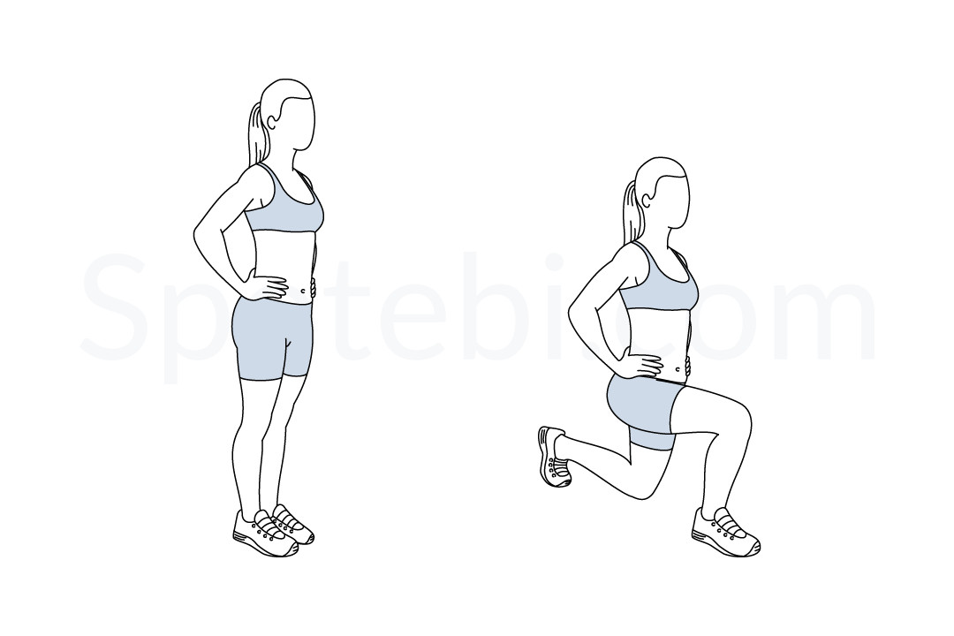 | Reverse Lunge  ▶ Watch on YouTube | 3 × 10/leg | Step BACK, front knee tracks over toes, torso upright
 | Seated Leg Curl  ▶ Watch on YouTube | 3 × 15 | Full range, pause at full flexion, controlled return
 | Glute Bridge (Bodyweight)  ▶ Watch on YouTube | 3 × 20 | Feet flat, drive hips up, squeeze glutes 1 full second at top

SATURDAY — Swim (Longer Session)
45-60 minutes. Kick sets, pull buoy intervals, or technique drills. Use this session to work on breathing rhythm and stroke mechanics if desired. Consider water aerobics or aqua jogging for variety while staying gentle on the spine.

SUNDAY — Active Recovery
20-30 minute walk, light stretching, or yoga. Focus on hip flexors, hamstrings, and thoracic rotation. This is not a rest day in the sedentary sense — it's active recovery. Move, but don't load.

SECTION 3 — NUTRITION PLAN
Eating Window: 12:00 PM – 8:00 PM (16:8 Intermittent Fasting)
The 16-hour fast leverages overnight hormone shifts — growth hormone peaks during the fast, and insulin stays low. Breaking the fast at noon keeps the morning productive and simplifies meal timing around training.
Daily Macro Targets
170g+  Protein / day | <80g  Net Carbs / day | 35g+  Fiber / day | <25g  Added Sugar / day
Meal 1 — 12:00 PM (Break Fast)
- 4-5 egg whites + 1-2 whole eggs, scrambled in olive oil
- 1 avocado, sliced — DAILY NON-NEGOTIABLE. Do not remove this.
- Cherry tomatoes + cucumber
- Olive oil, lemon juice, fresh herbs
Meal 2 — 3:00 PM
- 6-8 oz grilled chicken, salmon, shrimp, or canned tuna
- Large salad: arugula, spinach, olives, roasted peppers, red onion
- Dressing: olive oil + red wine vinegar + Dijon mustard
- Optional: 1/4 cup chickpeas for extra fiber
Meal 3 — 6:30–7:30 PM (Largest Meal)
- 8 oz protein: salmon, sea bass, chicken thigh, lean ground turkey, or shrimp
- Roasted vegetables: broccoli, asparagus, zucchini, eggplant, or cauliflower
- Training days only: lentils, white beans, or 1/2 cup quinoa as a carb source
- Olive oil as cooking fat throughout
Snacks (Between Meals, If Needed)
- Plain full-fat Greek yogurt + blueberries or strawberries
- Hard-boiled eggs (2-3)
- String cheese + almonds or walnuts
- Protein shake — whey or casein, <5g sugar per serving
Rules & Limits
- Avocado: 1 daily — full stop. Healthy fats + fiber + satiety, no debate.
- AVOID: white bread, pasta, regular rice, fruit juice, cream-based sauces, fried food
- Water: 80-100 oz minimum daily — track it
- Electrolyte packet (zero sugar — LMNT or Liquid IV Zero) daily during the fast
- Coffee and green tea are fine during the fast — no cream or sugar

SECTION 4 — BACK SAFETY & RECOVERY
Pre-Workout Activation (Every Session — 5 Minutes)
Do this EVERY session without exception. This sequence fires the deep stabilizers that protect the lumbar spine before any loading begins.
Exercise | Sets/Reps | Note
Dead Bug | 2 × 10/side | Lower back flat on floor — always
Bird-Dog | 2 × 8/side | Hold 2 seconds, spine neutral
Glute Bridge | 2 × 15 | Squeeze glutes at top, pause
Post-Workout Stretching (5-10 Minutes)
Stretch | Duration | How-To
Hip Flexor Stretch | 45 sec/side | Lunge position, sink hips forward
Piriformis Stretch (Figure-4) | 45 sec/side | Lying on back, cross ankle over opposite knee
Child's Pose | 60 seconds | Arms extended, breathe into low back
Cat-Cow | 10 reps | Slow and controlled, full range
Professional Assessment
Recommendation: Schedule one session with a sports physical therapist within your first month in Tampa. Get a baseline assessment of your lumbar spine mechanics under movement. A 55-year-old with chronic lower back history who is returning to structured training will benefit enormously from knowing exactly where their ROM limits are before pushing into new patterns. This is not optional — it is smart.

