CURRICULUM VITAE

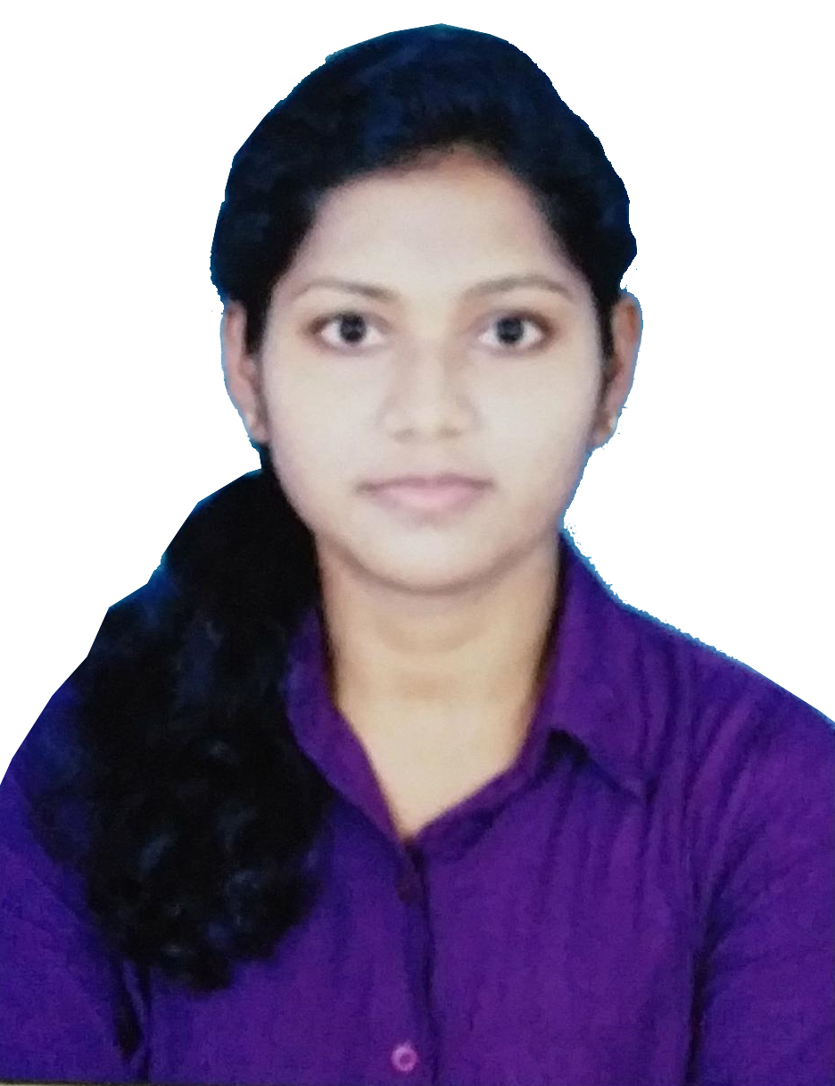

BHABANIRANI SWAIN
S/O- SAROJ KUMAR SWAIN
AT/PO-Narendrapur, PS- Hinjilicut
Ganjam, Odisha- 761103
Mob- +91-6371300518
Email ID: raniswain078@gmail.com

CAREER OBJECTIVE
To be a part of an organization, which can use my skills, experience & expertise in its process of growth, challenges & changes, while giving me ample opportunity to learn and enrich my competencies, so as to make meaningful & substantial contribution.

ACADEMIC CREDENTIALS
- Pursuing M.C.A from Biju Patnaik University of Technology Rourkela,Odisha.
- BCA passed from Berhampur University.
- 12th (Science) passed from Council of Higher Secondary Education,Odisha.
- 10th passed from Board of Secondary Education,Odisha.

COMPUTER PROFICIENCY
- Working knowledge on MS-Office,
- Programming Language:- C, C#.NET, SQL, HTML
- Working Comfortable with : Windows 7,8,10,XP

PERSONAL DETAILS
- Father’s Name : Saroj Kumar Swain
- Mothe’s Name : Sudashna Swain
- Date of Birth : 21 Jan 2001
- Gender : Female
- Nationality : Indian
- Religion : Hindu
- Category : OBC
- Martial Status : Unmarried
- Language Known : Oriya, Hindi & English (Read, Write & speak fluently)
Declaration: I hereby declare that all the furnished details above are true and correct to the best of my knowledge and belief.

Date: BHABANIRANI SWAIN

Place: Berhampur

